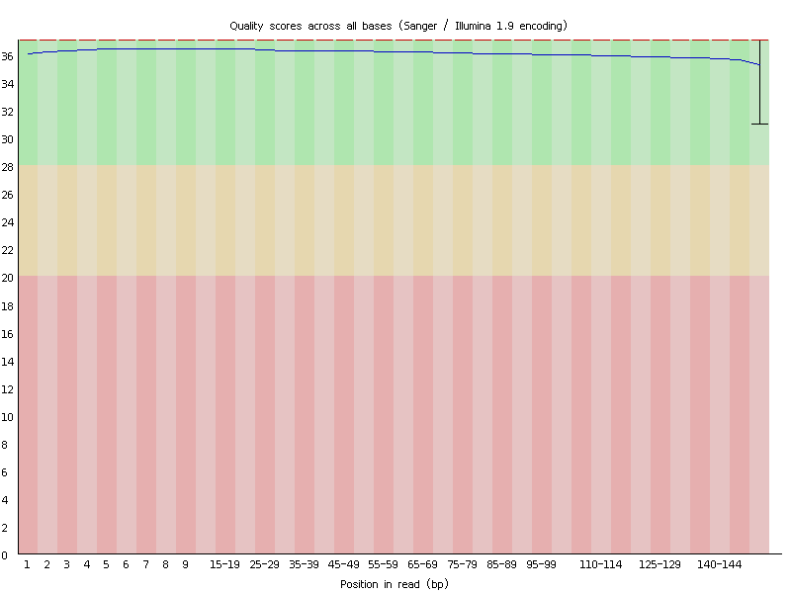
Figure S1 Raw data base quality
Note: Paired-end sequencing data are displayed separately: the abscissa is the base position of reads, and the ordinate is the corresponding base quality (represented by Q value). The base quality distribution of the corresponding position is displayed by boxplot. The background color is divided into three parts: green, yellow and red according to the base quality from good to bad, which visually shows the base quality.

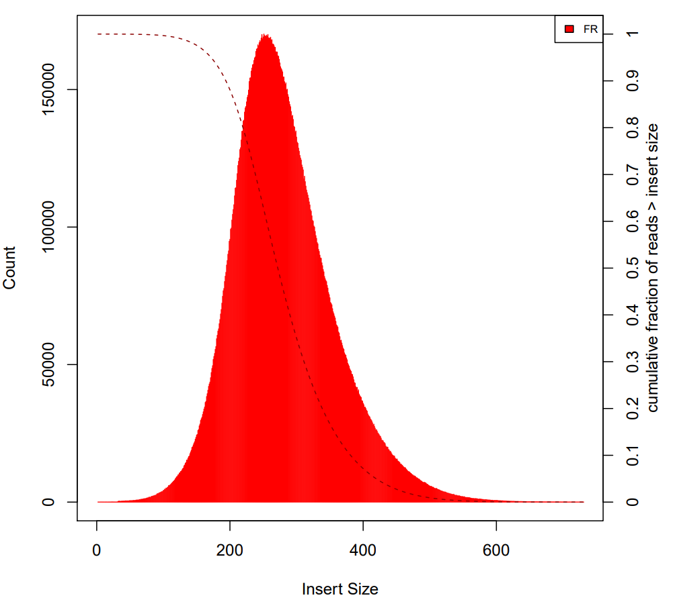
Figure S2 Fragment length distribution statistics of interrupted sequences during library construction.
Note: The abscissa is the insert length of the sequencing reads. The red shaded part in the figure represents the number of fragments with a specific insert length, corresponding to the left ordinate, and the red dotted line represents the proportion of fragments larger than the specific insert length, corresponding to the right ordinate.

Table S1 Whole-exome sequencing data statistics
Sample | R1 |  |  |  |  | R2
Sample | Total Reads | Reads length | Q20 | Q30 | BaseCount (M) | Total Reads | Reads length | Q20 | Q30 | BaseCount (M)
VSD-1 | 28753750 | 15-151 | 99.98 % | 97.65 % | 4297.27 | 28753750 | 15-151 | 99.88 % | 97.98 % | 4290.48
VSD-2 | 27379763 | 15-151 | 99.98 % | 97.60 % | 4094.84 | 27379763 | 15-151 | 99.87 % | 97.50 % | 4088.21
VSD-3 | 41366945 | 15-151 | 99.98 % | 97.59 % | 6177.25 | 41366945 | 15-151 | 99.89 % | 97.92 % | 6166.98
VSD-4 | 40162777 | 15-151 | 99.98 % | 96.80 % | 6008 | 40162777 | 15-151 | 99.82 % | 94.24 % | 5998.41
VSD-5 | 22877832 | 15-151 | 99.98 % | 97.46 % | 3425.21 | 22877832 | 15-151 | 99.85 % | 95.64 % | 3419.74
VSD-6 | 33865429 | 15-151 | 99.98 % | 96.61 % | 5066.02 | 33865429 | 15-151 | 99.84 % | 94.94 % | 5058.06
VSD-7 | 28146816 | 15-151 | 99.98 % | 96.69 % | 4209.86 | 28146816 | 15-151 | 99.83 % | 94.73 % | 4203.21
VSD-8 | 27907226 | 15-151 | 99.98 % | 96.76 % | 4175.64 | 27907226 | 15-151 | 99.82 % | 93.87 % | 4168.77
VSD-9 | 28588314 | 15-151 | 99.98 % | 96.72 % | 4278.68 | 28588314 | 15-151 | 99.83 % | 94.73 % | 4271.75
VSD-10 | 30256806 | 15-151 | 99.98 % | 96.81 % | 4525.17 | 30256806 | 15-151 | 99.85 % | 94.65 % | 4518.05
VSD-11 | 28769827 | 15-151 | 99.98 % | 96.69 % | 4301.25 | 28769827 | 15-151 | 99.83 % | 94.86 % | 4294.39
VSD-12 | 28487315 | 15-151 | 99.98 % | 96.82 % | 4261.58 | 28487315 | 15-151 | 99.85 % | 94.42 % | 4254.75
VSD-13 | 24636731 | 15-151 | 99.98 % | 96.94 % | 3683.67 | 24636731 | 15-151 | 99.84 % | 95.66 % | 3677.68
VSD-14 | 26341401 | 15-151 | 99.98 % | 96.87 % | 3938.05 | 26341401 | 15-151 | 99.81 % | 94.61 % | 3931.68
VSD-15 | 30311173 | 15-151 | 99.98 % | 96.69 % | 4531.25 | 30311173 | 15-151 | 99.82 % | 95.12 % | 4524.3
VSD-16 | 33245327 | 15-151 | 99.98 % | 96.64 % | 4972.70 | 33245327 | 15-151 | 99.82 % | 94.91 % | 4964.90
VSD-17 | 29647648 | 15-151 | 99.98 % | 96.86 % | 4435.38 | 29647648 | 15-151 | 99.84 % | 95.58 % | 4428.18
VSD-18 | 55771808 | 15-151 | 99.98 % | 96.83 % | 8347.29 | 55771808 | 15-151 | 99.86 % | 94.84 % | 8333.93
VSD-19 | 25886272 | 15-151 | 99.98 % | 97.16 % | 3865.35 | 25886272 | 15-151 | 99.83 % | 95.45 % | 3859.34
VSD-20 | 26195558 | 15-151 | 99.98 % | 97.01 % | 3913.30 | 26195558 | 15-151 | 99.83 % | 94.52 % | 3907.24
Note: ‘Total Reads’ and ‘Read Length’ represent the original sequence number and sequencing read length, ‘Q20 (%)’ and ‘Q30 (%)’ represent the sequences whose sequencing quality Q is not lower than 20 and 30 in the original data, respectively proportion.

Table S2 BWA comparison results
Sample | The total number of reads participating in the genome alignment | The number of reads aligned to the genome | Comparison ratio | Number of bases aligned to the genome | 10X percentage of bases covered
VSD-1 | 57507500 | 57223381 | 0.995059 | 8486461509 | 0.969870
VSD-2 | 54759526 | 54448172 | 0.994314 | 8075412756 | 0.974369
VSD-3 | 82733890 | 82300393 | 0.994760 | 12188358850 | 0.956932
VSD-4 | 80325554 | 79590409 | 0.990848 | 11778617119 | 0.991557
VSD-5 | 45755664 | 45454920 | 0.993427 | 6741477407 | 0.976019
VSD-6 | 67730858 | 67166539 | 0.991668 | 9945617439 | 0.987224
VSD-7 | 56293632 | 55797209 | 0.991182 | 8259114571 | 0.981628
VSD-8 | 34707396 | 34365774 | 0.990157 | 5080394828 | 0.933922
VSD-9 | 35536528 | 35216622 | 0.990998 | 5211736819 | 0.949094
VSD-10 | 38097090 | 37764484 | 0.991270 | 5581084100 | 0.958988
VSD-11 | 35739458 | 35430166 | 0.991346 | 5234969355 | 0.942288
VSD-12 | 35736992 | 35423124 | 0.991217 | 5236492534 | 0.946641
VSD-13 | 34681364 | 34426324 | 0.992646 | 5093733681 | 0.902349
VSD-14 | 36980786 | 36648033 | 0.991002 | 5418618946 | 0.937593
VSD-15 | 42514152 | 42155978 | 0.991575 | 6234007381 | 0.953267
VSD-16 | 37290000 | 36976646 | 0.991597 | 5468832264 | 0.942586
VSD-17 | 32320918 | 32079631 | 0.992535 | 4746849962 | 0.915890
VSD-18 | 63246710 | 62696503 | 0.991301 | 9286265299 | 0.985856
VSD-19 | 51772544 | 51392441 | 0.992658 | 7599420850 | 0.971143
VSD-20 | 52391116 | 51927213 | 0.991145 | 7673822452 | 0.972784

