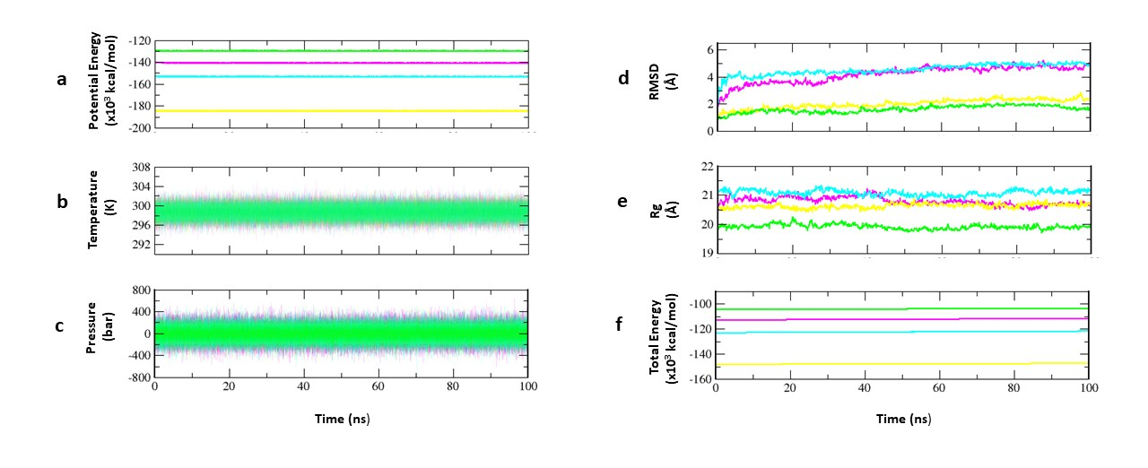
Supplementary Figure 1 Graphs showing the dynamic parameters of the models during MD simulation. (a) Potential energy; (b) Temperature; (c) Pressure; (d) RMSD; (e) Rg; (f) Total energy. Plots for Leishmania donovani PAF-AH, Trypanosoma cruzi PAF-AH, Trypanosoma brucei PAF-AH and human PAF-AH are shown in cyan, magenta, yellow and green, respectively.

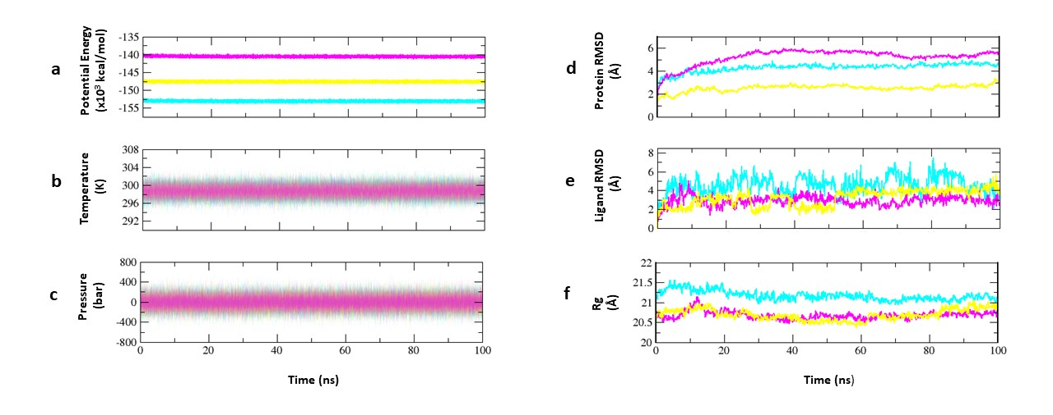
Supplementary Figure 2 Graphs showing the dynamic parameters of parasitic PAF-AH complexes with their respective inhibitor molecules during MD simulation. (a) Potential energy; (b) Temperature; (c) Pressure; (d) Protein RMSD; (e) Ligand RMSD; (f) Rg. Plots for Leishmania donovani PAF-AH-D1, Trypanosoma cruzi PAF-AH-C1 and Trypanosoma brucei PAF-AH-B1 are shown in cyan, magenta and yellow, respectively.

Models | ERRAT | Verify 3D | Ramachandran Plot
Models | ERRAT | Verify 3D | Allowed Region | Generously allowed | Disallowed
Swiss 1 Ld | 87.64 | 67.81 | 96.6 | 2.1 | 1.2
Swiss 2 Ld | 79.66 | 72.37 | 97.9 | 1.2 | 0.9
Swiss 3 Ld | 85.20 | 67.89 | 97.6 | 0.9 | 1.5
Geno 3D 1 Ld | 74.10 | 60.21 | 91.1 | 4.9 | 4.1
Geno 3D 2 Ld | 80.50 | 56.40 | 90.2 | 6.5 | 3.3
Geno 3D 3 Ld | 86.54 | 54.67 | 89.5 | 8.1 | 2.4
Geno 3D 4 Ld | 80.86 | 71.97 | 93.1 | 3.3 | 3.7
Geno 3D 5 Ld | 80.57 | 61.59 | 91.1 | 6.1 | 2.8
Swiss 1 Tc | 83.47 | 69.59 | 97.2 | 1.9 | 0.9
Swiss 2 Tc | 77.81 | 64.38 | 99.1 | 0.6 | 0.3
Swiss 3 Tc | 70.40 | 62.84 | 98.8 | 0.3 | 0.9
Geno 3D 1 Tc | 81.08 | 58.02 | 93.0 | 4.6 | 2.3
Geno 3D 2 Tc | 77.31 | 64.43 | 90.8 | 5.3 | 4.0
Geno 3D 3 Tc | 81.79 | 54.81 | 91.4 | 5.6 | 3.0
Geno 3D 4 Tc | 81.79 | 70.55 | 88.7 | 7.6 | 3.6
Geno 3D 5 Tc | 82.68 | 58.89 | 91.1 | 6.6 | 2.3
Swiss 1 Tb | 75.80 | 77.41 | 98.1 | 1.6 | 0.3
Swiss 2 Tb | 79.09 | 68.04 | 96.9 | 1.9 | 1.3
Swiss 3 Tb | 70.80 | 74.66 | 97.8 | 0.6 | 1.6
Geno 3D 1 Tb | 74.66 | 40.91 | 90.3 | 5.2 | 4.5
Geno 3D 2 Tb | 82.75 | 48.70 | 89.5 | 4.5 | 6.0
Geno 3D 3 Tb | 71.23 | 17.53 | 85.8 | 9.0 | 5.2
Geno 3D 4 Tb | 84.93 | 42.86 | 88.0 | 6.7 | 5.2
Geo 3D 5 Tb | 89.04 | 49.35 | 89.6 | 7.5 | 3.0

Supplementary Table. 1 Validation parameters for the PAFAH models of Leishmania donovani, Trypanosoma cruzi, and Trypanosoma brucei

