Supporting Information for

Seasonal dynamics of the upper respiratory tract microbiome in chronic obstructive pulmonary disease

Shuping Cai^{1,2}*, Jingyuan Gao³*, Xiaomin Liu³*, Junhao Yang³*, Dingyun Feng¹, Kuijun Li¹, Sijia Li¹, Hailing Yang¹, Zhang Wang³, Xinzhu Yi^{3#}, Yuqi Zhou^{1#}

¹ Department of Pulmonary and Critical Care Medicine, The Third Affiliated Hospital of Sun Yat-Sen University, Institute of Respiratory Diseases of Sun Yat-Sen University, Guangzhou, China
² Department of Pulmonary and Critical Care Medicine, The Seventh Affiliated hospital of SUN YAT-SEN University, Shenzhen China
³ Institute of Ecological Sciences, School of Life Sciences, South China Normal University, China

* These authors contributed equally to this work.
# Co-corresponding authors

Supplementary figures
Figure S1. Availability of samples for each subject from each time point. Red: sampled; gray: not sampled.
Figure S2. Microbiome composition at genus level in blank and samples.
Figure S3. The airway microbiome functional profile of COPD patients varied with months a). Principal component analysis (PCA) based on the abundance of KEGG orthology (KO) colored by sampling months. b). Composition of KO level 2 in different months. c). KO with significantly changed relative abundance in different months (FDR < 0.05). Kruskal-Wallis rank sum test was used to test differences of KEGG pathways in different months.
Figure S4. Differential and clustering analysis of KEGG pathways along the time course. Line charts represent the trends of zscore of the relative abundance of KEGG pathway over time. Full members of each cluster were listed in Table S3. Colors demonstrate membership values representing the degree to which data points belong to a cluster.

Supplementary Tables
Table S1. Detailed information on sampling of 18 subjects in different months of two years.
Table S2. Details of bacteria in 12 clusters in Figure 2.
Table S3. Full list of KEGG pathway in 12 clusters in Figure S3

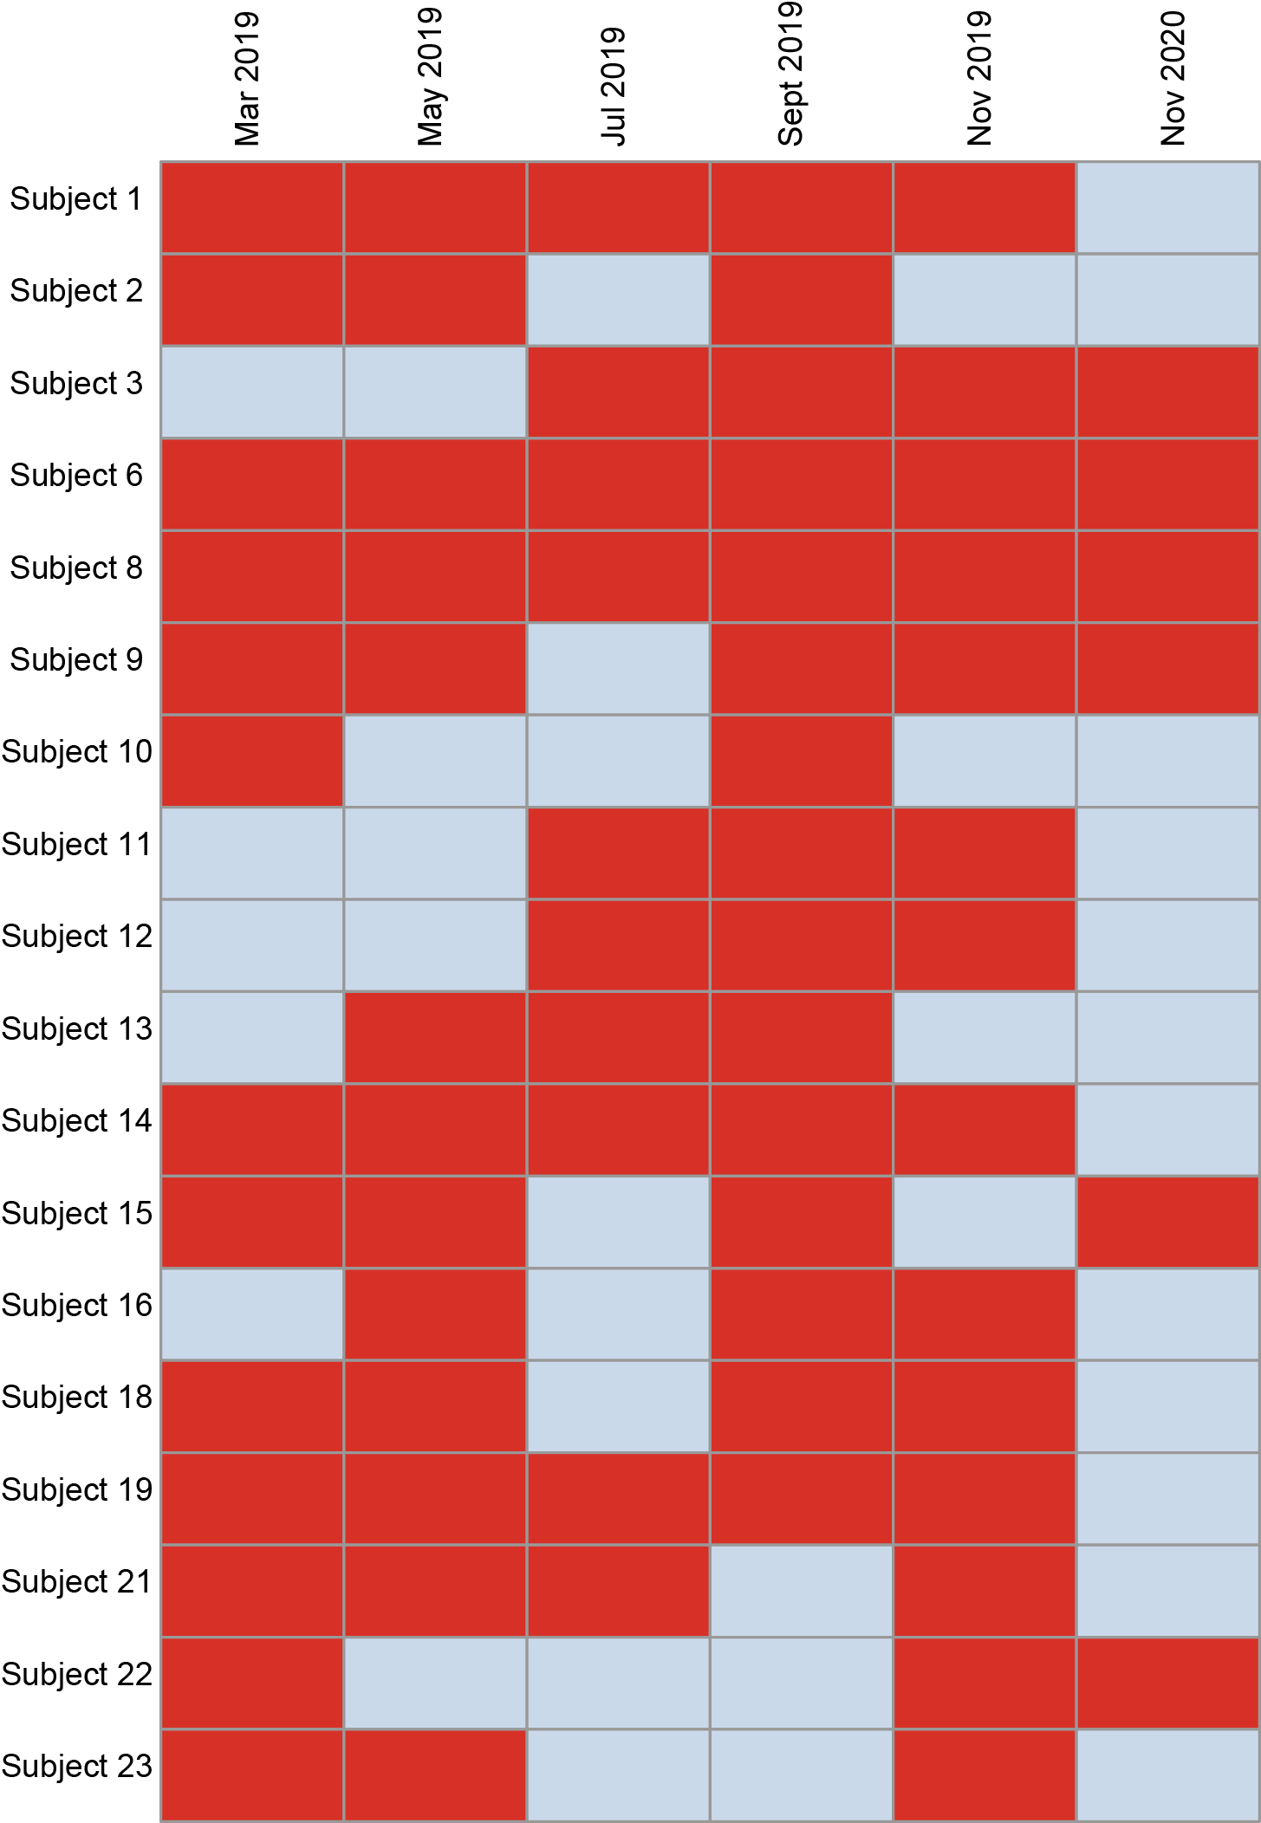
Figure S1

Figure S2

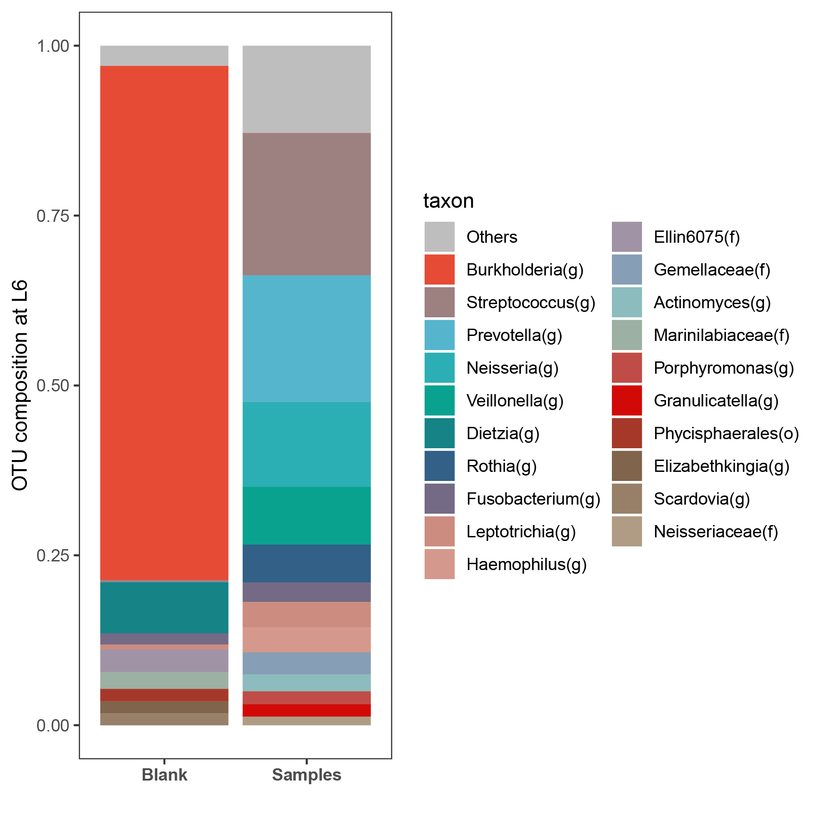

Figure S3
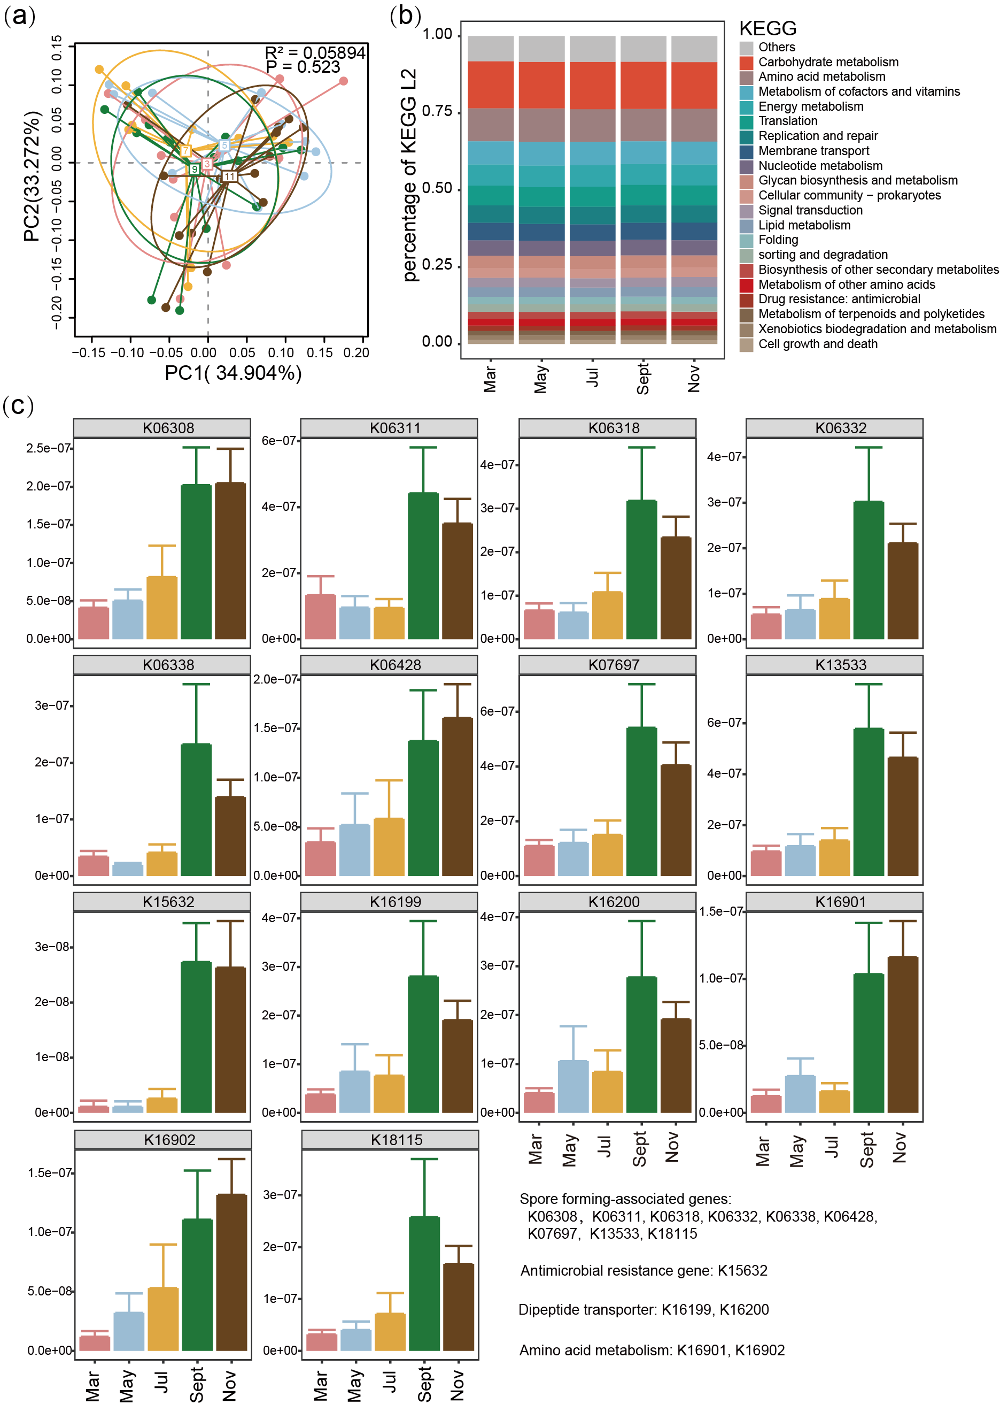

Figure S4
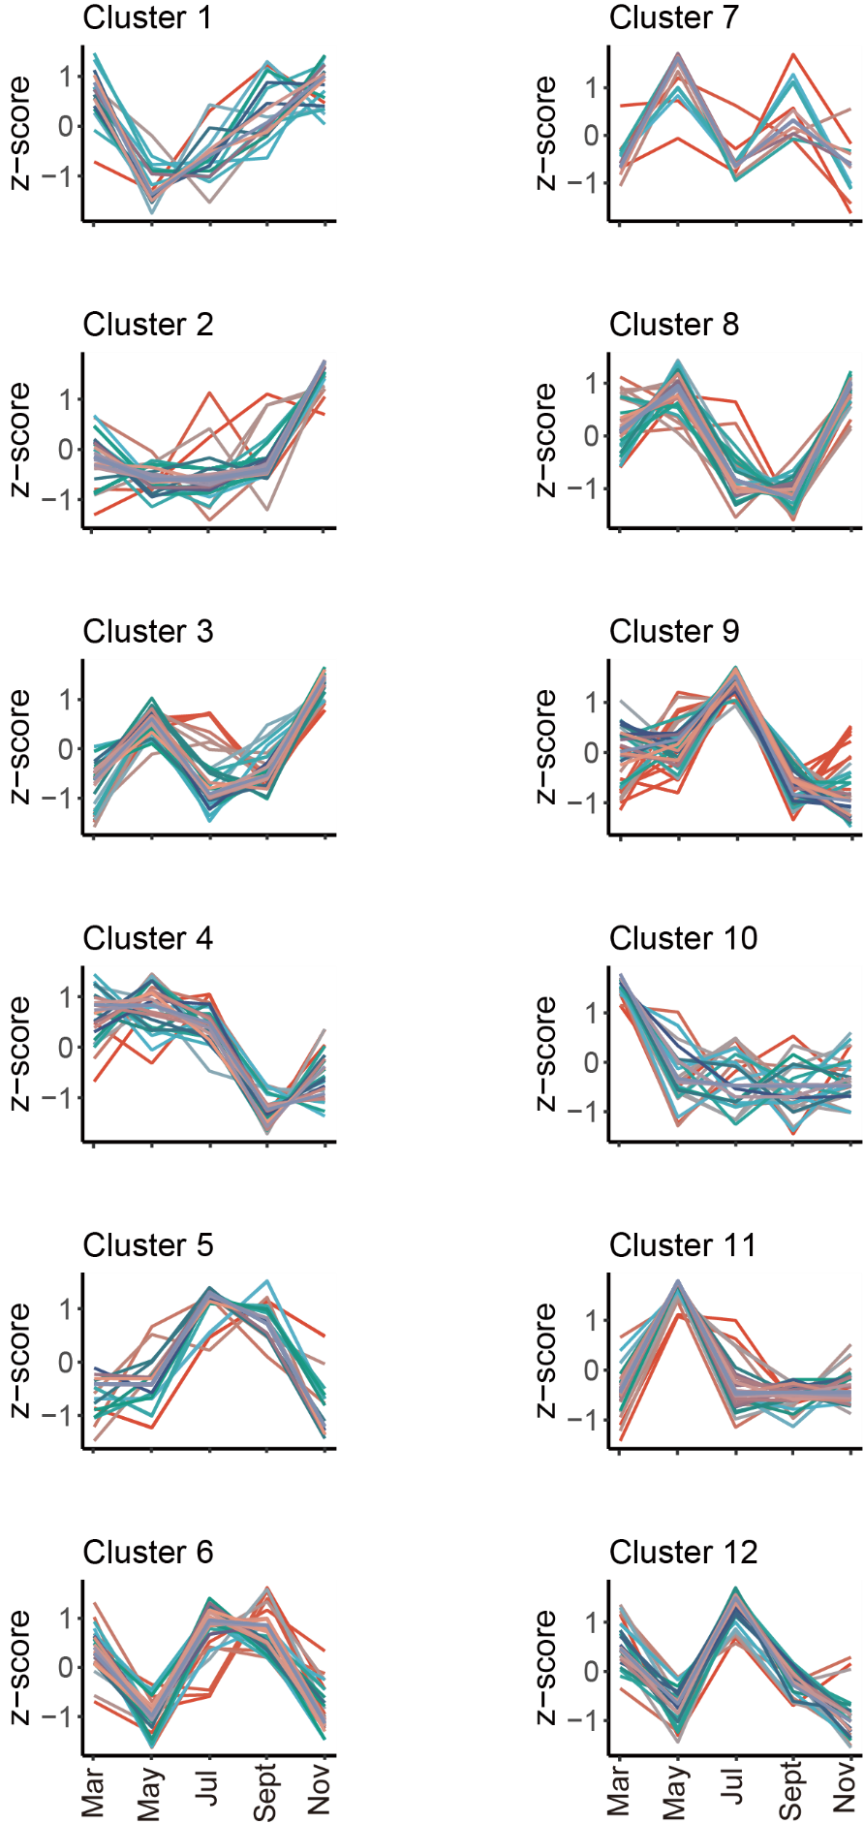

Table S1. Detailed sampling information
SampleID | SubjectID | Year | Group | Sample type | Month
S0103 | 1 | 2019 | COPDª | Swab | 3
S0105 | 1 | 2019 | COPD | Swab | 5
S0107 | 1 | 2019 | COPD | Swab | 7
S0109 | 1 | 2019 | COPD | Swab | 9
S0111 | 1 | 2019 | COPD | Swab | 11
S0203 | 2 | 2019 | COPD | Swab | 3
S0205 | 2 | 2019 | COPD | Swab | 5
S0209 | 2 | 2019 | COPD | Swab | 9
S0211 | 2 | 2019 | COPD | Swab | 11
S0803 | 8 | 2019 | COPD | Swab | 3
S0805 | 8 | 2019 | COPD | Swab | 5
S0807 | 8 | 2019 | COPD | Swab | 7
S0809 | 8 | 2019 | COPD | Swab | 9
S0811 | 8 | 2019 | COPD | Swab | 11
S0903 | 9 | 2019 | COPD | Swab | 3
S0905 | 9 | 2019 | COPD | Swab | 5
S0909 | 9 | 2019 | COPD | Swab | 9
S0911 | 9 | 2019 | COPD | Swab | 11
S1403 | 14 | 2019 | COPD | Swab | 3
S1405 | 14 | 2019 | COPD | Swab | 5
S1407 | 14 | 2019 | COPD | Swab | 7
S1409 | 14 | 2019 | COPD | Swab | 9
S1411 | 14 | 2019 | COPD | Swab | 11
S1503 | 15 | 2019 | COPD | Swab | 3
S1505 | 15 | 2019 | COPD | Swab | 5
S1509 | 15 | 2019 | COPD | Swab | 9
S1605 | 16 | 2019 | COPD | Swab | 5
S1609 | 16 | 2019 | COPD | Swab | 9
S1611 | 16 | 2019 | COPD | Swab | 11
S1903 | 19 | 2019 | COPD | Swab | 3
S1905 | 19 | 2019 | COPD | Swab | 5
S1907 | 19 | 2019 | COPD | Swab | 7
S1909 | 19 | 2019 | COPD | Swab | 9
S1911 | 19 | 2019 | COPD | Swab | 11
S2103 | 21 | 2019 | COPD | Swab | 3
S2105 | 21 | 2019 | COPD | Swab | 5
S2107 | 21 | 2019 | COPD | Swab | 7
S2111 | 21 | 2019 | COPD | Swab | 11
S2203 | 22 | 2019 | COPD | Swab | 3
S2211 | 22 | 2019 | COPD | Swab | 11
S2303 | 23 | 2019 | COPD | Swab | 3
S2305 | 23 | 2019 | COPD | Swab | 5
S2311 | 23 | 2019 | COPD | Swab | 11
S0603 | 6 | 2019 | COPD | Swab | 3
S0605 | 6 | 2019 | COPD | Swab | 5
S0607 | 6 | 2019 | COPD | Swab | 7
S0609 | 6 | 2019 | COPD | Swab | 9
S0611 | 6 | 2019 | COPD | Swab | 11
S1003 | 10 | 2019 | COPD | Swab | 3
S1005 | 10 | 2019 | COPD | Swab | 9
S1803 | 18 | 2019 | COPD | Swab | 3
S1805 | 18 | 2019 | COPD | Swab | 5
S1809 | 18 | 2019 | COPD | Swab | 9
S1811 | 18 | 2019 | COPD | Swab | 11
S0307 | 3 | 2019 | COPD | Swab | 7
S0309 | 3 | 2019 | COPD | Swab | 9
S0311 | 3 | 2019 | COPD | Swab | 11
S1107 | 11 | 2019 | COPD | Swab | 7
S1109 | 11 | 2019 | COPD | Swab | 9
S1111 | 11 | 2019 | COPD | Swab | 11
S1207 | 12 | 2019 | COPD | Swab | 7
S1209 | 12 | 2019 | COPD | Swab | 9
S1211 | 12 | 2019 | COPD | Swab | 11
S1305 | 13 | 2019 | COPD | Swab | 5
S1307 | 13 | 2019 | COPD | Swab | 7
S1309 | 13 | 2019 | COPD | Swab | 9
S151120 | 15 | 2020 | COPD | Swab | 11
S061120 | 6 | 2020 | COPD | Swab | 11
S081120 | 8 | 2020 | COPD | Swab | 11
S091120 | 9 | 2020 | COPD | Swab | 11
S031120 | 3 | 2020 | COPD | Swab | 11
S221120 | 22 | 2020 | COPD | Swab | 11
ª COPD: Chronic obstructive pulmonary disease

Table S2. Full list of bacteria in 12 clusters in Figure 3b
Cluster ID | OTU ID | Average relative abundance | Median relative abundance | Taxonomy ª
1 | otu_52 | 0.074478799 | 0.024170593 | (g)Rothia
1 | otu_155 | 0.037979977 | 0.018085002 | (f)Gemellaceae
1 | otu_194 | 0.003561052 | 0.002650177 | (g)Oribacterium
1 | otu_27 | 0.024557322 | 0.002306635 | (g)Corynebacterium
1 | otu_320 | 0.011184729 | 0.002012171 | (f)Neisseriaceae
1 | otu_189 | 0.000405384 | 0.000171771 | (g)Catonella
1 | otu_215 | 6.87072E-05 | 0.0000491 | (g)Schwartzia
1 | otu_174 | 0.000136434 | 0.0000245 | (g)Lactococcus
1 | otu_353 | 4.80827E-05 | 0.0000245 | (f)Aeromonadaceae
1 | otu_406 | 0.000224768 | 0.0000245 | (p)SR1
2 | otu_362 | 0.000588933 | 0.000269925 | (f)Enterobacteriaceae
2 | otu_391 | 0.000555559 | 0.000171771 | (g)Pseudomonas
2 | otu_387 | 0.000143305 | 0.000147232 | (g)Moraxella
2 | otu_361 | 0.000192382 | 0.0000982 | (g)Cardiobacterium
3 | otu_100 | 0.165569297 | 0.137073027 | (g)Prevotella
3 | otu_218 | 0.097676679 | 0.067579505 | (g)Veillonella
3 | otu_235 | 0.053385355 | 0.044881233 | (g)Leptotrichia
3 | otu_113 | 0.006913035 | 0.003091873 | (g)Capnocytophaga
3 | otu_216 | 0.003427562 | 0.002453867 | (g)Selenomonas
3 | otu_230 | 0.000864744 | 0.000588928 | (g)Bulleidia
3 | otu_91 | 9.61969E-05 | 0.0000491 | (o)Bacteroidales
3 | otu_224 | 4.02437E-05 | 0.0000245 | (g)Anaerococcus
3 | otu_414 | 6.08478E-05 | 0.0000245 | (o)CW040
4 | otu_381 | 0.022616804 | 0.010772477 | (g)Haemophilus
4 | otu_185 | 0.007700236 | 0.00611013 | (f)Lachnospiraceae
4 | otu_212 | 0.010131527 | 0.002871025 | (g)Megasphaera
4 | otu_379 | 0.003118377 | 0.00240479 | (g)Aggregatibacter
4 | otu_77 | 0.002450923 | 0.00203671 | (g)Atopobium
4 | otu_193 | 0.003427562 | 0.001742246 | (g)Moryella
4 | otu_168 | 0.0069415 | 0.001055163 | (g)Lactobacillus
4 | otu_141 | 3.04133E-05 | 0.0000245 | (g)Marinococcus
4 | otu_225 | 3.92592E-05 | 0.0000245 | (g)Finegoldia
5 | otu_222 | 0.000396549 | 0.000319003 | (g)Mogibacterium
5 | otu_200 | 0.000232626 | 0.0000491 | (f)Peptostreptococcaceae
5 | otu_209 | 0.000312127 | 0.0000491 | (f)Veillonellaceae
5 | otu_72 | 0.000140353 | 0.0000491 | (g)Bifidobacterium
5 | otu_183 | 5.29972E-05 | 0.0000245 | (g)Pseudoramibacter_Eubacterium
5 | otu_340 | 5.79068E-05 | 0.0000245 | (g)Bilophila
6 | otu_175 | 0.228515901 | 0.180604633 | (g)Streptococcus
6 | otu_378 | 0.003492344 | 0.00110424 | (g)Actinobacillus
6 | otu_408 | 0.00189733 | 0.001079702 | (g)Treponema
6 | otu_99 | 0.000869652 | 0.000588928 | (g)Tannerella
6 | otu_211 | 0.00079211 | 0.000490773 | (g)Dialister
6 | otu_202 | 0.000471143 | 0.000171771 | (g)Peptostreptococcus
6 | otu_322 | 0.000391635 | 0.000147232 | (g)Kingella
6 | otu_418 | 0.000174716 | 0.0000491 | (g)Mycoplasma
6 | otu_411 | 6.57511E-05 | 0.0000245 | (g)TG5
7 | otu_178 | 0.002985866 | 0.000883392 | (o)Clostridiales
7 | otu_93 | 0.001783473 | 0.000171771 | (g)Bacteroides
7 | otu_184 | 0.000236557 | 0.0000982 | (f)Lachnospiraceae
7 | otu_223 | 5.49597E-05 | 0.0000245 | (f)[Tissierellaceae]
7 | otu_410 | 0.000161944 | 0.0000245 | (g)Pyramidobacter
8 | otu_233 | 0.022683549 | 0.015631135 | (g)Fusobacterium
8 | otu_164 | 0.016768748 | 0.012588339 | (g)Granulicatella
8 | otu_347 | 0.010318021 | 0.008343149 | (g)Campylobacter
8 | otu_108 | 0.018218492 | 0.008269533 | (g)[Prevotella]
8 | otu_319 | 0.000977619 | 0.000490773 | (f)Neisseriaceae
8 | otu_22 | 0.001303494 | 0.000294464 | (f)Actinomycetaceae
8 | otu_226 | 0.000436792 | 0.000196309 | (g)Parvimonas
8 | otu_116 | 0.000266976 | 0.000171771 | (f)[Weeksellaceae]
8 | otu_415 | 7.26335E-05 | 0.0000736 | (f)F16
8 | otu_198 | 0.000215935 | 0.0000491 | (g)Peptococcus
8 | otu_74 | 0.000225752 | 0.0000491 | (g)Scardovia
9 | otu_297 | 0.00386435 | 0.001570475 | (g)Lautropia
9 | otu_156 | 0.000828428 | 0.000245387 | (g)Gemella
9 | otu_75 | 6.18353E-05 | 0.0000491 | (f)Coriobacteriaceae
9 | otu_363 | 0.000060848 | 0.0000245 | (f)Enterobacteriaceae
10 | otu_324 | 0.077698273 | 0.046746172 | (g)Neisseria
10 | otu_152 | 0.013453087 | 0.000343541 | (g)Staphylococcus
10 | otu_299 | 0.001468401 | 0.000220848 | (f)Comamonadaceae
10 | otu_66 | 0.000225755 | 0.0000982 | (g)Propionibacterium
10 | otu_96 | 0.000379857 | 0.0000982 | (g)Paludibacter
10 | otu_117 | 0.000226729 | 0.0000245 | (g)Chryseobacterium
10 | otu_296 | 0.00058892 | 0.0000245 | (g)Burkholderia
10 | otu_386 | 0.000522175 | 0.0000245 | (g)Enhydrobacter
11 | otu_23 | 0.023876129 | 0.014919513 | (g)Actinomyces
11 | otu_188 | 0.000536898 | 0.000220848 | (g)Butyrivibrio
11 | otu_236 | 9.61911E-05 | 0.0000245 | (c)BD1-5
11 | otu_298 | 0.000213969 | 0.0000245 | (f)Comamonadaceae
12 | otu_98 | 0.010953082 | 0.00554574 | (g)Porphyromonas
12 | otu_413 | 0.001235766 | 0.000539851 | (c)TM7-3
12 | otu_220 | 0.000545745 | 0.000466235 | (f)[Mogibacteriaceae]
12 | otu_201 | 0.000793093 | 0.000343541 | (g)Filifactor
12 | otu_159 | 0.000277777 | 0.000171771 | (g)Abiotrophia
12 | otu_385 | 0.003125257 | 0.000171771 | (g)Acinetobacter
12 | otu_140 | 0.000133489 | 0.0000491 | (g)Bacillus
12 | otu_171 | 6.96825E-05 | 0.0000245 | (f)Leuconostocaceae
ª: Parentheses give the lowest taxonomic level that can be classified. g: genus; f: family; o: order; c: class; p: phylum.

Table S3. Full list of KEGG pathway in 12 clusters in Figure S4
Cluster ID | KEGG pathwayª | Average  relative  abundance | Median  relative  abundance
1 | ABC transporters [PATH:ko02010] | 3308825.795 | 3411948.06
 | Quorum sensing [PATH:ko02024] | 1950510.989 | 1991034.74
 | Fatty acid biosynthesis [PATH:ko00061] | 905172.2604 | 896980.81
 | Phosphotransferase system (PTS) [PATH:ko02060] | 720167.108 | 746118.19
 | Arginine and proline metabolism [PATH:ko00330] | 487911.3084 | 499728.07
 | Streptomycin biosynthesis [PATH:ko00521] | 394233.16 | 396443.78
 | Glucagon signaling pathway [PATH:ko04922] | 361963.6468 | 362605.79
 | RNA polymerase [PATH:ko03020] | 284723.7208 | 287165.17
 | Prodigiosin biosynthesis [PATH:ko00333] | 201363.3072 | 193896.73
 | Staphylococcus aureus infection [PATH:ko05150] | 120448.786 | 103768.36
 | Aminobenzoate degradation [PATH:ko00627] | 97883.352 | 96325.36
 | RNA transport [PATH:ko03013] | 79024.0908 | 80980.95
 | MAPK signaling pathway - fly [PATH:ko04013] | 55421.3724 | 56938.18
 | Synthesis and degradation of ketone bodies [PATH:ko00072] | 66007.7568 | 52827.21
 | Xylene degradation [PATH:ko00622] | 48961.8336 | 42442.4
 | Bacterial invasion of epithelial cells [PATH:ko05100] | 13140.9756 | 10920.59
 | Steroid hormone biosynthesis [PATH:ko00140] | 120.2664 | 59
2 | Two-component system [PATH:ko02020] | 1781661.57 | 1765187.82
 | Central carbon metabolism in cancer [PATH:ko05230] | 358371.5636 | 349520.88
 | Lysine degradation [PATH:ko00310] | 282168.0144 | 286163.62
 | Inositol phosphate metabolism [PATH:ko00562] | 133720.5428 | 128875.81
 | Glucosinolate biosynthesis [PATH:ko00966] | 109352.806 | 107808.57
 | Biosynthesis of various secondary metabolites - part 2 [PATH:ko00998] | 110407.8508 | 106278.12
 | Chloroalkane and chloroalkene degradation [PATH:ko00625] | 92035.616 | 85337.07
 | Naphthalene degradation [PATH:ko00626] | 72080.1624 | 74089.15
 | Retinol metabolism [PATH:ko00830] | 43212.016 | 40825.86
 | Nonribosomal peptide structures [PATH:ko01054] | 10366.3788 | 7728.04
 | Shigellosis [PATH:ko05131] | 8537.8832 | 6539.27
 | Hypertrophic cardiomyopathy [PATH:ko05410] | 3170.1452 | 561
 | Dilated cardiomyopathy [PATH:ko05414] | 3063.73 | 560
 | ECM-receptor interaction [PATH:ko04512] | 3062.1116 | 560
 | Focal adhesion [PATH:ko04510] | 3063.7188 | 560
 | Regulation of actin cytoskeleton [PATH:ko04810] | 3063.2536 | 560
 | Arrhythmogenic right ventricular cardiomyopathy [PATH:ko05412] | 3061.62 | 560
 | Cell adhesion molecules [PATH:ko04514] | 3059.6664 | 560
 | Vibrio cholerae infection [PATH:ko05110] | 96.0728 | 42
 | Cell cycle [PATH:ko04110] | 32.94 | 24
 | Coronavirus disease - COVID-19 [PATH:ko05171] | 138.6552 | 9.33
 | secretion and action [PATH:ko04928] | 20.7456 | 8
 | mRNA surveillance pathway [PATH:ko03015] | 9.3 | 3
 | Cholinergic synapse [PATH:ko04725] | 4.18 | 1
 | Oxytocin signaling pathway [PATH:ko04921] | 4.6608 | 0.25
 | Apelin signaling pathway [PATH:ko04371] | 1.26 | 0.25
3 | Longevity regulating pathway - worm [PATH:ko04212] | 312548.1572 | 297042.52
 | Fatty acid degradation [PATH:ko00071] | 243550.2428 | 230418
 | Tryptophan metabolism [PATH:ko00380] | 202639.27 | 178696.48
 | Huntington disease [PATH:ko05016] | 143158.348 | 137298.82
 | Phosphatidylinositol signaling system [PATH:ko04070] | 134974.5048 | 124630.04
 | Longevity regulating pathway - multiple species [PATH:ko04213] | 129796.6688 | 117614.03
 | MAPK signaling pathway - plant [PATH:ko04016] | 111041.8328 | 108170.58
 | Alzheimer disease [PATH:ko05010] | 106339.6116 | 94750.01
 | Pathways of neurodegeneration - multiple diseases [PATH:ko05022] | 102110.2656 | 88440.17
 | Amyotrophic lateral sclerosis [PATH:ko05014] | 102104.5168 | 88439.92
 | Ribosome biogenesis in eukaryotes [PATH:ko03008] | 87163.662 | 82818.69
 | Lipoic acid metabolism [PATH:ko00785] | 84979.422 | 78986.32
 | FoxO signaling pathway [PATH:ko04068] | 79027.2944 | 67213.93
 | Longevity regulating pathway [PATH:ko04211] | 69682.6756 | 64969.6
 | Drug metabolism - cytochrome P450 [PATH:ko00982] | 57417.5284 | 54346.94
 | Metabolism of xenobiotics by cytochrome P450 [PATH:ko00980] | 57155.046 | 54330.85
 | Styrene degradation [PATH:ko00643] | 40562.7872 | 35809
 | Prion disease [PATH:ko05020] | 31132.0828 | 19880.98
 | Biosynthesis of unsaturated fatty acids [PATH:ko01040] | 23092.8524 | 17264.59
 | Non-alcoholic fatty liver disease [PATH:ko04932] | 27061.766 | 16692.5
 | Cardiac muscle contraction [PATH:ko04260] | 24538.5656 | 15495.5
 | Lipoarabinomannan (LAM) biosynthesis [PATH:ko00571] | 31506.7396 | 8549.28
 | MAPK signaling pathway - yeast [PATH:ko04011] | 14263.8168 | 7973.18
 | alpha-Linolenic acid metabolism [PATH:ko00592] | 10026.756 | 5699.44
 | Ether lipid metabolism [PATH:ko00565] | 8902.9392 | 5567.95
 | Linoleic acid metabolism [PATH:ko00591] | 8579.3584 | 5270.77
 | Autophagy - yeast [PATH:ko04138] | 9736.4928 | 4711.78
 | Meiosis - yeast [PATH:ko04113] | 9430.5756 | 4685.25
 | African trypanosomiasis [PATH:ko05143] | 8828.7832 | 4381.47
 | Chagas disease [PATH:ko05142] | 8712.4136 | 3823.52
 | Proteasome [PATH:ko03050] | 8670.5824 | 3397.57
 | Toll and Imd signaling pathway [PATH:ko04624] | 65.736 | 32.71
 | Melanogenesis [PATH:ko04916] | 7.5972 | 1
4 | Pyruvate metabolism [PATH:ko00620] | 1525783.662 | 1532466.87
 | tyrosine and tryptophan biosynthesis [PATH:ko00400] | 1160977.911 | 1188157.79
 | Porphyrin and chlorophyll metabolism [PATH:ko00860] | 1043127.855 | 1106830.98
 | Glyoxylate and dicarboxylate metabolism [PATH:ko00630] | 913510.9512 | 957328.83
 | Protein export [PATH:ko03060] | 931519.5868 | 945812.95
 | Bacterial secretion system [PATH:ko03070] | 865553.1452 | 889557.12
 | Folate biosynthesis [PATH:ko00790] | 872478.0668 | 880491.77
 | Lipopolysaccharide biosynthesis [PATH:ko00540] | 692668.1204 | 729752.35
 | Glycerophospholipid metabolism [PATH:ko00564] | 682510.8176 | 682793.91
 | Base excision repair [PATH:ko03410] | 658077.1296 | 668734.26
 | Arginine biosynthesis [PATH:ko00220] | 539181.1996 | 557068.42
 | Nitrogen metabolism [PATH:ko00910] | 509217.8208 | 533492.89
 | Histidine metabolism [PATH:ko00340] | 462838.336 | 495692.92
 | Glycerolipid metabolism [PATH:ko00561] | 412905.6012 | 406566.08
 | Biofilm formation - Vibrio cholerae [PATH:ko05111] | 336207.8524 | 343974.16
 | Riboflavin metabolism [PATH:ko00740] | 321171.65 | 342563.3
 | Ubiquinone and other terpenoid-quinone biosynthesis [PATH:ko00130] | 326707.1292 | 340599.94
 | Phenylalanine metabolism [PATH:ko00360] | 210364.4612 | 207379.78
 | Fluid shear stress and atherosclerosis [PATH:ko05418] | 195687.6636 | 200117.33
 | Novobiocin biosynthesis [PATH:ko00401] | 165796.1104 | 172635.52
 | piperidine and pyridine alkaloid biosynthesis [PATH:ko00960] | 130294.8192 | 130470.8
 | AMPK signaling pathway [PATH:ko04152] | 87463.7212 | 86186.98
 | Pathogenic Escherichia coli infection [PATH:ko05130] | 81801.898 | 79257.07
 | Nitrotoluene degradation [PATH:ko00633] | 35971.7532 | 32783.64
 | D-Arginine and D-ornithine metabolism [PATH:ko00472] | 11096.8524 | 8544.55
 | Flavone and flavonol biosynthesis [PATH:ko00944] | 7160.5592 | 4609.94
 | Isoflavonoid biosynthesis [PATH:ko00943] | 15.6448 | 3
 | Hematopoietic cell lineage [PATH:ko04640] | 5.0048 | 1
5 | O-Antigen nucleotide sugar biosynthesis [PATH:ko00541] | 712666.7544 | 716388.54
 | Nicotinate and nicotinamide metabolism [PATH:ko00760] | 693947.846 | 714638.52
 | Vitamin B6 metabolism [PATH:ko00750] | 264833.5588 | 267637.03
 | Ferroptosis [PATH:ko04216] | 131080.2488 | 128708.81
 | Acarbose and validamycin biosynthesis [PATH:ko00525] | 113672.3384 | 113947.31
 | Zeatin biosynthesis [PATH:ko00908] | 83124.908 | 84433
 | Primary immunodeficiency [PATH:ko05340] | 77941.9292 | 77697.13
 | Arachidonic acid metabolism [PATH:ko00590] | 64955.818 | 63085.84
 | Biosynthesis of vancomycin group antibiotics [PATH:ko01055] | 59735.1848 | 59873.82
 | Protein processing in endoplasmic reticulum [PATH:ko04141] | 39010.9904 | 32902.02
 | Apoptosis [PATH:ko04210] | 36299.4088 | 31334.56
 | PI3K-Akt signaling pathway [PATH:ko04151] | 34152.5856 | 30156.32
 | Protein digestion and absorption [PATH:ko04974] | 30098.282 | 26214.58
 | IL-17 signaling pathway [PATH:ko04657] | 21743.5624 | 21662.36
 | Estrogen signaling pathway [PATH:ko04915] | 21740.3216 | 21661.36
 | Progesterone-mediated oocyte maturation [PATH:ko04914] | 21740.308 | 21661.36
 | Prostate cancer [PATH:ko05215] | 21740.3216 | 21661.36
 | Antigen processing and presentation [PATH:ko04612] | 21740.308 | 21661.36
 | Th17 cell differentiation [PATH:ko04659] | 21740.308 | 21661.36
 | Renin-angiotensin system [PATH:ko04614] | 21082.882 | 20321.21
 | Yersinia infection [PATH:ko05135] | 626.0944 | 129.29
 | Tetracycline biosynthesis [PATH:ko00253] | 6.7472 | 1
6 | Ribosome [PATH:ko03010] | 3679504.364 | 3752909.91
 | Pyrimidine metabolism [PATH:ko00240] | 1824714.006 | 1852500.41
 | Amino sugar and nucleotide sugar metabolism [PATH:ko00520] | 1679712.325 | 1684310
 | Starch and sucrose metabolism [PATH:ko00500] | 1332838.654 | 1369694.35
 | Peptidoglycan biosynthesis [PATH:ko00550] | 1319647.716 | 1342495.69
 | Mismatch repair [PATH:ko03430] | 1186934.231 | 1209644.53
 | Galactose metabolism [PATH:ko00052] | 888067.7264 | 894589.35
 | Fructose and mannose metabolism [PATH:ko00051] | 892041.3396 | 885772.58
 | Cell cycle - Caulobacter [PATH:ko04112] | 715126.9712 | 725162.83
 | Drug metabolism - other enzymes [PATH:ko00983] | 530312.3952 | 543213.52
 | Vancomycin resistance [PATH:ko01502] | 400316.9528 | 406708.88
 | Antifolate resistance [PATH:ko01523] | 331908.318 | 333538.81
 | Other glycan degradation [PATH:ko00511] | 252959.9632 | 258783.08
 | Polyketide sugar unit biosynthesis [PATH:ko00523] | 217514.5684 | 221217.92
 | D-Alanine metabolism [PATH:ko00473] | 195147.928 | 200124.34
 | Lysosome [PATH:ko04142] | 150098.4636 | 144346.97
 | Insulin resistance [PATH:ko04931] | 136991.5124 | 131996.12
 | Sphingolipid metabolism [PATH:ko00600] | 137147.014 | 129909.74
 | Epithelial cell signaling in Helicobacter pylori infection [PATH:ko05120] | 97528.9828 | 102802.32
 | Glycosaminoglycan degradation [PATH:ko00531] | 94196.6516 | 99345.78
 | Glycosphingolipid biosynthesis - globo and isoglobo series [PATH:ko00603] | 93296.6568 | 92619.24
 | Thyroid hormone synthesis [PATH:ko04918] | 76929.7788 | 77676.24
 | Various types of N-glycan biosynthesis [PATH:ko00513] | 61417.3032 | 62284.3
 | Glycosphingolipid biosynthesis - ganglio series [PATH:ko00604] | 61409.1432 | 62283.3
 | kanamycin and gentamicin biosynthesis [PATH:ko00524] | 58325.3536 | 58386.15
 | Amoebiasis [PATH:ko05146] | 41643.4724 | 44388.95
 | Carbohydrate digestion and absorption [PATH:ko04973] | 39176.4548 | 36816.27
 | Pancreatic secretion [PATH:ko04972] | 37911.0868 | 36119.27
 | Salivary secretion [PATH:ko04970] | 37909.3068 | 36119.02
 | Cell cycle - yeast [PATH:ko04111] | 31.76 | 21
7 | Basal transcription factors [PATH:ko03022] | 1332.2968 | 473.72
 | Non-homologous end-joining [PATH:ko03450] | 991.8656 | 265.59
 | Dopaminergic synapse [PATH:ko04728] | 278.7288 | 64.56
 | Alcoholism [PATH:ko05034] | 278.1288 | 64.56
 | Amphetamine addiction [PATH:ko05031] | 278.2888 | 64.56
 | Serotonergic synapse [PATH:ko04726] | 281.4096 | 64.56
 | Cocaine addiction [PATH:ko05030] | 278.1288 | 64.56
 | Biosynthesis of various secondary metabolites - part 3 [PATH:ko00997] | 166.6812 | 46.85
 | Furfural degradation [PATH:ko00365] | 72.2972 | 7
 | Retrograde endocannabinoid signaling [PATH:ko04723] | 5.7404 | 2
 | Biosynthesis of type II polyketide products [PATH:ko01057] | 5.2712 | 1
8 | Propanoate metabolism [PATH:ko00640] | 840057.956 | 859985
 | Pantothenate and CoA biosynthesis [PATH:ko00770] | 782105.7728 | 770296.18
 | leucine and isoleucine biosynthesis [PATH:ko00290] | 563563.9428 | 568752.96
 | Biotin metabolism [PATH:ko00780] | 471549.9968 | 464448.95
 | Sulfur metabolism [PATH:ko00920] | 471626.0588 | 426297.42
 | Glutathione metabolism [PATH:ko00480] | 417735.6136 | 395658.05
 | Sulfur relay system [PATH:ko04122] | 336439.5204 | 338382.65
 | C5-Branched dibasic acid metabolism [PATH:ko00660] | 341185.2032 | 325621.39
 | leucine and isoleucine degradation [PATH:ko00280] | 316558.4432 | 294016.2
 | Tyrosine metabolism [PATH:ko00350] | 235679.9156 | 222244.87
 | Biofilm formation - Pseudomonas aeruginosa [PATH:ko02025] | 137051.226 | 130179.72
 | Parkinson disease [PATH:ko05012] | 127464.5116 | 127410.36
 | Mineral absorption [PATH:ko04978] | 86192.2092 | 81523.85
 | Pathways in cancer [PATH:ko05200] | 77972.0152 | 73015.22
 | Platinum drug resistance [PATH:ko01524] | 76651.7988 | 70787.55
 | Fat digestion and absorption [PATH:ko04975] | 38105.7632 | 36256.74
 | Proximal tubule bicarbonate reclamation [PATH:ko04964] | 27524.6576 | 22675.07
 | Hepatocellular carcinoma [PATH:ko05225] | 28917.5304 | 22277.64
 | Choline metabolism in cancer [PATH:ko05231] | 22564.2912 | 20279.8
 | Cushing syndrome [PATH:ko04934] | 24785.58 | 20152.99
 | Renal cell carcinoma [PATH:ko05211] | 24785.42 | 20152.99
 | Betalain biosynthesis [PATH:ko00965] | 16323.778 | 15223.82
 | Chemical carcinogenesis [PATH:ko05204] | 19056.352 | 14395.54
 | Phospholipase D signaling pathway [PATH:ko04072] | 17578.2024 | 14362.96
 | Axon regeneration [PATH:ko04361] | 17523.3272 | 14336.08
 | Atrazine degradation [PATH:ko00791] | 6879.6956 | 1385.66
 | Toxoplasmosis [PATH:ko05145] | 2541.4632 | 1202
 | Spinocerebellar ataxia [PATH:ko05017] | 2543.6484 | 1200
 | Epstein-Barr virus infection [PATH:ko05169] | 2526.5832 | 1199
 | Hepatitis B [PATH:ko05161] | 2527.7632 | 1199
 | Hepatitis C [PATH:ko05160] | 2528.1432 | 1199
 | Herpes simplex virus 1 infection [PATH:ko05168] | 2529.7164 | 1199
 | Human cytomegalovirus infection [PATH:ko05163] | 2531.764 | 1199
 | Human immunodeficiency virus 1 infection [PATH:ko05170] | 2526.5832 | 1199
 | Influenza A [PATH:ko05164] | 2530.9592 | 1199
 | Kaposi sarcoma-associated herpesvirus infection [PATH:ko05167] | 2532.104 | 1199
 | Measles [PATH:ko05162] | 2527.7632 | 1199
 | Small cell lung cancer [PATH:ko05222] | 2529.824 | 1199
 | Apoptosis - multiple species [PATH:ko04215] | 2526.5832 | 1199
 | Viral myocarditis [PATH:ko05416] | 2526.5832 | 1199
 | p53 signaling pathway [PATH:ko04115] | 2526.5832 | 1199
 | Colorectal cancer [PATH:ko05210] | 2526.5832 | 1199
 | Fluorobenzoate degradation [PATH:ko00364] | 3332.7108 | 872.49
 | Ethylbenzene degradation [PATH:ko00642] | 1219.7756 | 358.26
 | Bile secretion [PATH:ko04976] | 24.7144 | 12
9 | Cysteine and methionine metabolism [PATH:ko00270] | 1503955.85 | 1551225.32
 | Oxidative phosphorylation [PATH:ko00190] | 1394657.5 | 1470559.73
 | serine and threonine metabolism [PATH:ko00260] | 1338401.539 | 1353280.57
 | Carbon fixation pathways in prokaryotes [PATH:ko00720] | 1230924.648 | 1269227.32
 | Methane metabolism [PATH:ko00680] | 1010570.875 | 1036552.69
 | Citrate cycle (TCA cycle) [PATH:ko00020] | 903357.5384 | 964443.31
 | RNA degradation [PATH:ko03018] | 788347.908 | 807752.66
 | Carbon fixation in photosynthetic organisms [PATH:ko00710] | 745521.4996 | 766910.56
 | Photosynthesis [PATH:ko00195] | 553333.526 | 570737.76
 | Monobactam biosynthesis [PATH:ko00261] | 334961.6868 | 344484.07
 | Salmonella infection [PATH:ko05132] | 208090.0888 | 208238.93
 | Legionellosis [PATH:ko05134] | 194002.0128 | 202277.04
 | PPAR signaling pathway [PATH:ko03320] | 196194.744 | 191275.57
 | Plant-pathogen interaction [PATH:ko04626] | 160888.5216 | 162782.33
 | Bacterial chemotaxis [PATH:ko02030] | 121482.1 | 119253.23
 | Adipocytokine signaling pathway [PATH:ko04920] | 107597.0808 | 105548.99
 | MicroRNAs in cancer [PATH:ko05206] | 107437.8512 | 97049.48
 | GABAergic synapse [PATH:ko04727] | 97071.6484 | 91966.23
 | Glutamatergic synapse [PATH:ko04724] | 97008.5968 | 91948.83
 | Type I diabetes mellitus [PATH:ko04940] | 75720.2032 | 73949.98
 | Human papillomavirus infection [PATH:ko05165] | 73810.0512 | 73811.18
 | Type II diabetes mellitus [PATH:ko04930] | 72008.0132 | 73484.57
 | Viral carcinogenesis [PATH:ko05203] | 70751.8052 | 73088.62
 | Isoquinoline alkaloid biosynthesis [PATH:ko00950] | 61934.2048 | 63167.46
 | Apoptosis - fly [PATH:ko04214] | 44927.9952 | 44947.54
 | Biosynthesis of siderophore group nonribosomal peptides [PATH:ko01053] | 58686.5132 | 43959.92
 | Phenylpropanoid biosynthesis [PATH:ko00940] | 35658.1796 | 37709.92
 | N-Glycan biosynthesis [PATH:ko00510] | 33653.2176 | 31193.41
 | Flavonoid biosynthesis [PATH:ko00941] | 1777.226 | 910.27
 | diarylheptanoid and gingerol biosynthesis [PATH:ko00945] | 1777.226 | 910.27
 | RIG-I-like receptor signaling pathway [PATH:ko04622] | 1219.0172 | 895.27
 | Sphingolipid signaling pathway [PATH:ko04071] | 2220.4064 | 706.14
 | Photosynthesis - antenna proteins [PATH:ko00196] | 3446.2756 | 666.5
 | Sesquiterpenoid and triterpenoid biosynthesis [PATH:ko00909] | 725.1076 | 145.83
 | Steroid biosynthesis [PATH:ko00100] | 344.8088 | 73
10 | beta-Lactam resistance [PATH:ko01501] | 668222.5816 | 704971.2
 | Thiamine metabolism [PATH:ko00730] | 655630.3 | 675053.42
 | Selenocompound metabolism [PATH:ko00450] | 471717.6744 | 481874.78
 | Cationic antimicrobial peptide (CAMP) resistance [PATH:ko01503] | 397208.0424 | 404459.27
 | Biofilm formation - Escherichia coli [PATH:ko02026] | 326223.528 | 323979.2
 | Ascorbate and aldarate metabolism [PATH:ko00053] | 145792.6056 | 146548.29
 | Benzoate degradation [PATH:ko00362] | 158976.7176 | 136679.04
 | Phenazine biosynthesis [PATH:ko00405] | 98391.586 | 96989.76
 | Carbapenem biosynthesis [PATH:ko00332] | 87205.6952 | 92035.72
 | Insulin signaling pathway [PATH:ko04910] | 85749.3348 | 87336.89
 | Secondary bile acid biosynthesis [PATH:ko00121] | 61090.1312 | 65434.27
 | Prolactin signaling pathway [PATH:ko04917] | 30825.6532 | 31008.28
 | Chlorocyclohexane and chlorobenzene degradation [PATH:ko00361] | 34076.9364 | 29853.48
 | Penicillin and cephalosporin biosynthesis [PATH:ko00311] | 31343.7912 | 28116.47
 | Dioxin degradation [PATH:ko00621] | 27969.2612 | 25497.58
 | Neuroactive ligand-receptor interaction [PATH:ko04080] | 55.92 | 12
 | Calcium signaling pathway [PATH:ko04020] | 6.5588 | 5
 | Indole alkaloid biosynthesis [PATH:ko00901] | 4.9984 | 1
 | Pancreatic cancer [PATH:ko05212] | 4.68 | 1
11 | Peroxisome [PATH:ko04146] | 243637.8412 | 237762.38
 | Thermogenesis [PATH:ko04714] | 130769.3216 | 130619.26
 | beta-Alanine metabolism [PATH:ko00410] | 94325.0812 | 94251.87
 | Arabinogalactan biosynthesis - Mycobacterium [PATH:ko00572] | 43755.8688 | 28997.37
 | Pertussis [PATH:ko05133] | 33709.1148 | 27221.38
 | Carotenoid biosynthesis [PATH:ko00906] | 14244.4088 | 6310.08
 | Geraniol degradation [PATH:ko00281] | 7560.47 | 3042.36
 | Limonene and pinene degradation [PATH:ko00903] | 8486.1708 | 2734.29
 | Primary bile acid biosynthesis [PATH:ko00120] | 3309.5476 | 1631.03
 | Bladder cancer [PATH:ko05219] | 2389.0436 | 1422.34
 | Insect hormone biosynthesis [PATH:ko00981] | 5200.4956 | 1386.79
 | Caprolactam degradation [PATH:ko00930] | 4959.5268 | 1163.11
 | Toluene degradation [PATH:ko00623] | 3941.2572 | 1091.81
 | Polycyclic aromatic hydrocarbon degradation [PATH:ko00624] | 1008.9828 | 196.64
 | Steroid degradation [PATH:ko00984] | 264.5396 | 56.67
 | Mannose type O-glycan biosynthesis [PATH:ko00515] | 91.248 | 41
 | Other types of O-glycan biosynthesis [PATH:ko00514] | 91.248 | 41
 | cAMP signaling pathway [PATH:ko04024] | 499.1832 | 28.5
 | Staurosporine biosynthesis [PATH:ko00404] | 378.368 | 23.5
 | Renin secretion [PATH:ko04924] | 106.4152 | 8
 | Caffeine metabolism [PATH:ko00232] | 67.7492 | 5
 | Systemic lupus erythematosus [PATH:ko05322] | 23.3112 | 3
 | Endocytosis [PATH:ko04144] | 10.0336 | 1
 | Fc gamma R-mediated phagocytosis [PATH:ko04666] | 5.4896 | 1
 | GnRH signaling pathway [PATH:ko04912] | 3.88 | 1
 | Ras signaling pathway [PATH:ko04014] | 3.72 | 1
 | Fatty acid elongation [PATH:ko00062] | 24.006 | 0.5
 | Bisphenol degradation [PATH:ko00363] | 4.81 | 0.25
12 | Purine metabolism [PATH:ko00230] | 2476139.411 | 2498046.89
 | Glycolysis / Gluconeogenesis [PATH:ko00010] | 1748188.094 | 1764180.4
 | Aminoacyl-tRNA biosynthesis [PATH:ko00970] | 1692782.182 | 1740970.8
 | Homologous recombination [PATH:ko03440] | 1444471.362 | 1474133.37
 | aspartate and glutamate metabolism [PATH:ko00250] | 1135485.487 | 1171808.74
 | DNA replication [PATH:ko03030] | 1025937.206 | 1039147.62
 | Pentose phosphate pathway [PATH:ko00030] | 1015596.963 | 1023810.73
 | Lysine biosynthesis [PATH:ko00300] | 860027.6756 | 876118.98
 | One carbon pool by folate [PATH:ko00670] | 800113.1672 | 818120.51
 | Butanoate metabolism [PATH:ko00650] | 788775.4568 | 799139.26
 | Terpenoid backbone biosynthesis [PATH:ko00900] | 741164.2228 | 762195.46
 | Nucleotide excision repair [PATH:ko03420] | 564081.8128 | 585475.97
 | HIF-1 signaling pathway [PATH:ko04066] | 396647.126 | 394840.55
 | Flagellar assembly [PATH:ko02040] | 251083.058 | 263224.3
 | D-Glutamine and D-glutamate metabolism [PATH:ko00471] | 225561.904 | 231219.53
 | Pentose and glucuronate interconversions [PATH:ko00040] | 226037.0492 | 224030.21
 | Cyanoamino acid metabolism [PATH:ko00460] | 208575.6268 | 211917.1
 | Necroptosis [PATH:ko04217] | 215468.7336 | 211873.63
 | Tuberculosis [PATH:ko05152] | 198510.7136 | 199079.55
 | Taurine and hypotaurine metabolism [PATH:ko00430] | 190307.3184 | 191583.96
 | NOD-like receptor signaling pathway [PATH:ko04621] | 130128.3848 | 129355.9
 | Biosynthesis of ansamycins [PATH:ko01051] | 92428.3268 | 89684.9
 | Proteoglycans in cancer [PATH:ko05205] | 68869.6936 | 70220.6
 | Phosphonate and phosphinate metabolism [PATH:ko00440] | 63597.6428 | 66243.5
 | Thyroid hormone signaling pathway [PATH:ko04919] | 65456.0296 | 64978.55
ª: A collection of pathway maps representing the molecular interaction, reaction and relation networks for biological processes.

