Supplementary Table legends
Supplementary Table 1: Analysis of variance of different allergens in the allergic group.
 | no_allergy  (n=4250) | Antibiotic allergy  (n=1680) | Traditional Chinese medicine allergy  (n=68) | Foodborne allergy  (n=52) | analgesic and antipyretic allergy  (n=47) | NA  (n=330) | F | P
Average Omicron variant ORF1ab gene cycle threshold (ct Value) | 32.91 (2.65) | 32.50 (2.68) | 32.93 (2.78) | 31.81 (2.27) | 32.86 (2.61) | 32.50 (2.44) | 8.214 | P<0.001
Average Omicron variant N gene cycle threshold (ct Value) | 30.88 (2.44) | 30.52 (2.51) | 31.00 (2.59) | 29.74 (2.14) | 30.82 (2.50) | 30.58 (2.32) | 7.658 | P<0.001
Minimum Omicron variant ORF1ab gene cycle threshold (ct Value) | 30.85 (4.06) | 29.83 (4.44) | 30.43 (4.51) | 28.68 (3.92) | 30.37 (4.37) | 29.71 (4.18) | 18.823 | P<0.001
Minimum Omicron variant ORF1ab gene cycle threshold (ct Value) | 28.92 (3.83) | 27.99 (4.26) | 28.60 (4.38) | 26.72 (3.82) | 28.49 (4.18) | 27.90 (4.04) | 17.928 | P<0.001
Time of nucleic acid PCR from positive to negative（Days） | 5.17 (2.79) | 5.61 (3.06) | 5.28 (3.08) | 6.06 (2.88) | 6.11 (4.03) | 5.84 (3.48) | 8.735 | P<0.001
The bold value indicated a statistical significance with p < 0.05.

Supplementary Table 2: Multiple comparison of different allergies in the allergic group.
Outcome | I vsJ | The mean of the differences(I-J) | standard error | P
Average Omicron variant ORF1ab gene cycle threshold (ct Value)* | No_allergy vs Antibiotic allergy | 0.418 | 0.076 | P<0.001
 | No_allergy vs Foodborne allergy | 1.103 | 0.369 | P<0.05
Average Omicron variant N gene cycle threshold (ct Value)* | No_allergy vs Antibiotic allergy | 0.365 | 0.071 | P<0.001
Average Omicron variant N gene cycle threshold (ct Value)* | No_allergy vs Foodborne allergy | 1.136 | 0.343 | P<0.05
Minimum Omicron variant ORF1ab gene cycle threshold (ct Value)** | No_allergy vs Antibiotic allergy | 1.014 | 0.125 | P<0.001
 | No_allergy vs Foodborne allergy | 2.171 | 0.547 | P<0.01
 | No_allergy vs Allergy(NA) | 1.135 | 0.238 | P<0.001
Minimum Omicron variant ORF1ab gene cycle threshold (ct Value)** | No_allergy vs Antibiotic allergy | 0.931 | 0.119 | P<0.001
 | No_allergy vs Foodborne allergy | 2.198 | 0.534 | P<0.01
 | No_allergy vs Allergy(NA) | 1.023 | 0.23 | P<0.001
Time of nucleic acid PCR from positive to negative（Days)* | No_allergy vs Antibiotic allergy | -0.431 | 0.086 | P<0.001
Time of nucleic acid PCR from positive to negative（Days)* | No_allergy vs Allergy(NA) | -0.662 | 0.196 | P<0.05
*: Bonferroni correction used;
**: Tamhane's T2 correction used;
I, J: Two variables for comparison.
The bold value indicated a statistical significance with p < 0.05.

Supplementary Table 3: Relationship between allergy and clinical signs.
Characteristics | no_allergy | allergy | χ2 | P
Have clinical features | 1345(31.6) | 916(42.1) | 69.099 | P<0.001
Cough | 979(23.0) | 644(29.6) | 32.928 | P<0.001
Sputum | 637(15.0) | 449(20.6) | 32.76 | P<0.001
Fatigue | 358(8.4) | 288(13.2) | 36.927 | P<0.001
Fever | 296(7.0) | 274(12.6) | 56.467 | P<0.001
Myalgia | 285(6.7) | 230(10.6) | 29.207 | P<0.001
Sore throat | 141(3.3) | 113(5.2) | 13.361 | P<0.001
Stuffy nose | 88(2.1) | 73(3.4) | 9.736 | P<0.05
Gastrointestinal symptoms | 9(0.2) | 7(0.3) | 0.702 | P>0.05
dyspnea | 3(0.1) | 3(0.1) | 0.699 | P>0.05
chest tightness | 2(0.0) | 4(0.2) | 2.888 | P>0.05
Abnormal sense of smell | 16(0.4) | 11(0.5) | 0.575 | P>0.05
Abnormal sense of taste | 16(0.4) | 11(0.5) | 0.575 | P>0.05
The bold value indicated a statistical significance with p < 0.05.

Supplementary Table 4: Diagram of differences in baseline characteristics between COVID-19 patients with and without a history of antibiotic allergy.
 | Before PSM matching |  |  |  | After PSM matching
Characteristic | No-allergy  (n=62293) | Allergy to antibiotics  (n=1832) | P |  | No-allergy  (n=3281) | Allergy to antibiotics  (n=1675) | P
age(mean(SD)) | 44.92(14.77) | 47.64(15.69) | <0.001 |  | 46.36(15.34) | 46.58(15.41) | 0.633
sex(%)
Female | 23922(38.4) | 1016(55.5) | <0.001 |  | 1773(54.0) | 911(54.4) | 0.839
male | 38371(61.6) | 816(44.5) |  |  | 1508(46.0) | 764(45.6)
vaccine(%)
Unvaccinated | 13881(22.3) | 462(25.2) | 0.003 |  | 759(23.1) | 394(23.5) | 0.786
Vaccinated | 48412(77.7) | 1370(74.8) |  |  | 2522(76.9) | 1281(76.5)
Bvaccine(%)
unvaccinated | 13881(22.3) | 462(25.2) | 0.023 |  | 759(23.1) | 394(23.5) | 0.978
adenovirus-vectoredvaccines | 1202(1.9) | 29(1.6) |  |  | 49(1.5) | 25(1.5)
inactivatedvaccines | 46450(74.6) | 1320(72.1) |  |  | 2437(74.3) | 1236(73.8)
recombinantproteinsubunitvaccines | 760(1.2) | 21(1.1) |  |  | 36(1.1) | 20(1.2)
Svaccine(%)
unvaccinated | 13881(22.3) | 462(25.2) | <0.001 |  | 759(23.1) | 394(23.5) | 0.95
Boostervaccination | 20553(33.0) | 662(36.1) |  |  | 1209(36.8) | 616(36.8)
unboostervaccination | 27859(44.7) | 708(38.6) |  |  | 1313(40.0) | 665(39.7)
Chronicdiseases(%)
hypertension | 6621(10.6) | 369(20.1) | <0.001 |  | 557(17.0) | 295(17.6) | 0.602
diabetes | 2324(3.7) | 136(7.4) | <0.001 |  | 183(5.6) | 99(5.9) | 0.679
cardiovascular | 2514(4.0) | 200(10.9) | <0.001 |  | 221(6.7) | 126(7.5) | 0.333
cerebrovascular | 468(0.8) | 32(1.7) | <0.001 |  | 1(0.0) | 2(0.1) | 0.553
respiratory | 388(0.6) | 54(2.9) | <0.001 |  | 21(0.6) | 17(1.0) | 0.208
kidney | 201(0.3) | 25(1.4) | <0.001 |  | 3(0.1) | 2(0.1) | 1
other_inflammation | 515(0.8) | 65(3.5) | <0.001 |  | 52(1.6) | 29(1.7) | 0.79
oncology | 221(0.4) | 26(1.4) | <0.001 |  | 7(0.2) | 5(0.3) | 0.786

Supplementary Table 5: Analysis of variance of different allergens in the antibiotic allergic group.
Outcome | no_allergy  (n=3281) | penicillin  (n=1153) | Cephalosporin  (n=180) | Sulfonamide  (n=120) | Macrolide  (n=31) | Quinolone  (n=30) | Antibiotic_NA  (n=161) | F | P
Average Omicron variant ORF1ab gene cycle threshold (ct Value) | 32.93(2.63) | 32.43(2.76) | 32.73(2.45) | 32.60(2.48) | 32.88(2.62) | 32.46(2.86) | 32.60(2.37) | 5.468 | P<0.001
Average Omicron variant N gene cycle threshold (ct Value) | 30.90(2.42) | 30.45(2.58) | 30.78(2.32) | 30.55(2.32) | 30.91(2.33) | 30.48(2.60) | 30.63(2.31) | 5.047 | P<0.001
Minimum Omicron variant ORF1ab gene cycle threshold (ct Value) | 30.87(4.05) | 29.75(4.47) | 30.14(4.41) | 30.01(4.34) | 31.10(3.87) | 29.77(5.00) | 29.82(4.30) | 11.889 | P<0.001
Minimum Omicron variant ORF1ab gene cycle threshold (ct Value) | 28.94(3.83) | 27.91(4.28) | 28.32(4.23) | 28.07(4.21) | 29.18(3.37) | 27.81(4.75) | 27.98(4.20) | 11.11 | P<0.001
Time of nucleic acid PCR from positive to negative（Days） | 5.17(2.72) | 5.63(3.03) | 5.48(3.27) | 5.59(2.90) | 5.19(2.90) | 5.47(3.21) | 5.61(3.14) | 4.368 | P<0.001
The bold value indicated a statistical significance with p < 0.05.

Supplementary Table 6: Multiple comparisons of different allergens in the antibiotic allergic group.
Outcome | I vsJ | The mean of the differences(I-J) | standard error | P
Average Omicron variant ORF1ab gene cycle threshold (ct Value)* | No_allergy vs penicillin | 0.5 | 0.09 | P<0.01
Average Omicron variant N gene cycle threshold (ct Value)* | No_allergy vs penicillin | 0.45 | 0.08 | P<0.01
Minimum Omicron variant ORF1ab gene cycle threshold (ct Value)** | No_allergy vs penicillin | 1.12 | 0.15 | P<0.01
Minimum Omicron variant N gene cycle threshold (ct Value)** | No_allergy vs penicillin | 1.03 | 0.14 | P<0.01
Time of nucleic acid PCR from positive to negative（Days)** | No_allergy vs penicillin | -0.46 | 0.1 | P<0.01
*: Bonferroni correction used;
**: Tamhane's T2 correction used;
I, J: Two variables for comparison;
The bold value indicated a statistical significance with p < 0.05.

Supplementary Table 7: Logistic regression of clinical signs in COVID-19 patients with and without a history of antibiotic allergy.
Characteristics | no_allergy(n=3281) | Allergy to antibiotics(n=1675) | χ2 | P
Have clinical features | 1053(32.1) | 709(42.3) | 50.692 | P<0.001
Cough | 766(23.3) | 505(30.1) | 26.911 | P<0.001
Sputum | 491(15.0) | 346(20.7) | 25.593 | P<0.001
Fatigue | 290(8.8) | 221(13.2) | 22.745 | P<0.001
Fever | 238(7.3) | 205(12.2) | 33.853 | P<0.001
Myalgia | 222(6.8) | 174(10.4) | 19.786 | P<0.001
Sore throat | 110(3.4) | 91(5.4) | 12.331 | P<0.001
Stuffy nose | 71(2.2) | 59(3.5) | 8.011 | P<0.05
Gastrointestinal symptoms | 8(0.2) | 6(0.4) | 0.515 | P>0.05
dyspnea | 3(0.1) | 2(0.1) | 0.086 | P>0.05
chest tightness | 2(0.1) | 3(0.2) | 1.536 | P>0.05
Abnormal sense of smell | 12(0.4) | 8(0.5) | 0.345 | P>0.05
Abnormal sense of taste | 12(0.4) | 8(0.5) | 0.345 | P>0.05
The bold value indicated a statistical significance with p < 0.05.

Supplementary Figure legends
Supplementary Figure 1: Baseline characteristics of COVID-19 patients with and without allergy history before and after PSM matching.
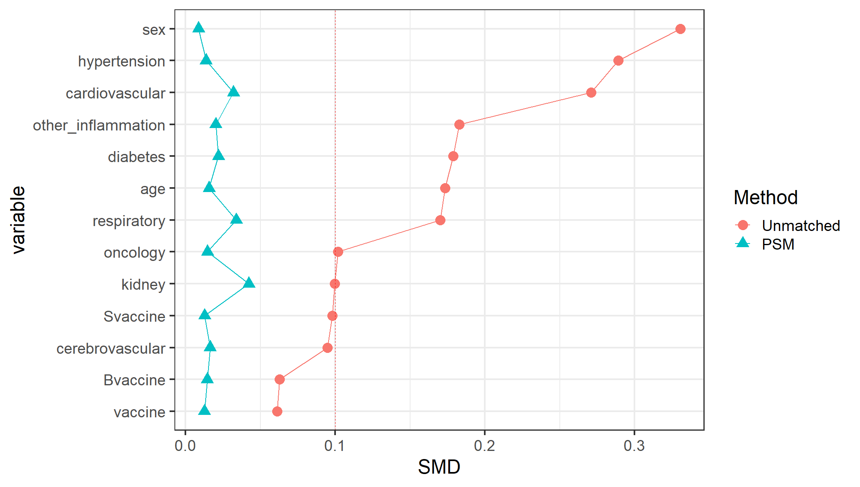
Supplementary Figure 2: Baseline characteristics of COVID-19 patients with and without a history of antibiotic allergy before and after PSM matching.

