Contents
Supplementary Table 1 ICD-10-CM codes used for RA and VTE diagnosis. p2
Supplementary Materials and Methods p4
Imaging procedures used for VTE diagnosis confirmation p4
Provider selection for chart procurement in ORD Cohorts (primary and secondary objective samples) p4
Provider notes extraction in primary VTE case definition performance sample from the MC Cohort (exploratory objective sample) p4
Supplementary Table 2 Comparison of demographic characteristics across study samples between patients with abstracted versus not abstracted charts/provider notes. p6
Supplementary Table 3 Demographic and clinical characteristics for the primary objective sample from ORD Cohorts 1 and 2. p8
Supplementary Figure 1 Patient attrition and samples for performance evaluation of VTE case definitions. p10

Supplementary Table 1 ICD-10-CM codes used for RA and VTE diagnosis.
Diagnosis | ICD-10-CM codes
RA | M0500, M05011, M05012, M05019, M05021, M05022, M05029, M05031, M05032, M05039, M05041, M05042, M05049, M05051, M05052, M05059, M05061, M05062, M05069, M05071, M05072, M05079, M0509,  M0510, M05111, M05112, M05119, M05121, M05122, M05129, M05131, M05132, M05139, M05141, M05142, M05149, M05151, M05152, M05159, M05161, M05162, M05169, M05171, M05172, M05179, M0519,  M0520, M05211, M05212, M05219, M05221, M05222, M05229, M05231, M05232, M05239, M05241, M05242, M05249, M05251, M05252, M05259, M05261, M05262, M05269, M05271, M05272, M05279, M0529,  M0530, M05311, M05312, M05319, M05321, M05322, M05329, M05331, M05332, M05339, M05341, M05342, M05349, M05351, M05352, M05359, M05361, M05362, M05369, M05371, M05372, M05379, M0539,  M0540, M05411, M05412, M05419, M05421, M05422, M05429, M05431, M05432, M05439, M05441, M05442, M05449, M05451, M05452, M05459, M05461, M05462, M05469, M05471, M05472, M05479, M0549,  M0550, M05511, M05512, M05519, M05521, M05522, M05529, M05531, M05532, M05539, M05541, M05542, M05549, M05551, M05552, M05559, M05561, M05562, M05569, M05571, M05572, M05579, M0559,  M0560, M05611, M05612, M05619, M05621, M05622, M05629, M05631, M05632, M05639, M05641, M05642, M05649, M05651, M05652, M05659, M05661, M05662, M05669, M05671, M05672, M05679, M0569,  M0570, M05711, M05712, M05719, M05721, M05722, M05729, M05731, M05732, M05739, M05741, M05742, M05749, M05751, M05752, M05759, M05761, M05762, M05769, M05771, M05772, M05779, M0579,  M0580, M05811, M05812, M05819, M05821, M05822, M05829, M05831, M05832, M05839, M05841, M05842, M05849, M05851, M05852, M05859, M05861, M05862, M05869, M05871, M05872, M05879, M0589, M059,  M0600, M06011, M06012, M06019, M06021, M06022, M06029, M06031, M06032, M06039, M06041, M06042, M06049, M06051, M06052, M06059, M06061, M06062, M06069, M06071, M06072, M06079, M0608, M0609,  M0680, M06811, M06812, M06819, M06821, M06822, M06829, M06831, M06832, M06839, M06841, M06842, M06849, M06851, M06852, M06859, M06861, M06862, M06869, M06871, M06872, M06879, M0688, M0689,  M069

Diagnosis | ICD-10-CM codes
PE | 126.0, 126.02, 126.09, 126.9, 126.92, 126.99
Lower extremity DVT | 180.10, 180.11, 180.12, 180.13,  180.201, 180.201, 180.203, 180.209, 180.211, 180.212, 180.213, 180.219, 180.221, 180.222, 180.223, 180.229, 180.231, 180.232, 180.233, 180.239, 180.291, 180.292, 180.293, 180.299,  180.3,  182.401, 182.402, 182.403, 182.409, 182.411, 182.412, 182.413, 182.419, 182.421, 182.422, 182.423, 182.429, 182.431, 182.432, 182.433, 182.439, 182.441, 182.442, 182.443, 182.449, 182.491, 182.492, 182.493, 182.499, 182.4y1, 182.4y2, 182.4y3, 182.4y9, 182.4z1, 182.4z2, 182.4z3, 182.4z9
Upper extremity DVT | 182.210, 182.290,  182.601, 182.602, 182.603, 182.609, 182.621, 182.622, 182.623, 182.629, 182.a11, 182.a12, 182.a13, 182.a19, 182.b11, 182.b12, 182.b13, 182.b19, 182.c11, 182.c12, 182.c13, 182.c19
Other VT | 180.8, 180.9, 181, 182.0, 182.1, 182.220, 182.3, 182.890, 182.90

Abbreviations: DVT, deep vein thromboembolism; ICD-10-CM, International Classification of Diseases, Tenth Revision, Clinical Modification; PE, pulmonary embolism; RA, rheumatoid arthritis; VT, venous thrombosis; VTE, venous thromboembolism.

Supplementary Materials and Methods

Imaging procedures used for VTE diagnosis confirmation
Imaging procedures used for confirmation of VTE diagnosis included angiogram, computed tomography (CT) scan, lung ventilation-perfusion scan, magnetic resonance imaging (MRI)/magnetic resonance angiography (MRA)/magnetic resonance venography (MRV), venogram, or venous duplex ultrasound.

Provider selection for chart procurement in ORD Cohorts (primary and secondary objective samples)
For each patient with a presumptive claims-based VTE, 1 provider, as well as 1 alternate provider, were identified to be contacted for chart procurement, using a combination of VTE diagnosis codes (excluding diagnostic testing codes), dates of service, and location of care. Patient name, date of birth, and dates of service, together with provider name and mailing address were given to the data collection vendor to support procurement of each patient’s clinical chart from that provider for abstraction of VTE-related confirmatory data. The provider of interest (including inpatient hospitals, ER providers, and outpatient providers) was contacted directly to request the medical chart for the identified patient over a 90-day period that included the qualifying VTE date (event date). The provider most likely to have rendered services for the presumptive VTE was the primary target for chart procurement and abstraction.

Provider notes extraction in primary VTE case definition performance sample from the MC Cohort (exploratory objective sample)
The Optum de-identified Market Clarity Dataset deterministically links medical and pharmacy claims with EHR data from providers across the continuum of care. When provider notes are available, review and abstraction can provide valuable insights. Since Market Clarity is a de-identified data source, the specific provider(s) contributing notes are unknown. For this study, case-sensitive targeted search terms were used to focus abstraction on clinical data related to the study population and objectives (i.e., terms related to RA and VTE). Search terms used to identify relevant provider clinical notes (listed in alphabetical order, including partial words) were abatacept, adalimumab, anakinra, angiogram, anticoagulant, anticoagulation, apixaban, arm, arthritis, baricitinib, blockage, brachial, Budd-Chiari, calf, certolizumab, clot, computed axial, computed tomography, CT, dabigatran, D-dimer, deep, defect, DMARD, doppler, duplex, DVT, edoxaban, embol…, enoxaparin, etanercept, extremity, femoral, fondaparinux, Geneva score, golimumab, Homan’s, iliac, infliximab, leg, lung, magnetic resonance, mesentery, MRA, MRI, MRV, occlusion, PE, perfusion, phlebitis, plethysmography, popliteal, portal, posterior tibial, profunda, pulmon…, RA, radial, restriction, rheumatoid, rivaroxaban, sarilumab, segmental, subclavian, subsegmental, thromb…, thrombophlebitis, tinzaparin, tocilizumab, tofacitinib, ulnar, ultrasound, upadacitinib, vein, venogram, venography, venous duplex, ventilation, VQ scan, warfarin, and X-ray.

Supplementary Table 2 Demographic characteristics of patients with abstracted versus not abstracted charts/provider notes.
 | Not abstracted | Abstracted
Primary VTE sample, ORD Cohort 1+2 | (n = 99) | (n = 155)
Age, y | 65.0 (10.0) | 66.4 (10.7)
Age group  18–34 years  35–54 years  55–64 years  65–74 years  ≥75 years | 0  17 (17.2)  27 (27.3)  35 (35.4)  20 (20.2) | 0  23 (14.8)  35 (22.6)  54 (34.8)  43 (27.7)
Female | 78 (78.8) | 114 (73.5)
Non-commercial insurance | 77 (77.8) | 125 (80.6)
Secondary VTE sample, ORD Cohort 1 | (n = 50) | (n = 76)
Age, y | 61.5 (11.0) | 64.6 (11.4)
Age group  18–34 years  35–54 years  55–64 years  65–74 years  ≥75 years | 1 (2.0)  13 (26.0)  13 (26.0)  18 (36.0)  5 (10.0) | 1 (1.3)  14 (18.4)  23 (30.3)  20 (26.3)  18 (23.7)
Female | 39 (78.0) | 52 (68.4)
Non-commercial insurance | 36 (72.0) | 52 (68.4)
Primary alternate VTE sample, MC Cohort | (n = 4) | (n = 64)
Age, y | 65.8 (15.7) | 60.2 (12.5)
Age group  18–34 years  35–54 years  55–64 years  65–74 years  ≥75 years | 0  1 (25.0)  1 (25.0)  1 (25.0)  1 (25.0) | 2 (3.1)  16 (25.0)  22 (34.4)  15 (23.4)  9 (14.1)
Female | 3 (75.0) | 48 (75.0)
Insurance type  Commercial  Medicare  Medicaid  Unknown | 0  1 (25.0)  2 (50.0)  1 (25.0) | 27 (42.2)  20 (31.3)  12 (18.8)  5 (7.8)

Notes: Data represent mean (SD) for continuous variables and n (%) for categorical variables.
Abbreviations: MC, Market Clarity; ORD, Optum Research Database; SD, standard deviation; VTE, venous thromboembolism.
Supplementary Table 3 Demographic and clinical characteristics for the primary objective sample from ORD Cohorts 1 and 2.
Cohort source | ORD Cohort 1  (n = 38) | ORD Cohort 2  (n = 117)
Claims-based variables
Age, y | 65.0 (11.5) | 66.8 (10.4)
Age ≥65 years | 21 (55.3) | 76 (65.0)
Female | 25 (65.8) | 89 (76.1)
Non-commercial insurance | 29 (76.3) | 96 (82.1)
Charlson comorbidity score | 2.4 (1.8) | 2.5 (1.7)
Follow-up time, d | 626.3 (378.7) | 1,004.8 (533.3)
RA therapy during follow-up  TNFi: adalimumab  certolizumab  etanercept  golimumab SC  golimumab IV  infliximab  JAKi: baricitinib  tofacitinib  upadacitinib  Non-TNFi: abatacept  anakinra  sarilumab  tocilizumab | 16 (42.1)  1 (2.6)  3 (7.9)  1 (2.6)  3 (7.9)  5 (13.2)  0  11 (29.0)  0  NRª | 31 (26.5)  6 (5.1)  26 (22.2)  1 (0.9)  8 (6.8)  15 (12.8)  1 (0.9)  21 (17.9)  0  20 (17.1)  1 (0.9)  3 (2.6)  28 (23.9)
Chart/notes-based comorbidities
Evidence of prior VTE | 9 (23.7) | 35 (29.9)
Atrial fibrillation | 6 (15.8) | 19 (16.2)
COPD | 11 (29.0) | 31 (26.5)
Hypertension | 26 (68.4) | 86 (73.5)
Cancer | 3 (7.9) | 9 (7.7)
Obese (BMI ≥30 kg/m²)^{b} | 15 (42.9) | 51 (48.1)
Ever smoker^{b} | 19 (52.8) | 63 (56.8)

Notes: Data represent mean (SD) for continuous variables and n (%) for categorical variables. ªClaims for non-TNFi RA therapies were not reported in ORD Cohort 1. ^{b}Denominator varies because of missing data.
Abbreviations: BMI, body mass index; COPD, chronic obstructive pulmonary disease; IV, intravenous; JAKi, Janus kinase inhibitor; NR, not reported; ORD, Optum Research Database; RA, rheumatoid arthritis; SC, subcutaneous; SD, standard deviation; TNFi, tumor necrosis factor inhibitor; VTE, venous thromboembolism.
Supplementary Figure 1 Patient attrition and samples for performance evaluation of VTE case definitions.
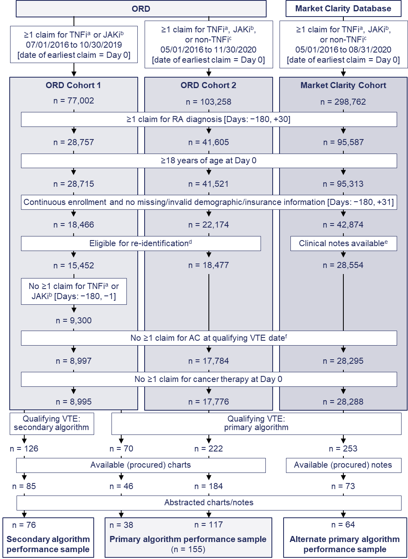
Notes: ªTNFi therapy included adalimumab, certolizumab pegol, etanercept, golimumab, or infliximab. ^{b}JAKi therapy included baricitinib, tofacitinib, or upadacitinib. ^{c}Non-TNFi therapy included abatacept, anakinra, tocilizumab, or sarilumab. ^{d}With patient and provider identifiable information available to support medical chart identification and abstraction. ^{e}Patients with no missing insurance information, with partner claims or administrative service only, and with provider(s) who had contributed free-text clinical notes within the 3-month observation period in an EHR database that could be extracted and redacted for abstraction. ^{f}Exclusion of patients with ≥1 claim for AC therapy (apixaban, dabigatran, dalteparin, edoxaban, enoxaparin, fondaparinux, rivaroxaban, tinzaparin, and warfarin) prescribed before the VTE qualifying event and with a runout date that overlaps with the VTE qualifying ED.
Abbreviations: AC, anticoagulant; ED, event date; EHR, electronic health record; JAKi, Janus kinase inhibitor; ORD, Optum Research Database; RA, rheumatoid arthritis; TNFi, tumor necrosis factor inhibitor; VTE, venous thromboembolism.

