Supplementary Figure 1. Pain Profile Adult Version – Version 2
Pain Story
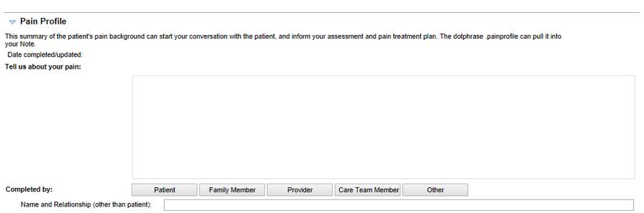
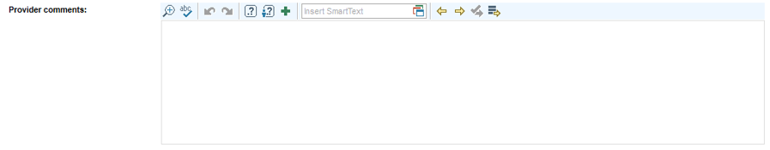
[Note: Provider Comments section only visible in provider view]
Pain Areas

Mark all of the areas of your body where you feel pain: Michigan Body Map
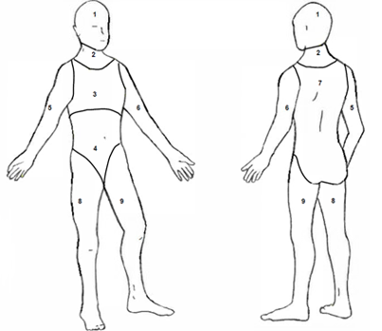

1: Head
2: Neck
3: Chest
4: Abdomen
5: Right arm
6: Left arm
7: Back
8: Right leg
9: Left leg
Other location/
generalized pain

[Note: Patient can select multiple body map sites and will answer follow-up questions below for each site selected. Example provided if patient selects “Head”.]

What kind of pain?
Throbbing | Shooting | Stabbing | Sharp | Cramping | Gnawing | Hot/Burning
Aching | Heavy | Tender | Splitting | Tiring/Exhausting | Sickening | Fearful
Punishing/Cruel

Are there any other words you use to describe your pain?

____________________________________________________

Average over last week?

0 No pain | 1 | 2 | 3 | 4 | 5 | 6 | 7 | 8 | 9 | 10 Worst pain ever

Click here for more detail on Pain Scales [links to FACE images and numbering and color scale]
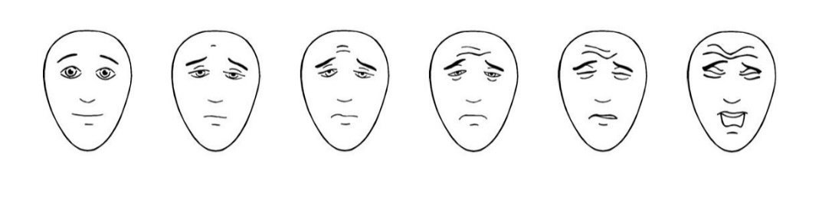
0 |  | 2 |  | 4 |  | 6 |  | 8 |  | 10

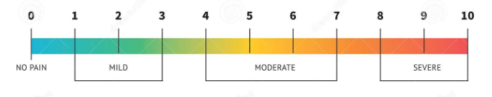

How long have you had this pain?

Less than 6 weeks | 6 weeks – 12 weeks | More than 3 months

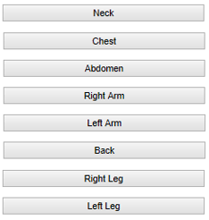
Other Location/Generalized Pain

Pain Impact

Does your pain impact your sleep? Never Almost Never Sometimes Often Almost Always

Does your pain impact your mood? Never Almost Never Sometimes Often Almost Always

Does your pain impact your everyday activities? Never Almost Never Sometimes Often Almost Always

Which activities? __________________________________________________________________________

Pain Treatments
[Note: there is branching logic with follow-up questions depending on the patient’s response. Example shown for “Physical/Occupational therapy” and “NSAIDS/Anti-inflammatory meds”.]

Non-medications
Physical/Occupational therapy Current Past Never/Not Sure
If Current or Past:
How long have you used it and when did you start? _____________________________________
Was it effective? Not Effective Partially Effective Effective
If Past, also:
Would you try it again? Yes No Maybe
If Never/Not Sure:
Would you try it? Yes No Maybe
Exercise/Yoga/Stretching Current Past Never/Not Sure
Mindfulness/Meditation Current Past Never/Not Sure
Counseling/Behavioral interventions Current Past Never/Not Sure
Chiropractic/Massage Current Past Never/Not Sure
Acupuncture Current Past Never/Not Sure
Music therapy/Art therapy Current Past Never/Not Sure
Pet therapy Current Past Never/Not Sure
Distraction/Play/Apps (technology) Current Past Never/Not Sure
Heat/Cold Current Past Never/Not Sure
Aromatherapy (for example: essential oils) Current Past Never/Not Sure
Rest Current Past Never/Not Sure
TENS Unit Current Past Never/Not Sure
Positioning/Immobilization Current Past Never/Not Sure
Other non-medication treatments you’ve tried Current Past

_______________________________________________________________

Medications

NSAIDS/Anti-inflammatory meds Current Past Never/Not Sure
(examples: Ibuprofen, Naproxen, Celecoxib)

If Current or Past:
How long have you used it and when did you start? _____________________________________
Was it effective? Not Effective Partially Effective Effective

If Past, also:
Would you try it again? Yes No Maybe

Antidepressants Current Past Never/Not Sure
(examples: Amitriptyline, Duloxetine, Bupropion)

Anticonvulsants Current Past Never/Not Sure
(examples: Gabapentin, Pregabalin, Tegretol)

Muscle relaxants Current Past Never/Not Sure
(examples: Cyclobenzaprine, Carisoprodol, Metaxalone)

Other pain meds Current Past Never/Not Sure
(examples: Lidocaine patch/creme, Sumatriptan, Pain Pumps)

Injections Current Past Never/Not Sure
(examples: Epidural, Steriod, Facet Injections)

Sedatives/Sleep medications Current Past Never/Not Sure
(examples: Lorazepam, Alprazolam, Tylenol PM, Eszopiclone)

Opioids Current Past Never/Not Sure
(examples: Oxycodone, Fentanyl patch, Hydrocodone, Tylenol 3 or 4, Codeine, Morphine)

Methadone/Buprenorphine/Suboxone Current Past Never/Not Sure

Other medication treatments you have tried (cannabis/THC/CBD, supplements/herbals, etc.)

_________________________________________________________________

Pain Goals

What are your goals and expectations for your pain management?

Please talk with your provider and care team about what you have entered in the Pain Profile.

Additional: [Note: only displays in the clinical version and provides a link to the Pain Management Website]
Pain management resources

Supplementary Figure 2. Consort flow diagram of patient eligibility screening and sample selection
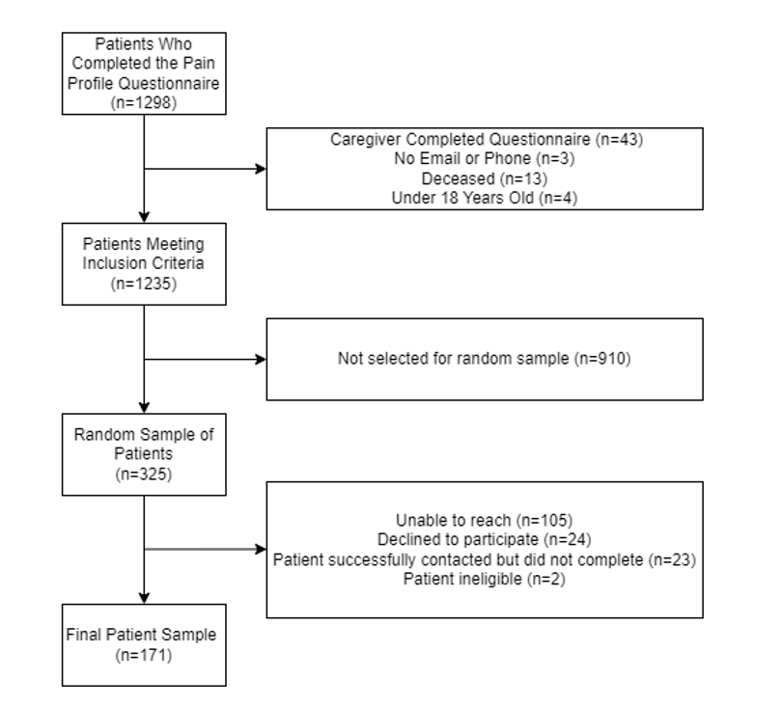

Brummett CM, Bakshi RR, Goesling J, et al. Preliminary validation of the Michigan Body Map. Pain. 2016;157(6):1205-1212. doi:10.1097/j.pain.0000000000000506
Melzack R. The short-form McGill Pain Questionnaire. Pain. 1987;30(2):191-197. doi:10.1016/0304-3959(87)91074-8
Breivik H, Borchgrevink PC, Allen SM, et al. Assessment of pain. Br J Anaesth. 2008;101(1):17-24. doi:10.1093/bja/aen103
Hicks CL, von Baeyer CL, Spafford P, van Korlaar I, Goodenough B. The Faces Pain Scale - Revised: Toward a common metric in pediatric pain measurement. Pain, 2001;93:173-183.

