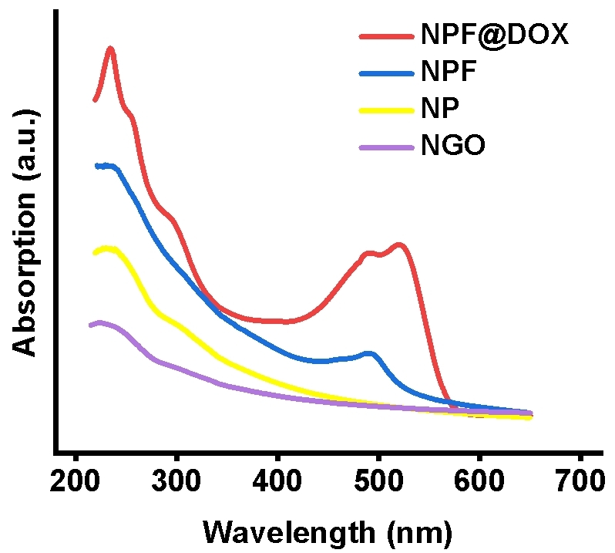
Figure S1. UV–Vis spectra of NGO, NP, NPF, and NPF@DOX nanocarriers.
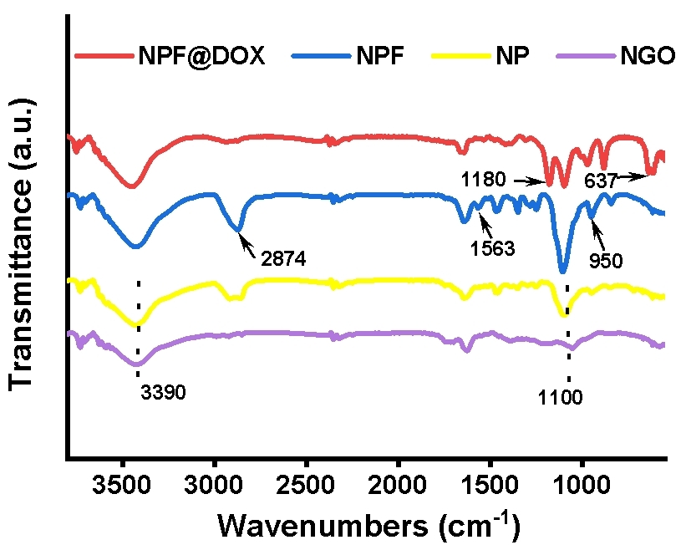
Figure S2. Fourier-transform infrared spectra of NGO, NP, NPF, and NPF@DOX nanocarriers.
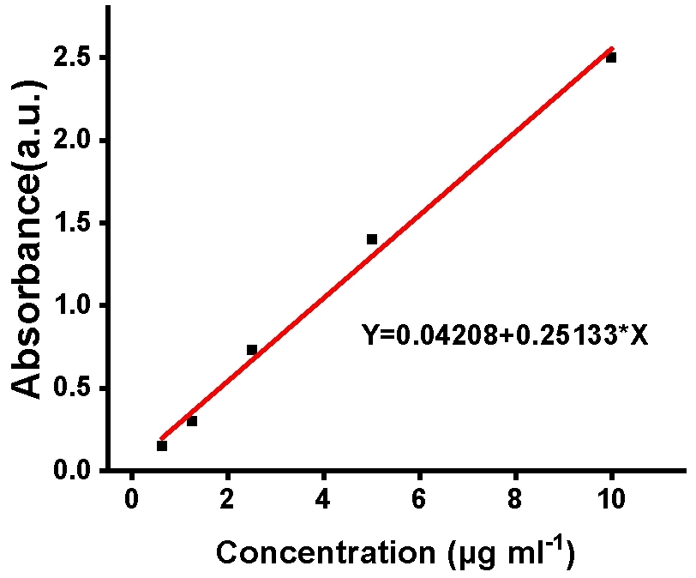
Figure S3. The standard DOX curve.
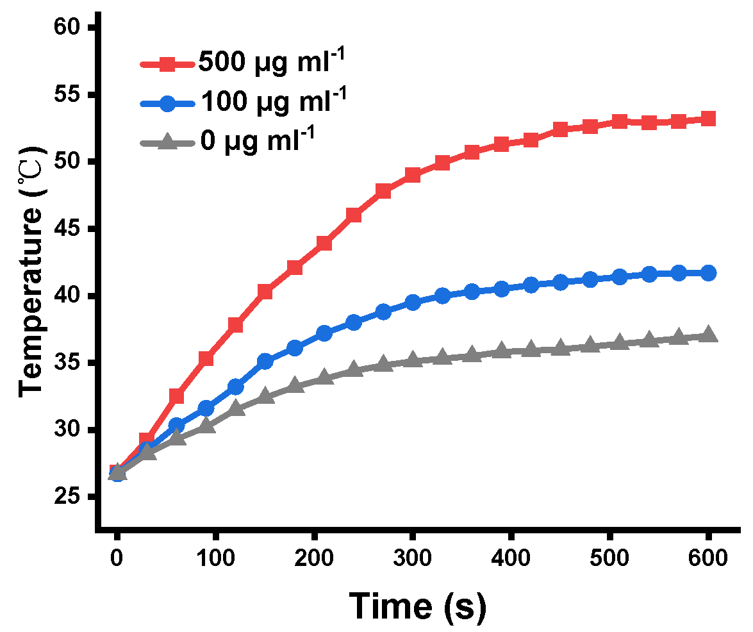
Figure S4. Photothermal curves and photos of NPF@DOX at different doses after 808 nm irradiation (1.0 W/cm²).
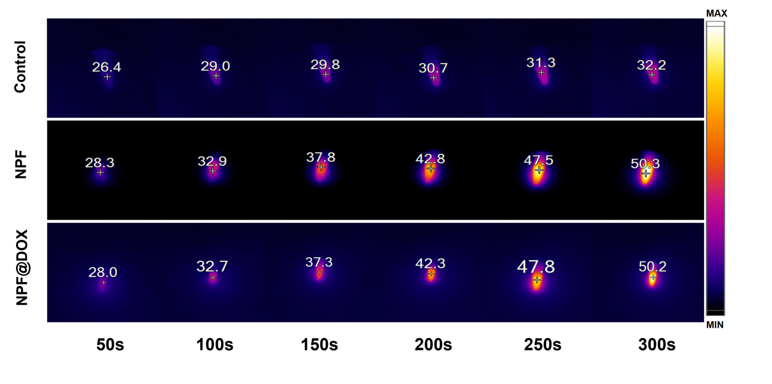
Figure S5. Photothermal infrared thermography of NPF@DOX and NS after 808 nm irradiation (1.0 W/cm², 5 min).
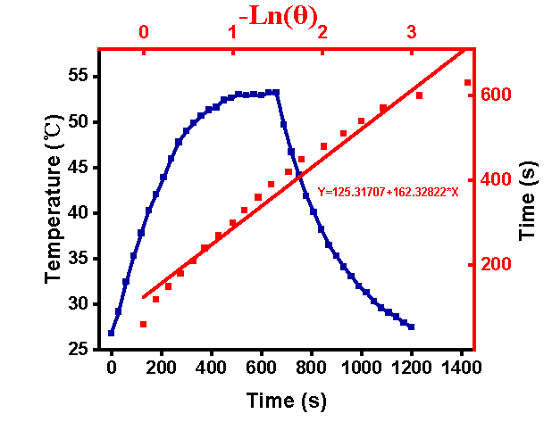
Figure S6. Photothermal performance of NPF@DOX while cooling to room temperature with linear analysis.
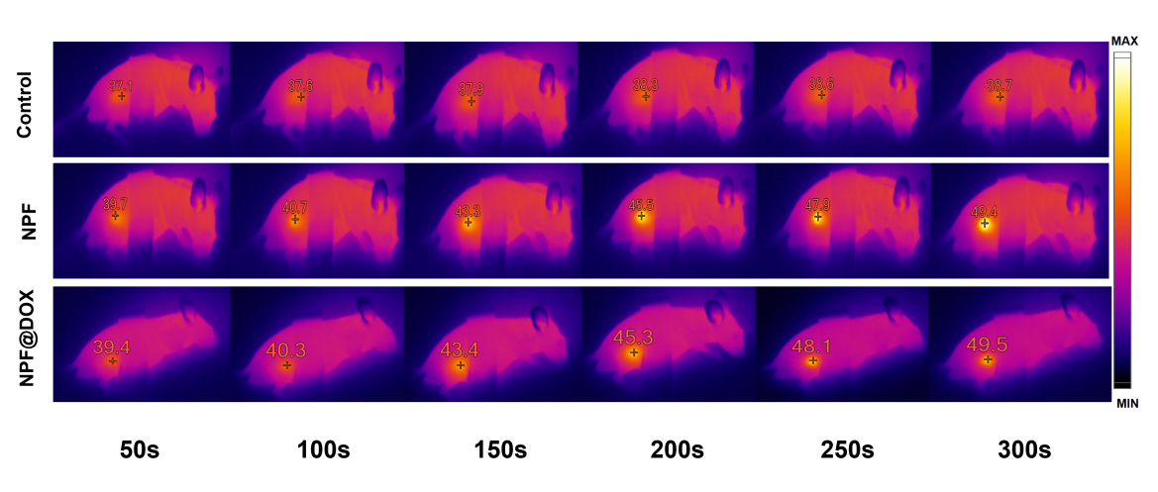
Figure S7. CAL-27 tumor-bearing mice were intravenously injected with either NPF@DOX or NS while being exposed to 808 nm irradiation (1.0 W/cm², 5 min) during photothermal infrared thermography.
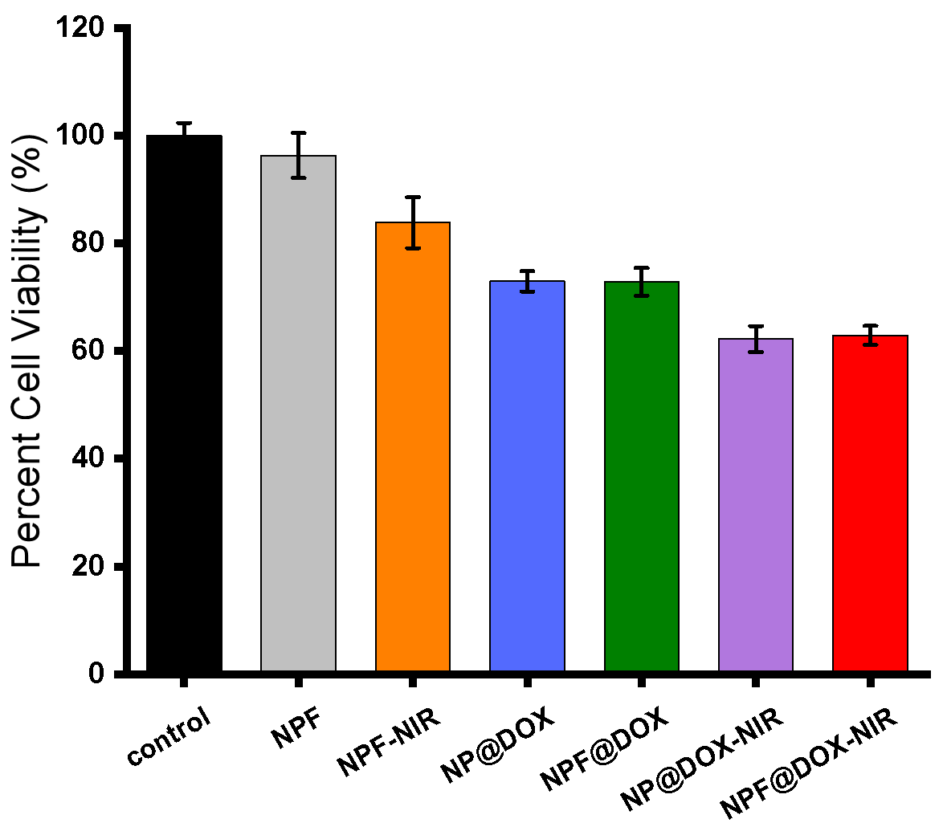
Figure S 8. Viability of HOK cells after treatment with control, NPF, NPF-NIR, NP@DOX, NPF@DOX, NP@DOX-NIR, and NPF@DOX-NIR. Data are presented as means ± SD, n=3.

