Supplementary
Table S1. Antibody details and dilution ratios.
Antibody name | Catalog number | Dilution ratio
Gapdh (HRP conjugate) | HRP-60004 (Proteintech) | 1:2000
Anti-hnRNPA1 antibody | Ab5832 (abcam) | 1:1000
Phospho-p44/42MAPK (Erk1/2) (Thr202/Tyr204) | 4370T (CST) | 1:1000
p44/42 MAPK (Erk1/2) | 4695T (CST) | 1:1000
PhosphoMEK1/2  (Ser217/221) | 9154T (CST) | 1:1000
MEK1/2 antibody  Anti-mouse IgG  Anti-rabbit IgG | 9122S (CST)  7076 (CST)  7074P2 (CST) | 1:1000  1:2000  1:2000
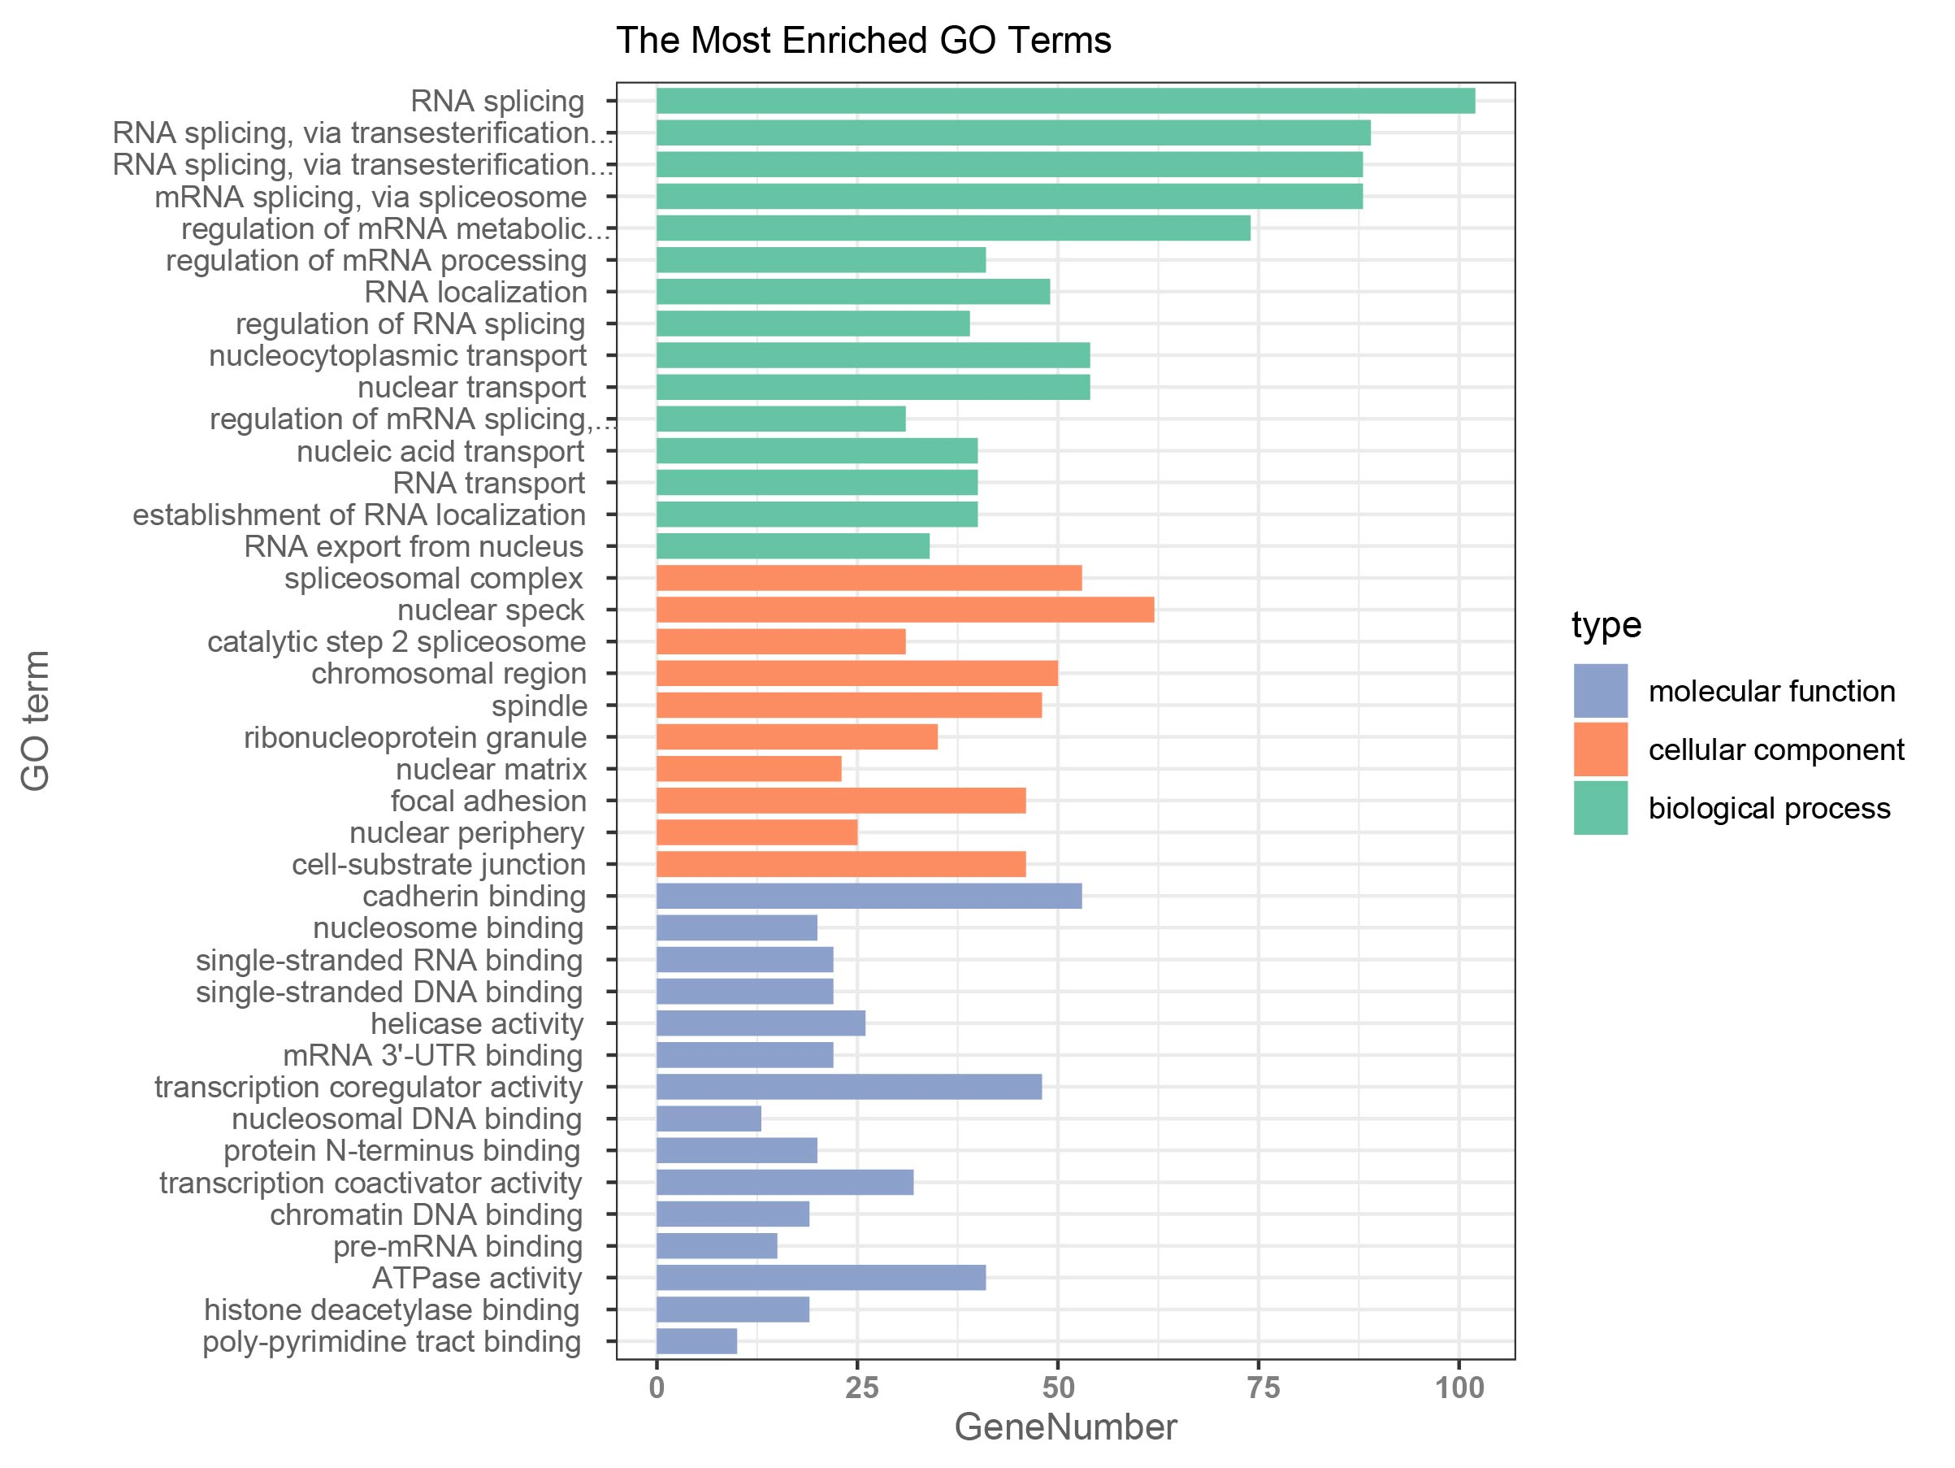
Figure S1. GO Enrichment analysis.
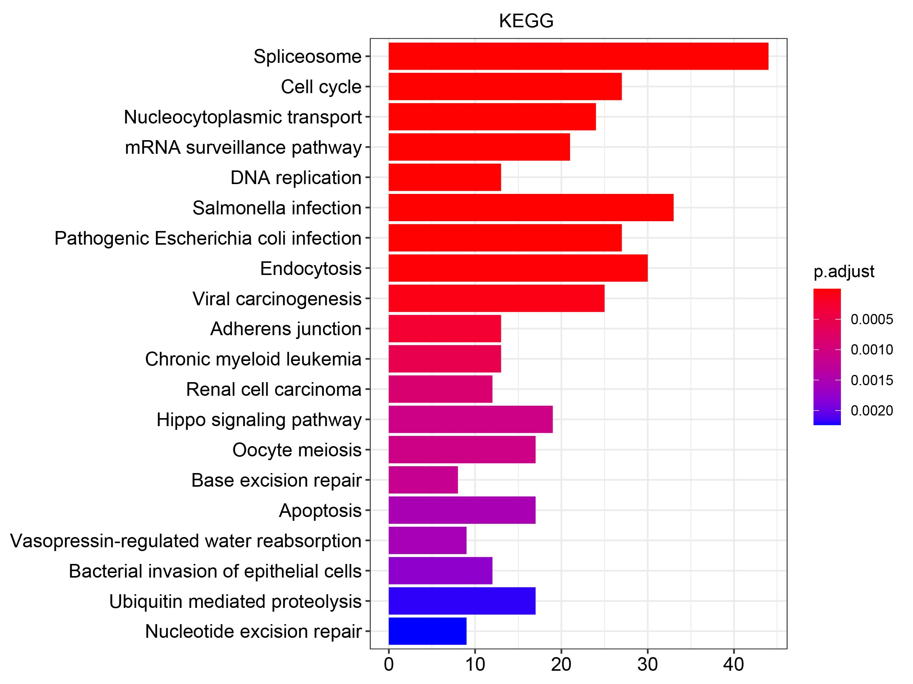
Figure S2. Kyoto encyclopedia of genes and genomes analysis.

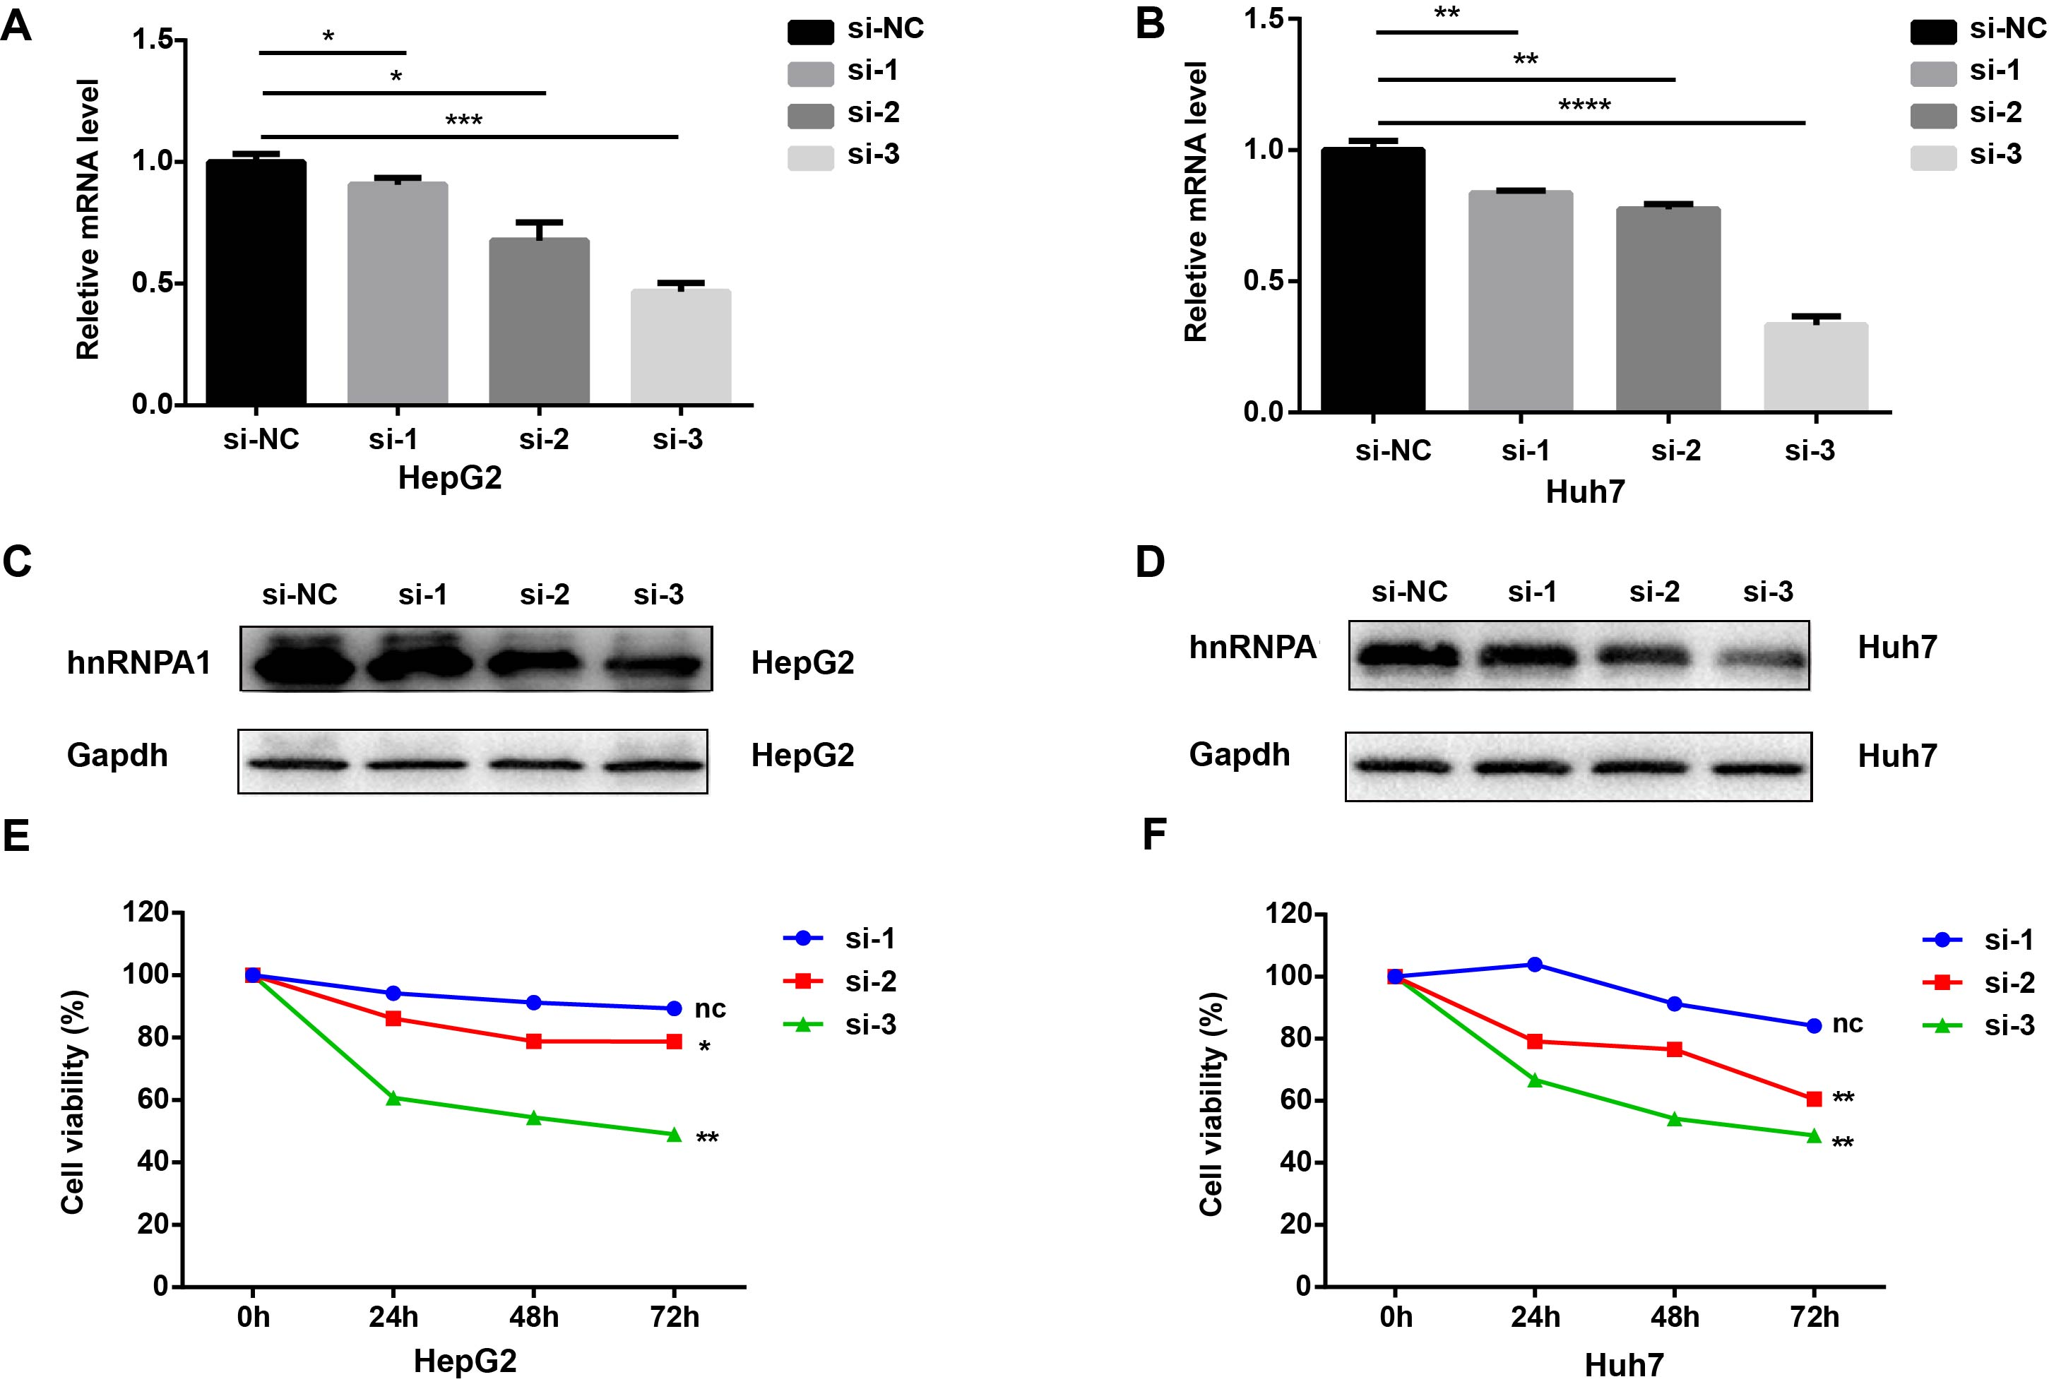
Figure S3. Screening of si-RNA knockdown effect. A-B. Relative hnRNPA1 expression level in HepG2 (A) and Huh7 (B) cells transfected with si-RNAs targeting hnRNPA1 by qRT-PCR. C-D. HnRNPA1 protein expression level in HepG2 (C) and Huh7 (D) cells transfected with si-RNAs targeting hnRNPA1. E-F. Proliferation of HepG2 (E) and Huh7 (F) cells after knockdown of hnRNPA1 by CCK-8. Data are expressed as the means ± SD from three independent experiments. Nc: no statistical significance, *P < 0.05, **P < 0.01, ***P < 0.001 and **** P < 0.0001.

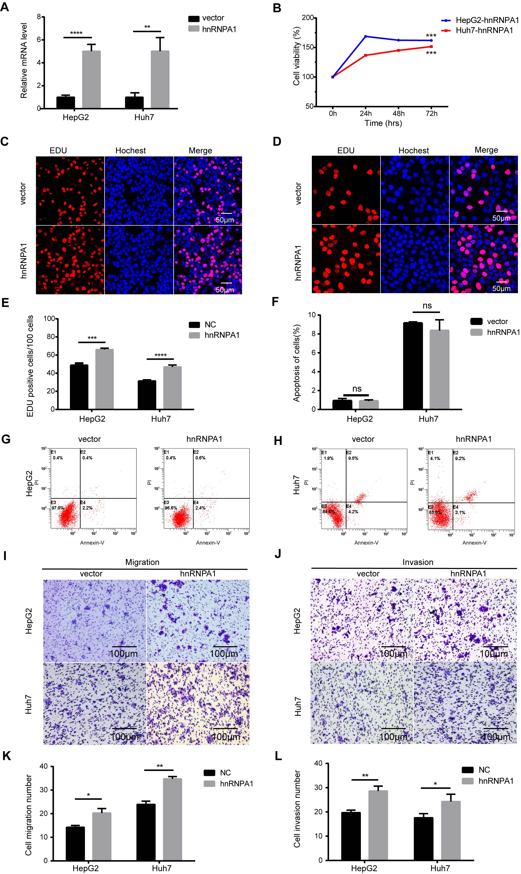
Figure S4. Overexpression of hnRNPA1 promotes the proliferation, migration, and invasion of HCC cells. (A). Relative hnRNPA1 expression level in HepG2 and Huh7 cells after hnRNPA1 overexpression by q-PCR. B-E. Proliferation of HepG2 and Huh7 cells after hnRNPA1 overexpression by CCK-8 (B) and EDU assay (C-E), scale bar = 50 μm. F-H. Representative results and statistical analysis of apoptosis in HepG2 (G) and Huh7 cells (H). I-L. Representative results and statistical analysis of the transwell assay (scale bar = 100 μm) in HepG2 and Huh7 cells after overexpression of hnRNPA1. Data are expressed as the means ± SD from three independent experiments. Nc: no statistical significance, *P < 0.05, **P < 0.01, ***P < 0.001 and **** P < 0.0001.

