Occupational risk factors for physical and mental health in primary healthcare providers: a national cross-sectional survey from 62 urban communities in China

Supplementary materials

Table S1. The roles primary healthcare providers played in the COVID-19 prevention and control
 | Pre-screening triage |  | COVID test |  | Service for quarantined patients |  | Fever Clinic |  | Epidemiological interview |  | Other service
 | n | % | n | % | n | % | n | % | n | % | n | %
Overall | 2857 | 58.29 | 2954 | 60.27 | 1297 | 26.46 | 548 | 11.18 | 1001 | 20.42 | 433 | 8.83
Doctors | 905 | 64.14 | 912 | 64.64 | 448 | 31.75 | 233 | 16.51 | 380 | 26.93 | 98 | 22.63
Nurses | 1173 | 67.03 | 1253 | 71.60 | 579 | 33.09 | 201 | 11.49 | 392 | 22.40 | 77 | 17.78
Other professionals | 779 | 44.77 | 789 | 45.34 | 270 | 15.52 | 114 | 6.55 | 229 | 13.16 | 258 | 14.83
Without professional title | 436 | 46.98 | 391 | 42.13 | 144 | 15.52 | 61 | 6.57 | 116 | 12.50 | 119 | 12.82
Senior professional title | 1336 | 59.78 | 1434 | 64.16 | 639 | 28.59 | 260 | 11.63 | 454 | 20.31 | 172 | 7.70
Intermediate professional title | 913 | 63.27 | 948 | 65.70 | 417 | 28.90 | 196 | 13.58 | 356 | 24.67 | 113 | 7.83
Junior professional title | 172 | 58.31 | 181 | 61.36 | 97 | 32.88 | 31 | 10.51 | 75 | 25.42 | 29 | 9.83
Work for less than 5 years | 641 | 58.71 | 634 | 57.53 | 270 | 24.50 | 109 | 9.89 | 208 | 18.87 | 86 | 7.80
Work for 5 to 9 years | 609 | 58.28 | 717 | 68.61 | 283 | 27.08 | 135 | 12.92 | 222 | 21.24 | 79 | 7.56
Work for 10 years or longer | 1601 | 58.15 | 1603 | 58.23 | 744 | 27.03 | 304 | 11.04 | 571 | 20.74 | 268 | 9.73

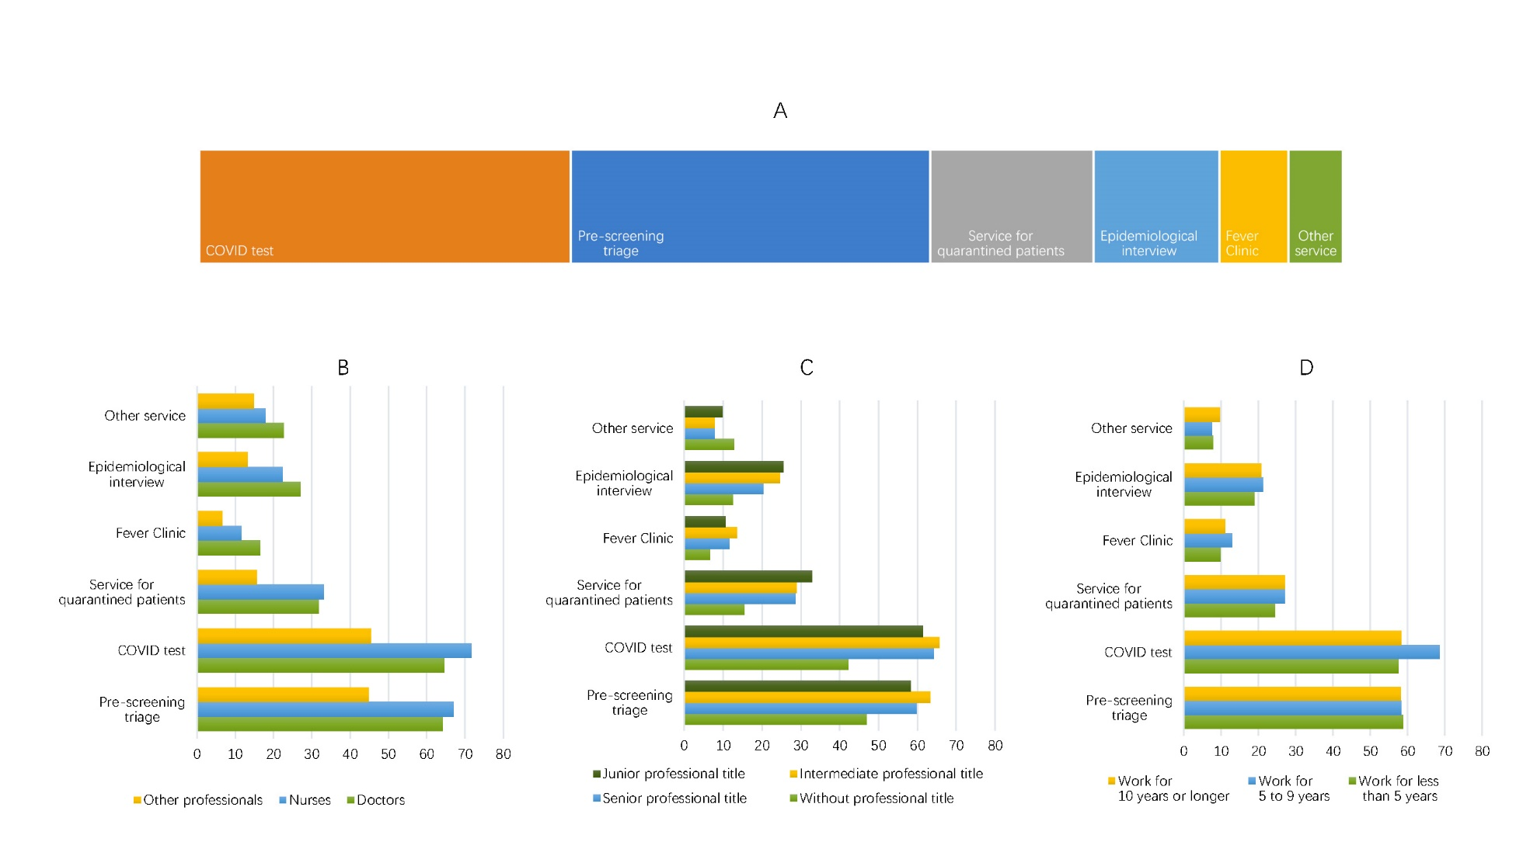
Figure S1 The roles primary healthcare providers played in the COVID-19 prevention and control. A: The overall proportions of the study populations who took charge of COVID-19 related work; B: Proportions of COVID-19 related work stratified by professional expertise; C: Proportions of COVID-19 related work stratified by professional levels; D: Proportions of COVID-19 related work stratified by work years.

