Supplementary materials

Supplementary table 1. Classification, pharmacology and mechanism of action of antibiotics used in this study
Family | Antibiotic | Pharmacology | Mode of action | Reference
ß-lactam Penicillin | Piperacillin | Broad-spectrum semi-synthetic penicillin | Drug targeting binds penicillin binding proteins（PBP） at the cytoplasmic membrane, hinders the cross coupling process of linear dodecas accharide polymers outside the cytosol, and interferes with cell wall synthesis | ^{1, 2}
ß-lactam Cephalosporin | Ceftazidime | Broad-spectrum semi-synthetic third-generation cephalosporins,more antibacterial activity against gram-negative bacteria than first-generation and second-generation cephalosporins |  | ^{1, 2}
 | Cefotaxime |  |  | ^{1, 2}
 | Cefepime | The fourth generation of new broad-spectrum semi-synthetic cephalosporins | Binds to one or more PBPs of bacteria and affects bacterial cell wall synthesis and metabolism | ^{1, 2}
ß-lactam/ß-lactamase inhibitor | Amoxicillin/clavulanic acid | Amoxicillin is a semi-synthetic broad-spectrum penicillin with a strong ability to penetrate cells; Clavulanic acid is the first clinical β- lactamase inhibitor | Penicillin target binding PBPs on the cytoplasmic membrane, hindering the cross coupling process of linear dodecas accharide polymers outside the cytosol, interfering with the synthesis of the cell wall; Clavulanic acid as β- Lactamase inhibitors, acetylation β - Lactamases, which inactivate the enzyme | ^{1, 2}
 | Piperacillin/tazobactam | Piperacillin is a semi-synthetic penicillin antibiotic; Tazobactam β- Lactamase inhibitor | Tazobactam is the third generation β- Lactamase inhibitors that act antibacterial by inhibiting bacterial cell wall synthesis | ^{1, 2}
ß-lactam Carbapenems | Imipenem | Artificial synthesis of broad spectrum antibiotics, resistant to β- Lactamases, but can be hydrolyzed by metallo β- Lactamase | Binding to PBPs1a, 1b, and 2 leads to inactivation of bacterial cell wall lysis | ^{1, 2}
 | Meropenem |  | Binds to PBPs2,3 and 4, resulting in loss of bacterial cell wall lysis | ^{1, 2}
Single ring β- Lactam | Amtreonam | Novel class of monoamide ring β- Lactam antibiotics with broad resistance to β- Lactamase stabilization | Binds to PBP3 and inhibits bacterial cell wall synthesis | ^{1, 2}
Aminoglycosides | Gentamicin | Multicomponent broad-spectrum aminoglycoside antibiotics | It binds to a conserved 16SrRNA sequence at the A-site of the bacterial 30S ribosomal subunit, resulting in an incorrect mRNA translation and blocking protein synthesis | ^{1, 2}
 | Amikacin | Semi synthetic broad spectrum aminoglycoside antibiotics derived from kanamycin with antimicrobial activity |  | ^{1, 2}
Fluoroquinolone | Ciprofloxacin | Third generation broad-spectrum quinolone antibiotics that are fungicides | By inhibiting the activities of bacterial DNA polymerase and topoisomerase IV, the replication, repair, and transcription processes of DNA are inactivated, which rapidly reduces bacterial reproduction | ^{1, 2}
 | Levofloxacin | Broad spectrum fourth generation synthetic quinolones |  | ^{1, 2}
Sulfonamides | Sulfamethoxazole/trimethoprim（SMZ/TMP） | Sulfamethoxazole belongs to the intermediate acting sulfonamides and trimethoprim to the sulfonamide potentiators | SMZ inhibits dihydrofolate synthetase and interferes with the first step of folate synthesis;TMP acts on the second step of folate anabolism and selectively inhibits dihydrofolate reductase; both combinations of which can double block folate metabolism in bacteria | ^{1, 2}
Chloramphenicol | Chloramphenicol | A broad-spectrum bacteriostatic agent that is bactericidal at high concentrations | Binds to the 50S subunit of bacterial ribose, inhibits transpeptidase, and prevents protein synthesis | ^{1, 2}
Tetracycline | Tetracycline |  | Binds specifically to the ribosomal 30S subunit, histidyl tRNA impedes protein synthesis and inhibits bacterial growth | ^{1, 2}

Supplementary table 2. Analysis of risk factors for carbapenem-resistant Klebsiella pneumoniae (CRKP) and extended-spectrum β-lactamase-Klebsiella pneumoniae (ESBL-KP) infection
 | CRKP |  | ESBL-KPN
 | OR (95%CI) | P-value |  | OR (95%CI) | P-value
Sex |  |  | Sex
Female | 1 | NA | Female | 1 | NA
Male | 0.895(0.725-1.105) | 0.303 | Male | 1.174(1.025-1.345) | <0.05
Age, y |  |  | Age, y
<1 | 1 | NA | <1 | 1 | NA
1-20 | 0.185(0.093-0.369) | <0.05 | 1-20 | 0.079(0.041-0.151) | <0.05
21-50 | 0.704(0.354-1.398) | <0.05 | 21-50 | 0.571(0.352-0.925) | <0.05
51-70 | 0.533(0.369-0.771) | <0.05 | 51-70 | 0.892(0.701-1.135) | 0.352
71-80 | 1.552(1.176-2.050) | <0.05 | 71-80 | 1.304(1.109-1.533) | <0.05
81+ | 2.100(1.548-2.850) | <0.05 | 81+ | 1.315(1.061-1.631) | <0.05
Season |  |  | Season
First quarter | 1 | NA | First quarter | 1 | NA
Second quarter | 1.173(0.889-1.547) | 0.26 | Second quarter | 1(0.828-1.209) | 0.997
Third quarter | 0.703(0.532-0.928) | <0.05 | Third quarter | 1.318(1.103-1.574) | <0.05
Fourth quarter | 0.976(0.728-1.311) | 0.874 | Fourth quarter | 0.667(0.558-0.796) | <0.05
Specimen type |  |  | Specimen type
Sputum | 1 | NA | Sputum | 1 | NA
Urine | 2.320(1.758-3.061) | <0.05 | Urine | 3.158(2.558-3.899) | <0.05
Blood | 0.489(0.308-0.778) | <0.05 | Blood | 0.418(0.302-0.579) | <0.05
Department |  |  | Department
Non-ICU | 1 | NA | Non-ICU | 1 | NA
ICU | 4.778(3.826-5.976) | <0.05 | ICU | 3.126(2.700-3.619) | <0.05
Notes:
Abbreviation: CRKP, carbapenem-resistant Klebsiella pneumoniae; ESBL-KP, extended-spectrum β-lactamase-Klebsiella pneumoniae; ICU, Intensive care unit.
P<0.05 was considered statistically significant.
The items in bold represent the risk factors for CRKP and ESBL-KP infection.

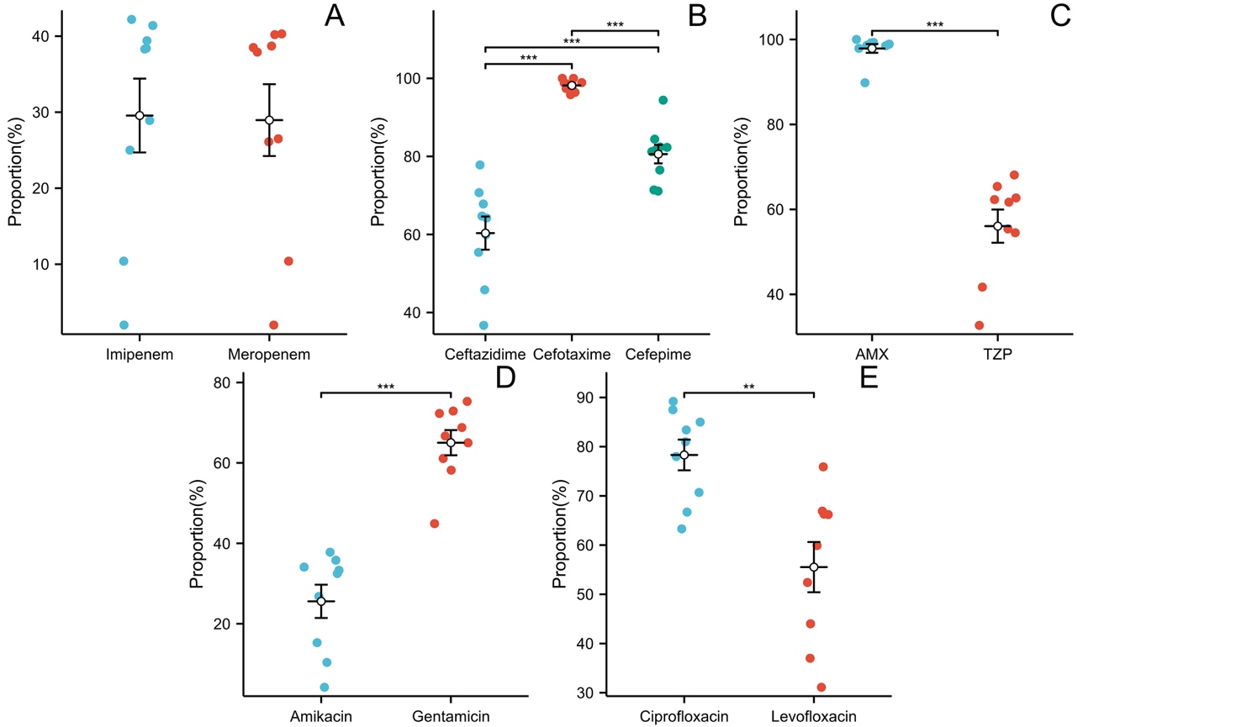
Supplementary figure 1. Scatter chart of the resistance rate of extended-spectrum β-lactamase-Klebsiella pneumoniae (ESBL-KP) to common antibiotics. (A-E) Carbapenem antibiotics, cephalosporin antibiotics, β_lactam/β_lactamase inhibitor antibiotics, aminoglycoside antibiotics, fluoroquinolone antibiotics. AMX, Amoxicillin/clavulanic acid; TZP, Piperacillin/tazobactam. "*" represents the size of P value, none * represents P value ≥ 0.05, * represents 0.01 ≤ P<0.05, * * represents 0.001 ≤ P<0.01, * * *represents 0.0001 ≤ P<0.001.

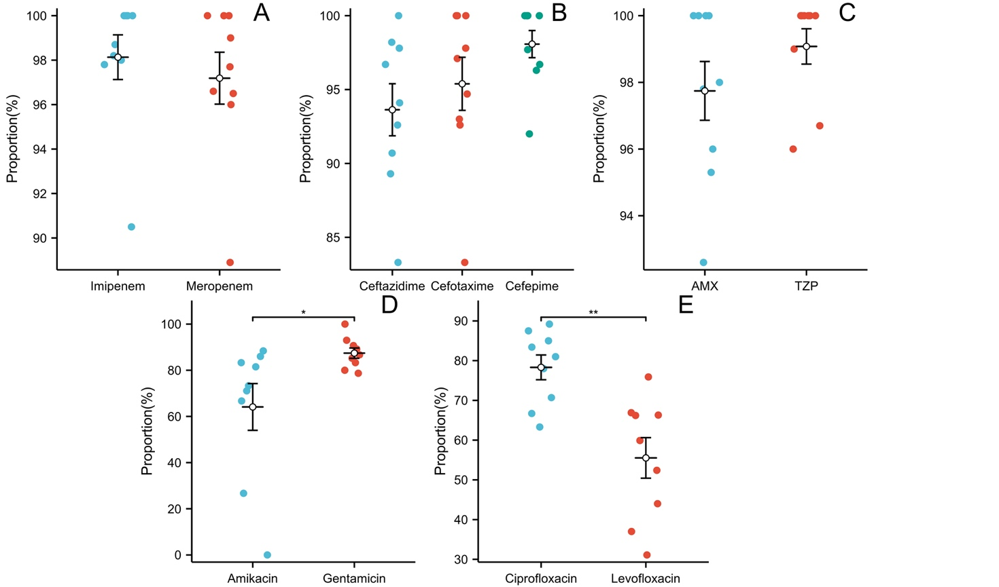
Supplementary figure 2. Scatter chart of the resistance rate of carbapenem-resistant Klebsiella pneumoniae (CRKP) to common antibiotics. (A-E) Carbapenem antibiotics, cephalosporin antibiotics, β_lactam/β_lactamase inhibitor antibiotics, aminoglycoside antibiotics, fluoroquinolone antibiotics. AMX, Amoxicillin/clavulanic acid; TZP, Piperacillin/tazobactam. "*" represents the size of P value, none * represents P value ≥ 0.05, * represents 0.01 ≤ P<0.05, * * represents 0.001 ≤ P<0.01, * * *represents 0.0001 ≤ P<0.001.

Reference
1. Issakhanian L, Behzadi P. Antimicrobial Agents and Urinary Tract Infections. Curr Pharm Des. 2019;25(12):1409-1423. doi:10.2174/1381612825999190619130216
2. Khonsari MS, Behzadi P, Foroohi F. The prevalence of type 3 fimbriae in Uropathogenic Escherichia coli isolated from clinical urine samples. Meta Gene. 2021;28(2)

