High versus Medium Dose of Inhaled Corticosteroid in Chronic Obstructive Lung Disease: A Systematic Review and Meta-analysis

Supplementary Material

Contents
Prisma Checklist 2
ETable 1: Baseline Methodology of the Included RCTs 5
EFigure 1 Moderate, Severe or Very Severe COPD Subgroup 9
EFigure 2: Patients with Recent Exacerbation Subgroup 10
EFigure 3: Funnel Plots 11
EFigure 4: Risk of Bias Assessment (RoB2 Tool) 15

Prisma Checklist
Section and Topic | Item # | Checklist item | Status
TITLE
Title | 1 | Identify the report as a systematic review. | COMPLETE
ABSTRACT
Abstract | 2 | See the PRISMA 2020 for Abstracts checklist. | COMPLETE
INTRODUCTION
Rationale | 3 | Describe the rationale for the review in the context of existing knowledge. | COMPLETE
Objectives | 4 | Provide an explicit statement of the objective(s) or question(s) the review addresses. | COMPLETE
METHODS
Eligibility criteria | 5 | Specify the inclusion and exclusion criteria for the review and how studies were grouped for the syntheses. | COMPLETE
Information sources | 6 | Specify all databases, registers, websites, organisations, reference lists and other sources searched or consulted to identify studies. Specify the date when each source was last searched or consulted. | COMPLETE
Search strategy | 7 | Present the full search strategies for all databases, registers and websites, including any filters and limits used. | COMPLETE
Selection process | 8 | Specify the methods used to decide whether a study met the inclusion criteria of the review, including how many reviewers screened each record and each report retrieved, whether they worked independently, and if applicable, details of automation tools used in the process. | COMPLETE
Data collection process | 9 | Specify the methods used to collect data from reports, including how many reviewers collected data from each report, whether they worked independently, any processes for obtaining or confirming data from study investigators, and if applicable, details of automation tools used in the process. | COMPLETE
Data items | 10a | List and define all outcomes for which data were sought. Specify whether all results that were compatible with each outcome domain in each study were sought (e.g. for all measures, time points, analyses), and if not, the methods used to decide which results to collect. | COMPLETE
Data items | 10b | List and define all other variables for which data were sought (e.g. participant and intervention characteristics, funding sources). Describe any assumptions made about any missing or unclear information. | COMPLETE
Study risk of bias assessment | 11 | Specify the methods used to assess risk of bias in the included studies, including details of the tool(s) used, how many reviewers assessed each study and whether they worked independently, and if applicable, details of automation tools used in the process. | COMPLETE
Effect measures | 12 | Specify for each outcome the effect measure(s) (e.g. risk ratio, mean difference) used in the synthesis or presentation of results. | COMPLETE
Synthesis methods | 13a | Describe the processes used to decide which studies were eligible for each synthesis (e.g. tabulating the study intervention characteristics and comparing against the planned groups for each synthesis (item #5)). | COMPLETE
Synthesis methods | 13b | Describe any methods required to prepare the data for presentation or synthesis, such as handling of missing summary statistics, or data conversions. | COMPLETE
Synthesis methods | 13c | Describe any methods used to tabulate or visually display results of individual studies and syntheses. | COMPLETE
Synthesis methods | 13d | Describe any methods used to synthesize results and provide a rationale for the choice(s). If meta-analysis was performed, describe the model(s), method(s) to identify the presence and extent of statistical heterogeneity, and software package(s) used. | COMPLETE
Synthesis methods | 13e | Describe any methods used to explore possible causes of heterogeneity among study results (e.g. subgroup analysis, meta-regression). | COMPLETE
Synthesis methods | 13f | Describe any sensitivity analyses conducted to assess robustness of the synthesized results. | COMPLETE
Reporting bias assessment | 14 | Describe any methods used to assess risk of bias due to missing results in a synthesis (arising from reporting biases). | COMPLETE
Certainty assessment | 15 | Describe any methods used to assess certainty (or confidence) in the body of evidence for an outcome. | COMPLETE
RESULTS
Study selection | 16a | Describe the results of the search and selection process, from the number of records identified in the search to the number of studies included in the review, ideally using a flow diagram. | COMPLETE
Study selection | 16b | Cite studies that might appear to meet the inclusion criteria, but which were excluded, and explain why they were excluded. | COMPLETE
Study characteristics | 17 | Cite each included study and present its characteristics. | COMPLETE
Risk of bias in studies | 18 | Present assessments of risk of bias for each included study. | COMPLETE
Results of individual studies | 19 | For all outcomes, present, for each study: (a) summary statistics for each group (where appropriate) and (b) an effect estimate and its precision (e.g. confidence/credible interval), ideally using structured tables or plots. | COMPLETE
Results of syntheses | 20a | For each synthesis, briefly summarise the characteristics and risk of bias among contributing studies. | COMPLETE
Results of syntheses | 20b | Present results of all statistical syntheses conducted. If meta-analysis was done, present for each the summary estimate and its precision (e.g. confidence/credible interval) and measures of statistical heterogeneity. If comparing groups, describe the direction of the effect. | COMPLETE
Results of syntheses | 20c | Present results of all investigations of possible causes of heterogeneity among study results. | COMPLETE
Results of syntheses | 20d | Present results of all sensitivity analyses conducted to assess the robustness of the synthesized results. | COMPLETE
Reporting biases | 21 | Present assessments of risk of bias due to missing results (arising from reporting biases) for each synthesis assessed. | COMPLETE
Certainty of evidence | 22 | Present assessments of certainty (or confidence) in the body of evidence for each outcome assessed. | COMPLETE
DISCUSSION
Discussion | 23a | Provide a general interpretation of the results in the context of other evidence. | COMPLETE
Discussion | 23b | Discuss any limitations of the evidence included in the review. | COMPLETE
Discussion | 23c | Discuss any limitations of the review processes used. | COMPLETE
Discussion | 23d | Discuss implications of the results for practice, policy, and future research. | COMPLETE
OTHER INFORMATION
Registration and protocol | 24a | Provide registration information for the review, including register name and registration number, or state that the review was not registered. | COMPLETE
Registration and protocol | 24b | Indicate where the review protocol can be accessed, or state that a protocol was not prepared. | COMPLETE
Registration and protocol | 24c | Describe and explain any amendments to information provided at registration or in the protocol. | COMPLETE
Support | 25 | Describe sources of financial or non-financial support for the review, and the role of the funders or sponsors in the review. | COMPLETE
Competing interests | 26 | Declare any competing interests of review authors. | COMPLETE
Availability of data, code and other materials | 27 | Report which of the following are publicly available and where they can be found: template data collection forms; data extracted from included studies; data used for all analyses; analytic code; any other materials used in the review. | COMPLETE

ETable 1: Baseline Methodology of the Included RCTs
Study | Design | Country/  Region(s) | Population | Exacerbation Definition | Study's Primary Outcome
Cheng et al,  2014 ²⁰ | Prospective, randomized, non-blinded study. | Taiwan | i) Diagnosis of COPD over 6 months prior to screening, ii) Chronic airway symptoms presence despite treatment, iii) Persistent airway limitations (postbronchodilator FEV1/FVC <70% and FEV1 < 80% of the predicted value, no FEV1 reversibility), iv) Smoking history of more than 10 pack-years, v) Age of >40 yo. | Acute event characterized by a worsening of the patient’s respiratory symptoms beyond normal day-to day variation leading to a change in medications. | i) Comparisons of lung function (start versus end of study), ii) Incidence of pneumonia.
Doherty et al,  2012 ²¹ | Randomized, placebo-controlled, double-blind, double-dummy, multicenter study. | North, Central, South America, Europe, Africa and Asia | i) Diagnosis of COPD, ii) Age > 40 yo, iii) Post-bronchodilator FEV1 of 25%–60% predicted (moderate-severe COPD) iv) Active COPD symptomatology for at least 24 months prior to enrollment, v) Current or ex-smokers with >10 pack/year history, vi) Clinically acceptable laboratory tests at screening. | Mild exacerbation: clinically judged deterioration of COPD symptoms on any two consecutive days, Moderate: clinically judged deterioration of COPD requiring antibiotic and/or oral steroid treatment, Severe: deterioration of COPD that resulted in emergency treatment or hospitalization. | i) MF/F 400/10 µg compared with MF 400 µg for FEV1 AUC 0–12 h at the week 13, ii) MF/F 400/10 µg and MF/F 200/10 µg compared with F 10 µg for AM predose FEV1 at the week 13.
Dransfield et al, 2013 ²² | Two replicate multicenter, randomized, double blind, parallel-group studies. | Study 1: 15 countries, Study 2: 15 countries. | i) Diagnosis of COPD, ii) Age > 40 yo, iii) Smoking history > 10 pack-years, iv) postbronchodilator FEV1 <70% predicted normal, v) History of at least 1 COPD exacerbations in the year before screening. | Moderate exacerbations were defi ned as worsening symptoms of COPD (≥2 consecutive days) necessitating treatment with oral corticosteroids or antibiotics, or both; severe exacerbations were similar events that necessitated hospital admission. | Yearly rate of moderate and severe exacerbations.
Ferguson et al,  2018 ²³ | Randomized, double-blind, parallel-group, phase III study. | Canada, Czech Republic, Germany, Hungary, Poland, Russia, USA. | i) Diagnosis of COPD, ii) Current or former smokers (⩾10 pack-years), iii) Age 40–80 yo, iv) Active symptomatology (CAT score ⩾10) despite treatment, v)FEV1 <80% of predicted normal value at the first screening visit and a post-bronchodilator FEV1/FVC ratio <0.70 and post bronchodilator FEV1 ⩾30% but <80% of predicted normal value at the second screening visit. | Acute change in usual symptoms beyond normal day-to-day variation, lasting ≥2 days. Moderate: necessitating use of systemic corticosteroids and/or antibiotics for ⩾3 days. Severe: necessitating COPD-related hospitalization or death. | i) Change from baseline in morning pre-dose trough FEV1 (BFF MDI versus FF MDI) at week 24, ii) Change from baseline in FEV1 AUC 0–4 h (BFF MDI versus BD MDI) at week 24.

ETable 1: Baseline Methodology of the Included RCTs (continued)
Hanania et al,  2020 ²⁴ | Phase 3, randomized, double-blind, parallel-group study. | 18 countries | i) Diagnosis of COPD, ii) Age of 40–80 yo, iii) Current/former smokers (⩾10 pack-years), iv) Active Symptomatology (CAT⩾10) despite treatment, v) Post-bronchodilator FEV1)/forced vital capacity ratio <0.70 and post-bronchodilator FEV1 >25% to <80% predicted normal, vi) history of at least one moderate/severe COPD exacerbation in the previous 12 months. | Acute changes beyond normal day-to-day variation in usual COPD symptoms, lasting for ≥2 days. Moderate: necessitating the use of systemic corticosteroids and/or antibiotics for ≥3 days. Severe: resulting in COPD-related hospitalization or death. | Change from baseline in morning pre-dose trough FEV1 at week 12.
Martinez et al,  2013 ²⁵ | Multicenter, randomized, stratified (by smoking status), placebo-controlled, double-blind, parallel-group study. | Czech Republic, Germany, Japan, Poland, Romania, Russian Federation, Ukraine, and the United States. | i) Diagnosis of COPD, ii) Age >40 yo iii) Smoking history > 10 pack-years iv) Postbronchodilator FEV1 <70% of predicted normal, v) mMRC >2. | Moderate: acute worsening of COPD requiring systemic corticosteroids and/or antibiotics. Severe: requiring hospitalization. | i) Weighted mean FEV1 0-4h post-dose on day 168, ii) Change from baseline in trough (23-24 h post-dose) FEV1 on day 169.
Papi et al,  2017 ²⁶ | Randomized, parallel-group, double-blind study. | 16 countries | i) Diagnosis of COPD, ii) Age >40 yo, iii) Post-bronchodilator FEV1 <50% predicted, iv) At least 1 moderate or severe COPD exacerbation in the last 12 months, v) Minimum 10 pack-year smoking history. | Moderate: necessitating systemic corticosteroids and/or antibiotics. Severe: necessitating hospitalization or resulting in death. | Annualized rate of moderate-to-severe COPD exacerbations during the 52-week treatment period.
Rabe et al,  2020 ¹³ | Phase 3, randomized, double-blind, parallel-group trial. | 26 countries. | i) Diagnosis of COPD, ii) Age 40-80 yo, iii) Active COPD symptomatology (CAT≥10) iv) Treated with at least two inhaled maintenance therapies, v) Postbronchodilator FEV1 of 25 to 65% of the predicted normal value, v) Smoking history of at least 10 pack-years, vi) History of at least one moderate or severe COPD exacerbation (if FEV 1<50%) or at least two moderate or at least one severe COPD exacerbation (if FEV1 ≥50%). | Moderate: necessitating the use of systemic corticosteroids and/or antibiotics for ≥3 days. Severe: resulting in COPD-related hospitalization or death. | Annual rate of moderate or severe COPD exacerbations.

ETable 1: Baseline Methodology of the Included RCTs (continued)
Rennard et al,  2009 ²⁷ | Randomized, double-blind, double dummy, parallel-group, active- and placebo-controlled, multicenter trial. | US, Europe and Mexico. | i) Moderate to very severe COPD with previous exacerbations (at least one within 1–12 months before study visit), ii) Age >40 yo, iii) Actively symptomatic (Modified Medical Research Council dyspnea scale score of >2 at time of assessment) COPD for >2 years, iv) Smoking history of >10 pack-years iv) Prebronchodilator FEV1<50% of predicted normal. | Worsening of COPD requiring an oral corticosteroid or hospitalization. | Pre-dose FEV1 and 1-hour post-dose FEV1.
Sharafkhaneh et al, 2012 ²⁸ | Randomized, double-blind, double-dummy, parallel-group, multicenter study. | USA (106 sites), Central and South America (53 sites) and South Africa (21 sites). | i) Diagnosis of COPD, ii) Symptomatic disease for >2 years, iii) Current smokers or ex-smokers with >10 pack-years history, iv) Age >40 yo, v) History of ≥1 COPD exacerbation requiring treatment within 12 months before screening, vi) Prebronchodilator FEV1 < 50% of predicted normal. | Worsening of COPD that required treatment with a course of oral corticosteroids, hospitalization, or both. | Number of COPD exacerbations during the randomized treatment period.
Tashkin et al,  2008 ³⁰ | Randomized, double-blind, double-dummy, placebo-controlled, parallel-group study. | US, Czech Republic, the Netherlands, Poland and South Africa. | i) Diagnosis of moderate to very severe COPD, ii) History of COPD for >2 years, iii) History of previous exacerbations (at least one within prior 1–12 months), vi) Actively Symptomatic COPD (Modified Medical Research Council dyspnea scale ≥2, breathlessness, cough and sputum scale (BCSS) score of ≥2 per day for at least half of the 2-week run-in period), v) Current or ex-smokers with history of ≥10 pack-years, vi) Age ≥40 yo, vi) Prebronchodilator FEV1 of ≤50% of predicted normal. | Worsening of COPD symptoms that required treatment with oral corticosteroids and/or hospitalization (recorded by patients, confirmed by the study coordinators and/or investigators). | i) Pre-doseFEV1, ii) 1-hour post-dose FEV1.
Tashkin et al,  2012 ²⁹ | Randomized, placebo-controlled, parallel group, multicenter, double-blind, double-dummy study. | South America, Asia, Africa, Europe, and North America. | i) Age > 40 yo ii) Diagnosis of moderate to very severe COPD (FEV1/FVC ratio <0.70). iii) Active COPD symptoms for at least 24 months iv) Post-bronchodilator FEV1 <60% predicted normal and >25% predicted normal at screening. | Mild: >12 inhalations/day of inhaled rescue medication or 2 or more nebulized treatments/day of inhaled rescue medication. Moderate: treatment with antibiotics or oral steroids. Severe: emergency room treatment or hospitalization. | i) Mean change from baseline in FEV1 AUC 0-12h postdose at the week 13 endpoint ii) Mean change from baseline in morning predose FEV1 at the week 13.

ETable 1: Baseline Methodology of the Included RCTs (continued)
Zheng et al,  2015 ³¹ | Randomized, double-blind, placebo-controlled, parallel-group, multicenter study. | Mainland China, Taiwan, the Philippines and South Korea. | i) Asian outpatients, ii) Age >40 yo, iii) COPD per FEV1/FVC and FEV1, iii) Smoking history >10 pack-years iv) mMRC > 2. | Acute worsening of COPD symptoms requiring the use of any treatment other than rescue inhalers. Moderate: acute worsening of COPD requiring systemic corticosteroids and/or antibiotics. Severe: requiring hospitalization. | Change from baseline in prebronchodilator, pre-dose trough FEV1 at Week 24.
Abbreviations: yo: years old / AUC: area under curve / h: hour(s) / CAT: COPD Assessment Test score / FEV1: Forced Expiratory Volume in 1 second / FVC: Forced Vital Capacity / mMRC: Modified Medical Research Council Dyspnea Scale

EFigure 1 Moderate, Severe or Very Severe COPD Subgroup
A) Comparison of Any AECOPD risk between patients using High Dose ICS versus Medium ICS as part of maintenance therapy,
B) Comparison of Mortality Rate between patients using High Dose ICS versus Medium ICS as part of maintenance therapy,
C) Comparison of Moderate/Severe AECOPD risk between patients using High Dose ICS versus Medium ICS as part of maintenance therapy.
D) Comparison of Pneumonia Risk between patients using High Dose ICS versus Medium ICS as part of maintenance therapy.
EFigure 1A EFigure 1B
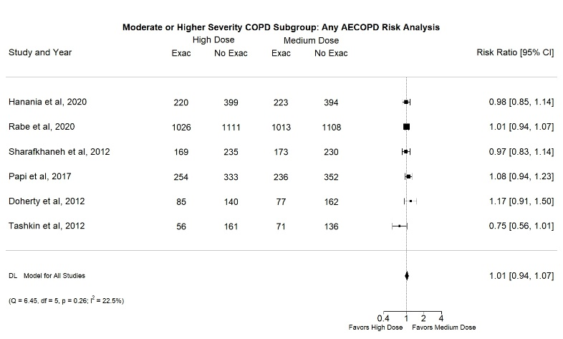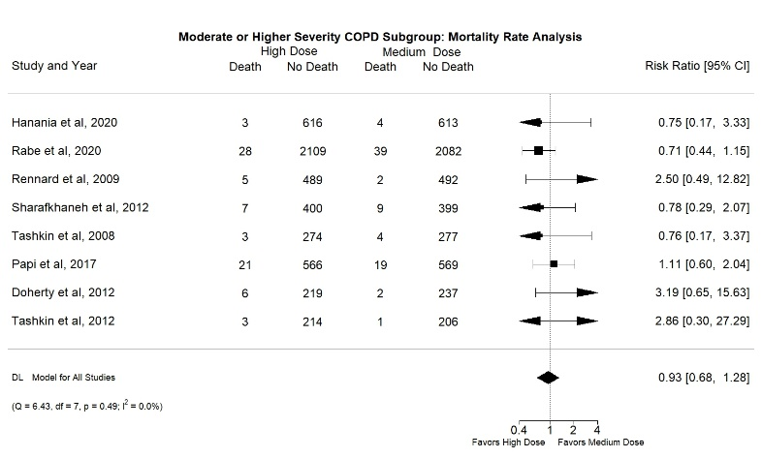
EFigure 1C EFigure 1D
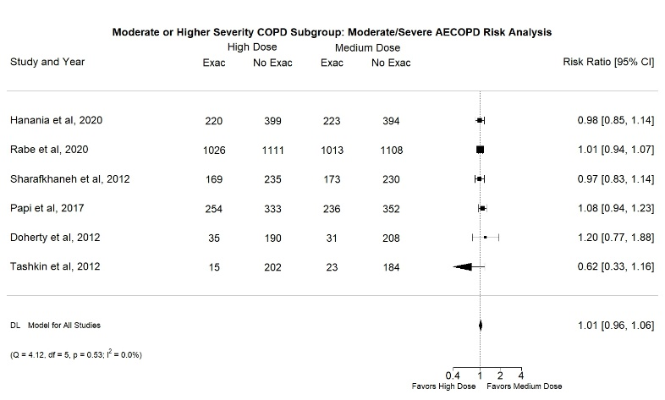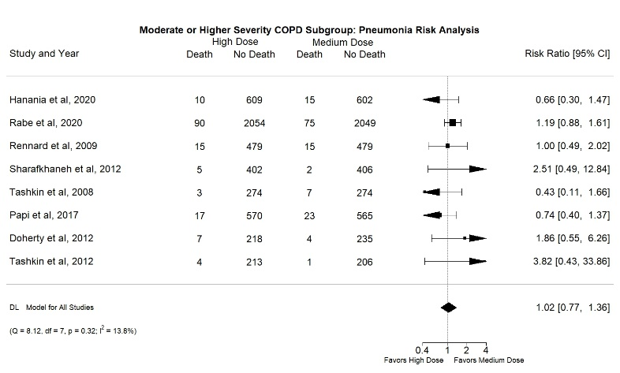

EFigure 2: Patients with Recent Exacerbation Subgroup
A) Comparison of Any AECOPD risk between patients using High Dose ICS versus Medium ICS as part of maintenance therapy,
B) Comparison of Mortality Rate between patients using High Dose ICS versus Medium ICS as part of maintenance therapy,
C) Comparison of Moderate/Severe AECOPD risk between patients using High Dose ICS versus Medium ICS as part of maintenance therapy.
D) Comparison of Pneumonia Risk between patients using High Dose ICS versus Medium ICS as part of maintenance therapy.
EFigure 2A EFigure 2B
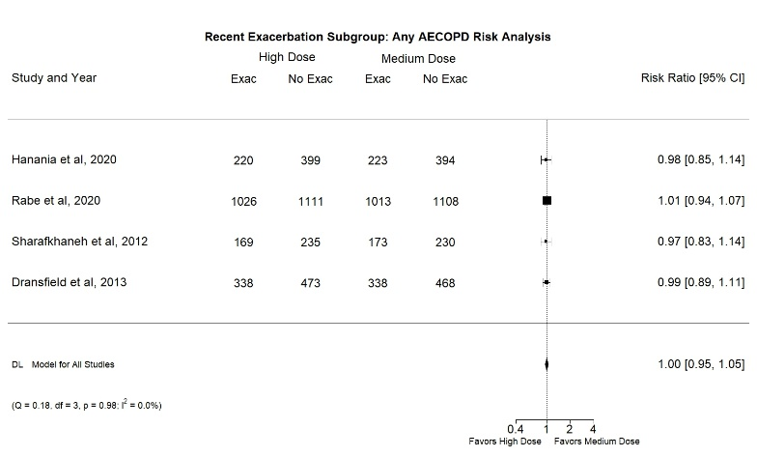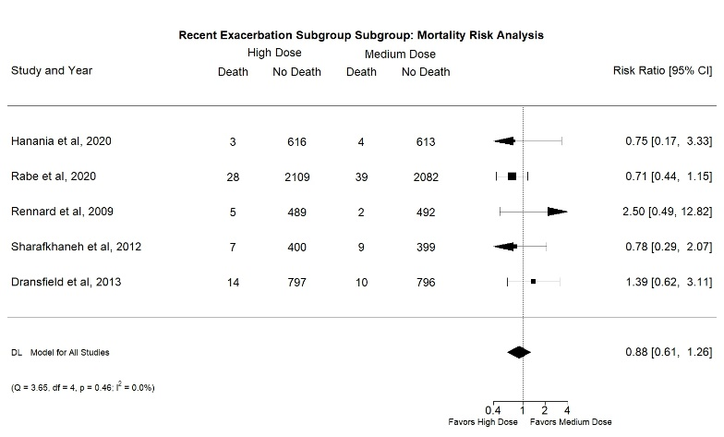
EFigure 2C EFigure 2D
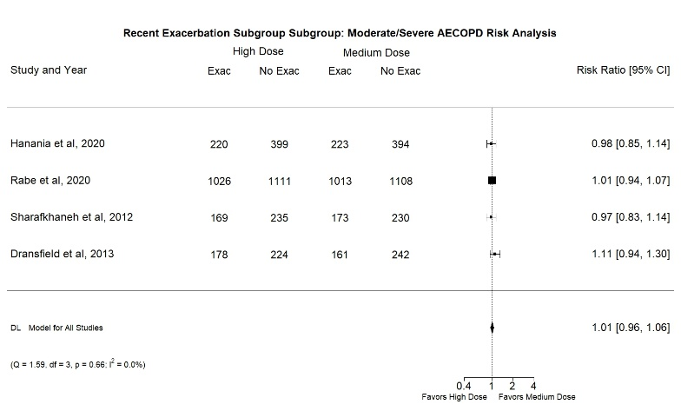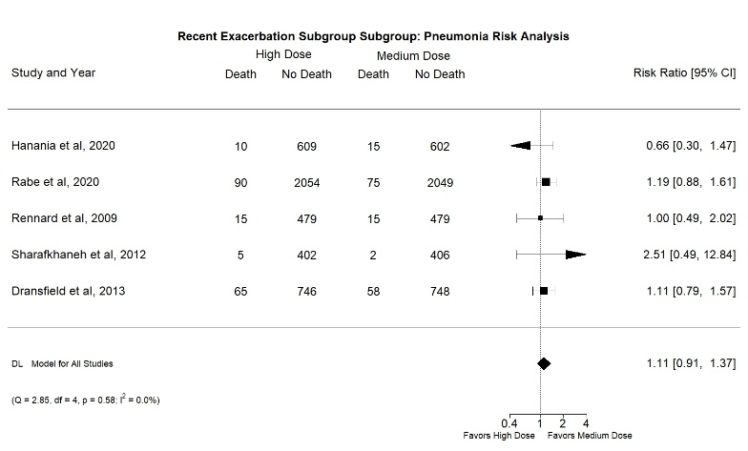

EFigure 3: Funnel Plots
A) Main Analysis, Any AECOPD risk Analysis,
B) Main Analysis, Mortality rate Analysis,
C) Main Analysis, Moderate/Severe AECOPD Risk Analysis,
D) Main Analysis, Pneumonia Risk Analysis,
E) Moderate/Severe/Very Severe COPD Subgroup, Any AECOPD risk Analysis,
F) Moderate/Severe/Very Severe COPD Subgroup, Mortality rate Analysis,
G) Moderate/Severe/Very Severe COPD Subgroup, Moderate/Severe AECOPD Risk Analysis,
H) Moderate/Severe/Very Severe COPD Subgroup, Pneumonia Risk Analysis,
I) Patients with Recent Exacerbation Subgroup, Any AECOPD Risk Analysis,
J) Patients with Recent Exacerbation Subgroup, Mortality rate Analysis,
K) Patients with Recent Exacerbation Subgroup, Moderate/Severe AECOPD Risk Analysis,
L) Patients with Recent Exacerbation Subgroup, Pneumonia Risk Analysis.
EFigure 3A EFigure 3B
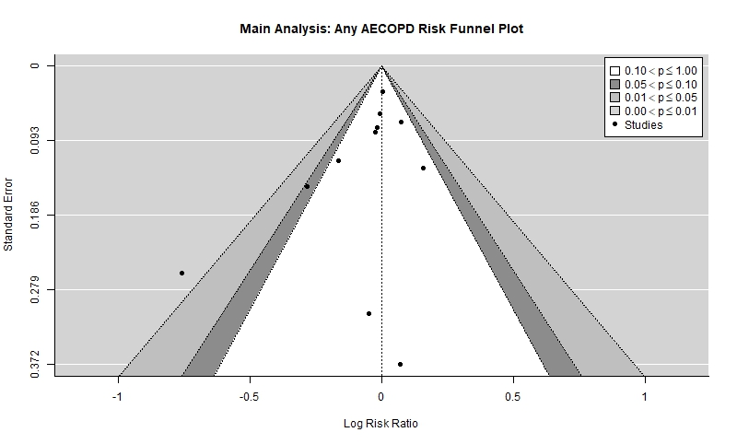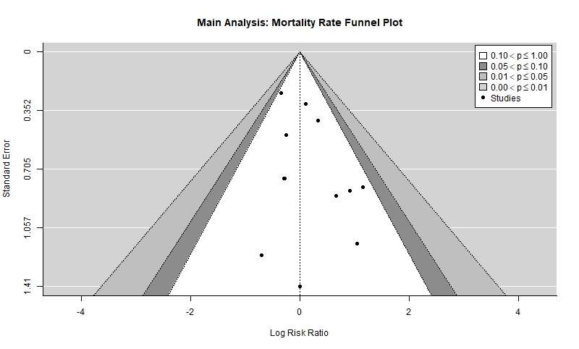
EFigure 3C EFigure 3D
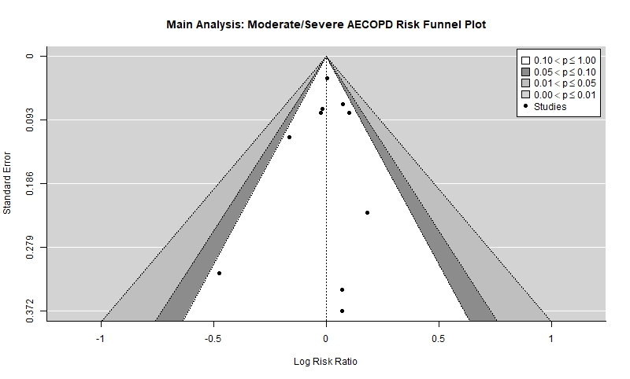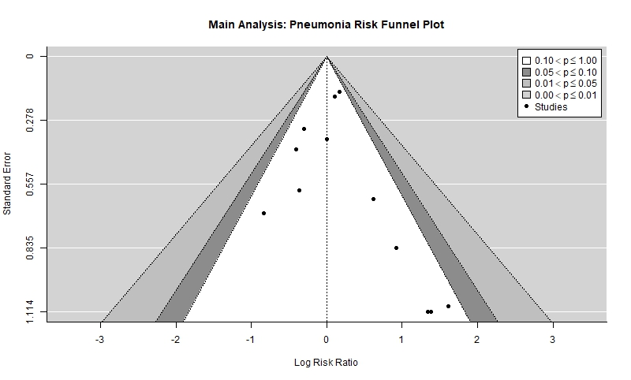
EFigure 3E EFigure 3F
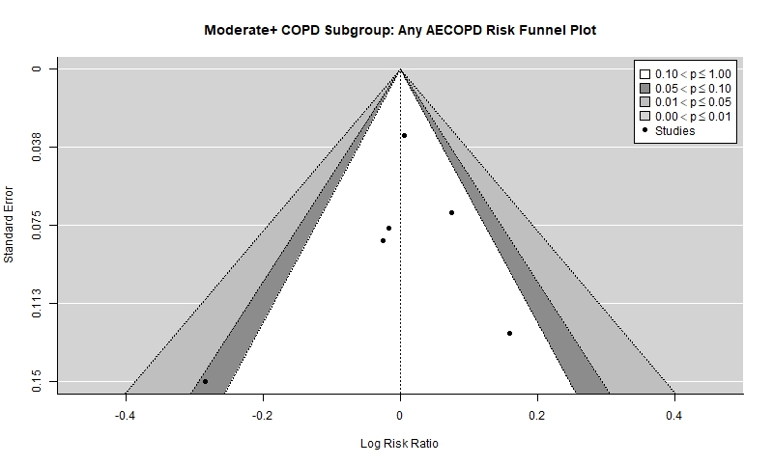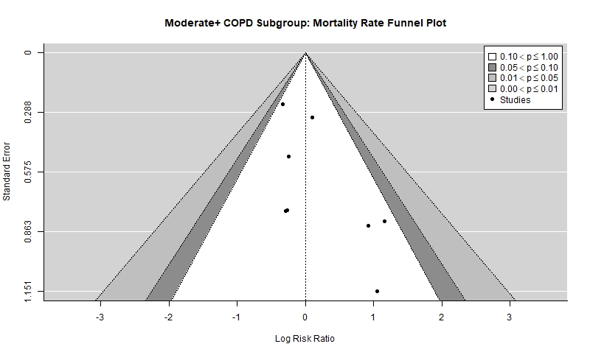

EFigure 3G EFigure 3H
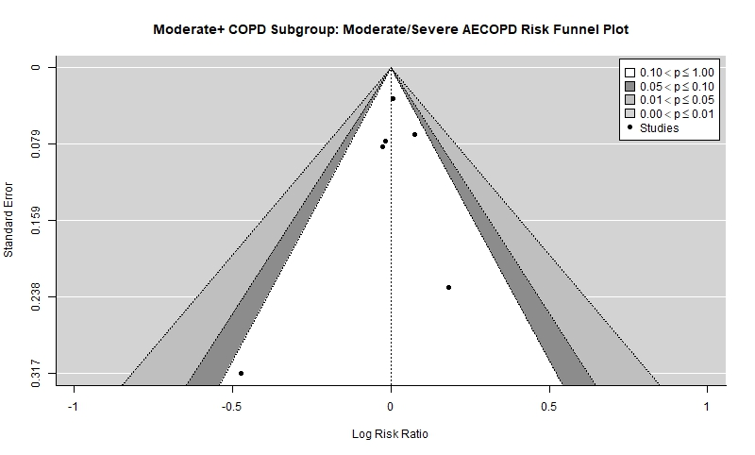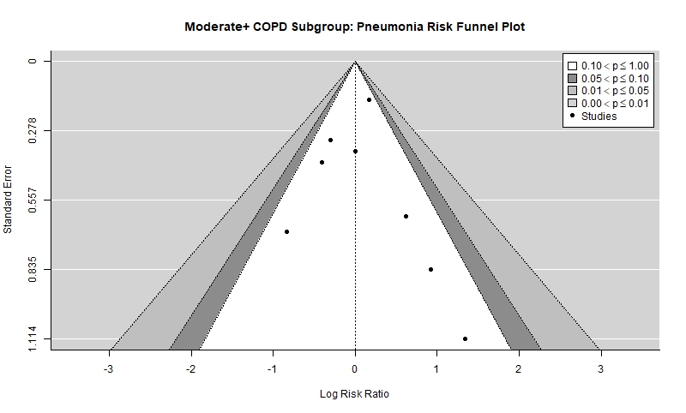
EFigure 3I EFigure 3J
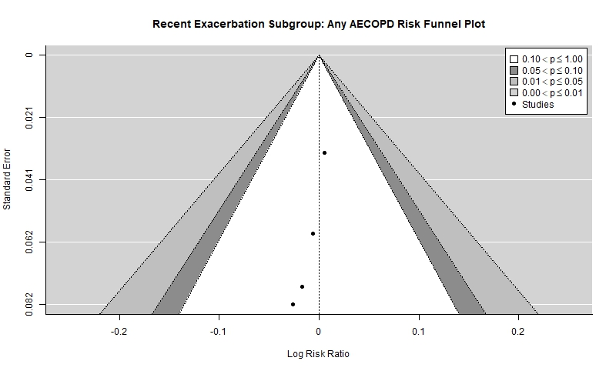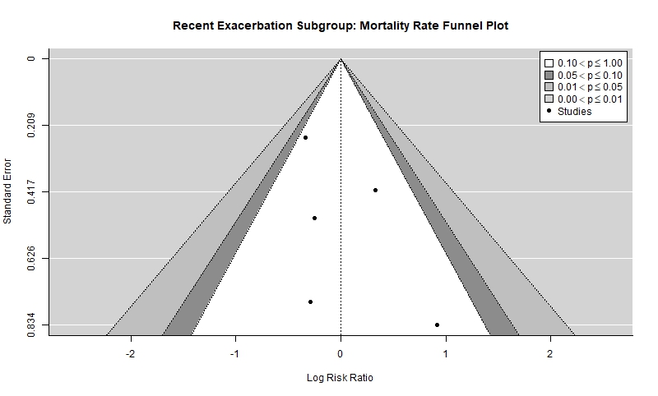

EFigure 3K EFigure 3L
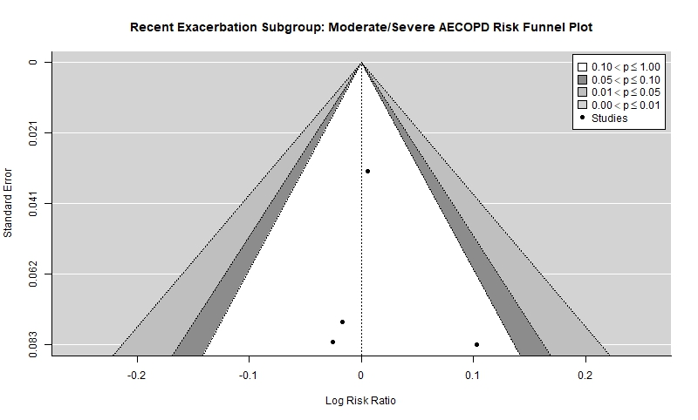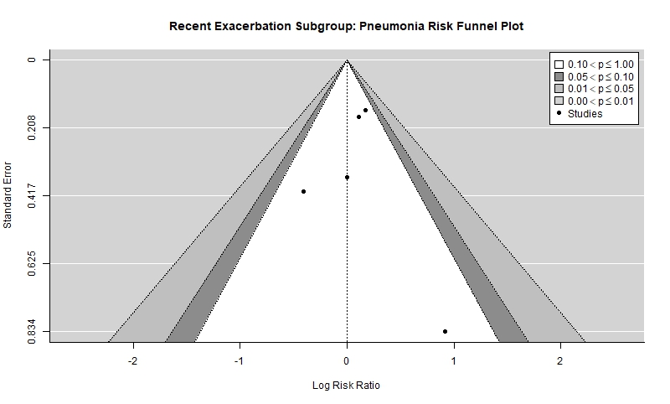

EFigure 4: Risk of Bias Assessment (RoB2 Tool)
