Supporting Information
Polyvinyl Alcohol (PVA)-based Nanoniosome for Enhanced in vitro Delivery and Anticancer Activity of Thymol

Mohammadreza Abdihaji^{1, †}, Masoumeh Mirzaei Chegeni^{2, †}, Alireza Hadizadeh^{3,4}, Negar Farrokhzad⁵, Zahra Kheradmand⁶, Parastoo Fakhrfatemi⁷, Fardad Faress⁸, Kasra Moeinabadi-Bidgoli⁹, Hassan Noorbazargan¹⁰, Ebrahim Mostafavi^{11, 12, *}

¹Department of Biology, The Center for Genomics and Bioinformatics, Indiana University, Bloomington, Indiana, USA
²Department of Biology, Science and Research branch, Islamic Azad University, Tehran, Iran
³School of Medicine, Tehran University of Medical Sciences, Tehran, Iran
⁴Research Center for Advanced Technologies in Cardiovascular Medicine, Cardiovascular Diseases Research Center Institute, Tehran University of Medical Sciences, Tehran, Iran
⁵ Faculty of Biology, Medicine and Health, University of Manchester, Manchester, UK
⁶ Department of Agriculture, Islamic Azad University Maragheh Branch, Maragheh, Iran
⁷ Faculty of Pharmacy, Shiraz University of Medical Sciences, Shiraz, Iran
⁸Department of Business, Data Analysis, The University of Texas Rio Grande Valley (UTRGV) Edinburg, Texas, USA
⁹Basic and Molecular Epidemiology of Gastroenterology Disorders Research Center, Shahid Beheshti University of Medical Sciences, Tehran, Iran
¹⁰Department of Biotechnology, School of Advanced Technologies in Medicine, Shahid Beheshti University of Medical Sciences, Tehran, Iran
¹¹Stanford Cardiovascular Institute, Stanford University School of Medicine, Stanford, CA 94305, USA
¹²Department of Medicine, Stanford University School of Medicine, Stanford, CA 94305, USA

†Mohammadreza Abdihaji, and Masoumeh Mirzaei Chegeni contributed equally to this work

*Correspondence: ebimsv@stanford.edu; ebi.mostafavi@gmail.com (E. Mostafavi)

2. Materials and methods
2.1. Materials
Thymol (TH), Span® 60 (sorbitan monostearate) and Vitamin E were purchased from Millipore Sigma (Burlington, MA USA) and used without further purification. Chloroform, methanol, Polyvinyl alcohol (PVA), dimethyl sulfoxide (DMSO), dialysis membrane (MWCO 12,000 Da), sodium dodecyl sulfate (SDS), phosphate-buffered saline (PBS) and Amicon (Ultra-15-Membrane, MWCO 30,000 Da) were acquired from Merck Chemical Co. (Darmstadt, Germany). The MCF-7, AGS, HepG2, and HFF cell lines were purchased from Pasteur Institute Cell Bank (Tehran, Iran). Medium RPMI-1640 (Dulbecco's Adjusted Eagle Medium), formaldehyde, trypsin-EDTA, Trypan blue, fetal bovine serum (FBS), phosphate-buffer, 3-(4,5-dimethylthiazol-2-yl)-2,5-diphenyltetrazolium bromide (MTT) and penicillin/streptomycin (PS) 100 X were acquired from Gibco, ThermoFisher Scientific (Waltham, MA, USA). 1X binding buffer and annexin V-FITC flow cytometry kit was obtained from Affymetrix Biosciences, ThermoFisher Scientific. The RNA Extraction and cDNA Synthesis kits (Cat No. ER101-01 and AE301-02) were purchased from Transgene Biotech Ltd. (Beijing, China). DCFDA/H2DCFDA - Cellular Reactive Oxygen Species (ROS) Assay Kit was obtained from Abcam Company (Cambridge, United Kingdom). Triton™ X-100 and DAPI (4′,6-Diamidino-2-phenylindole dihydrochloride). propidium iodide was purchased from Calbiochem (San Diego, CA, USA).

2.15. Statistical analysis
Statistical analysis and curve fitting were performed using GraphPad Prism software version 8(GraphPad Software, Inc., San Diego, CA, USA). Data from three independent experiments were expressed as means ± standard deviations. Statistical significance was determined with a one-way analysis of variance after validating the normality and homoscedasticity of the data sets. For all analyses, statistical significance was pre-set at α = 0.05. Box–Behnken method was performed using Design-Expert software version 10 (Stat-Ease Inc., Minneapolis, MN, USA).
Table S1. Different levels for variables in the Box–Behnken design optimization
Level | -1 | 0 | +1
A (Lipid, µmol) | 200 | 250 | 300
B (Hydration time, min) | 30 | 45 | 60
C (Vitamin E: Span 60, molar ratio) | 0.5 | 1 | 2
Drug concentration: 1mg/ml, Sonication time:7 min

Table S2. Primers and their sequences are used in real-time PCR
Gene | Forward Primer | Reverse Primer
Caspase3 | CATACTCCACAGCACCTGGTTA | ACTCAAATTCTGTTGCCACCTT
Caspase9 | CATATGATCGAGGACATCCAG | TTAGTTCGCAGAAACGAAGC
MMP-2 | TTGACGGTAAGGACGGACTC | CATACTTCACACGGACCACTTG
MMP-9 | GCACGACGTCTTCCAGTACC | CAGGATGTCATAGGTCACGTAGC
CyclinD | CAGATCATCCGCAAACACGC | AAGTTGTTGGGGCTCCTCAG
CyclinE | CTCCAGGAAGAGGAAGGCAA | TTGGGTAAACCCGGTCATCA
ß-actin | TCCTCCTGAGCGCAAGTAC | CCTGCTTGCTGATCCACATCT

Table S3. The optimized responses obtained by Box–Behnken method and the experimental data for the same responses under the optimum conditions.
Parameter | Predicted by RSM | Nio-TH | Nio-TH/PVA | Vehicle (Nio/PVA)
Average size (nm) | 199.747 | 184.17±5.40 | 241.93±6.37 | 132.48±6.52
PDI | 0.228 | 0.178±0.007 | 0.193±0.010 | 0.151±0.005
Entrapment Efficiency (EE) (%) | 73.183 | 75.32±0.59 | 83.64±1.17 | -
Zeta potential (mV) | - | -18.35±1.58 | -23.68±1.34 | -29.4±1.25

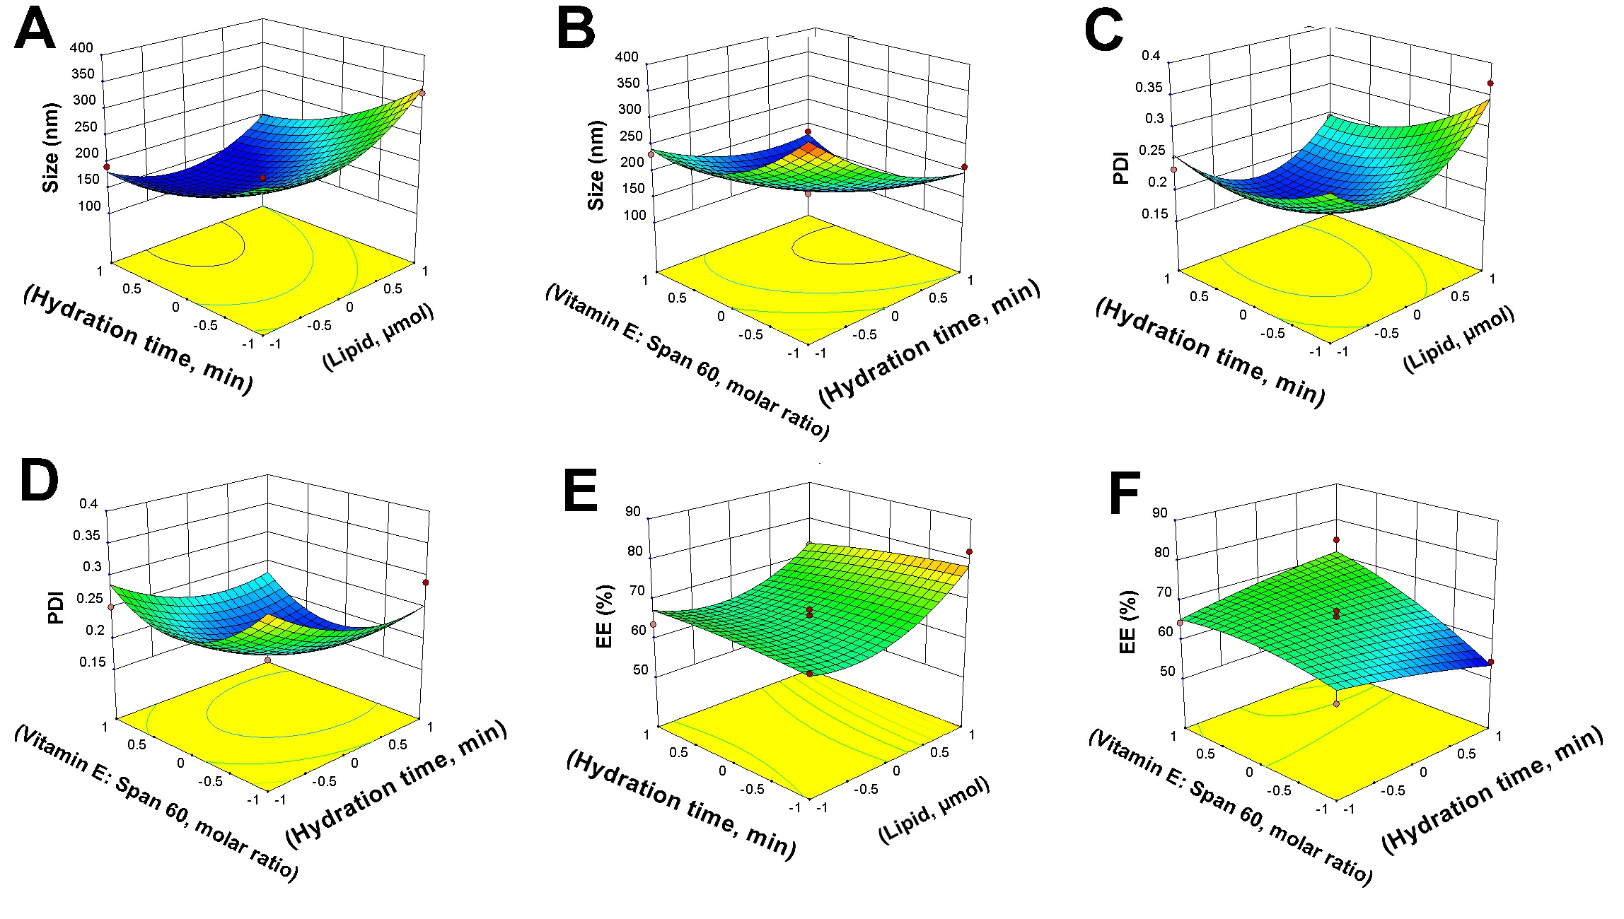
Figure S1. A, B) Box–Behnken method for average diameter as a function of the parameters; C, D) Box–Behnken method for PDI as a function of the parameters; E, F) Box–Behnken method for encapsulation efficiency (EE) as a function of the parameters.

