Supplementary information
Title: Real-life anemia management among patients with non-dialysis-dependent chronic kidney disease in three European countries
Authors: Danilo Fliser¹, Maria Mata Lorenzo², Katherine Houghton³, Claire Ainsworth^{3†}, Martin Blogg², Elena González de Antona Sánchez⁴, José Portolés⁵
Affiliations: ¹Saarland University Medical Center, Homburg, Germany; ²Astellas Pharma Europe Ltd., Addlestone, UK; ³RTI Health Solutions, Manchester, UK; ⁴Astellas Pharma España S.A., Madrid, Spain; ⁵Hospital Universitario Puerta de Hierro, Madrid, Spain
†Current affiliation: OPEN Health Evidence & Access, Manchester, UK
*Corresponding author:
Danilo Fliser
Saarland University Medical Center, Homburg, Germany
Tel.: +49 – (0)6841 – 16 15040
Fax: +49 – (0)6841 – 16 15454
Email: danilo.fliser@uks.eu

Supplementary Table 1 Association of baseline variables and time to initiation of ESA with time to dialysis and time to ESRD
 | Time to dialysis |  | Time to ESRD
 | HR (95% CI) | P valueª | HR (95% CI) | P valueª
Age, years | 0.979 (0.965, 0.992) | 0.002 | 0.986 (0.973, 0.998) | 0.020
Sex
Male | Ref | Ref | Ref | Ref
Female | 0.745 (0.511, 1.086) | 0.125 | 0.922 (0.673, 1.263) | 0.615
Country
Spain | Ref | Ref | Ref | Ref
Germany | 1.131 (0.706, 1.813) | 0.608 | 0.996 (0.654, 1.518) | 0.986
UK | 0.740 (0.474, 1.156) | 0.185 | 0.798 (0.547, 1.164) | 0.241
Time to ESA initiation following anemia diagnosis, years | 1.020 (0.908, 1.146) | 0.733 | 1.014 (0.933, 1.101) | 0.747
eGFR, mL/min/1.73m², at baseline | 0.947 (0.921, 0.974) | <0.001 | 0.931 (0.908, 0.954) | <0.001
CKD stage at time of anemia diagnosis
Stage 3b | 0.377 (0.197, 0.722) | 0.003 | 0.540 (0.280, 1.039) | 0.065
Stage 4 | 0.406 (0.226, 0.730) | 0.003 | 0.562 (0.308, 1.025) | 0.060
Stage 5 | Ref | Ref | Ref | Ref
CCI category at baseline
Mild (1–2) | 0.774 (0.259, 2.313) | 0.647 | 1.209 (0.483, 3.029) | 0.685
Moderate (3–4) | 0.948 (0.554, 1.624) | 0.847 | 1.142 (0.701, 1.862) | 0.594
Severe (≥5) | Ref | Ref | Ref | Ref
ESA type first initiated
Short-acting | 0.669 (0.391, 1.146) | 0.144 | 0.755 (0.485, 1.176) | 0.214
Long-acting^{b} | Ref | Ref | Ref | Ref
ESA weekly dose group^{c}
Group 1 | 1.112 (0.610, 2.027) | 0.729 | 1.331 (0.753, 2.354) | 0.325
Group 2 | 1.549 (0.778, 3.084) | 0.213 | 1.853 (0.979, 3.508) | 0.058
Group 3+4 | Ref | Ref | Ref | Ref
Only patients with non-missing data on all covariates were included in the model (n=670). ªDifferences assessed using the Wald test. ^{b}MPG-EPO is included with darbepoetin alfa in the long-acting ESA group for this analysis, due to small sample size. ^{c}Group 1: <5,000 IU short-acting / <5,000 IU darbepoetin alfa / <1,800 IU MPG-EPO; medium dose: ≥5,000 to ≤8,000 IU short-acting / ≥5,000 to <8,000 IU darbepoetin alfa / ≥1,800 to <3,000 IU MPG-EPO; high dose: >8,000 IU short-acting / ≥8,000 IU darbepoetin alfa / ≥3,000 IU MPG-EPO. CCI, Charlson comorbidity index; CI, confidence interval; CKD, chronic kidney disease, eGFR, estimated glomerular filtration rate; ESA, erythropoiesis-stimulating agent; HR, hazard ratio; IU, international units; MPG-EPO, methoxy polyethylene glycol-epoetin beta; ref, reference

Supplementary Figure 1 Study design.
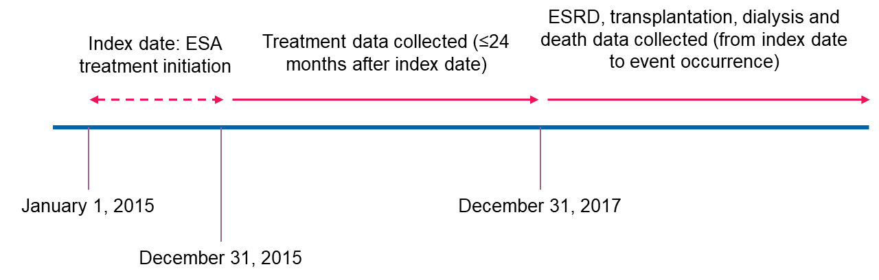
ESA, erythropoiesis-stimulating agent; ESRD, end-stage renal disease

Supplementary Figure 2 ESA treatment changes.
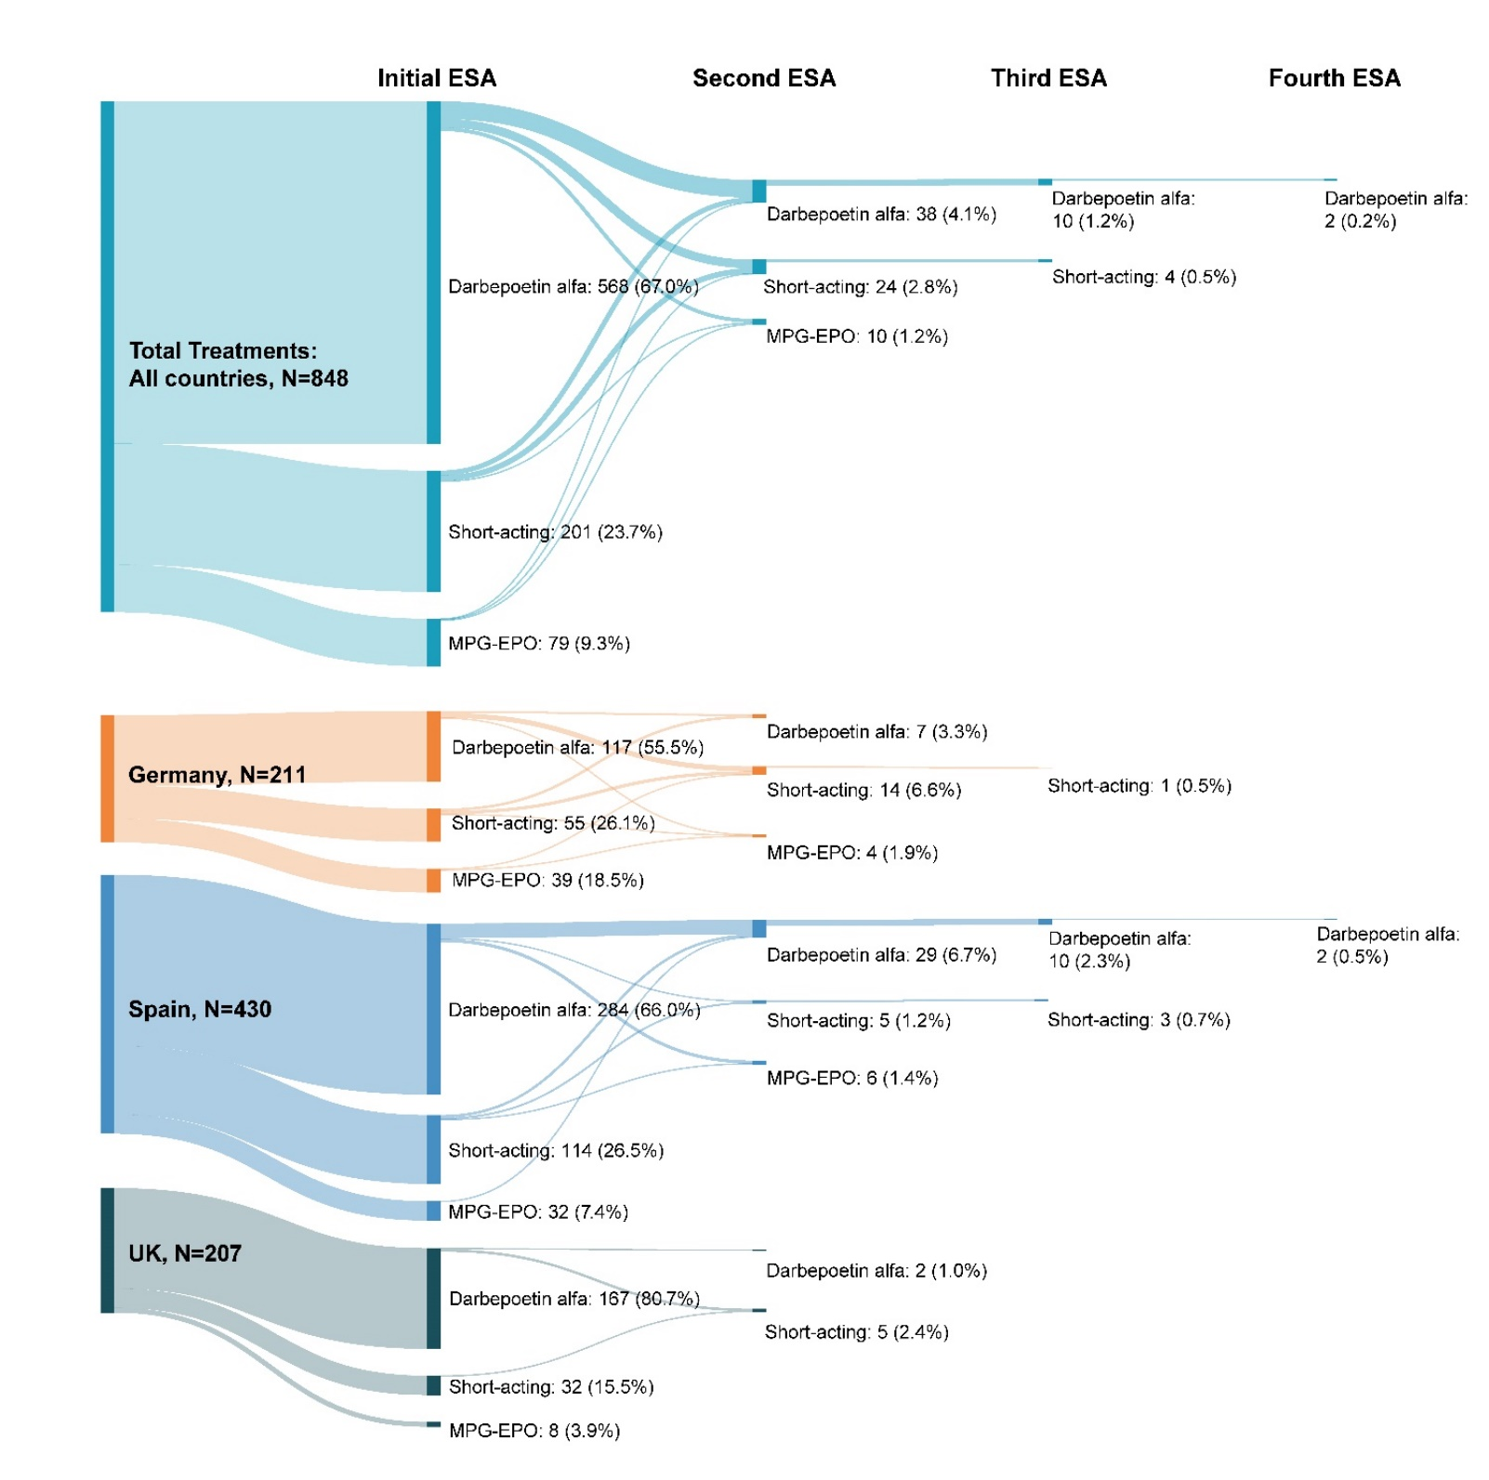
ESA, erythropoiesis-stimulating agent; MPG-EPO, methoxy polyethylene glycol-epoetin beta

Supplementary Figure 3 Blood transfusions and deaths by A) inflammation status and B) ESA dose group
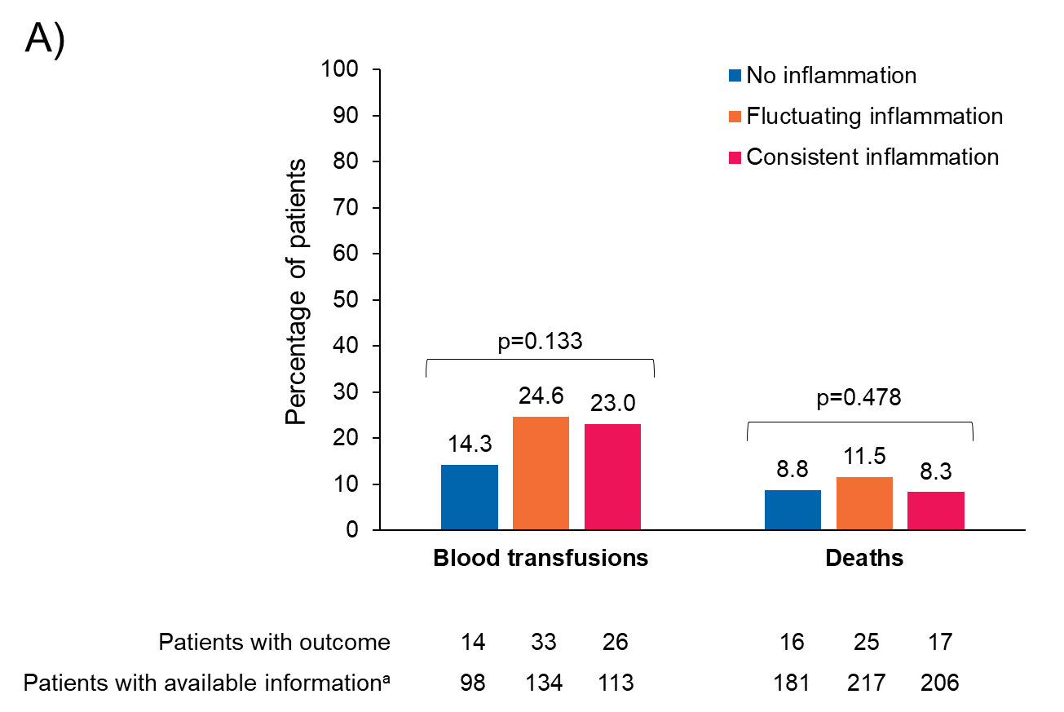
ªPercentages are calculated based on the number of patients with information available, excluding those for whom “don’t know” was a collected response on the CRF. Between-group differences were assessed using Fisher’s exact test. Data on blood transfusions were extracted from ESA initiation until the earliest of the following: 24 months after initiation, the last available medical record, ESRD, transplantation, dialysis, or death. Data on the incidence of death were collected from ESA initiation until the date of medical record abstraction. Inflammation status was assessed using all CRP data during the 24-month observation period following ESA initiation: no inflammation (CRP consistently recorded at <5 mg/L), fluctuating inflammation (CRP levels varied between <5 mg/L and ≥5 mg/L across testing occasions), or consistent inflammation (CRP consistently recorded at ≥5 mg/L). CRF, chronic renal failure; CRP, C-reactive protein; ESA, erythropoiesis-stimulating agent; ESRD, end-stage renal disease

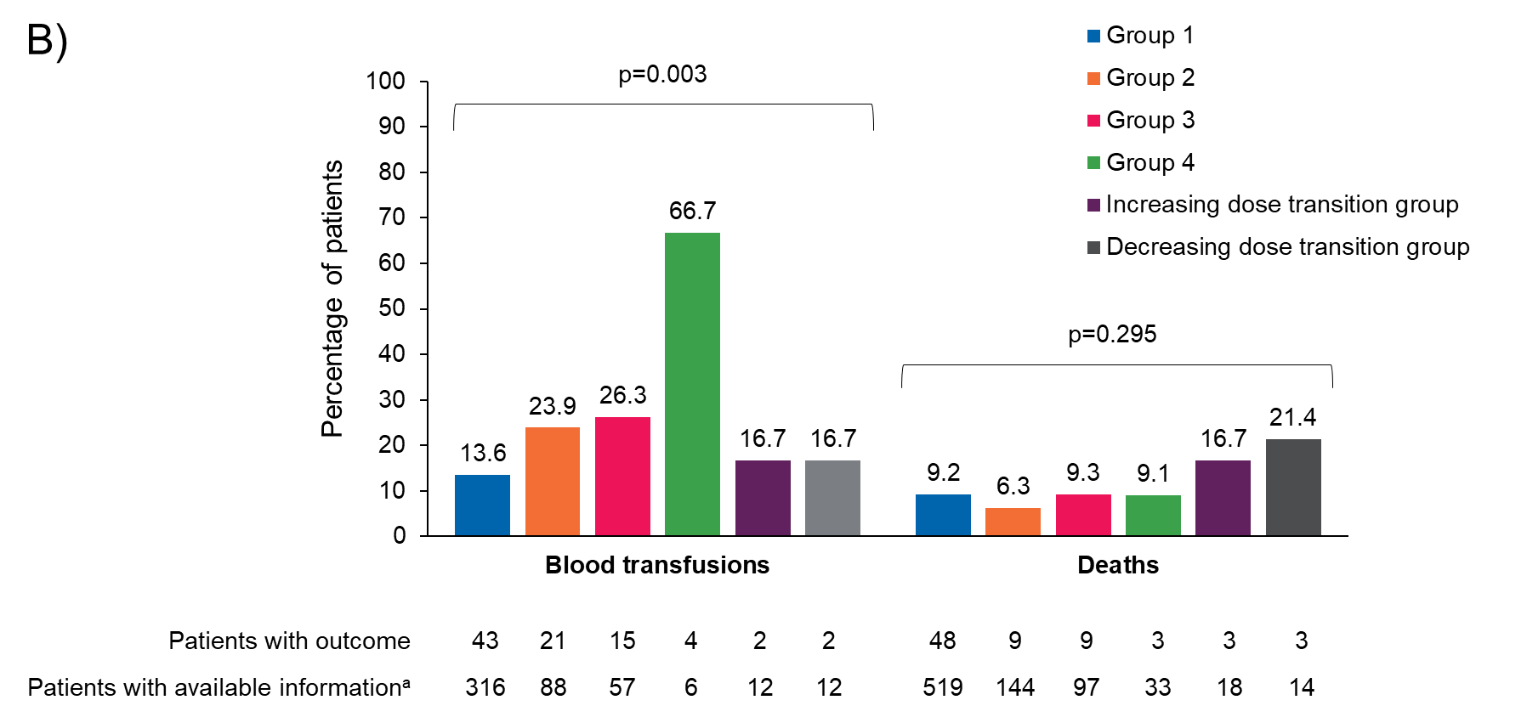
ªPercentages calculated based on the number of patients with information available, excluding those for whom “don’t know” was a collected response on the CRF. Between-group differences were assessed using Fisher’s exact test. Data on blood transfusions were extracted from ESA initiation until the earliest of the following: 24 months after initiation, the last available medical record, ESRD, transplantation, dialysis, or death. Data on the incidence of death were collected from ESA initiation until the date of medical record abstraction. ESA weekly dose groups were defined as follows: Group 1, <5,000 IU short-acting / <5,000 IU darbepoetin alfa / <1,800 IU MPG-EPO; Group 2, ≥5,000 to ≤8,000 IU short-acting / ≥5,000 to <8,000 IU darbepoetin alfa / ≥1,800 to <3,000 IU MPG-EPO; Group 3, >8,000 to ≤16,000 IU short-acting / ≥8,000 to ≤16,000 IU darbepoetin alfa / ≥3,000 to <5,400 IU MPG-EPO; Group 4, >16,000 IU short-acting / >16,000 IU darbepoetin alfa / ≥5,400 IU MPG-EPO. Patients included in the dosing range subgroups remained within that dosing range for the duration of the study period; patients who transitioned between dosing range subgroups during the study period are included in the “increased dosing transition” and “decreased dosing transition” subgroups, as appropriate. Between-group differences were assessed using Fisher’s exact test. CRF, chronic renal failure; ESA, erythropoiesis-stimulating agent; ESRD, end-stage renal disease; IU, international units; MPG-EPO, methoxy polyethylene glycol-epoetin beta

