Giuseppe Ventriglia et al.

SUPPLEMENTARY MATERIALS
Figure 1S. Prescribing habits of GPs with more than 20 years of medical practice and GPs with less than 20 years in managing patients with MSK pain.
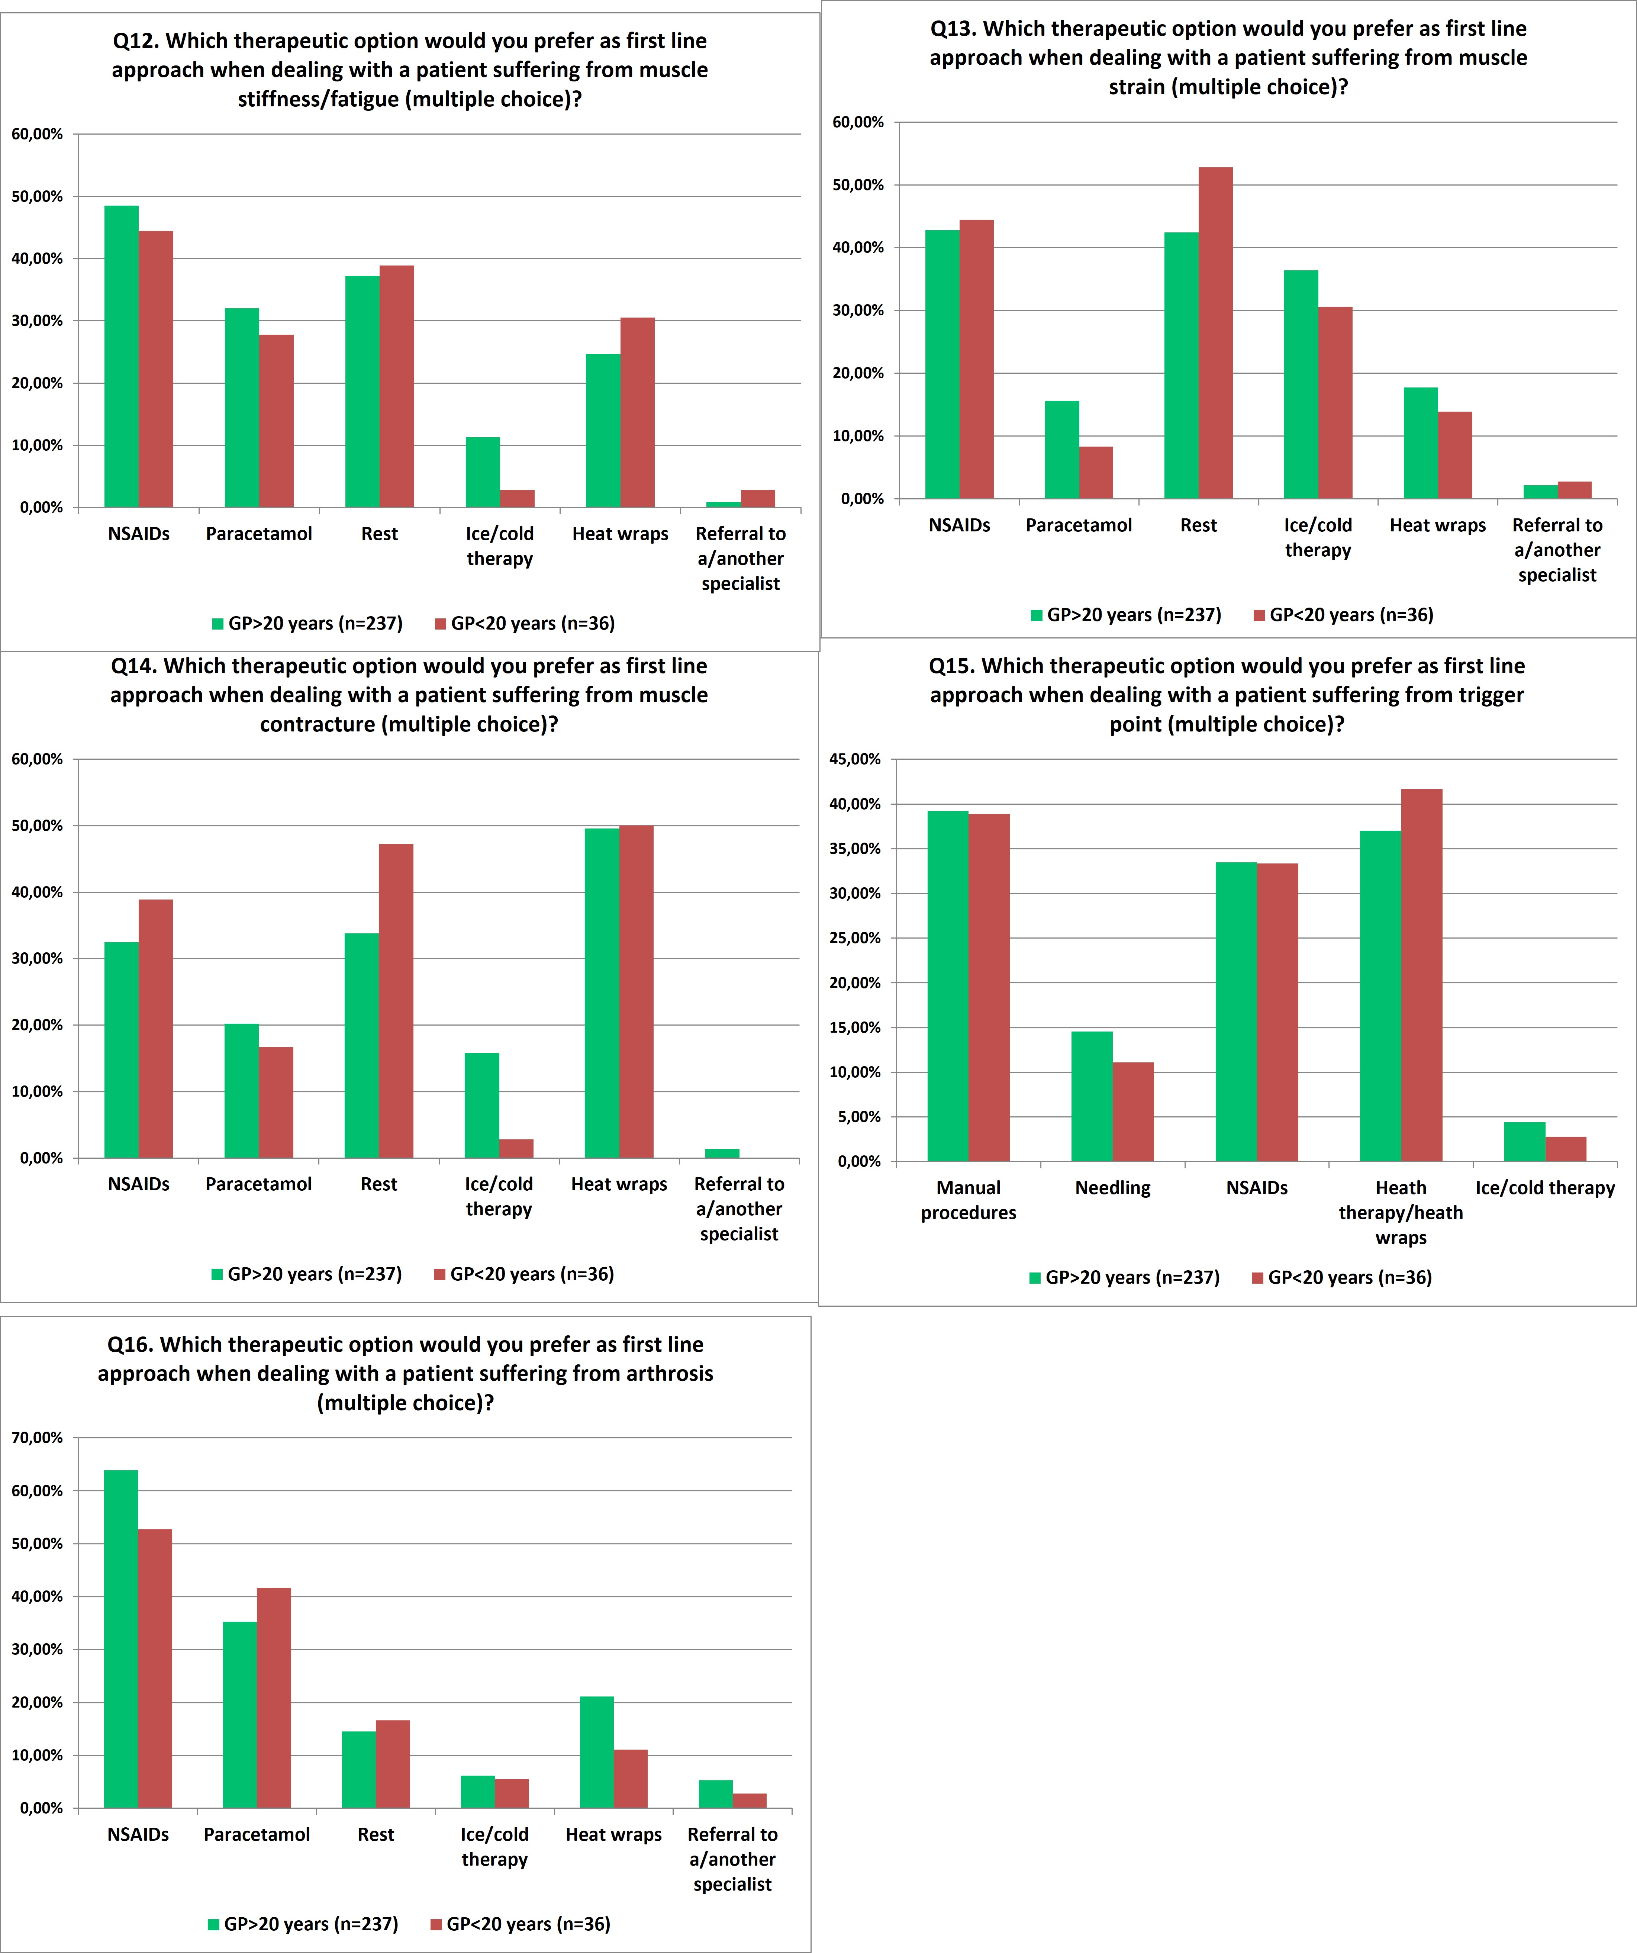

Figure 2S. Prescribing habits of GPs and specialists managing patients suffering from arthrosis (Q16).

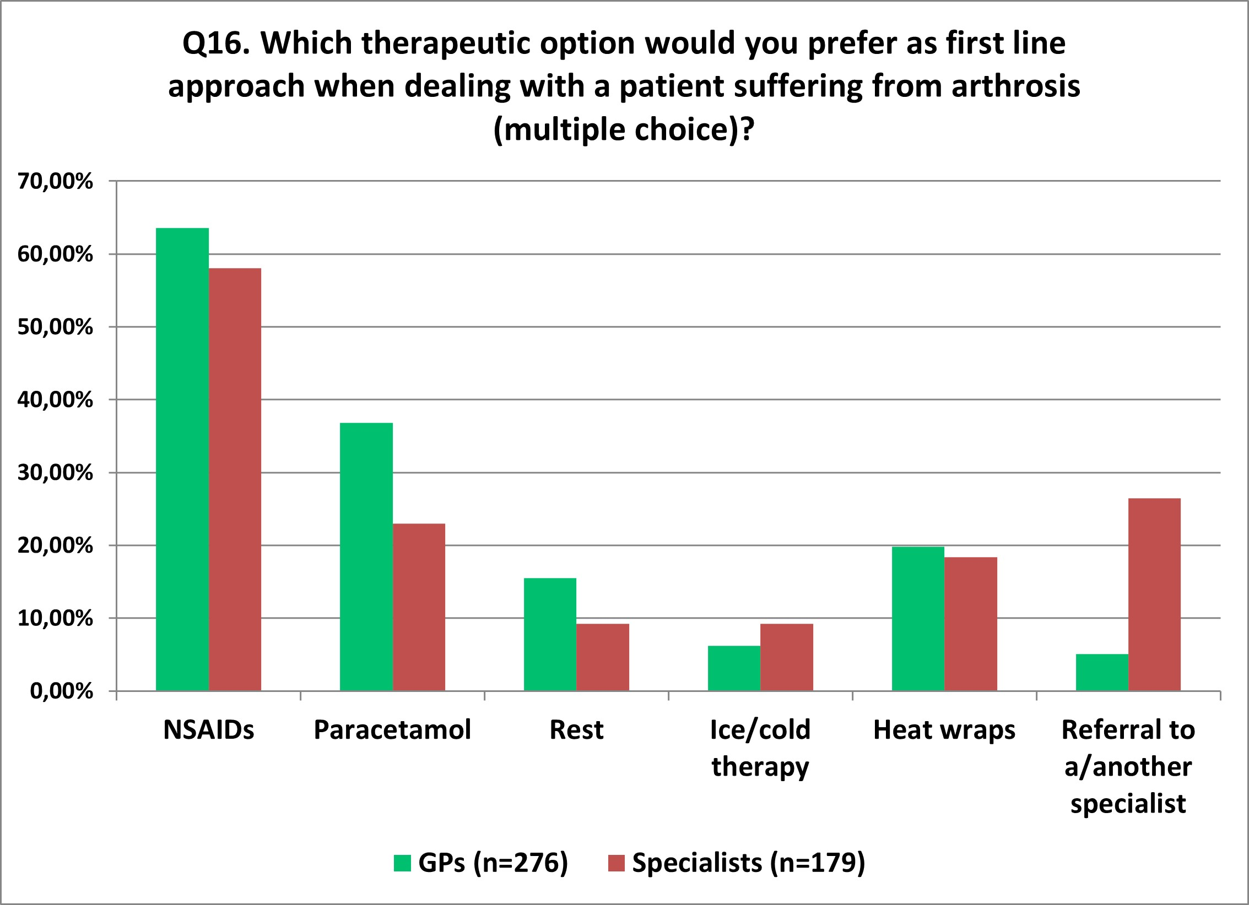

Survey questionnaire

Demographic Items

Q1: Please indicate your specialization:
Q1a: family medicine
Q1b: sport medicine
Q1c: physiatry

Q2: Please indicate your working geographical area?
Q2a: Northern Italy
Q2b: Central
Q2c: Southern Italy (including Islands, namely Sicily and Sardinia)

Q3: Please indicate how many years of medical practice did you spend as healthcare professional:
Q3a: < 5 years
Q3b: 5-10 years
Q3c: 10-20 years
Q3d: > 20 years

Clinical profile of the patients encountered by the participant physicians in their daily practice

Q4: How much frequently do patients suffering from musculoskeletal pain refer to your attention?
Q4a: never
Q4b: rarely/sometimes
Q4c: often
Q4d: always

Q5: The patients referring to you because of their musculoskeletal pain are:
Q5a: mostly patients who were already self-medicated
Q5b: mostly patients who have already trialed one or more analgesic medications
Q5c: resembling answer Q5a and Q5b in the same proportion
Q5d: is not always possible to define such patients

Q6: Based on your clinical experience, please list the three most frequent anatomical sites patients commonly reported as sites of pain
Q6a: Lumbar area
Q6b: Cervical area
Q6c: Thoracic area
Q6d: Knee
Q6e: Neck
Q6f: Shoulder
Q6g: Hip
Q6h: Hand
Q6i: Arm
Q6j: Wrist
Q6k: Ankle/foot
Q6l: localized to a muscle

Q7: The patients referring to you because of their musculoskeletal pain suffer from:
Q7a: very frequently acute pain
Q7b: very frequently chronic pain
Q7c: a pain resembling answer Q7a and Q7b in the same proportion

Q8: Which type of pain is mostly reported by your patients with musculoskeletal pain?
Q8a: mechanical
Q8b: inflammatory
Q8c: neuropathic
Q8d: mixed
Q8e: is not always possible to define such patients

Q9: Please indicate the most frequent cause of musculoskeletal pain as reported by your patients
Q9a: arthrosis
Q9b: incorrect posture
Q9c: demanding work
Q9d: intense/prolonged physical exercise
Q9e: trauma (e.g., sprain)
Q9f: lesion (e.g., muscle strain)

Q10: Based on your clinical experience and your perception, which age group more frequently refers to you because of a MSK pain of traumatic origin?
Q10a: 14-18 years
Q10b: 18-40 years
Q10c: 40-65 years
Q10d: > 65 years

Q11: Based on your clinical experience and your perception, which age group more frequently refers to you because of a MSK pain of non-traumatic origin?
Q11a: 14-18 years
Q11b: 18-40 years
Q11c: 40-65 years
Q11d: > 65 years

Therapeutic approach and prescribing habits of physicians when dealing with patients with musculoskeletal pain

Q12: Please indicate which therapeutic option would you prefer as first line approach when dealing with a patient suffering from muscle stiffness/fatigue:
Q12a: non-steroidal anti-inflammatory drugs (NSAIDs)
Q12b: paracetamol
Q12c: rest
Q12d: ice/cold therapy
Q12e: heat wraps
Q12f: referral to a/another specialist

Q13: Please indicate which therapeutic option would you prefer as first line approach when dealing with a patient suffering from muscle strain:
Q13a: non-steroidal anti-inflammatory drugs (NSAIDs)
Q13b: paracetamol
Q13c: rest
Q13d: ice/cold therapy
Q13e: heat wraps
Q13f: referral to a/another specialist

Q14: Please indicate which therapeutic option would you prefer as first line approach when dealing with a patient suffering from muscle contracture:
Q14a: non-steroidal anti-inflammatory drugs (NSAIDs)
Q14b: paracetamol
Q14c: rest
Q14d: ice/cold therapy
Q14e: heat wraps
Q14f: referral to a/another specialist

Q15: Please indicate which therapeutic option would you prefer as first line approach when dealing with a patient suffering from trigger point:
Q15a: manual procedures
Q15b: needling
Q15c: non-steroidal anti-inflammatory drugs (NSAIDs)
Q15d: Heath therapy/heath wraps

Q15e: Ice/cold therapy

Q16: Please indicate which therapeutic option would you prefer as first line approach when dealing with a patient suffering from arthrosis:
Q16a: non-steroidal anti-inflammatory drugs (NSAIDs)
Q16b: paracetamol
Q16c: rest
Q16d: ice/cold therapy
Q16e: heat wraps
Q16f: referral to a/another specialist

Physician attitude and beliefs about the use of thermotherapy in musculoskeletal pain management

Q17: Please rate your degree of agreement/disagreement with the following statement: “The thermotherapy can be of help after having treated traumatic pain with ice/cold application for 48-72h”
Q17a: I disagree
Q17b: it depends on specific circumstances
Q17c: I much agree
Q17d: I fully agree

Q18: Based on your clinical experience in musculoskeletal pain management by using heat wraps, please indicate in which attitude you most recognize yourself:
Q18a: I use heat wraps rarely in patients with comorbidities
Q18b: I use heat wraps in combination with pharmacological and non-pharmacological treatments
Q18c: I use the heat wraps in monotherapy

Q19: Based on your clinical experience, please evaluate the efficacy/usefulness of thermotherapy in managing patients with musculoskeletal pain:
Q19a: None
Q19b: Poor
Q19c: Enough
Q19d: Much
Q19e: I do not know

Q20: Please select which are the benefits you most confer to thermotherapy:
Q20a: Pain relief
Q20b: Increased connective tissue elasticity
Q20c: Increased blood flow and local tissue metabolism
Q20d: Placebo effect
Q20e: All of the above

Q21: Please rate your degree of agreement/disagreement with the following statement: “The heat is indicated for muscular pain, even chronic, because it stretches the muscles and helps the rest, also by modifying pain perception”
Q21a: I disagree
Q21b: it depends on specific circumstances
Q21c: I much agree
Q21d: I fully agree

Q22: Please indicate how often you would recommend your patients with musculoskeletal pain the use of heat wraps:
Q22a: Never
Q22b: Sometimes
Q22c: Often
Q22d: Very often

