Supplementary Material

Methods and Materials
Determination of cell borders and conversion of Mtb fluorescence to bacterial number
To determine cell borders, phase contrast images were segmented by a custom code using the MATLAB R2018a image analysis toolbox. Cells were identified using edge detection and cell borders between adjacent cells were discriminated using the watershed algorithm. Segmentation was manually curated for errors. Cells in each frame in the same field of view were linked to cells in the previous frame by root mean squared closest centroid. To determine the number of Mtb internalized per cell, single Mtb fluorescence was obtained by filtering the culture through a 5 mm filter and validating the resulting product as a single cell by microscopy. We converted Mtb fluorescent signal inside cells to bacterial numbers by dividing the signal by the mean single Mtb fluorescence at the acquisition settings used for each experiment. Each macrophage internalization event was manually segmented at the time of pickup, and the fluorescence from the internalized bacteria was divided by the movie-specific average fluorescence per bacterium to obtain the Mtb number per internalization.
Cytokine and chemokine profiles
A 2-fold dilution of the cell culture supernatant (75 μL of sample + 75 μL of Calibrator Diluent RD6-52. 50 μL of standard) was added to each well and suspended by inversion or vortexing. 50 μL of the microparticle cocktail was added to each well , securely covered with a foil plate sealer and incubated for 2 hours at room temperature on a horizontal orbital microplate shaker (0.12” orbit) set at 800 ± 50 rpm. A magnetic device designed to accommodate a microplate was used towash the bottom of the microplate. three times. 50 μL of diluted Biotin-Antibody Cocktail was then added to each well and incubated for 1 hour at room temperature on the shaker set at 800 ± 50 rpm. 50 μL of diluted Streptavidin-PE was added to each well and incubated for 30 minutes at room temperature on the shaker set at 800 ± 50 rpm. Microparticles were suspended by adding 100 μL of Wash Buffer to each well and incubated for 2 minutes on the shaker set at 800 ± 50 rpm. The plane was read within 90 minutes using a Luminex® or Bio-Rad analyzer.
Phagocytosis assay
MDMs were resuspended in culture medium to yield 50 – 80% confluency. 100µL was seeded in each well of a 96-well plate and incubate overnight at 37°C, 5% CO2. MDMs were treated with treatment conditions. 10µL of Zymosan suspension was added to each well and mixed well then transferred to a cell culture incubator for 15min – 2 hours. The culture medium was removed by gently aspirating or inverting the plate and blotting on a paper towel. 200µL of cold, serum-free medium was added to each well. Promptly remove the cold media by gently aspirating or inverting the plate and blotting on a paper towel. The culture medium was removed and 100µl of fixation solution was added to each well and incubated for 5min. The fixation solution was removed by gently aspirating or inverting the plate and blotting on a paper towel, followed by two washes with PBS. We then added 100µl of 1x blocking reagent to each well and incubated at 37°c for 60min. The blocking regent was removed as above, followed by three washes with PBS. 100µl of prediluted 1x permeabilization solution was added to each well and incubated at 37°c for 5min. The permeabilization solution was removed as above followed by one wash with PBS. 100µl of prediluted 1x detection reagent was added to each well and incubated at 37°c for 60min. The detection reagent solution was removed as above, followed by three washes with PBS. 50 µl of detection buffer was added to each well and incubated for 10min at 37°c. To initiate the reaction 100µl of substrate was added and incubated for 5 – 20 min at 37°c. The reaction was stopped by adding 50 µl of the stop solution and mixed for 5min. The absorbance was read at OD 405nm.

Control start Control end INH start INH end
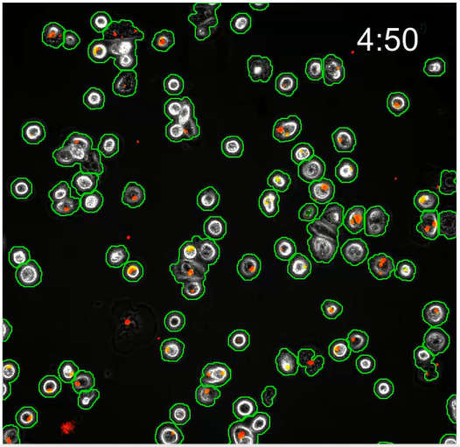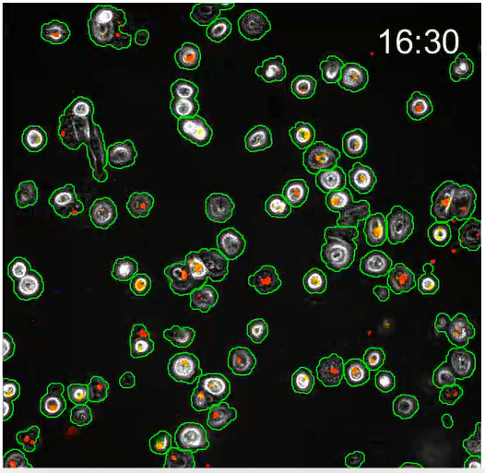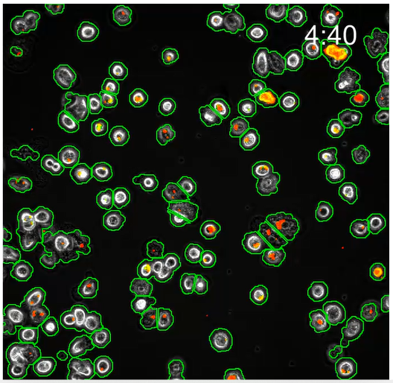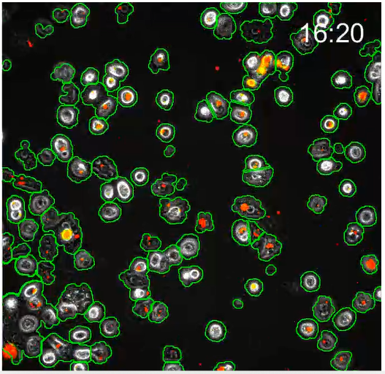
MET start MET end INH and MET start INH and MET end
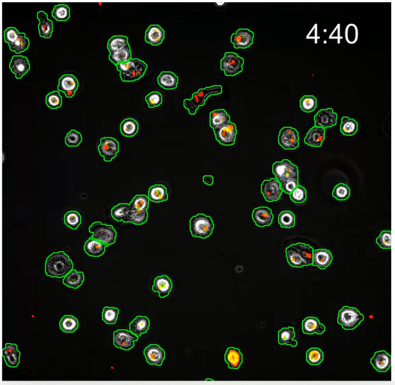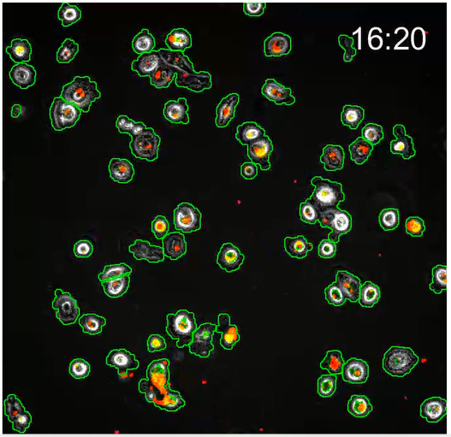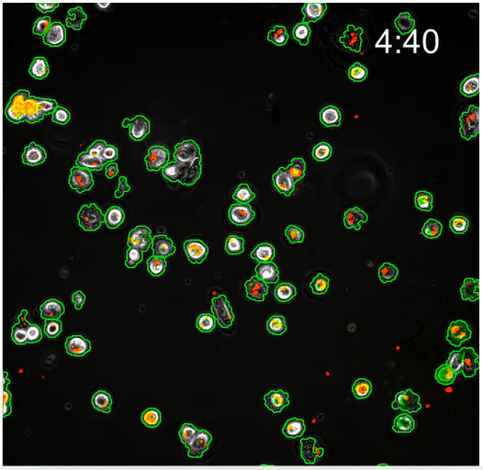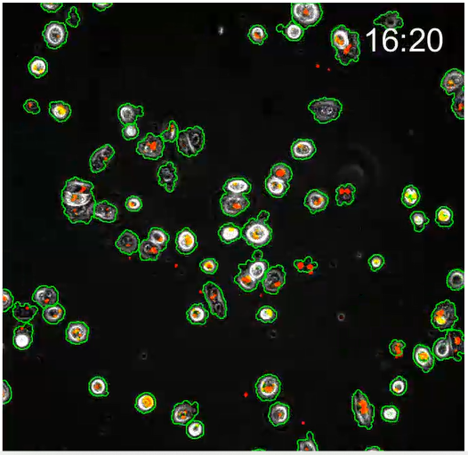

Fig. S1 Macrophage internalization of Mtb aggregates. Mtb infections of MDMs were imaged by time-lapse microscopy at a resolution of 10 min between image acquisitions. Macrophage borders and locations were tracked using a custom written, MATLAB based image analysis code. Images from the start and end of the time-lapse analysis of each treatment condition. The border of the analyzed macrophages is shown as a green outline. RFP-expressing Mtb are shown in red. Time is hours: minutes. Scale bar is 20 mm.

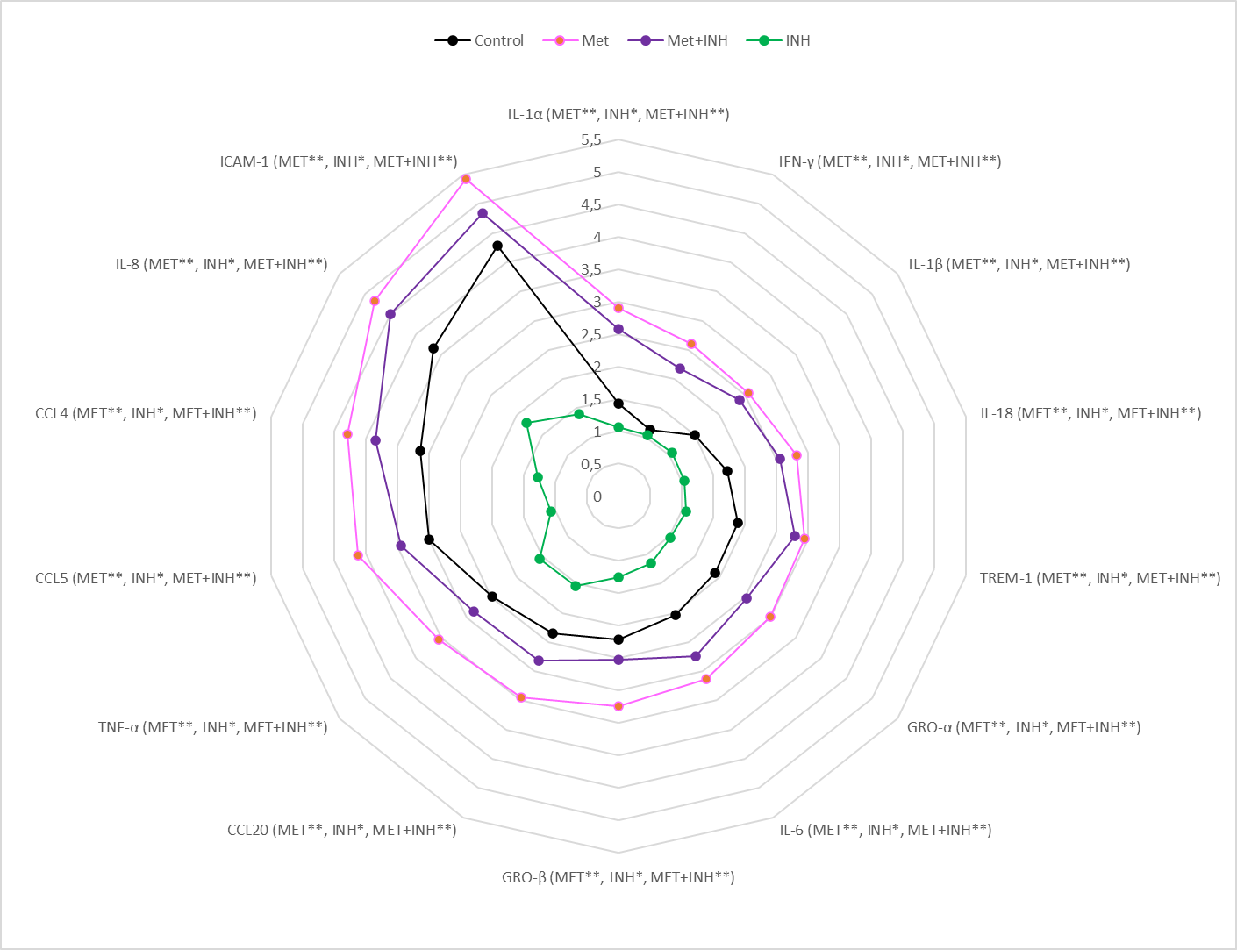
Fig. S2 MET enhances immune response to Mtb in the first 48 hours. Mtb infected macrophages were treated with MET, INH and a combination of MET with INH. Evaluated cytokines: TNFα, IFNγ, IL-1α/β, IL-6, IL-18 and IL-10, and chemokines: CCL4, CCL5, CCL20, ICAM-1, TREM-1, GRO-α and GRO-β levels (pg/mL). Non-parametric, multiple hypothesis, Mann-Whitney U test. P-values <0.05 were considered significant.

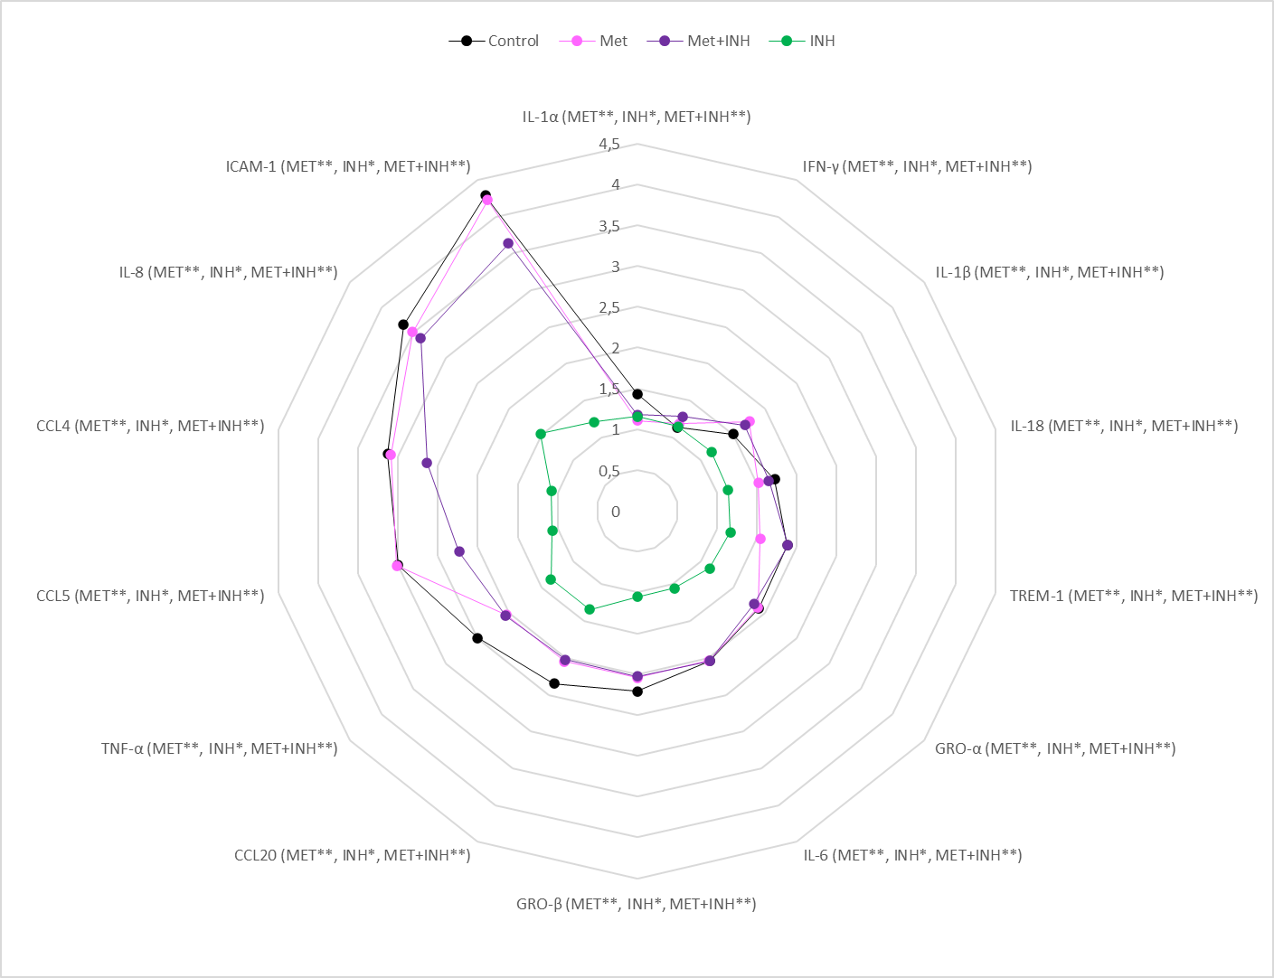
Fig. S3 MET modulates immune response to Mtb at 72 hours. Mtb infected macrophages were treated with MET, INH and a combination of MET with INH. Evaluated cytokines: TNFα, IFNγ, IL-1α/β, IL-6, IL-18 and IL-10, and chemokines: CCL4, CCL5, CCL20, ICAM-1 TREM-1, GRO-α and GRO-β levels (pg/mL). Non-parametric, multiple hypothesis, Mann-Whitney U test. P-values <0.05 were considered significant.

Source code

close all

clear all

folderRoot='G:\2018.06.08_Metformin_2\Analysis_2_Automated SegmentationSR';

fovToDoAb = [10 13];

fovToDoMedium = [1 7 8];%%%cell 1 picked up - excluded

fovToDoMet = [17 19];

fovToDoMet_INH = [27 29 32];

%fovToDoMedium = [21 22 23 25 27 29];%%%cell 1 picked up - excluded

fovToDo =[fovToDoAb, fovToDoMedium, fovToDoMet, fovToDoMet_INH];

fluorSignalCombinedAb = [];
fluorSignalCombinedMedium = [];
fluorSignalCombinedMet = [];
fluorSignalCombinedMet_INH = [];

%% Options

AllConditionsGraphing =1;
CreateCellMatrix = 1;

% Normslizing condition
Normalizing = 1;

%Interquartile range
IQRMetformin = 1;

%% AllConditionsGraphing

if AllConditionsGraphing ==1

for fovIndex = 1:numel(fovToDo)

fovNum = fovToDo(fovIndex);

cd([folderRoot '\' 'FOV' num2str(fovNum)]);

for iCell =1:150

nameCell = (['cell' num2str(iCell) 'BW']);

if exist(nameCell)>0

cd(nameCell)

load('dataMatrixCell')

fluorSignal = dataMatrix(:, 1);

if ismember(fovNum, fovToDoAb)

fluorSignalCombinedAb = [fluorSignalCombinedAb, fluorSignal];

elseif ismember(fovNum, fovToDoMedium)

fluorSignalCombinedMedium = [fluorSignalCombinedMedium, fluorSignal];

elseif ismember(fovNum, fovToDoMet)

fluorSignalCombinedMet = [fluorSignalCombinedMet, fluorSignal];

else

fluorSignalCombinedMet_INH = [fluorSignalCombinedMet_INH, fluorSignal];
end

cd('../')

end

end

end

figure,

medianAb =median(fluorSignalCombinedAb, 2); %%%note column vector

medianMedium =median(fluorSignalCombinedMedium(:, 2:end), 2);

medianMet =median(fluorSignalCombinedMet, 2);

medianMet_INH =median(fluorSignalCombinedMet_INH, 2);

timeVectHr = ((1:72)./6);

plot(timeVectHr, medianAb, 'color', [0.85 0.33 0.1])

%plot(timeVectHr, medianAb, 'Color', [0 0.5 0])

hold on

%plot(timeVectHr, medianMedium./medianMedium(1), 'Color', 'Blue')

plot(timeVectHr, medianMedium,'color', [0 0.45 0.74])

hold on

plot(timeVectHr, medianMet,'color', [0.49 0.18 0.56])

hold on

plot(timeVectHr, medianMet_INH,'color',[0.93 0.69 0.13])

hold on

% LogAb = log(medianAb./medianAb(1)); %%%%linearlize
% LogMedium = log(medianMedium./medianMedium(1));

LogAb = log(medianAb); %%%%linearlize
LogMedium = log(medianMedium);
LogMet = log (medianMet);
LogMet_INH = log (medianMet_INH);

% LogAb = medianAb./medianAb(1); %%%%linearlize
% LogMedium = medianMedium./medianMedium(1);

%%%does linear fit Ab
fitLogAb = polyfit(timeVectHr', LogAb, 1);
fitYvaluesAb = polyval(fitLogAb, timeVectHr); %%%linear fir y values evaluated for same x values as raw data (can evaluate over any interval)
expFitAb = exp (fitYvaluesAb);
%expFitAb = fitYvaluesAb;

%%%does linear fit Medium
fitLogMedium = polyfit(timeVectHr', LogMedium, 1);
fitYvaluesMedium = polyval(fitLogMedium, timeVectHr); %%%linear fir y values evaluated for same x values as raw data (can evaluate over any interval)
expFitMedium = exp (fitYvaluesMedium);
%expFitMedium = fitYvaluesMedium;

%%%does linear fit Met
fitLogMet = polyfit(timeVectHr', LogMet, 1);
fitYvaluesMet = polyval(fitLogMet, timeVectHr); %%%linear fir y values evaluated for same x values as raw data (can evaluate over any interval)
expFitMet = exp (fitYvaluesMet);
%expFitMet = fitYvaluesMet;

%%%does linear fit Met_INH
fitLogMet_INH = polyfit(timeVectHr', LogMet_INH, 1);
fitYvaluesMet_INH = polyval(fitLogMet_INH, timeVectHr); %%%linear fir y values evaluated for same x values as raw data (can evaluate over any interval)
expFitMet_INH = exp (fitYvaluesMet_INH);
%expFitMet_INH = fitYvaluesMet_INH;

hold on;

%plot(timeVectHr', expFitAb./expFitAb(1), 'Color', [0 0.5 0])

plot(timeVectHr', expFitAb,'color',[0.85 0.33 0.1],"LineWidth",2)

hold on

%plot(timeVectHr', expFitMedium./expFitMedium(1), 'Color', [0.5 0 0])

plot(timeVectHr', expFitMedium,'color', [0 0.45 0.74],"LineWidth",2)
hold on

plot(timeVectHr', expFitMet,'color',[0.49 0.18 0.56],"LineWidth",2 )
hold on

plot(timeVectHr', expFitMet_INH,'color', [0.93 0.69 0.13],"LineWidth",2 )
hold on

%%%doubling time in hours

doublingTimeAb = log(2)/fitLogAb(1);

doublingTimeMedium = log(2)/fitLogMedium(1);

doublingTimeMet = log(2)/fitLogMet(1);

doublingTimeMet_INH = log(2)/fitLogMet_INH(1);

xlabel("Time(h)",'FontWeight','bold')
ylabel("Bacterial Fluorescence",'FontWeight','bold')
legend({"Isoniazid, dT = 29.86","Control,dT = 14.68", "Metformin,dT = 21.12", "Metformin + Isoniazid,dT = -36.78"},"NumColumns",2, "FontSize", 6.5, "Location","northwest")

end

%% CREATECELLMATRIX

if CreateCellMatrix ==1

CellMatrix = zeros(68,72);

figure
figure1= plot (timeVectHr, fluorSignalCombinedAb);

xlabel("Time(h)",'FontWeight','bold')
ylabel("Bacterial Fluorescence",'FontWeight','bold')
ylim ([0 1600000])
legend({"INH(17)"}, "FontSize", 6.5, "Location","northwest")

figure
figure2= plot (timeVectHr, fluorSignalCombinedMedium);

xlabel("Time(h)",'FontWeight','bold')
ylabel("Bacterial Fluorescence",'FontWeight','bold')
ylim ([0 1600000])
legend({"Control(15)"}, "FontSize", 6.5, "Location","northwest")

figure
figure3= plot (timeVectHr, fluorSignalCombinedMet);

xlabel("Time(h)",'FontWeight','bold')
ylabel("Bacterial Fluorescence",'FontWeight','bold')
ylim ([0 1600000])
legend({"Met(17)"}, "FontSize", 6.5, "Location","northwest")

figure
figure4= plot (timeVectHr, fluorSignalCombinedMet_INH);

xlabel("Time(h)",'FontWeight','bold')
ylabel("Bacterial Fluorescence",'FontWeight','bold')
ylim ([0 1600000])
legend({"Met/INH(18)"}, "FontSize", 6.5, "Location","northwest")
end

%% Normalize

if Normalizing ==1

NormalizedMatrixAb = (fluorSignalCombinedAb./fluorSignalCombinedAb(1,:));

NormalizedMatrixMedium = (fluorSignalCombinedMedium./fluorSignalCombinedMedium(1,:));

NormalizedMatrixMet = (fluorSignalCombinedMet./fluorSignalCombinedMet(1,:));

NormalizedMatrixMet_INH = (fluorSignalCombinedMet_INH./fluorSignalCombinedMet_INH(1,:));

figure
figure1= plot (timeVectHr, NormalizedMatrixAb);

xlabel("Time(h)",'FontWeight','bold')
ylabel("Mtb (normalized to first frame)",'FontWeight','bold')
ylim ([0 18])
legend({"INH(17)"}, "FontSize", 6.5, "Location","northwest")

figure
figure2= plot (timeVectHr, NormalizedMatrixMedium);

xlabel("Time(h)",'FontWeight','bold')
ylabel("Mtb (normalized to first frame)",'FontWeight','bold')
ylim ([0 18])
legend({"Control(16)"}, "FontSize", 6.5, "Location","northwest")

figure
figure3= plot (timeVectHr, NormalizedMatrixMet);

xlabel("Time(h)",'FontWeight','bold')
ylabel("Mtb (normalized to first frame)",'FontWeight','bold')
ylim ([0 18])
legend({"Met(17)"}, "FontSize", 6.5, "Location","northwest")

figure
figure4= plot (timeVectHr, NormalizedMatrixMet_INH);

xlabel("Time(h)",'FontWeight','bold')
ylabel("Mtb (normalized to first frame)",'FontWeight','bold')
ylim ([0 18])
legend({"Met/INH(18)"}, "FontSize", 6.5, "Location","northwest")

end

%% Interquartile range

if IQRMetformin == 1

QuarterAb= quantile(fluorSignalCombinedAb, [0.75, 0.25], 2);
IQRAb= iqr(fluorSignalCombinedAb,2);
QuarterMedium= quantile(fluorSignalCombinedMedium, [0.75, 0.25], 2);
IQRMedium= iqr(fluorSignalCombinedMedium,2);
QuarterMet= quantile(fluorSignalCombinedMet, [0.75, 0.25], 2);
IQRMet= iqr(fluorSignalCombinedMet,2);
QuarterMet_INH= quantile(fluorSignalCombinedMet_INH, [0.75, 0.25], 2);
IQRMet_INH= iqr(fluorSignalCombinedMet_INH,2);

% hold on
figure
fill([timeVectHr fliplr(timeVectHr)], [QuarterAb(:,1); flip(QuarterAb(:,2))], 1, 'facecolor', [0.85 0.33 0.1] ,'edgecolor', 'none', 'facealpha', 0.2);
hold on

fill([timeVectHr fliplr(timeVectHr)], [QuarterMet_INH(:,1); flip(QuarterMet_INH(:,2))], 1, 'facecolor', [0.93 0.69 0.13],'edgecolor', 'none', 'facealpha',0.4 );
hold on

fill([timeVectHr fliplr(timeVectHr)], [QuarterMedium(:,1); flip(QuarterMedium(:,2))], 1, 'facecolor', [0 0.45 0.74],'edgecolor', 'none', 'facealpha', 0.8);
hold on

fill([timeVectHr fliplr(timeVectHr)], [QuarterMet(:,1); flip(QuarterMet(:,2))], 1, 'facecolor', [0.49 0.18 0.56],'edgecolor', 'none', 'facealpha', 0.6);
hold on

plot(timeVectHr, medianAb, 'Color', [0.85 0.33 0.1]);
hold on

plot(timeVectHr, medianMet_INH, 'Color', [0.93 0.69 0.13]);
hold on

plot(timeVectHr, medianMedium, 'Color', [0 0.45 0.74]);
hold on

plot(timeVectHr, medianMet, 'Color', [0.49 0.18 0.56]);
hold on

xlabel("Time (h)")
ylabel("Bacterial fluoresence units")
legend({"INH IQR","Met/INH IQR","Medium IQR","Met IQR","INH","Met/INH","Medium","Met"},"NumColumns",2,"FontSize", 7,"Location", "northwest")

end

