SUPPORTING INFORMATION

Nanodepots encapsulating a latency reversing agent and broadly neutralizing antibody enhance natural killer cell cytotoxicity against an in vitro model of latent HIV
Joshua Ghofrani^{1,2}
Allan Bowen²
Jie Chen²
Preethi B. Balakrishnan²
Allison B. Powell^{1,2}
Kondareddy Cherukula²
Conrad Russell Y. Cruz^{2,3}
R. Brad Jones⁴
Rebecca M. Lynch⁵
Elizabeth E. Sweeney^{2,6}
Rohan Fernandes^{1,2,7}

¹ The Institute for Biomedical Sciences, School of Medicine and Health Sciences, George Washington University, Washington, DC, USA; ² The George Washington Cancer Center, The George Washington University, Washington, DC, USA; ³ Center for Cancer and Immunology Research, Children's National Hospital, Washington, DC, USA. ⁴ Division of Infectious Diseases, Department of Medicine, Weill Cornell Medicine, New York, NY, USA; ⁵ Department of Microbiology, Immunology, and Tropical Medicine, The George Washington University School of Medicine and Health Sciences, Washington, DC, USA; ⁶ Department of Biochemistry and Molecular Medicine, School of Medicine and Health Sciences, George Washington University, Washington, DC, USA; ⁷ Department of Medicine, School of Medicine and Health Sciences, George Washington University, Washington, DC, USA.

Corresponding author: Rohan Fernandes
800 22nd St. NW
Science and Engineering Hall, Suite 8410
Washington, DC 20052
United States of America
Tel: +1 202 994 0899
Email: rfernandes@gwu.edu

This supporting information contains:
Figure S1. PLGA ND size and polydispersity index.
Figure S2. PLGA is non-toxic to NK cells.
Figure S3. TNF-α reactivates latent HIV in a latently infected T cell line with minimal toxicity.
Figure S4. NK cell phenotype in the presence of TNF-α.
Figure S5. NDs encapsulating TNF-α and 3BNC117 reverse latency, reduce viral p24, and potentiate bnAb binding.
Figure S6. Time-dependent function of TNF-α and 3BNC117.
Figure S7. TNF-α and 3BNC117 release at 24 h without solvent-replacement.
Figure S8. TNF-α-3BNC117-NDs enhance NK-mediated killing of ACH-2 cells.
Figure S9. Detection of p24 by ELISA in the presence of PLGA.

Supplementary Figure S1. PLGA ND size and polydispersity index (PDI). ND hydrodynamic diameters and PDI values were measured at Day 0, 3, and 21 post-synthesis by dynamic light scattering. (A): Blank NDs, (B): 3BNC117-NDs, (C): TNF-α-NDs, (D): TNF-α-3BNC117-NDs. Values represent means ± st. dev. (n=3/group.)

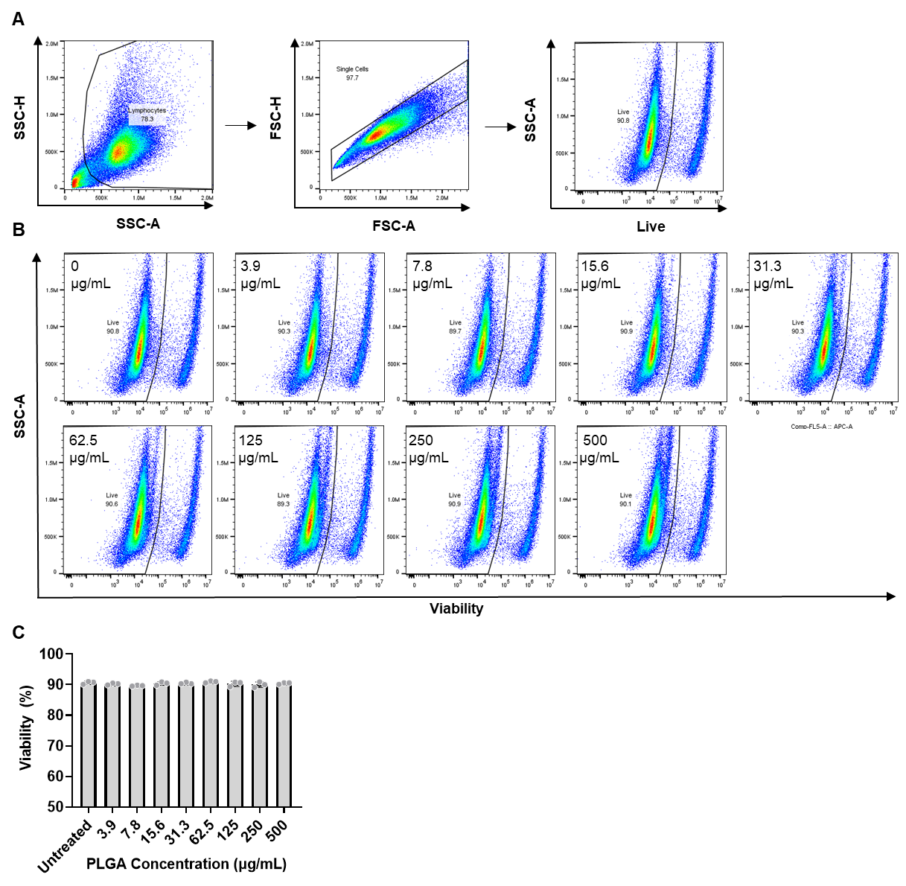
Supplementary Figure S2. PLGA is non-toxic to NK92 cells. NK92 cells were incubated for 24 h alone or in the presence of varied doses of blank PLGA NDs (0 – 500 μg/mL). After 24 h, cells were stained with a fixable viability stain. Cell viability (%) was then determined by flow cytometry. (A) Gating strategy to quantify the viability of NK cells. (B) Corresponding scatterplots depicting percentage live NK cells in each dose condition. (C) Bar graph of viability percentages represented in (B). Values represent means ± st. dev. (n=3/group.)

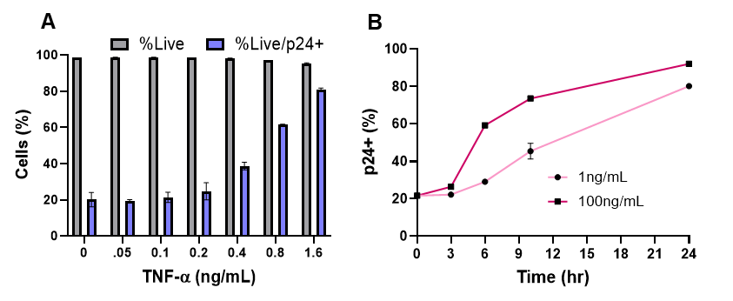
Supplementary Figure S3. TNF-α reactivates HIV in a latently infected T cell line with minimal toxicity. (A) ACH-2 cells were cultured with increasing concentrations of TNF-α. After 24 h, ACH-2 cell viability (gray) and p24 expression (blue), as a measure of HIV activation, were measured by flow cytometry. (B) ACH-2 cells were cultured with a low (1 ng/mL) or high (100 ng/mL) dose of TNF-α between 0 to 24 h as indicated. p24 expression was measured by flow cytometry. (n≥3/group. Values represent means ± st. dev).

Supplementary Figure S4. NK92 cell phenotype in the presence of TNF-α. (A) Viability, activating, inhibitory receptor expression, and (B) chemokine receptor expression on NK cells after 24 h treatment with TNF-α (0 – 400 ng/mL). Values represent means ± st. dev. *p <0.05. * [with bar] indicates a significant linear trend with increasing TNF-α dose. Significance was determined by two-way ANOVA with Dunnett’s multiple comparisons test.

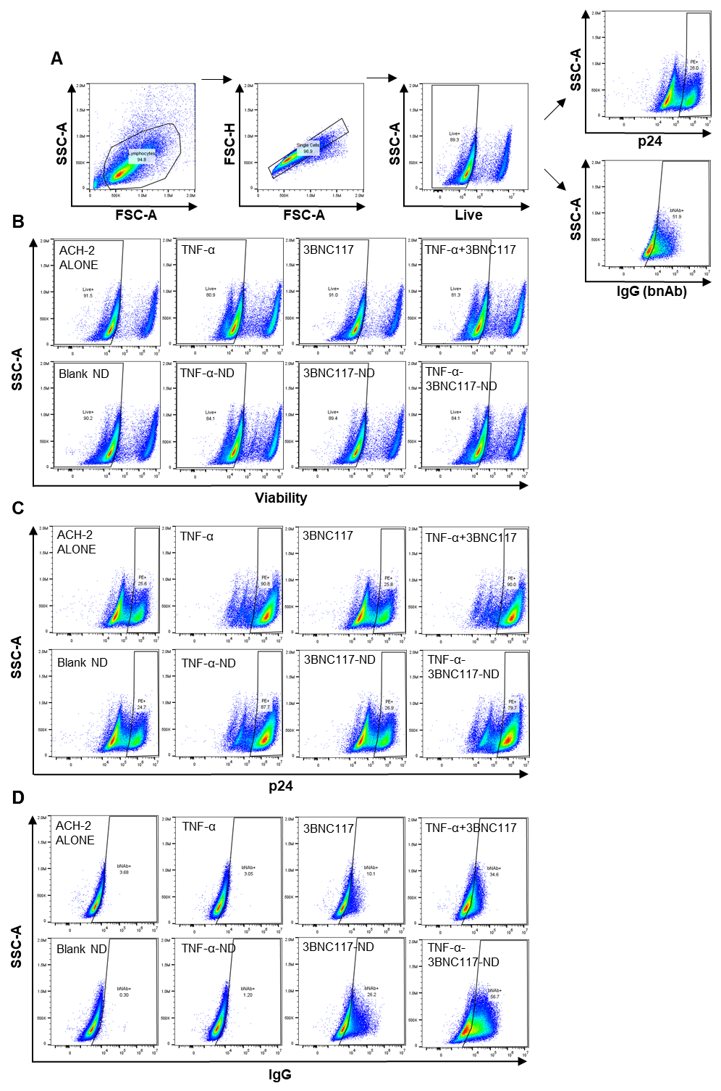
Supplementary Figure S5. NDs encapsulating TNF-α and 3BNC117 reverse latency, reduce viral p24, and potentiate bnAb binding. ACH-2 cells were cultured for 24 h with NDs or free agent controls. (A) Gating strategy to quantify live ACH-2 (CD5+) cells’ expression of intracellular p24 and surface bound IgG. Representative scatterplots depict (B) viability and (C) p24 expression (as a measure of latent HIV reactivation) by flow cytometry. (D) 3BNC117 binding to total live lymphocytes was analyzed by detecting secondary antibody (IgG) binding via flow cytometry. Data shown are representative scatterplots of live ACH-2 cells positive for each marker indicated.

Figure S6. Time-dependent function of TNF-α and 3BNC117. Time-dependent function of TNF-α and 3BNC117. (A) Equivalent doses of TNF-α were incubated in PBS at 37°C. At the elapsed times indicated, the remaining concentration of TNF-α was determined by ELISA. Inset equations report the one-phase decay best-fit line and the half-life of free TNF-α. (B-C) PLGA NDs or their constituent controls were pre-incubated in cell media containing 10% FBS at 37°C for 72 h (150 ng/mL TNF-α, 1.5 ug/mL 3BNC117) prior to addition to ACH-2 cells in culture. After 24 h, ACH-2 cell reactivation was measured by (B) intracellular staining for capsid protein, and (C) IgG binding was measured by surface staining with anti-IgG secondary antibody and quantified by flow cytometry. IgG bound was represented as % out of total live lymphocytes. (D-E) PLGA NDs or their constituent controls were pre-incubated in PBS at 37°C for 72 h (150 ng/mL TNF-α, 1.5 ug/mL 3BNC117) prior to addition to ACH-2 cells. After 24 h, ACH-2 cell reactivation was measured by (D) intracellular staining for capsid proteins, and (E) IgG binding was measured by surface staining with anti-IgG secondary antibody and represented as both (E) % positive out of total live lymphocytes and (F) % positive out of reactivated (capsid+) ACH-2 cells.

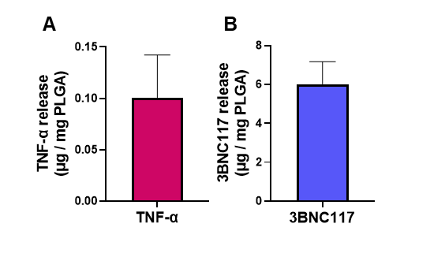
Supplementary Figure S7. TNF-α and 3BNC117 release at 24 h without solvent replacement. Cumulative release of TNF-α (A) and 3BNC117 (B) from TNF-α-3BNC117 NDs after 24 h in PBS at 37°C as determined by ELISA. Values represent means ± st. dev. (n=4/group.)

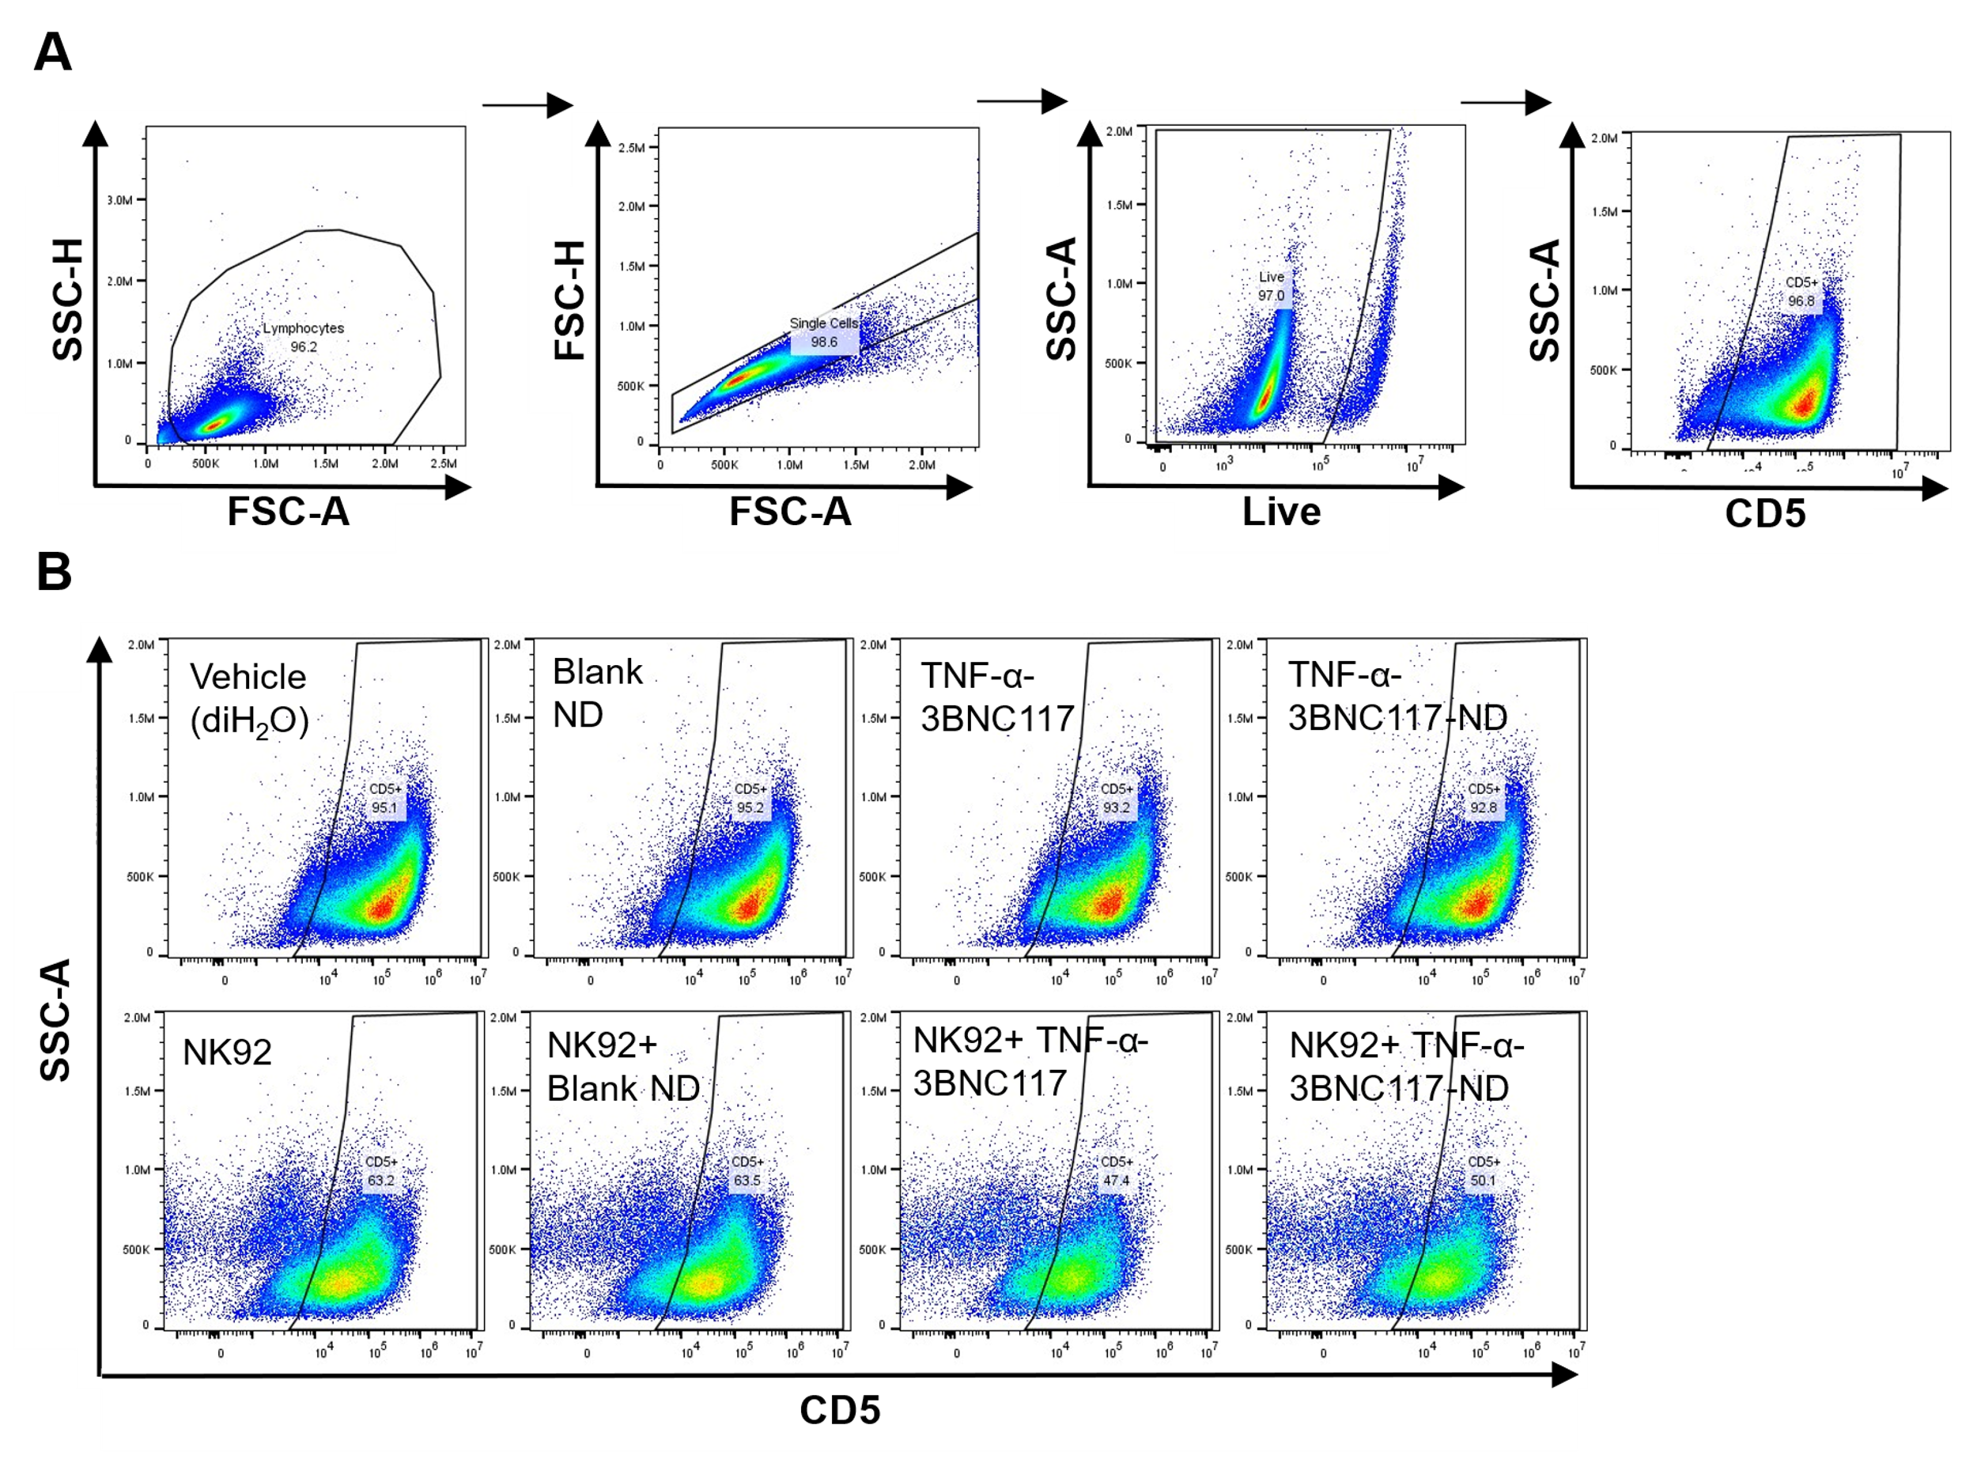
Supplementary Figure S8. TNF-α-3BNC117-NDs enhance NK-mediated killing of ACH-2 cells. ACH-2 were treated with vehicle (deionized H₂O), Blank NDs, TNF-α-3BNC117-NDs, or free TNF-α and 3BNC117 for 24 h at a dose of 30 ng/mL TNF-α and 2 μg/mL 3BNC117. At 19 h, 40,000 NK cells were added to select conditions (1:2.5 effector:target cell ratio). After 24 h, the number of live ACH-2 cells was determined via flow cytometry. (A) Gating strategy to quantify number of live ACH-2 cells (CD5+). (B) Representative scatterplots of remaining live ACH-2 cells are shown for each treatment condition. The number of remaining live ACH-2 cells was then used to calculate a percent target cell death value associated with each condition as described in Figure 4.

Supplementary Figure S9. Detection of p24 by ELISA in the presence of PLGA. Cell-free supernatant was collected from ACH-2 cell culture after viral reactivation was induced with 20 ng/mL TNF-α for 24 h. The presence of p24 capsid protein in the viral supernatant was determined by p24 ELISA in the presence of a low or high dose of blank PLGA NPs.

