Supplementary Table 1 Correlation profile of 24 types of immune cells with the expression of ICOS and ICOSLG.
Immune cells | ICOS |  | ICOSLG
Immune cells | Rho (Spearman) | P value | Rho (Spearman) | P value
aDC | 0.668 | <0.001 | 0.095 | 0.016
B cells | 0.539 | <0.001 | 0.027 | 0.490
CD8 T cells | 0.390 | <0.001 | 0.155 | <0.001
Cytotoxic cells | 0.638 | <0.001 | 0.094 | 0.016
DC | 0.599 | <0.001 | 0.054 | 0.170
Eosinophils | 0.350 | <0.001 | 0.041 | 0.298
iDC | 0.471 | <0.001 | 0.114 | 0.004
Macrophages | 0.604 | <0.001 | 0.134 | <0.001
Mast cells | 0.432 | <0.001 | 0.067 | 0.089
Neutrophils | 0.493 | <0.001 | 0.010 | 0.793
NK CD56bright cells | -0.089 | 0.023 | -0.008 | 0.847
NK CD56dim cells | 0.344 | <0.001 | 0.091 | 0.020
NK cells | 0.139 | <0.001 | 0.228 | <0.001
pDC | 0.203 | <0.001 | 0.089 | 0.024
T cells | 0.735 | <0.001 | 0.091 | 0.020
T helper cells | 0.595 | <0.001 | 0.091 | 0.020
Tcm | 0.188 | <0.001 | 0.155 | <0.001
Tem | 0.370 | <0.001 | 0.139 | <0.001
TFH | 0.482 | <0.001 | 0.111 | 0.005
Tgd | 0.392 | <0.001 | 0.108 | 0.006
Th1 cells | 0.705 | <0.001 | 0.111 | 0.005
Th17 cells | 0.027 | 0.499 | -0.020 | 0.610
Th2 cells | 0.353 | <0.001 | 0.049 | 0.211
TReg | 0.580 | <0.001 | 0.142 | <0.001
Note: Bold values are statistically significant (P value < 0.05).

Supplementary Table 2 Correlation profile of immunoinhibitors with ICOS and ICOSLG expression.
Immunoinhibitors | ICOS |  | ICOSLG
Immunoinhibitors | Rho (Spearman) | P value | Rho (Spearman) | P value
ADORA2A | 0.368 | <0.001 | 0.149 | <0.001
BTLA | 0.712 | <0.001 | 0.128 | 0.001
CD160 | 0.401 | <0.001 | 0.091 | 0.021
CD244 | 0.659 | <0.001 | -0.010 | 0.794
CD274 | 0.771 | <0.001 | 0.105 | 0.007
CD96 | 0.824 | <0.001 | 0.141 | <0.001
CSF1R | 0.597 | <0.001 | 0.158 | <0.001
CTLA4 | 0.814 | <0.001 | 0.136 | <0.001
HAVCR2 | 0.730 | <0.001 | 0.148 | <0.001
IDO1 | 0.724 | <0.001 | 0.100 | 0.011
IL10 | 0.664 | <0.001 | 0.045 | 0.252
IL10RB | -0.007 | 0.860 | 0.072 | 0.067
KDR | 0.418 | <0.001 | 0.154 | <0.001
KIR2DL1 | 0.335 | <0.001 | 0.088 | 0.026
KIR2DL3 | 0.318 | <0.001 | 0.087 | 0.027
LAG3 | 0.626 | <0.001 | 0.085 | 0.031
LGALS9 | 0.057 | 0.144 | 0.155 | <0.001
PDCD1 | 0.617 | <0.001 | 0.134 | <0.001
PDCD1LG2 | 0.794 | <0.001 | 0.122 | 0.002
TGFB1 | 0.406 | <0.001 | 0.103 | 0.009
TGFBR1 | 0.352 | <0.001 | 0.109 | 0.005
TIGIT | 0.828 | <0.001 | 0.171 | <0.001
VTCN1 | 0.057 | 0.147 | -0.005 | 0.894
Note: Bold values are statistically significant (P value < 0.05).

Supplementary Table 3 Clinicopathological characteristics according to ICOS and ICOSLG expression in studied lesions analyzed by IHC.
Characteristic |  | ICOS^{high} | ICOS^{low} | Total | P value | ICOSLG^{high} | ICOSLG^{low} | Total | P value
CEA | <=5 | 32 (32.7%) | 66 (67.3%) | 98 | 0.372 | 24 (24.5%) | 74 (75.5%) | 98 | 0.696
CEA | >5 | 9 (42.9%) | 12 (57.1%) | 21 |  | 6 (28.6%) | 15 (71.4%) | 21
CA199 | <=37 | 40 (34.5%) | 76 (65.5%) | 116 | 0.727 | 29 (25.0%) | 87 (75.0%) | 116 | 0.585
CA199 | >37 | 1 (33.3%) | 2 (66.7%) | 3 |  | 1 (33.3%) | 2 (66.7%) | 3
CA125 | <=35 | 40 (34.2%) | 77 (65.8%) | 117 | 0.572 | 29 (24.8%) | 88 (75.2%) | 117 | 0.442
CA125 | >35 | 1 (50.0%) | 1 (50.0%) | 2 |  | 1 (50.0%) | 1 (50.0%) | 2
Note: Bold values are statistically significant (P value < 0.05).

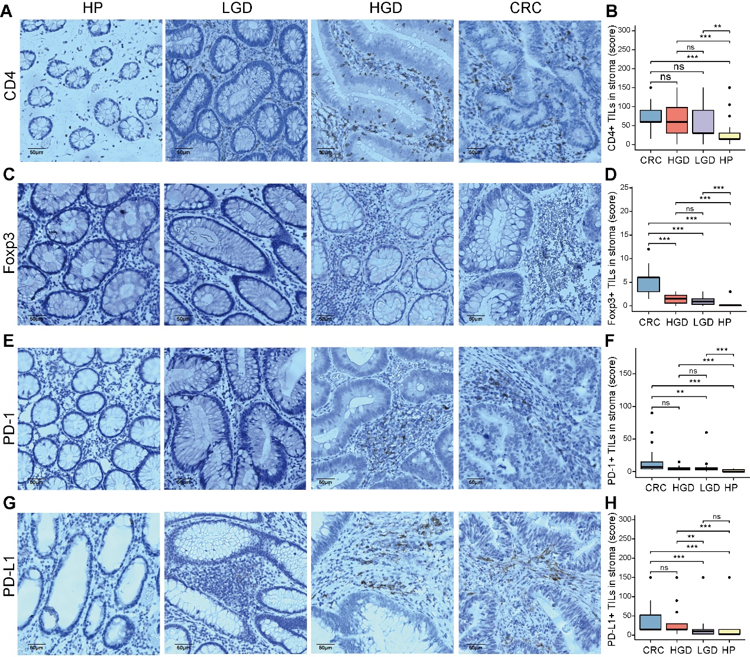

Supplementary Figure 1. The association of CD4+/Foxp3+ TILs and PD-1/PD-L1 with the progression of precancerous–carcinoma lesions. (A, B) CD4+ T cells in HP, LGD, HGD, or CRC tissues from the clinical cohort. (C, D) Foxp3+ T cells in HP, LGD, HGD, or CRC tissues from the clinical cohort. (E, F) Immunohistochemical staining of PD-1 in HP, LGD, HGD, and CRC samples. (G, H) Immunohistochemical staining of PD-L1 in HP, LGD, HGD, and CRC samples. Bar scale = 50 μm. *p < 0.05, **p < 0.01, ***p < 0.001, ns, no significant difference.

