Supplementary material
Physicochemical and biopharmaceutical controllability of new self-assembled fatty acid conjugated leuprolide for the enhanced anticancer activity
Hai V. Ngo¹, Hye-Eun Bak¹, Hy D. Nguyen¹, Kye Wan Lee², Chulhun Park³, Beom-Jin Lee^{1,}*
¹College of Pharmacy, Ajou University, Suwon 16499, Republic of Korea
²Dongkook Pharmaceutical Co., Ltd., Seoul 06072, Republic of Korea
³College of Pharmacy, Jeju National University, Jeju 63243, Republic of Korea

Title
Peptide Drug-Fatty Acid Conjugate for Improving Cancer Targeting

*Corresponding author at: College of Pharmacy, Ajou University, Suwon 16499, Republic of Korea.
E-mail address: bjl@ajou.ac.kr (Beom-Jin Lee).

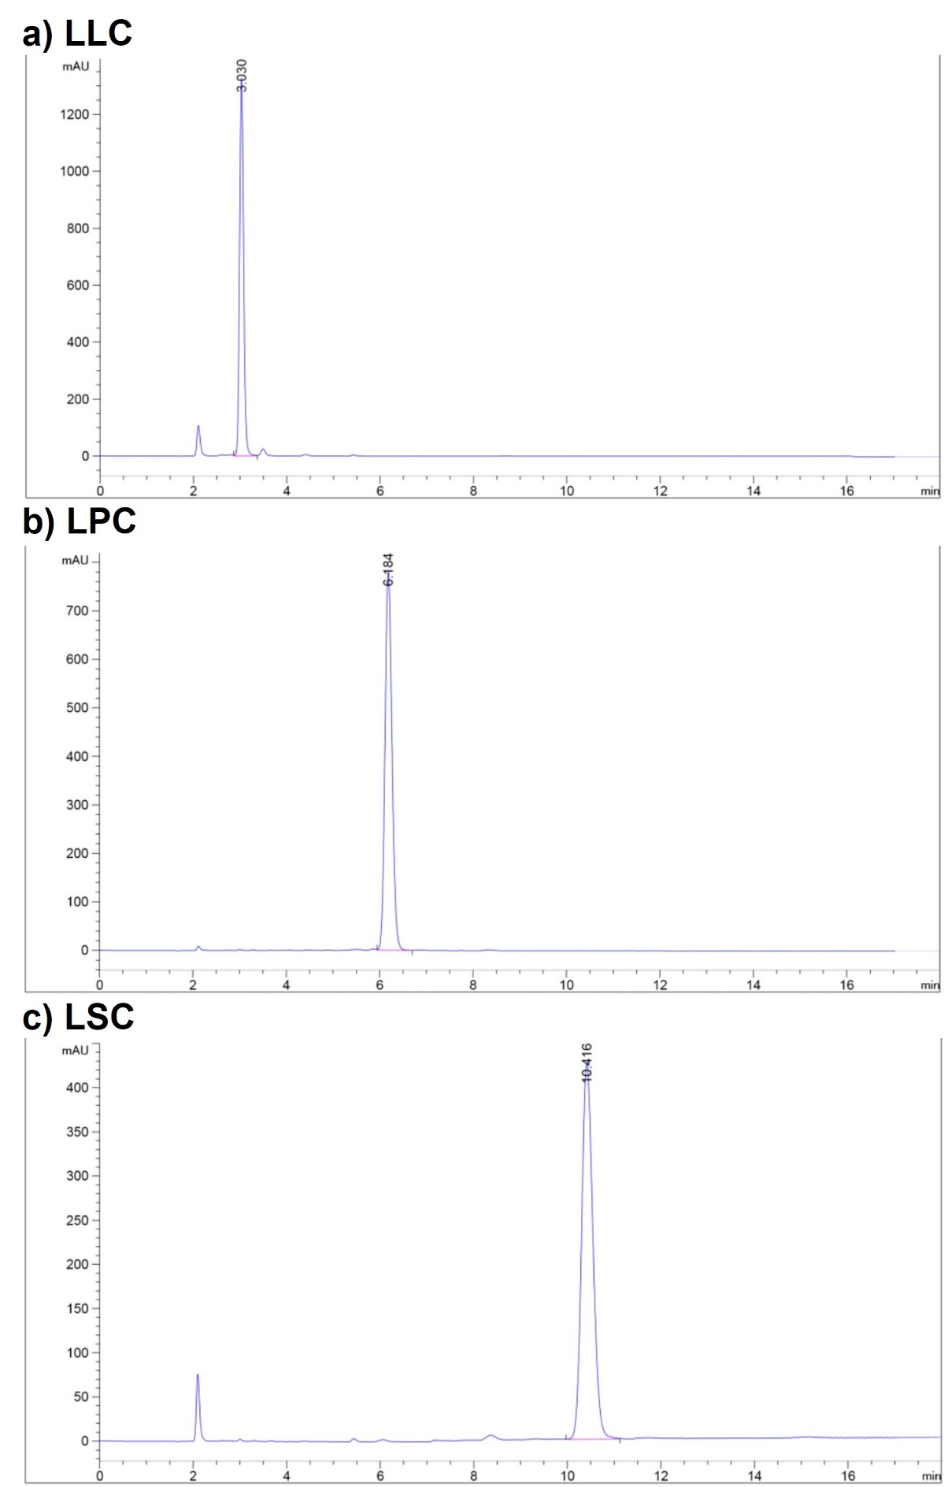

Figure S1. HPLC profiles of LFCs (at 250 ppm) in the LFCs mobile phase

