Supplementary Table 1. Baseline characteristics of patients according to sICH
Variables | Non-sICH (n=386) | sICH (n=40) | P
Demographic characteristics
Age, years | 71 (63, 78) | 76 (67, 83) | 0.007
Male, % | 248 (64.2) | 25 (62.5) | 0.826
Vascular risk factors, %
Hypertension | 262 (67.9) | 31 (77.5) | 0.211
Diabetes mellitus | 70 (18.1) | 9 (22.5) | 0.499
Dyslipidemia | 47(12.2) | 7 (17.5) | 0.335
Coronary heart disease | 72 (19.0) | 7 (17.5) | 0.868
Atrial fibrillation | 106 (27.5) | 23 (57.5) | < 0.001
Previous stroke | 92 (23.9) | 7 (17.5) | 0.362
Smoking |  |  | 0.388
Never | 217 (56.4) | 27(67.5)
Former | 122 (31.7) | 9(22.5)
Current | 46 (11.9) | 4(10.0)
Drinking alcohol |  |  | 0.208
Never | 255 (66.2) | 32 (80.0)
Former | 95 (24.8) | 6 (15.0)
Current | 35 (9.0) | 2 (5.0)
Clinical data
Previous antiplatelet, % | 67 (17.4) | 7 (17.5) | 0.982
Previous statin, % | 37 (9.6) | 3 (7.5) | 0.664
Initial NIHSS score | 14 (11, 18) | 17.0 (14, 21) | 0.007
SBP, mmHg | 137 (124, 153) | 142 (128, 157) | 0.334
DBP, mmHg | 84.2±14.6 | 89.1±16.6 | 0.045
Intravenous thrombolysis, % | 158 (40.9) | 22 (55.0) | 0.086
Door-to-puncture time, min | 105.0 (75.0, 132.0) | 119.0 (78.0,147.0) | 0.335
Onset-to-puncture time, min | 243.0 (177.0, 305.0) | 220.0 (190.0,275.0) | 0.375
Number of device passes | 2 (1, 3) | 2 (1, 4) | 0.013
Poor collateral status, % | 166 (43.0) | 23 (57.5) | 0.079
Successful recanalization, % | 331 (85.8) | 36 (90.0) | 0.459
Stroke subtype, % |  |  | 0.003
LAA | 174 (45.1) | 7 (17.5)
CE | 166 (43.0) | 25 (62.5)
Other subtypes | 46 (11.9) | 8 (20.0)
Laboratory data
TC, mmol/L | 4.14 (3.42, 5.00) | 4.33 (3.64, 5.02) | 0.434
TG, mmol/L | 1.06 (0.76, 1.53) | 1.03 (0.78, 1.43) | 0.545
LDL, mmol/L | 2.49 (1.92, 3.15) | 2.64 (2.04, 3.07) | 0.722
HDL, mmol/L | 1.06 (0.89,1.28) | 1.23 (1.08,1.42) | 0.002
FBG, mmol/L | 6.31 (5.16,7.69) | 7.96 (6.62,9.87) | < 0.001
NSE, ng/mL | 15.16 (12.58, 19.55) | 23.47 (17.70, 31.66) | < 0.001
Abbreviation: sICH, symptomatic intracranial hemorrhage; NIHSS, National Institutes of Health Stroke Scale; SBP, Systolic blood pressure; DBP, Diastolic blood pressure; LAA, large-artery atherosclerosis; CE, cardioembolism; TC, total cholesterol; TG, triglyceride; LDL, low-density lipoprotein; HDL, high-density lipoprotein; FBG, fasting blood glucose; NSE, neuron specific enolase.

Supplementary Figure 1
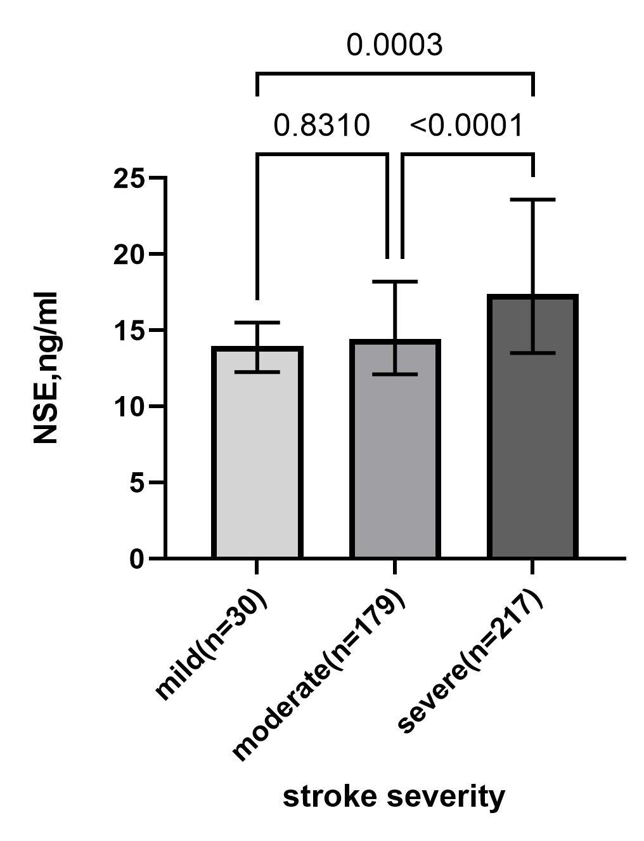
Supplementary Figure 1 Comparisons of NSE levels between mild (NIHSS 0-4), moderate (NIHSS 5-14) and severe (NIHSS >14) stroke. Value represents median; error bars represent interquartile range

Supplementary Figure 2
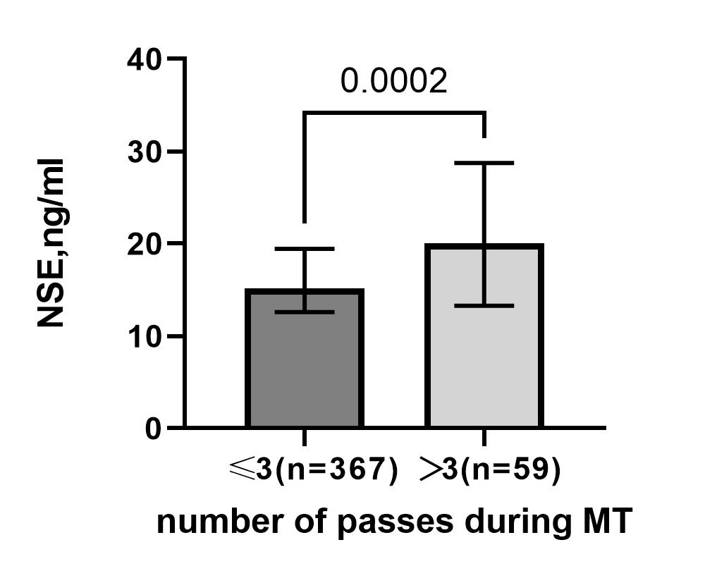
Supplementary Figure 2 Comparisons of NSE levels based on number of passes during MT. Value represents median; error bars represent interquartile range

