Physical examination
Friedman tongue position was assessed to evaluate oropharyngeal crowding by asking the patient to sit upright with their head in a neutral position and having them open their mouth without sticking their tongue out[16].
Grade 1: tonsils, pillars, and soft palate were clearly visible;
Grade 2: the uvula, pillars, and upper pole were visible;
Grade 3: only part of the soft palate was visible; the tonsils, pillars, and base of the uvula could not be seen;
Grade 4: only the hard palate was visible.
The Brodsky tonsil grading scale is depended on the percentage of oropharyngeal airway occupied by the tonsils[17]. Moreover, tonsil hypertrophy is the tonsil occupying more than 50%(Grade 3 and Grade 4).
Grade 1: Tonsils sit just outside of the tonsillar fossa with obstruction of less than 25 percent of the airway;
Grade 2: Tonsils are readily seen in the airway-25 to 50 percent of the airway is obstructed;
Grade 3: Tonsils denote a 50 to 75 percent obstruction of the airway;
Grade 4: Tonsils involve a greater than 75 percent obstruction of the airway.
The adenoid grading scale is dependent on the percentage of posterior naris occupied by the adenoid assessed by nasal endoscopy or fiberoptic laryngoscopy[17]. Moreover, our study defines adenoid hypertrophy as the adenoid occupying more than 75%(Grade 4).
Grade 1: adenoid occupy ≤ 25% of the posterior naris occupied;
Grade 2: adenoid occupy > 25% and ≤ 50% of the posterior naris occupied;
Grade 3: adenoid occupy > 50% and ≤ 75% of the posterior naris occupied;
Grade 4: adenoid occupies> 75% of the posterior naris occupied.
The pharyngeal grade was used to estimate the degree of pharyngeal narrowing by asking the patient to sit upright with their head in a neutral position and having them open their mouth without sticking their tongue out. Furthermore, use the tongue depressor if necessary. The pharyngeal narrowing is based on the intersection of palatopharyngeal arches and tongue width[18].
Grade 1: palatopharyngeal arch intersects at the edge of the tongue;
Grade 2:palatopharyngeal arch intersects at ≥ 25% of the tongue diameter;
Grade 3: palatopharyngeal arch intersects at ≥ 50% of the tongue diameter;
Grade 4: palatopharyngeal arch intersects at ≥ 75% of the tongue diameter.

Table S1 Demographic between the participants
 | Excluded participants(n=26) | Included participants(n=145) | p value
Age(years) | 8.28±1.91 | 7.88±1.76 | 0.277
Gender(Male/%) | 17, 65.4% | 95, 63.4% | 1.000
BMI(z score) | 0.88±1.21 | 0.52±1.24 | 0.176

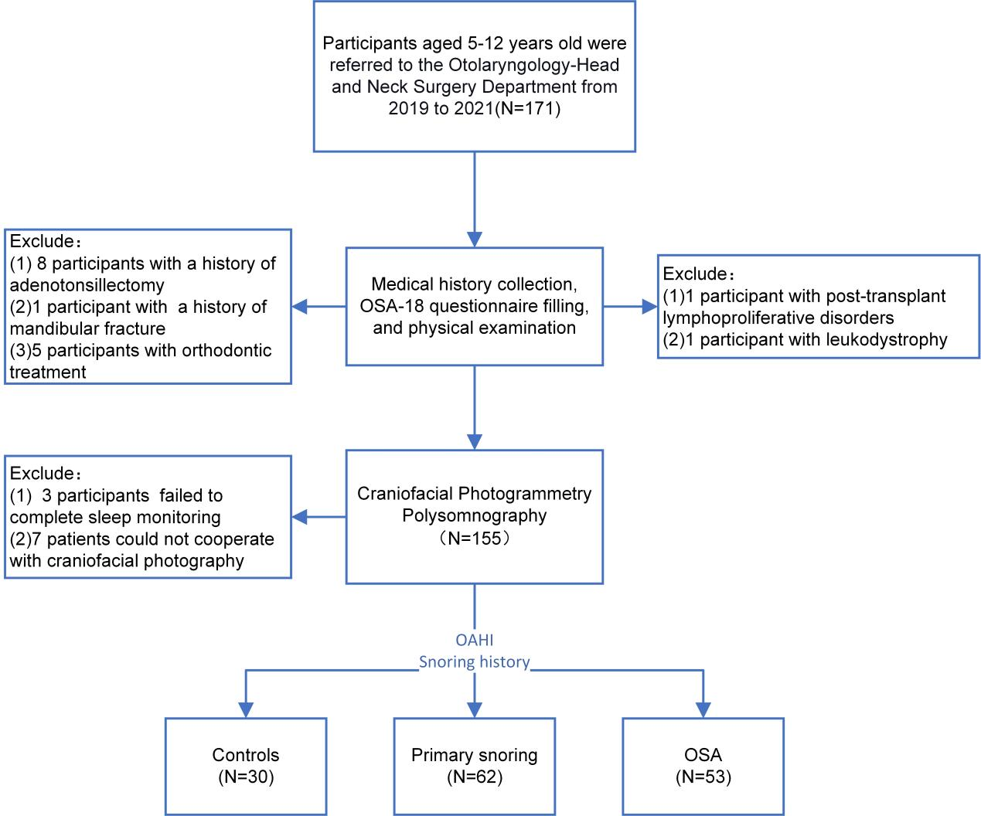
Figure S1 Flow diagram of participant selection

Table S2 Sleep-related symptoms between the participants
OSA-18 | Controls(n=30) | PS (n=62) | OSA(n=53) | p value
- Loud snoring | 2.50[1.75, 3.00] | 4.00[4.00, 5.00]† | 5.00[4.00, 6.00]‡ | <0.001
- Breath holding/pauses | 1.00[1.00, 2.00] | 2.00[1.00, 3.00]† | 3.00[2.00, 4.00]‡ | <0.001
3. Choking or gasping | 1.00[1.00, 2.00] | 2.00[1.00, 3.00]† | 2.00[1.00, 3.50]‡ | <0.001
4. Fragmented sleep | 4.00[2.00, 5.00] | 4.00[3.75, 5.00] | 5.00[3.00, 6.00]‡ | 0.013
5. Mouth breathing | 5.00[4.00, 5.00] | 5.00[4.00, 6.00] | 5.00[4.00, 6.50] | 0.784
- Frequent colds or upper respiratory tract infections | 4.00[2.00, 4.00] | 4.00[3.00, 5.00] | 4.00[3.00, 5.00] | 0.087
7. Rhinorrhea | 3.00[1.75, 4.00] | 4.00[3.00, 5.00]† | 4.00[2.00, 4.00] | 0.010
8. Dysphagia | 1.00[1.00, 1.25] | 1.00[1.00, 2.00] | 1.00[1.00, 2.50] | 0.202
9. Mood swings or tantrums | 3.00[2.00, 4.00] | 4.00[3.00, 5.00] | 4.00[2.00, 4.00] | 0.540
10. Aggression/hyperactivity | 2.00[1.00, 3.25] | 3.00[2.00, 4.00] | 2.00[1.00, 4.00] | 0.173
11. Discipline problems | 2.00[1.00, 3.00] | 3.00[1.00, 4.00] | 3.00[1.00, 4.00] | 0.113
12. Daytime drowsiness | 1.00[1.00, 2.25] | 2.00[1.00, 3.00]† | 2.00[1.00, 3.00] | 0.009
13. Poor attention span | 4.00[1.00, 5.00] | 4.00[3.00, 5.00] | 4.00[2.00, 5.00] | 0.281
14. Difficulty awakening | 4.00[2.75, 5.00] | 4.00[3.00, 5.00] | 4.00[2.00, 5.00] | 0.415
15. Caregiver worried over child health | 5.00[3.75, 7.00] | 5.00[4.00, 7.00] | 5.00[4.00, 7.00] | 0.297
16. Caregiver concerned not enough air | 4.00[2.00, 5.00] | 5.00[4.00, 6.00] | 5.00[4.00, 7.00]‡ | 0.011
17. Caregiver missed activities | 2.00[1.00, 3.25] | 3.50[2.00, 4.00] | 3.00[1.00, 4.00] | 0.064
18. Caregiver frustration | 4.00[2.00, 5.00] | 4.50[4.00, 6.00] | 4.00[3.00, 5.00] | 0.250
Note:
The bold text highlights the significant differences between the three groups.
† =P<0.05 between PS group and control group
‡ =p<0.05 between OSA group and control group

Table S3 The univariate logistic regression for predicting children with obstructive sleep apnea
 | OR [95% CI] | p value
gender | 0.643[0.313, 1.320] | 0.229
BMI(z score) | 1.490[1.104, 2.010] | 0.009
Neck circumference(cm) | 1.112[0.977, 1.266] | 0.107
Neck-to-height ratio(%) | 1.281[1.025, 1.601] | 0.029
OSA-18 questionnaire total score | 1.015[0.993, 1.038] | 0.184
Sleep disturbance(Item1-4) | 1.187[1.087,1.295] | <0.001
Physical suffering(Item5-8) | 1.005[0.913, 1.106] | 0.919
Emotional distress(Item9-11) | 1.015[0.937,1.100] | 0.713
Daytime problems(Item12-14) | 0.957[0.872,1.051] | 0.358
Caregiver concerns(Item15-18) | 1.020[0.960,1.085] | 0.519
Pharyngeal grade | 2.267[1.411, 3.641] | <0.001
Tonsil hypertrophy | 3.698[1.817, 7.528] | <0.001
Adenoid hypertrophy | 2.798[1.351, 5.793] | 0.006
Upper face width(UFW) | 1.836[1.192, 2.827] | 0.006
Lower face width(LFW) | 1.703[1.255, 2.310] | <0.001
Lower part of LFH(LLFH) | 2.370[1.266, 4.436] | 0.007
LFW/FH | 0.062[0.004,1.044] | 0.054
UFH/LFH | 0.062[0.004, 1.043] | 0.054
ULFH/LLFH | 0.005[0.000,0.321] | 0.013
Facial convexity angle | 1.063[0.996, 1.135] | 0.067
Inner-canthus width | 2.604[0.847, 8.002] | 0.095
Lateral-canthus width | 1.795[0.967,3.332] | 0.064
Nose width | 4.410[1.174, 16.561] | 0.028
Lip width | 2.090[0.948, 4.610] | 0.068
Nasal-upper lip relationship angle | 1.008[0.967, 1.049] | 0.715
Lips relationship angle | 0.989[0.962, 1.017] | 0.441
Lower lips-mandibular convexity angle | 0.986[0.959, 1.013] | 0.311
Maxillary-mandibular relationship angle(ANB) | 0.888[0.775, 1.017] | 0.087

Note:
The bold text highlights the significant differences between the three groups.

