Supplementary Figure 1. The flow chart of the patient enrollment.
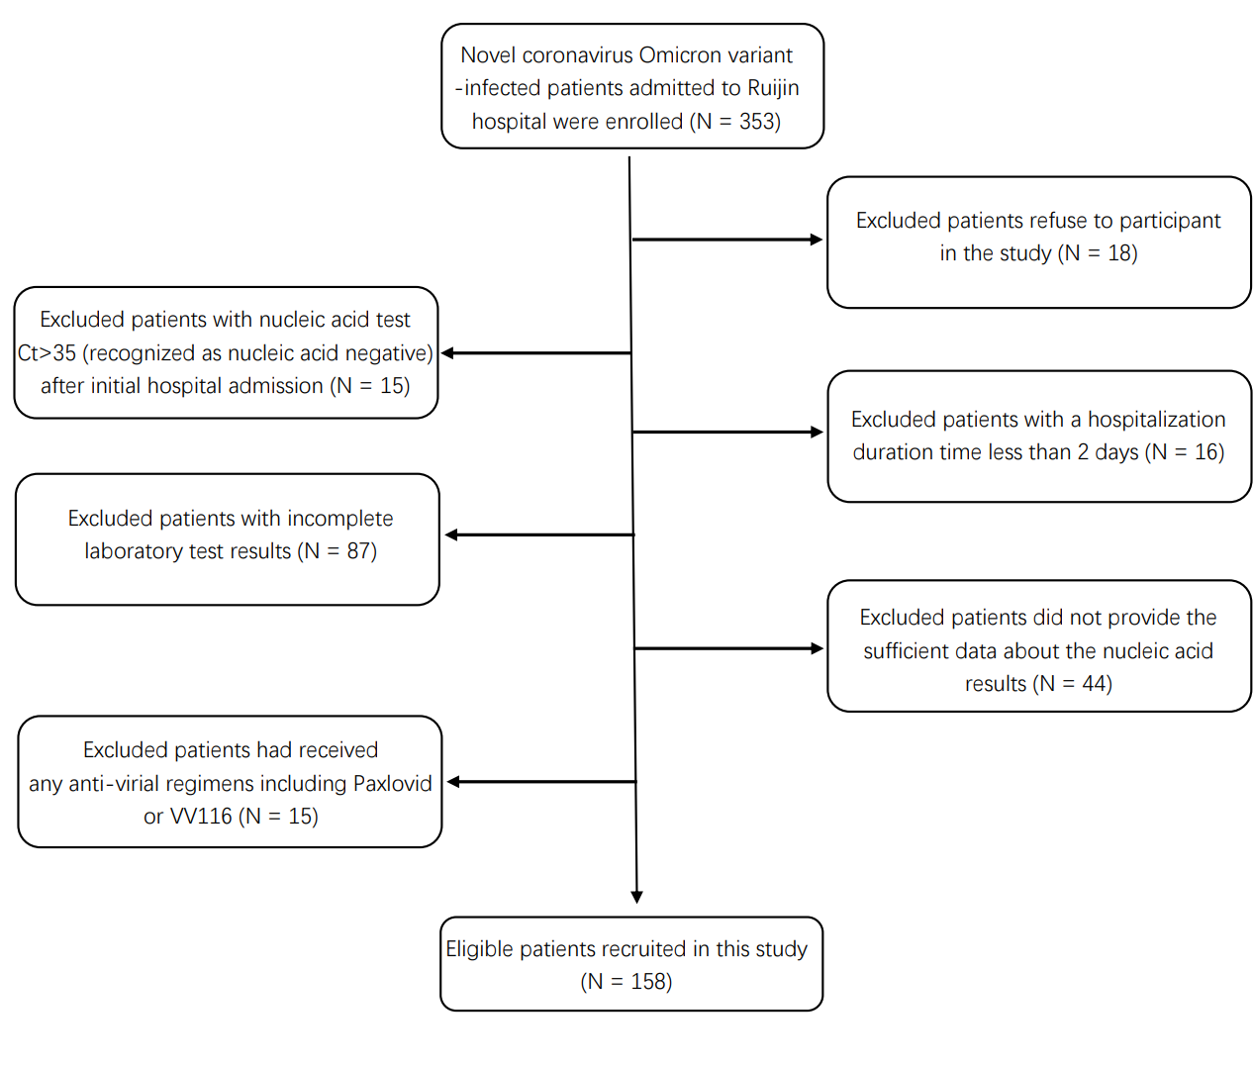

Supplementary Figure 2. Kaplan-Meier plot for duration time from infection to the nucleic acid negative conversion time and the plasma 25(OH)D level in COVID-19 patients with age > = 60 years old.

Supplementary Table 1. The types of Covid-19 vaccines received by participants.
Types of Covid-19 vaccines | N (%)
Sinopharm / BIBP (Beijing Institute of Biological Products Co., Ltd) | 103 (55.38%)
sinovac (Sinovac Life Sciences Co., Ltd) | 63 (33.87%)
Sinopharm / WIBP (Wuhan Institute of Biological Products Co., Ltd) | 10 (5.38%)
CanSinoBio (CanSino Biologics Inc) | 5 (2.69%)
Zhifei Longcom, China (Anhui Zhifei Longcom Biopharmaceutical) | 5 (2.69%)
Total | 186

Supplementary Table 2. The univariate Cox proportional hazard regression analysis of nucleic acid negative conversion time in COVID-19 patients (N = 158, P > = 0.05)
Variable | Duration time of virus infection to nucleic acid negative conversion
 | HR (95% CI) | P
WBC#, ×10⁹/L (≥5.5 vs. <5.5) | 1.35 (0.98-1.87) | 0.066
PLT#, ×10⁹/L (>200 vs. ≤200) | 1.12 (0.81-1.54) | 0.487
MPV, fL (>10 vs. ≤10) | 0.75 (0.55-1.04) | 0.083
MONO% (>7.3 vs. ≤7.3) | 0.75 (0.55-1.03) | 0.071
MONO#, ×10⁹/L (>0.4 vs. ≤0.4) | 1.18 (0.86-1.62) | 0.297
MCHC, g/L (≥344 vs. <344) | 0.94 (0.69-1.29) | 0.721
MCV, fL (≥89.4 vs. <89.4) | 0.84 (0.61-1.15) | 0.273
MCH, pg (≥30.8 vs. <30.8) | 0.79 (0.58-1.09) | 0.154
LYMPH#, ×10⁹/L (≥1.59 vs. <1.59) | 0.87 (0.64-1.19) | 0.391
EO#,×10⁹/L (≥0.09 vs. <0.09) | 1.13 (0.83-1.56) | 0.439
EO% (≥1.5 vs. <1.5) | 0.84 (0.61-1.15) | 0.277
BASO% (≥0.4 vs. <0.4) | 0.97 (0.71-1.33) | 0.849
BASO#, ×10⁹/L (≥0.03 vs. <0.03) | 1.12 (0.79-1.59) | 0.510
ALP, U/L (≥79 vs. <79) | 1.02 (0.74-1.39) | 0.908
ALT, U/L (≥22 vs. <22) | 0.87(0.64-1.19) | 0.383
AST, U/L (≥21 vs. <21) | 1.01 (0.74-1.38) | 0.959
UREA, mmol/L (≥4.8 vs. <4.8) | 1.15 (0.84-1.57) | 0.395
CREA, μmol/L (≥78 vs. <78) | 0.88 (0.65-1.21) | 0.441
DBIL, μmol/L (≥2.3 vs. <2.3) | 0.91 (0.67-1.25) | 0.569
GGT, U/L (≥24 vs. <24) | 1.03 (0.75-1.41) | 0.850
TBIL, μmol/L (≥12.8 vs. <12.8) | 0.94 (0.68-1.28) | 0.681
TP, g/L (≥68 vs. <68) | 0.81 (0.59-1.11) | 0.184
TBA, μmol/L (≥4.3 vs. <4.3) | 1.01 (0.74-1.39) | 0.938
UA, μmol/L (≥331.9 vs. <331.9) | 1.29 (0.94-1.78) | 0.114
PA, g/L (≥207 vs. <207) | 0.85 (0.62-1.17) | 0.319
ADA, U/L (≥12 vs. <12) | 0.84 (0.61-1.16) | 0.288
eGFR, mL/min (≥87.9 vs. <87.9) | 1.35 (0.98-1.86) | 0.064
CG, mg/L (≥1.8 vs. <1.8) | 1.04(0.75-1.42) | 0.831
Cystatin C, mg/L (≥0.9 vs. <0.9) | 1.15 (0.84-1.58) | 0.385
Sex (Female vs. Male) | 0.77 (0.56-1.06) | 0.113
Vaccination status |  | 0.872
0 | Reference
1 | 0.87 (0.60-1.27) | 0.473
2 | 1.20 (0.37-3.85) | 0.765
3 | 0.93 (0.61-1.40) | 0.716

