Emory Med URiM Students Mentorship
Needs Assessment – Appendix-1
We are finding out what exactly you as an underrepresented minority medical student at Emory Medical School desire from a mentoring relationship. All answers are confidential!

If you had a personal relationship with a faculty physician of color who took you under their wing, what guidance would you want them to provide you? Please check all that apply!
- Maintaining self-care as a physician-in-training (exercise, spirituality, etc)
- Managing micro-aggressions in the workplace
- How to manage sadness encountered with patients
- Study strategies
- Review sessions on specific topics
- How to interview for residency
- How to network for the job market
- Maintaining a strong social life + work/life balance as a medical professional
- Maintaining friendships, romantic & familial relationships as a medical professional

Other:
Anything else important to you in a mentorship relationship?

Your answer
Submit
Clear form

Figure 1. Chart of the responses.

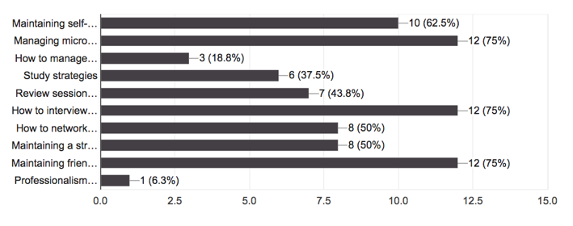
Additional suggestions that came from this survey:
- Advice on career goals, navigating promotions at an academic institution
- Advocacy for scholarship opportunities and advancement
- Research opportunities, Scholarship opportunities, Insight on day-to-day life as an attending physician in their field

Emory’s EMPACT Program Survey Appendix-2
(Engage, Mentor, Prepare, Advocate for, Cultivate, and Teach)
This survey is regarding attitudes towards mentoring and support servives at Emory University School of Medicine. This survey will take approximately 5 minutes to complete. Completing this survery is optional for participation in this program. Your responses will be kept confidential, and your name will not be recorded with any connection to this data.
- For Medical Students, which year are you in school?
M1 M MD/MPH

M2 MD/PhD

M3 Other

M4

- For Faculty, Residents/Fellows, please select your clinical role.
MD/DO resident/fellow MD/DO faculty

- If you are a resident or fellow physician, please select your current year of training.
PGY-1 PGY-4

PGY-2 PGY-5

PGY-3 PGY-6

- If you are a Faculty member what is your clinical mix? Check all that apply
Clinical Administrative Medical Educator

Research Consultant I am not a Faculty member

- For Faculty, what is your School of Medicine Rank? _____ _____________________________.
- For Faculty and /or resident or fellow, please list, your specialty here: ________________________________.
- For Faculty and /or resident or fellow, what year did you finish medical school? ________________________.
- For Faculty and /or resident or fellow, what is your geographic region of origin? ____________________.

- What is your gender identity?
Male Female Other

Non-binary Choose not to answer

- What is your ethnicity?
Hispanic c

Non-Hispanic

Choose not to answer

- What is your race?
Black or African American American Indian or Alaska Native

White Native Hawaiian or Islander

Asian Multi-Racial

Other___________________________ Choose not to answer

- For everyone, prior mentoring experience?

Yes

No

If yes as Mentor Mentee Both

- Please select your level of agreement with the following statements.
 | Strongly Agree | Agree | Neutral | Disagree | Strongly Disagree
I feel confident that I have the resources I needs to excel at Emory University School of Medicine (SOM)
I feel there are barriers to my success at Emory University School of Medicine
I currently have a mentor at Emory University School of Medicine
I currently have a mentor OUTSIDE of Emory University School of Medicine.
I am aware of the resources available to for me to help me succeed at Emory University School of Medicine.
If I were to become depressed or anxious, I know where to seek help at Emory University School of Medicine
If I have family issues that come up that may affect my academic performance, I know where to seek help at Emory SOM
I am aware of the term microaggressions

 | Strongly Agree | Agree | Neutral | Disagree | Strongly Disagree
I know how to address microaggressions

I am aware of the term imposter syndrome
I feel like I have the imposter syndrome

 | Strongly Agree | Agree | Neutral | Disagree | Strongly Disagree
I am currently satisfied with my mentor (s)

I am aware of resources available if experiencing academic or personal difficulty
I feel ready to handle my clinical education and/or clinical rotations, (if med student/resident/fellow) or (workplace if faculty)
I feel I need an advocate here at Emory SOM
I have insight on the day to day activities of an attending

I need advice on career goals, i.e. how to choose a specialty, insight into subspecialty training CV/ portfolio preparation, networking with other medical professionals
I am able to maintain having social life and work/life balance as a medical professional
I am able to maintain friendships, romantic & familial relationships as a medical professional
 | Strongly Agree | Agree | Neutral | Disagree | Strongly Disagree
I am aware of scholarship and research opportunities for my level of training (students/resident/fellows faculty)
I need assistance with study strategies
I am able to maintain self-care (exercise, spirituality)
I prefer meetings with my mentor in person

I prefer meetings with my mentor via teleconference ie. zoom, gotomeetings, skype, text
I am aware of the idea of peer mentoring

I feel I am learning in an inclusive environment
I have a good social support system here at Emory SOM

I feel I have a sense of community at Emory SOM

I have overcome barriers to success at Emory SOM

I find value in a mentor/mentee relationship

