Supplementary Figure 1 The statistical results of data collection.
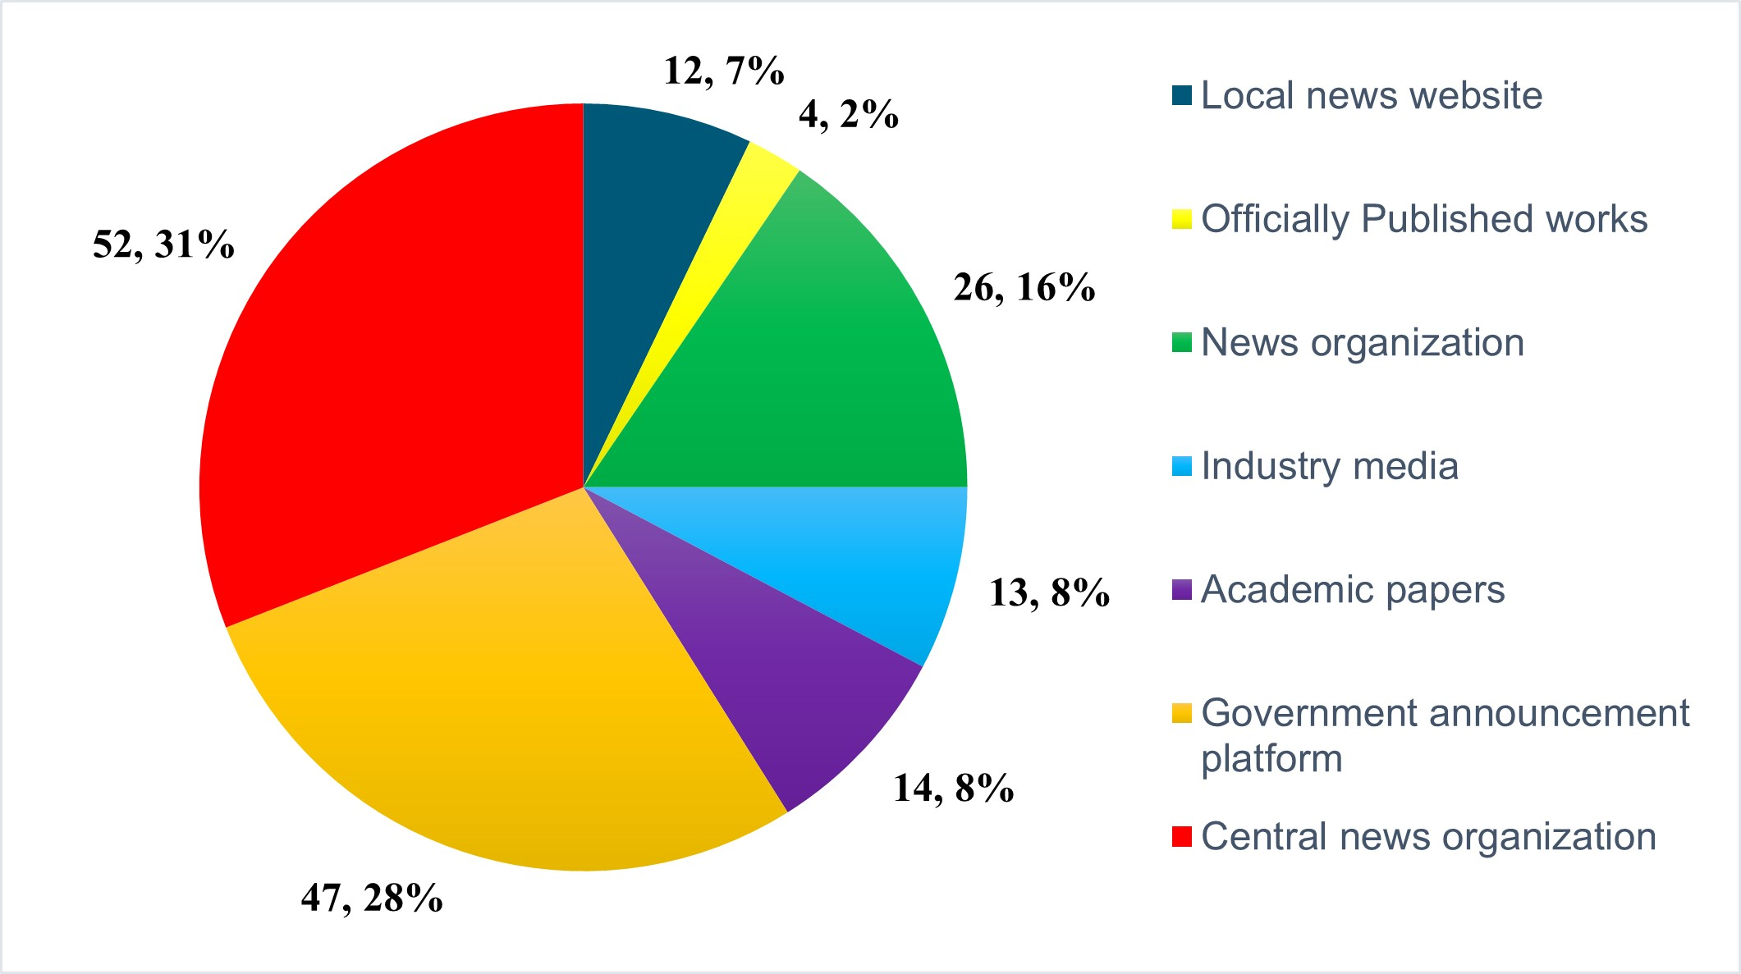

Supplementary Figure 2 Flow chart of grounded theory research.
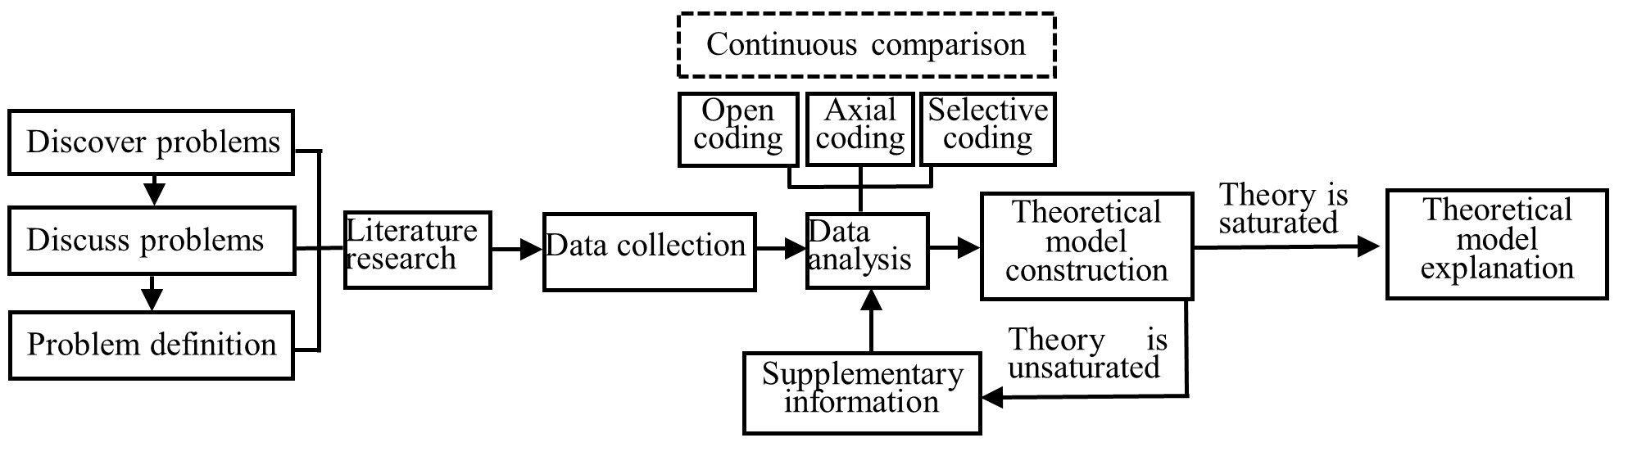

Supplementary Figure 3 Statistical results of each coding process.
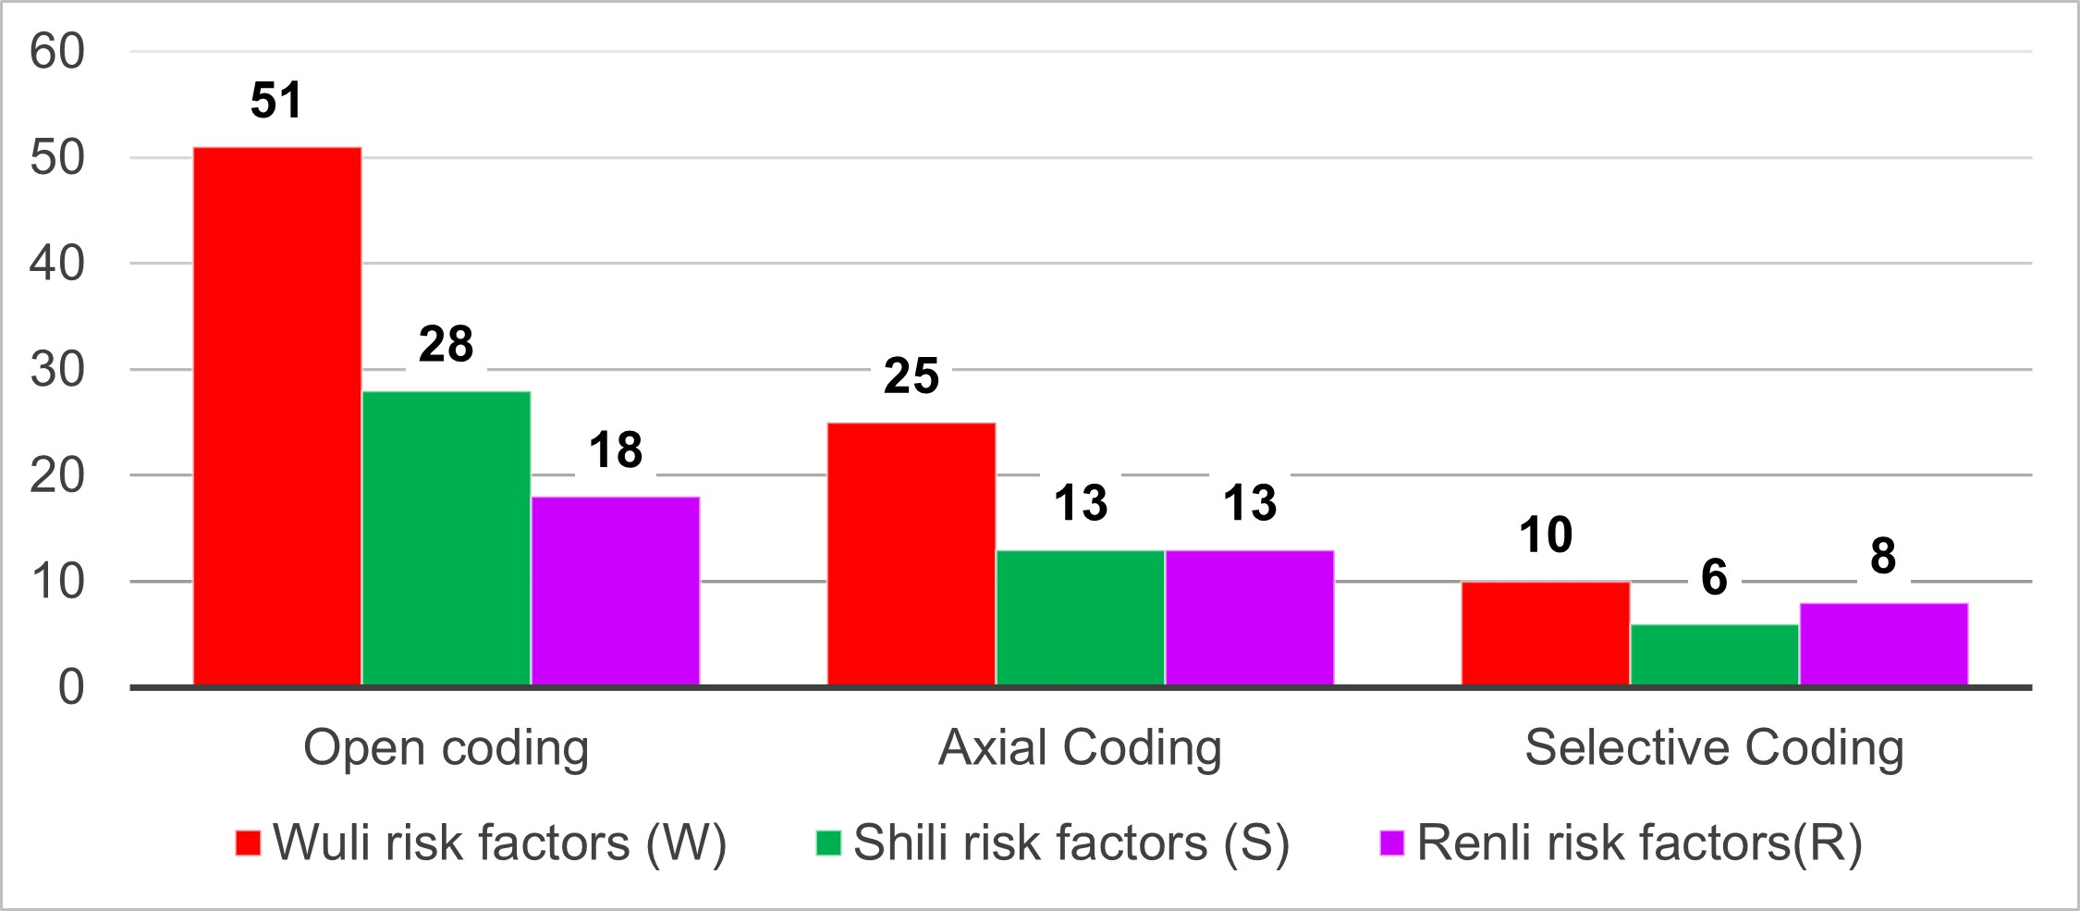

Supplementary Figure 4 Statistical analysis of these risk factors at different stages
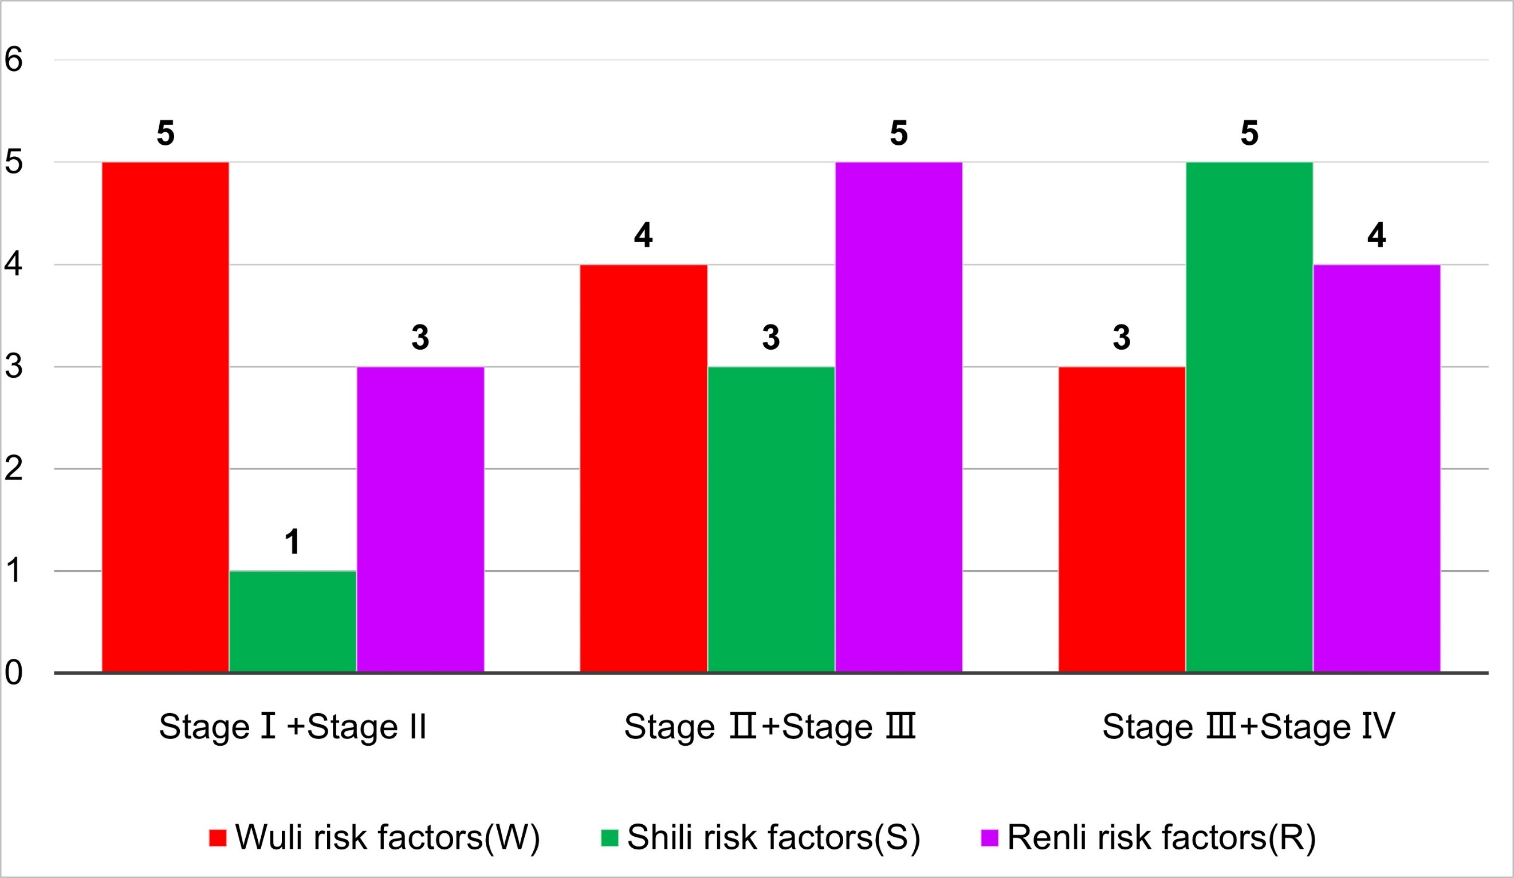

Supplementary Figure 5 The stage I of the micro mechanism underlying the outbreak of major emerging infectious disease.
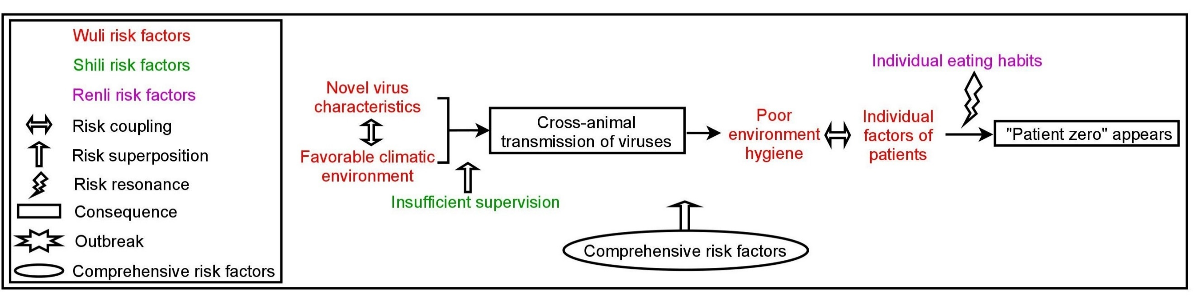

Supplementary Figure 6 The stage II of the micro mechanism underlying the outbreak of major emerging infectious disease.
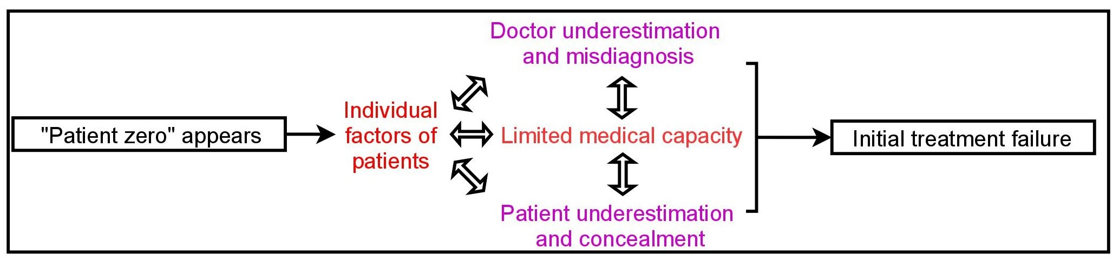

Supplementary Figure 7 The stage III of the micro mechanism underlying the outbreak of major emerging infectious disease.

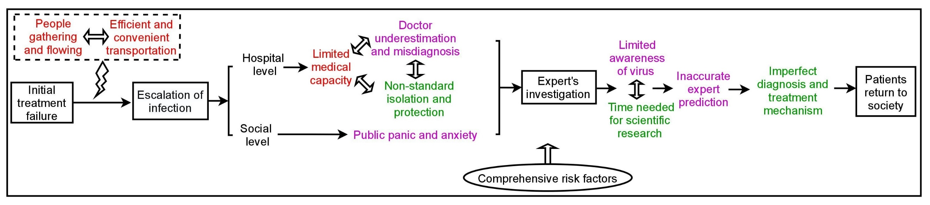

Supplementary Figure 8 The stage IV of the micro mechanism underlying the outbreak of major emerging infectious disease.
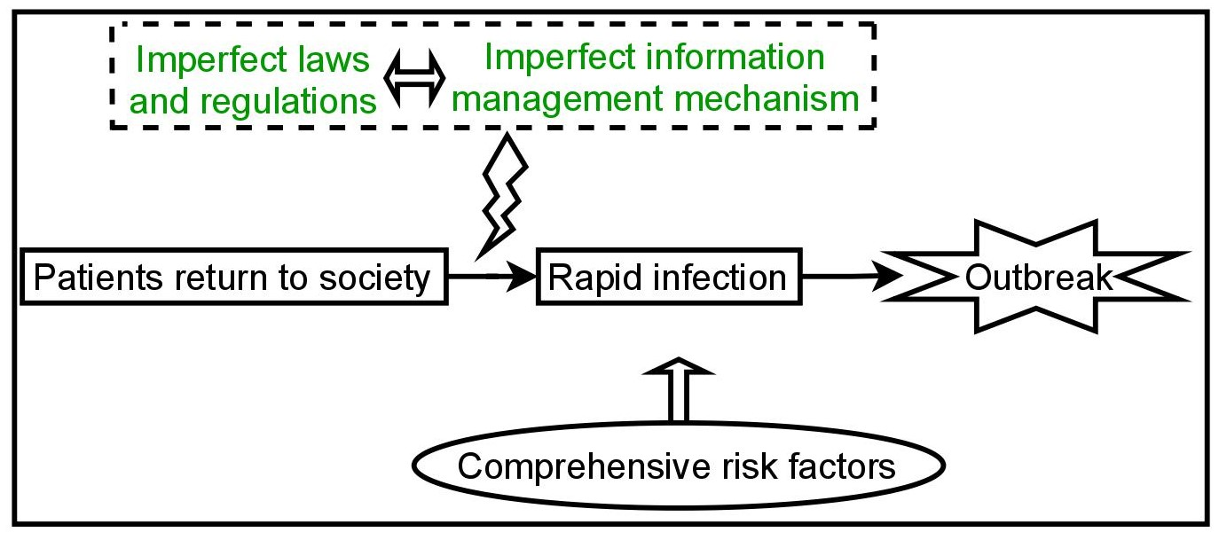

Supplementary Table 1 The list of data sources

Case | No. | URL | Category
SARS | 1 | https://kns.cnki.net/kcms2/article/abstract?v=3uoqIhG8C45iO2vZ0jWu7b6KLB8DnSLpx2uMwm0_gOF8Uataf1P4CPzMrfF8sKuMKpHGpNjq1eTca0OIoFxHF3GV8uOdiXBw5DJ3UfLv4AQ%3d&uniplatform=NZKPT | Central news organization
SARS | 2 | https://kns.cnki.net/kcms2/article/abstract?v=3uoqIhG8C45iO2vZ0jWu7b6KLB8DnSLpx2uMwm0_gOF8Uataf1P4CPzMrfF8sKuM3AgDo7XJeBm1fukFRMTUddgub-5NzhlBg4EuVIamuB4%3d&uniplatform=NZKPT | Central news organization
SARS | 3 | https://kns.cnki.net/kcms2/article/abstract?v=3uoqIhG8C45iO2vZ0jWu7b6KLB8DnSLpx2uMwm0_gOF8Uataf1P4CPzMrfF8sKuMjc2ziL14sva3BGE41VxrAxyDGG0Bb1nbzo5zCd6mNp8%3d&uniplatform=NZKPT | Central news organization
SARS | 4 | https://kns.cnki.net/kcms2/article/abstract?v=3uoqIhG8C45iO2vZ0jWu7b6KLB8DnSLpx2uMwm0_gOF8Uataf1P4CPzMrfF8sKuMpGuYy4g5xulf_O5Pj_BewTBamVhwc4XND7S3FAVguXU%3d&uniplatform=NZKPT | Central news organization
SARS | 5 | https://kns.cnki.net/kcms2/article/abstract?v=3uoqIhG8C45iO2vZ0jWu7UbrV6wh9WJCnMMNQsg3QTHoor_Fl18cFVfzGHGjzLFXPSQQG_2QrV7zHzQ43XxsdyHAbVgWrcjB&uniplatform=NZKPT | Central news organization
SARS | 6 | https://baijiahao.baidu.com/s?id=1659455932725833094&wfr=spider&for=pc | Central news organization
SARS | 7 | https://kns.cnki.net/kcms2/article/abstract?v=3uoqIhG8C45iO2vZ0jWu7b6KLB8DnSLpx2uMwm0_gOF8Uataf1P4CPzMrfF8sKuMz2VjoIkbG_HCOwVtFt01mv_W2I_3FwxilvJ_Xga5jiU%3d&uniplatform=NZKPT | Central news organization
SARS | 8 | https://kns.cnki.net/kcms2/article/abstract?v=3uoqIhG8C45iO2vZ0jWu7Yk_1TS65PUJ2T-DJAfVfvqBnijQv8p8v4O1gCWHDqgVGh4fEEQkCin_2UBg2TvTNAyXrrh9rKhE&uniplatform=NZKPT | Central news organization
SARS | 9 | https://kns.cnki.net/kcms2/article/abstract?v=3uoqIhG8C45iO2vZ0jWu7Yk_1TS65PUJ2T-DJAfVfvqBnijQv8p8vwcLbpES1zvFjMXOBBN50uoGaeT1KjLHHqEeQ7UvBtKy&uniplatform=NZKPT | Central news organization
SARS | 10 | https://news.sina.com.cn/w/2003-04-16/22591000627.shtml | Central news organization
SARS | 11 | https://kns.cnki.net/kcms2/article/abstract?v=3uoqIhG8C45iO2vZ0jWu7UbrV6wh9WJCnMMNQsg3QTHVfFwdfDIHVPdKleXGvS7NkjUPK9OKVdTc4bPGCjB2P9OSZ7R6b7gc&uniplatform=NZKPT | Central news organization
SARS | 12 | https://kns.cnki.net/kcms2/article/abstract?v=3uoqIhG8C45iO2vZ0jWu7Yk_1TS65PUJ2T-DJAfVfvqBnijQv8p8v_K1GODvpASMPZ78Ya5oJH-PNlCEVkRu5RpUQG697shy&uniplatform=NZKPT | Central news organization
SARS | 13 | https://kns.cnki.net/kcms2/article/abstract?v=3uoqIhG8C45iO2vZ0jWu7UbrV6wh9WJCnMMNQsg3QTHoor_Fl18cFVfzGHGjzLFX6_zU8-D6kIJgvyXFHDGjH5WQPSHzF0NE&uniplatform=NZKPT | Central news organization
SARS | 14 | https://kns.cnki.net/kcms2/article/abstract?v=3uoqIhG8C45iO2vZ0jWu7Yk_1TS65PUJ2T-DJAfVfvqBnijQv8p8v5wulJ0YhXYaygG3CGVaZGs_Tt7C2_PShA1BbFFcCBoe&uniplatform=NZKPT | Central news organization
SARS | 15 | https://kns.cnki.net/kcms2/article/abstract?v=3uoqIhG8C45iO2vZ0jWu7UbrV6wh9WJCnMMNQsg3QTHoor_Fl18cFVfzGHGjzLFX_iBCWh44JFEcr5tx0ib6ylZXkBPfoOWK&uniplatform=NZKPT | Central news organization
SARS | 16 | https://kns.cnki.net/kcms2/article/abstract?v=3uoqIhG8C45iO2vZ0jWu7b6KLB8DnSLpx2uMwm0_gOF8Uataf1P4CPzMrfF8sKuM1y7TToQuw6KFZmHT9cGj9uqvuXtr-hpAJZclsg2vuYs%3d&uniplatform=NZKPT | Central news organization
SARS | 17 | https://kns.cnki.net/kcms2/article/abstract?v=3uoqIhG8C45iO2vZ0jWu7UbrV6wh9WJCnMMNQsg3QTHoor_Fl18cFVfzGHGjzLFXWGVQ_jg-CxQuAeZnZtRuDj9cCztyrwsA&uniplatform=NZKPT | Central news organization
COVID-19 | 18 | www.inewsweek.cn/society/2020-03-10/8711.shtml | Central news organization
COVID-19 | 19 | https://baijiahao.baidu.com/s?id=1662948898209768077&wfr=spider&for=pc | Central news organization
COVID-19 | 20 | https://baijiahao.baidu.com/s?id=1656854942952571446&wfr=spider&for=pc | Central news organization
COVID-19 | 21 | legal.people.com.cn/n1/2020/0102/c42510-31532084.html | Central news organization
COVID-19 | 22 | http://k.sina.com.cn/article_2272058151_876cdb2701900pcq5.html | Central news organization
COVID-19 | 23 | https://page.om.qq.com/page/OfWfppXn16Aaf3Sw_M2h64UA0 | Central news organization
COVID-19 | 24 | www.inewsweek.cn/society/2020-03-10/8724.shtml | Central news organization
COVID-19 | 25 | https://baijiahao.baidu.com/s?id=1657332178697020224&wfr=spider&for=pc | Central news organization
COVID-19 | 26 | https://baijiahao.baidu.com/s?id=1656416106921723080&wfr=spider&for=pc | Central news organization
COVID-19 | 27 | https://baijiahao.baidu.com/s?id=1657643665345020877&wfr=spider&for=pc | Central news organization
COVID-19 | 28 | hi.people.com.cn/n2/2020/0319/c231187-33889866.html | Central news organization
COVID-19 | 29 | https://m.gmw.cn/baijia/2020-01/28/33510917.html | Central news organization
COVID-19 | 30 | https://baijiahao.baidu.com/s?id=1656170679583694776&wfr=spider&for=pc | Central news organization
COVID-19 | 31 | https://baijiahao.baidu.com/s?id=1657221251676572763&wfr=spider&for=pc | Central news organization
COVID-19 | 32 | https://baijiahao.baidu.com/s?id=1656485566169225343&wfr=spider&for=pc | Central news organization
COVID-19 | 33 | society.people.com.cn/n1/2020/0123/c1008-31560463.html | Central news organization
COVID-19 | 34 | www.inewsweek.cn/society/2020-03-10/8713.shtml | Central news organization
COVID-19 | 35 | https://baijiahao.baidu.com/s?id=1657439752104910950&wfr=spider&for=pc | Central news organization
COVID-19 | 36 | www.inewsweek.cn/society/2020-01-02/8222.shtml | Central news organization
COVID-19 | 37 | www.inewsweek.cn/society/2020-01-02/8226.shtml | Central news organization
COVID-19 | 38 | https://mp.weixin.qq.com/s?__biz=MjM5MjAxNDM4MA==&mid=2666287812&idx=2&sn=b2d2db81dc1b5a510e486645f1bcc379&chksm=bdb43b878ac3b29156f7807e413df5b7fc672d6c5c6070c8db575cc9e8c8a752041c5bd0467f&scene=27 | Central news organization
COVID-19 | 39 | www.inewsweek.cn/society/2020-03-10/8712.shtml | Central news organization
COVID-19 | 40 | https://baijiahao.baidu.com/s?id=1660338140527663778&wfr=spider&for=pc | Central news organization
COVID-19 | 41 | news.cyol.com/app/2020-01/24/content_18339251.htm | Central news organization
COVID-19 | 42 | http://www.xinhuanet.com/politics/2020-01/23/c_1210450385.htm | Central news organization
COVID-19 | 43 | http://www.xinhuanet.com/politics/2020-01/21/c_1125491374.htm | Central news organization
COVID-19 | 44 | https://baijiahao.baidu.com/s?id=1656752754558004429&wfr=spider&for=pc | Central news organization
COVID-19 | 45 | jx.people.com.cn/n2/2020/0121/c186330-33735860.html | Central news organization
COVID-19 | 46 | https://baijiahao.baidu.com/s?id=1656313864558057354&wfr=spider&for=pc | Central news organization
COVID-19 | 47 | https://mp.weixin.qq.com/s/IzzCnz4Yr2jEIYZePiu_ow?article_exclude_marked=9420ef234147783bf115beb5af38813e | Central news organization
COVID-19 | 48 | https://baijiahao.baidu.com/s?id=1656307831996304386&wfr=spider&for=pc | Central news organization
COVID-19 | 49 | news.cyol.com/yuanchuang/2020-02/07/content_18356755.htm | Central news organization
COVID-19 | 50 | www.inewsweek.cn/society/2020-02-25/8553.shtml | Central news organization
COVID-19 | 51 | www.inewsweek.cn/society/2020-03-11/8791.shtml | Central news organization
COVID-19 | 52 | https://baijiahao.baidu.com/s?id=1656299073950693305&wfr=spider&for=pc | Central news organization
SARS | 53 | www.nhc.gov.cn/wjw/zcjd/201304/551e7786870a443f9b119f38320d7a41.shtml | Government announcement platform
SARS | 54 | www.nhc.gov.cn/wjw/zcjd/201304/819cec1a01664ae1860f7fabbe2dc66d.shtml | Government announcement platform
SARS | 55 | www.nhc.gov.cn/wjw/zcjd/201304/ee7e6713c4ee4199abba9a2adaf830b9.shtml | Government announcement platform
SARS | 56 | www.nhc.gov.cn/wjw/zcjd/201304/826d03198c56412e8fa1c9fbf1702202.shtml | Government announcement platform
SARS | 57 | www.nhc.gov.cn/wjw/zcjd/201304/71f40ea6795d495bbb6d80f850c903ee.shtml | Government announcement platform
SARS | 58 | www.nhc.gov.cn/wjw/zcjd/201304/027a70f447f64e4594b6643ac376668d.shtml | Government announcement platform
SARS | 59 | www.nhc.gov.cn/wjw/zcjd/201304/8a520e3a0ac845abb0cbbc759ccfe290.shtml | Government announcement platform
SARS | 60 | www.nhc.gov.cn/wjw/zcjd/201304/c53f7355df2b44a0aa75a3201a7dd936.shtml | Government announcement platform
SARS | 61 | www.nhc.gov.cn/wjw/zcjd/201304/8b4214d92c9f4088b0a61e27a1329a7c.shtml | Government announcement platform
SARS | 62 | www.nhc.gov.cn/wjw/zcjd/201304/ba7a07f544c44893a489fe14ed05ee7c.shtml | Government announcement platform
SARS | 63 | www.nhc.gov.cn/wjw/zcjd/201304/de8ea86091ec4488bf55c6184b30b298.shtml | Government announcement platform
SARS | 64 | www.nhc.gov.cn/wjw/zcjd/201304/8a853b022535482f9aff0b27d06a98ab.shtml | Government announcement platform
SARS | 65 | www.nhc.gov.cn/wjw/zcjd/201304/012861234e094bd4bfe7ea755051bd78.shtml | Government announcement platform
SARS | 66 | www.nhc.gov.cn/wjw/zcjd/201304/c7c12c5b4c314ebfb38bfe1dcdb6e303.shtml | Government announcement platform
SARS | 67 | www.nhc.gov.cn/wjw/zcjd/201304/92fee350292846fd81a8ce43176b7425.shtml | Government announcement platform
SARS | 68 | www.nhc.gov.cn/wjw/zcjd/201304/36622dfd8b574d13b30c8d02e024a360.shtml | Government announcement platform
SARS | 69 | www.nhc.gov.cn/wjw/zcjd/201304/a1ad13eb48814bc5a3d89672a84b22ad.shtml | Government announcement platform
SARS | 70 | www.nhc.gov.cn/wjw/zcjd/201304/94b7a8ff76b44543b6d7cd73c33ddd62.shtml | Government announcement platform
SARS | 71 | www.nhc.gov.cn/wjw/zcjd/201304/09bd32af0def4a6ea0d9242aed140c00.shtml | Government announcement platform
SARS | 72 | www.nhc.gov.cn/wjw/zcjd/201304/45d440d5bfab4f33886c2437a986b7f5.shtml | Government announcement platform
SARS | 73 | www.nhc.gov.cn/wjw/zcjd/201304/cf0d42b85dc64be39560d21ce832b09e.shtml | Government announcement platform
SARS | 74 | www.nhc.gov.cn/wjw/zcjd/201304/b9066a175efb465aa4244664b63e55c1.shtml | Government announcement platform
SARS | 75 | www.nhc.gov.cn/wjw/zcjd/201304/3608af3e5a174f5392009620eef82a08.shtml | Government announcement platform
SARS | 76 | www.nhc.gov.cn/wjw/zcjd/201304/23666d9f8dac438d91beba2cd282f588.shtml | Government announcement platform
SARS | 77 | www.nhc.gov.cn/wjw/zcjd/201304/5c93ff867004490db05baa60d5bff783.shtml | Government announcement platform
SARS | 78 | http://www.gov.cn/ztzl/content_355388.htm | Government announcement platform
SARS | 79 | www.nhc.gov.cn/wjw/zcjd/201304/63d0fc55f8044ca6b163a7ca7b8bc13f.shtml | Government announcement platform
SARS | 80 | www.nhc.gov.cn/wjw/zcjd/201304/ee21e2af2f914f29a4878ee834acffc3.shtml | Government announcement platform
SARS | 81 | www.nhc.gov.cn/wjw/zcjd/201304/67a9f08536064940b568cde643e9f0f0.shtml | Government announcement platform
SARS | 82 | www.nhc.gov.cn/wjw/zcjd/201304/1c3004e9eb98473fb5da3160d7062cef.shtml | Government announcement platform
SARS | 83 | www.nhc.gov.cn/wjw/zcjd/201304/c604667b1d5e45b69298330732eca800.shtml | Government announcement platform
SARS | 84 | www.nhc.gov.cn/wjw/zcjd/201304/868945ec0a5942f59757ae9ca4aff30d.shtml | Government announcement platform
SARS | 85 | www.nhc.gov.cn/wjw/zcjd/201304/ecef0c053d9e48358388adbf448749a5.shtml | Government announcement platform
SARS | 86 | www.nhc.gov.cn/wjw/zcjd/201304/e1843210978b4fe892706e841c2e2b9d.shtml | Government announcement platform
SARS | 87 | www.nhc.gov.cn/wjw/zcjd/201304/02d1e98e353041f38328291d6d58b830.shtml | Government announcement platform
COVID-19 | 88 | www.nhc.gov.cn/xcs/jdt/202001/61add0d230e047eaab777d062920d8a8.shtml | Government announcement platform
COVID-19 | 89 | www.nhc.gov.cn/wjw/xwdt/202001/12ec9062d5d041f38e210e8b69b6d7ef.shtml | Government announcement platform
COVID-19 | 90 | www.nhc.gov.cn/xcs/yqfkdt/202001/ae62cf78b3194caabeaeef248f2b6a80.shtml | Government announcement platform
COVID-19 | 91 | www.nhc.gov.cn/xcs/fkdt/202001/50050057b6fe4a2b90763d95c4273ceb.shtml | Government announcement platform
COVID-19 | 92 | www.nhc.gov.cn/xcs/s3574/202001/93d87a5185ed44e98372e68e2bc1840d.shtml | Government announcement platform
COVID-19 | 93 | www.nhc.gov.cn/xcs/s3574/202001/d5d1880058834cc0ae8af4748f3b8dd2.shtml | Government announcement platform
COVID-19 | 94 | www.nhc.gov.cn/xcs/yqfkdt/202001/914723e57818485fb30bf995cb7989de.shtml | Government announcement platform
COVID-19 | 95 | www.hubei.gov.cn/hbfb/rdgz/201912/t20191228_1801236.shtml | Government announcement platform
COVID-19 | 96 | http://www.rmzxb.com.cn/c/2020-02-15/2521548.shtml | Government announcement platform
COVID-19 | 97 | http://www.wnast.com/a/xinwenjd/2020/0201/3984.html | Government announcement platform
COVID-19 | 98 | https://www.ccdi.gov.cn/yaowen/202001/t20200127_210367.html | Government announcement platform
COVID-19 | 99 | http://www.npc.gov.cn/npc/c30834/202003/00223b1916954389b785128b9cad74a0.shtml | Government announcement platform
SARS | 100 | https://kns.cnki.net/kcms2/article/abstract?v=3uoqIhG8C45iO2vZ0jWu7b6KLB8DnSLpx2uMwm0_gOF8Uataf1P4CJfeCNTlpAMJEdsZ9_xy5VU0pBuMLbc6zil_KP71vX8ZG02Z-8Zffuk%3d&uniplatform=NZKPT | News organization
SARS | 101 |  | News organization
  https://kns.cnki.net/kcms2/article/abstract?v=3uoqIhG8C45iO2vZ0jWu7b6KLB8DnSLpx2uMwm0_gOF8Uataf1P4CJfeCNTlpAMJwtpZo4zj-pLUPqi5sW46BDyU3gMrGR8UWIm_To4DuWY%3d&uniplatform=NZKPT
SARS | 102 | https://kns.cnki.net/kcms2/article/abstract?v=3uoqIhG8C45iO2vZ0jWu7b6KLB8DnSLpx2uMwm0_gOF8Uataf1P4CJfeCNTlpAMJxuaraygjompBzLEf8TpdY6-XldSokup0JXQIm8Bq4ec%3d&uniplatform=NZKPT | News organization
SARS | 103 | https://kns.cnki.net/kcms2/article/abstract?v=3uoqIhG8C45iO2vZ0jWu7b6KLB8DnSLpx2uMwm0_gOF8Uataf1P4CJfeCNTlpAMJ6RiMOGSY__iWG-T9Q5DCBBCXDMs_FOWjAXqmz6n-lhg%3d&uniplatform=NZKPT | News organization
SARS | 104 | https://kns.cnki.net/kcms2/article/abstract?v=3uoqIhG8C45iO2vZ0jWu7b6KLB8DnSLpx2uMwm0_gOF8Uataf1P4CJfeCNTlpAMJ2tXLZHJ-4ukPAJwF77EVN7MnEIlGAi0wR8x1u4NRuHc%3d&uniplatform=NZKPT | News organization
COVID-19 | 105 | www.infzm.com/contents/175833 | News organization
COVID-19 | 106 | http://www.infzm.com/contents/178385 | News organization
COVID-19 | 107 | www.infzm.com/contents/175354 | News organization
COVID-19 | 108 | https://www.bjnews.com.cn/detail/158017318214008.html | News organization
COVID-19 | 109 | www.infzm.com/contents/175294 | News organization
COVID-19 | 110 | www.infzm.com/contents/179990 | News organization
COVID-19 | 111 | https://baijiahao.baidu.com/s?id=1656471716438457930&wfr=spider&for=pc | News organization
COVID-19 | 112 | www.infzm.com/contents/175887 | News organization
COVID-19 | 113 | https://static.nfapp.southcn.com/content/202002/01/c3049605.html | News organization
COVID-19 | 114 | https://www.bjnews.com.cn/detail/157956966815214.html | News organization
COVID-19 | 115 | https://baijiahao.baidu.com/s?id=1656299462545045551&wfr=spider&for=pc | News organization
COVID-19 | 116 | https://www.bjnews.com.cn/detail/158029200614806.html | News organization
COVID-19 | 117 | https://www.bjnews.com.cn/detail/158009700414574.html | News organization
COVID-19 | 118 | www.infzm.com/contents/177864 | News organization
COVID-19 | 119 | https://www.bjnews.com.cn/detail/162315962214597.html | News organization
COVID-19 | 120 | http://www.infzm.com/contents/178912?source=131 | News organization
COVID-19 | 121 | https://www.bjnews.com.cn/detail/157953440115064.html | News organization
COVID-19 | 122 | www.infzm.com/contents/175288 | News organization
COVID-19 | 123 | https://www.bjnews.com.cn/detail/157967891615792.html | News organization
COVID-19 | 124 | https://www.bjnews.com.cn/detail/157785860115180.html | News organization
COVID-19 | 125 | https://www.bjnews.com.cn/detail/158046234715050.html | News organization
SARS | 126 | news.sina.com.cn/c/2003-01-17/094434341s.shtml | Local news website
SARS | 127 | finance.sina.com.cn/roll/20030515/1659340996.shtml | Local news website
SARS | 128 | news.sina.com.cn/c/2003-02-12/0128904405.shtml | Local news website
SARS | 129 | news.sina.com.cn/c/2003-05-10/12461043432.shtml | Local news website
SARS | 130 | news.sina.com.cn/c/2003-02-11/0631903171.shtml | Local news website
SARS | 131 | news.sina.com.cn/c/2003-02-10/1357902615.shtml | Local news website
SARS | 132 | news.sina.com.cn/c/2003-01-19/0301879790.shtml | Local news website
SARS | 133 | news.sina.com.cn/c/2003-02-11/0955903417.shtml | Local news website
SARS | 134 | news.sohu.com/27/88/news215458827.shtml | Local news website
SARS | 135 | news.sina.com.cn/c/2003-02-12/0131904406.shtml | Local news website
SARS | 136 | news.sina.com.cn/c/2003-05-10/13031043471.shtml | Local news website
SARS | 137 | news.sina.com.cn/c/2003-02-11/0953903415.shtml | Local news website
SARS | 138 | https://xueshu.baidu.com/usercenter/paper/show?paperid=a9116b016324ec54ca5063483abed1fd&site=xueshu_se | Officially Published works
SARS | 139 | https://xueshu.baidu.com/usercenter/paper/show?paperid=e5c116fa17c4aab8c3488042d164acde&site=xueshu_se&hitarticle=1 | Officially Published works
SARS | 140 | http://www.chinawriter.com.cn/2014/2014-03-10/195076.html | Officially Published works
SARS | 141 | http://opac.shisu.edu.cn/opac/item.php?marc_no=0000622686 | Officially Published works
SARS | 142 | https://www.lifeweek.com.cn/article/84500 | Industry media
SARS | 143 | https://www.lifeweek.com.cn/article/49053 | Industry media
SARS | 144 | https://www.lifeweek.com.cn/article/23593 | Industry media
SARS | 145 | https://www.lifeweek.com.cn/article/23594 | Industry media
SARS | 146 | https://www.lifeweek.com.cn/article/23592 | Industry media
SARS | 147 | https://www.lifeweek.com.cn/article/45898 | Industry media
SARS | 148 | https://www.lifeweek.com.cn/article/79444 | Industry media
COVID-19 | 149 | https://www.lifeweek.com.cn/article/83936 | Industry media
COVID-19 | 150 | http://www.cb.com.cn/index/show/zj/cv/cv13472201260/p/3.html | Industry media
COVID-19 | 151 | https://www.lifeweek.com.cn/article/84490 | Industry media
COVID-19 | 152 | https://www.lifeweek.com.cn/article/83928 | Industry media
COVID-19 | 153 | https://www.lifeweek.com.cn/article/83954 | Industry media
COVID-19 | 154 | https://www.lifeweek.com.cn/article/83921 | Industry media
SARS | 155 | https://kns.cnki.net/kcms2/article/abstract?v=3uoqIhG8C44YLTlOAiTRKgchrJ08w1e7ZCYsl4RS_3iXj4PUNsJlZmfpB7vuWrUmov__B6u3bCKHPeoayUoptBD2AMZqDaO0&uniplatform=NZKPT | Academic papers
SARS | 156 | https://kns.cnki.net/kcms2/article/abstract?v=3uoqIhG8C467SBiOvrai6cVePIGuwmbS3U2ptMn63qTNxOkvzeoys5CjvyrtUW-mWkDT-cF5L0RUF2zTAGLi5vfQWZPW0DGT&uniplatform=NZKPT | Academic papers
SARS | 157 | http://www.cnki.com.cn/Article/CJFDTotal-KJDB202023020.htm | Academic papers
SARS | 158 | https://kns.cnki.net/kcms2/article/abstract?v=3uoqIhG8C44YLTlOAiTRKgchrJ08w1e7ZCYsl4RS_3i7exDHj5htc_oVv4Ai5bedejDXXDKgDaH7m64dCt69EBixSwYAqCn0&uniplatform=NZKPT | Academic papers
SARS | 159 | https://kns.cnki.net/kcms2/article/abstract?v=3uoqIhG8C44YLTlOAiTRKgchrJ08w1e7eeyE9jLkqq_Y2LPe7d01z1NXsiAzujgusYTpuW_C9sTnb4QdnVKeq_ASuFCfvsW2&uniplatform=NZKPT | Academic papers
SARS | 160 | http://www.cnki.com.cn/Article/CJFDTotal-ZGXD200803029.htm | Academic papers
SARS | 161 | https://kns.cnki.net/kcms2/article/abstract?v=3uoqIhG8C467SBiOvrai6cVePIGuwmbS3U2ptMn63qSv7LAAmUyMsQE2-TST7cN1iLCpz7LEmnlmlaH6tE6xHA6iT9iiDB7o&uniplatform=NZKPT | Academic papers
SARS | 162 | https://kns.cnki.net/kcms2/article/abstract?v=3uoqIhG8C44YLTlOAiTRKgchrJ08w1e7ZCYsl4RS_3gkaM-ABy8uCV9F25DKbXvdm2LIzxpx10LaSQL2mqiUYBbCvOBLhOai&uniplatform=NZKPT | Academic papers
COVID-19 | 163 | https://kns.cnki.net/kcms2/article/abstract?v=3uoqIhG8C44YLTlOAiTRKibYlV5Vjs7iy_Rpms2pqwbFRRUtoUImHYnWJolkNE7bThad53p6HPHXKjBNr4iBwneNxFRFS0X5&uniplatform=NZKPT | Academic papers
COVID-19 | 164 | https://rs.yiigle.com/yufabiao/1180150.htm | Academic papers
COVID-19 | 165 | https://www.sciengine.com/SSV/doi/10.1360/SSV-2020-0044 | Academic papers
COVID-19 | 166 | https://kns.cnki.net/kcms2/article/abstract?v=3uoqIhG8C44wp2hFvIb_znleNvEqg4RtCv9vPRf2sA9Rm7doptViYxfD8Y_LuSlAL3iQPxZnH2psBBPD6eplOPPRtq91OHx1&uniplatform=NZKPT | Academic papers
COVID-19 | 167 | https://www.thelancet.com/article/S0140-6736(20)30183-5/fulltext | Academic papers
COVID-19 | 168 | https://kns.cnki.net/kcms2/article/abstract?v=3uoqIhG8C44YLTlOAiTRKibYlV5Vjs7iy_Rpms2pqwbFRRUtoUImHZwGiZq1dabs4l1vIepzXoNzcX-0LSkjkVnrvsL9vS8Z&uniplatform=NZKPT | Academic papers

Supplementary Table 2 Coding results of Wuli risk factors

Category | Selective coding | Axial coding | Open coding
Wuli risk factors(W) | (SW1) Novel virus characteristics | (AW1) High mutability of novel virus | (OW1) Easy mutation of novel virus
Wuli risk factors(W) | (SW1) Novel virus characteristics | (AW2) High infectiveness of novel virus | (OW2) Easy infection of novel virus
Wuli risk factors(W) | (SW1) Novel virus characteristics | (AW3) High destructiveness of novel virus | (OW3) High severity rate of novel virus
Wuli risk factors(W) | (SW1) Novel virus characteristics | (AW4) Diverse hosts | (OW4) Infects wild animals
Wuli risk factors(W) | (SW1) Novel virus characteristics | (AW4) Diverse hosts | (OW5) Wide range of hosts
Wuli risk factors(W) | (SW1) Novel virus characteristics | (AW4) Diverse hosts | (OW6) Cross-species infection
Wuli risk factors(W) | (SW2) Favorable climatic environment | (AW5) Suitable climate and temperature | (OW7) Suitable natural climate
Wuli risk factors(W) | (SW2) Favorable climatic environment | (AW5) Suitable climate and temperature | (OW8) Suitable survival temperature
Wuli risk factors(W) | (SW3) Shortage of medical resources | (AW6) Unreasonable space layout | (OW9) Unreasonable ward layout
Wuli risk factors(W) | (SW3) Shortage of medical resources | (AW7) Shortage of medical staff | (OW10) Insufficient physicians
Wuli risk factors(W) | (SW3) Shortage of medical resources | (AW7) Shortage of medical staff | (OW11) Shortage of medical talents
Wuli risk factors(W) | (SW3) Shortage of medical resources | (AW8) Shortage of medical equipment | (OW12) Shortage of first-aid equipment
Wuli risk factors(W) | (SW3) Shortage of medical resources | (AW8) Shortage of medical equipment | (OW13) Shortage of virus detection equipment
Wuli risk factors(W) | (SW3) Shortage of medical resources | (AW9) Shortage of protective materials | (OW14) Shortage of protective masks
Wuli risk factors(W) | (SW3) Shortage of medical resources | (AW9) Shortage of protective materials | (OW15) Shortage of isolation wards
Wuli risk factors(W) | (SW4) Limited medical capacity | (AW10) Limited treatment capacity | (OW16) Limited treatment capacity in private hospitals
Wuli risk factors(W) | (SW4) Limited medical capacity | (AW10) Limited treatment capacity | (OW17) Limited treatment capacity of primary clinics
Wuli risk factors(W) | (SW5) Insufficient development in scientific disciplines | (AW11) Insufficient professional staff | (OW18) Shortage of staff in the departments
Wuli risk factors(W) | (SW5) Insufficient development in scientific disciplines | (AW11) Insufficient professional staff | (OW19) Severe brain drain
Wuli risk factors(W) | (SW5) Insufficient development in scientific disciplines | (AW12) Insufficient investment in scientific disciplines | (OW20) Insufficient investment in emergency medicine research
Wuli risk factors(W) | (SW5) Insufficient development in scientific disciplines | (AW12) Insufficient investment in scientific disciplines | (OW21) Insufficient investment in infection research
Wuli risk factors(W) | (SW6) Contaminated object and environment | (AW13) Contaminated object and facility | (OW22) Surface contamination of objects
Wuli risk factors(W) | (SW6) Contaminated object and environment | (AW13) Contaminated object and facility | (OW23) Contamination of body secretions
Wuli risk factors(W) | (SW6) Contaminated object and environment | (AW13) Contaminated object and facility | (OW24) Public facilities contamination
Wuli risk factors(W) | (SW6) Contaminated object and environment | (AW14) Contaminated natural and indoor environment | (OW25) Indoor pollution
Wuli risk factors(W) | (SW6) Contaminated object and environment | (AW14) Contaminated natural and indoor environment | (OW26) Local air pollution
Wuli risk factors(W) | (SW7) Poor environment hygiene | (AW15) Poor environment hygiene | (OW27) Poor ventilation
Wuli risk factors(W) | (SW7) Poor environment hygiene | (AW15) Poor environment hygiene | (OW28) Improper disposal of rubbish
Wuli risk factors(W) | (SW7) Poor environment hygiene | (AW15) Poor environment hygiene | (OW29) Dirty sewage flowing on floor
Wuli risk factors(W) | (SW8) People gathering and flowing | (AW16) High concentration of people | (OW30) Gathering in public
Wuli risk factors(W) | (SW8) People gathering and flowing | (AW16) High concentration of people | (OW31) Large-scale event gathering
Wuli risk factors(W) | (SW8) People gathering and flowing | (AW17) Large flow of people | (OW32) Increase in tourist flow
Wuli risk factors(W) | (SW8) People gathering and flowing | (AW17) Large flow of people | (OW33) Mass migration of people
Wuli risk factors(W) | (SW8) People gathering and flowing | (AW18) Patients gathering in hospitals | (OW34) Extended waiting time to see a doctor
Wuli risk factors(W) | (SW8) People gathering and flowing | (AW18) Patients gathering in hospitals | (OW35) Large number of patients
Wuli risk factors(W) | (SW8) People gathering and flowing | (AW18) Patients gathering in hospitals | (OW36) Centralized treatment of patients
Wuli risk factors(W) | (SW8) People gathering and flowing | (AW19) High population density | (OW37) Increasing population density
Wuli risk factors(W) | (SW8) People gathering and flowing | (AW19) High population density | (OW38) High residential population density
Wuli risk factors(W) | (SW9) Efficient and convenient transportation | (AW20) Strong transportation capacity | (OW39) Long distance of transportation
Wuli risk factors(W) | (SW9) Efficient and convenient transportation | (AW20) Strong transportation capacity | (OW40) Wide reach of transportation
Wuli risk factors(W) | (SW9) Efficient and convenient transportation | (AW21) Convenient transportation | (OW41) Fast transportation means
Wuli risk factors(W) | (SW9) Efficient and convenient transportation | (AW21) Convenient transportation | (OW42) High transportation efficiency
Wuli risk factors(W) | (SW9) Efficient and convenient transportation | (AW22) Important geographical location | (OW43) Strong regional connectivity
Wuli risk factors(W) | (SW9) Efficient and convenient transportation | (AW22) Important geographical location | (OW44) Frequent international exchanges
Wuli risk factors(W) | (SW10) Individual factors of patients | (AW23) High economic pressure | (OW45) Low income
Wuli risk factors(W) | (SW10) Individual factors of patients | (AW23) High economic pressure | (OW46) High treatment costs
Wuli risk factors(W) | (SW10) Individual factors of patients | (AW24) Aging and underlying diseases | (OW47) Underlying diseases
Wuli risk factors(W) | (SW10) Individual factors of patients | (AW24) Aging and underlying diseases | (OW48) Physical aging
Wuli risk factors(W) | (SW10) Individual factors of patients | (AW25) Individual immunity | (OW49) High susceptibility in some individuals
Wuli risk factors(W) | (SW10) Individual factors of patients | (AW25) Individual immunity | (OW50) Differences in individual immunity
Wuli risk factors(W) | (SW10) Individual factors of patients | (AW25) Individual immunity | (OW51) Decreased immunity

Supplementary Table 3 Coding results of Shili risk factors

Category | Selective coding | Axial coding | Open coding
Shili risk factors(S) | (SS1) Imperfect diagnosis and treatment mechanism | (AS1) Low diagnostic success rate | (OS1) Inconsistent diagnostic standards
Shili risk factors(S) | (SS1) Imperfect diagnosis and treatment mechanism | (AS1) Low diagnostic success rate | (OS2) Low detection accuracy
Shili risk factors(S) | (SS1) Imperfect diagnosis and treatment mechanism | (AS2) Imperfect patient admission system | (OS3) Difficulty in admitting patients
Shili risk factors(S) | (SS2) Imperfect information management mechanism | (AS3) Imperfect information communication mechanism | (OS4) Emergency hotline not optimal
Shili risk factors(S) | (SS2) Imperfect information management mechanism | (AS3) Imperfect information communication mechanism | (OS5) Inadequate communication between hospitals
Shili risk factors(S) | (SS2) Imperfect information management mechanism | (AS3) Imperfect information communication mechanism | (OS6) Poor communication of internal information
Shili risk factors(S) | (SS2) Imperfect information management mechanism | (AS3) Imperfect information communication mechanism | (OS7) Poor communication with the media
Shili risk factors(S) | (SS2) Imperfect information management mechanism | (AS4) Imperfect information release mechanism | (OS8) Imperfect information release system
Shili risk factors(S) | (SS2) Imperfect information management mechanism | (AS4) Imperfect information release mechanism | (OS9) Delayed information release
Shili risk factors(S) | (SS2) Imperfect information management mechanism | (AS5) Imperfect information reporting mechanism | (OS10) Insufficient mandatory reporting
Shili risk factors(S) | (SS2) Imperfect information management mechanism | (AS5) Imperfect information reporting mechanism | (OS11) Complicated reporting process
Shili risk factors(S) | (SS2) Imperfect information management mechanism | (AS5) Imperfect information reporting mechanism | (OS12) Inconsistent reporting method
Shili risk factors(S) | (SS2) Imperfect information management mechanism | (AS6) Misleading information by authoritative media | (OS13) Inaccuracy in refuting rumors
Shili risk factors(S) | (SS2) Imperfect information management mechanism | (AS6) Misleading information by authoritative media | (OS14) Inaccurate media reports
Shili risk factors(S) | (SS2) Imperfect information management mechanism | (AS6) Misleading information by authoritative media | (OS15) Inaccurate official releases
Shili risk factors(S) | (SS3) Insufficient supervision | (AS7) Insufficient hygiene supervision | (OS16) Inadequate supervision on food hygiene
Shili risk factors(S) | (SS3) Insufficient supervision | (AS8) Insufficient supervision of illegal transactions | (OS17) Insufficient supervision on wildlife trade
Shili risk factors(S) | (SS3) Insufficient supervision | (AS8) Insufficient supervision of illegal transactions | (OS18) Insufficient supervision of illegal wildlife hunting
Shili risk factors(S) | (SS4) Non-standard isolation and protection | (AS9) Non-standard isolation methods | (OS19) Non-standard in-home isolation
Shili risk factors(S) | (SS4) Non-standard isolation and protection | (AS10) Non-standard external protective measures | (OS20) Lack of external protection
Shili risk factors(S) | (SS4) Non-standard isolation and protection | (AS10) Non-standard external protective measures | (OS21) Inadequate degree of protection
Shili risk factors(S) | (SS5) Imperfect laws and regulations | (AS11) Low applicability of laws and regulations | (OS22) Low practicability of emergency plans
Shili risk factors(S) | (SS5) Imperfect laws and regulations | (AS11) Low applicability of laws and regulations | (OS23) Limited scope of notifiable infectious diseases
Shili risk factors(S) | (SS5) Imperfect laws and regulations | (AS12) Imprecise laws and regulations | (OS24) Unclear provisions
Shili risk factors(S) | (SS5) Imperfect laws and regulations | (AS12) Imprecise laws and regulations | (OS25) Conflicting legal provisions
Shili risk factors(S) | (SS6) Time-consuming for scientific research | (AW13) Time-consuming for medical research | (OS26) Time-consuming for medicine research
Shili risk factors(S) | (SS6) Time-consuming for scientific research | (AW13) Time-consuming for medical research | (OS27) Time-consuming for etiological investigation
Shili risk factors(S) | (SS6) Time-consuming for scientific research | (AW13) Time-consuming for medical research | (OS28) Time-consuming for pathogen detection

Supplementary Table 4 Coding results of Renli risk factors

Category | Selective coding | Axial coding | Open coding
Renli risk factors(R) | (SR1) Inaccurate expert prediction | (AR1) Inconsistent opinions of experts | (OR1) Inconsistent opinions on prevention and control measures
Renli risk factors(R) | (SR1) Inaccurate expert prediction | (AR1) Inconsistent opinions of experts | (OR2) Inconsistent opinions on the cause of the disease
Renli risk factors(R) | (SR1) Inaccurate expert prediction | (AR2) Inaccurate epidemic prediction | (OR3) Inaccurate prediction of epidemic situation
Renli risk factors(R) | (SR2) Poor ability of emergency response | (AR3) Poorly educated emergency responders | (OR4) Insufficient comprehensive emergency response capacity
Renli risk factors(R) | (SR2) Poor ability of emergency response | (AR4) Insufficient emergency response capacity of doctors | (OR5) Lack of infection prevention knowledge
Renli risk factors(R) | (SR2) Poor ability of emergency response | (AR4) Insufficient emergency response capacity of doctors | (OR6) Unskilled operation technology
Renli risk factors(R) | (SR3) Doctor underestimation and misdiagnosis | (AR5) Doctor misdiagnosis of diseases | (OR7) Doctor misdiagnosis of diseases
Renli risk factors(R) | (SR3) Doctor underestimation and misdiagnosis | (AR6) Doctor underestimation of diseases | (OR8) Doctor underestimation diseases
Renli risk factors(R) | (SR4) Limited awareness of virus | (AR7) Limited awareness of virus characteristics | (OR9) Limited awareness of biological characteristics of the virus
Renli risk factors(R) | (SR4) Limited awareness of virus | (AR7) Limited awareness of virus characteristics | (OR10) Limited awareness of outbreak mode of the virus
Renli risk factors(R) | (SR5) Insufficient crisis awareness and common sense | (AR8) Insufficient public health crisis awareness and common sense | (OR11) Insufficient awareness of public health crisis
Renli risk factors(R) | (SR5) Insufficient crisis awareness and common sense |  | (OR12) Insufficient common sense of public health
Renli risk factors(R) | (SR6) Patient underestimation and concealment | (AR9) Patients underestimating the condition | (OR13) Underestimating clinical symptoms
Renli risk factors(R) | (SR6) Patient underestimation and concealment | (AR10) Patients intentionally conceal | (OR14) Concealing health conditions
Renli risk factors(R) | (SR6) Patient underestimation and concealment | (AR10) Patients intentionally conceal | (OR15) Concealing epidemic prevention investigation
Renli risk factors(R) | (SR7) Individual eating habits | (AR11) Eating wildlife | (OR16) Indiscriminate wildlife eating habits
Renli risk factors(R) | (SR8) Public panic and anxiety | (AR12) Extreme psychological anxiety | (OR17) Psychological tension and anxiety
Renli risk factors(R) | (SR8) Public panic and anxiety | (AR13) Excessive public panic | (OR18) public panic buying

