Support Information
Ultrasound/pH-responsive nanodroplets combined with ultrasound-targeted microbubble disruption to initiate ferroptosis in triple negative breast cancer
Rui Liu¹, Dandan Shi¹, Lu Guo¹, Shan Xiao¹, Mengmeng Shang¹, Xiao Sun¹, Dong Meng¹, Yading Zhao¹, Xiaoxuan Wang¹ and Jie Li¹
¹Department of Ultrasound, Qilu Hospital of Shandong University, Jinan, Shandong 250012, China
Corresponding authors:
Jie Li, PhD
Department of Ultrasound, Qilu Hospital of Shandong University, Jinan, Shandong 250012, China
Email address: jieli@email.sdu.edu.cn

 | SIM (μg) : O-CMC (μg) | EE(%) | LE(%)
  Formulation
1 | 1000:4500 | 65.97±0.04 | 11.99±0.01
2 | 1500:4500 | 66.76±0.07 | 16.69±0.02
3 | 2000:4500 | 77.59±0.03 | 23.87±0.01
4 | 2500:4500 | 61.12±0.03 | 21.83±0.01
Supplementary Table 1. The formulation optimization of EE and LE of SIM-NDs. All results represent the means ± SD (n = 3).

Figure S1. (A) The percentage of positive cell rate was obtained from Figure 2B using Flowjo. (B) The percentage of positive cell rate was obtained from Figure 2D using Flowjo. All results represent the means ± SD (n = 3). ***p<0.001, ****p<0.0001.

Figure S2. Representative images of lipid peroxidation levels of MDA-MB-231 cells after various treatments (BODIPY C11 probe staining). C11-BOIPY represents levels of staining with the probe (unoxidized), while oxC11-BODIPY (oxidized) indicates the levels of lipid ROS. Scale bar: 40μm.

Figure S3. Biochemical parameters (ALT, AST, ALB, BUN, CRE) in different groups. All results represent the means ± SD (n = 3).

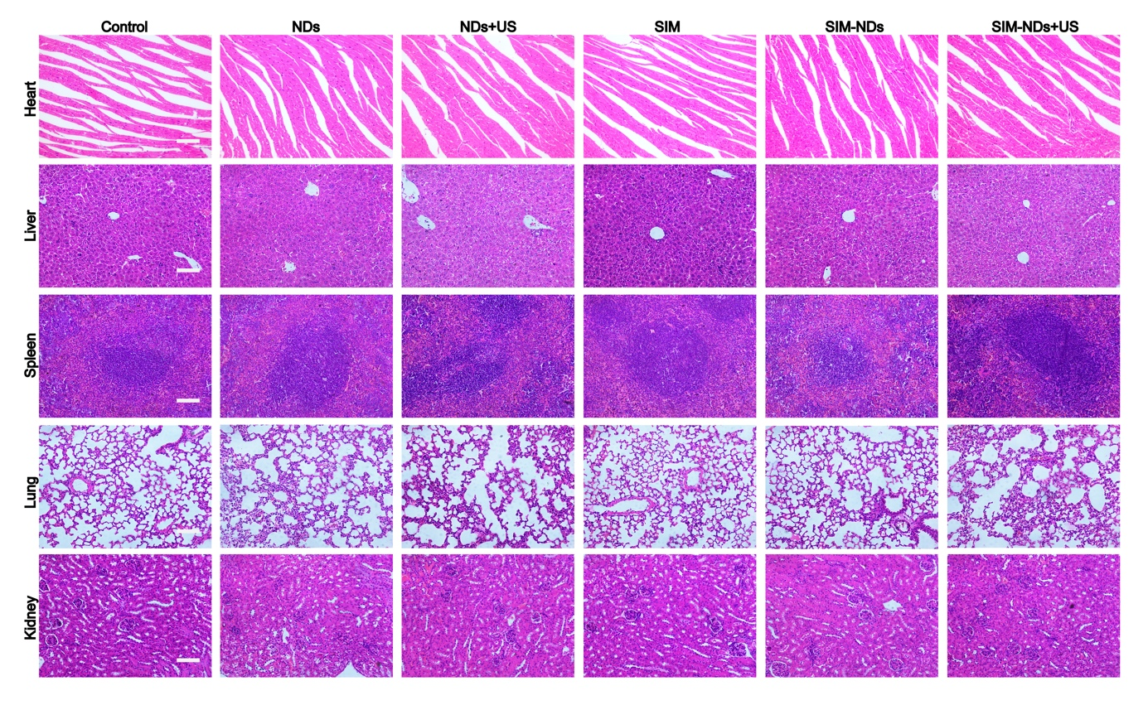
Figure S4. HE staining of major organs in the different groups. Scale bar: 100 μm.
Figure S5. (A) ELISA analysis of IL-6 level in serum after injections. (B) ELISA analysis of TNF-α level in serum after injections. All results represent the means ± SD (n = 3).

