Table S1. Mn ratio in the MnO_{x}-CeO₂ NPs

 | Molar ratio of Mn/(Mn+Ce)
 | Experimental design (%) | ICP-MS (%)
MnO_{x}-CeO₂ NPs | 0 | 0.0
MnO_{x}-CeO₂ NPs | 10 | 3.0
MnO_{x}-CeO₂ NPs | 20 | 3.8
MnO_{x}-CeO₂ NPs | 30 | 4.0
MnO_{x}-CeO₂ NPs | 40 | 4.4

Figure S1. The ·OH scavenging effect of MnO_{x}-CeO₂ NPs.

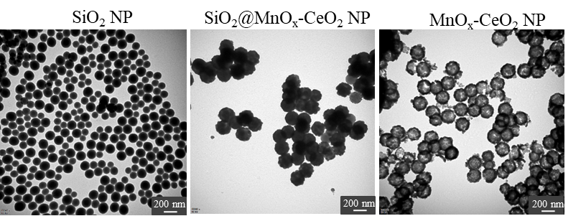
Figure S2. The TEM image of SiO₂ NPs, SiO₂@ MnO_{x}-CeO₂ NPs and MnO_{x}-CeO₂ NPs.

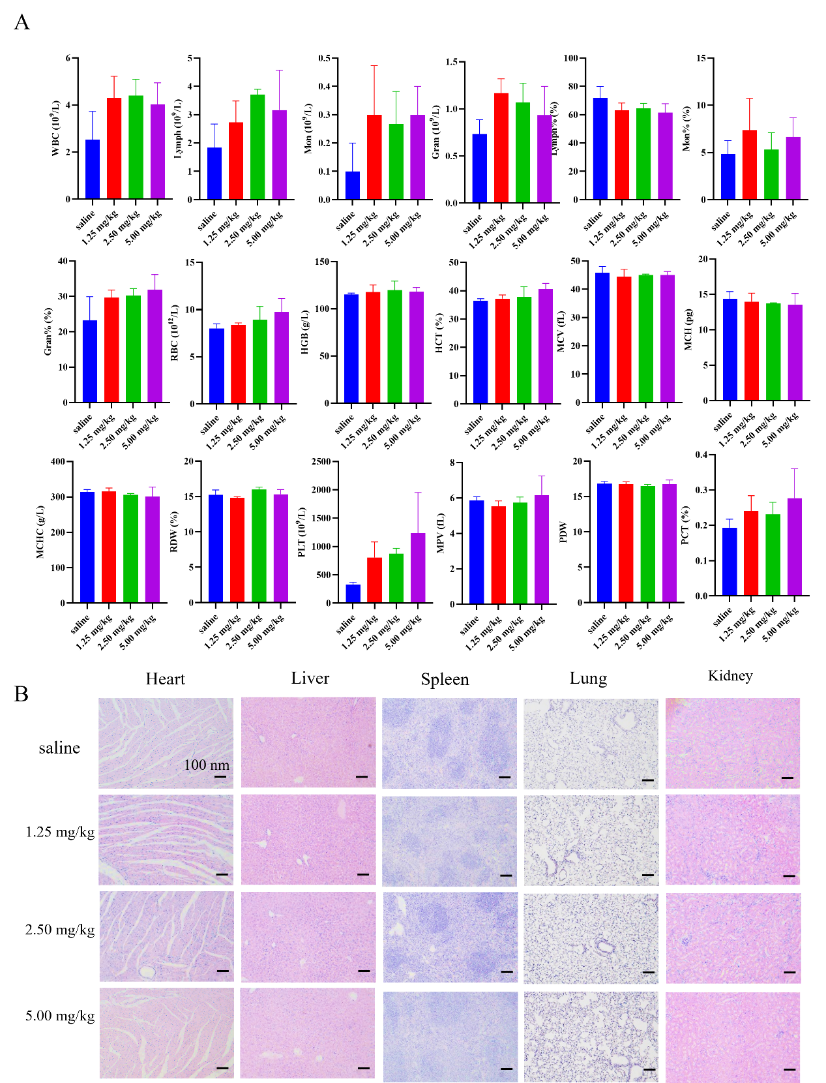

Figure S3. In vivo saefty of MnO_{x}-CeO₂ NPs 28 days after i.v. injection. (A) blood analysis, (B) H&E staining of different organs.

Figure S4. In vivo bioditribution of MnO_{x}-CeO₂ NPs after i.v. injection.

