Supplementary material Method
Procedure and quality control of mNGS
1. Procedure of mNGS
Lumbar lesion specimens (LLS) were collected by intraoperative lesion sampling. The samples were stored in a sterile container, then preserved and transported to Cellular & Molecular Diagnostics Center of Sun Yat-sen memorial hospital within 30 minutes in dry ice (4℃). The whole process of sequencing and pathogen detection pipeline were carried out in the laboratory of Cellular & Molecular Diagnostics Center of Sun Yat-sen memorial hospital, Sun Yat-sen university, Guangzhou, China.
The DNA of samples was extracted by nucleic acid extraction kit (MAGEN Guangzhou, CHINA). Next, the DNA libraries were prepared using the DNA library building kit (NextEra XT (Illumina, USA)). The DNA libraries concentration was measured by Qubit 3.0. Then the sequencing was carried out by NextSeq 500/550 High Output v2 kit (75 cycles). The data was basically filtered by FastQC software, and the effective sequence (clean reads) was the one after removing the linker, low-quality base and too short sequence. Then, reads of human were removed by mapping clean reads to human reference genome (GRCh38). The remaining data were aligned to the microbial genome database. The comparison software used was Burrows Wheeler Alignment (BWA, bowtie2) (http://bio-bwa.sourceforge.net/). The microbial database contains more than 18000 kinds of microorganisms, including clinically common bacteria, fungi, viruses and parasites.

2. Quality control of procedure
During the process of sampling, storage, transportation and sequencing, aseptic procedures are strictly followed to ensure that qualified LLS are collected. LLS were sent to lab within 30 minutes after removal. In the lab, the specimens were kept in the -80 degree refrigerator to prevent nucleic acid degradation. All detection procedures are finished within 48 hours after receiving specimen ensuring timely guidance for clinical treatment.
Both Nucleic acid extraction and library preparation were conducted in parallel with quality control samples.
The results of the two pipelines are highly consistent. To eliminate laboratory contamination, a minimum threshold of 5 RPM (reads per million) was specified. For the LLS, the concentration of DNA extracted was 62.8ng/ul, and the concentration of library was 6.44ng/ul. The total number of raw reads was 19915957, and the total number of clean reads was 19788732. 98.35% of the human sequences were filtered, and 299085 reads were compared with the microbial database. The Q30 was 92.69%, and the quality scores across all bases was shown below (Supplementary Figure 2).
Surgical technique
Firstly, the ilium was exposed through an incision of the left lower abdomen, and the autologous bone was removed for later use. With the assistance of the C-arm, the intervertebral space of the lesion was exposed and the pus was mainly concentrated in the intervertebral space. Secondly, we removed local pus, damaged intervertebral discs and damaged bone tissue thoroughly. Then, using hydrogen peroxide and iodine tincture to wash the lesion for three times. After cleaning the lesion site with normal saline, the autograft bone was implanted into the L3/4 intervertebral space. Thirdly, a drainage tube was placed in the left lower abdomen, and the wound was closed. Finally, the patient's lateral position was changed to a prone position, and screws and fixation rods were inserted from the patient's paravertebral muscle space.
Supplementary Figures
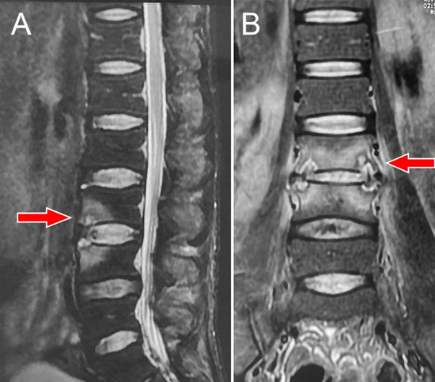
Supplementary Figure 1 The lumbar spine MR images taken at the local hospital in October, 2021
The red arrow points to the lesion site. (A) A T2-weighted MR image shows: abnormal signals can be seen in the vertebral body of L3 and L4, but there is no obvious abnormal signal in the intervertebral space and paravertebral tissue. (B) A T2-weighted MR image shows: abnormal signals can be seen in the vertebral body of L3 and L4, but there is no obvious abnormal signal in the intervertebral space and paravertebral tissue.

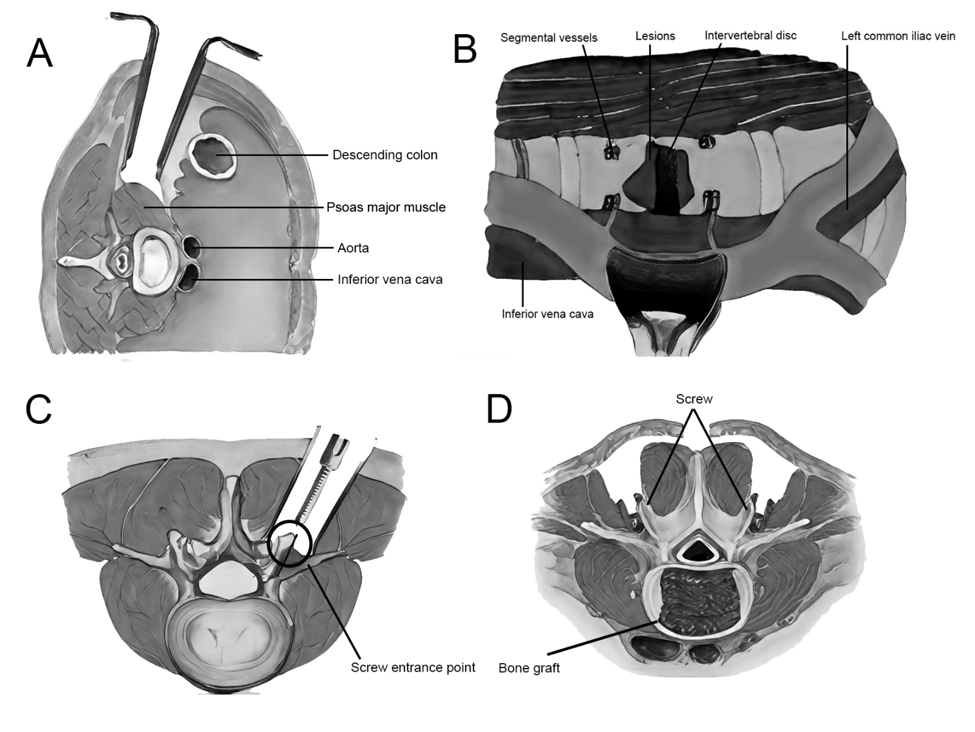
Supplementary Figure 2 Schematic diagram of surgical treatment
(A) Surgical approach in right decubitus position. (B) Exposing the lesion and surrounding important tissues. (C) Finding the screw entrance point through the paravertebral muscle space. (D) The bone grafting and internal fixation were finished.
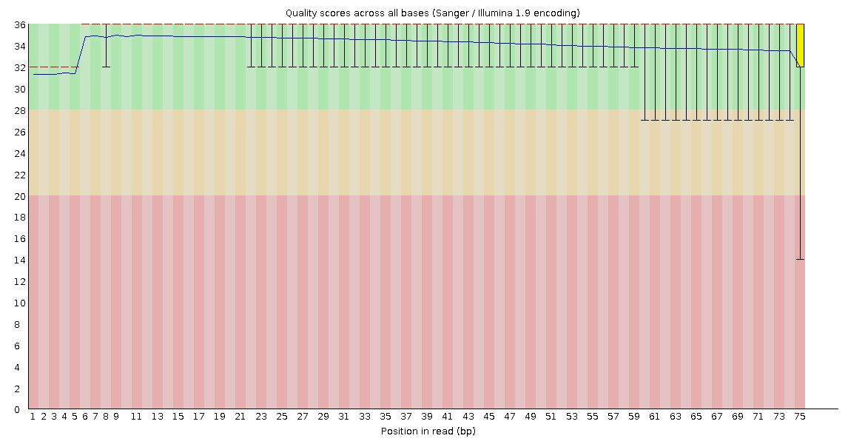
Supplementary Figure 3 The quality scores across all bases in the mNGS of LLS

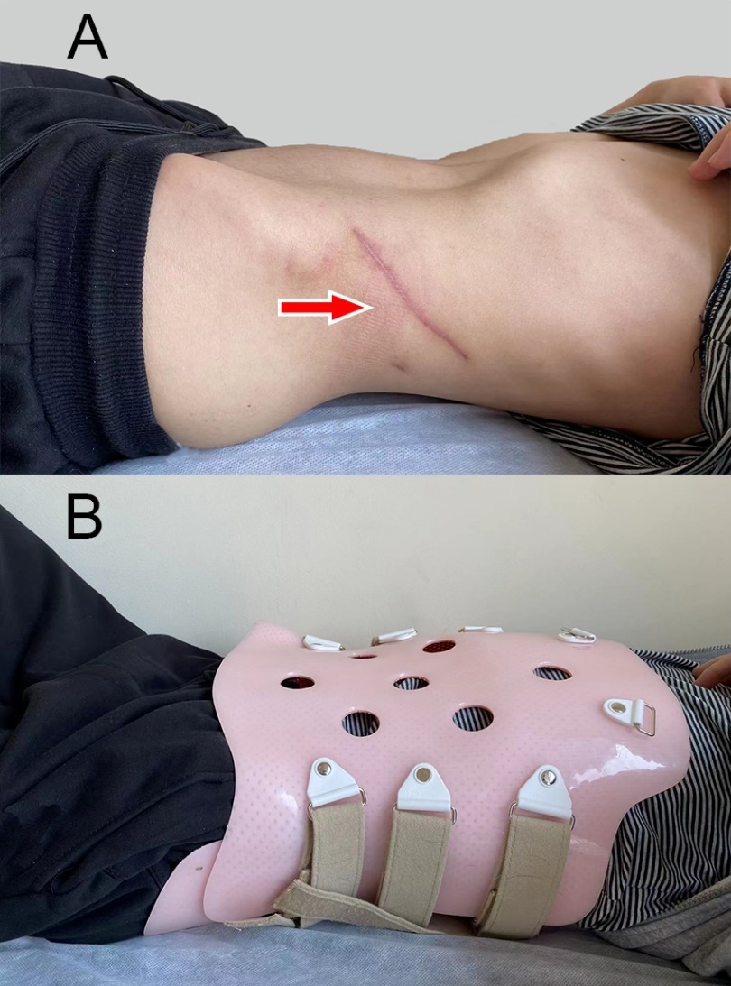
Supplementary Figure 4 Three-month follow-up image of the patient
(A) The red arrow points to the lesion site, and the left lower abdominal wound healed well. (B) The spinal protection brace worn by the patient within three months after surgery.

