Supplementary materials
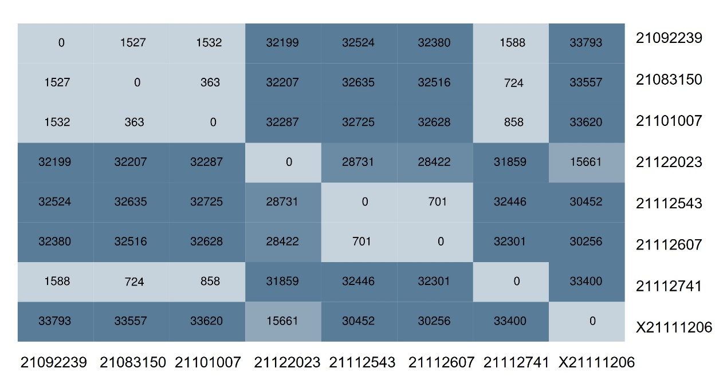
Figure S1. Heatmap of SNP distribution of eight isolates
Heatmap of SNP distribution of eight isolates drawn using BacWGSTdb⁴³, with colors deepening as SNPs increase.

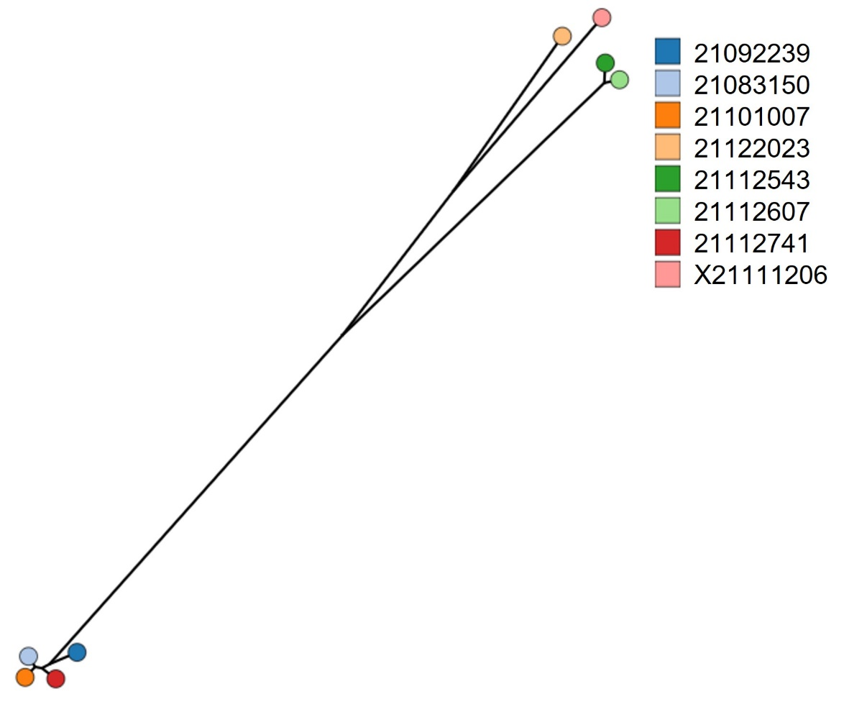
Figure S2. Relatives of eight isolates based on SNP distances
The eight isolates were divided into three subgroups

Figure S3. Hemolytic phenotype of eight isolates. PBS is negative control, and ddH₂O is positive control.

