Supplementary Materials:
The overall MoCA score did not correlate with the remaining objective sleep quality parameters, including arousals (r(20) = .19, p = .390, 95% C.I. [-0.25, 0.57]; q = .036) and sleep-stage transitions (r(20) = 0.16, p = .480, 95% C.I. [-0.28, 0.54]; q = .043), representing sleep fragmentation, and deep sleep, reflecting slow-wave sleep (r(20) = .14, p = .599, 95% C.I. [-0.30, 0.53]; q = .050).

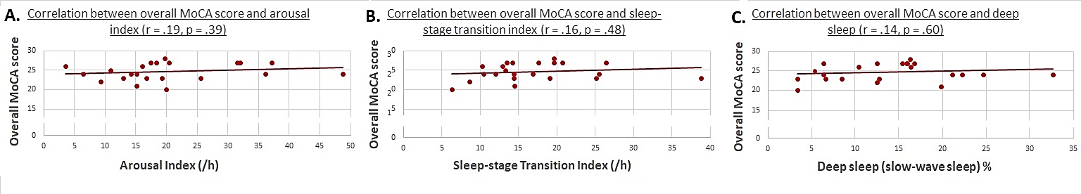
Supplementary Figure 1: Correlation between overall MoCA score and arousals (A); sleep-stage transitions (B); and slow-wave sleep (C).

