Supplementary Information
Sericin/nano-hydroxyapatite hydrogels based on graphene oxide for effective bone regeneration via immunomodulation and osteoinduction
Mei Fu,¹ Jun Li,² Mingchong Liu,¹ Chensong Yang,¹ Qidong Wang,¹ Hongrui Wang,³ Bingdi Chen,² Qingge Fu*³ and Guixin Sun*¹
¹ Department of Traumatic Surgery, Shanghai East Hospital, School of Medicine, Tongji University, Shanghai, China.
² Institute for Regenerative Medicine, Shanghai East Hospital, The Institute for Biomedical Engineering & Nano Science, School of Medicine, Tongji University, Shanghai, China.
³ Department of Orthopedic Trauma, Changhai Hospital, Naval Medical University (Second Military Medical University), Shanghai, China.
∗Corresponding Authors
Guixin Sun, Email: sunguixin@tongji.edu.cn (Main corresponding author)
Qingge Fu, Email: fqg7821@163.com (Associate corresponding author)

Section S1. Experiment and method sections
Section S1.1 Materials
Graphene oxide was purchased from Nanjing Xianfengnanometer Materials Co., Ltd. (Nanjing, China). Alginate, nano-hydroxyapatite (particle size: 60-80 nm), calcium disodium EDTA (EDTA-2Ca), and D-(+)-Gluconic acid δ-lactone (GDL) were obtained from McLean Biochemical Co., Ltd. (Shanghai, China). CD 68, CD 206, iNOS, and Agr-1 antibodies were all obtained from Affinity Biosciences (Jiangsu, China). In addition, silk sericin powder was provided by Tiansi Biotechnology Company (Huzhou, China).
Section S1.2 Characterization of hydrogels - Scanning electron microscopy (SEM) and Transmission electron microscope (TEM)
After the preparation of hydrogels was completed, samples were frozen at -20°C for 24 hours, then moved to -80°C for overnight refrigeration, and then lyophilized for 3 days. The freeze-dried samples were divided into thin slices and adhered to the surface of conductive tapes on the SEM sample stubs. After being sprayed with gold, the surface morphology of the sample was examined using the S-3400-N SEM under an acceleration voltage of 15 kV.
TEM sample preparation: A suitable amount of GO powder and nHAP powder was dissolved in anhydrous ethanol and ultrasonic dispersion was performed. Then, the dispersed sample was dropped onto the carbon supported film copper mesh and dried. Observations was conducted on a JEOL 2100F (JEOL, Tokyo, Japan) transmission electron microscope at 200 kV.
Section S1.3 Characterization of hydrogels - Fourier transform infrared (FTIR) spectroscopy and X-ray diffraction (XRD)
Various hydrogels were lyophilized and pressed into powder, and samples were obtained via potassium bromide compression. Then the infrared absorption peaks affiliated with the nanocomposite hydrogel were detected. Thermo Scientific Nicolet iS20 FTIR spectrometer was employed, with a scanned wavenumber of between 4000 and 500 cm⁻¹.
X-ray diffraction (XRD) data were detected by an X’pert pro with Cu Ka radiation (Bruker, Germany) (λ=1.5418 Å) to explore the structural changes in the corresponding hydrogel polymer, and the operating voltage and current were 40 kV and 40 mA, respectively.
Section S1.4 Characterization of hydrogels - Mechanical property of hydrogels
A cylindrical hydrogel of approximately 10 mm in height and 20 mm in diameter was used during the compression test. The CMT6103 instrument was taken advantage of to measure the stress/strain on various hydrogels.
Section S1.5 Characterization of hydrogels - Rheological experiments
The rheological properties of different hydrogels were evaluated by a rheometer (Thermo Fisher Mars 40, Germany). The loss moduli (G") and storage moduli (G') of various hydrogels were estimated by dynamic frequency scanning at a speed of between 0.1 and 100 rad/s. During the experiment, the stress temperature and amplitude were set at 37°C and 0.1%, respectively.
Section S1.6 Characterization of hydrogels - Porosity analysis
After being freeze-dried, the hydrogel was kept for 24 hours in a graduated measuring cylinder with a known volume of ethanol (V1), until the scaffold was completely saturated with dehydrated alcohol. After 24 hours, the total volume was recorded (V2), and the remaining ethanol volume (V3) was measured after the hydrogel was cautiously taken out of the cylinder. The overall volume of the hydrogel was (V2-V3), and a measurement of the void volume of the hydrogel was derived from the volume of ethanol held within the hydrogel (V1-V3). The experiment was performed in triplicates. According to the following equation, the percentage of porosity of different hydrogels could be determined:
Porosity% = (V1 − V3/V2 − V3)×100%
Section S1.7 Characterization of hydrogels - Swelling study
Briefly, the initial weight of the freeze-dried samples was recorded as W0. The different samples were submerged in 1× PBS at 37 ◦C for different periods. The immersed scaffold was taken out of the solvent at the end of every incubation time, and extra water was wiped off the surface of the sample. The final weight of samples was recorded as Wt. After measurement, the scaffold was again placed in the same solvent. The experiment was carried out in triplicates. Based on the following equation, the swelling ratio of the different samples was calculated:
Swelling ratio = (Wt−W0)/W0×100%
Section S1.8 Characterization of hydrogels - Degradation in vitro
In brief, the certain size scaffolds, with the initial weights recorded as M0 (n = 3), were incubated in a degrading medium which was made up of 0.1 M PBS with the supplement of 500 μg/mL lysozyme at 37 °C, then being shaken at 150 r/min, and the protease solution was replaced every 2 days to maintain lysozyme activity. The sample was taken out from the deteriorating medium at set intervals, dried on filter sheets, and reweighed (Mt). The following formula was used to calculate in vitro degradation:
Degradation rate (%) = (M0 − Mt) /M0 ×100%
Section S1.9 In vitro research - Isolation and culture of BMSCs and rat peritoneal macrophages
Following a prior protocol, BMSCs were extracted from two-week-old female Sprague Dawley (SD) rats. In brief, the femur and tibia were taken and isolated from muscle and connective tissue. After both extremities of the bone had been removed, bone marrow isolates were washed out and kept in Dulbecco’s Modified Eagle’s Medium (DMEM, HyClone, China) with the extra supplement of 10%(v/v) fetal bovine serum (FBS, Gibco, USA) and 1%(v/v) penicillin/streptomycin (PS, Gibco, USA). Cells were cultivated at 37°C with a 5% CO2 environment after being filtered using a 70-micron filter (Millipore, Ireland), with media being updated every two to three days. Upon BMSCs reaching 70-80% in the cell culture dish, cells were passaged utilizing 0.25% trypsin/EDTA. For the subsequent experiments, cells of passages 3 to 5 were employed.
Rat peritoneal macrophages were isolated and identified as previously described [56]. Four SD male rats aged five weeks were sacrificed by cervical dislocation and submerged in 75% ethanol for ten minutes, and then injected with 10mL ice-cold PBS with 3% (v/v) FBS into the peritoneal cavity using a needle, taking care not to puncture any organs. The injection was followed by a gentle massage of the peritoneum and a period of standing for 5-7 minutes to dislodge more attached cells into PBS solution. An incision of 2 mm was created in the ventral midline, and a sterilized, pasteurized straw was used to collect the yellow liquid from the abdominal cavity, which was further centrifuged under experimental conditions of 1500g for 8 minutes. After the supernatant was completely taken off, the remaining cell was cultivated in 1640 medium (GIBCO) with the supplement of 10%(v/v) FBS, 1% (v/v) PS, and further incubated at 37 °C under 5% CO2. To identify the phenotype of cells isolated from the peritoneal cavity, 1.5×10⁶ cells were plated into a six-well plate. After 2 hours, the media was refreshed to eliminate non-adherent cells, and immunofluorescence staining in connection with the makers, such as iNOS, CD68, and CD206 was conducted for the adherent cell.
Section S1.10 In vitro research - In vitro biocompatibility of hydrogels
The cell counting kit-8 (CCK-8) cell proliferation assay was performed as recommended by the manufacturer. Cells (2×10⁴ cells/mL) were inoculated into 24-well plates treated with different hydrogels. A negative control group was characterized by the absence of hydrogel. After 1, 3, and 7 days of treatment, the CCK-8 work solution (Beyotime, China) was applied to 24-well plates with a content of 100μL/mL and incubated for 2.5 hours in the incubation environment of keeping cells away from the light. Afterward, 100 μL of supernatant was transported to 96-well plates, and by the enzyme labels instrument (BioTech), the optical density (OD) value was recorded at 450 nm.
The viability of cells was evaluated using the Live/Dead cell staining kit (Beyotime, China). In brief, BMSCs (1×10⁴ cells /mL) were cultured on the surface of different hydrogel scaffolds. The media was removed after the third day of cultivation, and cells were stained for 30 minutes away from light using the Live/Dead staining kit. The fluorescence micrographs were acquired at laser wavelengths of 488 nm for living and 543 nm for dead cells, respectively, using the laser confocal scanning microscope (LCSM, DMi8, Leica, Germany).
The morphology of cells seeded onto hydrogel scaffolds was observed using actin cytoskeleton staining. Following one and four days of co-culture, cells were carefully flushed three times with 1×PBS and fixed for a half-hour through 4% paraformaldehyde (PFA, Beyotime, China). Following, 0.1% Triton-X 100 work solution (Beyotime, China) was utilized to further permeabilize fixed cells for about 15 minutes, continued by 1 hour of blocking. After three PBS washes, phalloidin (TRITC Phalloidin, Yeasen Biotech Co., Ltd) was mixed in PBS at a 1:500 ratio and carefully applied to BSMCs, and further incubated for 1 h at room temperature (RT), and 4,6-diamidino-2-phenylindole (DAPI, Beyotime, China) was employed to mark the nuclei. Cell morphologies were examined using the LCSM (DMi8, Leica, Germany).
Section S1.11 In vitro research - Osteogenesis differentiation and mineralization of BMSCs in vitro
BMSCs (1× 10⁶ cells per well) were incubated with different hydrogel scaffolds in osteogenic differentiation media. Groups without scaffolds were regarded as the control group. As previously described, BMSCs were stained and assessed for alkaline phosphatase (ALP) activity using a 5-bromo-4-chloro-3-indolyl phosphate/Nitro blue tetrazolium (BCIP/NBT) ALP kit (Beyotime, China) and Alkaline Phosphatase Assay Kit (Beyotime, Shanghai, China) after 7 days of incubation. The activity of ALP was measured by dissolving BMSCs on ice for 30 minutes with 1% Triton X-100. After centrifuging the cell-lysis solution at 12000 g for 30 minutes at 4 °C, the supernatant was collected. Following that, the ALP assay working solution was combined with 50 uL of the supernatant and incubated for additional 30 minutes. Using the enzyme-labeling device (BioTech), the ALP activity was detected at 405 nm, and the bicinchoninic acid (BCA) Protein Assay Kit (Beyotime, China) was used to normalize the ALP levels to the total protein content. BMSCs were fixed in 4% PFA for 30 mins and further incubated with BCIP/NBT work solution for 30mins to stain ALP away from light. To end the staining reaction, the BCIP/NBT solution was carefully removed and washed with PBS, and the zone that was stained purple was considered positive. Images of positive cells were obtained under the optical microscope.
Staining of ARS was used to assess the mineralized nodule formation property. Following 21 days of co-culture with scaffolds, BMSCs were fixed for 30 minutes with 4% PFA, washed three times, and covered with the ARS staining solution (40 mM, pH = 4.2, Cyagen, China) to be incubated for 1 hour in RT. Afterward, cells were washed several times to eliminate dye, and optical microscope was used to visualize calcium nodules. The alizarin red that had been calcified was disseminated into the solution to quantify the calcium concentration by soaking the stained samples in 10% cetylpyridinium chloride (TCI, Shanghai, China) for 1 hour under shaking circumstances. 96-well plates were loaded with 100 μL of the suspension and analyzed with the enzyme-labeling instrument (BioTech) at 570 nm.
Section S1.12 In vitro research - Western blotting
Briefly, to extract total cellular protein, cells were lysed on ice for 30 minutes with RIPA lysis buffer containing phosphatase and protease inhibitors (Beyotime, China), and by the BCA protein assay kit (Beyotime, Shanghai), the levels of protein were measured. After that, protein denaturation was accomplished by heating the protein suspension at 100℃ for 10 minutes, followed by loading the suspension on SDS-PAGE gels for gel electrophoresis to separate proteins of different molecular weights, and then transferring the proteins to polyvinylidenefluoride (PVDF, Millipore, USA) membranes. Blocking of the membrane was performed with 1×TBST solution including 5% skim milk (Beyotime, Chian) and incubation at 4 ℃ overnight with corresponding primary antibodies： Runx2 (CST, 1:1000), OPN (Santa Cruz, 1:1000), iNOS (Affinity, 1:1000), Arg-1 (Affinity, 1:1000), and antibodies β-actin (Beyotime, 1:1000). After that, the membrane underwent three 1×TBST washes, and incubated at RT for 60 minutes on a shaker with the corresponding secondary antibody (1:5000). Chemiluminescence (Beyotime) was used to capture the band signals, and Image J was used to quantify the intensity of the signals.
Section S1.13 In vitro research - Immunofluorescence analysis
Fixation of cells with 4% PFA was performed at RT for 30 minutes, followed by three times washes in 1×PBS. Cells were permeabilized for 20 minutes with 0.2 %Triton X-100, and then blocked with the 10% goat serum solution, and further incubated overnight at 4℃ with the corresponding primary antibodies: Arginase-1 (Affinity, 1:250), iNOS (Affinity, 1:250), RunX2 (Affinity, 1:250), and OPN (Affinity,1:250). Following washing with 1×PBS three times， cells were incubated with goat anti-rabbit-CY3 (Beyotime, China) for 1 hour at RT, counterstained with DAPI, and then photographed using the LCSM (DMi8, Leica, Germany).
Section S1.14 In vitro research - Real-time polymerase chain reaction analysis
In brief, RNA was extracted utilizing Trizol reagent (Beyotime, China) following the protocol of the manufacturer. Using the Nano Drop 2000 spectrophotometer (Thermo Fisher Scientific), the purity and concentration of the extracted RNA were detected. Prime Script RT Master Mix (TaKaRa, Japan) was utilized for reverse transcription. In order to analyze the gene expression of COLI, OCN, RunX2, OPN, iNOS, Arg-1, and β-actin, RT-qPCR was then performed using SYBR Green Master Mix (Bio-Rad, USA) and implemented using the Light Cycler® 480II (Roche). Denaturation (40 cycles) at 95°C for 15s and amplification at 60°C for 1 minute were conducted under the experimental conditions. The assay was carried out in triplicates (n = 3) and results were analyzed using the 2^{ΔΔCt} method. The data were normalized to the expression of β-actin. Table S1 listed the primer sequences for each gene.
Table S1-Primer sequences of each gene.
Gene | Forward sequences (5′–3′) | Reverse sequences (3′–5′)
RunX2 | TCTTCCCAAAGCCAGAGCG | TGCCATTCGAGGTGGTCG
OPN | AAGCCTGACCCATCTCAGAA | GCAACTGGGATGACCTTGAT
COLI | CTGCCCAGAAGAATATGTATCACC | GAAGCAAAGTTTCCTCCAAGACC
OCN | AAACATGGCAAGGTGTGTGA | AGGTGACCAGGACGTTTTTG
TNF-α | ATGGGCTCCCTCTCATCAGTTCC | CCTCCGCTTGGTGGTTTGCTAC
iNOS | TCTTGGAGCGAGTTGTGGATTGTTC | AGTGATGTCCAGGAAGTAGGTGAGG
Arg-1 | AGACCACAGTATGGCAATTGGAAGC | TTGTCAGCGGAGTGTTGATGTCAG
Il-10 | GGCAGTGGAGCAGGTGAAGAATG | TGTCACGTAGGCTTCTATGCAGTTG
β-Actin | GTGACGTTGACATCCGTAAAGA | GCCGGACTCATCGTACTCC
Section S1.15 In vivo research - The preparation of animal model
All rats were obtained from the Tongji University Experiment Animal Center (Shanghai, China). Throughout the experiment, all rats were fed and watered as needed and housed animal RT at 23±2 ℃ with a continuous light/dark routine. As previously reported, the model of skull defects was developed. In brief, twenty-four 12-week-old male SD rats weighing 300-340 g were randomly allocated to four groups: rats without hydrogel scaffold implanted after surgery were identified as the control group; Instead, 3 experimental groups were composed of rats implanted with the three aforementioned categories of hydrogel scaffolds: Ser, nHAP, or S+H, respectively. 3% pentobarbital sodium was injected into the animal (30 mg/kg) to reduce anesthesia intraperitoneally. In the midline of the cranium, a lengthwise incision was established after the cranial hair was cut off using a hair cutter, and the skin and subcutaneous tissue were then incised to reveal the skull., and a defect of 5 mm diameter on the cranium was produced by a low-speed dental motor. Sterilization of different scaffolds was performed before implantation. Subsequently, the skin and soft tissues were then stitched up layer by layer. The rats were 0.1 mg administered penicillin once daily for three days following the procedure. To ease discomfort, 1 mg/kg of ketorolac was provided once a day for three days. After 8 weeks of implantation， cranial samples were gathered and fixed in 4 % PFA for 24 hours at RT before being scanned with microcomputed tomography (micro-CT) and histologically and immunohistochemically examined.
Section S1.16 In vivo study - Micro-CT Scanning
Cranium samples were scanned using the high-resolution micro-CT imaging device (Quantum GX, PerkinElmer, USA) at the time point following surgery to assess bone regeneration at the defect sites. A square area of interest was chosen after 3D reconstruction to perform a bone morphometric investigation.
Section S1.17 In vivo study - Histological evaluation
The decalcification for rat cranial samples was conducted in 10% ethylenediaminetetraacetic acid (EDTA, Leagene, China) for one month, with solution replacements every 2 days. After completing the procedure of decalcification and dehydration using graded alcohol series processing methods, the dehydrated samples were embedded in paraffin according to the previous protocols and sliced into 5-mm thick slices. To investigate bone regeneration and morphological changes in the specimens, the staining of H&E and Masson was then conducted. Observations of the stained sections of samples were carried out with the DMi8 microscope (Leica, Germany).
Section S1.18 In vivo study - Immunohistochemistry (IHC) staining
The levels of COLI, iNOS, and Arg-1 markers were detected employing IHC staining. Following dewaxing, hydration, antigen repair, and blocking, primary antibodies were applied to tissue slices and incubated overnight at 4℃. Then, the sections were exposed for 30 minutes to the appropriate secondary antibodies. The chromogenic reaction was initiated with the DAB Kit (Cell Signaling Technology, USA), then the slides were dehydrated, counterstained with hematoxylin, and coverslipped. Observations of the stained sections of samples were carried out with the Leica DMi8 microscope (Germany).

Section S2. Results
Figure S1 Schematic presentation for the development of the Alg/GO/Ser/nHAP nanocomposite hydrogel and its underlying mechanism for bone regeneration. (A) Fabrication process of the Alg/GO/Ser/nHAP nanocomposite hydrogel. (B) The synergy of direct osteogenesis activity of nHAP and immune-induced osteogenesis effect of sericin. (C) Nanocomposite hydrogel was implanted into the rat cranial bone defect for promoting bone repair in vivo.

Figure S2 TEM morphology of GO.
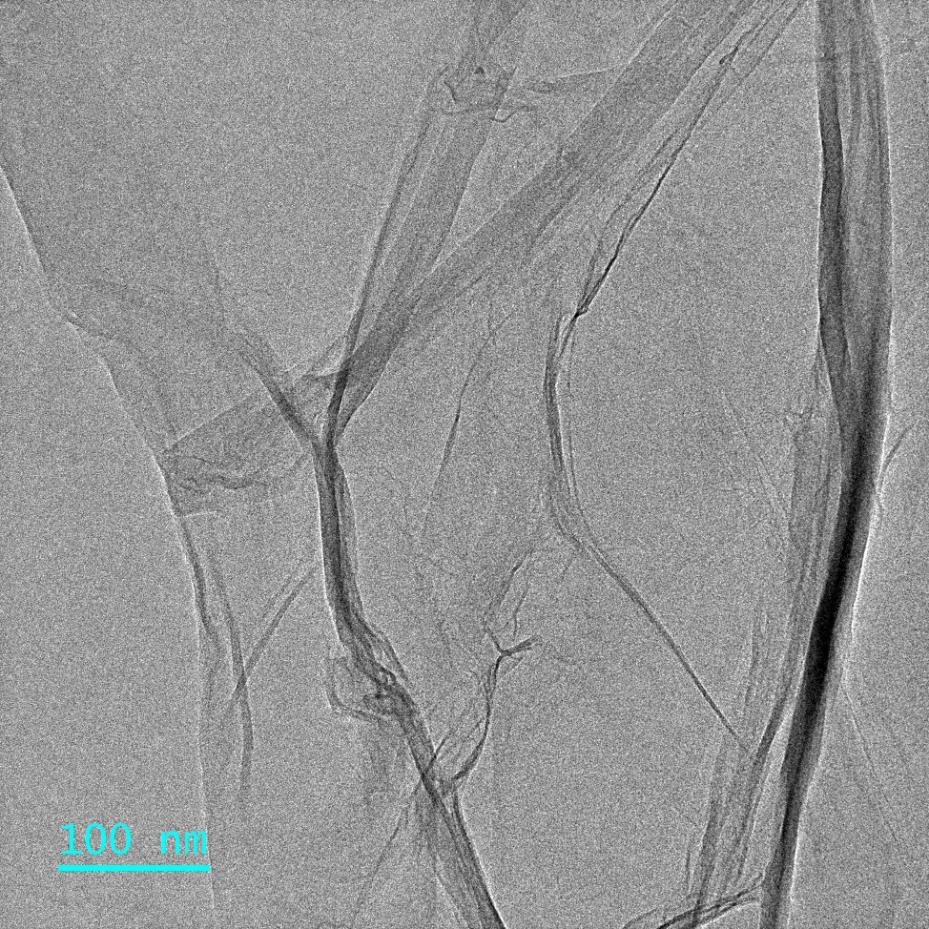

Figure S3 TEM morphology of nHAP.
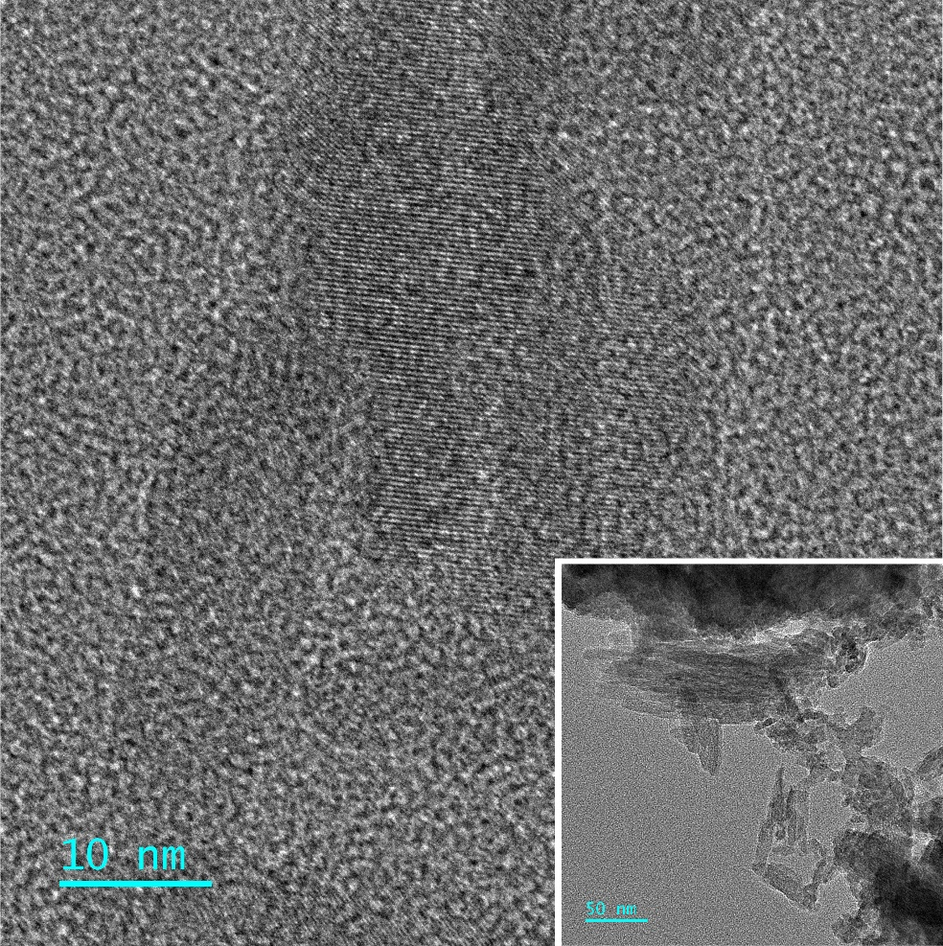

Figure S4 XRD analysis of Alg, Alg/GO, Alg/GO/Ser, Alg/GO/nHAP, and Alg/GO/Ser/nHAP freeze-dried hydrogel.

Table S2 Porosity measurements of different hydrogel scaffolds
Samples | Alg | Alg/GO | Alg/GO/Ser | Alg/GO/nHAP | Alg/GO/Ser/nHAP
Porosity (%) | 85.42±1.92 | 82.75±1.34 | 75.32±1.60 | 66.68±1.07 | 61.98±0.94

Figure S5 Immunofluorescence staining of CD68, iNOS, and CD206 on macrophages isolated from rat abdominal cavity. (A) CD68 staining, the results demonstrated that most of the extracted cells were the original macrophages (M0), and the positive rate was 93.17% ± 0.71%. (B) Arg-1 staining, the results also indicated that very few cells were M2 phenotype macrophages (4.43% ± 0.31%), and (C) iNOS staining, the results showed that very few cells were M1 phenotype macrophages (5.71% ± 0.25%).

