Supplementary Table 1:
Table S1-1，Chromatography analysis conditions under positive-ion mode
positive-ion mode
chromatography column | BEH C8 column (2.1×100 mm×1.7 μm, Waters, Milford, MA, United States)
flow rate |  | 0.35 mL/min |  | injection volume |  | 5 μL
time (min) |  |  | solvent A (water with 0.1% formic acid) |  | solvent B (acetonitrile with 0.1% formic cid)
0.0 |  |  | 95 |  | 5
1.0 |  |  | 95 |  | 95
1.1 |  |  | 95 |  | 5
11 |  |  | 0 |  | 100
11.1 |  |  | 0 |  | 100
13 |  |  | 0 |  | 100
15 |  |  | 95 |  | 5
Table S1-2，Chromatography analysis conditions under negative-ion mode
negative-ion mode
chromatography column | HSS T3 column (2.1×100 mm×μm, Waters, Milford, MA, United States)
flow rate |  | 0.35 mL/min |  | injection volume |  | 5 μL
time(min) |  |  | solvent A (water with 0.1% formic acid) |  | solvent B (acetonitrile with 0.1% formic cid)
0.0 |  |  | 95 |  | 5
1.0 |  |  | 95 |  | 95
1.1 |  |  | 95 |  | 5
11 |  |  | 0 |  | 100
11.1 |  |  | 0 |  | 100
13 |  |  | 0 |  | 100
15 |  |  | 95 |  | 5
Supplementary Table 2:
Table S2-1，Mass Spectrometry Conditions under positive-ion mode
positive-ion mode
Instrument type | Q-Exactive (Thermo Fisher, USA)
Spray Voltage | 3.8 kV | Capillary temperature | 320 °C
Sheath gas flow rate | 35 Arb | Aux gas heater temperature | 350 °C
Aux gas flow rate | 8 Arb | S-lens RF level | 50
Mass range (m/z) | 100-1200Da | Full ms resolution | 70,000
TopN | 5 | MS/MS resolution | 17,500
NCE/stepped NCE | 20, 40 | Other parameters | Defaults
Table S2-2,Mass Spectrometry Conditions under negative-ion
negative-ion
Instrument type | Q-Exactive (Thermo Fisher, USA)
Spray Voltage | -3.0 kV | Capillary temperature | 320 °C
Sheath gas flow rate | 35 Arb | Aux gas heater temperature | 350 °C
Aux gas flow rate | 8 Arb | S-lens RF level | 50
Mass range (m/z) | 100-1,200Da | Full ms resolution | 70,000
TopN | 5 | MS/MS resolution | 17,500
NCE/stepped NCE | 20, 40 | Other parameters | Defaults

Supplementary Table 3:
Table S3-1 Differential metabolites of DAT versus DNC
Var ID | Compounds | Fold Change  (FC) | log2(FC) | P | VIP | Ion mode | Trend
V99 | Urea-1-carboxylate | 1.935 | 0.95234 | 0.049592 | 1.8268325 | Pos | ↑
V1137 | (R)-Piperazine-2-carboxylate | 2.4096 | 1.2688 | 0.0085166 | 2.292975834 | Pos | ↑
V1591 | L-(-)Histidinol | 0.38509 | -1.3767 | 0.033423 | 1.908080255 | Pos | ↓
V1791 | 4-Acetamidobutyric acid | 0.49538 | -1.0134 | 0.019571 | 2.156628655 | Pos | ↓
V2886 | Atrazin-desisopropyl | 2.8309 | 1.5013 | 0.012457 | 2.135164205 | Pos | ↑
V3610 | Homoarginine | 1.6656 | 0.73601 | 0.027005 | 1.934626953 | Pos | ↑
V4850 | 1,2,3,4-Tetrahydro-6-Methoxy-1-oxo-β-carboline | 0.62457 | -0.67907 | 0.028544 | 1.95433167 | Pos | ↓
V5015 | Cimaterol | 1.7324 | 0.79279 | 0.031935 | 1.874875659 | Pos | ↑
V5560 | Diethyl phenyl phosphate | 3.4478 | 1.7857 | 0.0014297 | 2.489001186 | Pos | ↑
V6379 | Deoxyadenosine | 0.37021 | -1.4336 | 0.017091 | 2.093866909 | Pos | ↓
V7234 | α-Terpinyl anthranilate | 2.108 | 1.0759 | 0.003239 | 2.359220226 | Pos | ↑
V8311 | 2,6-Di-Tert-Butyl-4-(4-Methoxy-Phenyl)-Pyranylium | 0.022962 | -5.4446 | 0.047933 | 1.929235072 | Pos | ↓
V8375 | 3-Dehydrosphinganine | 0.64921 | -0.62324 | 0.026899 | 1.985775074 | Pos | ↓
V8420 | 17R,18S-Epoxy-5Z,8Z,11Z,14Z-icosatetraenoic acid | 0.010231 | -6.6109 | 0.04701 | 1.935135117 | Pos | ↓
V8691 | 5,8,11-Eicosatrienoic acid | 0.59572 | -0.74729 | 0.027477 | 1.919498273 | Pos | ↓
V8771 | Gly-Tyr-Ala | 0.4355 | -1.1992 | 0.024363 | 1.989954553 | Pos | ↓
V8984 | all-trans-4-Oxoretinoic acid | 0.023661 | -5.4014 | 0.043545 | 1.96059943 | Pos | ↓
V10346 | Danofloxacin | 0.42653 | -1.2293 | 0.0040443 | 2.308268945 | Pos | ↓
V10445 | Nadifloxacin | 0.40522 | -1.3032 | 0.004022 | 2.308671795 | Pos | ↓
V11659 | (3'R,4'R)-3'-Epoxyangeloyloxy-4'-acetoxy-3',4'-dihydroseselin | 0.00072215 | -10.435 | 0.04885 | 1.918571282 | Pos | ↓
V11710 | 5α-Cholestan-5α,6β-diol | 0.61456 | -0.70237 | 0.034898 | 1.932210647 | Pos | ↓
V12284 | Glycocholic acid | 0.62935 | -0.66806 | 0.0034256 | 2.392241305 | Pos | ↓
V13292 | Cytochalasin B | 0.50176 | -0.99492 | 0.041297 | 1.810853191 | Pos | ↓
V13587 | 1-Palmitoylglycerophosphocholine | 0.57506 | -0.79822 | 0.047989 | 1.78819496 | Pos | ↓
V14426 | Cer-NP t33:2; Cer-NP t19:1/14:1 | 1.9355 | 0.95268 | 0.042643 | 1.797784638 | Pos | ↑
V17315 | PC 34:4 | 1.6086 | 0.68577 | 0.014879 | 2.09024162 | Pos | ↑
V17626 | PC 36:6 | 1.6104 | 0.68743 | 0.049861 | 1.752002703 | Pos | ↑
V18216 | SM d42:2 | 2.4469 | 1.2909 | 0.022869 | 2.072411228 | Pos | ↑
V18256 | SM d42:1 | 1.671 | 0.74075 | 0.034002 | 1.889190616 | Pos | ↑
V991 | Synephrine | 1.5753 | 0.65566 | 0.011008 | 1.903927984 | Neg | ↑
V1363 | 1-Methylxanthine | 2.4339 | 1.2833 | 0.013875 | 1.944391346 | Neg | ↑
V1679 | Hippuric acid | 2.2943 | 1.198 | 0.024941 | 1.784027561 | Neg | ↑
V1697 | 1-Heptanesulfonic Acid | 2.1421 | 1.099 | 0.036118 | 1.632082135 | Neg | ↑
V2515 | O-methoxycatechol-O-sulphate | 2.4872 | 1.3145 | 0.019314 | 1.748176006 | Neg | ↑
V3503 | 3-hydroxytridecanoic acid | 0.4195 | -1.2533 | 0.039282 | 1.678595187 | Neg | ↓
V5581 | Threoninyl-Tryptophan | 0.53935 | -0.89071 | 0.017477 | 1.772844892 | Neg | ↓
V6148 | Picrocrocin | 4.4654 | 2.1588 | 0.0056822 | 2.061231334 | Neg | ↑
V6202 | 5,6-Epoxy-18R-HEPE | 0.030498 | -5.0351 | 0.044343 | 1.69250602 | Neg | ↓
V6374 | Norethindrone acetate | 2.7303 | 1.4491 | 0.017634 | 1.904537542 | Neg | ↑
V6578 | Tetrahydrocorticosterone | 0.46008 | -1.1201 | 0.026325 | 1.802207652 | Neg | ↓
V6662 | 11β-Prostaglandin F2α | 3.9052 | 1.9654 | 0.0066338 | 2.02619608 | Neg | ↑
V7487 | Deacetylvindoline | 27.645 | 4.7889 | 0.034399 | 1.776497929 | Neg | ↑
V7652 | Melleolide H | 4.8461 | 2.2768 | 0.00017915 | 2.361867175 | Neg | ↑
V7654 | 1-Acetoxy-3-hydroxy-3-isopropyl-6,8a-dimethyl-7-oxo-1,2,3,3a,4,7,8,8a-octahydro-4-azulenyl 4-hydroxybenzoate | 2.4963 | 1.3198 | 0.022379 | 1.732113205 | Neg | ↑
V7655 | LPA 18:4 | 17.78 | 4.1522 | 0.0056459 | 2.153126483 | Neg | ↑
V10046 | SM d34:1 | 0.39321 | -1.3466 | 0.0047496 | 1.984101073 | Neg | ↓
V10382 | PC 36:2 | 0.43161 | -1.2122 | 0.016853 | 1.765266237 | Neg | ↓
Table S3-2 Differential metabolites of DHG versus DAT
Var ID | Compounds | Fold Change  (FC) | log2(FC) | P | VIP | Ion mode | Trend
V1087 | D-Pipecolinic acid | 0.655 | -0.611 | 0.001 | 2.434 | Pos | ↓
V1088 | Vigabatrin | 0.627 | -0.673 | 0.011 | 2.100 | Pos | ↓
V2886 | Atrazin-desisopropyl | 0.331 | -1.595 | 0.009 | 2.192 | Pos | ↓
V3596 | Antipyrine | 0.336 | -1.575 | 0.044 | 1.862 | Pos | ↓
V5376 | L-Carnosine | 18.861 | 4.237 | 0.011 | 2.296 | Pos | ↑
V5560 | Diethyl phenyl phosphate | 0.268 | -1.898 | 0.001 | 2.500 | Pos | ↓
V5573 | Dodecanedioic aicd | 0.428 | -1.225 | 0.020 | 2.136 | Pos | ↓
V6863 | Phenylacetyl-L-glutamine | 1.639 | 0.713 | 0.018 | 2.024 | Pos | ↑
V7194 | 5β-Dihydrotestosterone | 0.409 | -1.289 | 0.003 | 2.401 | Pos | ↓
V7234 | α-Terpinyl anthranilate | 0.408 | -1.293 | ＜0.001 | 2.617 | Pos | ↓
V7286 | 19-Nortestosterone | 6.907 | 2.788 | 0.012 | 2.257 | Pos | ↑
V7599 | 1-Methyladenosine | 1.760 | 0.816 | 0.012 | 2.067 | Pos | ↑
V8000 | 5β-Androstan-3β-ol-17-one | 14.033 | 3.811 | 0.015 | 2.232 | Pos | ↑
V8231 | 17α-Ethinylestradiol | 8.686 | 3.119 | 0.007 | 2.403 | Pos | ↑
V8233 | 3-Methoxy-D-homoestra-1,3,5(10),8,14-pentaen-17aβ-ol | 8.894 | 3.153 | 0.035 | 1.991 | Pos | ↑
V8311 | 2,6-Di-Tert-Butyl-4-(4-Methoxy-Phenyl)-Pyranylium | 237.120 | 7.890 | 0.001 | 2.671 | Pos | ↑
V8316 | Norethisterone | 65.582 | 6.035 | 0.014 | 2.244 | Pos | ↑
V8419 | 17β-Hydroxy-7α-methylandrost-1,4-diene-3-one | 374.980 | 8.551 | 0.004 | 2.497 | Pos | ↑
V8420 | 17R,18S-Epoxy-5Z,8Z,11Z,14Z-icosatetraenoic acid | 427.060 | 8.738 | 0.001 | 2.716 | Pos | ↑
V8428 | Allylestrenol | 0.464 | -1.107 | 0.046 | 1.834 | Pos | ↓
V8485 | Cyclohexanone, 4-[1-hydroxy-1-phenyl-3-(1-pyrrolidinyl)propyl]- | 0.232 | -2.109 | 0.002 | 2.349 | Pos | ↓
V8541 | Abietic acid | 9.014 | 3.172 | 0.002 | 2.584 | Pos | ↑
V8983 | Gibberellin A12 | 434.890 | 8.765 | 0.037 | 1.968 | Pos | ↑
V8984 | all-trans-4-Oxoretinoic acid | 155.520 | 7.281 | ＜0.001 | 2.779 | Pos | ↑
V8985 | Momilactone A | 79.055 | 6.305 | 0.017 | 2.200 | Pos | ↑
V9067 | all-trans-4-Hydroxyretinoic acid | 45.840 | 5.519 | 0.027 | 2.064 | Pos | ↑
V9139 | 15-Oxoete | 9.394 | 3.232 | 0.005 | 2.464 | Pos | ↑
V9676 | 9-peroxy-5Z,7E,11Z,14Z-eicosatetraenoate | 0.415 | -1.270 | 0.041 | 1.831 | Pos | ↓
V9761 | Erucamide | 0.460 | -1.120 | 0.007 | 2.277 | Pos | ↓
V10562 | β-Gentiobiose | 2.277 | 1.187 | 0.026 | 1.987 | Pos | ↑
V11403 | Sparfloxacin | 0.238 | -2.074 | 0.039 | 1.889 | Pos | ↓
V11659 | (3'R,4'R)-3'-Epoxyangeloyloxy-4'-acetoxy-3',4'-dihydroseselin | 5461.800 | 12.415 | 0.012 | 2.273 | Pos | ↑
V13556 | LPC 16:1 | 0.423 | -1.240 | 0.032 | 1.914 | Pos | ↓
V13587 | 1-Palmitoylglycerophosphocholine | 1.858 | 0.894 | 0.021 | 1.953 | Pos | ↑
V16071 | Cer-NS d41:1 | 2.947 | 1.559 | 0.004 | 2.367 | Pos | ↑
V16242 | Cer 42:1 | 3.090 | 1.628 | 0.002 | 2.449 | Pos | ↑
V16373 | Cer-NS d43:1 | 3.355 | 1.746 | 0.003 | 2.438 | Pos | ↑
V16417 | Cer(t18:0/24:0) | 2.552 | 1.352 | 0.002 | 2.388 | Pos | ↑
V17433 | PC 34:0 | 1.603 | 0.680 | 0.019 | 1.993 | Pos | ↑
V17586 | PC 35:1 | 0.433 | -1.208 | 0.028 | 2.002 | Pos | ↓
V18218 | SM d42:2 | 0.353 | -1.503 | 0.001 | 2.426 | Pos | ↓
V18256 | SM d42:1 | 0.573 | -0.803 | 0.034 | 1.820 | Pos | ↓
V1363 | 1-Methylxanthine | 0.392 | -1.353 | 0.023 | 1.976 | Neg | ↓
V1697 | 1-Heptanesulfonic Acid | 0.364 | -1.460 | 0.002 | 2.387 | Neg | ↓
V2446 | Xanthotoxol | 0.295 | -1.762 | 0.035 | 1.850 | Neg | ↓
V3280 | Flavanone | 2.687 | 1.426 | 0.046 | 1.740 | Neg | ↑
V3503 | 3-hydroxytridecanoic acid | 1.787 | 0.837 | 0.039 | 1.762 | Neg | ↑
V4293 | 2-Aminoflubendazole | 2.245 | 1.167 | 0.043 | 1.769 | Neg | ↑
V5343 | 6-Gingerol | 36.811 | 5.202 | 0.038 | 1.875 | Neg | ↑
V5896 | Zearalenone | 12.250 | 3.615 | 0.004 | 2.380 | Neg | ↑
V6148 | Picrocrocin | 0.389 | -1.362 | 0.017 | 2.034 | Neg | ↓
V6202 | 5,6-Epoxy-18R-HEPE | 173.430 | 7.438 | 0.005 | 2.373 | Neg | ↑
V6250 | Prostaglandin E2 | 8.784 | 3.135 | 0.029 | 1.954 | Neg | ↑
V6578 | Tetrahydrocorticosterone | 5.170 | 2.370 | 0.003 | 2.437 | Neg | ↑
V6620 | Prostaglandin D2 | 4.745 | 2.246 | 0.026 | 1.971 | Neg | ↑
V6621 | Prostaglandin I2 | 42.382 | 5.405 | 0.004 | 2.402 | Neg | ↑
V6622 | 5(S),6(R)-Lipoxin a4 | 8.805 | 3.138 | 0.002 | 2.460 | Neg | ↑
V6662 | 11β-Prostaglandin F2γ | 0.343 | -1.543 | 0.020 | 1.878 | Neg | ↓
V7018 | Enalapril | 0.645 | -0.632 | 0.005 | 2.117 | Neg | ↓
V7487 | Deacetylvindoline | 0.077 | -3.705 | 0.040 | 1.869 | Neg | ↓
V7506 | Leonubiastrin; methyl (1R,4aS,9S,10S)-10-acetoxy-5,9-dihydroxy-7-isopropyl-1,4a-dimethyl-2-oxo-1,2,4a,9,10,10a-hexahydrophenanthrene-1-carboxylate | 24.180 | 4.596 | 0.048 | 1.799 | Neg | ↑
V7655 | LPA 18:4 | 0.135 | -2.893 | 0.008 | 2.265 | Neg | ↓
V7731 | Pangamic acid | 0.438 | -1.193 | 0.005 | 2.122 | Neg | ↓
V9043 | LPC 17:0 | 1.572 | 0.653 | 0.049 | 1.674 | Neg | ↑
V9442 | LPC 20:1 | 0.460 | -1.120 | 0.002 | 2.244 | Neg | ↓
V10047 | SM d34:1 | 3.788 | 1.922 | 0.010 | 2.110 | Neg | ↑
V10332 | PC 36:4 | 1.863 | 0.898 | 0.036 | 1.754 | Neg | ↑
↑：upregulate;↓：downregulate

Supplementary figure 1
Figure S1: Colonic segments of the groups included in the colitis experiment

Supplementary figure 2
Figure S2 Base peak intensity of QC

Supplementary figure 3
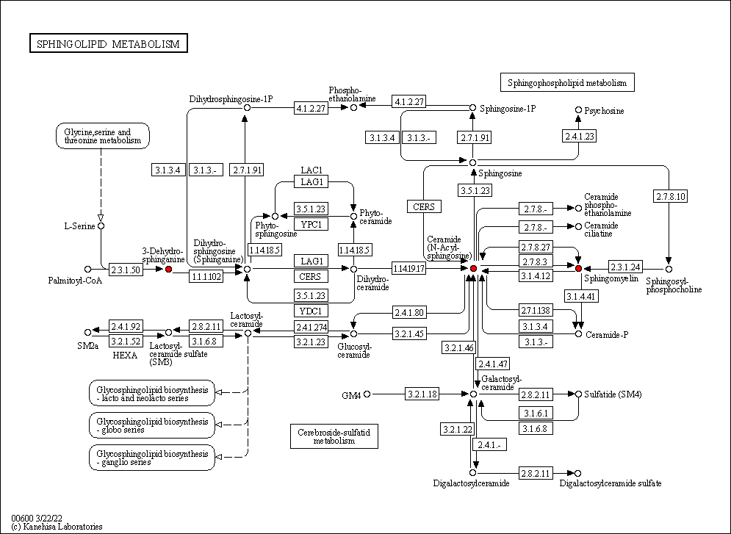
Figure S3-1 Sphingolipid metabolism diagram from KEGG:Metabolites involved in sphingolipid metabolism are in red

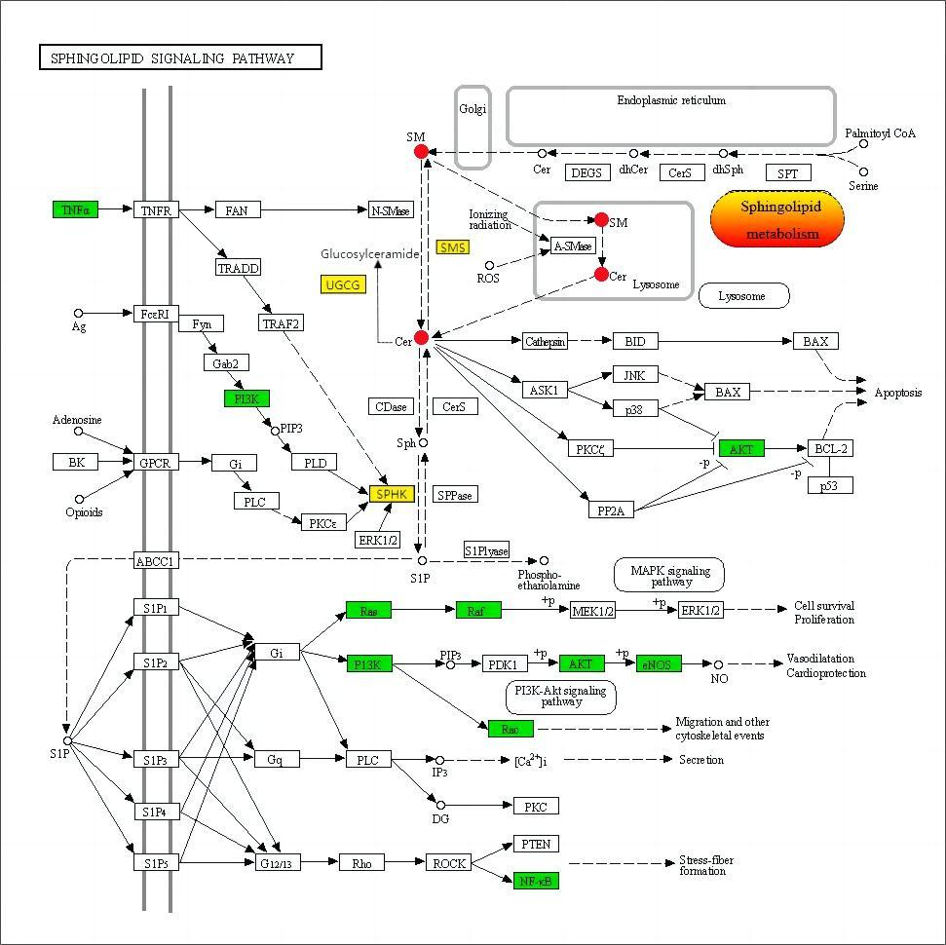
Figure S3-2 Results of target proteins of baicalin with pathway in KEGG database.The red part is metabolites involved in the sphingolipid signalling pathway.Green is the target of baicalin modulation.Yellow for enzymes related to sphingolipid metabolism

Figure S3-3 Targets of baicalin in the regulation of sphingolipid signaling pathway

