Supporting Information

Materials
All reagents and solvents were commercially available and utilized directly without further purification unless specified. JC-1 staining Kit, Calcein AM/PI Detection Kit, and Hematoxylin and Eosin Staining Kit was provided byNanJingKeyGen Biotech Co., Ltd. (China).Cell Counting Kit-8 was ordered from Dojindo Laboratories (Kumamoto, Japan).
3,3',5,5'-Tetramethylbenzidine (TMB), methylene blue (MB), copper(II) sulfate (CuSO₄), phosphotungstateacid,ammonium persulphate, aniline were purchased fromAladdin. Propidium iodide (PI), calcein acetoxymethyl ester (Calcein AM),5,5-dimethyl-1pyrroline N-oxide (DMPO), 4’,6-diamidino-2-phenylindole (DAPI), and 2,7-dichlorofluorescin diacetate (DCFH-DA) were purchased from Alfa Aesar. PVP(M_{w}= 5000) were provided by Adamas-beta. 5,5’-Dithiobis(2-nitrobenzoic acid) was ordered from Tokyo Chemical Industry.
Mouse fibroblast cells (L929 cells) and mouse breast carcinoma cells (4T1 cells) lines were kindly provided by the Department of Cell Biology, School of Basic Medicine, Southern Medical University. The use of the L929 and 4T1 cell lines have been approved by the ethical review board Southern Medical University.
Instruments
UV absorption spectrum were performed withThermofisher Evolution 300 spectropolarimeter. Infrared spectroscopy (IR) was recordedon a Shimadzu FTIR-8100 spectrophotometer. The size distribution of nanoparticles was characterized by Zetasizer Nano series (Nano ZS90, Malvern Instrument Ltd.). The TEM was recorded on JEM-1400plus.Particle size was detected by Zetasizer Nano ZS (Malvern Panalytical, UK). Photoacoustic images were captured with an MSOT system (iThera Medical, Germany). Infrared thermography was captured by TiS40 infrared camera (Fluke, USA). The XPS was provided by Kratos Axis Ulra DLD (Kratos, UK). TheESRwas recorded by Bruker ELEXSYS-II E500 CW-EPR. Cellular fluorescence images were obtained by an Olympus IX70 inverted microscope. The contents of Cu and W were determined by inductively coupled plasma spectrometry (720ES, Agilent).

Calculation of Photothermal Conversion Efficiency
The photothermal conversion efficiency for CuPW@PANINanorods was calculated by measuring the temperature change of CuPW@PANINanorods aqueous dispersion as a function of time under the continuous irradiation of 1064 nm laser (0.7 W/cm²) for 1050 s (t) till the temperature of solution reached a steady-state case. The photothermal conversion efficiency (η) was calculated by Equation. (1),
η = [hA(T_{max}- T_{surr}) - Q_{Dis}]/[I(1 - 10^{-A}_{λ})] (1)
where h is the heat transfer coefficient, A the area of the container, T_{max} the maximum steady-state temperature (61.9 °C), T_{Surr} the ambient temperature of the environment (30.0°C), Q_{Dis} represents the heat dissipation from the light absorbed by the solvent and the sample cell, I is the incident laser power (0.7 W/cm²), and A_{λ} is the absorbance of the sample at 1064 nm (0.51196). The value of hA was calculated by Equation. (2),
hA = m_{D}c_{D}/τ_{s} (2)
Where τ_{s} is the time constant for the heat transfer in the system, which was accessed based on the measurements (τ_{s} =310.4 s); and m_{D} and c_{D} is the mass (1 g) and heat capacity (4.2 J/g) of the DI water used to disperse CuPW@PANINanorods, respectively. The photothermal conversion efficiency of CuPW@PANINanorods was calculated to be 45.14%.
Cell Culture and Cytotoxicity Assay
Mouse fibroblast cells (L929 cells) and mouse breast carcinoma cells (4T1 cells)lines were kindly provided by the Department of Cell Biology, School of Basic Medicine, Southern Medical University. The use of the L929 and 4T1 cell lines have been approved by the ethical review board Southern Medical University.
Mouse fibroblast cells (L929 cells) and mouse breast carcinoma cells (4T1 cells) were cultured with dulbecco’s modified eagle medium (DMEM) medium with 10% fetal bovine and 1% penicillin–streptomycin in 5% CO₂ incubator at 37 °C.
Cytotoxicity of CuPW@PANI Nanorods was evaluated by CCK-8 assay. Specifically, 4T1or L929 cells were seeded into 96-well plates at a density of 1×10⁶cells/well and incubated with CuPW@PANI Nanorods with different concentrations (0, 6.25, 12.5, 25, 50, 100, or 200 µg/mL) for 24 h. The viability of cells in the dark was measured by the CCK-8 assay. The absorbance at 450 nm was recorded on a microplate reader (BioTek Synergy HT, USA). All experiments were conducted in triplicate and presented as mean ± SD compared to the OD values of untreated cells.
In vitroability to kill tumor cells
4T1 cells (1×10⁴ cells/well) were seeded on 96-well plates and incubated overnight at 37 °C container. Then, 4T1 cells were treatedwithfivegroups:(1) PBS: incubation with PBS for 4h,(2) CuPW@PANI Nanorods: incubation with CuPW@PANINanorodswith a concentration of 100 µg/mL for 4 h, (3) CDT: incubation with CuPW@PANINanorodswith a concentration of 100 µg/mL for 4h, then incubation with100 µM H₂O₂ for 4 h,(4) NIR-II PTT: incubation with CuPW@PANINanorodswith a concentration of 100 µg/mL for 4 h, then irradiated with the 1064 nm laser (0.75 W/cm²) for 5 min,(5) CDT+NIR-II PTT: incubation with CuPW@PANINanorodswith a concentration of 100 µg/mL for 4h, then incubation with100 µM H₂O₂for 4 h, then irradiated with the 1064 nm laser (0.75 W/cm²) for 5 min). After treatment, the treated cells were incubated for another 3 h and rinsed with PBS for further cytotoxicity assay. The standard CCK-8 assay was employed to determine the relative viabilities of treated cells. To detect intracellular ROS levels, DCFH-DA was used as an ROS fluorescence probe by incubating the cells for 10 min. Similarly, for the JC-1assay, the culture medium was replaced with JC-1 staining solution according to the manufacturer’s protocol. For live/dead staining, the treated cells were stained with Calcein-AM and PI for 15 min. After rinsed by PBS, the cell samples were observed with a fluorescence microscopy (FV1200-IX83, Olympus, Japan) and FACS Caliburflow cytometer using 488 nm laser for Annexin V-FITC and 561 nm laser for PI excitation.
Animal Experiments
Animal experiments were performed according to the Guidelines for theCare and Use of Laboratory Animals of Animal Centre of South MedicalUniversity.Animal experiment is in accordance with the regulations of the Animal Ethical and Welfare Committee of Southern Medical University (SYXK2016-0167).Female Balb/c mice (5~6 weeks old) were ordered from the Animal Centre of South Medical University. Female Balb/c mice were subcutaneously transplanted with 4T1 cancer cells (100 μL, 2 × 10⁶ cells) andused for subsequent experiments when the tumor volume approached 100 mm³.

In vitro and in vivo PA imaging of CuPW@PANI Nanorods
CuPW@PANI Nanorods were prepared at the concentration of 0, 12.5, 25, 50, 100, 200 µg/mL, respectively. PA imaging was performed on a multispectral optoacoustic tomography (MSOT) inVision 256-TF small animal scanner (iThera Medical GmbH, Munich, Germany).
4T1 cells (2×10⁶) were seeded in a 75 cm² culture bottle. When cells reached exponential growth, the culture medium was discarded, and CuPW@PANI Nanorods (100 μg/mL) in culture medium was added into culture bottle and incubated for 4 h. The cells were washed entirely with PBS buffer, digested with trypsin and centrifuged, then re-suspended with 0.5% agarose solution. After cooling, the PA image was detected by the MSOT system.
4T1 tumor-bearing mouse were in anesthesia by 2% isoﬂurane in oxygen and placed in a prone position. After intravenous injection of CuPW@PANI Nanorods (100 μL,10 mg/kg), the MSOT system was used to captured the PA images of tumor area.
Evaluation of biodistribution.
4T1tumor-bearing mice (n = 3) were intravenously injected with CuPW@PANI Nanorods (10 mg/kg). At 3, 6, 12, and 24 h post-injection, the micewere sacrificed. Their major organs (heart, liver, spleen, lung, and kidneys) and tumors weredissected, rinsed with PBS, weighed, and dissolved in a mixed solution of HNO₃ and H₂O₂.The biodistributions in different organs and tumors were calculated as the Cu percentage ofthe injected dose per gram of tissue.
In vivoCDT enhanced NIR II Photothermal therapy anti-cancer evaluation.
Histological examination. Histological analysis was performed after treatment.Representative mice from various treatment groups were sacrificed. Subsequently, the tumors were excised and sectioned intothick slices for H&E staining. Photographs were obtained via CLSM.
TUNEL assay. Apoptotic cells were detected using an APO-BrdU TUNEL kit(Invitrogen, Catalog No. A35125). This assay was performed according to the manufacturer’s protocol. First, the slides were fixed with 4% paraformaldehyde in PBS for 10 min at roomtemperature. After washing with PBS, the slides were incubated in a permeabilization solutionfor 2 min. Subsequently, they were washed, and the tumor samples were incubated with aTUNEL reaction mixture (Colorimetric TUNEL Apoptosis Assay Kit) for 60 min at 37 °C ina humidified atmosphere in the dark. After gently rinsing with PBS, the slides were mountedand prepared for confocal luminescence imaging.
Evaluation of in vivo toxicity.
For long-term toxicity evaluation, healthy Balb/c mice(n =3) were intravenously injected with CuPW@PANI Nanorods (0, 10, 20, and 40 mg/kg). The body weights of all the mice were recorded every 4 days. After injection for 28d, all the mice were sacrificed. Before euthanizing the mice, their blood samples were collected for complete bloodpanel and blood biochemistry tests. For histological examination, mice from each group weresacrificed, and their main organs (heart, liver, spleen, lung, and kidney)were obtained for H&E staining.
In Vivo Assessment of anti-tumor property
When the tumor volume reached about 100mm³, mice bearing 4T1 tumor were randomly divided into five groups (n=4), including:(1) PBS: intravenousinjection with 100µL PBS,(2) CuPW@PANI Nanorods: intravenous injection with CuPW@PANI Nanorods (100 µL, 2.5 mg/kg),(3) NIR-II PTT: intravenous injection with CuPW@PANI Nanorods (100 µL, 2.5 mg/kg), 12h later NIR II irradiation (1064 nm, 0.75 W/cm², 10 min),(4) CDT: intravenous injection with CuPW@PANI Nanorods (100 µL, 2.5 mg/kg), 12h later intratumoral injection H₂O₂ (100µL 100µM), (5) CDT+NIR-II PTT: intravenous injection with CuPW@PANI Nanorods (100 µL, 2.5mg/kg), 12h later intratumoral injection H₂O₂ (100µL 100µM) then NIR II irradiation (1064 nm, 0.75 W/cm², 10 min). Body weights and tumor volumes wererecorded every other day after treatments. The tumor volume was measured according to the following equation: volume = length × width²× 0.5. The mice were sacrificed on the 14th day,the tumor weregathered for H&E staining and Tunnel staining.
Statistical analysis
All data shown in this article are from at least three independent experiments and expressed as means ± standard deviation (SD). Analysis of variance was carried on multiple group comparisons, and the result of *P<0.05 was statistically significant.

Table S1Release of Cu and W of CuPW@PANI Nanorodsstored in PBS(pH=7.4 or 6.0 ) for 7 days.
 | pH=7.4 | pH=6.0
Cu(mM) | trace | trace
W(mM) | trace | trace

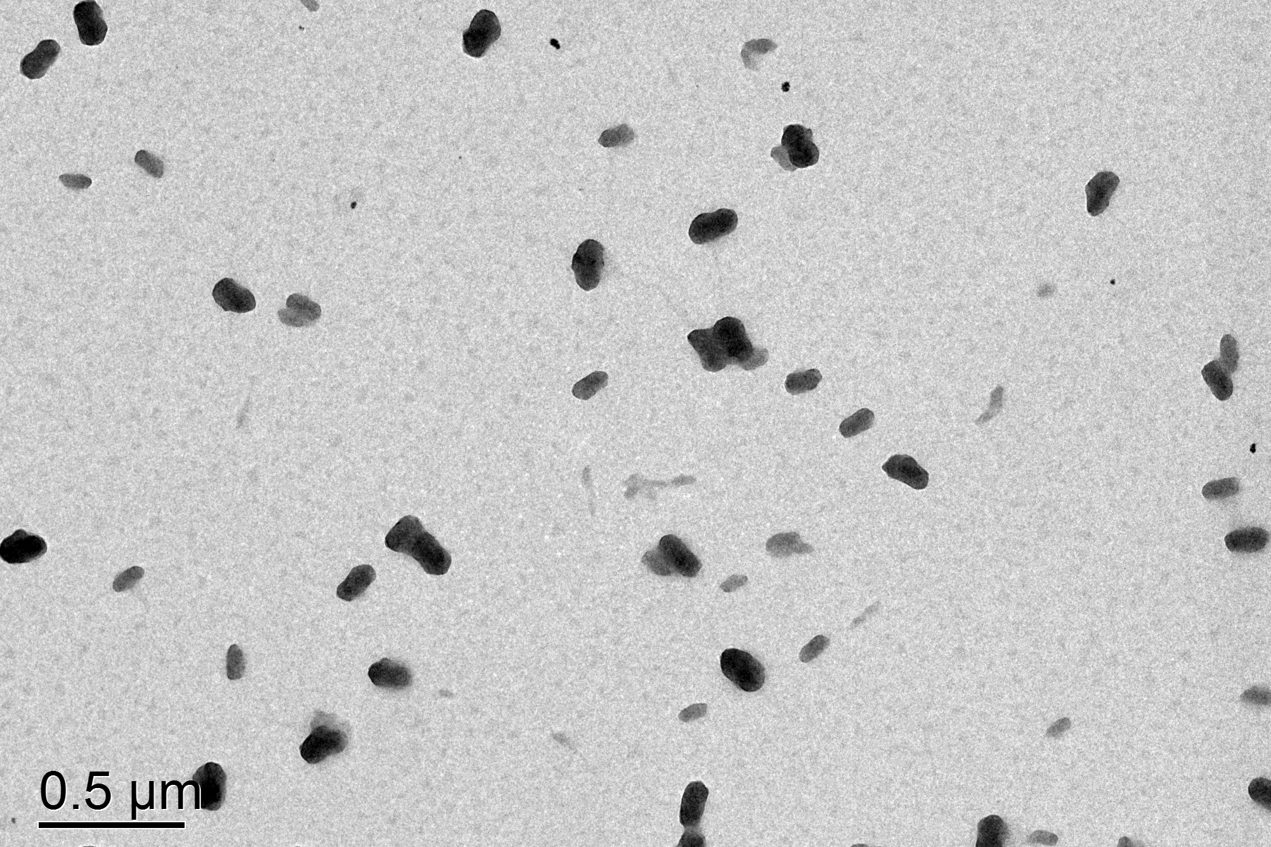
Figure S1 The TEM ofCuPW@PANI Nanorods.

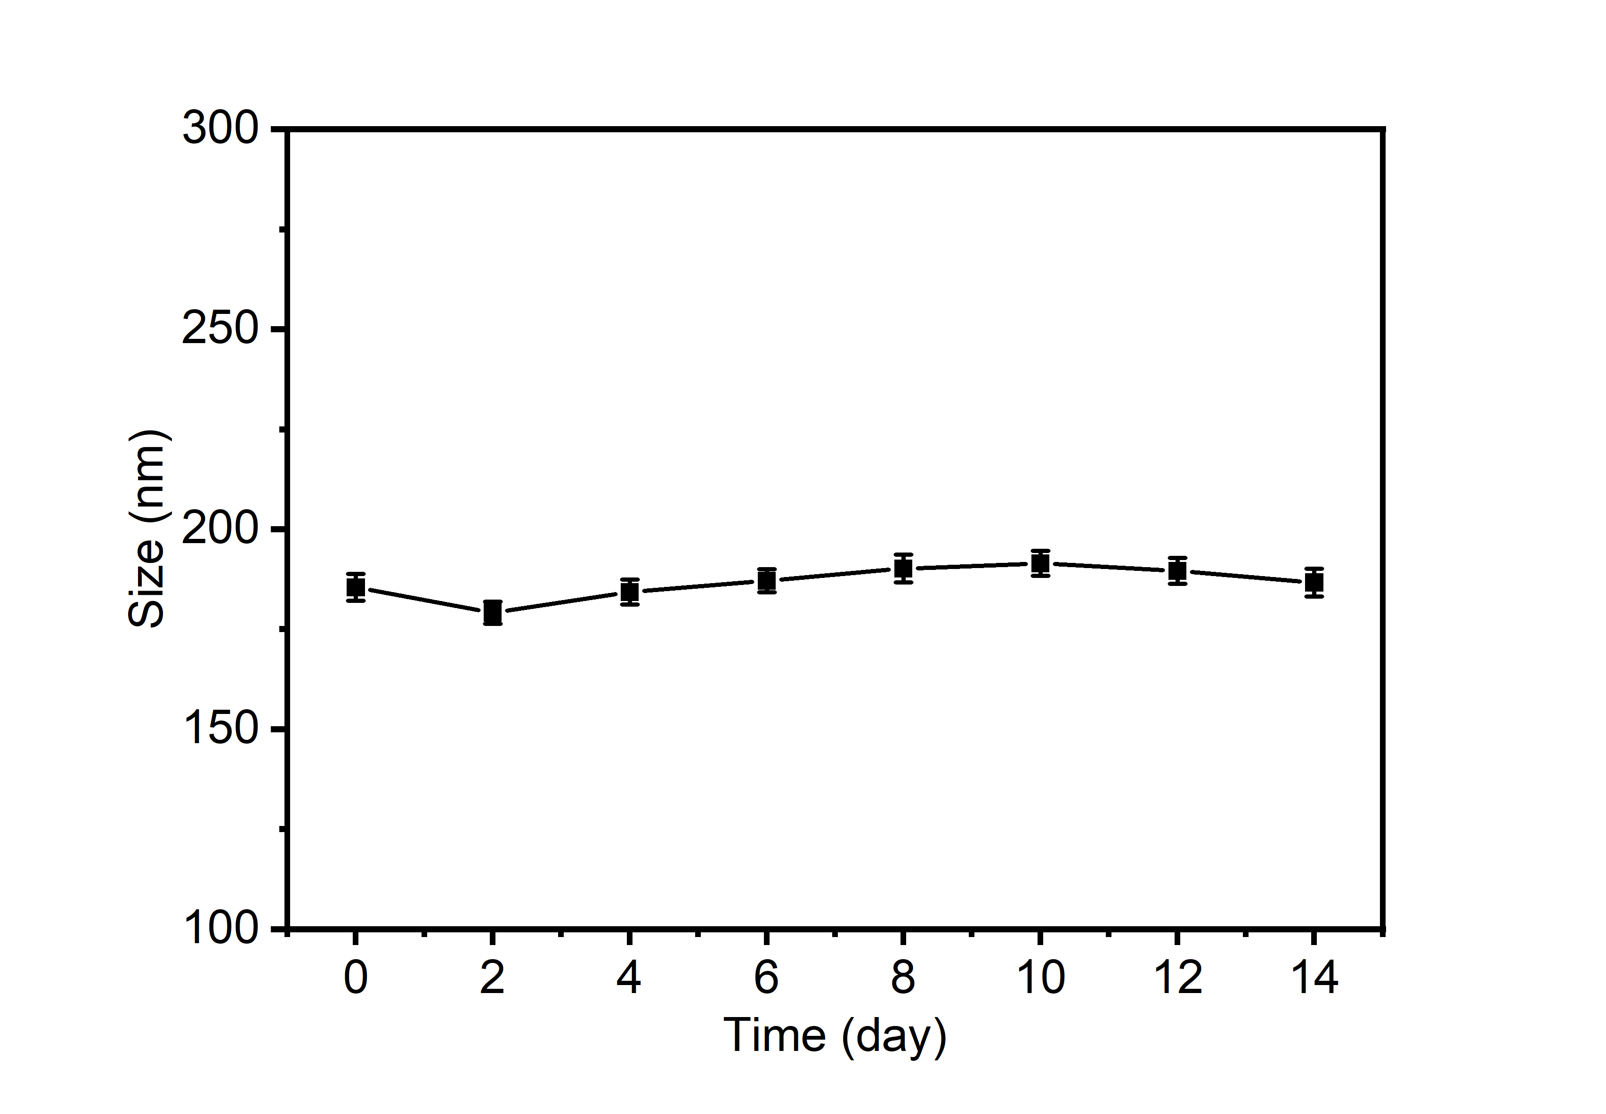
Figure S2.The size of CuPW@PANI Nanorodsstoredat r.t. for14 days.

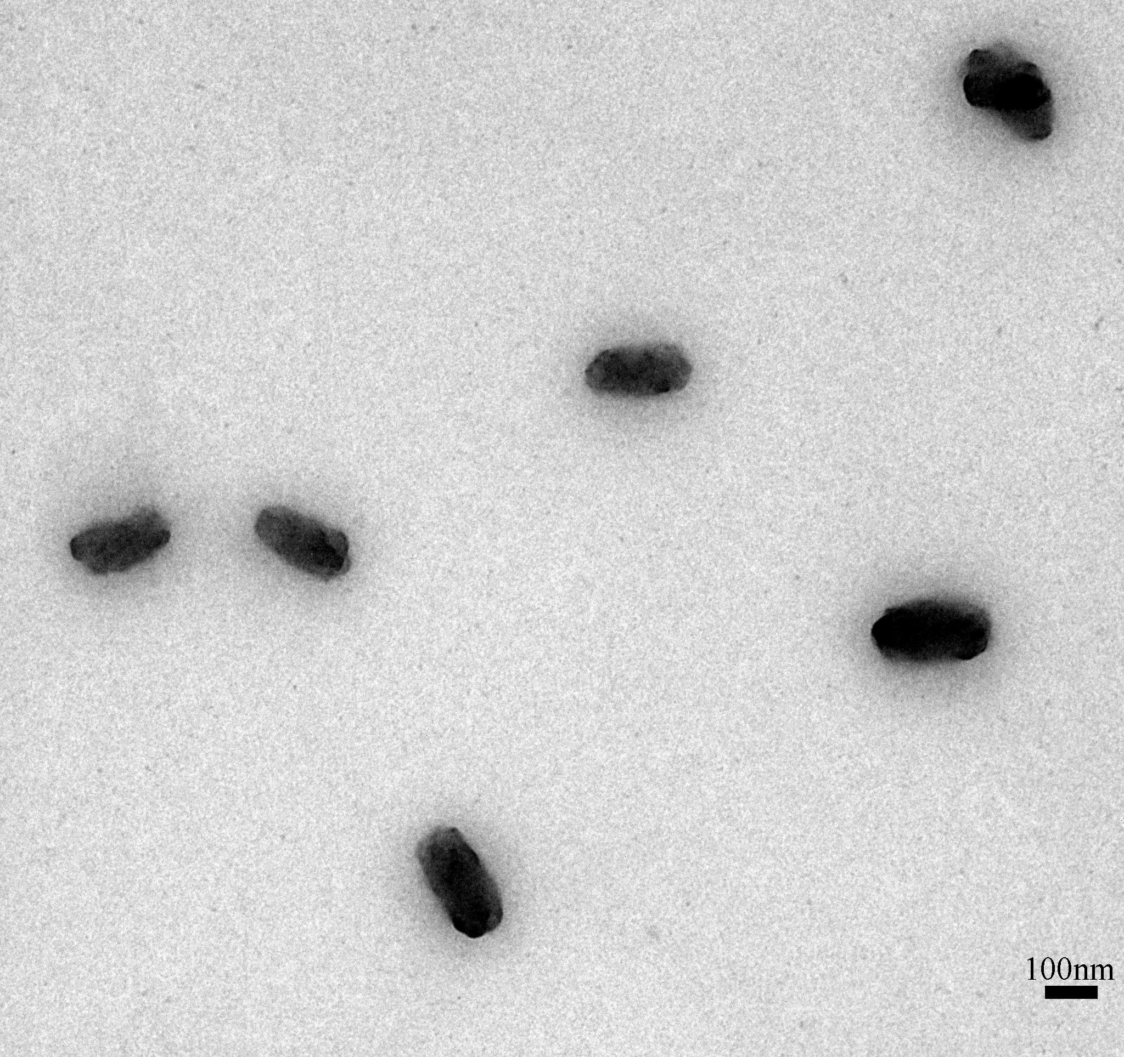
Figure S3.The TEM of CuPW@PANI Nanorodsstored in PBS(pH=6.0) for 7 days.
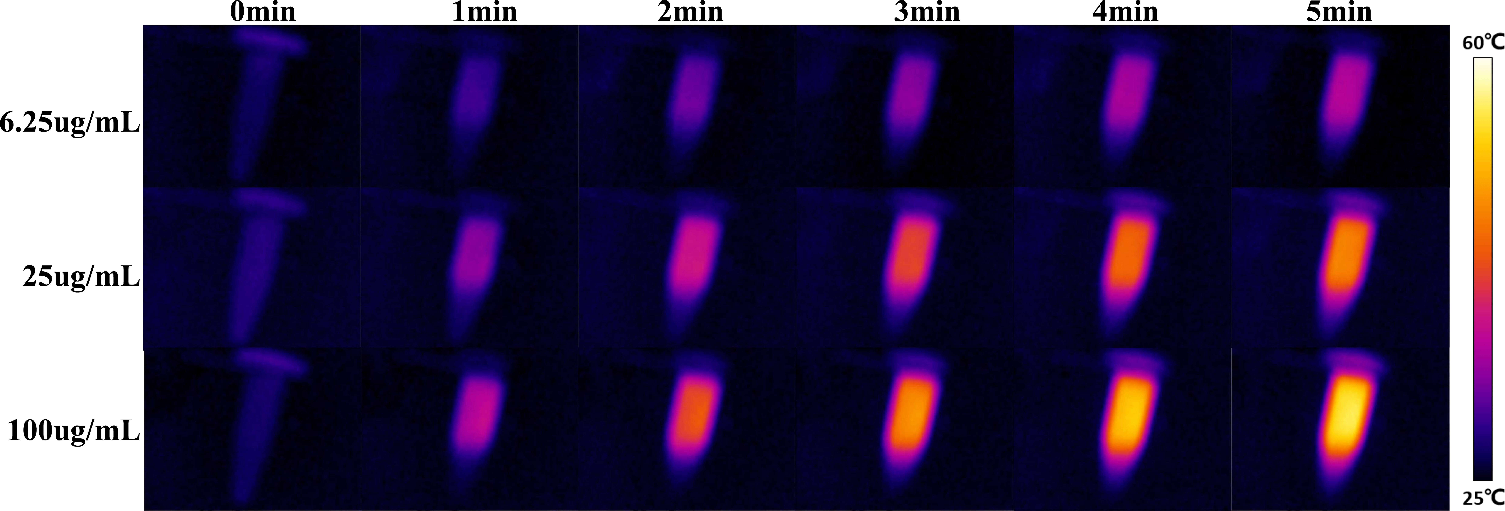
Figure S4.Infrared (IR) thermal images of CuPW@PANI Nanorods (6.25, 25, 100μg/mL) under 1064 nm laser irradiation (1.0 W/cm²) at different time points.

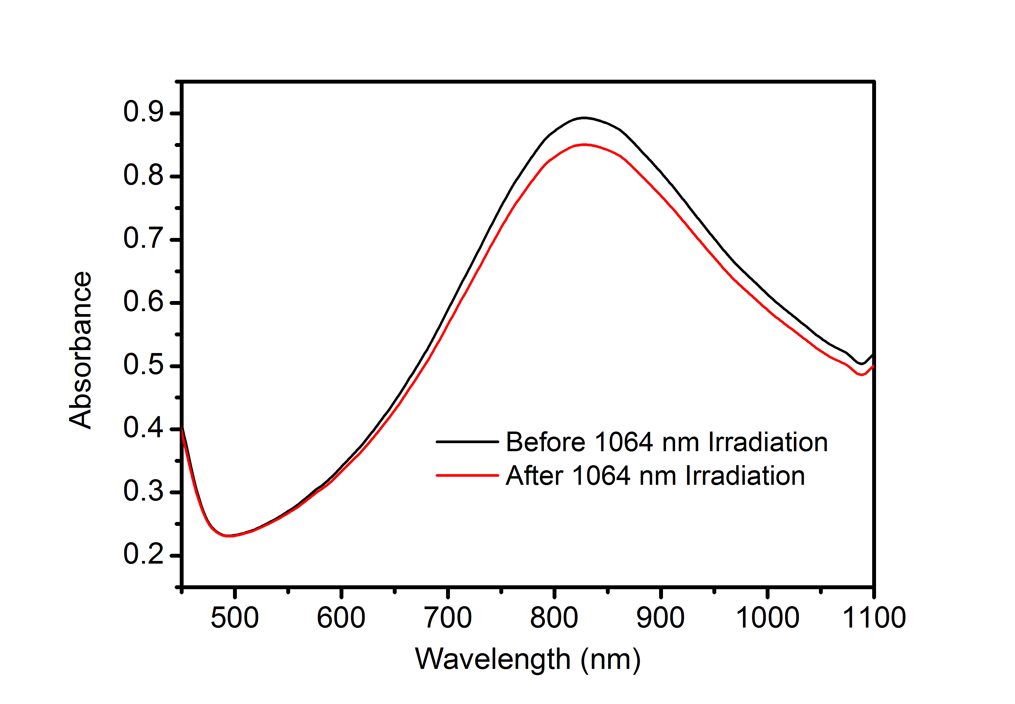
Figure S5.The UV-vis absorption spectrum of CuPW@PANI Nanorods after 1064 nm laser irradiation for 30 min.

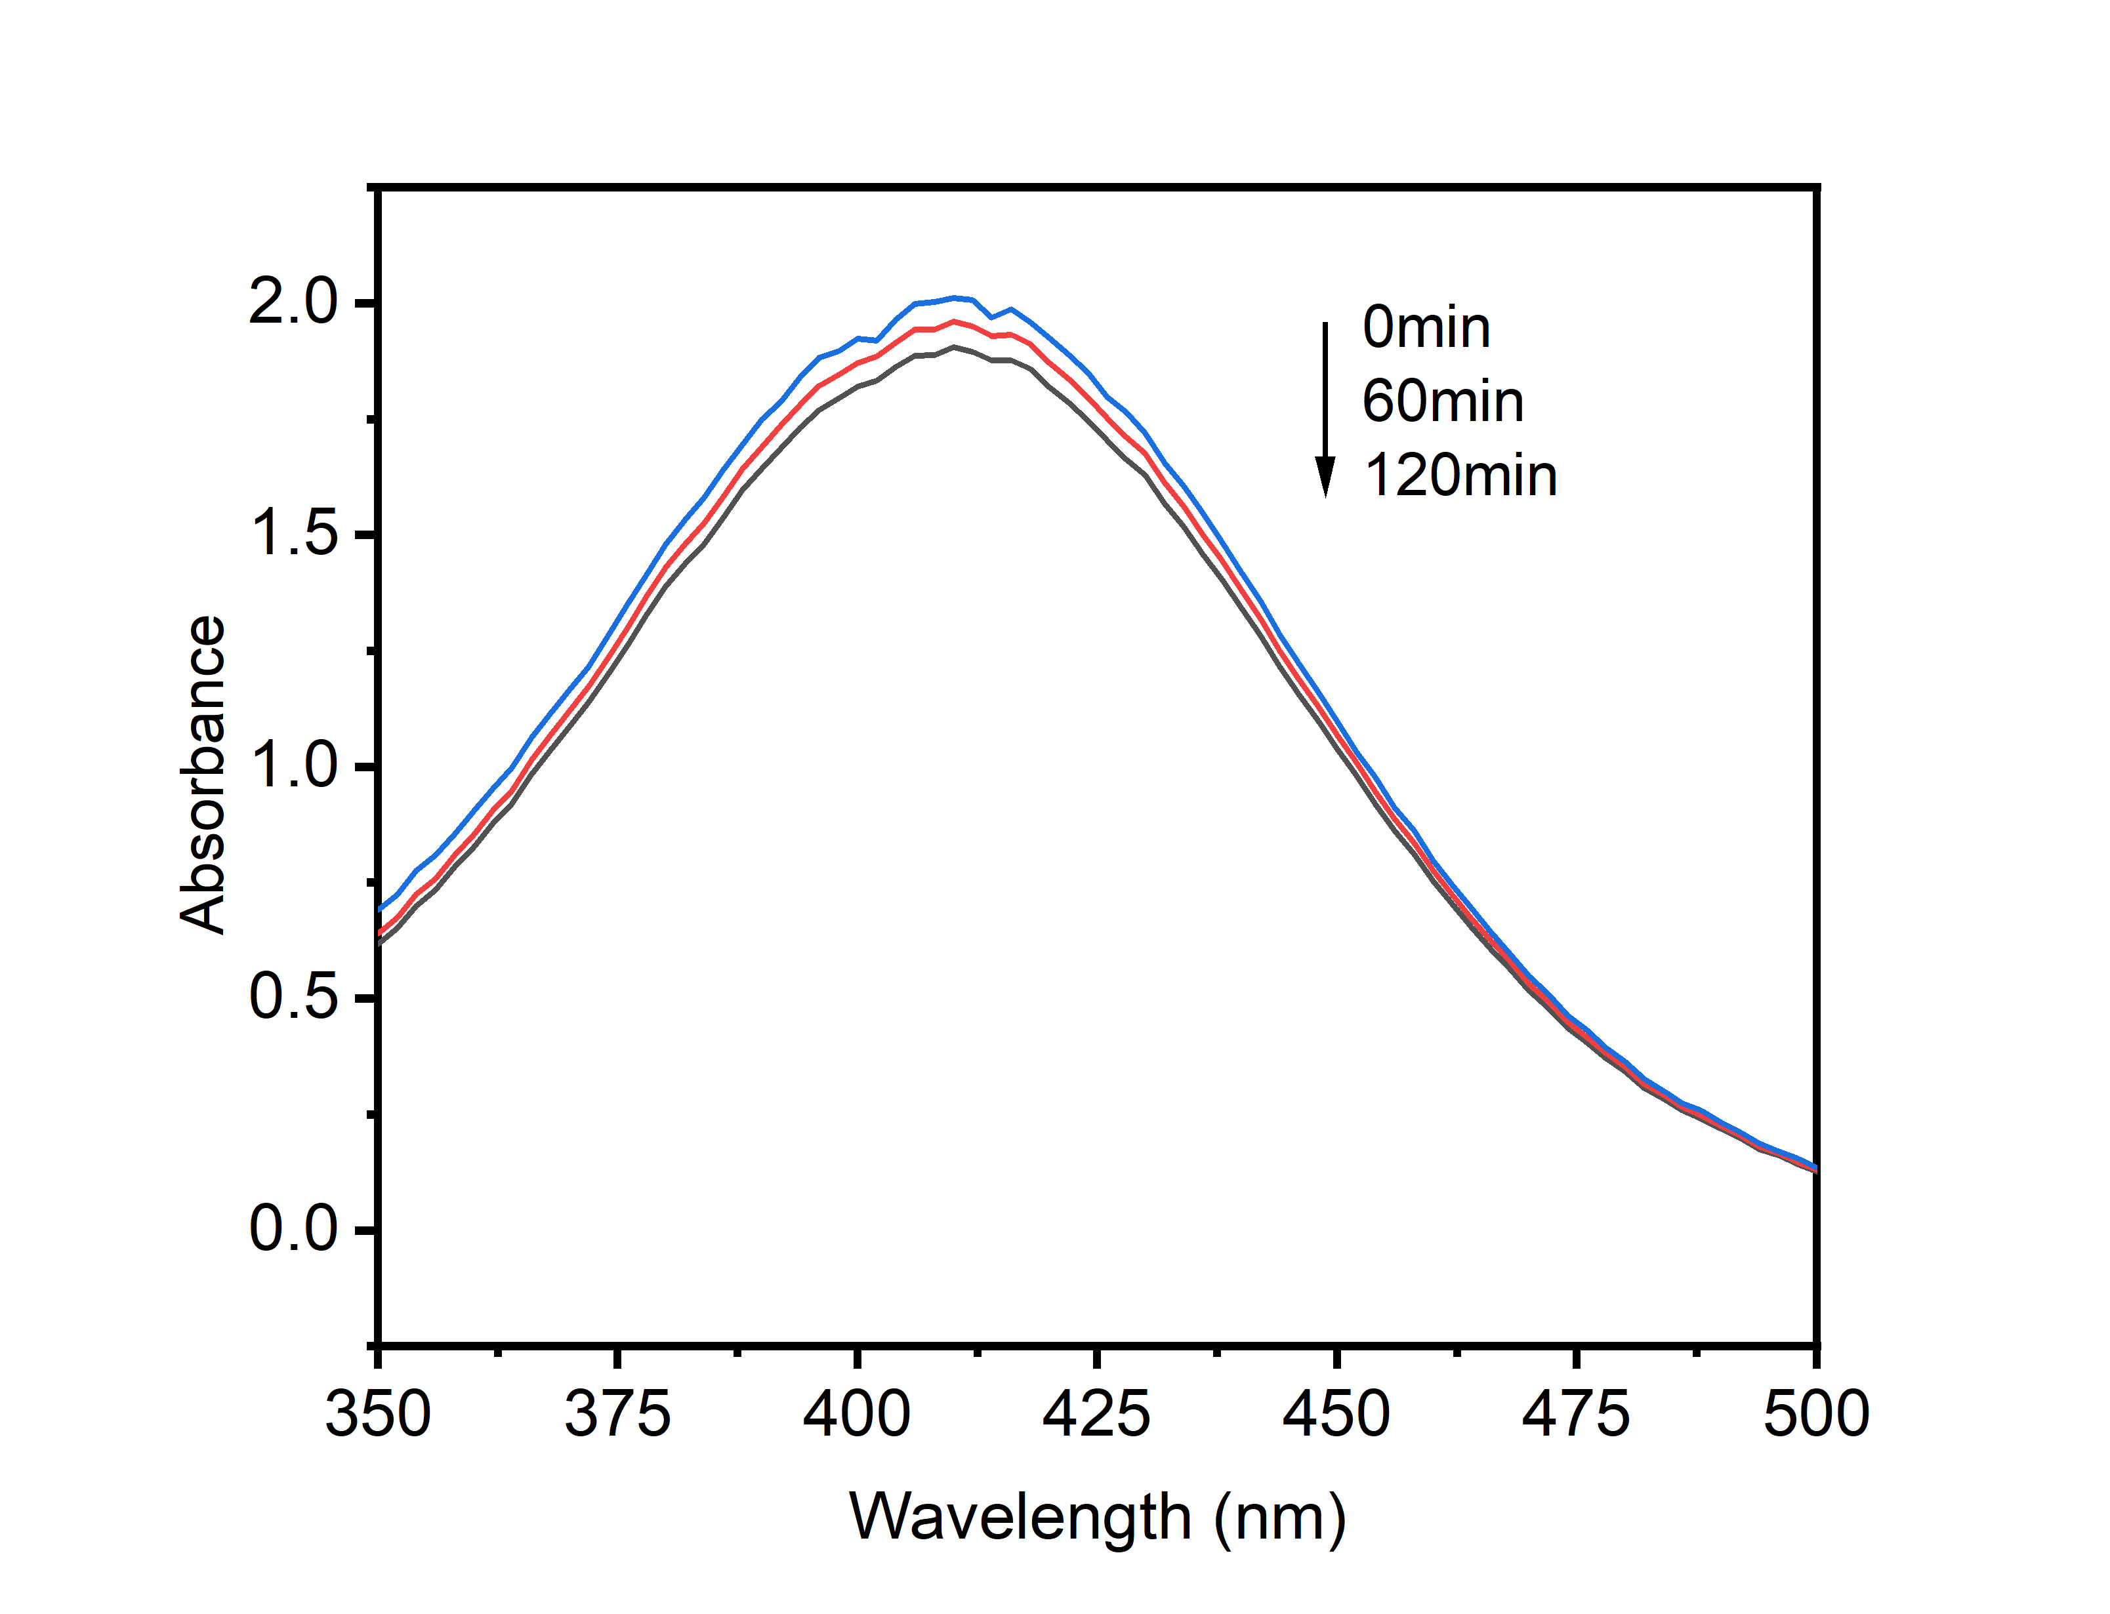
Figure S6The absorption of DTNB incubated with GSH after different duration.

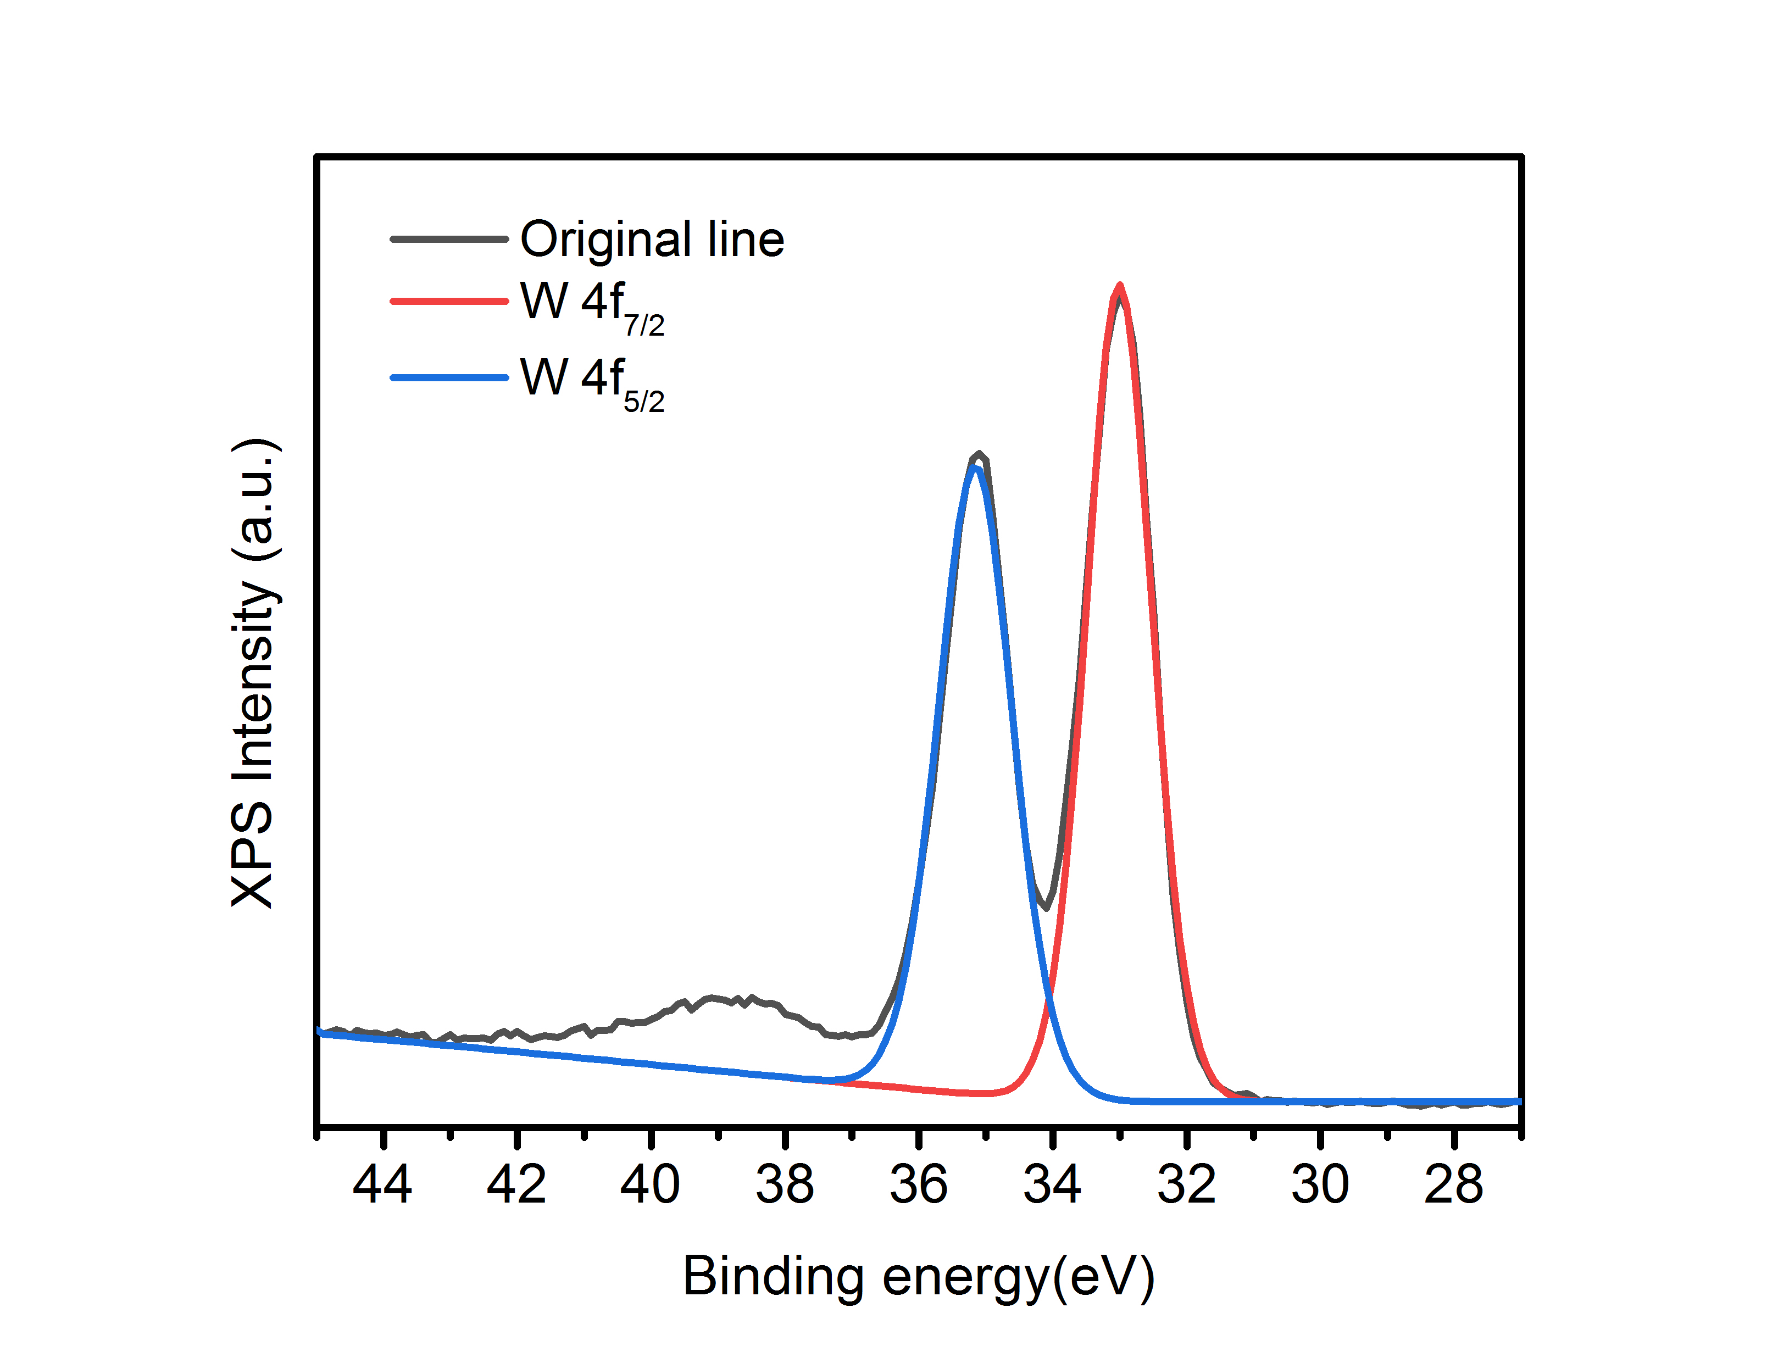

Figure S7.XPS spectrum of W4f in CuPW@PANI Nanorods after reaction with GSH.
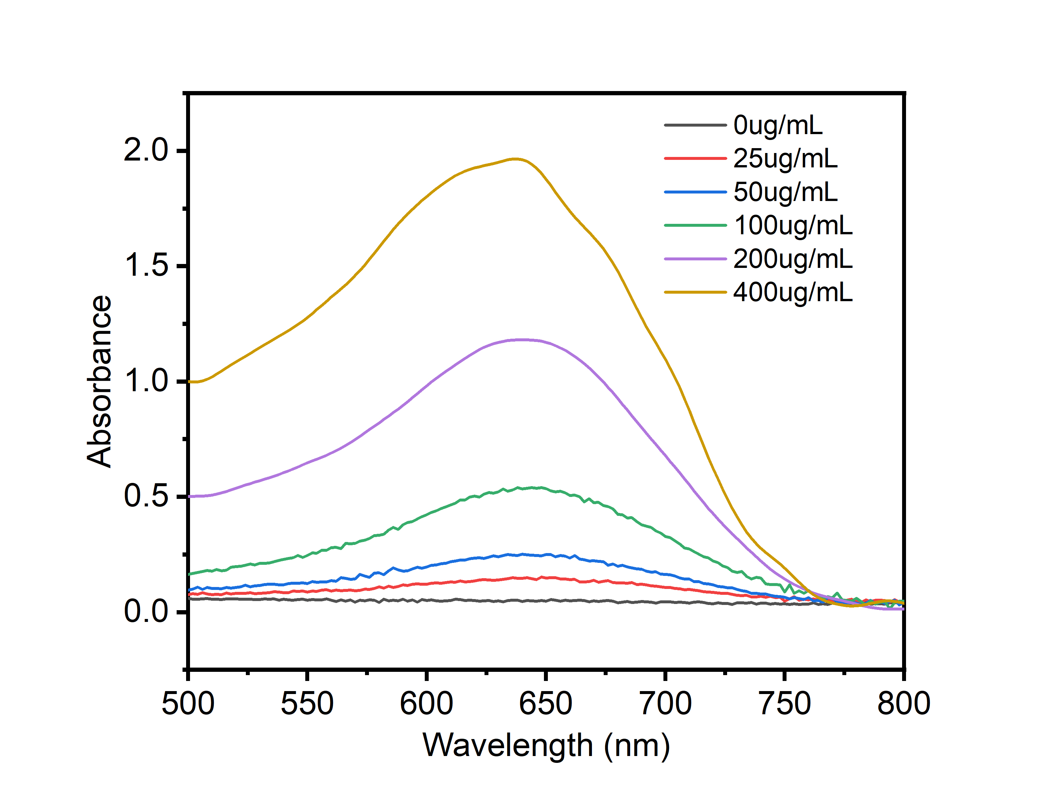
Figure S8. The UV-vis spectrum of TMB reaction with CuPW@PANI Nanorods with different concentration.

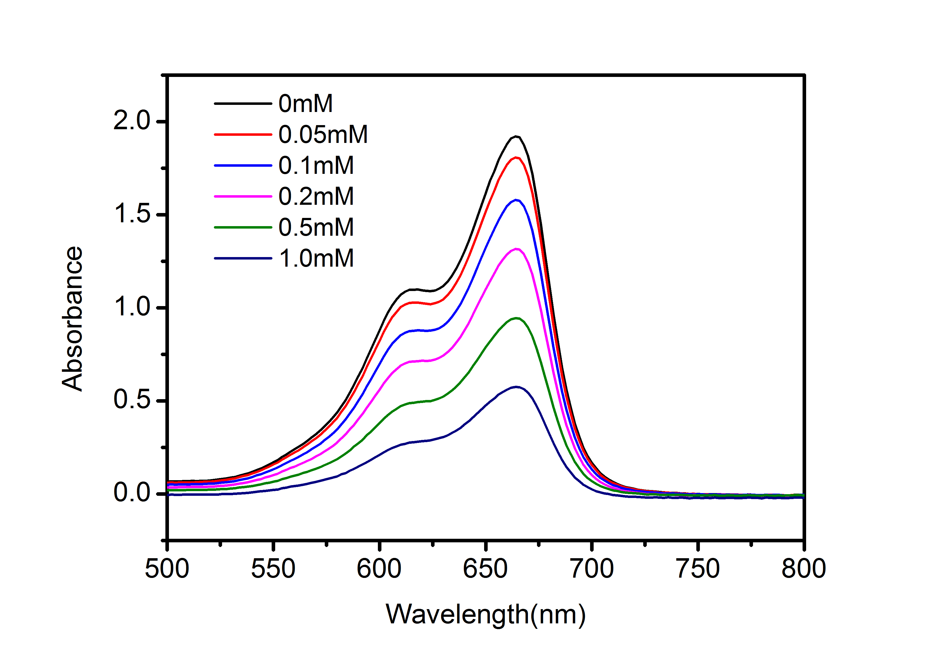
Figure S9.The UV-vis spectrum of MB reaction with CuPW@PANI Nanorods and different concentration H₂O₂.

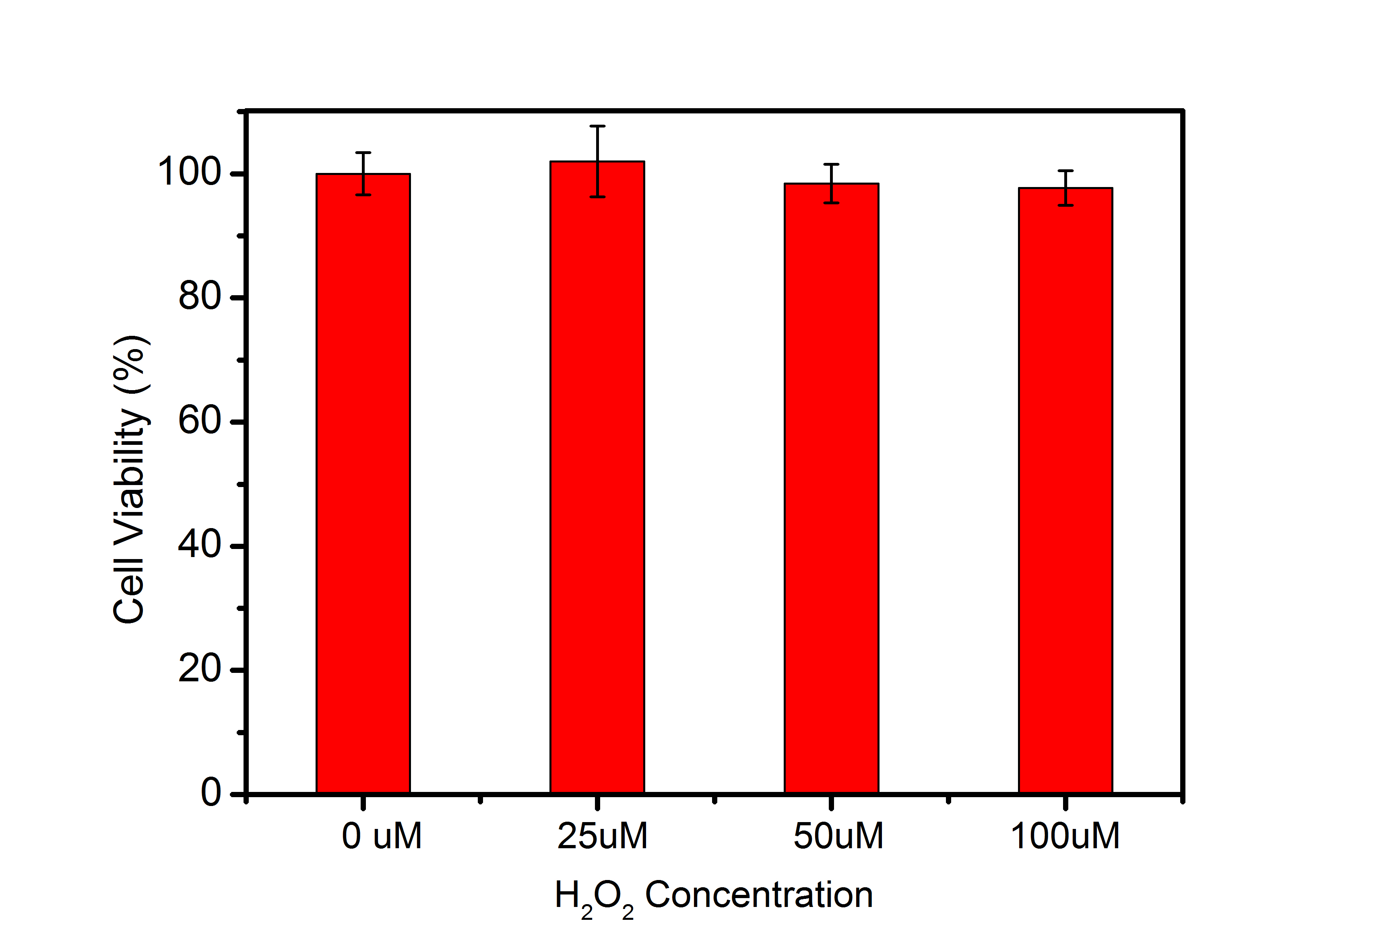
Figure S10 Cytotoxicity of 4T1 cells after incubation with H₂O₂ for 24h.

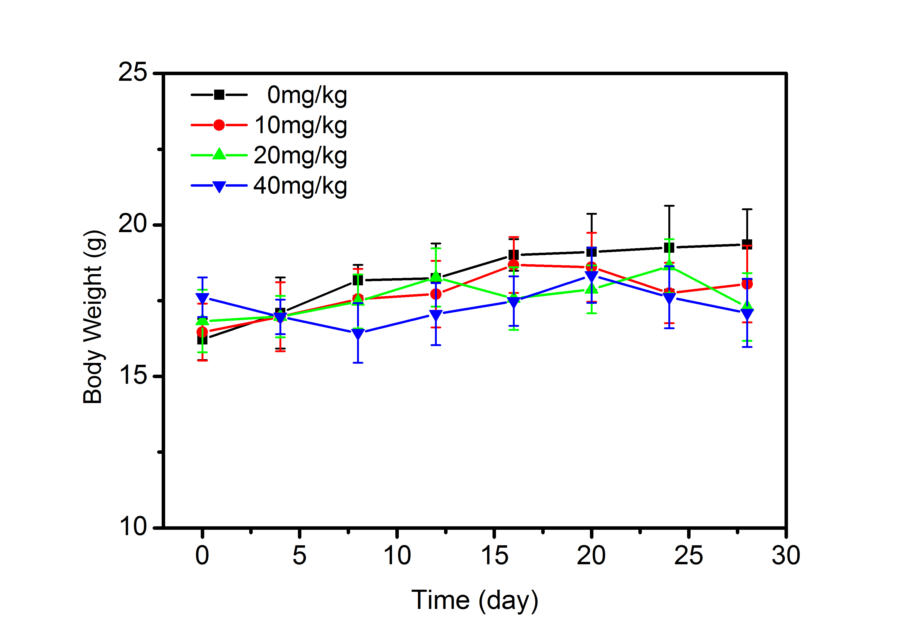
Figure S11. The body weight of mice after injection with CuPW@PANI Nanorods with different concentration.

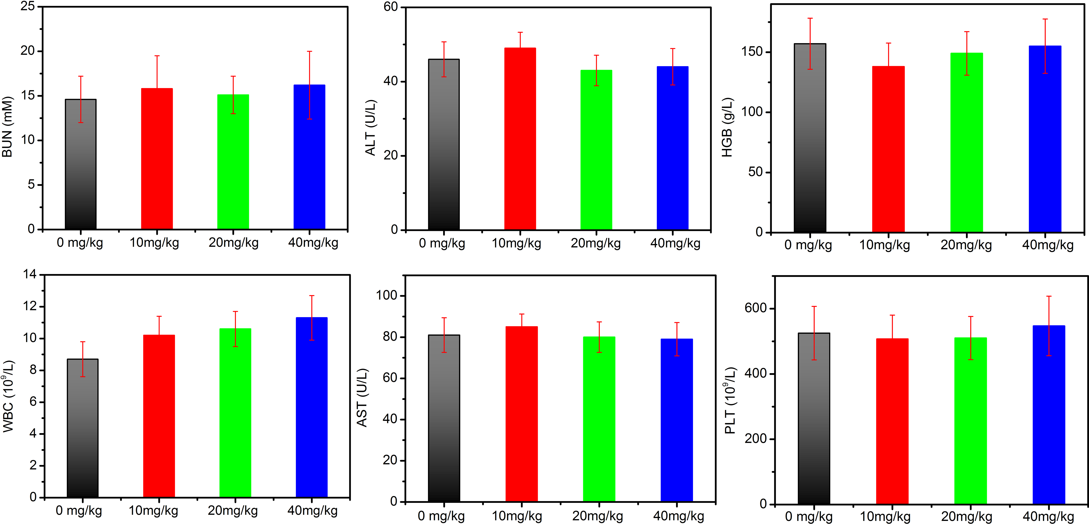
Figure S12.The blood index of mice after injection with CuPW@PANI Nanorods with different concentration.

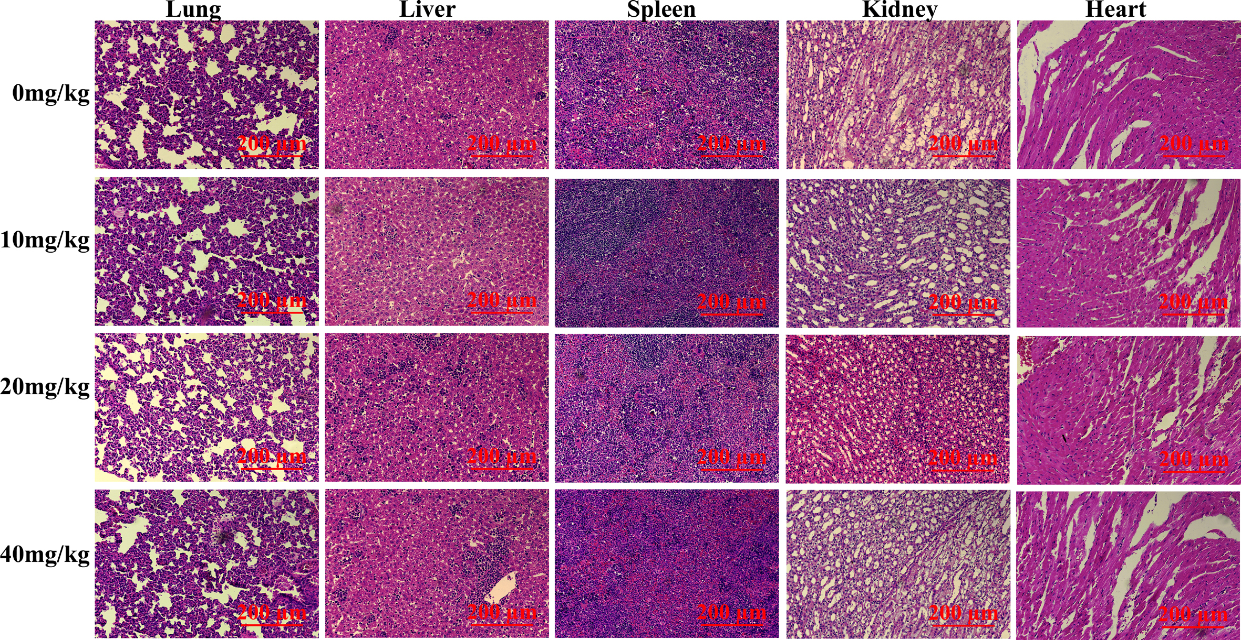
Figure S13.The H&E staining of major organs in mice after injection with CuPW@PANI Nanorods with different concentration.

