Supporting Information

Chemicals and reagents
All reagents were used as received without further purification. Luria-Bertani (LB) broth was purchased from Qingdao Hope Biotechnology (Qingdao, China). Columbia blood agar medium (blood agar plates) was obtained from Guangzhou Detgerm Microbiological Science (Guangzhou, China). L929 cells were obtained from the American Type Culture Collection (ATCC; Manassas, VA, USA). SD rats were obtained from Minhou Runyi Laboratory Animal Technology Co., Ltd. (Beijing, China). Methicillin-resistant Staphylococcus aureus MRSA (ATCC 43300), S. aureus (ATCC 29213), E. coli (ATCC 25922), and P. aeruginosa (ATCC 27853) were obtained from ATCC. Ultrapure water was generated using a Milli-Q system (Millipore Sigma, Burlington, MA, USA) and was used in all experiments.

Characterization
Fourier-transform infrared (FTIR) spectra were recorded on a PerkinElmer Spectrum-2000 FTIR spectrophotometer (4000-400 cm⁻¹; PerkinElmer, Waltham, MA, USA) with powdered samples spread on a KBr plate. Powder x-ray diffusion (XRD) patterns were obtained using a Philips X’Pert-MPD diffractometer (Philips, Amsterdam, Netherlands) with Cu Kα radiation (λ =1.54056 Å). The absorption spectra were measured using a PerkinElmer Lambda 900 ultraviolet-visible spectrophotometer (UV/VIS) (PerkinElmer) equipped with an integrating sphere at 293 K, and BaSO₄ plates were used as a reference. ¹H nuclear magnetic resonance spectroscopy (NMR) spectra were recorded on a Bruker AVIII 400 spectrometer (Bruker, Billerica, MA, USA), and chemical shifts were reported in parts per million (ppm) downfield from tetramethylsilane. Scanning electron microscopy SEM (JSM-7600F, JEOL Ltd., Tokyo, Japan) was used to study the morphology of the bacteria.

Disk diffusion assay
The inhibitory zone diameters of (1,4-DBTPP)Br₂ against three strains were performed with the agar diffusion method. ¹ The concentration of bacterial suspensions was adjusted to 1.0 × 10⁸ colony forming units per mL (Cfu mL⁻¹). The solid media plate was swabbed with the bacterial suspension and incubated for 30 min for absorption. Filter paper discs (6.0 mm in diameter) were soaked with suspensions of (1,2-DBTPP)Br₂, (1,4-DBTPP)Br₂, (1,6-DBTPP)Br₂ and placed on the surface of the inoculated agar plates. Petri dishes were incubated at 37 ℃ for 24 h. The average diameters of the inhibition zone surrounding the discs were measured.

Determination of MIC and MBC
The minimum inhibitory concentrations (MICs) of the (1,2-DBTPP)Br₂, (1,4-DBTPP)Br₂ and (1,6-DBTPP)Br₂ against four bacterial strains were measured by the broth microdilution method according to the National Committee for Clinical Laboratory Standards method (NCCLS). MIC was determined in 96-well plates as previously reported. ² Briefly, methicillin-resistant Staphylococcus aureus strains (MRSA), Staphylococcus aureus, Escherichia coli, and Pseudomonas aeruginosa were respectively inoculated from fresh plates into LB broth and grown overnight at 35 ℃ with shaking at 250 rpm. The cells were harvested by centrifugation and re-suspended in fresh LB broth to a final concentration of 1.0 × 10⁶ cfu mL⁻¹. (1,2-DBTPP)Br₂, (1,4-DBTPP)Br₂ and (1,6-DBTPP)Br₂ were all serially diluted from 64000 to 4.0 μg mL⁻¹ in distilled water. Standardized bacteria suspension (180 µL) were added to each well. Phosphate buffered saline (PBS) was used as positive controls. The plates were incubated for 20 h at 35 ℃, and the MIC values of the (1,2-DBTPP)Br₂, (1,4-DBTPP)Br₂ and (1,6-DBTPP)Br₂ were defined as the lowest concentration of material at which no visible bacterial growth can be observed. Positive growth controls demonstrated visible turbidity after 20 h at 35 ℃. In order to determine the minimum bactericidal concentration (MBC) from the wells without visible growth, 10 μL was plated on blood agar plates, and the number of colonies was counted after incubation at 35 ℃ for 20 h. The MBC was defined as the lowest concentration to kill 99.9% of the start bacterial inocula. The experiment was performed in triplicates and repeated at least three times. ³

Reactive Oxygen Species (ROS) Generation Detection
DCFH-DA assay (Reactive Oxygen Species Assay Kit, Beyotime) was used to detect the level of bacterial ROS induced by (1,4-DBTPP)Br₂. ⁴ Briefly, MRSA cells at a final concentration of 10⁸ Cfu mL⁻¹ were inoculated with 10 µM of DCFH-DA in 1.5 ml centrifuge tubes at 37 ℃ for 30 min for probe loading. After removal of the unloaded DCFH-DA by centrifugation, the bacterial cells were treated with 1 × MIC, 2 × MIC, 4 × MIC of (1,4-DBTPP)Br₂ for 2 h. The samples were washed three times with sterile saline solution (0.9% NaCl). Sample without (1,4-DBTPP)Br₂ was set as control group. The amount of cellular ROS was measured as the relative fluorescence intensity of the probes, which was detected in a Multi-mode detection platform (Molecular Devices, SpectraMax i3x) in fluorescence mode with excitation at 488 nm and emission at 525 nm.
Statistical Analysis
GraphPad Prism 6 software (GraphPad Software, San Diego, CA, United States) was used to perform statistical analyses. All experiments were carried out in triplicate. Analysis of variance was used to analyze the data, and p < 0.05 was considered to be statistically significant.

Characterization of Products Quaternary Phosphorus Salts
(1,2-DBTPP)Br₂: IR (cm⁻¹): 3655(m), 3310(m), 3012(m), 2892(m), 2804(m), 1670(s), 1476(m), 1587(s), 1482(s), 1435(s), 1315(m), 1154(m), 1107(s), 997(s), 835(m), 715(s), 689(s), 532(s), 485(s). XRD patterns suggest its good crystalline phase. ¹H NMR (500 MHz, Chloroform-d) δ 8.00 – 7.95 (m, 12H), 7.77 – 7.73 (m, 6H), 7.65 (t, J = 7.8 Hz, 12H), 4.17 (d, J = 4.4 Hz, 4H).
(1,4-DBTPP)Br₂: IR (cm⁻¹): 3007(w), 2861(m), 2278(m), 1660(m), 1476(m), 1581(m), 1447(m), 1435(s), 1315(m), 1378(w), 1325(w), 1158(w), 1107(s), 991(s), 887(w), 809(m), 725(s), 683(s), 495(s), 448(s). UV-Vis: 214 and 270 nm. ¹H NMR (500 MHz, Chloroform-d) δ 7.94 – 7.87 (m, 12H), 7.75 – 7.71 (m, 6H), 7.68 (ddd, J = 8.6, 6.6, 3.4 Hz, 12H), 4.03 (t, J = 14.7 Hz, 4H).
(1,6-DBTPP)Br₂: IR (cm⁻¹): 3000(w), 2854(m), 2287(m), 1670(m), 1482(m), 1585(m), 1463(m), 1434(s), 1311(m), 1405 (w), 1328(w), 1160(w), 1111(s), 994(s), 860(w), 815(m), 719(s), 686(s), 495(s), 456(s). UV-Vis: 210 and 267 nm. ¹H NMR (500 MHz, DMSO-d₆) δ 7.39 – 7.30 (m, 30H), 2.11 (s, 1H), 2.07 (p, J = 1.9 Hz, 11H).

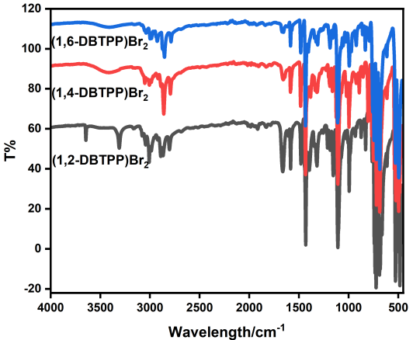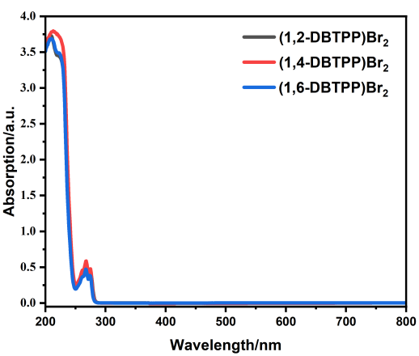

(A) (B)

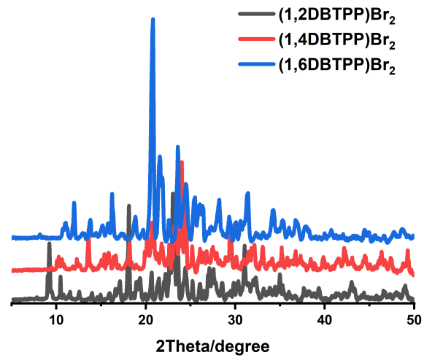

(C)

Figure S1 Characterizations of (1,2-DBTPP)Br₂, (1,4-DBTPP)Br₂, and (1,6-DBTPP)Br₂: (A) FT-IR spectra; (B) UV-Vis spectra; (C) XRD patterns.
(A)
(B)
(C)
Figure S2 ¹H NMR spectra: (A) (1,2-DBTPP)Br₂; (B) (1,4-DBTPP)Br₂; (C) (1,6-DBTPP)Br₂
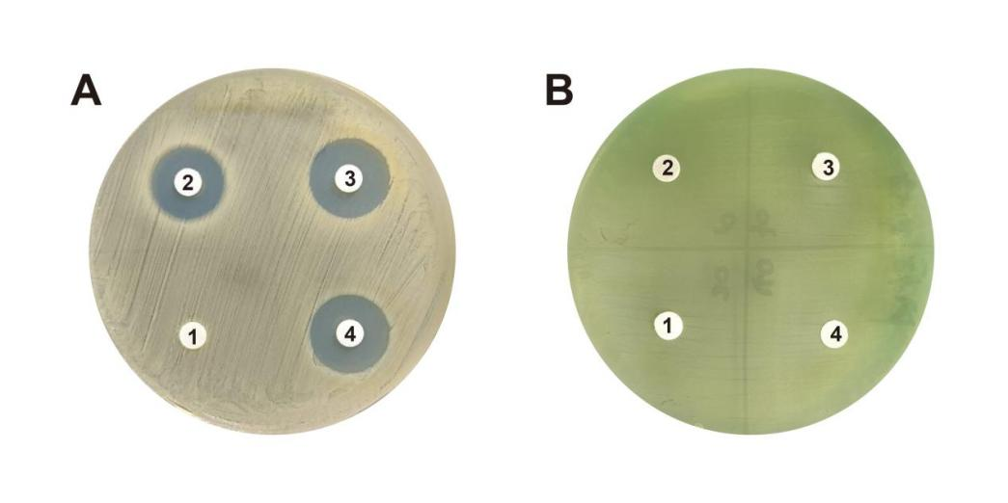
Figure S3 Disk diffusion assay for (1,2-DBTPP)Br₂, (1,4-DBTPP)Br₂ and (1,6-DBTPP)Br₂ by using (A) Methicillin-resistant Staphylococcus aureus (MRSA) and (B) Pseudomonas aeruginosa (PA). 1–4: PBS, (1,2-DBTPP)Br₂, (1,4-DBTPP)Br₂, and (1,6-DBTPP)Br₂.

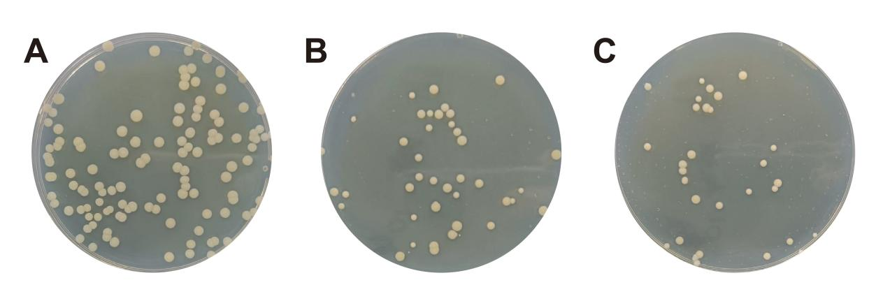

Figure S4 Images of MRSA colonies spread on LB agar plates at 6 h with (A) 1 × MIC, (B) 2 × MIC and (C) 4 × MIC of (1,4-DBTPP)Br₂.

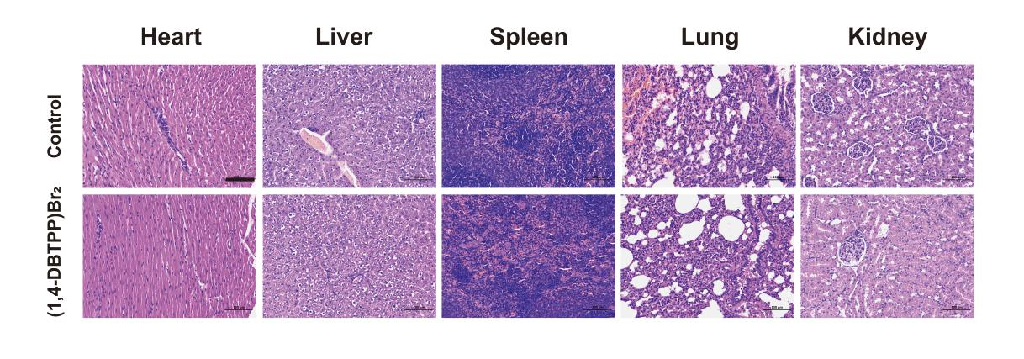
Figure S5 Histological photographs of heart, liver, spleen, lung, and kidney of the MRSA infected mice after treated by (1,4-DBTPP)Br₂ and PBS for 12 days, respectively. The scale bars: 100 μm.

References
1. Pu F, Liu X, Xu BL, Ren JS, Qu XG. Miniaturization of metal–biomolecule frameworks based on stereoselective self-assembly and potential application in water treatment and as antibacterial agents. Chem. Eur. J. 2012;18:4322–4328.
2. Wang HY, Xu KJ, Liu LH, Tan JPK, Chen YB, Li YT, Fan WM, Wei ZQ, Sheng JF, Yang YY, Li LJ. The efficacy of self-assembled cationic antimicrobial peptide nanoparticles against Cryptococcus neoformans for the treatment of meningitis. Biomaterials 2010;31:2874–2881.
3. Sharifi A, Mohammadzadeh A, Salehi TZ, Mahmoodi P, Nourian A. Cuminum cyminum L. essential oil: a promising antibacterial and antivirulence agent against multidrug-resistant Staphylococcus aureus. Front Microbiol. 2021;12:667833.
4. Zhao RT, Lv M, Li Y, Sun MX, Kong W, Wang LH, Song SP, Fan CH, Jia LL, Qiu SF, Sun YS, Song HB, Hao RZ. Stable nanocomposite based on PEGylated and silver nanoparticles loaded graphene oxide for long-term antibacterial activity. ACS Appl. Mater. Interfaces 2017;9(18):15328–15341.

