Supplementary figure

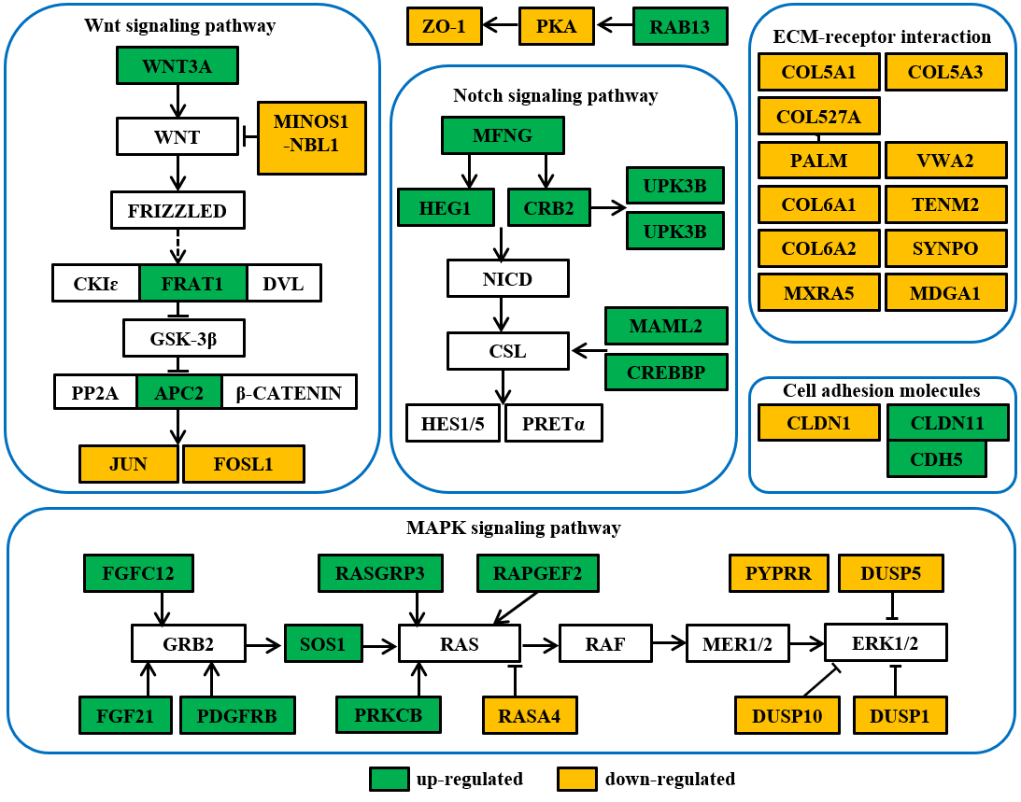
Figure S1. GSEA shows tumor related signaling pathways altered in FAT1 knockdown HCC cells.

