Supplementary Materials
Supplementary Table 1 Primer sequences and product sizes of the carbapenemase genes.
Carbapenemase genes | Primer sequences (5'-3') | Product sizes (bp)
KPC | F: CGTCTAGTTCTGCTGTCTTG  R: CTTGTCATCCTTGTTAGGCG | 798
NDM | F: GGTTTGGCGATCTGGTTTTC  R: CGGAATGGCTCATCACGATC | 621
OXA-48 | F: GCGTGGTTAAGGATGAACAC  R: CATCAAGTTCAACCCAACCG | 438
IMP | F: GGAATAGAGTGGCTTAAYTCTC  R: GGTTTAAYAAAACAACCACC | 232
VIM | F: GATGGTGTTTGGTCGCATA  R: CGAATGCGCAGCACCAG | 390
Note: F, Forward primer; R, Reverse primer; KPC, Klebsiella pneumoniae carbapenemase; NDM, New Delhi metallo-β-lactamase; OXA-48, Oxacillin hydrolyzing enzymes-48; IMP, imipenemase metallo-β-lactamase; VIM, Verona integron-mediated metallo-β-lactamase; bp, base pairs.

Supplementary Table 2 Primer sequences and product sizes of the virulence genes.
Virulence genes | Primer sequences (5'-3') | Product sizes (bp)
magA | F: GGACCGTTAATTTGCTTTGT  R: TTCGTTCACTTTCGGACTGG | 724
rmpA | F: GTATTGGTTGACAGCAGGATTT  R: CTTTGGTAGCATGATAGCGTTT | 356
wabG | F: GTGCAGAGCCATGAACGTATTCCC  R: CAGAGCGTCGCAGACGTAACCAT | 717
uge | F: GGAAGGCTGCCGTCATACCA  R: GGATTACATCCTGCACCCGAAC | 374
fimH | F: AGGATCGTTAATCGCGGTGCTG  R: TGTGGTCCGGGCATAGGTGG | 415
kfu | F: CCGCCTCGATCCCACCCTTGAA  R: GCCAGCGGCACAGGACCAGTAA | 449
Note: F, Forward primer; R, Reverse primer; bp, base pairs.

Supplementary Table 3 Primer sequences and product sizes of the housekeeping genes.
Housekeeping genes | Primer sequences (5'-3') | Product sizes (bp)
gapA | F: TGAAATATGACTCCACTCACGG  R: CTTCAGAAGCGGCTTTGATGGCTT | 662
infB | F: ACTAAGGTTGCCTCCGGCGAAGC  R: CGCTTTCAGCTCAAGAACTTC | 462
mdh | F: CCCAACTCGCTTCAGGTTCAG  R: CCGTTTTTCCCCAGCAGCAG | 756
pgi | F: CTGCTGGCGCTGATCGGCAT  R: TTATAGCGGTTAATCAGGCCGT | 566
phoE | F: ACCTACCGCAACACCGACTTCTTCGG  R: CGCTTTCAGCTCAAGAACTTC | 602
tonB | F: CTTTATACCTCGGTACATCAGGTT  R: ATTCGCCGGCTGRGCRGAGAG | 539
rpoB | F: GGCGAAATGGCWGAGAACCA  R: GAGTCTTCGAAGTTGTAACC | 1075
Note: F, Forward primer; R, Reverse primer; bp, base pairs.

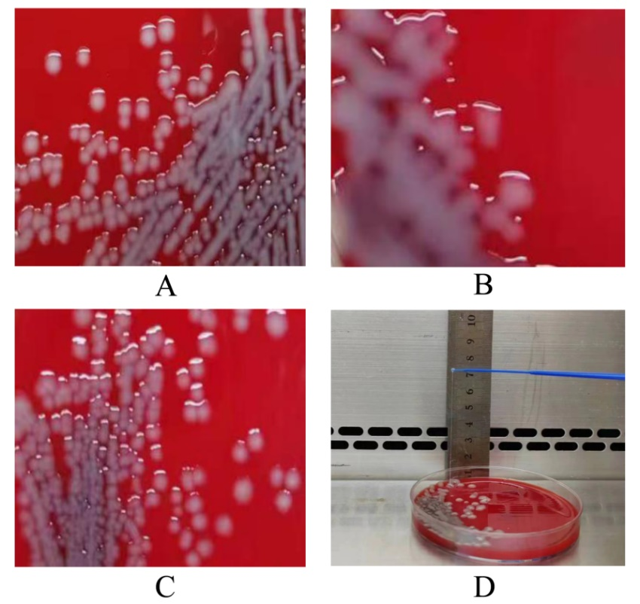
Supplementary Figure 1 Phenotypic characteristics of the recovered CRKP isolates. A: white, moist, and convex colonies; B: grey, moist, convex and mucous colonies (colony fusion could be seen); C: grey, convex and smooth colonies; D: a representative positive string test.
Supplementary Table 4 Relationship between multiple drug resistance phenotypes and carbapenemase genes.
Phenotype | Metallo-β-lactamase ^{b} | Serine carbapenemase ^{c} | Total
MDR ª | 64 (NDM 62, VIM 2) | 6 | 70
XDR | 7 (NDM 6, VIM 1) | 13 | 20
PDR | 0 | 4 | 4
Note:
ª vs. XDR (P < 0.001). ^{b} Number of CRKP isolates carrying either NDM or VIM. ^{c} Number of CRKP isolates carrying KPC.
MDR, multidrug resistant phenotype; XDR, extensively drug-resistant phenotype; PDR, pandrug-resistant phenotype; NDM, New Delhi metallo-β-lactamase; KPC, Klebsiella pneumoniae carbapenemase; VIM, Verona integron-mediated metallo-β-lactamase.

