Supplementary

Appendix 1
Rad-score = 0.2683616-0.007303793×original_gldm_HighGrayLevelEmphasis
-0.019798136×gradient_glcm_JointEnergy
-0.005929206×logarithm_glrlm_LowGrayLevelRunEmphasis
-0.001563209×square_ngtdm_Complexity
-0.030593146×squareroot_firstorder_Entropy
-0.004176788×squareroot_firstorder_Median
+0.002425937×wavelet.LHH_gldm_HighGrayLevelEmphasis

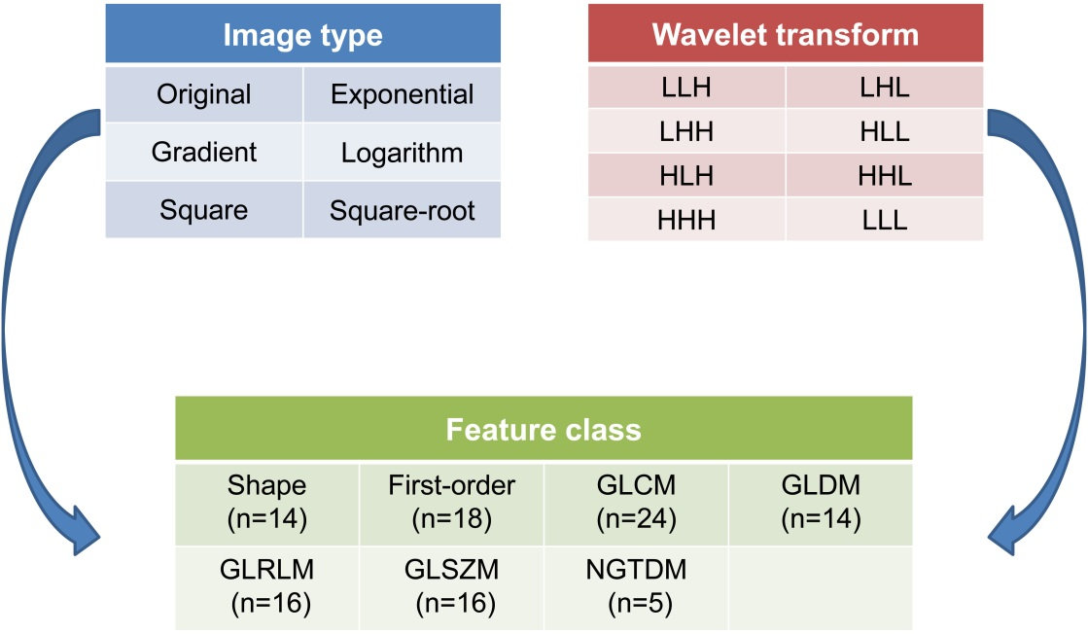
Figure S1. Extracted radiomics features used in the study. These features include the combination of different feature classes and image types, and the combination of different feature classes and decompositions after wavelet transform. Wavelet transform applies all possible combinations of high-pass (H) or low-pass (L) filters (LLH, LHL, LHH, HLL, HLH, HHL, HHH, LLL), resulting in 8 decompositions. GLCM: gray-level co-occurrence matrix, GLDM: gray-level dependence matrix, GLRLM: gray-level run length matrix, GLSZM: gray-level size zone matrix, NGTDM: neighbouring grey tone difference matrix.

Table S1. Comparisons of the preoperative clinicopathologic characteristics and rad-scores between the training and validation cohorts.
Variable |  | Training cohort (n=354) | Validation cohort (n=163) | P value
Age, year |  | 48.7±8.0 | 49.6±8.4 | 0.241*
BC family history, n(%) | No | 346 (97.7%) | 158 (97.5%) | 0.892$
BC family history, n(%) | Yes | 8 (2.3%) | 4 (2.5%) | 0.892$
Tumor size, cm |  | 2.37 (1.79-3.07) | 2.48 (1.72-3.11) | 0.172#
Clinical T stage, n(%) | cT1 | 113 (31.9%) | 60 (36.8%) | 0.274$
Clinical T stage, n(%) | cT2 | 241 (68.1%) | 103 (63.2%) | 0.274$
US-reported LN status, n(%) | Negative | 254 (71.8%) | 115 (70.6%) | 0.779$
US-reported LN status, n(%) | Positive | 100 (28.2%) | 48 (29.4%) | 0.779$
ABUS retraction phenomenon, n(%) | Negative | 256 (72.3%) | 111 (68.1%) | 0.326$
ABUS retraction phenomenon, n(%) | Positive | 98 (27.7%) | 52 (31.9%) | 0.326$
Histologic type, n(%) | IDC | 306 (86.4%) | 148 (26.8%) | 0.334$
Histologic type, n(%) | ILC or mixed | 41 (11.6%) | 12 (26.8%) | 0.334$
Histologic type, n(%) | Other | 7 (26.8%) | 3 (26.8%) | 0.334$
ER, n(%) | Negative | 61 (17.2%) | 38 (23.3%) | 0.103$
ER, n(%) | Positive | 293 (82.8%) | 125 (76.7%) | 0.103$
PR, n(%) | Negative | 103 (29.1%) | 42 (25.8%) | 0.434$
PR, n(%) | Positive | 251 (70.9%) | 121 (74.2%) | 0.434$
HER-2, n(%) | Negative | 324 (91.5%) | 143 (87.7%) | 0.175$
HER-2, n(%) | Positive | 30 (8.5%) | 20 (12.3%) | 0.175$
Ki-67 status, n(%) | Negative (<20%) | 91 (25.7%) | 52 (31.9%) | 0.143$
Ki-67 status, n(%) | Positive (≥20%) | 263 (74.3%) | 111 (68.1%) | 0.143$
Rad-score |  | 0.274±0.041 | 0.280±0.046 | 0.115*
Variables are expressed as median (interquartile range) if they are not normally distributed. *for independent sample t-test, $for chi-square test, and #for Mann-Whitney U test. US: ultrasound, LN: lymph node, ABUS: automated breast ultrasound system, ER: estrogen receptor, PR: progesterone receptor, HER-2: human epidermal growth factor receptor-2.

