Supplementary File

Table S1. Detailed characteristics of randomized controlled trials enrolled for meta-analysis
Study | Dropout | Patient characters | Training onset,  duration and frequency | Intervention | Usual care | Outcomes
Abdellaoui 2011,  France  (n=17) [18] | 2 | ICU patients  Median age: 59-67 years  Male: 87%  Median FEV1: 15-25% predicted | Onset: started in ICU, mean 12 ±8 days after admission  Duration: 6 weeks  Frequency: 5 days/week  Follow up: 6 weeks | Inpatient PR: neuromuscular electrostimulation (NMES) on quadriceps and hamstring muscles of both legs 1h/day | Placebo (sham) and standard care | Max quadricep contraction, 6MWD, MRC, adverse event
Behnke 2000, Germany (n=30) [19] | 16 | Mean age: 66 years  Male: 77%  Mean FEV1: 35.8% predicted | Onset: 4-7 days after admission  Duration: hospital-based 10 days, home-based 6 months  Frequency: daily  Follow up: 6 months | Inpatient PR: standard care + daily walking exercise (a 6-min treadmill, and 5 self-controlled walking on corridor, achieving 75% of treadmill walking distance)  Outpatient PR: home-based walking training 3 times /day at 125% of best 6MWD | Standard care: medication and 30min daily breathing exercise (diaphragmatic and pursed lip breathing) | COPD readmission, Borg scale, CRQ, 6MWD, FEV1, mortality
Borges 2014,  Brazil(n=46) [20] | 17 | Mean age: 66 years  Male: 62%  Mean FEV1: 40.4% predicted | Onset: 3rd day of hospitalization  Duration: average 5.6 session (at least 3 session)  Frequency: daily  Follow up: 1 month | Inpatient PR: standard care + whole-body resistance training:  upper limb (shoulder flexion and abduction, elbow flexion)  lower limb (knee extension and flexion, hip flexion) | Standard care: medication, chest physiotherapy | 6MWD, SGRQ, muscle strengths (upper and lower limbs)
Daabis 2017,  Egypt(n=45) [34] | 0 | Mean age: 60 years  Male: no data  Mean FEV1: 54.7% | Onset: within 10 days of discharge  Duration: 8 weeks  Frequency: 3 time/week  Follow up: 8 weeks | Outpatient PR:  Endurance training group: 30 minutes of treadmill training and an 30-min of low-intensity resistance training with free weights.  Combined training group: 30 min of ST which consisted of exercises performed on weight training machines (upper and lower limbs), and 30 min of endurance training. | Control group: medical treatment only. No exercise | 6MWD, SGRQ, FEV1, mMRC, muscle strength
Deepak 2014,  India(n=60) [35] | 4 | Mean age: 59 years  Male: 93%  Mean FEV1: 50% | Onset: within 2 weeks of discharge  Duration: 12 weeks  Frequency: not reported  Follow up: 12 weeks | Outpatient PR: exercise training up to 2 hr/session (mixture of limb strengthening and aerobic activities), breathing training, chest physiotherapy , education, nutrition | Control group: medical treatment without PR | 6MWD, SGRQ, mMRC
Eaton 2009,  New Zealand  (n=97) [21] | 13 | Mean age: 70 years  Male: 42-45%  Mean FEV1: 35.5% | Onset: inpatient as soon as medically appropriate  Duration: 8 weeks  Frequency: 2/week  Follow up: 12 weeks | Inpatient PR: daily 30min (walking+upper and lower limb strengthening exercise)  Outpatient PR: hospital based PR exercise training 1hr/session + education (coping with dyspnea, airway clearance, nutrition, vaccine) | Control group: standard treatment without PR | 6MWD, COPD hospital readmission, CRQ, Borg, mMRC, adverse events
Ghanem 2010,  Egypt(n=39) [22] | 0 | Mean age: 57 years  Male: not reported  Mean FEV1: 27.2% | Onset: at discharge  Duration: 2 months  Frequency: every other day  Follow up: 2 months | Outpatient PR: home-based exercise with endurance training (walking, cycling), strength training (upper and lower limbs) and respiratory muscle training (diaphragmatic breathing and pursed lip breathing) | Control group: standard treatment without PR | 6MWD, CRQ, FEV1
He 2015,  China(n=101) [23] | 7 | Mean age: 71 years  Male: 88%  Mean FEV1: 38.3% | Onset: inpatient 2nd day  Duration: average 9 days  Frequency: 2/day  Follow up: 9-10 days (hospitalization) | Inpatient PR: endurance+strength+ breathing retraining | Control group: standard hospital care | 6MWD, CRQ, SGRQ, adverse events
Johnson-Warrington 2016, United Kingdom (n=78) [32] | 7 | Age: 68 years  Male: 36%  FEV1: 41.5% | Onset: upon discharge  Duration: 3 months  Frequency: daily  Follow up: 3 months | Outpatient PR: home-based exercise (daily walk and thrice-weekly resistance training using free weight upper and lower limbs) , phone call regular follow up | Standard medical treatment | hospital readmission, mortality, CRQ, shuttle walk distance
Kirsten1998,  Germany (n=31) [24] | 2 | Mean age: 64 years  Male: 90%  Mean FEV1: 35.9% | Onset: within 6-8 days after admission  Duration: 10 days  Frequency: daily  Follow up: 11 days | Inpatient PR: 6MWT + 5 session walking per day for 10 days | Control group: standard hospital care without exercise | 6MWD, Borg, FEV1
Ko 2011,  Hong Kong  (n=60) [25] | 9 | Mean age: 74 years  Male: 98%  Mean FEV1: 43.5% | Onset: 2-3 week after discharge  Duration: 8 weeks  Frequency: 3/week  Follow up: 12 months | Outpatient PR: treadmill, arm cycling, arm and leg strengthening (2hr/session) + educate breathing technique, educate home exercise 20min a day | Educate to regular exercise | 6MWD, SGRQ, hospital readmission, ER readmission, mortality, FEV1
Ko 2017,  Hong Kong  (n=180) [26] | 38 | Mean age: 75 years  Male: 96%  Mean FEV1: 45.5% | Onset: 3-4 week after discharge  Duration: 8 weeks  Frequency: 3/week  Follow up: 12 months | Outpatient PR: exercise training program at home or a short course of outpatient pulmonary rehabilitation + breathing technique + education (nutrition, quit smoking) | Standard medical treatment | 6MWD, SGRQ, hospital readmission, mortality
Ko 2020,  Hong Kong  (n=136) [27] | 13 | Mean age: 75 years  Male: 97%  Mean FEV1: 47.5% | Onset: 2-4 week after discharge  Duration: 4-8 weeks  Frequency: 1-2/week  Follow up: 12 months | Outpatient PR: Physiotherapy department: treadmill, upper and lower limb weight lifting and stretching exercise (2hr/session).  Home exercise: slow or brisk walking, static bike cycling, free weights lifting by upper extremity and stretching exercise | Standard medical treatment | readmission, mortality, CAT, mMRC, 6MWT, SGRQ, FEV1
Liao 2015,  Taiwan  (n=62) [28] | 1 | Mean age: 70 years  Male: 61%  FEV1: not reported | Onset: during admission  Duration: 4 days  Frequency: 2/day  Follow up: 4 days | Inpatient PR: walking training 10-30min/session, upper limb exercise, education (respiration, cough, nutrition) | Standard medical treatment | 6MWD, Borg, cough
Man 2004,  United Kingdom (n=42) [29] | 8 | Mean age: 70 years  Male: 40%  Mean FEV1: 39.2% | Onset: within 10 days of discharge  Duration: 8 weeks  Frequency: 2/week  Follow up: 12 weeks | Outpatient PR: 1hr exercise: endurance (walking, cycling) and strength exercise (upper and lower limbs) and 1hr patient education (disease, nutrition, life styles) | Standard medical treatment | CRQ, SGRQ, hospital readmission, ER admission, mortality, shuttle walk distance, adverse event
Murphy 2005,  Ireland(n=31) [30] | 5 | Mean age: 66 years  Male: 65%  Mean FEV1: 40% | Onset: within days of discharge  Duration: 6 weeks  Frequency: 2/week  Follow up: 26 weeks | Outpatient PR: home-based PR with endurance (stepping up and down stair, stand up from chair) and resistance exercise (upper limb), 30-40min/session | Standard medical treatment | SGRQ, hospital readmission (AE), MRC, Borg, Shuttle walk distance, 3-min step test
Seymour 2010,  United Kingdom (n=60) [36] | 11 | Mean age: 66 years  Male: 45%  Mean FEV1: 52% | Onset: within 7 days of discharge  Duration: 8 weeks  Frequency: 2/week  Follow up: 12 weeks | Outpatient PR: endurance (aerobic) and resistance exercise (limbs strengthening), 2hr/session | Standard medical treatment | SRGQ, CRQ, hospital readmission (AE), shuttle walking distance
Torres-Sánchez 2016, Spain (n=49) [33] | 0 | Mean age: 73 years  Male: 95%  Mean FEV1: 40% | Onset: during admission  Duration: hospital stay (mean 8.8 days)  Frequency: 2/day  Follow up: mean 8.8 days | Inpatient PR: 15min deep breath exercise, 20-30min limb exercise (both endurance and resistance exercise) | Standard medical treatment | FEV1, Borg scale, two-minute  step-in-place test, EuroQol-5D
Torres-Sánchez 2018, Spain (n=90) [31] | 0 | Age: 72 years  Male: 87%  FEV1: 30.6% | Onset: during admission  Duration: hospital stay (9-10.5 days)  Frequency: daily  Follow up: 9-10.5 days | Inpatient PR:  Endurance group: range of motion exercise +controlled breathing 30-40min/session  Resistance group: lower limb resistance exercise | Standard medical treatment | FEV1, Borg scale, EuroQol-5D
Troosters 2010, Belgium (n=40) [37] | 4 | Age: 67-69 years  Male: 74-76%  FEV1: 40-50% | Onset: during admission  Duration: 7 days  Frequency: daily  Follow up: 8 days | Inpatient PR: quadricep resistance training (knee-extension chair) | Standard medical treatment + breathing exercise, secretion clearing technique | 6MWD, Maximal voluntary quadriceps force, adverse event

Table S2. Summary and comparison of characteristics of excluded randomized controlled trials.
Study | Reasons for exclusion
Studies included by Puhan et al. Cochrane review 2016 but excluded by this meta-analysis:
Carr 2009, n=34 [S1] | Enrolled AECOPD patients with mild, moderate, and severe exacerbations.
Greening 2014, n=389 [42] | Patient population includes other chronic lung disease (COPD account for 80%). Besides, usual care group also received outpatient PR 3 months later (not true control group)
Nava 1998, n=70 [43] | Control group also performed walking and lower limb exercise. (not true control group)
Tang 2012, n=32 [S2] | Outcomes were adverse event and 3-minute walking distance.
Torres-Sánchez 2014, n=60  [S3] | Poster only, no available published fulltext article
Trooster 2002, n=46 [S4] | Poster only, no available published fulltext article
Studies included by Ryrsø et al. meta-analysis 2018 but excluded by this study:
Puhan 2012, n=36 [40] | Compared early PR within 2 weeks and late PR within 6 months of AECOPD hospitalization. (not true control group)
Revitt 2018, n=28 [41] | Compared early PR within 4 week and late PR in 7 weeks of AECOPD hospitalization. (not true control group)
Trooster 2000, n=100 [39] | Enrolled AECOPD patients without exacerbation.
Studies not included by neither previous meta-analysis nor this study:
Cox 2018, n=58 [S5] | Usual care group also performed outpatient PR 4-6 weeks after AECOPD hospitalization (not true control group)
Torres-Sánchez 2017, n=58  [S6] | Outcomes were muscle strength, walking steps, balance.
Vivodtzev 2006, n=17 [S7] | Usual care group also performed active limb mobilization, slow walking, and arm lifting exercise. (not true control group)
Kjærgaard 2020, n=150 [S8] | Compared early PR (within 2 weeks of discharge) and late PR (within 2 months of discharge) in AECOPD patients with hospitalization. (not true control group)

Supplementary Reference
S1. Carr SJ, Hill K, Brooks D, Goldstein RS. Pulmonary rehabilitation after acute exacerbation of chronic obstructive pulmonary disease in patients who previously completed a pulmonary rehabilitation program. J CardiopulmRehabil Prev. 2009; 29(5):318-24.
S2. Tang CY, Blackstock FC, Clarence M, Taylor NF. Early rehabilitation exercise program for inpatients during an acute exacerbation of chronic obstructive pulmonary disease: a randomized controlled trial. J CardiopulmRehabil Prev. 2012; 32(3):163-9.
S3. Torres-Sánchez I, Valenza MC, Valenza-Demet G, Cabrera-Martos I, Flores-Barba MJ, Ruíz-Sáez A. Quality of life in hospitalized patients for exacerbation of COPD included in a physical therapy program. Chest 2014;145(3_MeetingAbstracts):372A.
S4. Troosters T, Gosselink R, De Paepe K, Decramer M. Pulmonary rehabilitation improves survival in COPD patients with a recent severe acute exacerbation. American Journal of Respiratory and Critical Care Medicine 2002;165(8):A16.
S5. Cox M, O'Connor C, Biggs K, Hind D, Bortolami O, Franklin M, et al. The feasibility of early pulmonary rehabilitation and activity after COPD exacerbations: external pilot randomised controlled trial, qualitative case study and exploratory economic evaluation. Health Technol Assess. 2018; 22(11):1-204.
S6. Torres-Sánchez I, Valenza MC, Cabrera-Martos I, López-Torres I, Benítez-Feliponi Á, Conde-Valero A. Effects of an Exercise Intervention in Frail Older Patients with Chronic Obstructive Pulmonary Disease Hospitalized due to an Exacerbation: A Randomized Controlled Trial. COPD. 2017; 14(1):37-42.
S7. Vivodtzev I, Pépin JL, Vottero G, Mayer V, Porsin B, Lévy P, Wuyam B. Improvement in quadriceps strength and dyspnea in daily tasks after 1 month of electrical stimulation in severely deconditioned and malnourished COPD. Chest. 2006; 129(6):1540-8.
S8. Kjærgaard JL, Juhl CB, Lange P, Wilcke JT. Early pulmonary rehabilitation after acute exacerbation of COPD: a randomised controlled trial. ERJ Open Res. 2020;6(1):00173-2019.

Figure S1. Hospital readmission subgroup analysis forest plot: early PR versus usual care.

Figure S2. 6MWD subgroup analysis forest plot: early PR versus usual care.

Figure S3. SGRQ total score subgroup analysis forest plot: early PR versus usual care.

Figure S4. Borg score subgroup analysis forest plot: early PR versus usual care.
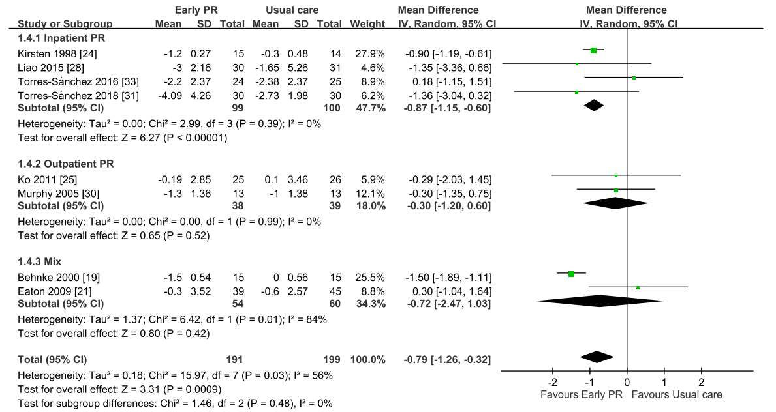

Figure S5. mMRC subgroup analysis forest plot: early PR versus usual care.
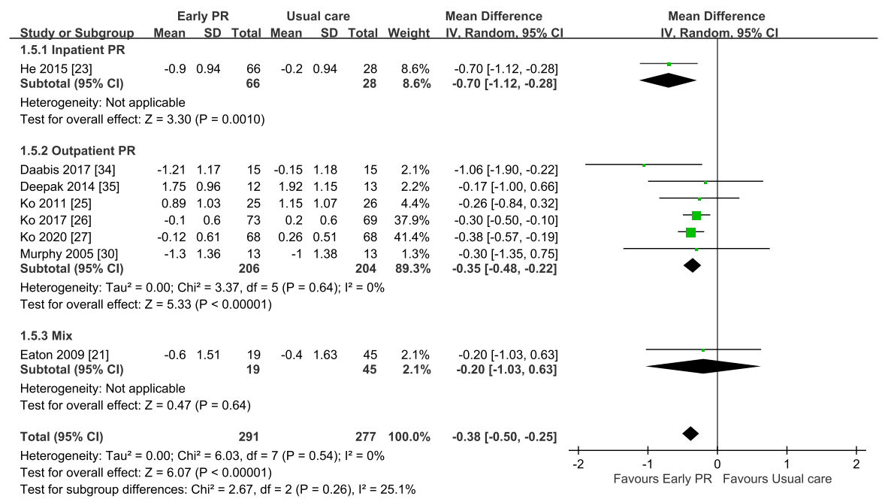

Figure S6. Mortality subgroup analysis forest plot: early PR versus usual care.
