SUPPLEMENTARY FIGURES LEGENDS
SUPPLEMENTARY FIGURE 1 | AKT1 shRNA sequencing results.
SUPPLEMENTARY FIGURE 2 | AKT overexpression plasmid construction. (A) CMV-MCS-IRES-EGFP-SV40-Neomycin vector structural overview. (B) Vector digestion product and target fragment PCR results. (C) Recombinant vector and target fragment cloning results.
SUPPLEMENTARY TABLE S1-2 | AKT1 target sequence and shRNA sequence.

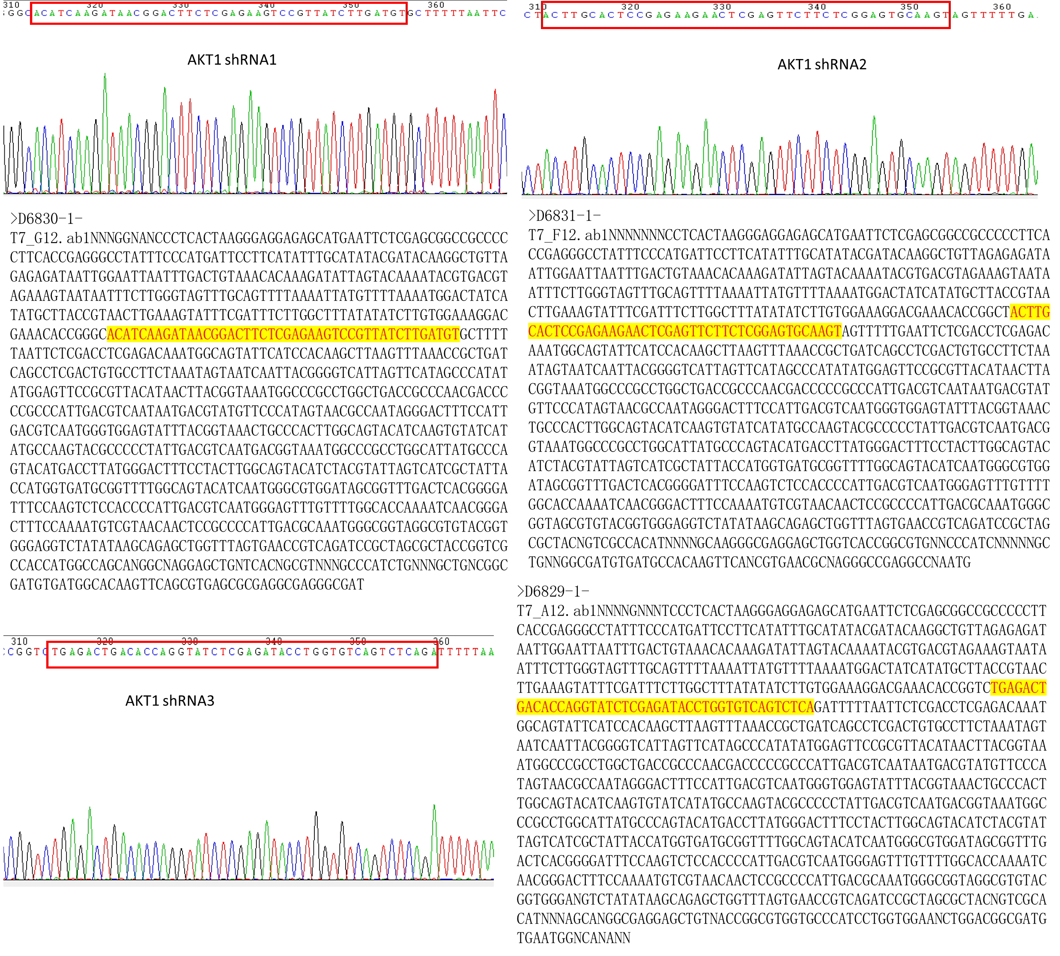

Supplementary Fig.1

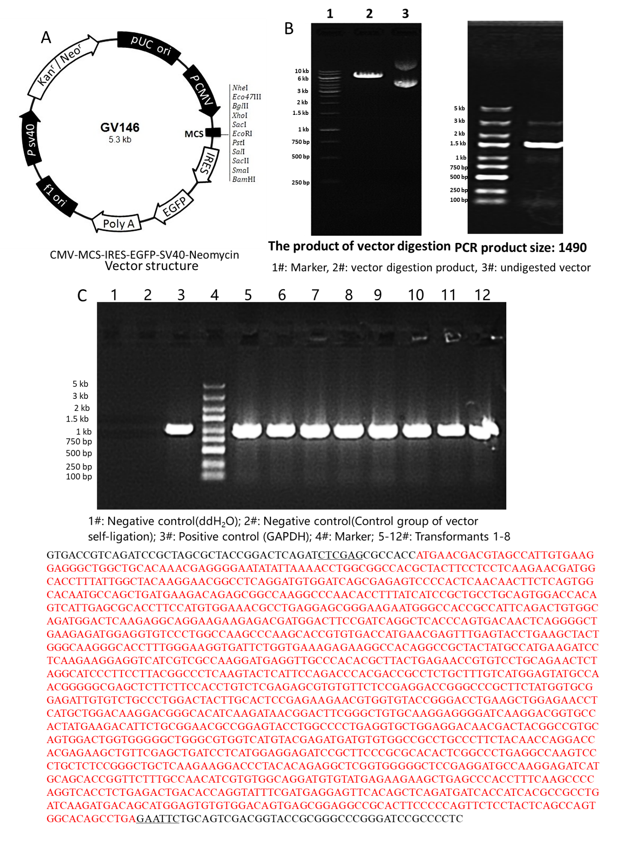

Supplementary Fig.2

Supplementary Table S1-S2

