Cellular Uptake of Differently Charged Mesoporous Bioactive Glass Nanoparticles to Enable Intracellular Delivery of Therapeutic Agents
Negar Hassani Besheli¹, Juul Verbakel¹, Maryam Hosseini¹, Lea Andrée¹, Ben Joosten², X. Frank Walboomers¹, Alessandra Cambi², Fang Yang¹, Sander C. G. Leeuwenburgh¹

¹ Department of Dentistry – Regenerative Biomaterials, Radboud Institute for Molecular Life Sciences, Radboudumc, Philips van Leydenlaan 25, 6525 EX Nijmegen, The Netherlands
² Department of Cell Biology, Radboud Institute for Molecular Life Sciences, Radboud University Medical Center, Geert Grooteplein Zuid 26-28, 6525 GA Nijmegen, The Netherlands

Table S 1 Chemical composition of ALF.
Reagent |  | Concentration (g/L)
Magnesium chloride (MgCl₂) | 0.050
Sodium chloride (NaCl) | 3.210
Disodium hydrogen phosphate (Na₂HPO₄) | 0.071
Sodium sulfate (Na₂SO₄) | 0.039
Calcium chloride dihydrate (CaCl₂·2H₂O) | 0.128
Sodium citrate dihydrate (C₆H₅Na₃O₇·2H₂O) | 0.077
Sodium hydroxide (NaOH) | 6.000
Citric acid (C₆H₈O₇) | 20.800
Glycine (H₂NCH₂COOH) | 0.059
Sodium tartrate dihydrate (C₄H₄O₆Na₂·2H₂O) | 0.090
Sodium lactate (C₃H₅NaO₃) | 0.085
Sodium pyruvate (C₃H₃O₃Na) | 0.086

Note: Reprinted from Acta Biomater, 66, Naruphontjirakul P, Porter AE, Jones JR. In vitro osteogenesis by intracellular uptake of strontium containing bioactive glass nanoparticles. 67–80, Copyright 2018, with permission from Elsevier.³¹

Supplemental Figures
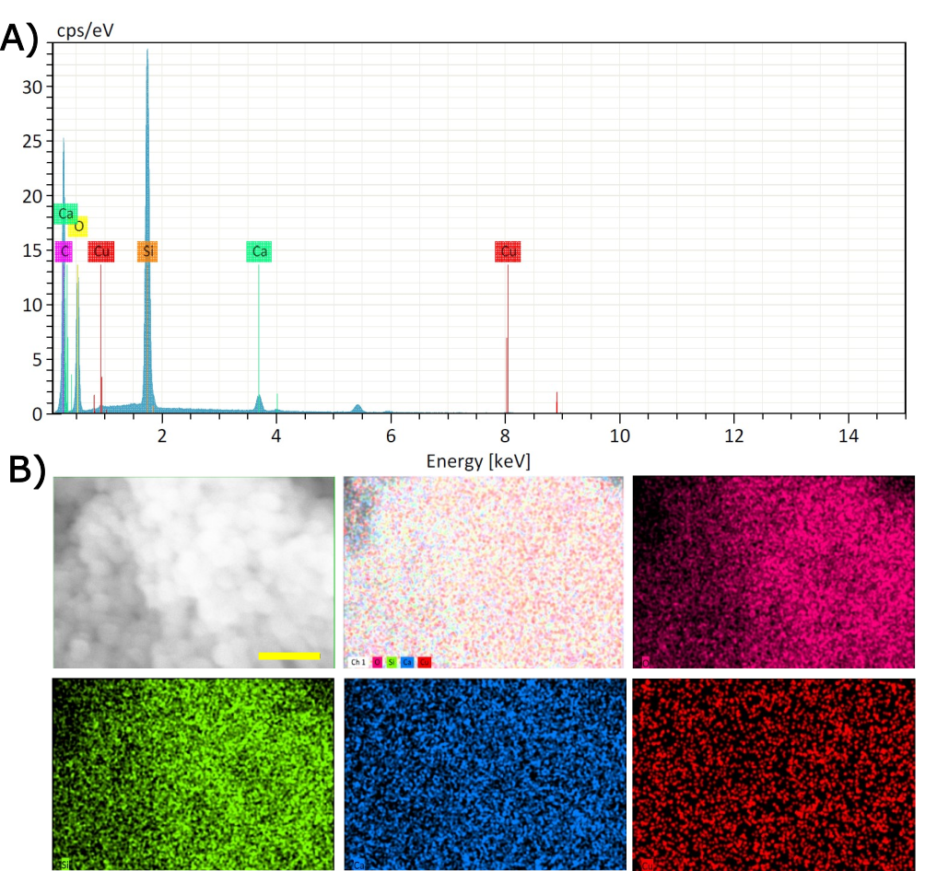
Figure S 1 (A) Representative EDX spectrum and (B) elemental distribution of synthesized Cu-MBGNs displaying the presence of Si, Ca, and Cu.
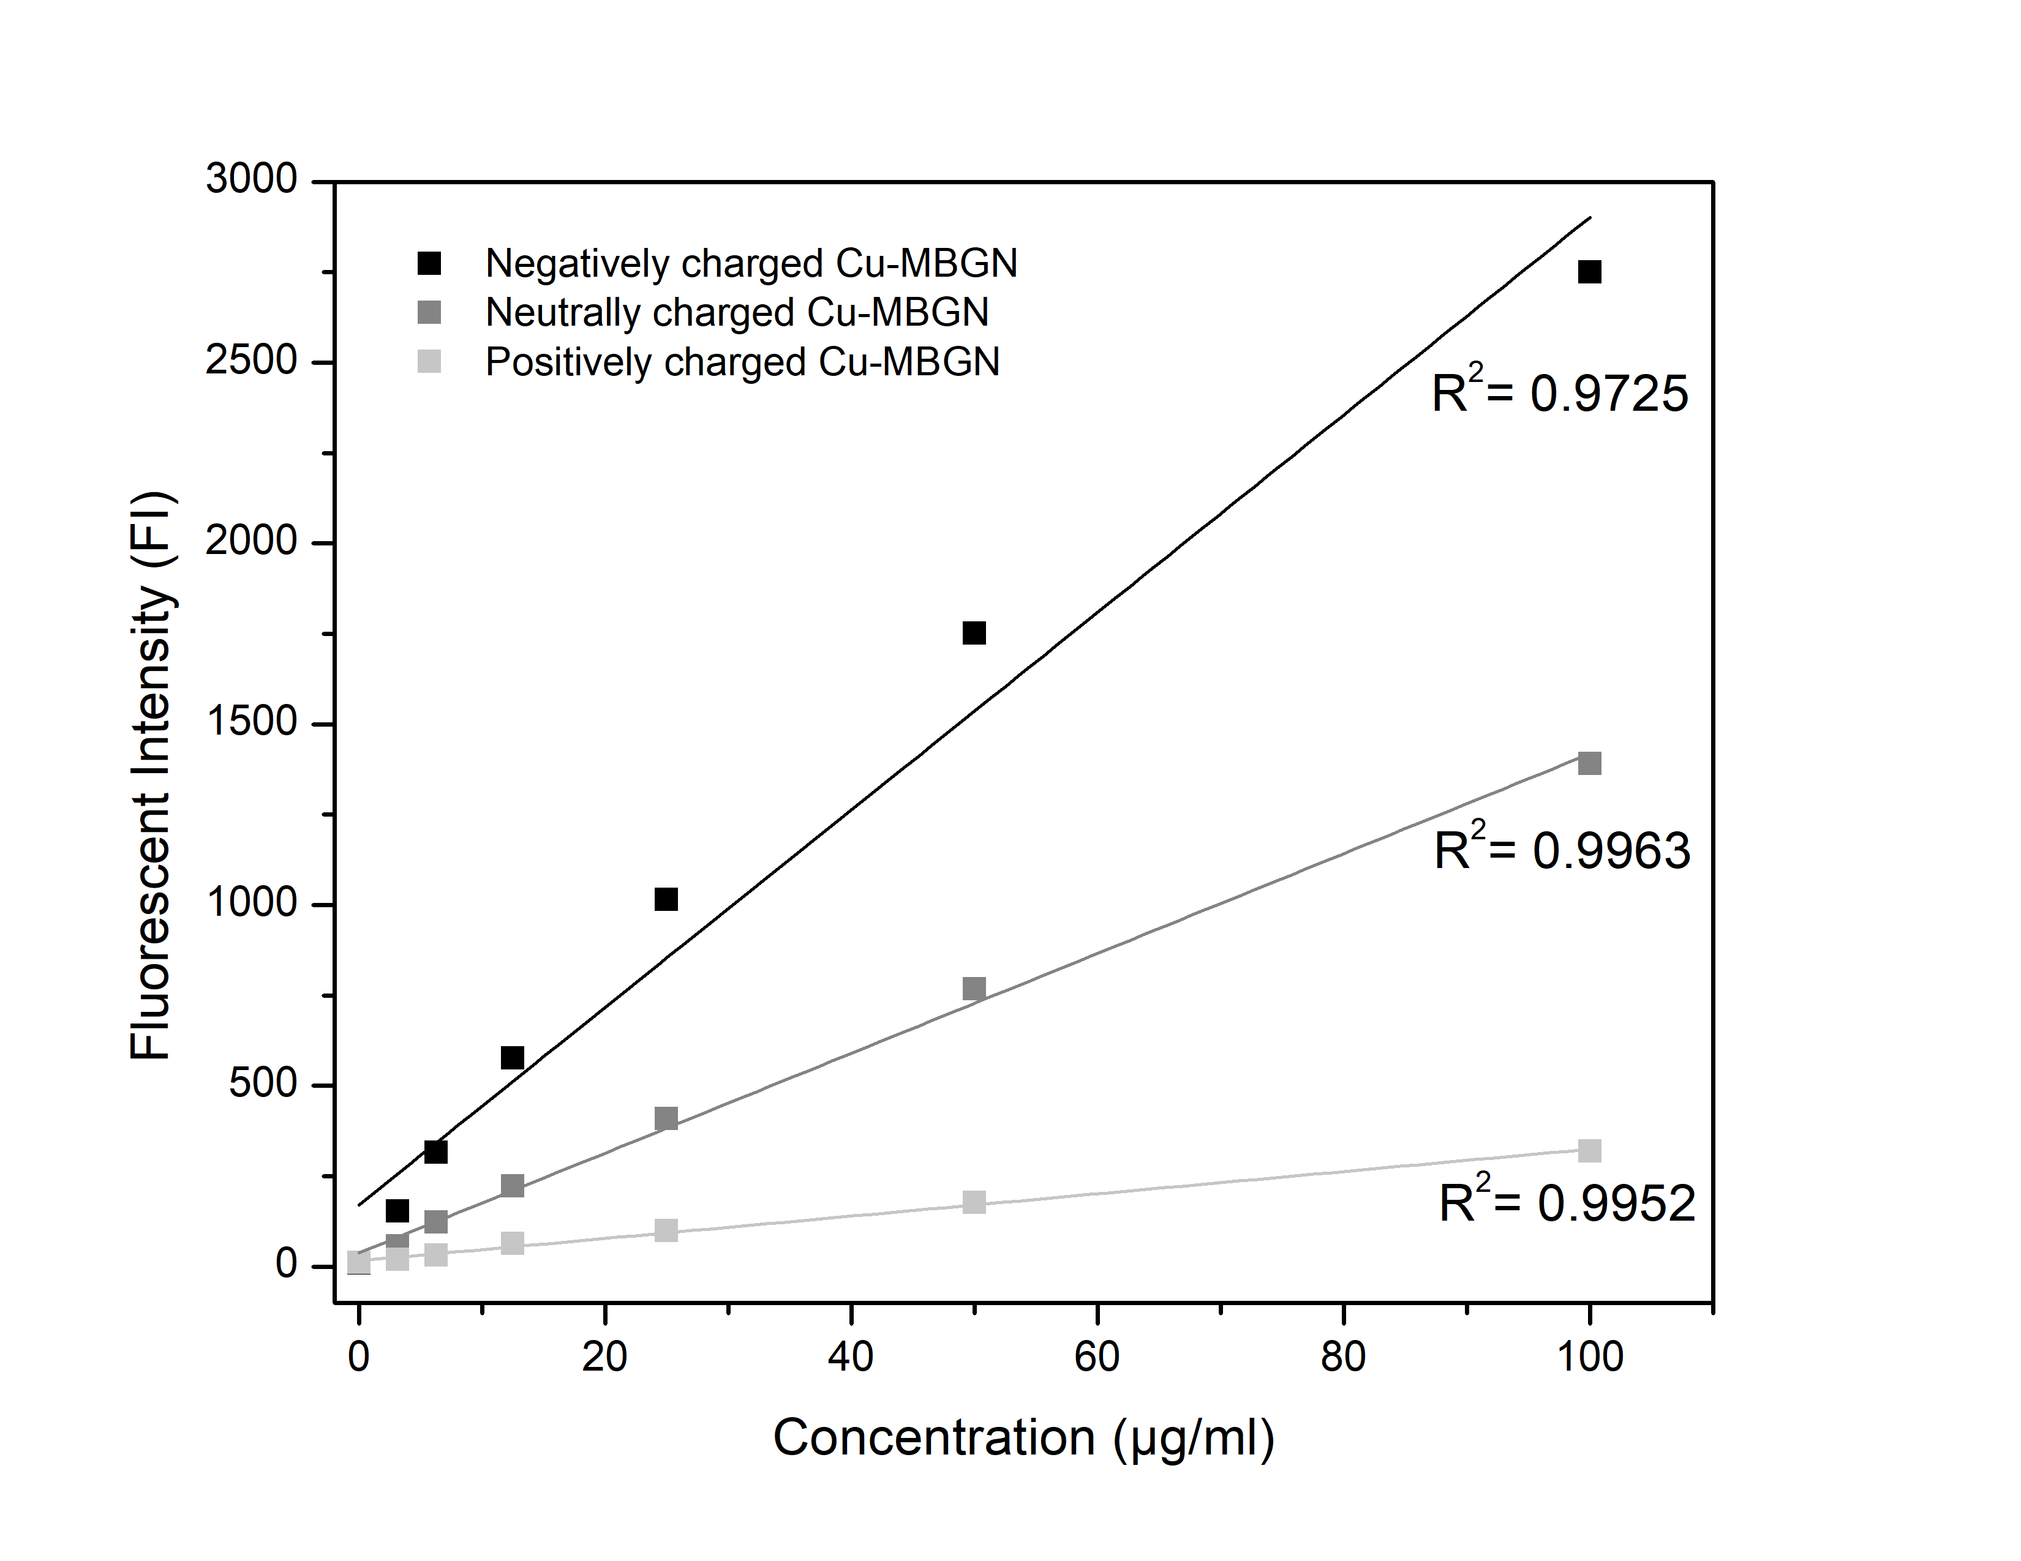
Figure S 2 Linear relationship between fluorescence intensity and concentration of differently charged Cu-MBGNs.
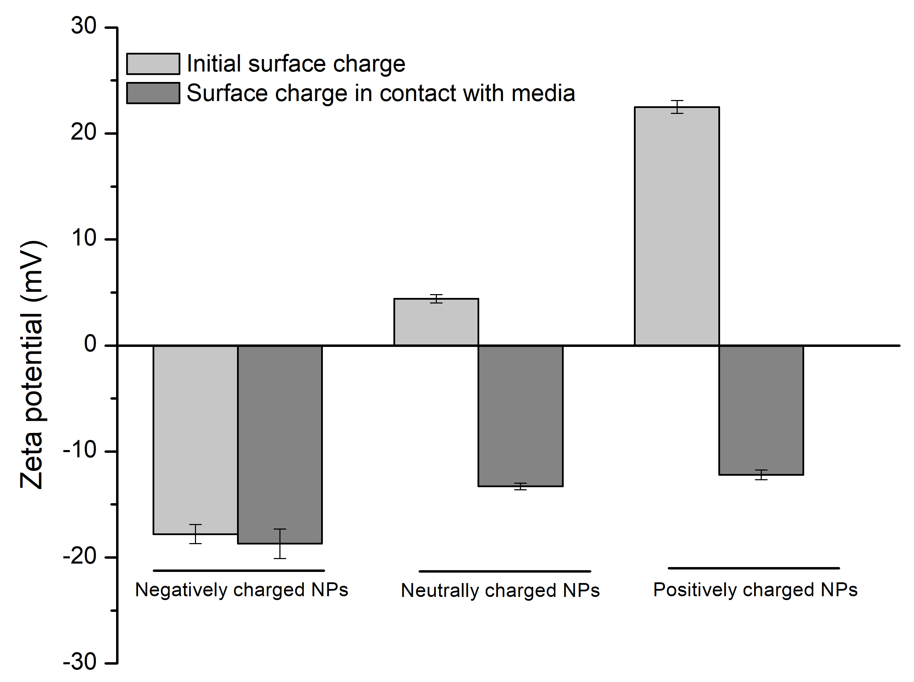
Figure S 3 Zeta potential measurement of the nanoparticles after 24 h of incubation in media containing FBS.
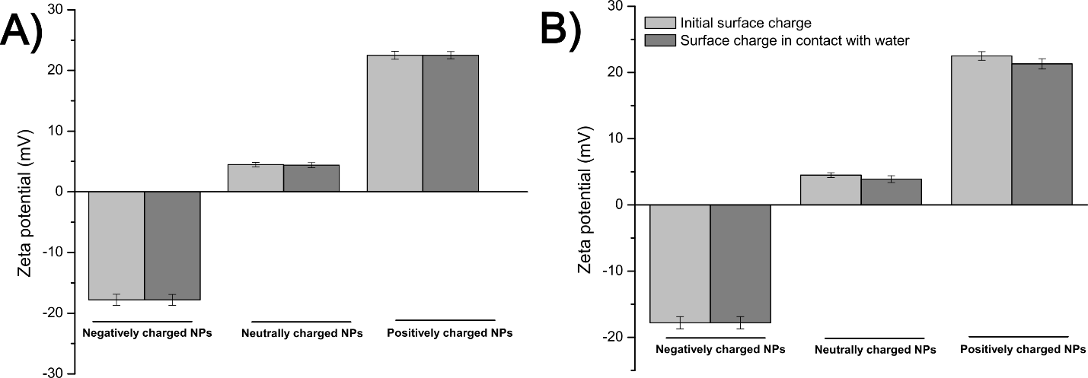
Figure S 4 Zeta potential measurement of the nanoparticles after (A) 4 h and (B) 24h of incubation in water.
Supplemental movies
Movie S1 Confocal Z-stack movie of internalized negatively charged Cu-MBGNs into MC3T3-E1 cells.
Movie S2 Confocal Z-stack movie of internalized neutrally charged Cu-MBGNs into MC3T3-E1 cells.
Movie S3 Confocal Z-stack movie of internalized positvely charged Cu-MBGNs into MC3T3-E1 cells.
Movie S4 Confocal Z-stack movie of internalized negatively charged Cu-MBGNs into RAW 264.7 cells
Movie S5 Confocal Z-stack movie of internalized neutrally charged Cu-MBGNs into RAW 264.7 cells.
Movie S6 Confocal Z-stack movie of internalized positvely charged Cu-MBGNs into RAW 264.7 cells.

