Supplementary Information

Text S1. Calculation method for the genetic score 1
Tables
Table S1. Obesity phenotype and asthma control 1
Table S2. SNPs of BMI (p-value of meta-analysis< 5×10⁻⁸) 2
Table S3. SNPs of WHtR (p-value of meta-analysis< 5×10⁻⁸) 6
Table S4. SNPs of asthma (p-value of meta-analysis< 5×10⁻⁸) 10
Figures
Figure S1. Quality Control (QC) flow chart 14
Figure S2. Q-Q plot and Manhattan plot of the GWAS meta-analyses results for BMI and WHtR 15
Figure S3. Q-Q plot and Manhattan plot of the GWAS meta-analyses results for asthma 16
Figure S4. Expression quantitative trait loci (eQTL) violin plots between genotypes of BMI-associated risk SNPs and gene expression from the Genotype-Tissue Expression (GTEx) 17
Figure S5. eQTL violin plots between genotypes of WHtR-associated risk SNPs and gene expression from the GTEx 18
Figure S6. eQTL violin plots between genotypes of asthma-associated SNPs and gene expression from the GTEx 19
Figure S7. Top 10 biological process (BP) terms with the highest p-value by gene ontology (GO) enrichment analysis 20
Figure S8. Top 10 pathway with the highest p-value by pathway enrichment analysis 21
Figure S9. The performance of predictive model of poorly controlled asthma by general obesity (presented as BMI) related traits and genetics scores 22
Figure S10. The performance of predictive model of poorly controlled asthma by central obesity (presented as WHtR) related traits and genetics scores 23

Text S1. Calculation method for the genetic score
the scores were constructed with the following rule: If the dominant model was significant, it was firstly considered. However, if the dominant model was insignificant, the significant additive model would be selected. If the dominant or additive model was not significant, the recessive model was chosen. A1 is the minor allele, and A2 is the major allele. In dominant model, the coefficient of ' A1A1 + A1A2' and ' A2A2' were 1 and 0 respectively. In recessive model, the coefficient of ' A1A1' and 'A1A2+ A2A2' were 1 and 0 respectively. In additive model, the coefficient of ' A1A1' , ' A1A2' and ' A2A2' were 2, 1, 0 respectively.

Table S1. Obesity phenotype and asthma control
Variable | Uncontrolled asthma
Variable | aOR (95% CI) | p-value
BMI
BMI
Underweight | 0.56 (0.21, 1.53) | 0.259
Normal | Ref | -
Overweight | 1.07 (0.79, 1.44) | 0.655
Obesity | 1.49 (1.09, 2.03) | 0.012
One of the parents has asthma | 1.68 (1.16, 2.42) | 0.006
WHtR
Obesity (ref: non-obesity) | 1.62 (1.22, 2.15) | <0.001
One of the parents has asthma | 1.65 (1.14, 2.39) | 0.007
Abbreviations: aOR, adjusted odds ratio; CI, confidence interval; BMI, body mass index; WHtR, waist-to-height ratio.

Table S2. SNPs of BMI (p-value of meta-analysis< 5×10⁻⁸)
SNPs | Chr: Position | Allele1 | Allele2 | p- value of genetic model |  |  | p-value of  meta-analysis
 |  |  |  | Additive | Dominant | Recessive | p-value of  meta-analysis
rs11210996 | 1: 44887362 | A | G | 1.36E-04 | 1.41E-02 | 4.78E-05 | 8.37E-09
rs7549310 | 1: 158122966 | T | C | 9.69E-05 | 6.54E-04 | 5.92E-04 | 1.83E-08
rs961562 | 1: 158431666 | C | T | 6.38E-05 | 2.57E-04 | 9.68E-03 | 4.48E-09
Affx-6583783 | 1: 202681729 | C | T | 9.21E-05 | 1.15E-04 | 4.27E-02 | 5.33E-09
rs17012757 | 1: 208714411 | A | G | 2.33E-05 | 2.56E-05 | 2.58E-01 | 1.17E-09
rs78619714 | 1: 208773264 | A | G | 7.80E-05 | 5.35E-04 | 3.99E-03 | 3.12E-09
rs2800930 | 1: 209436177 | A | G | 1.61E-04 | 2.40E-05 | 7.67E-01 | 3.76E-08
rs1498385 | 1: 220114215 | G | A | 1.51E-04 | 1.10E-04 | 5.06E-01 | 4.57E-08
rs12048956 | 1: 225869849 | A | G | 3.11E-05 | 8.86E-06 | 5.25E-01 | 1.10E-09
rs7581129 | 2: 4666664 | C | T | 2.60E-05 | 9.98E-04 | 1.26E-04 | 2.81E-10
rs6713642 | 2: 18282657 | A | G | 1.64E-04 | 2.35E-03 | 1.87E-03 | 1.19E-08
rs12466048 | 2: 30002690 | A | C | 1.08E-04 | 1.05E-04 | 1.63E-02 | 4.46E-09
rs10188389 | 2: 30021598 | T | C | 2.60E-04 | 1.91E-04 | 2.84E-02 | 3.22E-08
rs13413184 | 2: 34135144 | G | A | 2.28E-05 | 7.33E-04 | 4.30E-04 | 1.48E-10
rs12464508 | 2: 126394868 | G | A | 8.29E-05 | 3.31E-03 | 2.32E-04 | 3.39E-09
rs12618696 | 2: 126395158 | A | G | 8.88E-05 | 3.53E-03 | 2.39E-04 | 3.94E-09
rs3980656 | 2: 126401516 | A | C | 1.68E-04 | 8.52E-03 | 1.46E-04 | 1.59E-08
Affx-18912871 | 2: 208693307 | C | T | 3.05E-04 | 8.07E-04 | 1.21E-02 | 4.52E-08
rs12694559 | 2: 221980851 | G | A | 5.00E-05 | 3.21E-05 | 2.48E-02 | 9.25E-10
rs1679252 | 3: 22046939 | G | T | 1.97E-04 | 9.20E-03 | 2.89E-04 | 1.58E-08
rs826217 | 3: 24269789 | C | T | 1.09E-04 | 1.58E-03 | 2.71E-04 | 1.68E-08
rs34464573 | 3: 37442498 | A | - | 2.45E-04 | 2.29E-03 | 3.15E-03 | 4.69E-08
rs10510927 | 3: 64750744 | C | A | 1.11E-04 | 2.10E-04 | 3.59E-02 | 9.99E-09
rs318773 | 3: 64778758 | G | A | 9.26E-05 | 5.20E-04 | 6.27E-03 | 5.69E-09
rs382322 | 3: 64794157 | A | G | 1.83E-04 | 2.60E-04 | 4.70E-02 | 2.47E-08
rs1906064 | 3: 97450010 | A | G | 1.62E-04 | 2.80E-03 | 1.19E-03 | 1.10E-08
rs9820608 | 3: 124075754 | C | T | 2.14E-04 | 1.34E-04 | 7.43E-02 | 2.67E-08
rs62277159 | 3: 156526082 | G | A | 1.56E-04 | 1.70E-03 | 1.83E-04 | 4.53E-08
rs79209862 | 3: 156631388 | C | A | 1.13E-04 | 2.86E-03 | 5.40E-05 | 1.50E-08
rs59899313 | 3: 156635810 | A | G | 1.01E-04 | 2.61E-03 | 5.26E-05 | 1.18E-08
rs2287481 | 3: 169785660 | T | C | 2.93E-04 | 6.73E-04 | 1.67E-02 | 4.81E-08
rs17531088 | 3: 174893775 | C | T | 2.71E-04 | 4.86E-03 | 1.30E-03 | 3.21E-08
rs2035101 | 3: 174895840 | C | T | 2.83E-04 | 7.24E-03 | 8.42E-04 | 3.57E-08
rs2075050 | 4: 13526386 | G | A | 2.38E-04 | 7.18E-03 | 8.52E-04 | 3.02E-08
rs34859220 | 4: 17521797 | A | G | 6.19E-05 | 2.02E-04 | 1.44E-02 | 6.07E-09
rs35546694 | 4: 17543721 | T | C | 1.19E-04 | 7.97E-05 | 2.24E-01 | 1.64E-08
rs2062990 | 4: 33461734 | G | A | 1.07E-04 | 8.32E-04 | 3.27E-03 | 8.88E-09
(Continued on next page)
SNPs | Chr: Position | Allele1 | Allele2 | p- value of genetic model |  |  | p-value of  meta-analysis
 |  |  |  | Additive | Dominant | Recessive | p-value of  meta-analysis
rs17709654 | 4: 55788140 | G | A | 1.40E-04 | 3.73E-04 | 2.62E-02 | 2.33E-08
rs6534543 | 4: 127245675 | T | G | 5.85E-05 | 8.32E-04 | 2.72E-04 | 4.10E-09
rs4425324 | 4: 145142144 | A | C | 8.69E-05 | 4.70E-04 | 4.38E-03 | 2.96E-09
rs4569733 | 4: 153585984 | T | C | 2.74E-04 | 5.07E-04 | 1.88E-02 | 3.73E-08
rs7677112 | 4: 182237123 | G | A | 2.60E-04 | 3.77E-04 | 2.79E-02 | 3.60E-08
rs250846 | 5: 14116980 | C | T | 2.14E-04 | 1.19E-03 | 6.49E-03 | 2.92E-08
rs7720861 | 5: 81893325 | T | C | 1.13E-04 | 4.20E-04 | 9.37E-03 | 1.32E-08
rs13186402 | 5: 146884365 | T | C | 7.45E-05 | 6.60E-05 | 1.46E-01 | 6.22E-09
rs74676523 | 6: 16720981 | A | C | 3.90E-05 | 2.80E-05 | 3.55E-01 | 2.55E-09
rs12203389 | 6: 21220531 | A | G | 1.82E-04 | 1.32E-04 | 2.61E-02 | 1.52E-08
rs9388658 | 6: 128962761 | T | C | 1.79E-04 | 1.07E-03 | 5.68E-03 | 1.60E-08
rs545102 | 6: 128988094 | C | T | 1.44E-04 | 8.01E-04 | 5.78E-03 | 9.91E-09
rs72971630 | 6: 136115951 | A | G | 2.16E-04 | 8.76E-05 | 3.06E-01 | 4.75E-08
rs9355826 | 6: 158046952 | G | A | 2.93E-04 | 2.58E-03 | 4.19E-03 | 4.57E-08
rs213272 | 7: 18504411 | A | G | 2.44E-04 | 9.46E-04 | 8.13E-03 | 2.75E-08
rs74802098 | 7: 28950561 | C | T | 2.12E-05 | 8.19E-05 | 9.77E-03 | 6.41E-10
rs10954664 | 7: 81775555 | C | T | 1.64E-05 | 2.28E-04 | 8.18E-04 | 7.91E-11
rs851845 | 7: 147210919 | C | T | 2.14E-04 | 1.10E-03 | 5.74E-03 | 2.11E-08
rs7001120 | 8: 25844226 | G | A | 2.94E-04 | 3.76E-03 | 2.71E-03 | 4.41E-08
rs73570753 | 8: 28175255 | T | C | 1.08E-04 | 2.35E-04 | 2.55E-02 | 8.48E-09
Affx-32123528 | 8: 36728094 | T | G | 9.66E-05 | 1.59E-04 | 1.02E-01 | 2.20E-08
rs66527557 | 8: 88008175 | T | G | 9.59E-05 | 2.96E-03 | 1.68E-04 | 5.19E-09
rs67067838 | 8: 88018209 | A | G | 1.78E-04 | 3.21E-03 | 6.01E-04 | 1.98E-08
rs3102478 | 8: 96746039 | G | C | 1.10E-04 | 1.47E-02 | 1.01E-04 | 4.81E-09
rs2565147 | 8: 97778346 | G | C | 1.23E-07 | 1.85E-07 | 1.25E-01 | 3.50E-14
rs3763558 | 8: 97796731 | A | C | 1.27E-07 | 1.91E-07 | 1.24E-01 | 3.73E-14
rs12678667 | 8: 97802582 | A | G | 4.75E-06 | 6.68E-06 | 1.05E-01 | 3.65E-11
rs7837462 | 8: 97840032 | A | G | 2.69E-05 | 2.23E-05 | 3.07E-01 | 1.28E-09
rs2319931 | 8: 97847774 | C | A | 2.85E-05 | 2.15E-05 | 3.06E-01 | 1.30E-09
rs4006531 | 8: 126867505 | A | G | 3.33E-05 | 5.69E-04 | 8.31E-04 | 3.33E-10
rs10491756 | 9: 13559821 | T | G | 1.58E-04 | 1.34E-03 | 1.02E-03 | 3.16E-08
rs3781484 | 10: 21105691 | A | G | 1.22E-05 | 3.85E-05 | 1.47E-02 | 1.90E-10
rs12220495 | 10: 21109906 | T | C | 8.29E-06 | 2.19E-05 | 2.17E-02 | 8.83E-11
rs7946655 | 11: 7437611 | T | C | 2.64E-04 | 3.40E-04 | 2.03E-02 | 3.30E-08
rs11529173 | 11: 20305097 | G | A | 2.95E-04 | 1.71E-04 | 4.54E-02 | 4.07E-08
rs7108795 | 11: 38611186 | T | G | 2.35E-06 | 1.99E-05 | 1.58E-03 | 3.73E-12
rs7122539 | 11: 66662731 | G | A | 2.54E-04 | 1.67E-02 | 3.20E-04 | 2.98E-08
rs6483452 | 11: 95409626 | A | T | 1.32E-04 | 9.64E-05 | 1.71E-01 | 1.82E-08
rs35636563 | 12: 29410853 | T | C | 1.96E-04 | 2.25E-04 | 6.47E-02 | 2.96E-08
(Continued on next page)
SNPs | Chr: Position | Allele1 | Allele2 | p- value of genetic model |  |  | p-value of  meta-analysis
 |  |  |  | Additive | Dominant | Recessive | p-value of  meta-analysis
rs74401896 | 12: 126750468 | A | G | 1.14E-04 | 5.49E-05 | 1.60E-01 | 9.96E-09
rs7323765 | 13: 20807243 | C | G | 1.31E-04 | 5.40E-03 | 3.01E-04 | 7.85E-09
rs927577 | 13: 28063413 | A | G | 2.53E-04 | 5.48E-04 | 1.80E-02 | 3.36E-08
rs9512729 | 13: 28076865 | T | C | 2.47E-04 | 1.36E-03 | 6.87E-03 | 3.28E-08
rs7991712 | 13: 28437325 | T | C | 1.20E-04 | 1.35E-03 | 2.31E-03 | 6.09E-09
rs4943394 | 13: 37154085 | A | G | 8.25E-05 | 1.39E-04 | 3.95E-02 | 5.54E-09
rs2699316 | 13: 103939313 | G | T | 3.07E-06 | 2.62E-06 | 7.84E-03 | 1.71E-12
Affx-8893628 | 13: 105737267 | G | T | 1.46E-04 | 3.69E-04 | 3.67E-02 | 2.81E-08
rs10136204 | 14: 46610740 | G | T | 1.50E-04 | 8.13E-05 | 5.58E-02 | 1.09E-08
rs117777319 | 14: 59363486 | C | T | 9.37E-05 | 3.77E-05 | 3.75E-01 | 9.51E-09
rs11630820 | 15: 25852143 | T | C | 1.37E-04 | 1.49E-03 | 6.63E-04 | 2.40E-08
rs12161931 | 15: 57751124 | G | C | 4.78E-05 | 1.15E-03 | 5.62E-04 | 1.05E-09
rs1567618 | 15: 57759466 | T | C | 5.65E-05 | 1.68E-04 | 1.11E-02 | 1.55E-09
rs6494633 | 15: 67423306 | T | C | 1.20E-04 | 2.99E-03 | 1.09E-06 | 2.49E-08
rs16948292 | 15: 94158240 | G | A | 1.06E-04 | 1.48E-04 | 1.33E-01 | 2.10E-08
rs17544094 | 15: 94158965 | A | G | 4.39E-05 | 4.57E-05 | 1.54E-01 | 2.76E-09
rs72759792 | 15: 94175919 | T | C | 1.33E-04 | 7.80E-05 | 5.01E-01 | 3.01E-08
rs9940100 | 16: 27091802 | G | C | 2.37E-04 | 5.25E-03 | 1.45E-03 | 2.85E-08
rs2285748 | 17: 5295001 | A | G | 2.13E-04 | 1.81E-03 | 4.16E-03 | 2.43E-08
rs2301739 | 17: 5308377 | C | T | 1.66E-04 | 2.39E-03 | 2.04E-03 | 1.40E-08
Affx-14080836 | 17: 5366650 | G | C | 1.19E-04 | 9.00E-04 | 5.06E-03 | 9.37E-09
rs3865351 | 17: 5382031 | T | C | 1.82E-05 | 1.24E-04 | 3.84E-03 | 1.59E-10
rs9910302 | 17: 5394248 | A | G | 1.34E-04 | 3.35E-04 | 2.53E-02 | 1.44E-08
rs72816758 | 17: 10404118 | G | A | 2.54E-04 | 1.17E-03 | 9.05E-03 | 4.49E-08
rs79814358 | 17: 13090334 | A | G | 2.22E-04 | 1.35E-03 | 6.07E-03 | 3.22E-08
Affx-14935219 | 18: 43427623 | A | G | 6.57E-05 | 3.15E-05 | 7.17E-02 | 2.09E-09
rs2282614 | 18: 43429966 | C | T | 1.11E-05 | 1.28E-05 | 1.19E-02 | 3.43E-11
rs570975 | 18: 43430139 | A | G | 5.25E-05 | 2.96E-05 | 6.39E-02 | 1.36E-09
rs12455488 | 18: 43434921 | C | T | 1.21E-04 | 7.72E-05 | 6.83E-02 | 8.15E-09
rs55872303 | 18: 43441400 | T | A | 1.46E-05 | 4.59E-05 | 5.30E-03 | 6.44E-11
rs8099496 | 18: 43445816 | C | G | 1.79E-04 | 1.04E-04 | 7.87E-02 | 1.84E-08
rs11082493 | 18: 43457656 | C | T | 1.28E-04 | 3.49E-05 | 1.52E-01 | 9.51E-09
rs12983584 | 19: 17642864 | T | C | 2.30E-05 | 4.94E-03 | 4.06E-05 | 1.49E-10
rs4808998 | 19: 19939387 | A | G | 1.32E-04 | 1.48E-04 | 9.77E-02 | 1.80E-08
rs12984317 | 19: 31993783 | G | A | 2.09E-04 | 5.11E-04 | 2.84E-02 | 4.81E-08
rs34783010 | 19: 46180414 | T | G | 7.84E-05 | 4.93E-05 | 1.23E-01 | 4.66E-09
rs10423928 | 19: 46182304 | A | T | 6.72E-05 | 4.21E-05 | 1.21E-01 | 3.41E-09
Affx-16231985 | 19: 58899056 | T | C | 2.30E-04 | 2.06E-03 | 3.55E-03 | 2.49E-08
rs6108463 | 20: 10280505 | C | T | 9.24E-06 | 1.88E-04 | 1.45E-04 | 8.76E-11
(Continued on next page)
SNPs | Chr: Position | Allele1 | Allele2 | p- value of genetic model |  |  | p-value of  meta-analysis
 |  |  |  | Additive | Dominant | Recessive | p-value of  meta-analysis
rs5994253 | 22: 17793012 | A | G | 1.47E-04 | 2.26E-03 | 6.39E-04 | 1.90E-08
rs4819450 | 22: 17879078 | T | C | 6.84E-05 | 1.30E-03 | 6.97E-05 | 6.41E-09
Affx-19042757 | 22: 17912139 | G | C | 1.25E-04 | 6.20E-04 | 6.51E-03 | 9.48E-09
rs5769817 | 22: 49426434 | C | T | 1.87E-04 | 7.68E-06 | 3.92E-01 | 1.75E-08

Table S3. SNPs of WHtR (p-value of meta-analysis< 5×10⁻⁸)
SNPs | Chr: Position | Allele1 | Allele2 | p- value of genetic model |  |  | p-value of  meta-analysis
 |  |  |  | Additive | Dominant | Recessive | p-value of  meta-analysis
rs2365498 | 1: 62312654 | G | A | 1.17E-04 | 7.93E-04 | 3.63E-03 | 5.45E-09
rs7540030 | 1: 63249975 | A | G | 2.78E-04 | 3.05E-03 | 2.05E-03 | 4.94E-08
rs471093 | 1: 67242571 | A | G | 1.92E-04 | 1.96E-04 | 3.47E-02 | 1.82E-08
rs4839387 | 1: 110968264 | G | T | 5.62E-05 | 4.73E-04 | 1.85E-03 | 1.03E-09
rs11102109 | 1: 110990929 | A | C | 3.10E-04 | 5.77E-03 | 1.55E-03 | 4.69E-08
rs1289726 | 1: 164412847 | T | G | 2.98E-04 | 2.12E-04 | 3.87E-02 | 4.64E-08
rs12755303 | 1: 181528555 | G | A | 2.17E-04 | 4.82E-05 | 7.23E-02 | 2.05E-08
rs6684803 | 1: 227513724 | G | A | 2.20E-04 | 1.41E-03 | 4.46E-03 | 3.05E-08
rs2953650 | 1: 227540456 | A | G | 1.46E-04 | 3.59E-04 | 1.82E-02 | 1.42E-08
rs28458951 | 1: 235145946 | C | T | 1.70E-04 | 5.61E-06 | 6.07E-01 | 1.62E-08
rs16860836 | 2: 13954007 | C | T | 1.79E-05 | 4.63E-05 | 1.54E-02 | 1.94E-10
rs13413184 | 2: 34135144 | G | A | 2.17E-04 | 1.48E-03 | 4.81E-03 | 2.27E-08
rs11406323 | 2: 40782411 | T | - | 2.87E-04 | 2.98E-02 | 1.70E-04 | 3.88E-08
rs1568532 | 2: 159097942 | G | T | 9.13E-05 | 1.18E-03 | 9.20E-05 | 1.54E-08
rs4673304 | 2: 205434906 | T | C | 9.71E-05 | 8.15E-05 | 9.55E-02 | 7.47E-09
rs11711765 | 3: 16243596 | G | A | 3.13E-04 | 1.37E-03 | 8.02E-03 | 4.87E-08
rs116945425 | 3: 19168569 | C | T | 8.68E-05 | 3.69E-04 | 8.38E-03 | 1.27E-08
rs6445725 | 3: 55263626 | G | A | 2.05E-04 | 4.04E-04 | 3.65E-02 | 3.66E-08
rs1906064 | 3: 97450010 | A | G | 2.95E-04 | 1.47E-02 | 2.54E-04 | 4.15E-08
rs11711827 | 3: 196317973 | T | C | 9.54E-05 | 3.54E-04 | 6.10E-03 | 3.47E-09
rs2062990 | 4: 33461734 | G | A | 1.13E-04 | 3.49E-03 | 1.35E-04 | 9.71E-09
rs73809009 | 4: 40400453 | T | C | 8.29E-05 | 3.00E-04 | 1.35E-02 | 7.12E-09
rs17586736 | 4: 40400621 | T | A | 7.60E-05 | 2.69E-04 | 1.42E-02 | 6.04E-09
rs17084662 | 4: 65200217 | A | G | 2.27E-04 | 1.46E-03 | 5.30E-03 | 3.07E-08
rs17253722 | 4: 77367287 | A | G | 3.66E-05 | 1.24E-04 | 1.54E-02 | 1.69E-09
rs6848127 | 4: 85858329 | T | C | 2.49E-04 | 2.45E-04 | 4.70E-02 | 3.57E-08
rs6533014 | 4: 103349740 | G | A | 1.26E-04 | 1.48E-03 | 2.06E-03 | 6.44E-09
rs6534543 | 4: 127245675 | T | G | 7.09E-05 | 1.07E-03 | 2.15E-04 | 6.13E-09
rs4425324 | 4: 145142144 | A | C | 5.47E-05 | 2.09E-04 | 5.41E-03 | 1.05E-09
rs4696124 | 4: 152935555 | G | T | 8.39E-05 | 2.83E-05 | 9.06E-01 | 1.21E-08
rs11735097 | 4: 174559666 | G | T | 1.06E-04 | 5.12E-05 | 7.89E-02 | 6.00E-09
rs4695868 | 4: 174570113 | C | T | 2.03E-05 | 5.44E-05 | 9.15E-03 | 1.63E-10
rs26956 | 5: 59790985 | A | C | 1.06E-04 | 1.70E-03 | 1.33E-03 | 4.54E-09
rs35387 | 5: 59802669 | G | C | 2.13E-04 | 3.29E-03 | 1.67E-03 | 1.99E-08
rs12153582 | 5: 89008780 | C | T | 9.01E-05 | 4.76E-04 | 6.36E-03 | 8.48E-09
rs12519946 | 5: 167665598 | C | G | 2.85E-04 | 4.47E-05 | 1.06E-01 | 3.88E-08
rs13177353 | 5: 173424817 | A | G | 1.55E-04 | 1.96E-03 | 1.72E-03 | 1.22E-08
(Continued on next page)
SNPs | Chr: Position | Allele1 | Allele2 | p- value of genetic model |  |  | p-value of  meta-analysis
 |  |  |  | Additive | Dominant | Recessive | p-value of  meta-analysis
rs73353387 | 6: 4151489 | T | C | 6.01E-05 | 3.01E-05 | 9.18E-02 | 1.98E-09
rs4605929 | 6: 4151518 | A | G | 1.15E-04 | 2.12E-04 | 2.22E-02 | 7.14E-09
rs74676523 | 6: 16720981 | A | C | 1.10E-05 | 2.19E-05 | 5.16E-02 | 1.93E-10
rs2151317 | 6: 64468738 | C | T | 1.51E-04 | 1.47E-04 | 3.21E-01 | 4.66E-08
rs117583806 | 6: 86937543 | T | G | 1.37E-04 | 7.20E-05 | 5.42E-01 | 3.14E-08
rs9388658 | 6: 128962761 | T | C | 1.65E-04 | 3.05E-03 | 1.37E-03 | 1.34E-08
rs545102 | 6: 128988094 | C | T | 1.01E-04 | 2.11E-03 | 1.03E-03 | 4.50E-09
rs433395 | 7: 23401955 | T | G | 2.18E-04 | 5.81E-04 | 2.34E-02 | 4.17E-08
rs74802098 | 7: 28950561 | C | T | 5.47E-05 | 2.37E-04 | 7.27E-03 | 4.54E-09
rs11238340 | 7: 55020736 | T | C | 2.14E-04 | 6.52E-04 | 1.50E-02 | 2.78E-08
rs139159024 | 8: 3312598 | G | T | 1.03E-04 | 5.18E-04 | 6.35E-03 | 9.04E-09
rs7008421 | 8: 3315792 | T | C | 1.40E-04 | 2.38E-04 | 3.83E-02 | 1.56E-08
rs2725716 | 8: 5435862 | T | G | 1.77E-04 | 4.12E-04 | 3.02E-02 | 3.36E-08
rs6998654 | 8: 22227522 | T | C | 1.25E-04 | 1.07E-03 | 2.02E-03 | 1.35E-08
rs7431 | 8: 22398462 | G | A | 1.68E-04 | 5.78E-04 | 9.36E-03 | 1.36E-08
rs4873644 | 8: 53379300 | C | T | 7.95E-05 | 5.82E-05 | 4.79E-02 | 3.07E-09
rs903027 | 8: 62409428 | G | T | 1.16E-04 | 2.86E-04 | 1.12E-02 | 5.70E-09
rs66527557 | 8: 88008175 | T | G | 1.66E-04 | 5.92E-03 | 1.15E-04 | 1.72E-08
rs67067838 | 8: 88018209 | A | G | 2.35E-04 | 5.99E-03 | 2.75E-04 | 3.59E-08
rs3102478 | 8: 96746039 | G | C | 1.72E-04 | 1.82E-02 | 1.53E-04 | 1.31E-08
rs1975282 | 8: 96909657 | A | C | 1.53E-04 | 2.22E-04 | 2.74E-02 | 1.22E-08
rs2565147 | 8: 97778346 | G | C | 2.00E-06 | 4.10E-06 | 5.01E-02 | 1.00E-11
rs3763558 | 8: 97796731 | A | C | 1.11E-06 | 2.30E-06 | 4.98E-02 | 3.08E-12
rs12678667 | 8: 97802582 | A | G | 1.16E-05 | 2.55E-05 | 4.41E-02 | 2.31E-10
rs7837462 | 8: 97840032 | A | G | 2.58E-05 | 3.77E-05 | 1.14E-01 | 1.20E-09
rs2319931 | 8: 97847774 | C | A | 2.66E-05 | 4.12E-05 | 9.15E-02 | 1.15E-09
rs800574 | 8: 116717451 | A | C | 2.58E-04 | 9.36E-04 | 1.53E-02 | 4.72E-08
rs800535 | 8: 116720390 | T | G | 9.87E-05 | 6.82E-05 | 4.13E-02 | 4.71E-09
rs4006531 | 8: 126867505 | A | G | 1.64E-04 | 1.10E-03 | 4.13E-03 | 1.18E-08
rs4416856 | 8: 138694431 | T | C | 8.17E-06 | 3.57E-05 | 4.14E-03 | 2.70E-11
rs4495466 | 8: 138705476 | G | A | 5.82E-06 | 2.47E-05 | 5.70E-03 | 2.11E-11
rs4631498 | 8: 138750268 | A | G | 1.01E-04 | 2.72E-04 | 2.29E-02 | 1.04E-08
rs3897732 | 8: 139175625 | T | C | 2.66E-04 | 1.72E-03 | 4.75E-03 | 3.32E-08
rs10812220 | 9: 25311297 | C | T | 2.21E-04 | 6.48E-04 | 1.11E-02 | 2.29E-08
rs7038072 | 9: 25326440 | C | T | 2.08E-04 | 5.24E-04 | 1.32E-02 | 2.03E-08
rs11791402 | 9: 25340212 | T | C | 1.20E-04 | 1.46E-04 | 2.60E-02 | 6.54E-09
rs10966868 | 9: 25342777 | G | C | 3.03E-05 | 3.68E-05 | 1.59E-02 | 3.01E-10
rs9942969 | 9: 25689989 | G | A | 9.83E-06 | 4.67E-06 | 4.10E-02 | 3.32E-11
rs4461986 | 9: 25690311 | A | C | 3.19E-05 | 2.70E-02 | 3.97E-06 | 2.99E-10
(Continued on next page)

SNPs | Chr: Position | Allele1 | Allele2 | p- value of genetic model |  |  | p-value of  meta-analysis
 |  |  |  | Additive | Dominant | Recessive | p-value of  meta-analysis
rs7019362 | 9: 89669656 | T | G | 2.58E-04 | 8.57E-03 | 7.40E-04 | 3.15E-08
Affx-34367482 | 9: 93386423 | C | T | 2.18E-04 | 1.51E-03 | 4.39E-03 | 2.33E-08
rs10985402 | 9: 124578782 | T | G | 1.29E-04 | 3.84E-03 | 5.51E-04 | 7.27E-09
rs7047145 | 9: 124822176 | T | C | 8.65E-05 | 1.04E-04 | 9.50E-02 | 9.02E-09
rs11251441 | 10: 2750208 | C | T | 1.97E-04 | 6.67E-03 | 4.65E-04 | 1.89E-08
rs11251448 | 10: 2757555 | T | G | 2.14E-04 | 2.23E-04 | 1.07E-01 | 4.68E-08
rs7905174 | 10: 14908241 | T | A | 1.42E-04 | 1.29E-04 | 2.87E-02 | 8.98E-09
rs12220495 | 10: 21109906 | T | C | 1.05E-04 | 2.92E-04 | 2.36E-02 | 1.72E-08
rs596642 | 10: 35936753 | T | C | 9.68E-05 | 1.34E-03 | 1.48E-03 | 3.30E-09
rs3750779 | 10: 71712502 | T | C | 3.11E-05 | 2.26E-04 | 2.47E-03 | 9.41E-10
rs7918637 | 10: 107942299 | T | C | 1.56E-04 | 2.79E-04 | 5.45E-02 | 2.92E-08
rs11016162 | 10: 130093238 | T | C | 3.55E-05 | 7.56E-05 | 1.49E-02 | 3.96E-09
rs10833295 | 11: 20348963 | T | C | 1.45E-04 | 6.06E-04 | 9.89E-03 | 2.34E-08
rs1000677 | 11: 33814061 | G | A | 2.59E-04 | 1.32E-03 | 8.41E-03 | 4.09E-08
rs7108795 | 11: 38611186 | T | G | 1.14E-06 | 1.57E-05 | 5.23E-04 | 8.07E-13
rs7944359 | 11: 42346370 | T | C | 9.50E-05 | 4.17E-03 | 1.12E-04 | 4.50E-09
rs16936559 | 11: 42379607 | A | C | 6.96E-05 | 6.49E-05 | 3.15E-01 | 9.66E-09
rs78494560 | 11: 76764655 | A | G | 3.72E-05 | 1.87E-04 | 5.91E-03 | 1.20E-09
rs6489544 | 12: 583542 | A | G | 1.06E-04 | 1.19E-04 | 4.37E-01 | 3.49E-08
rs10744055 | 12: 14459357 | A | C | 2.58E-04 | 1.91E-02 | 1.60E-04 | 2.86E-08
rs35636563 | 12: 29410853 | T | C | 1.81E-05 | 1.55E-05 | 4.81E-02 | 1.70E-10
rs12314737 | 12: 29446844 | G | A | 6.47E-05 | 3.69E-05 | 7.74E-02 | 2.33E-09
rs1150982 | 12: 32060340 | C | G | 1.90E-04 | 3.49E-04 | 5.82E-02 | 4.51E-08
rs12296235 | 12: 33834543 | C | A | 1.04E-04 | 1.27E-04 | 1.49E-01 | 1.79E-08
rs10506115 | 12: 33845977 | G | A | 3.81E-05 | 8.18E-04 | 1.26E-04 | 1.57E-09
rs1550565 | 12: 68968865 | G | A | 3.20E-04 | 1.13E-03 | 9.17E-03 | 4.82E-08
rs10745657 | 12: 93973501 | G | A | 1.97E-04 | 1.41E-02 | 1.40E-05 | 2.50E-08
rs60850144 | 13: 26513782 | G | A | 7.31E-05 | 4.59E-04 | 3.95E-03 | 3.52E-09
rs7323933 | 13: 26520697 | T | C | 1.55E-04 | 3.53E-04 | 2.97E-02 | 2.19E-08
rs1980744 | 13: 26525954 | C | A | 7.45E-05 | 4.71E-04 | 3.94E-03 | 3.60E-09
rs2699316 | 13: 103939313 | G | T | 1.02E-05 | 5.32E-05 | 2.45E-03 | 2.62E-11
rs1449104 | 14: 84937257 | G | A | 1.53E-05 | 2.63E-06 | 5.79E-02 | 6.66E-11
rs12161931 | 15: 57751124 | G | C | 2.10E-04 | 4.28E-03 | 9.10E-04 | 2.68E-08
rs1567618 | 15: 57759466 | T | C | 1.63E-04 | 4.97E-04 | 1.45E-02 | 1.58E-08
rs351230 | 15: 74482997 | A | G | 1.42E-04 | 7.66E-03 | 1.43E-04 | 9.60E-09
rs16948292 | 15: 94158240 | G | A | 1.15E-04 | 1.23E-04 | 2.26E-01 | 2.45E-08
rs11649344 | 16: 7946980 | T | C | 1.59E-04 | 2.68E-04 | 4.45E-02 | 2.23E-08
rs1878092 | 16: 27124486 | C | T | 1.41E-04 | 4.59E-03 | 4.84E-04 | 8.71E-09
rs2161627 | 16: 66065992 | C | T | 8.65E-05 | 1.25E-04 | 2.28E-02 | 3.59E-09
(Continued on next page)
SNPs | Chr: Position | Allele1 | Allele2 | p- value of genetic model |  |  | p-value of  meta-analysis
 |  |  |  | Additive | Dominant | Recessive | p-value of  meta-analysis
rs9926661 | 16: 66066808 | G | T | 4.36E-05 | 4.55E-05 | 2.37E-02 | 7.74E-10
rs3865351 | 17: 5382031 | T | C | 6.27E-05 | 1.29E-03 | 8.93E-04 | 2.34E-09
rs9910302 | 17: 5394248 | A | G | 1.72E-04 | 5.21E-04 | 2.03E-02 | 2.47E-08
rs72816758 | 17: 10404118 | G | A | 1.36E-04 | 6.31E-04 | 7.76E-03 | 1.16E-08
rs12326088 | 18: 73507569 | T | G | 1.65E-05 | 1.85E-06 | 2.51E-01 | 1.32E-10
rs17055051 | 18: 73508591 | A | G | 3.07E-05 | 2.90E-06 | 3.14E-01 | 5.00E-10
rs78805127 | 18: 74269405 | T | G | 9.99E-05 | 1.00E-04 | 3.86E-01 | 2.39E-08
rs75080842 | 18: 74270848 | C | T | 7.75E-05 | 8.17E-05 | 3.81E-01 | 1.54E-08
rs12983584 | 19: 17642864 | T | C | 2.24E-04 | 1.43E-02 | 3.42E-04 | 2.36E-08
rs34783010 | 19: 46180414 | T | G | 1.03E-04 | 3.92E-05 | 2.12E-01 | 8.18E-09
rs10423928 | 19: 46182304 | A | T | 8.62E-05 | 3.31E-05 | 2.08E-01 | 5.79E-09
rs6037988 | 20: 4830412 | C | T | 1.96E-04 | 3.42E-04 | 1.64E-02 | 1.85E-08
rs815998 | 20: 12980668 | C | T | 1.52E-04 | 9.96E-04 | 4.41E-03 | 1.49E-08
rs2866705 | 20: 40330362 | T | C | 5.46E-05 | 2.35E-03 | 1.28E-04 | 1.47E-09
rs4812541 | 20: 40342897 | C | T | 5.06E-05 | 8.87E-05 | 1.33E-02 | 9.46E-10
rs6029785 | 20: 40343341 | C | T | 2.95E-05 | 1.29E-03 | 1.14E-04 | 3.69E-10
rs4591400 | 20: 48782534 | A | G | 2.11E-04 | 4.05E-03 | 4.09E-04 | 3.58E-08
rs6020323 | 20: 48785923 | G | A | 1.86E-04 | 3.63E-03 | 3.93E-04 | 2.71E-08
rs2259403 | 21: 14693381 | A | G | 1.32E-04 | 7.00E-03 | 2.89E-04 | 7.92E-09
rs885867 | 22: 38811282 | T | C | 2.26E-04 | 1.87E-04 | 3.56E-02 | 2.41E-08

Table S4. SNPs of asthma (p-value of meta-analysis< 5×10⁻⁸)
SNPs | Chr: Position | Allele1 | Allele2 | p- value of genetic model |  |  | p-value of  meta-analysis
 |  |  |  | Additive | Dominant | Recessive | p-value of  meta-analysis
rs11210858 | 1: 43978837 | T | C | 6.38E-05 | 1.35E-05 | 1.35E-05 | 1.41E-09
Affx-12675072 | 1: 63480641 | T | A | 2.55E-05 | 9.48E-05 | 9.48E-05 | 1.83E-10
rs12566149 | 1: 63483556 | T | G | 5.35E-05 | 9.08E-05 | 9.08E-05 | 9.29E-10
rs4436421 | 1: 63490520 | T | C | 3.88E-05 | 4.08E-05 | 4.08E-05 | 4.40E-10
rs1883998 | 1: 171418955 | A | G | 2.41E-04 | 1.44E-04 | 1.44E-04 | 2.84E-08
rs1890865 | 1: 207152756 | G | A | 4.99E-05 | 3.09E-04 | 3.09E-04 | 2.76E-09
rs12066864 | 1: 239301959 | G | T | 2.11E-04 | 2.84E-04 | 2.84E-04 | 3.83E-08
rs4672323 | 2: 60083300 | C | T | 1.47E-04 | 1.78E-03 | 1.78E-03 | 9.83E-09
rs7562274 | 2: 60083748 | C | T | 1.35E-04 | 1.50E-03 | 1.50E-03 | 8.40E-09
rs7600300 | 2: 60086515 | G | A | 9.13E-05 | 7.21E-04 | 7.21E-04 | 3.62E-09
rs763297 | 2: 60097447 | C | T | 6.91E-05 | 1.47E-02 | 1.47E-02 | 1.58E-09
rs34399660 | 2: 60283233 | A | G | 1.75E-04 | 1.89E-03 | 1.89E-03 | 1.86E-08
rs60432528 | 2: 60283349 | T | A | 1.46E-04 | 1.50E-03 | 1.50E-03 | 1.23E-08
rs10520228 | 2: 79236614 | G | A | 4.83E-05 | 1.93E-05 | 1.93E-05 | 2.68E-09
rs442513 | 2: 79240834 | A | G | 2.61E-05 | 4.56E-06 | 4.56E-06 | 4.68E-10
rs437587 | 2: 79272737 | T | C | 1.95E-05 | 7.14E-06 | 7.14E-06 | 2.59E-10
rs11691046 | 2: 79277754 | T | C | 9.72E-05 | 7.93E-05 | 7.93E-05 | 1.15E-08
rs62174389 | 2: 169535153 | T | G | 1.28E-04 | 4.34E-05 | 4.34E-05 | 3.06E-08
rs4663568 | 2: 236207394 | G | C | 2.30E-04 | 8.94E-05 | 8.94E-05 | 4.79E-08
rs971930 | 3: 10872262 | T | G | 1.58E-04 | 1.61E-04 | 1.61E-04 | 3.19E-08
rs3821762 | 3: 10948477 | T | G | 7.07E-05 | 5.59E-05 | 5.59E-05 | 4.48E-09
rs4688261 | 3: 61620775 | A | G | 8.68E-05 | 7.29E-03 | 7.29E-03 | 2.67E-09
rs9866355 | 3: 116426586 | T | C | 1.86E-04 | 8.88E-03 | 8.88E-03 | 1.91E-08
rs2948814 | 3: 124804204 | A | C | 1.18E-04 | 7.25E-04 | 7.25E-04 | 5.61E-09
rs6448518 | 4: 27390449 | G | A | 3.08E-05 | 2.12E-04 | 2.12E-04 | 8.08E-10
rs210774 | 4: 27428596 | C | A | 5.33E-07 | 1.49E-06 | 1.49E-06 | 1.89E-13
rs210782 | 4: 27450750 | C | A | 4.77E-06 | 4.58E-06 | 4.58E-06 | 2.02E-11
rs981710 | 4: 27658939 | C | T | 1.85E-04 | 1.48E-04 | 1.48E-04 | 1.82E-08
rs12641222 | 4: 38154707 | T | C | 3.38E-05 | 6.74E-05 | 6.74E-05 | 9.80E-10
rs1397809 | 4: 60329832 | G | A | 8.93E-05 | 1.74E-04 | 1.74E-04 | 1.10E-08
rs17290730 | 4: 60356844 | G | C | 1.25E-04 | 3.94E-04 | 3.94E-04 | 2.60E-08
rs9993339 | 4: 60368014 | T | G | 1.13E-04 | 2.17E-04 | 2.17E-04 | 1.90E-08
rs11946397 | 4: 99415304 | T | G | 6.13E-05 | 1.22E-04 | 1.22E-04 | 2.27E-09
rs4073209 | 4: 140704956 | G | C | 2.71E-04 | 3.68E-04 | 3.68E-04 | 3.70E-08
rs58327553 | 4: 153256439 | T | C | 1.59E-04 | 9.16E-05 | 9.16E-05 | 2.97E-08
rs117949645 | 4: 178901907 | C | T | 1.04E-04 | 5.42E-05 | 5.42E-05 | 1.70E-08
rs1462512 | 4: 178908886 | C | G | 1.32E-04 | 1.27E-04 | 1.27E-04 | 2.00E-08
(Continued on next page)
SNPs | Chr: Position | Allele1 | Allele2 | p- value of genetic model |  |  | p-value of  meta-analysis
 |  |  |  | Additive | Dominant | Recessive | p-value of  meta-analysis
rs17065494 | 4: 178911822 | C | T | 1.10E-04 | 1.02E-04 | 1.02E-04 | 1.43E-08
rs1676177 | 4: 178967175 | A | G | 1.08E-04 | 7.10E-05 | 7.10E-05 | 1.42E-08
rs1381698 | 4: 178979494 | T | C | 1.19E-04 | 5.70E-04 | 5.70E-04 | 1.12E-08
rs2085707 | 5: 100631056 | T | C | 9.64E-05 | 2.33E-05 | 2.33E-05 | 6.67E-09
rs7714922 | 5: 100635105 | G | A | 1.25E-04 | 2.74E-05 | 2.74E-05 | 1.12E-08
rs7734086 | 5: 146855963 | C | T | 2.53E-04 | 2.10E-03 | 2.10E-03 | 3.99E-08
rs958677 | 5: 146862229 | C | A | 8.33E-05 | 1.32E-03 | 1.32E-03 | 3.38E-09
rs10065435 | 5: 148684169 | C | G | 1.35E-04 | 1.14E-03 | 1.14E-03 | 1.24E-08
rs6910196 | 6: 18102507 | A | C | 1.73E-04 | 5.86E-04 | 5.86E-04 | 3.41E-08
rs6910353 | 6: 18102558 | A | C | 2.25E-05 | 1.12E-03 | 1.12E-03 | 1.37E-10
rs12189658 | 6: 18103337 | A | T | 2.44E-05 | 3.65E-03 | 3.65E-03 | 1.61E-10
rs9477622 | 6: 18103661 | G | A | 6.39E-06 | 5.52E-04 | 5.52E-04 | 8.47E-12
rs6899431 | 6: 18110443 | C | T | 9.13E-05 | 5.11E-03 | 5.11E-03 | 2.93E-09
rs7767175 | 6: 46805403 | C | A | 1.99E-04 | 4.31E-03 | 4.31E-03 | 1.76E-08
rs220688 | 6: 46814311 | C | A | 2.99E-04 | 5.85E-03 | 5.85E-03 | 4.41E-08
rs13211684 | 6: 51175486 | C | T | 2.10E-04 | 1.27E-03 | 1.27E-03 | 3.80E-08
rs1327259 | 6: 51177811 | A | G | 1.43E-04 | 2.66E-04 | 2.66E-04 | 1.49E-08
rs9342841 | 6: 72251860 | T | C | 1.43E-04 | 1.27E-03 | 1.27E-03 | 9.20E-09
rs9494139 | 6: 135414793 | G | A | 1.66E-04 | 1.56E-03 | 1.56E-03 | 1.79E-08
rs7753012 | 6: 142745883 | T | G | 2.05E-04 | 6.23E-04 | 6.23E-04 | 3.68E-08
rs13195550 | 6: 143159284 | T | C | 1.92E-04 | 5.97E-03 | 5.97E-03 | 2.18E-08
rs9376710 | 6: 143193404 | A | G | 1.56E-04 | 8.44E-03 | 8.44E-03 | 1.05E-08
rs1514334 | 6: 163306080 | G | A | 1.84E-04 | 2.12E-03 | 2.12E-03 | 1.47E-08
rs9347189 | 6: 167660562 | A | G | 1.24E-04 | 4.82E-04 | 4.82E-04 | 7.34E-09
rs397728 | 6: 167683846 | T | G | 8.14E-05 | 1.82E-04 | 1.82E-04 | 2.83E-09
rs2076005 | 6: 167704944 | T | G | 1.96E-04 | 1.60E-04 | 1.60E-04 | 1.94E-08
rs6959056 | 7: 15721466 | A | G | 1.34E-04 | 1.54E-03 | 1.54E-03 | 7.72E-09
rs1156212 | 7: 15729606 | C | T | 1.63E-04 | 5.46E-04 | 5.46E-04 | 1.47E-08
rs72612644 | 7: 82518297 | A | G | 1.40E-04 | 1.86E-03 | 1.86E-03 | 1.09E-08
rs3800570 | 7: 138411332 | G | C | 9.47E-05 | 1.04E-04 | 1.04E-04 | 9.68E-09
rs3807147 | 7: 138440260 | T | C | 7.79E-05 | 9.65E-05 | 9.65E-05 | 1.25E-08
rs11770897 | 7: 138440932 | G | C | 9.13E-05 | 1.05E-04 | 1.05E-04 | 1.68E-08
rs12114153 | 8: 1240368 | G | A | 2.95E-04 | 1.04E-02 | 1.04E-02 | 4.51E-08
rs481958 | 8: 9868814 | T | G | 2.41E-04 | 5.58E-03 | 5.58E-03 | 2.62E-08
rs1962448 | 8: 9871971 | G | A | 1.86E-04 | 1.15E-02 | 1.15E-02 | 1.46E-08
rs10098030 | 8: 69013865 | A | G | 2.20E-04 | 2.70E-04 | 2.70E-04 | 2.55E-08
rs6472383 | 8: 69019228 | C | T | 1.58E-04 | 2.99E-04 | 2.99E-04 | 1.14E-08
rs2446930 | 8: 101085056 | C | T | 9.82E-05 | 1.99E-03 | 1.99E-03 | 3.73E-09
rs1380994 | 8: 101085778 | G | A | 1.04E-04 | 2.05E-03 | 2.05E-03 | 4.46E-09
(Continued on next page)
SNPs | Chr: Position | Allele1 | Allele2 | p- value of genetic model |  |  | p-value of  meta-analysis
 |  |  |  | Additive | Dominant | Recessive | p-value of  meta-analysis
rs11779405 | 8: 104107840 | G | A | 1.86E-04 | 1.60E-03 | 1.60E-03 | 2.70E-08
rs12765968 | 10: 5331445 | G | T | 1.58E-04 | 2.22E-04 | 2.22E-04 | 1.77E-08
rs7081029 | 10: 5333043 | T | C | 1.01E-04 | 6.39E-04 | 6.39E-04 | 6.18E-09
rs10900242 | 10: 43007849 | T | C | 1.03E-04 | 6.35E-04 | 6.35E-04 | 9.96E-09
rs7102136 | 11: 116005364 | C | T | 7.78E-05 | 3.22E-04 | 3.22E-04 | 5.80E-09
rs17673113 | 11: 123405152 | G | A | 1.34E-04 | 1.60E-03 | 1.60E-03 | 1.27E-08
rs4936824 | 11: 123408945 | C | T | 7.97E-05 | 6.68E-04 | 6.68E-04 | 4.34E-09
rs2240766 | 12: 4677255 | C | T | 2.23E-04 | 9.77E-04 | 9.77E-04 | 4.07E-08
rs9528692 | 13: 34739132 | G | A | 2.26E-05 | 2.65E-05 | 2.65E-05 | 6.44E-10
rs9318244 | 13: 74655739 | G | A | 9.72E-05 | 9.51E-05 | 9.51E-05 | 1.01E-08
rs7991812 | 13: 93226278 | C | T | 8.90E-05 | 3.31E-04 | 3.31E-04 | 5.59E-09
rs11626467 | 14: 24129574 | A | G | 2.19E-04 | 8.59E-04 | 8.59E-04 | 2.84E-08
rs58123776 | 14: 24308557 | G | A | 2.62E-04 | 8.55E-04 | 8.55E-04 | 4.45E-08
rs8013989 | 14: 34200023 | A | G | 1.63E-05 | 1.71E-05 | 1.71E-05 | 1.24E-10
rs56247013 | 14: 34490190 | A | C | 1.58E-04 | 1.12E-03 | 1.12E-03 | 2.75E-08
rs55912139 | 14: 34490349 | G | A | 1.24E-04 | 9.97E-04 | 9.97E-04 | 1.62E-08
rs11624981 | 14: 34490752 | G | A | 1.18E-04 | 2.38E-03 | 2.38E-03 | 8.79E-09
rs74870883 | 14: 38659367 | T | C | 8.19E-05 | 4.87E-05 | 4.87E-05 | 5.19E-09
rs10143946 | 14: 39040391 | G | T | 2.32E-04 | 1.36E-03 | 1.36E-03 | 3.28E-08
rs62012022 | 14: 48581396 | A | G | 2.53E-04 | 2.59E-03 | 2.59E-03 | 4.82E-08
rs17103145 | 14: 75801604 | G | A | 1.63E-04 | 1.60E-04 | 1.60E-04 | 3.96E-08
rs7163259 | 15: 27170985 | T | C | 1.23E-04 | 3.80E-05 | 3.80E-05 | 2.85E-08
rs72712082 | 15: 27190131 | T | C | 2.85E-04 | 8.38E-03 | 8.38E-03 | 4.04E-08
rs4774466 | 15: 63311270 | C | T | 1.84E-04 | 8.60E-04 | 8.60E-04 | 1.87E-08
rs1873148 | 15: 63312603 | G | A | 1.42E-04 | 7.65E-04 | 7.65E-04 | 1.08E-08
rs4374129 | 15: 80599097 | A | T | 1.29E-04 | 3.63E-04 | 3.63E-04 | 1.36E-08
rs8026387 | 15: 80599714 | G | T | 1.73E-04 | 2.01E-04 | 2.01E-04 | 2.72E-08
rs75173599 | 15: 88825383 | T | C | 5.82E-05 | 3.48E-05 | 3.48E-05 | 6.38E-09
rs4497664 | 15: 89261134 | C | T | 5.33E-05 | 1.21E-03 | 1.21E-03 | 3.06E-09
rs7178775 | 15: 91873887 | C | T | 2.37E-04 | 1.09E-04 | 1.09E-04 | 3.27E-08
rs12148732 | 15: 91878532 | G | T | 8.84E-05 | 1.39E-04 | 1.39E-04 | 4.16E-09
rs907026 | 16: 9288453 | T | C | 9.77E-05 | 1.26E-04 | 1.26E-04 | 9.95E-09
rs288603 | 16: 62672079 | C | T | 8.59E-05 | 3.72E-03 | 3.72E-03 | 3.18E-09
rs4795769 | 17: 31679192 | C | T | 2.78E-04 | 7.78E-05 | 7.78E-05 | 4.08E-08
rs34327232 | 17: 65031935 | G | A | 1.35E-05 | 1.89E-05 | 1.89E-05 | 1.17E-10
rs58654875 | 17: 65032026 | G | A | 1.39E-05 | 1.89E-05 | 1.89E-05 | 1.33E-10
rs4790993 | 17: 65035215 | T | C | 1.66E-04 | 2.20E-03 | 2.20E-03 | 1.41E-08
rs79358823 | 18: 10407315 | C | T | 1.57E-04 | 1.47E-03 | 1.47E-03 | 3.15E-08
rs1926075 | 20: 54880817 | C | A | 8.76E-05 | 1.25E-04 | 1.25E-04 | 3.16E-09
(Continued on next page)
SNPs | Chr: Position | Allele1 | Allele2 | p- value of genetic model |  |  | p-value of  meta-analysis
 |  |  |  | Additive | Dominant | Recessive | p-value of  meta-analysis
rs2837902 | 21: 42388524 | G | A | 2.05E-04 | 2.79E-02 | 2.79E-02 | 2.49E-08
rs117345678 | 22: 29379222 | A | G | 1.09E-04 | 1.92E-04 | 1.92E-04 | 2.95E-08

Figure S1. Quality Control (QC) flow chart
QC criteria for samples were showed as follows: genotype call-rate (GCR) ≥ 0.95, average heterozygosity within three standard deviations (SD) of the mean, no chromosomal aberrations, identity by descent (IBD) ≤ 0.1875, and no divergent ancestry. The QC for SNPs was established as follows: GCR ≥ 0.95, minor allele frequency (MAF) ≥ 0.01, and Hardy-Weinberg equilibrium (HWE) p ≥ 0.05/ n.
Abbreviation: SNP, single-nucleotide polymorphism; SD, standard deviation; GCR, genotyping call rate; CNV, copy number variation; LOH, loss of heterozygosity; IBD, identity by descent; MAF, minor allele frequency; HWE, Hardy–Weinberg equilibrium

- Q-Q plot of BMI (b) Q-Q plot of WHtR
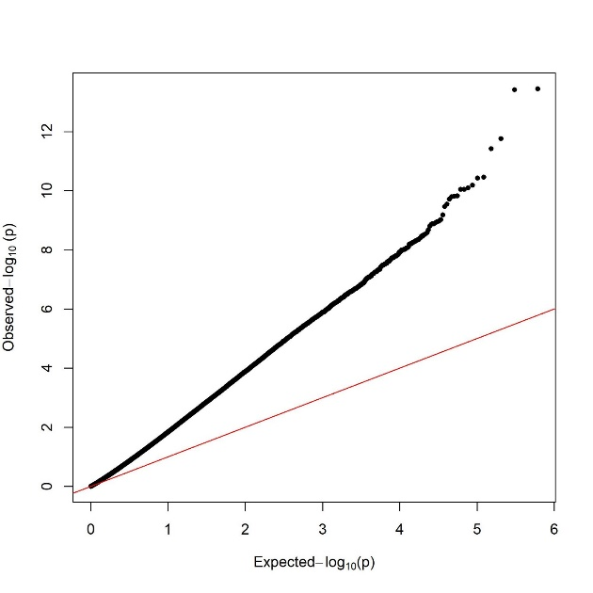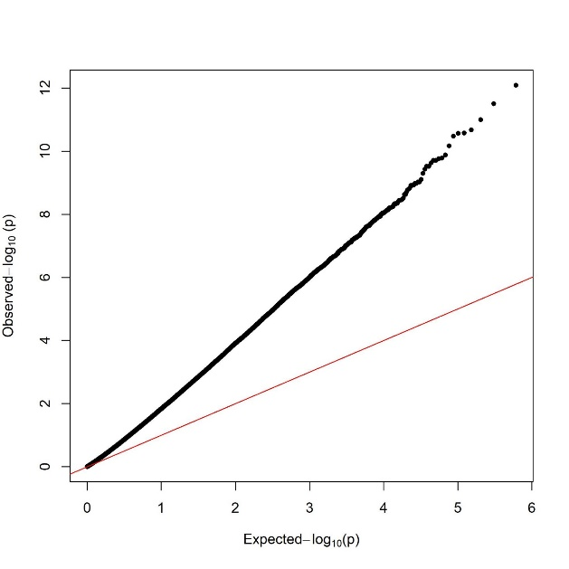
(c) Manhattan plot of BMI (d) Manhattan plot of WHtR

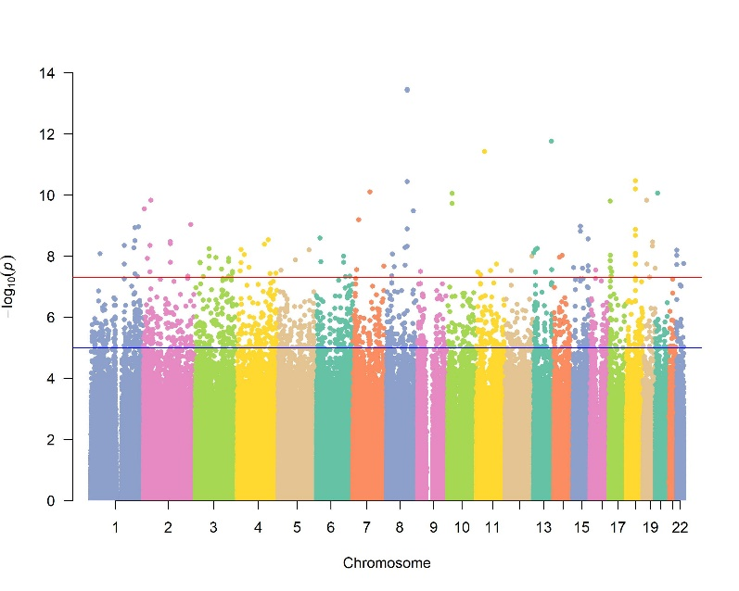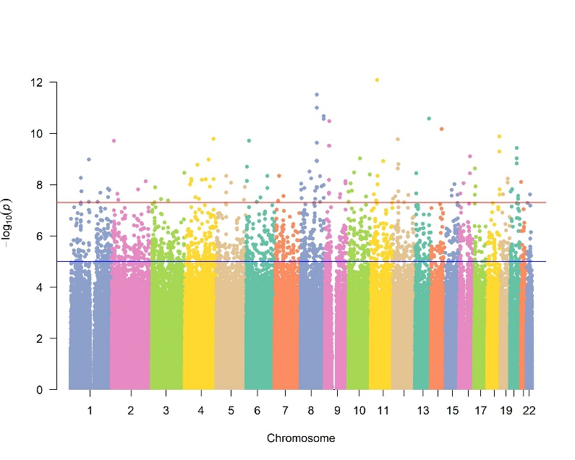

Figure S2. Q-Q plot and Manhattan plot of the GWAS meta-analyses results for BMI and WHtR

- Q-Q plot
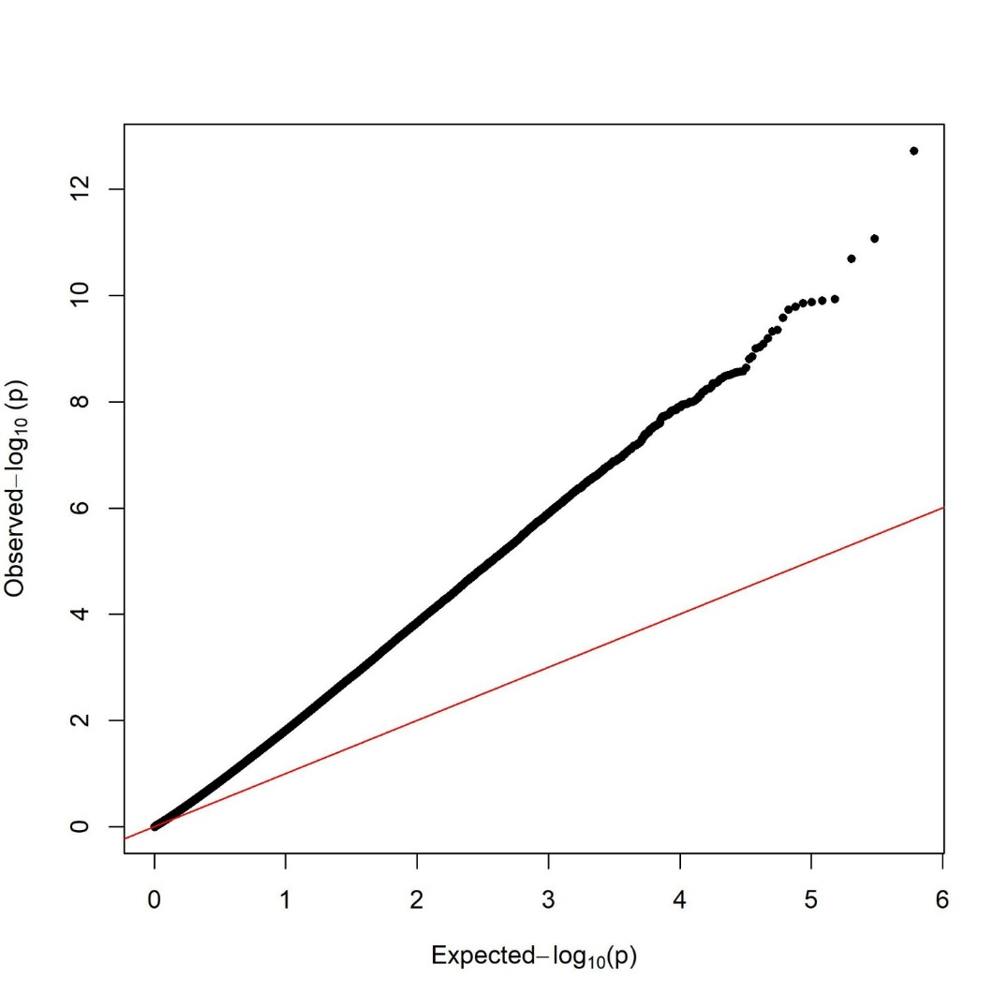
- Manhattan plot
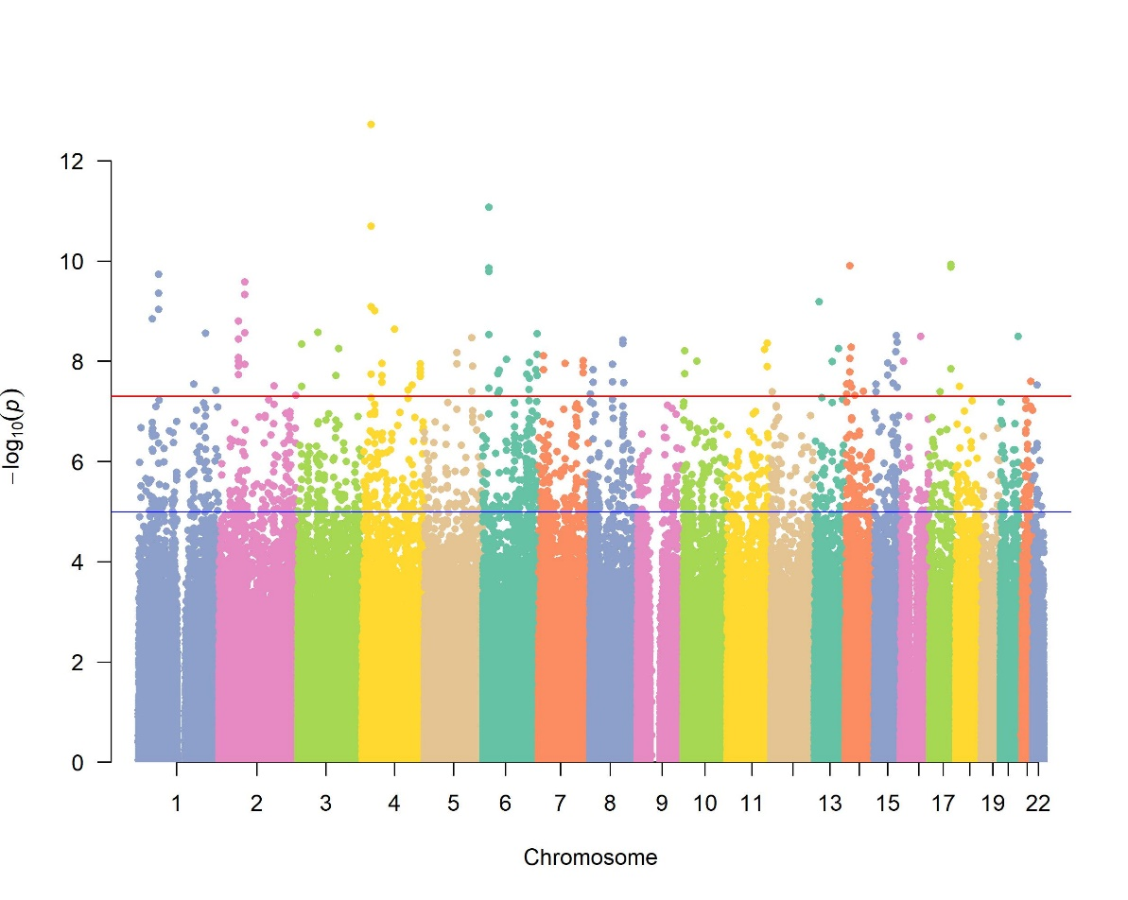

Figure S3. Q-Q plot and Manhattan plot of the GWAS meta-analyses results for asthma

Figure S4. Expression quantitative trait loci (eQTL) violin plots between genotypes of BMI-associated risk SNPs and gene expression from the Genotype-Tissue Expression (GTEx)
(a) eQTL effects of rs720631 on FZD5
216 GTEx individuals with the C/C genotype at SNP rs720631 have higher FZD5 gene expression in the esophageal mucosa than the 219 heterozygote (T/C) and 62 major allele homozygote (T/T) GTEx individuals.
(b) eQTL effects of rs7323765 on GJB6
255 GTEx individuals with the G/G genotype at SNP rs7323765 have lower GJB6 gene expression in the esophageal mucosa than the 200 heterozygote (C/G) and 42 major allele homozygote (C/C) GTEx individuals.

Figure S5. eQTL violin plots between genotypes of WHtR-associated risk SNPs and gene expression from the GTEx
(a) eQTL effects of rs11735097 on RP11-475B2.1
(b) eQTL effects of rs26956 on ELOVL7, DEPDC1B, and ERCC8
(c) eQTL effects of rs2151317 on LGSN
(d) eQTL effects of rs6020323 on LINC01273, TMEM189, CEBPB-AS1, UBE2V1, and RP11-112L6.3
(e) eQTL effects of rs4873644 on ALKAL1

Figure S6. eQTL violin plots between genotypes of asthma-associated SNPs and gene expression from the GTEx
(a) eQTL effects of rs4497664 on ISG20 and ACAN
(b) eQTL effects of rs437587 on REG3G

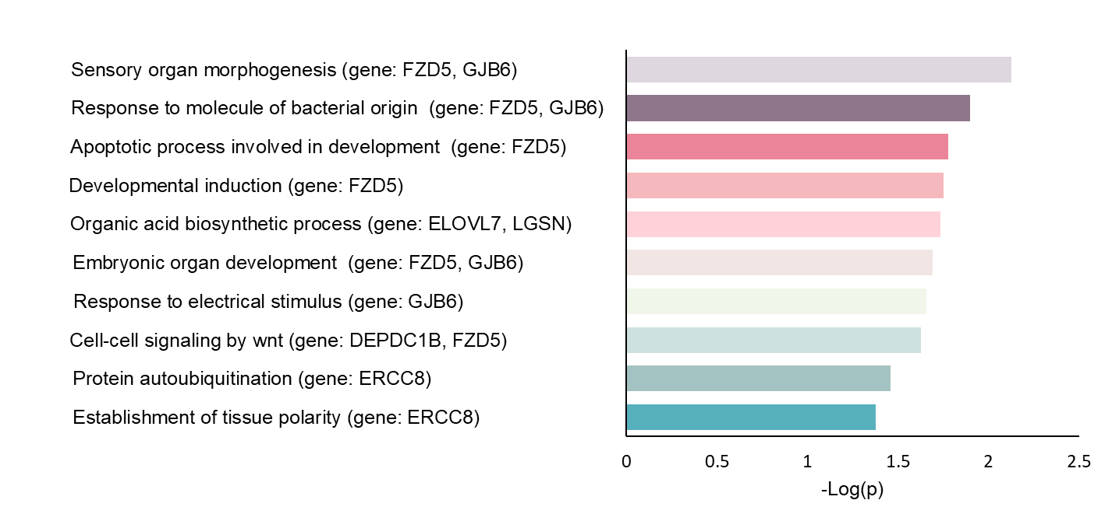

Figure S7. Top 10 biological process (BP) terms with the highest p-value by gene ontology (GO) enrichment analysis
The Y- axis was the GO BP terms, and the X- axis was the -Log(P-value). The larger the -Log(P-value), the more significant the BP is (p-value all <0.05, FDR >0.05).

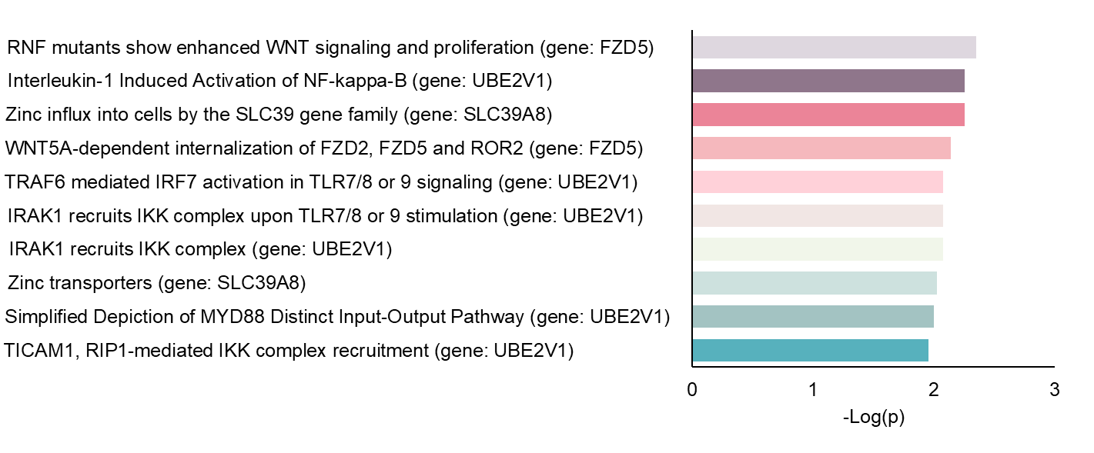

Figure S8. Top 10 pathway with the highest p-value by pathway enrichment analysis
The Y- axis was the pathway terms, and the X- axis was the -Log(P-value). The larger the -Log(P-value), the more significant the pathway is (top 10, p-value all <0.05, FDR >0.05).

FZD5, UBE2V1, and SLC39A8 genes were involved in immunity and glycosaminoglycan metabolism associated pathways:
- Immunity pathway:
  - WNT signaling
    - Reactome–RNF mutants show enhanced WNT signaling and proliferation
    - Reactome–WNT5A-dependent internalization of FZD2, FZD5 and ROR2
  - Toll-like Receptor Cascades
    - Wikipathway–Simplified Depiction of MYD88 Distinct Input-Output Pathway
    - Wikipathway–Interleukin-1 Induced Activation of NF-kappa-B
    - Reactome–IRAK1 recruits IKK complex upon TLR7/8 or 9 stimulation
    - Reactome–TRAF6 mediated IRF7 activation in TLR7/8 or 9 signaling
    - Reactome–IRAK1 recruits IKK complex”.
- zinc ion transmembrane transport pathway:
  - Reactome–Zinc transporters
  - Reactome–Zinc influx into cells by the SLC39 gene family

Figure S9. The performance of predictive model of poorly controlled asthma by general obesity (presented as BMI) related traits and genetics scores
(a) The effect of BMI traits on poorly controlled asthma
Model 1: BMI (continuous)
Model 2: BMI (binary)
Model 3: Model 1+ asthma genetic score+ one of the parents has asthma
Model 4: Model 2+ asthma genetic score+ one of the parents has asthma
(b) The effect of BMI-related genetic score on poorly controlled asthma
Model 1: BMI-related genetic risk score (GRS)
Model 2: Model 1+ asthma genetic score+ one of the parents has asthma
Model 3: BMI-related genetic protective score (GPS)
Model 4: Model 3+ asthma genetic score+ one of the parents has asthma
Model 5: Model 1+ Model3
Model 6: Model 5+ asthma genetic score+ one of the parents has asthma
(c) The effect of BMI and genetic score on poorly controlled asthma
Model 1: BMI (continuous) and BMI-related GRS
Model 2: Model 1+ one of the parents has asthma
Model 3: BMI (continuous) and BMI-related GPS
Model 4: Model 3+ one of the parents has asthma
Model 5: Model 1+ Model 3
Model 6: Model 5+ one of the parents has asthma
(d) The effect of general obesity and genetic score on poorly controlled asthma
Model 1: BMI (binary) and BMI-related GRS
Model 2: Model 1+ asthma genetic score+ one of the parents has asthma
Model 3: BMI (binary) and BMI-related GPS
Model 4: Model 3+ asthma genetic score+ one of the parents has asthma
Model 5: Model 1+ Model 3
Model 6: Model 5+ asthma genetic score+ one of the parents has asthma

Figure S10. The performance of predictive model of poorly controlled asthma by central obesity (presented as WHtR) related traits and genetics scores
(a) The effect of WHtR traits on poorly controlled asthma
Model 1: WHtR (continuous)
Model 2: WHtR (binary)
Model 3: Model 1+ asthma genetic score+ one of the parents has asthma
Model 4: Model 1+ asthma genetic score+ one of the parents has asthma
(b)The effect of WHtR-related genetic score on poorly controlled asthma
Model 1: WHtR-related genetic risk score (GRS)
Model 2: Model 1+ asthma genetic score+ one of the parents has asthma
Model 3: WHtR-related genetic protective score (GPS)
Model 4: Model 3+ asthma genetic score+ one of the parents has asthma
Model 5: Model 1+ Model3
Model 6: Model 5+ asthma genetic score+ one of the parents has asthma
(c) The effect of WHtR and genetic score on poorly controlled asthma
Model 1: WHtR (continuous) and WHtR-related GRS
Model 2: Model 1+ asthma genetic score+ one of the parents has asthma
Model 3: WHtR (continuous) and WHtR-related GPS
Model 4: Model 3+ asthma genetic score+ one of the parents has asthma
Model 5: Model 1+ Model 3
Model 6: Model 5+ asthma genetic score+ one of the parents has asthma
(d) The effect of central obesity and genetic score on poorly controlled asthma
Model 1: WHtR (binary) and WHtR-related GRS
Model 2: Model 1+ + asthma genetic score+ one of the parents has asthma
Model 3: WHtR (binary) and WHtR-related GPS
Model 4: Model 3+ asthma genetic score+ one of the parents has asthma
Model 5: Model 1+ Model 3
Model 6: Model 5+ asthma genetic score+ one of the parents has asthma

