Supplementary Figures

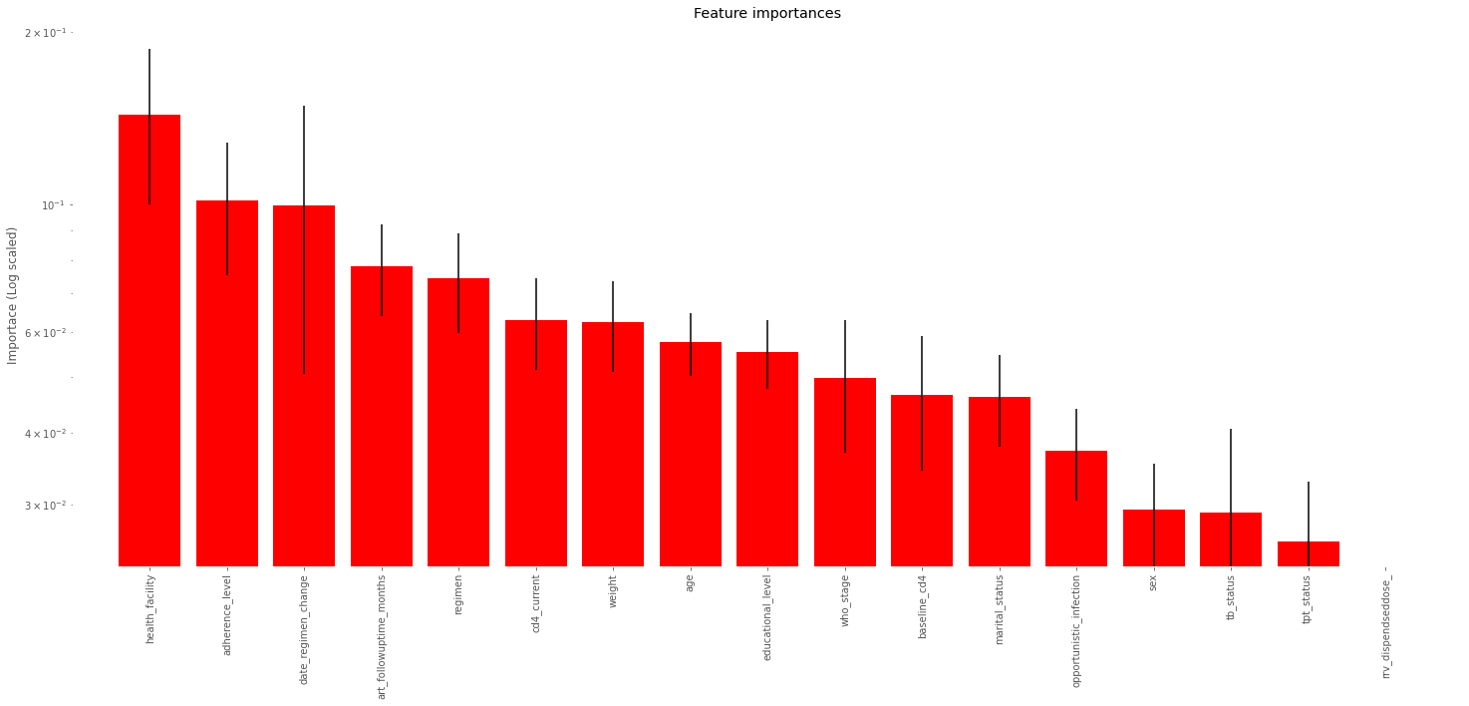

Figure 1: relative importance of the selected features in the prediction of unsuppressed viral load (ranked from most to least important).

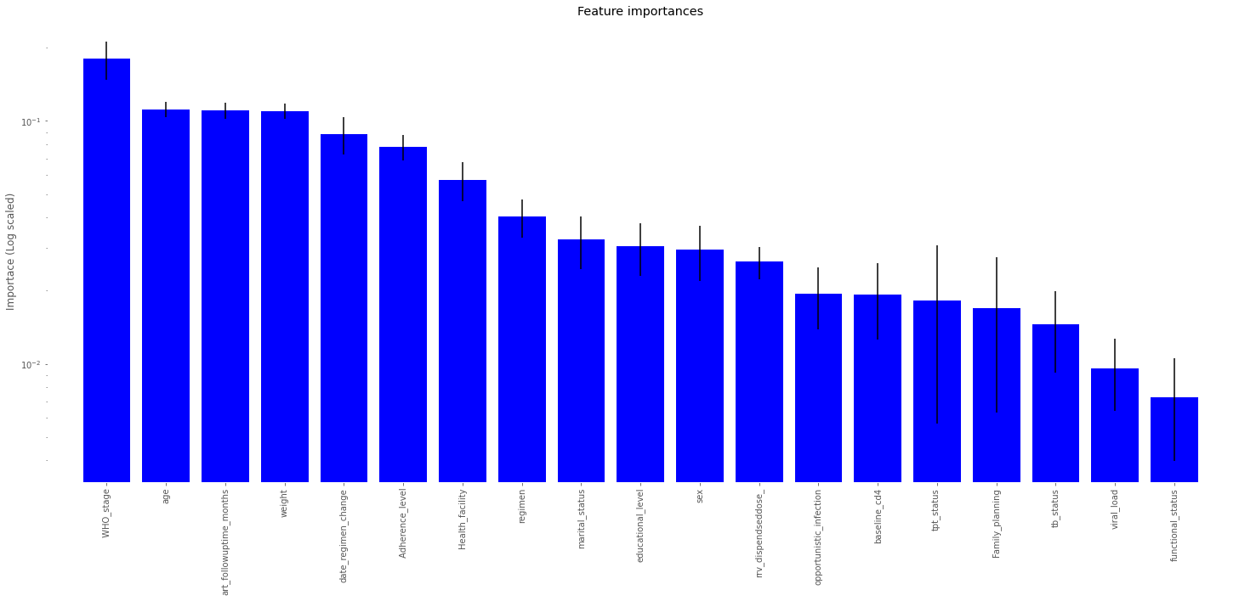
Figure 2: relative importance of the selected features in the prediction of low CD4 (ranked from most to least important).

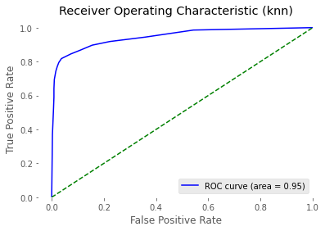
Figure 3: Receiver operating characteristic curves of K-nearest neighbor (KNN) model for viral load prediction

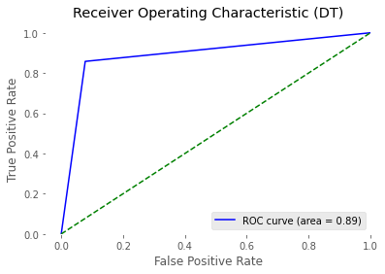

Figure 4: Receiver operating characteristic curves of Decision Trees (DT) model for viral load prediction

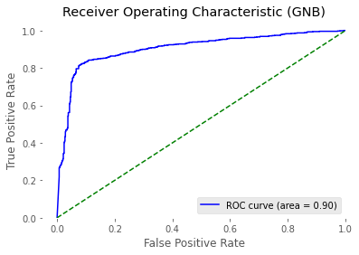
Figure 5: Receiver operating characteristic curves of Gaussian Nave Bayes (GNB) model for viral load prediction

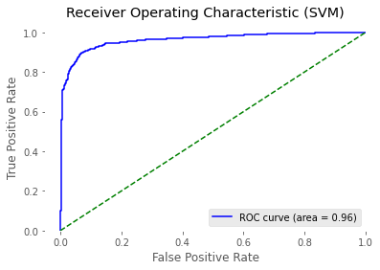

Figure 6: Receiver operating characteristic curves of Support Vector Classifier (SVC) model for viral load prediction

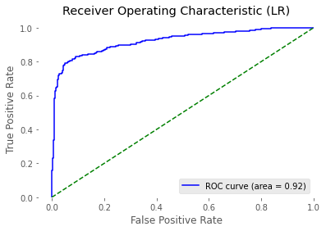

Figure 7: Receiver operating characteristic curves of Logistic Regression (LR) model for viral load prediction

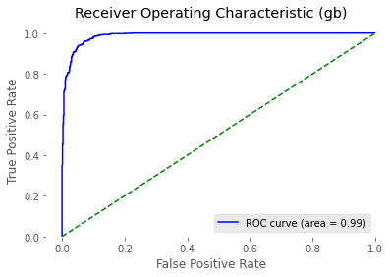

Figure 8: Receiver operating characteristic curves of Gradient Boosting (GB) model for viral load prediction

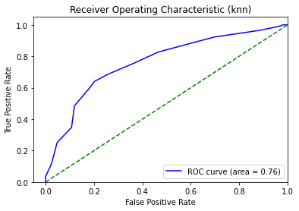
Figure 1: Receiver operating characteristic curves of K-nearest neighbor (KNN) model for CD4 prediction

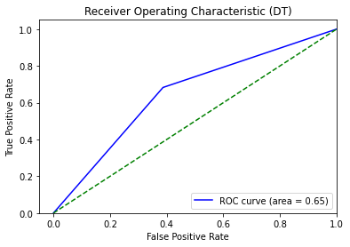
Figure 9: Receiver operating characteristic curves of Decision Trees (DT) model for CD4 prediction

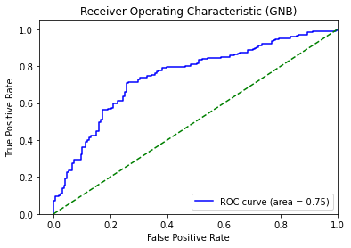
Figure 10: Receiver operating characteristic curves of Gaussian Nave Bayes (GNB) model for CD4 prediction

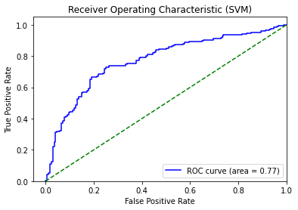

Figure 11: Receiver operating characteristic curves of Support Vector Classifier (SVC) model for CD4 prediction

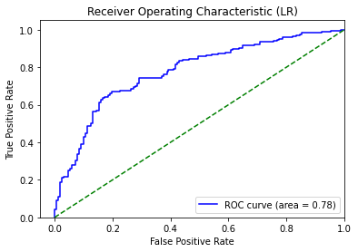

Figure 12: Receiver operating characteristic curves of Logistic Regression (LR) model for CD4 prediction

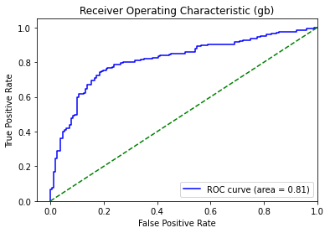

Figure 13: Receiver operating characteristic curves of Gradient Boosting (GB) model for CD4 prediction

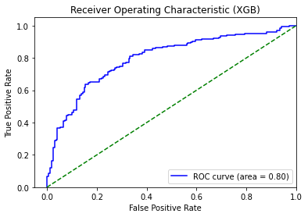
Figure 14: Receiver operating characteristic curves of eXtreme Gradient Boosting (XGBoost) model for CD4 prediction

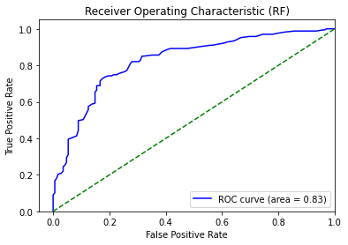
Figure 15: Receiver operating characteristic curves of Random Forest (RF) model for CD4 prediction

Table 1 extracted ART databases features(attributes) in the study
 | Attributes | Meaning | Value | Data type
Target features for predictive modeling | Viral load status | The viral load status of the patient currently on the ART | Suppressed  Unsuppressed | Ordinal
Target features for predictive modeling | CD4 | The CD4 count of the patient currently on the ART | <200  >200 | Ordinal
Predictors/features
 | Patient identification
 | Patient MRN |  |  | Numeric
 | Art Number |  |  | Numeric
 | Health facility |  | Dilla university Referrral hospital  Yirgachefe primary hospital
 | Sociodemographic factors
 | Sex | Sex of the patient | Female  Male | Nominal
 | Age | Age of the patient | Numeric age values | Numeric
 | Weight | The weight of the patient on ART | Numeric body weight values | Numeric
 | Marital status | The marital status of the patient | 1-Never married  2-Married  3-Separated  4-Divorsed  5-Widow/Widower | Nominal
 | Educational Level | Educational level of the patient | Unable to read and write  1-No education  2-Primary  3-Secondary  4-Teritiary | Ordinal
 | Clinical factors and behavioural features
 | Regimen | The current regimen the patient is taking on ART | 1a(30)=d4T(30)-3TC-NVP  1a(40)=d4T(40)-3TC-NVP  1b(30)=d4T(30)-3TC-EFV  1b(40)=d4T(40)-3TC-EFV  1c=AZT-3TC-NVP  1d=AZT-3TC-EFV  2a, 2b, 2c, 2d. 4a, 4b, 4c and 4d. 5a, 5b, 5c, 5d  Other | Nominal
 | Regimen change | Is the regimen changed after starting ART | Yes  No | Nominal
 | Functional status | Functional level of the patient | W-working  A-Ambulatory  B-Bedridden | Nominal
 | Data HIV confirmed | The date of the patient diagnosed with HIV |  | Date
 | ART Start Date | The date ART starts | From 2012-2022 | Date
 | ARV dispensed dose | Dose the patient took for Treatment |  | Numeric
 | Adherence level | The adherence level of a patient on ART | Good  Fair  Poor | Ordinal
 | TB screening status | TB diagnosis the patient is on ART | Positive  Negative | Nominal
 | Nutritional screening status |  | Overweight  Undernourished  Normal | Nominal
 | Sex for nutrition |  |  | Nominal
 | TPT started date | The date TPT starts |  | Date
 | TPT completed date | The date TPT completed | Completed  Not completed | Date
 | TPT type | Type of TPT provided |  | Nominal
 | CCS_Offered |  | Yes  No | Nominal
 | CCS_Accepted |  | Yes  No | Nominal
 | CCS_ScreenDone |  | Yes  No | Nominal
 | CCS_ScreenDone_Date |  |  | Date
 | CCS_Screen_Method |  | HPV DNA test  VIA
 | CCS_HPV_Result |  | HPV Negative  HPV Positive
 | Family Planning | This attribute asks the usage of Family planning methods | Yes/No | Yes/No
 | Pregnant | Asks the patient pregnant or not on ART | Yes/No | Yes/No
 | WHO stage | WHO stages at which the patient is on ART | 1-stage 1  2-sage 2  3-stage 3  4-stage 4 | Nominal
 | Opportunistic infection |  | Yes/No | Nominal
 | Past ARV Treatment | Dose the patient took Past ARV Treatment | Yes for treatment  No for not treatment | Yes/no
 | Baseline CD4 | The CD4 count of the patient at the start of ART | <100  >100 | Nominal
 | Viral load count | The viral load count of the patient currently on the ART |  | Numeric

