Supplementary Figures

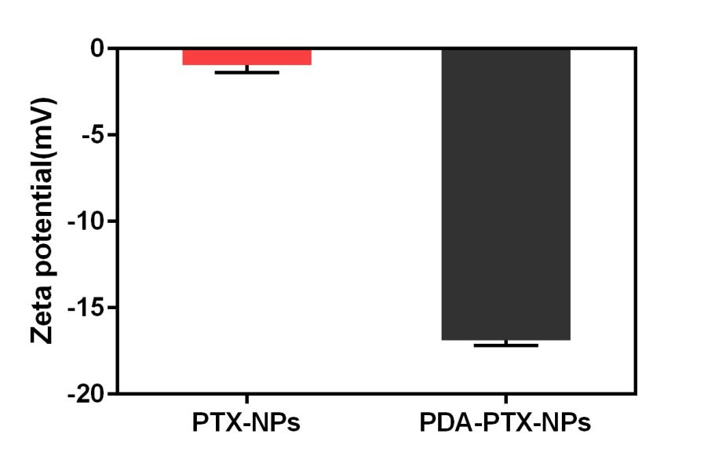
Figure S1. The average zeta potential of PTX-NPs and PDA-PTX-NPs. Data are presented as mean ± SD (n=3).

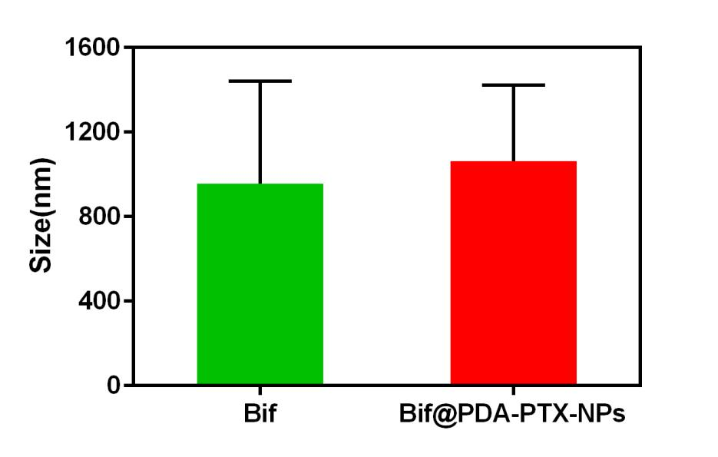
Figure S2. The average particle size of Bif and Bif@PDA-PTX-NPs. Data are presented as mean ± SD (n=3).

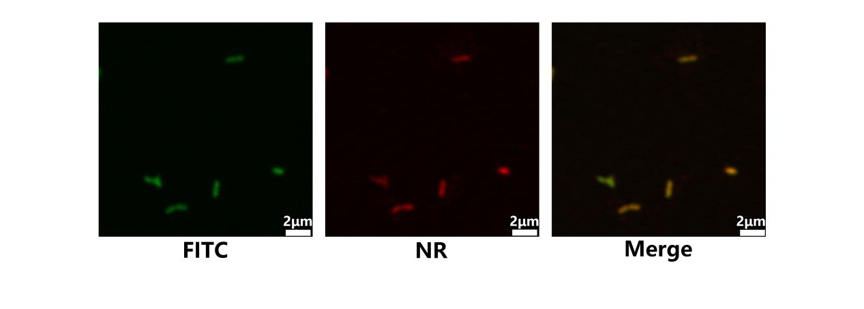

Figure S3. The confocal microscope images of Bif@PDA-NR-NPs. Green fluorescence indicates the FITC-labelled Bif, red fluorescence shows the NR-labelled PDA-NR-NPs. (Scale bar=2μm).

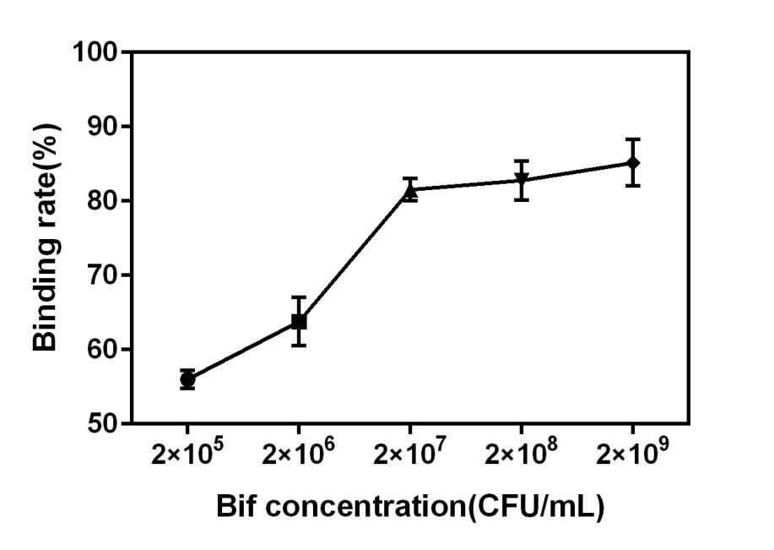
Figure S4. Binding rates of PTX-NPs on Bif with different concentrations. Data are represented as mean ± SD (n=3).

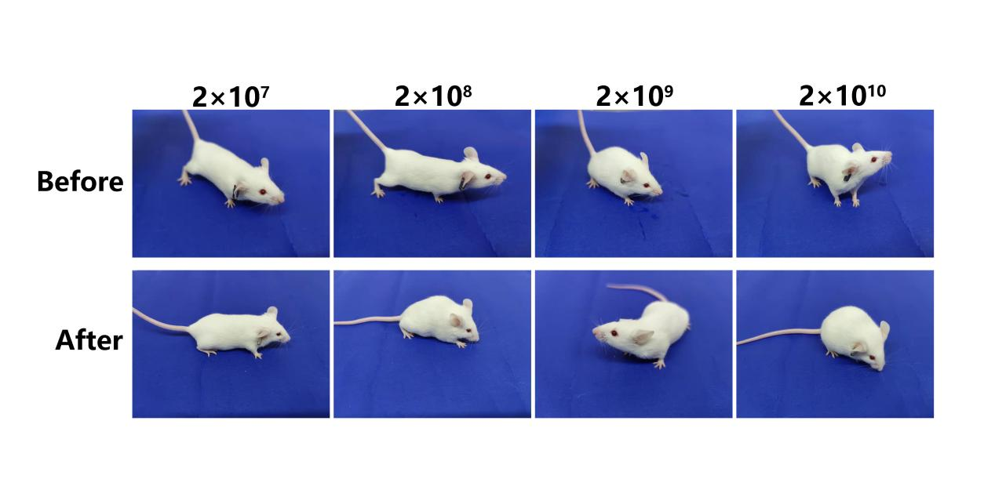
Figure S5. The photos of mice activity before and after tail injection of Bif suspensions with different concentrations.

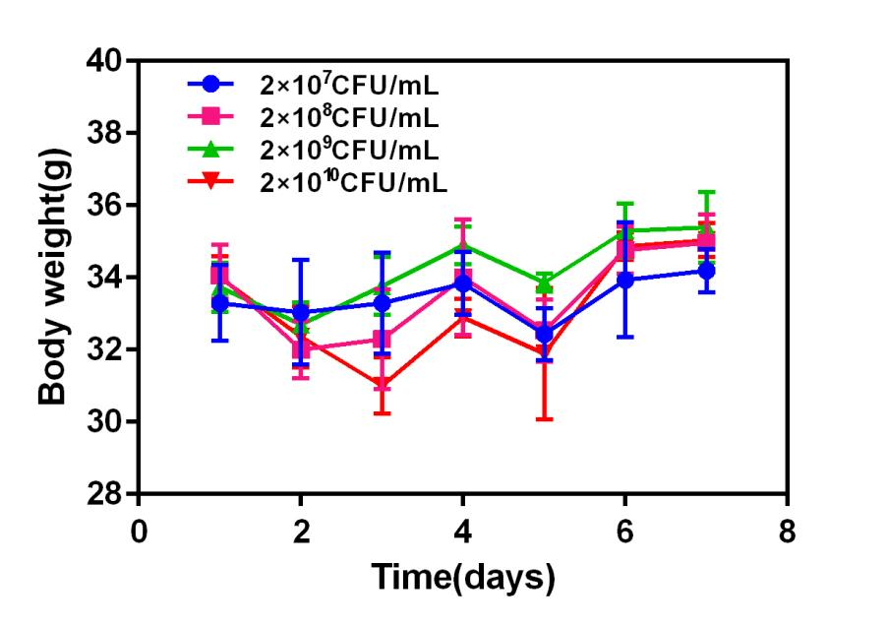
Figure S6. The body weight curves of mice after tail injection of Bif suspensions with different concentrations.

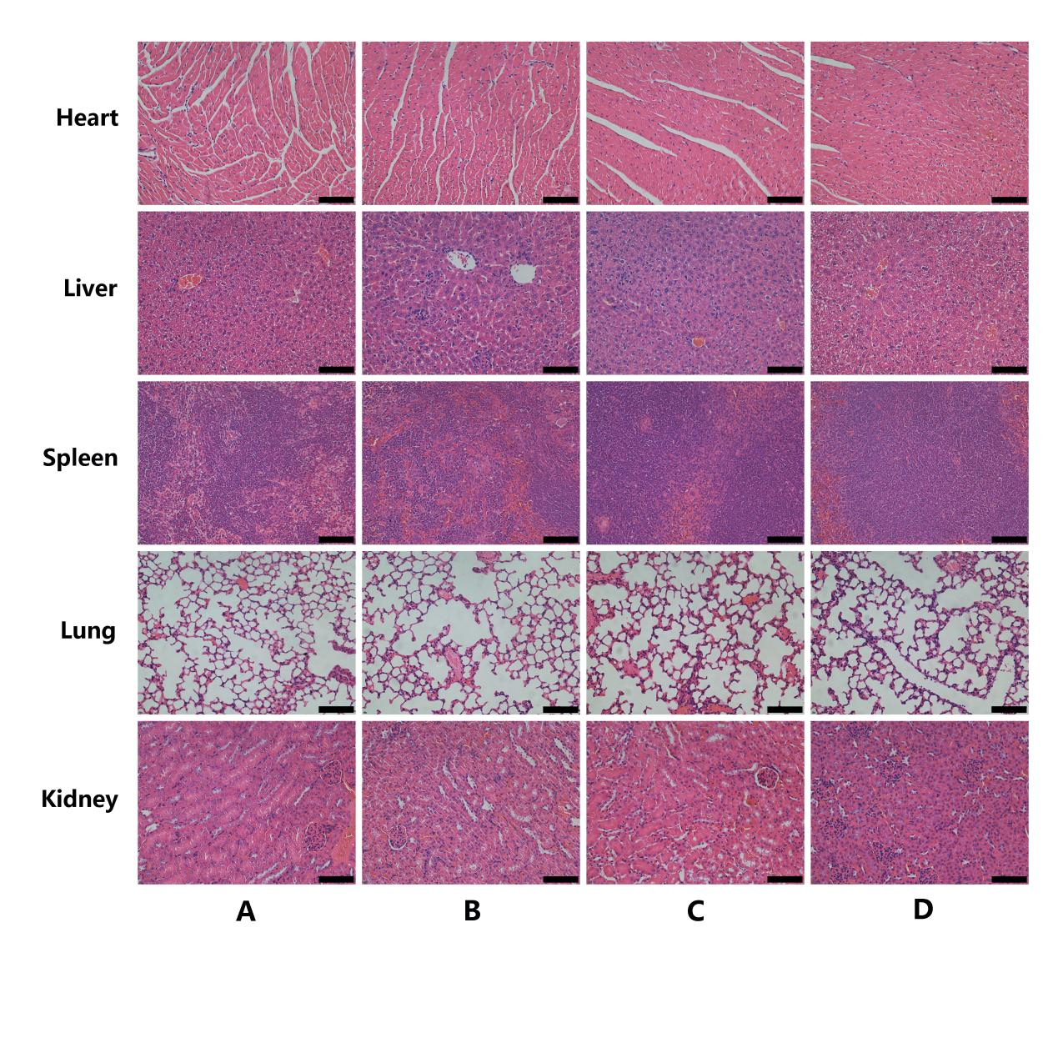
Figure S7. The hematoxylin and eosin staining images of major organs (including heart, liver, spleen, lung and kidney) after tail injection of Bif suspensions with different concentrations. (Scale bar=100μm). A: 2×10⁷CFU/mL; B: 2×10⁸CFU/mL; C: 2×10⁹CFU/mL; D: 2×10¹⁰CFU/mL.

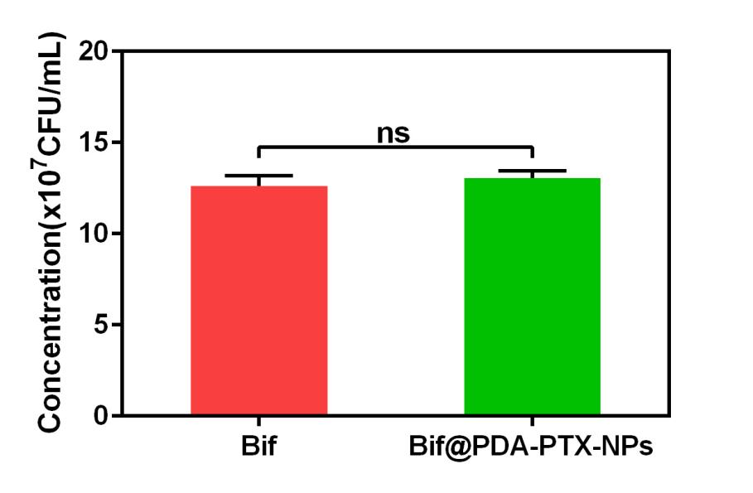
Figure S8. The number of bacteria after anaerobic incubation for 24h. Data are presented as mean ± SD (n=3, ns: no statistical significance).

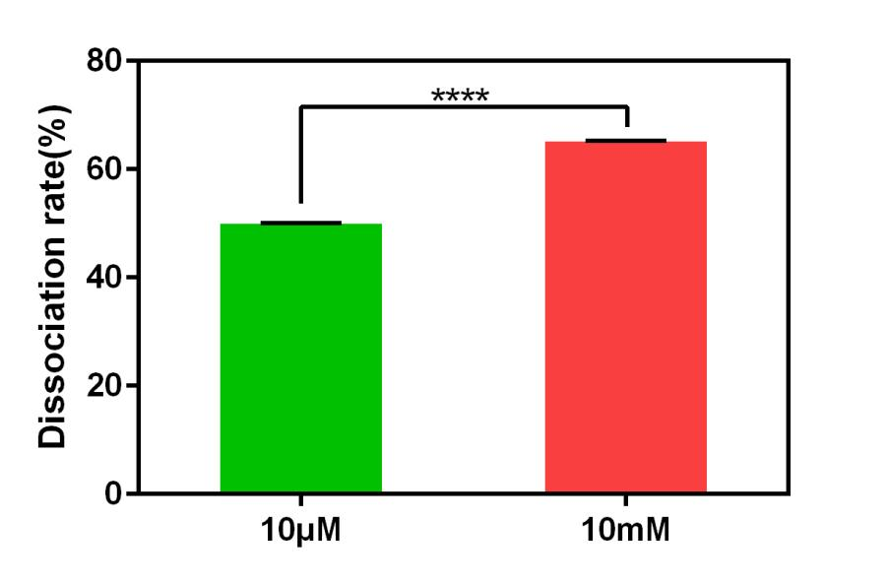
Figure S9. Dissociation rate of NR-NPs from Bif@PDA-NR-NPs solutions containing 10 μM GSH or 10 mM GSH. Data are presented as mean ± SD (n=3, ****P<0.0001).

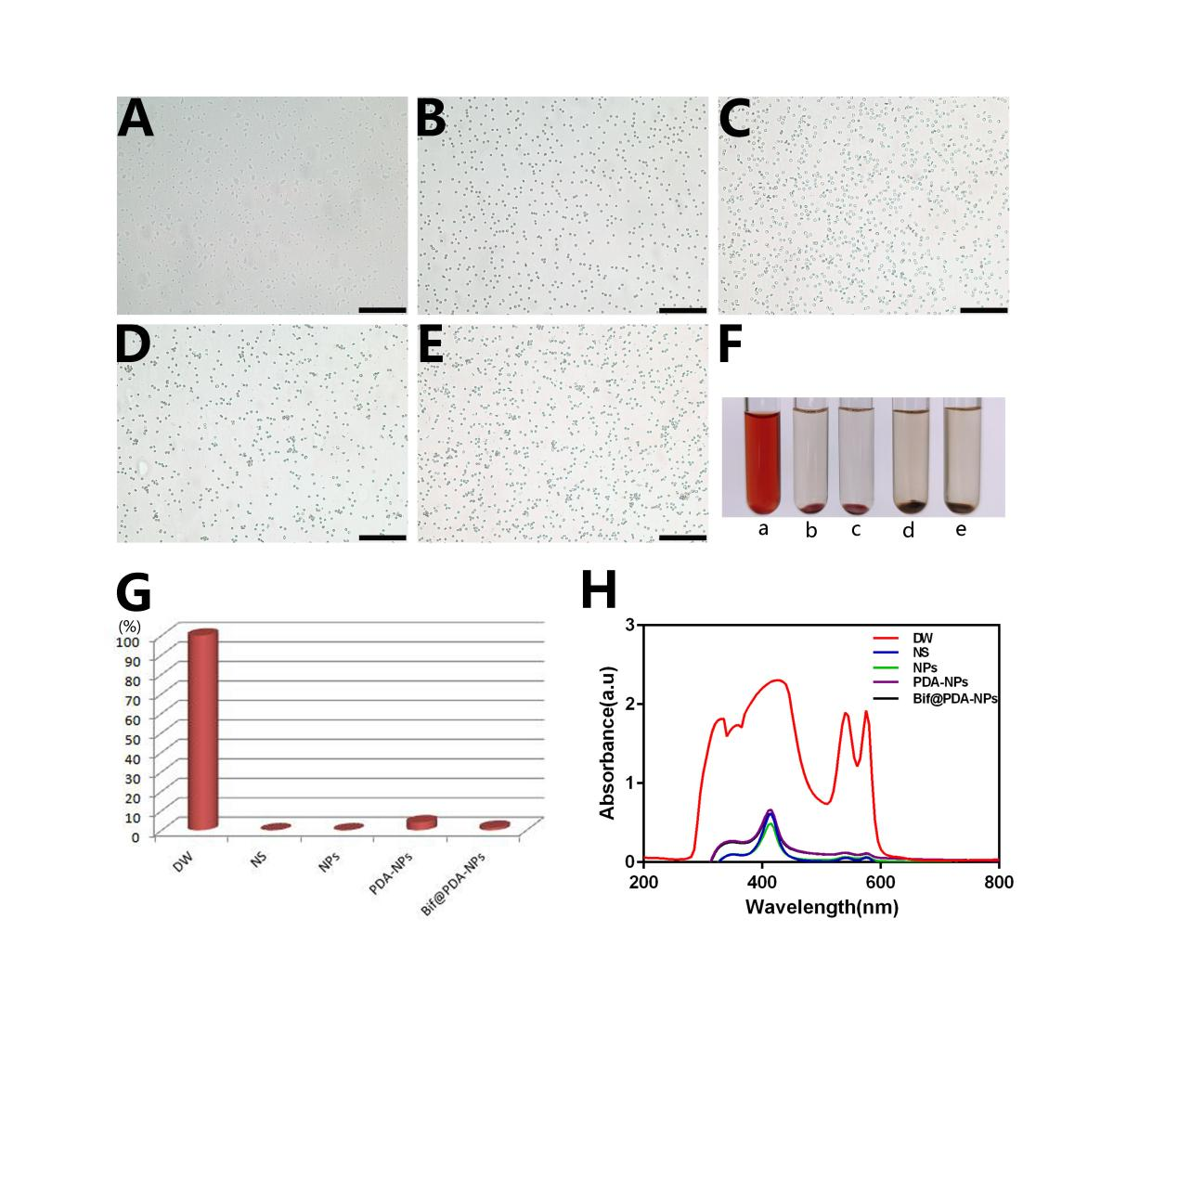
Figure S10. In vitro hemolysis analysis. (A-E) Representative microscope photos of red blood cells after incubated with different samples (Scale bar=100μm). A: distilled water (DW); B: normal saline (NS); C: NPs; D: PDA-NPs; E: Bif@PDA-NPs. (F) Photo of solutions in each group after centrifugation. a: DW; b: NS; c: NPs; d: PDA-NPs; e: Bif@PDA-NPs. (G) The hemolysis rate in each group. (H)UV-vis absorption spectra of hemolysis in each group.

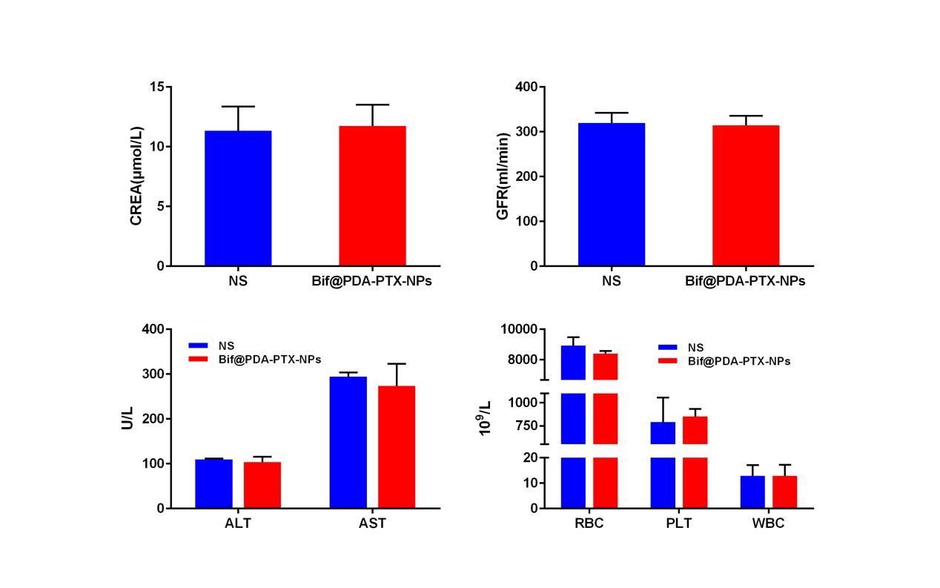
Figure S11. In vivo analysis of biochemistry and blood cell count of mice in the groups of NS and Bif@PDA-PTX-NPs. Data are presented as mean ± SD (n= 3). Abbreviations: creatinine (CREA), glomerular filtration rate (GFR), alanine aminotransferase (ALT), aspartate aminotransferase (AST), red blood cells (RBC), platelets (PLT), and white blood cells (WBC).

