Supplementary Data

Supplementary Figure 1 Flowchart of study population.
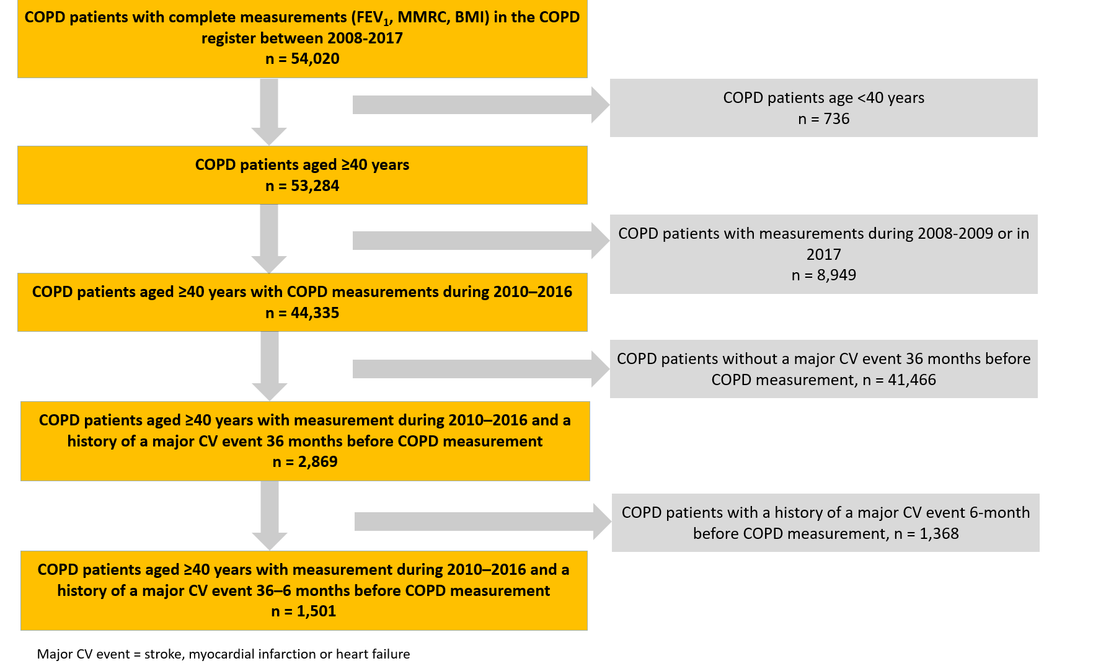
The COPD measurement represents the COPD measurement date/baseline, ie, the study index date defined as the date of a patient’s first visit at which a complete set of clinical measurements was registered. A major CV event was defined as stroke, myocardial infarction or heart failure. In summary, the study population comprised 1,501 COPD patients aged ≥40 years with a COPD measurement during 2010‒2016 and a history of severe CVD 36‒6 months prior to COPD measurement.
Abbreviations: COPD, chronic obstructive pulmonary disease; CV, cardiovascular.

Supplementary Figure 2 Study design to investigate the link between COPD exacerbations in patients with a history of cardiovascular events.

The COPD measurement represents the COPD measurement date/baseline, ie, the study index date defined as the date of a patient’s first visit at which a complete set of clinical measurements (mMRC, FEV1, BMI and smoking history) was registered. The exclusion period represents the 6-month period before COPD measurement, where all patients with CV events were excluded. The assessment period represents the 6-month period after COPD measurement when the first CV event or non-CV-related death was sought/detected prospectively. The date at which this occurred was defined as the event date; in the absence of any event in the assessment period, this was designated as the assessment period end date. The observation period represents was the 6-month period prior to the event/assessment period end date, where the COPD exacerbation history was evaluated in patients retrospectively.
Abbreviations: BMI, body mass index; COPD, chronic obstructive pulmonary disease; CV, cardiovascular; FEV₁, forced expiratory flow; mMRC, modified Medical Research Council.

