The analgesic efficacy of chest wall blocks for postoperative analgesia after video-assisted thoracoscopic surgeries: a systematic review and network meta-analysis- Supplementary files

Contents
Supplementary Table 1: literature search summary 3
Embase Session Results 5
Supplementary Table 2: justification for the risk of bias assessment grading 11
Supplementary Table 3: additional characteristics of included studies 23
Pairwise heterogeneity analysis 31
24-hour opioid requirement 32
Network diagram for 24-hour opioid requirement comparisons 32
Rankogram for 24-hour opioid requirement comparisons between the pain interventions 33
SUCRA graph for 24-hour opioid requirement comparisons between the pain interventions 33
Funnel plot for 24-hour opioid requirement comparisons 34
Leverage plot for 24-hour opioid requirement comparisons 34
Consistency plot for 24-hour opioid requirement comparisons 34
Sensitivity analysis excluding the study by Yeap et al 35
Sensitivity analysis excluding studies that used surgical site infiltration as control 38
Sensitivity analysis excluding studies with high risk of bias 39
Sensitivity analysis excluding studies with inadequate patient blinding 41
Subgroup analysis of studies with vs without chest tube 42
24-hour static pain score AUC 43
Network diagram for 24-hour pain score AUC comparisons 43
Rankogram for 24-hour pain score comparisons between the pain interventions 44
SUCRA graph for 24-hour pain score comparisons between the pain interventions 44
Funnel plot for 24-hour pain score comparisons 45
Leverage plot for 24-hour pain score comparisons 45
Consistency plot for 24-hour pain score comparisons 46
Sensitivity analysis excluding studies that used surgical site infiltration as control 47
Sensitivity analysis excluding studies with inadequate patient blinding 48
Sensitivity analysis excluding studies with high risk of bias 50
Subgroup analysis of studies with vs without chest tube 51
24-hour dynamic pain score AUC 52
Network diagram for 24-hour dynamic pain score AUC comparisons 52
Forest plot for 24-hour dynamic pain score comparisons between the pain interventions 53
League table for 24-hour dynamic pain score comparisons between the pain interventions 53
Rankogram for 24-hour dynamic pain score comparisons between the pain interventions 54
SUCRA graph for 24-hour dynamic pain score comparisons between the pain interventions 54
Funnel plot for 24-hour dynamic pain score comparisons 55
Leverage plot for 24-hour dynamic pain score comparisons 55
Consistency plot for 24-hour dynamic pain score comparisons 56
Postoperative nausea and vomiting (PONV) risk 56
Forest plot for PONV comparisons between the pain interventions 56
Network diagram for PONV comparisons 57
Rankogram for PONV comparisons between the pain interventions 57
SUCRA graph for PONV comparisons between the pain interventions 57
League table of PONV comparisons between the pain interventions 58
Consistency plot for PONV comparisons between the pain interventions 59
Leverage plot for PONV 59
Length of stay 60
Network diagram for length of stay comparisons 60
Forest plot for length of stay comparisons between the pain interventions 61
SUCRA graph for length of stay comparisons between the pain interventions 62
League table for length of stay comparisons between the pain interventions 62

Supplementary Table 1: literature search summary

Ovid MEDLINE(R) and Epub Ahead of Print, In-Process, In-Data-Review & Other Non-Indexed Citations and Daily <1946 to August 19, 2022>

1 exp Thoracic Surgery, Video-Assisted/ 8315
2 VATS.mp. [mp=title, book title, abstract, original title, name of substance word, subject heading word, floating sub-heading word, keyword heading word, organism supplementary concept word, protocol supplementary concept word, rare disease supplementary concept word, unique identifier, synonyms] 6527
3 video-assisted thoracic surgery.mp. [mp=title, book title, abstract, original title, name of substance word, subject heading word, floating sub-heading word, keyword heading word, organism supplementary concept word, protocol supplementary concept word, rare disease supplementary concept word, unique identifier, synonyms] 3360
4 exp Thoracoscopy/ 16110
5 1 or 2 or 3 or 4 19618
6 regional anesthesia.mp. [mp=title, book title, abstract, original title, name of substance word, subject heading word, floating sub-heading word, keyword heading word, organism supplementary concept word, protocol supplementary concept word, rare disease supplementary concept word, unique identifier, synonyms] 7512
7 exp Anesthesia, Conduction/ 70300
8 nerve block.mp. [mp=title, book title, abstract, original title, name of substance word, subject heading word, floating sub-heading word, keyword heading word, organism supplementary concept word, protocol supplementary concept word, rare disease supplementary concept word, unique identifier, synonyms] 28391
9 exp Nerve Block/ 25314
10 neurolysis.mp. [mp=title, book title, abstract, original title, name of substance word, subject heading word, floating sub-heading word, keyword heading word, organism supplementary concept word, protocol supplementary concept word, rare disease supplementary concept word, unique identifier, synonyms] 2545
11 transverse thoracic plane block.mp. [mp=title, book title, abstract, original title, name of substance word, subject heading word, floating sub-heading word, keyword heading word, organism supplementary concept word, protocol supplementary concept word, rare disease supplementary concept word, unique identifier, synonyms] 1
12 epidural anesthesia.mp. [mp=title, book title, abstract, original title, name of substance word, subject heading word, floating sub-heading word, keyword heading word, organism supplementary concept word, protocol supplementary concept word, rare disease supplementary concept word, unique identifier, synonyms] 6777
13 exp Anesthesia, Epidural/ 14043
14 PECs.mp. [mp=title, book title, abstract, original title, name of substance word, subject heading word, floating sub-heading word, keyword heading word, organism supplementary concept word, protocol supplementary concept word, rare disease supplementary concept word, unique identifier, synonyms] 1896
15 pectoral block.mp. [mp=title, book title, abstract, original title, name of substance word, subject heading word, floating sub-heading word, keyword heading word, organism supplementary concept word, protocol supplementary concept word, rare disease supplementary concept word, unique identifier, synonyms] 20
16 pectoralis block.mp. [mp=title, book title, abstract, original title, name of substance word, subject heading word, floating sub-heading word, keyword heading word, organism supplementary concept word, protocol supplementary concept word, rare disease supplementary concept word, unique identifier, synonyms] 9
17 serratus anterior block.mp. [mp=title, book title, abstract, original title, name of substance word, subject heading word, floating sub-heading word, keyword heading word, organism supplementary concept word, protocol supplementary concept word, rare disease supplementary concept word, unique identifier, synonyms] 17
18 SAM block.mp. [mp=title, book title, abstract, original title, name of substance word, subject heading word, floating sub-heading word, keyword heading word, organism supplementary concept word, protocol supplementary concept word, rare disease supplementary concept word, unique identifier, synonyms] 1
19 serratus anterior plane block.mp. [mp=title, book title, abstract, original title, name of substance word, subject heading word, floating sub-heading word, keyword heading word, organism supplementary concept word, protocol supplementary concept word, rare disease supplementary concept word, unique identifier, synonyms] 196
20 paravertebral block.mp. [mp=title, book title, abstract, original title, name of substance word, subject heading word, floating sub-heading word, keyword heading word, organism supplementary concept word, protocol supplementary concept word, rare disease supplementary concept word, unique identifier, synonyms] 1006
21 PVB.mp. [mp=title, book title, abstract, original title, name of substance word, subject heading word, floating sub-heading word, keyword heading word, organism supplementary concept word, protocol supplementary concept word, rare disease supplementary concept word, unique identifier, synonyms] 1146
22 TPVB.mp. [mp=title, book title, abstract, original title, name of substance word, subject heading word, floating sub-heading word, keyword heading word, organism supplementary concept word, protocol supplementary concept word, rare disease supplementary concept word, unique identifier, synonyms] 172
23 erector spinae block.mp. [mp=title, book title, abstract, original title, name of substance word, subject heading word, floating sub-heading word, keyword heading word, organism supplementary concept word, protocol supplementary concept word, rare disease supplementary concept word, unique identifier, synonyms] 108
24 ESB.mp. [mp=title, book title, abstract, original title, name of substance word, subject heading word, floating sub-heading word, keyword heading word, organism supplementary concept word, protocol supplementary concept word, rare disease supplementary concept word, unique identifier, synonyms] 523
25 ESP.mp. [mp=title, book title, abstract, original title, name of substance word, subject heading word, floating sub-heading word, keyword heading word, organism supplementary concept word, protocol supplementary concept word, rare disease supplementary concept word, unique identifier, synonyms] 3877
26 erector spinae plane block.mp. [mp=title, book title, abstract, original title, name of substance word, subject heading word, floating sub-heading word, keyword heading word, organism supplementary concept word, protocol supplementary concept word, rare disease supplementary concept word, unique identifier, synonyms] 868
27 intercostal block.mp. [mp=title, book title, abstract, original title, name of substance word, subject heading word, floating sub-heading word, keyword heading word, organism supplementary concept word, protocol supplementary concept word, rare disease supplementary concept word, unique identifier, synonyms] 158
28 6 or 7 or 8 or 9 or 10 or 11 or 12 or 13 or 14 or 15 or 16 or 17 or 18 or 19 or 20 or 21 or 22 or 23 or 24 or 25 or 26 or 27 87855
29 5 and 28 574

Search Name: Cochrane Central Register of Controlled Trials (CENTRAL)
Date Run: 22/08/2022 22:27:21
Comment:

ID Search Hits
#1 MeSH descriptor: [Thoracic Surgery, Video-Assisted] explode all trees 314
#2 MeSH descriptor: [Thoracoscopy] explode all trees 499
#3 ("video assisted thoracic surgery"):ti,ab,kw 300
#4 (VATS):ti,ab,kw 790
#5 #1 or #2 or #3 or #4 1212
#6 ("regional anesthesia"):ti,ab,kw 3639
#7 MeSH descriptor: [Anesthesia, Conduction] explode all trees 10601
#8 (nerve block):ti,ab,kw 12505
#9 MeSH descriptor: [Nerve Block] explode all trees 4624
#10 (neurolysis):ti,ab,kw 222
#11 (transverse thoracic plane block):ti,ab,kw 118
#12 (epidural anesthesia):ti,ab,kw 7928
#13 MeSH descriptor: [Anesthesia, Epidural] explode all trees 2039
#14 (PECs block):ti,ab,kw 271
#15 (pectoral block):ti,ab,kw 290
#16 (pectoralis block):ti,ab,kw 183
#17 (serratus anterior block):ti,ab,kw 361
#18 (SAM block):ti,ab,kw 48
#19 (serratus anterior plane block):ti,ab,kw 318
#20 (paravertebral block):ti,ab,kw 1256
#21 (PVB):ti,ab,kw 367
#22 (TPVB):ti,ab,kw 188
#23 (erector spinae block):ti,ab,kw 1024
#24 (ESB):ti,ab,kw 54
#25 (ESP):ti,ab,kw 580
#26 (erector spinae plane block):ti,ab,kw 923
#27 (intercostal block):ti,ab,kw 663
#28 #6 or #7 or #8 or #9 or #10 or #11 or #12 or #13 or #14 or #15 or #16 or #17 or #18 or #19 or #20 or #21 or #22 or #23 or #24 or #25 or #26 or #27 26766
#29 #5 AND #28 316

Embase Session Results
No.
Query
Results
1,084
#29
#5 AND #28
244,961
#28
#6 OR #7 OR #8 OR #9 OR #10 OR #11 OR #12 OR #13 OR #14 OR #15 OR #16 OR #17 OR #18 OR #19 OR #20 OR #21 OR #22 OR #23 OR #24 OR #25 OR #26 OR #27
255
#27
'intercostal block'
1,120
#26
'erector spinae plane block'
132,752
#25
'esp'
1,742
#24
'esb'
177
#23
'erector spinae block'
251
#22
'tpvb'
2,412
#21
'pvb'
1,710
#20
'paravertebral block'
288
#19
'serratus anterior plane block'
2
#18
'sam block'
36
#17
'serratus anterior block'
20
#16
'pectoralis block'
34
#15
'pectoral block'
162
#14
'pecs block'
35,138
#13
'epidural anesthesia'/exp
35,264
#12
'epidural anesthesia'
2
#11
'transverse thoracic plane block'
4,912
#10
'neurolysis'
47,245
#9
'nerve block'/exp
41,509
#8
'nerve block'
65,669
#7
'regional anesthesia'/exp
36,157
#6
'regional anesthesia'
35,233
#5
#1 OR #2 OR #3 OR #4
16,366
#4
'thoracoscopy'/exp
11,537
#3
'vats'
15,371
#2
'video assisted thoracoscopic surgery'/exp
4,158
#1
'video-assisted thoracic surgery'
© 2022 RELX Intellectual Properties SA. All rights reserved.
Embase, RELX Group and the RE symbol are trade marks of RELX Intellectual Properties SA, used under license.

# Query Limiters/Expanders Last Run Via Results
S30 (S5 AND S29) Expanders - Apply equivalent subjects
Search modes - Boolean/Phrase Interface - EBSCOhost Research Databases
Search Screen - Advanced Search
Database - CINAHL Plus with Full Text 83
S29 (S6 OR S7 OR S8 OR S9 OR S10 OR S11 OR S12 OR S13 OR S14 OR S15 OR S16 OR S17 OR S18 OR S19 OR S20 OR S21 OR S22 OR S23 OR S24 OR S25 OR S26 OR S27 OR S28) Expanders - Apply equivalent subjects
Search modes - Boolean/Phrase Interface - EBSCOhost Research Databases
Search Screen - Advanced Search
Database - CINAHL Plus with Full Text 18,768
S28 "intercostal block" Expanders - Apply equivalent subjects
Search modes - Boolean/Phrase Interface - EBSCOhost Research Databases
Search Screen - Advanced Search
Database - CINAHL Plus with Full Text 40
S27 "erector spinae plane block" Expanders - Apply equivalent subjects
Search modes - Boolean/Phrase Interface - EBSCOhost Research Databases
Search Screen - Advanced Search
Database - CINAHL Plus with Full Text 412
S26 "ESP" Expanders - Apply equivalent subjects
Search modes - Boolean/Phrase Interface - EBSCOhost Research Databases
Search Screen - Advanced Search
Database - CINAHL Plus with Full Text 700
S25 "ESB" Expanders - Apply equivalent subjects
Search modes - Boolean/Phrase Interface - EBSCOhost Research Databases
Search Screen - Advanced Search
Database - CINAHL Plus with Full Text 93
S24 "erector spinae block" Expanders - Apply equivalent subjects
Search modes - Boolean/Phrase Interface - EBSCOhost Research Databases
Search Screen - Advanced Search
Database - CINAHL Plus with Full Text 37
S23 "TPVB" Expanders - Apply equivalent subjects
Search modes - Boolean/Phrase Interface - EBSCOhost Research Databases
Search Screen - Advanced Search
Database - CINAHL Plus with Full Text 42
S22 "PVB" Expanders - Apply equivalent subjects
Search modes - Boolean/Phrase Interface - EBSCOhost Research Databases
Search Screen - Advanced Search
Database - CINAHL Plus with Full Text 109
S21 "paravertebral block" Expanders - Apply equivalent subjects
Search modes - Boolean/Phrase Interface - EBSCOhost Research Databases
Search Screen - Advanced Search
Database - CINAHL Plus with Full Text 354
S20 "serratus anterior plane block" Expanders - Apply equivalent subjects
Search modes - Boolean/Phrase Interface - EBSCOhost Research Databases
Search Screen - Advanced Search
Database - CINAHL Plus with Full Text 65
S19 "SAM block" Expanders - Apply equivalent subjects
Search modes - SmartText Searching Interface - EBSCOhost Research Databases
Search Screen - Advanced Search
Database - CINAHL Plus with Full Text 76
S18 "SAM block" Expanders - Apply equivalent subjects
Search modes - Boolean/Phrase Interface - EBSCOhost Research Databases
Search Screen - Advanced Search
Database - CINAHL Plus with Full Text 0
S17 "serratus anterior block" Expanders - Apply equivalent subjects
Search modes - Boolean/Phrase Interface - EBSCOhost Research Databases
Search Screen - Advanced Search
Database - CINAHL Plus with Full Text 5
S16 "pectoralis block" Expanders - Apply equivalent subjects
Search modes - Boolean/Phrase Interface - EBSCOhost Research Databases
Search Screen - Advanced Search
Database - CINAHL Plus with Full Text 1
S15 "pectoral block" Expanders - Apply equivalent subjects
Search modes - Boolean/Phrase Interface - EBSCOhost Research Databases
Search Screen - Advanced Search
Database - CINAHL Plus with Full Text 7
S14 "PECs block" Expanders - Apply equivalent subjects
Search modes - Boolean/Phrase Interface - EBSCOhost Research Databases
Search Screen - Advanced Search
Database - CINAHL Plus with Full Text 37
S13 (MH "Anesthesia, Epidural") Expanders - Apply equivalent subjects
Search modes - Boolean/Phrase Interface - EBSCOhost Research Databases
Search Screen - Advanced Search
Database - CINAHL Plus with Full Text 3,731
S12 "epidural anesthesia" Expanders - Apply equivalent subjects
Search modes - Boolean/Phrase Interface - EBSCOhost Research Databases
Search Screen - Advanced Search
Database - CINAHL Plus with Full Text 3,361
S11 "transverse thoracic plane block" Expanders - Apply equivalent subjects
Search modes - Boolean/Phrase Interface - EBSCOhost Research Databases
Search Screen - Advanced Search
Database - CINAHL Plus with Full Text 1
S10 "neurolysis" Expanders - Apply equivalent subjects
Search modes - Boolean/Phrase Interface - EBSCOhost Research Databases
Search Screen - Advanced Search
Database - CINAHL Plus with Full Text 529
S9 (MH "Nerve Block") Expanders - Apply equivalent subjects
Search modes - Boolean/Phrase Interface - EBSCOhost Research Databases
Search Screen - Advanced Search
Database - CINAHL Plus with Full Text 10,086
S8 "nerve block" Expanders - Apply equivalent subjects
Search modes - Boolean/Phrase Interface - EBSCOhost Research Databases
Search Screen - Advanced Search
Database - CINAHL Plus with Full Text 10,965
S7 (MH "Anesthesia, Conduction") Expanders - Apply equivalent subjects
Search modes - Boolean/Phrase Interface - EBSCOhost Research Databases
Search Screen - Advanced Search
Database - CINAHL Plus with Full Text 2,644
S6 "regional anesthesia" Expanders - Apply equivalent subjects
Search modes - Boolean/Phrase Interface - EBSCOhost Research Databases
Search Screen - Advanced Search
Database - CINAHL Plus with Full Text 3,192
S5 (S1 OR S2 OR S3 OR S4) Expanders - Apply equivalent subjects
Search modes - Boolean/Phrase Interface - EBSCOhost Research Databases
Search Screen - Advanced Search
Database - CINAHL Plus with Full Text 3,189
S4 (MH "Thoracoscopy") Expanders - Apply equivalent subjects
Search modes - Boolean/Phrase Interface - EBSCOhost Research Databases
Search Screen - Advanced Search
Database - CINAHL Plus with Full Text 1,682
S3 "VATS" Expanders - Apply equivalent subjects
Search modes - Boolean/Phrase Interface - EBSCOhost Research Databases
Search Screen - Advanced Search
Database - CINAHL Plus with Full Text 1,368
S2 (MH "Thoracic Surgery, Video-Assisted") Expanders - Apply equivalent subjects
Search modes - Boolean/Phrase Interface - EBSCOhost Research Databases
Search Screen - Advanced Search
Database - CINAHL Plus with Full Text 503
S1 video-assisted thoracic surgery Expanders - Apply equivalent subjects
Search modes - Boolean/Phrase Interface - EBSCOhost Research Databases
Search Screen - Advanced Search
Database - CINAHL Plus with Full Text 865

# Web of Science Search Strategy (v0.1)

# Database: Web of Science Core Collection

# Entitlements:

- WOS.SSCI: 1956 to 2022
- WOS.AHCI: 1975 to 2022
- WOS.CCR: 1985 to 2022
- WOS.BHCI: 2005 to 2022
- WOS.ISTP: 1991 to 2022
- WOS.ESCI: 2017 to 2022
- WOS.SCI: 1900 to 2022
- WOS.BSCI: 2005 to 2022
- WOS.ISSHP: 1991 to 2022
- WOS.IC: 1993 to 2022

# Searches:

2: video-assisted thoracic surgery (All Fields) OR thoracic surgery, video-assisted (All Fields) OR VATS (All Fields) OR thoracoscopy (All Fields) Date run: Tue Aug 23 2022 14:31:31 GMT-0400 (Eastern Daylight Time) Results: 25715

3: (((((((((((((((((((ALL=(regional anesthesia )) OR ALL=(anesthesia, conduction)) OR ALL=(nerve block)) OR ALL=(neurolysis)) OR ALL=(transverse thoracic plane block)) OR ALL=(epidural anesthesia)) OR ALL=(PECs block)) OR ALL=(pectoral block)) OR ALL=(Pectoralis block)) OR ALL=(serratus anterior block)) OR ALL=(SAM block)) OR ALL=(serratus anterior plane block)) OR ALL=(paravertebral block)) OR ALL=(PVB)) OR ALL=(TPVB)) OR ALL=(erector spinae block)) OR ALL=(ESB)) OR ALL=(ESP)) OR ALL=(erector spinae plane block)) OR ALL=(intercostal block) Date run: Tue Aug 23 2022 14:39:51 GMT-0400 (Eastern Daylight Time) Results: 165537

4: #2 AND #3 Date run: Tue Aug 23 2022 14:40:29 GMT-0400 (Eastern Daylight Time) Results: 560

Supplementary Table 2: justification for the risk of bias assessment grading

Kang 2020²⁸
Domain | Risk of bias | Justification
Randomization process | Some concerns | No description of allocation concealment, no group imbalance
Deviation from intended intervention | Low risk | Patient not blinded, personnel blinding unclear, however no protocol deviation reported
Missing Outcome data | High risk | 16% data missing, mostly GA group
Measurement of outcome | Some concerns | Unclear of assessor blinding
Selection of reported results | Low risk | Registered, ChiCTR1900026213
Overall | High risk
Fu 2021²⁶
Domain | Risk of bias | Justification
Randomization process | Some concerns | no concealment
Deviation from intended intervention | Low risk | patients and investigator blinded, unclear if healthcare team blinded, no protocol deviation reported
Missing Outcome data | High risk | 10% data missing
Measurement of outcome | Low risk | assessors blinded
Selection of reported results | Low risk | Registered, ChiCTR1900023205
Overall | High risk
Ding 2018²³
Domain | Risk of bias | Justification
Randomization process | Some concerns | Not concealed, no other problems
Deviation from intended intervention | Low risk | participants aware, no protocol deviation reported
Missing Outcome data | Some Concerns | 6 patients excluded: 5.8% missing outcome data
Measurement of outcome | Some Concerns | Methods of measure appropriate, did not differ, no mentioned of assessor blinding, unlikely to be influenced
Selection of reported results | Low Risk | Trial registered Researchregistry3729.
Overall | High risk | 3 "Some Concern"
Park 2018³⁵
Domain | Risk of bias | Justification
Randomization process | Low risk | Concealed, computerized
Deviation from intended intervention | Low risk | Patients aware, no deviations
Missing Outcome data | Some risk | 5.6% missing outcome data
Measurement of outcome | Some risk | Patients were not blinded; assessors blinded
Selection of reported results | Some risk | No multiple outcome measures, not Registered
Overall | High risk
Kim 2009³⁰
Domain | Risk of bias | Justification
Randomization process | Some concerns | Computerized, but not concealed
Deviation from intended intervention | Low risk | Participants aware, no protocol deviation reported
Missing Outcome data | High risk | 37/52 completed. 29% data missing
Measurement of outcome | Some concerns | Appropriate method, didn’t differ between groups, assessors aware, assessment might have been influenced
Selection of reported results | Some concerns | Not registered
Overall | High risk
Ekinci 2020²⁴
Domain | Risk of bias | Justification
Randomization process | Low risk | Concealed with envelopes
Deviation from intended intervention | Low risk | Participants aware, no protocol deviation reported
Missing Outcome data | Low risk | No missing data
Measurement of outcome | Some concerns | Patients were aware of intervention, Some bias of assessment
Selection of reported results | Low risk | Registered NCT03960762
Overall | Some risk
Kaya 2006²⁹
Domain | Risk of bias
Randomization process | Low risk | Participants, investigators, accessor were all blinded
Deviation from intended intervention | Low risk | Participant/personell unaware
Missing Outcome data | Some concerns | 47/50 completed, 6% data missing
Measurement of outcome | Low risk | Appropriate method, didn’t differ between groups, assessors unaware
Selection of reported results | Some concerns | Not registered
Overall | Some concerns
Luo 2021³³
Domain | Risk of bias
Randomization process | Low risk | Participants, investigators, accessor were blinded
Deviation from intended intervention | Low risk | Participant and assessors were both unaware
Missing Outcome data | Low risk | 40/42 completed, 5% data missing
Measurement of outcome | Low risk | Appropriate method, didn’t differ between groups, assessors unaware
Selection of reported results | Some concerns | not Registered
Overall | Some concerns
Yeap 2020⁴⁶
Domain | Risk of bias
Randomization process | Low risk | Randomly assorted into groups
Deviation from intended intervention | Some concerns | participants knew about block and personnel in study probably knew, no information about whether it caused deviations
Missing Outcome data | Low risk | Data for all patients
Measurement of outcome | Some concern | Appropriate method, didn’t differ between groups, assessors aware, assessment might have been influenced
Selection of reported results | Some concerns | Not registered
Overall | High risk
Ahmed 2017¹²
Domain | Risk of bias
Randomization process | Low Risk | Randomly assorted into groups participants and personnel blinded
Deviation from intended intervention | Low risk | Patients were blinded, investigators in PACU were unaware
Missing Outcome data | Low risk | Data for all patients
Measurement of outcome | Low risk | Patients and assessors blinded
Selection of reported results | Some concerns | Not registered
Overall | Some Concern
Lee 2020³²
Domain | Risk of bias
Randomization process | Low Risk | Randomly assorted into groups participants and personnel blinded
Deviation from intended intervention | Low risk | Patients, personnel, and accessors blinded
Missing Outcome data | Some concerns | 4/50 patients missing data, 8% data missing
Measurement of outcome | Low risk | Patients and assessors blinded
Selection of reported results | Low risk | Registered: NCT04250272
Overall | Some concerns
Viti 2020⁴³
Domain | Risk of bias
Randomization process | Low risk | Allocation sequence concealed and random
Deviation from intended intervention | Low risk | Participants unaware (single shot bock preformed after induction); assessors unaware
Missing Outcome data | Low risk | 90/94 completed data, 4.3% missing data
Measurement of outcome | Low risk | Appropriate method, didn’t differ between groups, assessors unaware
Selection of reported results | Low risk | Registered: NCT03134729.
Overall | Low risk
Vogt 2005⁴⁴
Domain | Risk of bias
Randomization process | Low risk | Allocation sequence concealed and random
Deviation from intended intervention | Low risk | participants unaware (single-shot block preformed after induction)
Missing Outcome data | High risk | 40/45 completed. 11% data missing
Measurement of outcome | Low risk | Appropriate method, didn’t differ between groups, assessors unaware, and patients unlikely to be aware 2/2 sham manipulation
Selection of reported results | Some concerns | Not registered
Overall | High risk
Zhao 2020⁵³
Domain | Risk of bias
Randomization process | Low risk | Allocation sequence concealed and random
Deviation from intended intervention | Low risk | Patients, anesthesiologists, study coordinator, data collection, and residents were all unaware
Missing Outcome data | Low risk | 66/66 completed the study. 0% missing data
Measurement of outcome | Low risk | Appropriate method, didn’t differ between groups, assessors and patients were unaware
Selection of reported results | Low risk | Registered: ChiCTR1900020875
Overall | Low risk
Chen 2020¹⁷
Domain | Risk of bias
Randomization process | Low risk | Allocation sequence concealed and random
Deviation from intended intervention | Low risk | All patients and investigators were blinded
Missing Outcome data | Low risk | 72/75 completed the study. 4% missing data
Measurement of outcome | Low risk | Appropriate method, didn’t differ between groups, assessors and patients were unaware of intervention
Selection of reported results | Low risk | Registered: ChiCTR1800018672
Overall | Low risk
Bialka 2021¹⁵
Domain | Risk of bias
Randomization process | Low risk | Allocation sequence concealed and randomized with computer
Deviation from intended intervention | Low risk | No blinding, but no deviations related to trial context
Missing Outcome data | High risk | 36.6% missing data
Measurement of outcome | Low risk | Appropriate method, did not differ between groups, outcome assessors aware of intervention
Selection of reported results | Low risk | Trial Registered, NCT04414488
Overall | High risk
Finnerty 2020²⁵
Domain | Risk of bias
Randomization process | Low risk | Allocation sequence concealed and randomized with computer
Deviation from intended intervention | Low risk | Participants and personnel unaware of intervention
Missing Outcome data | Low risk | No missing outcome data
Measurement of outcome | Low risk | Appropriate method, did not differ between groups, outcome assessors aware of intervention
Selection of reported results | Low risk | Trial Registered, NCT 03862612
Overall | Low risk
Zhang 2015⁵⁰
Domain | Risk of bias
Randomization process | Low risk | Random, no comments on concealing but no evidence of effect on baseline characteristics
Deviation from intended intervention | Low risk | Participants and personnel blinded; no apparent deviation due to trial context
Missing Outcome data | High risk | 12% missing outcome data
Measurement of outcome | Low risk | Method measurement appropriate and did not differ between groups, triple blinded
Selection of reported results | Low risk | Trial Registered, NCT ChiCTR-TRC-14004286
Overall | High risk
Baytar 2021¹⁴
Domain | Risk of bias
Randomization process | Low risk | Allocation sequence concealed and randomized with computer
Deviation from intended intervention | Low risk | Participants blinded, unclear if personnel blinded, no apparent deviations due to trial context
Missing Outcome data | High risk | 11% data missing
Measurement of outcome | Low risk | Method measurement appropriate and did not differ between groups, double blinded
Selection of reported results | Low risk | Trial Registered: CT04235530
Overall | High risk
Chen 2019¹⁶
Domain | Risk of bias
Randomization process | Low risk | computer generated and envelope sealed
Deviation from intended intervention | Low risk | Personnel blinded, no deviations
Missing Outcome data | High risk | 20% data missing
Measurement of outcome | Some concerns | unclear whether patients blinded
Selection of reported results | Low risk | ChiCTR1800019002)
Overall | High risk
Yoshioka, 2006⁴⁸
Domain | Risk of bias
Randomization process | Low risk | Randomized via sealed envelope
Deviation from intended intervention | Low risk | Patient not blinded, personnel blinding unclear, however no protocol deviation reported
Missing Outcome data | Low risk | No missing data
Measurement of outcome | High Risk | Method measurement appropriate and did not differ between groups, personnel and participants not blinded, patients had epidural in place after surgery its plausible that having the catheter would affect the way they rate their pain also its possible that the assessor (who can obviously see the epidural catheter) could be influences by its presence
Selection of reported results | Some concerns | Not registered
Overall | High risk
Turhan, 2021⁴¹
Domain | Risk of bias
Randomization process | Low risk | Computer-generated random  numbers and concealed using opaque closed envelopes
Deviation from intended intervention | Low risk | Participants not blinded; personnel blinded -- but no protocol deviations noted
Missing Outcome data | Low risk | 106/111 completed. 4.5% missing data
Measurement of outcome | Low risk | Method measurement appropriate and did not differ between groups, outcome assessors blinded
Selection of reported results | Some concerns | Not registered
Overall | Some concerns
Ciftci, 2020²¹
Domain | Risk of bias
Randomization process | Low risk | Computer-generated randomization
Deviation from intended intervention | Low risk | Personnel blinded, no deviations
Missing Outcome data | Low risk | No missing outcome data
Measurement of outcome | Low risk | Method measurement appropriate and did not differ between groups, personnel blinded
Selection of reported results | Low risk | Registered: 66291034-604.01.01-E.4419
Overall | Low risk
Semyonov, 2019³⁹
Domain | Risk of bias
Randomization process | Low risk | Computer-generated randomization
Deviation from intended intervention | Some Concerns | Patients and personnel are blinded, 9 patients had conversion to thoracotomy and were not excluded
Missing Outcome data | Low risk | No missing outcome data
Measurement of outcome | Low risk | Method measurement appropriate and did not differ between groups, patients and outcome assessors blinded -- block was performed at induction
Selection of reported results | Some concerns | Not registered
Overall | High Risk
Gaballah, 2019²⁷
Domain | Risk of bias
Randomization process | Low risk | Computerized randomization schedule with allocations sealed in opaque envelopes
Deviation from intended intervention | Low risk | Participants not blinded; personnel blinded -- but no protocol deviations noted
Missing Outcome data | Low risk | No missing outcome data
Measurement of outcome | Low risk | Method measurement appropriate and did not differ between groups, personnel and assessors blinded
Selection of reported results | Low risk | Registered: PACTR 201709002512418.
Overall | Low risk
Chu 2020¹⁹
Domain | Risk of bias
Randomization process | Low risk | Computerized, concealed envelopes
Deviation from intended intervention | Some concerns | Unclear if personnel blinded. Participants were likely blinded but unclear
Missing Outcome data | Some concerns | 9.2% not in final analysis
Measurement of outcome | Some concerns | Unclear if assessors blinded, participants likely blinded but unclear
Selection of reported results | Low risk | Registered: ChiCTR1800016379
Overall | High Risk
Ciftci 2020²⁰
Domain | Risk of bias
Randomization process | Some concerns | Computerized, no comment on concealment
Deviation from intended intervention | Low risk | Participants aware but no deviations
Missing Outcome data | Low risk | No missing outcome data
Measurement of outcome | Some risk | Participants were aware, other outcome assessors were blinded
Selection of reported results | Some concerns | Not registered
Overall | High risk
Kim 2018³¹
Domain | Risk of bias
Randomization process | Low risk | Concealed, computerized
Deviation from intended intervention | Low risk | Everyone was blinded
Missing Outcome data | Some concerns | 5.5% missing data
Measurement of outcome | Low risk | Same between groups, outcome assessors not aware
Selection of reported results | Low risk | NCT02311517
Overall | Some concerns
Okmen 2018³⁴
Domain | Risk of bias
Randomization process | Some risk | Computerized, no comment on concealment
Deviation from intended intervention | Low risk | Some personnel possibly aware of intervention, no evidence of deviations
Missing Outcome data | Low risk | No missing outcome data
Measurement of outcome | Low risk | Outcome measurement appropriate, outcome assessors blinded, patients likely blinded
Selection of reported results | Low risk | NCT03217292
Overall | Some risk
Shim 2020⁴⁰
Domain | Risk of bias
Randomization process | Low risk | Sealed in envelopes, randomized by independent researcher
Deviation from intended intervention | Low risk | Patients and personnel are blinded; outcome assessor blinded
Missing Outcome data | High risk | 8/54 lost, 14%
Measurement of outcome | Low risk | Outcome measurement appropriate, outcome assessors blinded, patients blinded
Selection of reported results | Low risk | NCT03777592
Overall | High risk
Yao 2020⁴⁵
Domain | Risk of bias
Randomization process | Low risk | Computerized, concealed envelopes
Deviation from intended intervention | Low risk | Patients, personnel and outcome assessors are blinded
Missing Outcome data | Low risk | 1.3% data missing
Measurement of outcome | Low risk | Outcome measures appropriate, outcome assessors blinded
Selection of reported results | Low risk | Registered: NCT03756987
Overall | Low risk
Ueda 2019⁴²
Domain | Risk of bias
Randomization process | High risk | No comment on randomization processes, no comment on concealment, possible baseline imbalances
Deviation from intended intervention | Some concerns | Participants aware of intervention, possibly affected outcome.
Missing Outcome data | Low risk | 4.4% missing
Measurement of outcome | Some concerns | Outcome measures appropriate, outcome assessors aware of intervention and could have been influenced
Selection of reported results | Low risk | UMIN000012884
Overall | High risk
Qiu 2021³⁷
Domain | Risk of bias
Randomization process | Low risk | Allocation concealment with sealed envelope, randomized using computer generator
Deviation from intended intervention | Low risk | No deviation reported
Missing Outcome data | Low risk | 2 out of 44. 4.5 % missing
Measurement of outcome | Low risk | Observer blinded
Selection of reported results | Some concerns | Not Registered
Overall | Some concerns
Zhang 2022⁵²
Domain | Risk of bias
Randomization process | Some concerns | Randomization and allocation concealment not reported, no characteristic imbalances
Deviation from intended intervention | Low risk | No deviation reported
Missing Outcome data | Some concerns | 6 patients excluded due to PONV and PCA discontinuation
Measurement of outcome | Low risk | Observer blinded
Selection of reported results | Low risk | ChiCTR1900024678
Overall | Some concerns
Dikici 2022²²
Domain | Risk of bias
Randomization process | Low risk | Allocation concealment with sealed envelope
Deviation from intended intervention | Low risk | No deviation reported
Missing Outcome data | Some concerns | CONSORT report not available
Measurement of outcome | Low risk | Observer blinded
Selection of reported results | Some concerns | Not Registered
Overall | Sone concerns
Zhang 2021⁵¹
Domain | Risk of bias
Randomization process | Low risk | Allocation concealment with sealed envelope, computer generated randomized list
Deviation from intended intervention | Low risk | No treatment deviations
Missing Outcome data | Low risk | No missing outcomes data
Measurement of outcome | Some concerns | Outcome measures appropriate, outcome assessors aware of intervention and could have been influenced
Selection of reported results | Low risk | ChiCTR1900023050
Overall | Some concerns
Qiu 2021³⁶
Domain | Risk of bias
Randomization process | Low risk | Allocation concealment with sealed envelope, computer generated randomized list
Deviation from intended intervention | Low risk | No treatment deviations
Missing Outcome data | Low risk | One (1) patient was excluded due to intraoperative hemorrhage
Measurement of outcome | Low risk | Observers were blinded
Selection of reported results | Low risk | ChiCTR180001767
Overall | Low risk
Yildirim 2022⁴⁷
Domain | Risk of bias
Randomization process | Some concerns | Allocation concealment technique not reported
Deviation from intended intervention | Low | Patient blinded, surgical procedure changes as below
Missing Outcome data | Some concerns | 5 out of 57 patients excluded for surgical procedure changes
Measurement of outcome | Low risk | Observer blinded
Selection of reported results | Low risk | NCT04855994
Overall | Some concerns

Chen 2022¹⁸
Domain | Risk of bias
Randomization process | Low risk | Allocation concealment with sealed envelope technique
Deviation from intended intervention | Low risk | 1 patient excluded due to unplanned ICU admission
Missing Outcome data | Low risk | 2 patients excluded (due to withdrawal of consent and ICU admission)
Measurement of outcome | Some concerns | Observer blinding not reported
Selection of reported results | Low risk | ChiCTR1900027208
Overall | Some concerns

Yuan 2022⁴⁹
Domain | Risk of bias
Randomization process | Low risk | Random number generator and sealed envelope technique
Deviation from intended intervention | Low risk | 3 cases converted to open surgery
Missing Outcome data | Some concerns | 3 cases converted to open surgery
Measurement of outcome | Low risk | Observer blinded
Selection of reported results | Low risk | ChiCTR2100041783
Overall | Some concerns

Qiu 2022³⁸
Domain | Risk of bias
Randomization process | Low risk | Random number generator and sealed envelope technique
Deviation from intended intervention | Low risk | 1 case converted to open surgery
Missing Outcome data | Low risk | 1 case converted to open surgery
Measurement of outcome | Low risk | Observer blinded
Selection of reported results | Low risk | ChiCTR2000031609
Overall | Low risk

Supplementary Table 3: additional characteristics of included studies
 | Block Techniques | Local Anaesthetic Doses | Regular Postoperative Analgesia | Chest Tube Insertion and Duration
Ahmed 2017¹² | Intercostal nerve block at level of thoracoscope insertion | 4 ml of 0.25% of bupivacaine | No regular analgesia reported | Yes, duration not reported
Azizoğlu 2021¹³ | Ultrasound guided SAPB at the 5th intercostal space | 0.4 mL/kg of 0.25% Bupivacaine | 1g Paracetamol, IV, Q6h | No
Baytar 2021¹⁴ | Ultrasound guided PVB at T4 transverse process;  ULTRASOUND guided SAPB at level of 4th and 5th ribs | 0.25% bupivocaine 20mL max (0.4cc/kg)  for both blocks | IV 20mg tenoxicam every 12 hours, 1g acetaminophen every 24 hours | No
Bialka 2021¹⁵ | Ultrasound guided PVB at T3-4; nerve stimulator used to identify intercostal muscle activity | 0.5% plain bupivicaine 0.3cc/kg | Acetaminophen 1g ever 6 hours, Ketoprofen 100mg every 12 hours | No
Chen 2019¹⁶ | Ultrasound guided SAPB at 5th and 6th ribs superficially;  Local infiltration | SAPB: 0.4 ml/kg 0.25% ropivacaine  Local: 10-15ml 0.25% ropivicaine | No regular analgesia reported | Yes, 3.7±0.9 for SAPB v 3.6±1.1 days for local infiltration
Chen 2020¹⁷ | Ultrasound guided PVB at T5-7  Ultrasound guided ICN at T4-T9  Ultrasound guided ESPB at T5 | PVB: 20mL of 0.375% ropivacaine  ICN: 17cc of 0.375% ropivacine  ESPB: 20cc 0f 0.375% ropivacaine | Diclofenac 50mg as needed | Yes, duration not reported
Chen 2022¹⁸ | Ultrasound guided PVB | 20ml 0.3% ropivacaine | Flurbiprofen 50mg as requested | Yes, duration not reported
Chu 2020¹⁹ | Ultrasound PVB guided at T4-5 and T7-8 | 20cc 0.375% Ropivacaine | Flurbiprofen 50-100 mg as needed | No
Ciftci 2020²⁰ | Ultrasound guided ESPB | 20cc 0.25% bupivicaine | 400mg ibuprofen every 8 hours as needed | No
Ciftci 2020²¹ | Ultrasound guided ESPB at T5  Ultrasound guided PVB at T5 | 20 mL of 0.25% bupivacaine for both | 400 mg ibuprofen every 8 hours | No
Dikici 2022²² | Ultrasound guided SAP at 4th and 5th intercostal levels  Local infiltration at three port sites | SAP: 0.25 mL/kg of bupivacaine 0.25%  Local: 0.5 mL/kg of bupivacaine 0.25% (divided equally between three port sites) | Dexketoprofen as needed | No
Ding 2018²³ | Ultrasound guided PVB at T4-6 for two groups  TEA placed with loss of resistance to saline at T5-6 | 15mL of 0.5% Ropivacaine in one PVB group  15mL of 0.5% ropivacaine combined with dexmedetomidine (1 μg/kg) in other PVB group | Flubriprofen 50mg every 6 hours | Yes, duration not specified
Ekinci 2020²⁴ | Ultrasound guided ESP at T5  Ultrasound guided SAP in interfascial plane at 4th and 5th ribs | 20-mL volume of 0.25% bupivacaine for both blocks | No regular analgesia reported | No
Finnerty 2020²⁵ | Ultrasound guided ESP at T5  Ultrasound guided SAP at 5th fib | 30ml of 0.25% levobupivacaine for both blocks | Tylenol 1g IV every 6 hours and Ibuprofen 400mg every 8 hours | No
Fu 2021²⁶ | Ultrasound guided PVB at T5-6  ESPB at interfacial plane between the erector spinae muscle and T5 transverse process  T5–T6 level | 20cc of 0.5% Ropivacaine for all three groups | Flurbiprofen 50 mg as rescue analgesia | Yes, duration not specified
Gaballah 2019²⁷ | Ultrasound guided ESP over T5  Ultrasound guided SAP over 6th rib | 20 mL of 0.25% bupivacaine in both groups | Ketorolac 30mg for VAS score >4 | No
Kang 2020²⁸ | Ultrasound guided PVB at T4-5 and T6-7 | 20 mL of 0.5% ropivacaine | No regular postoperative analgesia | No
Kaya 2006²⁹ | PVB at T4-8;  Sham block | PVB: 4 mL of 0.5% bupivacaine with 1:200,000 epinephrine per level  Sham block: 10 mL of 0.9% Normal Saline | No regular analgesia reported | No
Kim 2018³¹ | Ultrasound guided SAP at T5; Sham block | 0.4mL/kg of 0.375% ropivacaine  0.4mL/kg of 0.9% Normal Saline | Codeine 10 mg/acetaminophen 250mg/ibuprofen 200 mg combination tablet every 8 hours | No
Kim 2009³⁰ | Thoracic epidural anaesthesia at T5-6 or T6-7 | 6mL of 0.2% Ropivicaine with 50mcg of Fentanyl + infusion of 2,500 μg of fentanyl in 500 mL of 0.2% ropivacaine (3cc prn // Q15min // 4cc basal ) | No regular analgesia reported | yes, 53.5 in TEA group v 48.7 hrs in control group
Lee 2020³² | 3 ICN injections at port sites  U/S guided SAP at 5th rib level | 20mL of 0.375% ropivacaine both | Ketorolac 30mg for (NRS) score of 4 or 5 | Yes, 1 day median in both groups
Luo 2021³³ | PECS II block between T2-T6;  Sham block | 25mL of 0.5% Ropivacaine; 25mL of 0.9% normal saline | No regular analgesia reported | yes (3.35+/- 1.09 days in groups 1 VS 3.40+/- 1.64 days in group 2)
Okmen 2018³⁴ | Ultrasound guided SAP at mid axillary line | 20mL of 0.25% bupivacaine | Tenoxicam 20mg 1 dose. Paracetamol every 8 hours | No
Park 2018³⁵ | Ultrasound SAP at 5th and 7th ribs | 30mL of 0.375% Ropivacaine w/ 10ug Epinephrine | Propacetamol 1g, Ketorolac 15mg every 6 hours for 24 hours | Yes, duration not specified
Qui 2021³⁶ | Ultrasound guided superficial SPB between the 4th and 5th ribs | 0.4 ml/kg of 0.375% ropivacaine | 50mg flurbiprofen as needed with 200mg maximum daily | No
Qiu 2021³⁷ | Ultrasound guided SAP;  Ultrasound guided PVB at T4-T6 | 30 ml of 0.375% ropivacaine | 50 mg flurbiprofen as required | No
Qiu 2022³⁸ | Ultrasound guided PVB at T4-6 | 0.6ml/kg of 0.5% ropivaine | Parocoxib BID | Yes, duration not specified
Semyonov 2019³⁹ | Ultrasound guided SAP between 4th and 5th rib | 2mg/kg of 0.25% bupivacaine hydrochloride and 8mg of dexamethasone | Unspecified NSAIDS and acetaminophen | No
Shim 2020⁴⁰ | Ultrasound guided ESP at T5 | 25mL of 0.5% ropivacaine | No regular analgesia reported | No
Turhan 2021⁴¹ | Ultrasound guided ESP at T5;  Ultrasound guided PVB at T5;  ICN block at T4-T7 | 20mL of 0.5% bupivacaine total for all three blocks | 1 g of acetaminophen three times per day and 20 mg of tenoxicam once daily | yes. removal 2.91 days +/- 1.29 in group 1, 2.88 days +/- 1.3 in group 2; 2.97 days +/- 1.2 days in group 3≥ P= 0.96
Ueda 2019⁴² | ICN block at 4th-6th intercostal nerves  Epidural anaesthesia T4/5 or T5/6 interspace | ICN: 21mL of 0.375% ropivacaine  TEA: 5mL load of 0.2% ropivacaine with fentanyl continuously 2mL/hr for 2 days | Celecoxib 400mg once daily, Voltaren suppository, Intramuscular pentazocaine | Yes, 11 (52.4%) in ICB group and 10 (45.5%) in TEA group
Viti 2020⁴³ | Ultrasound guided SAP, deep approach | 30mL of 0.3% ropivacaine | Oral acetaminophen 1000mg every 12 hours | Yes. 4.7 days in group 1 VS 3.5 days in group 2
Vogt 2005⁴⁴ | PVB at T5;  Sham Puncture | Bupivacaine 3.75mg/mL and Epinephrine 1:200,000 0.4mL/Kg | Propacetamol 2g IV every 6 hours (until tolerating PO), then acetaminophen 1g PO every 6 hours | No
Yao 2020⁴⁵ | Ultrasound guided ESP at T5;  Sham block | ESP: 25mL of 0.5% ropivacaine.  Sham: 25mL 0.9% normal saline | Parecoxib 50mg every 12 hours | No
Yeap 2020⁴⁶ | Ultrasound guided PVB at T7 and T8;  Epidural anaesthesia at T7-8 | PVB: 30mL of 0.5% ropivacaine  TEA: Continuous epidural mixture of 0.125% bupivacaine and 0.05mg/mL of hydromorphone | No regular analgesia reported | No
Yildirim 2022⁴⁷ | Ultrasound guided PVB at T5/T7  PECs II at 4th intercostal space | PVB: 30 mL of 0.375% bupivacaine  PECs: 20mL of 0.375% bupivacaine | 1g acetaminophen as needed for pain score >4 | Yes, duration not reported
Yoshioka 2006⁴⁸ | Epidural anaesthesia at T5/6 or T6/7 | Bolus of 5mL of 0.25% bupivacaine, followed by continuous infusion of 80mL of 0.25% bupivacaine and 1 mg of fentanyl citrate at rate of 2mL/hr | Diclofenac and loxoprofen | Yes. 13 people in group 1 VS 12 people in group 2 have chest tube drainage
Yuan 2022⁴⁹ | Ultrasound guided T4-5, T6-7 PVB | 15mL of 0.33% ropivacaine or saline | Flurbiprofen as required | No
Zhang 2015⁵⁰ | PVB at T4 and T7, surgeon performed.  Wound infiltration  Sham block | PVB: 16mL of 0.5% ropivacaine  Wound Infiltration: 40mL of 0.5% ropivacaine maximum  Sham: 0.9% normal saline | Parecoxib 40mg at 0hr, 12hr, and 24hr postop. | Yes, duration not reported
Zhang 2021⁵¹ | Epidural anaesthesia at T7/8  Single-shot and continuous ESP block | Epidural: Three doses of 5mL of 0.1875% Ropivacaine injected every 5 minutes at beginning of case, then once every hour for entire case  ESP: 30cc of 0.375% ropivacaine as a SSB and post-operative continuous infusion of 0.2% ropivacaine dissolved in 250mL of 0.9% normal saline | No regular analgesia reported | No
Zhang 2022⁵² | Ultrasound guided PVB at T5;  Ultrasound guided Deep SAP;  Ultrasound guided Superficial SAP | 20 ml of 0.5% ropivacaine for all three blocks | Flurbiprofen 100mg as needed | No
Zhao 2020⁵³ | Ultrasound guided ESP at T4 and T6;  Ultrasound guided PVB at T4-6 | 30mL of 0.4% ropivacaine for both blocks | Loading dose of flurbiprofen 1.5mg/kg IV post-op then continuous infusion of flurbiprofen at 8mg/hr | Yes. 2.6 days +/- 0.6 in group 1 VS 2.9 days +/- 1.1 in group 2. (P = 0.174)

Pairwise heterogeneity analysis

Pairwise heterogeneity of postoperative opioid requirements
Pairwise comparisons | TE & 95% CI | I^2
PVB:ESP | 0.2358 &[-0.0220; 0.4936] | 55.60%
No block:ESP | -4.2733 & [-4.8837; -3.6629] | 11.30%
SAP:ESP | -0.1704 & [-0.5249; 0.1840] | 0%
No block:PVB | -1.3033 & [-1.5634; -1.0433] | 94.50%
No block:TEA | -0.6780 & [-1.1248; -0.2312] | 88%
No block:SAP | -0.7835 & [-1.0155; -0.5515] | 81.60%
PVB:TEA | -1.8163 & [-2.2087; -1.4238] | 94.40%

Pairwise heterogeneity of postoperative static NRS AUC
Pairwise comparisons | TE & 95% CI | I^2
ICN:SAP | -0.6075 & [-1.0453; -0.1696] | 91%
PVB:ESP | -0.2178 & [-0.4809; 0.0454] | 88.50%
No block:SAP | -1.6755 & [-1.8780; -1.4729] | 93.10%
No block:PVB | -1.0478 & [-1.2366; -0.8589] | 64.50%
No block:ESP | -4.1067 &[-4.7378; -3.4756] | 97.30%
PVB:TEA | -1.0450 & [-1.4003; -0.6897] | 96.10%
SAP:ESP | -0.4512 & [-0.7570; -0.1455] | 93.80%
No block:TEA | -1.0271 & [-1.3591; -0.6952] | 89.90%
PVB:SAP | -0.2489 & [-0.6341; 0.1363] | 73.00%

Pairwise heterogeneity of postoperative dynamic NRS AUC
Comparisons | TE & 95% CI | I^2
No block:SAP | -1.5801 & [-1.8842; -1.2760] | 96.50%
No block:PVB | -1.9615 & [-2.2628; -1.6601] | 82.30%
No block:ESP | -3.0786 & [-3.5963; -2.5608] | 96.10%
PVB:ESP | -0.3552 & [-0.7125; 0.0021] | 92.80%
PVB:TEA | -0.3905 & [-0.7140; -0.0671] | 59.90%
SAP:ESP | 0.2263 & [-0.1479; 0.6005] | 96.10%
No block:TEA | -1.5561 & [-1.9192; -1.1929] | 93.70%
PVB:SAP | -0.0451 & [-0.4258; 0.3357] | 0.00%

Pairwise heterogeneity of PONV risks
Pairwise comparisons | TE & 95% CI | I2
PVB:SAP | 2.5729 [1.2948; 5.1123] | 0.0%
No block:SAP | 0.5004 [0.3458; 0.7242] | 0.0%
No block:PVB | 0.6798 [0.2058; 2.2449] | 0.0%
SAP:ESP | 0.4964 [0.2028; 1.2153] | 0.0%
PVB:ESP | 9.5396 [2.3894; 38.0854] | 67.5%
No block:TEA | 0.0888 [0.0080; 0.9860] | 93.1%
No block:ESP | 0.3254 [0.0332; 3.1936] | 47.9%

24-hour opioid requirement

Network diagram for 24-hour opioid requirement comparisons
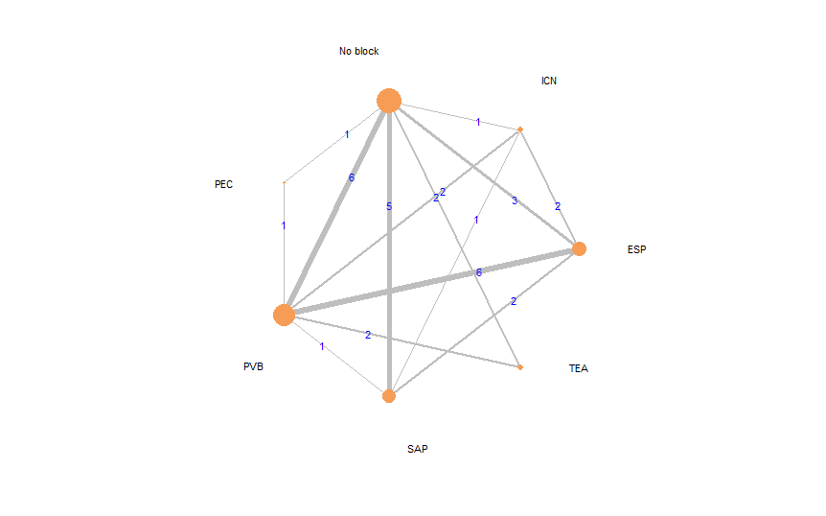

Rankogram for 24-hour opioid requirement comparisons between the pain interventions
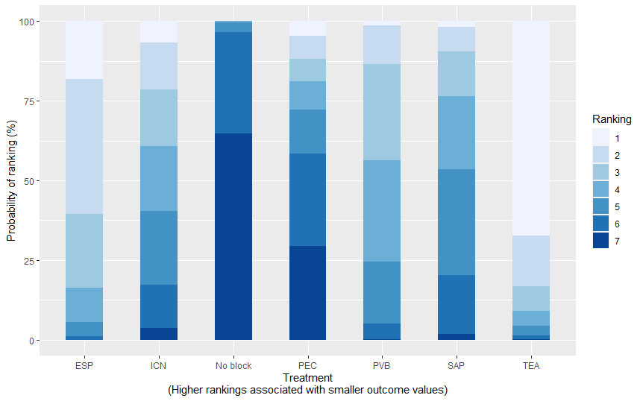

SUCRA graph for 24-hour opioid requirement comparisons between the pain interventions
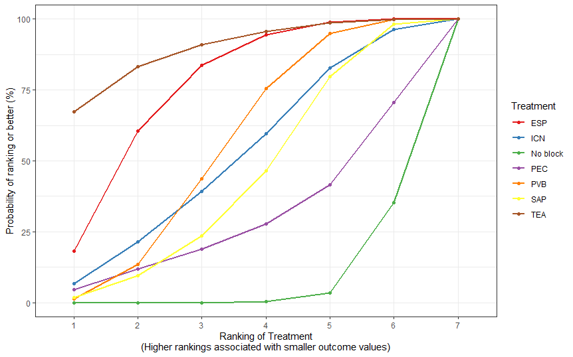

Funnel plot for 24-hour opioid requirement comparisons
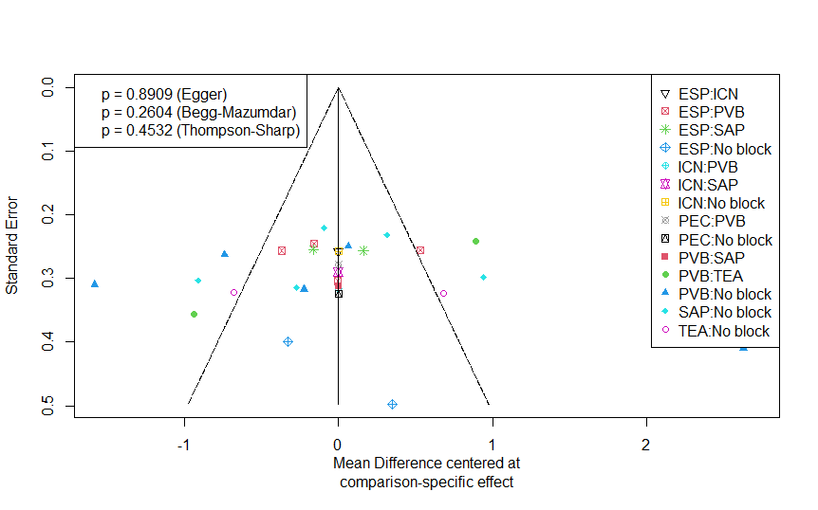

Leverage plot for 24-hour opioid requirement comparisons

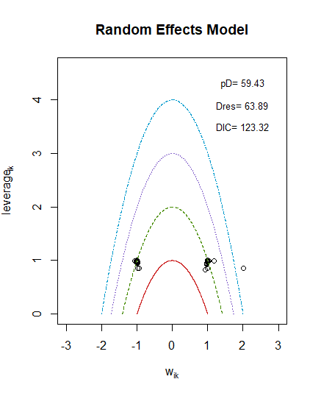
Consistency plot for 24-hour opioid requirement comparisons
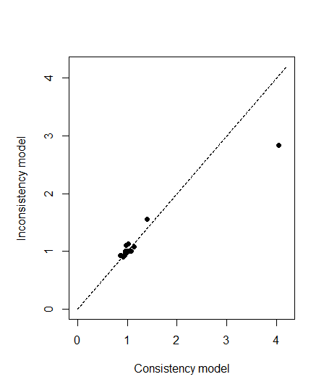

Sensitivity analysis excluding the study by Yeap et al
League table

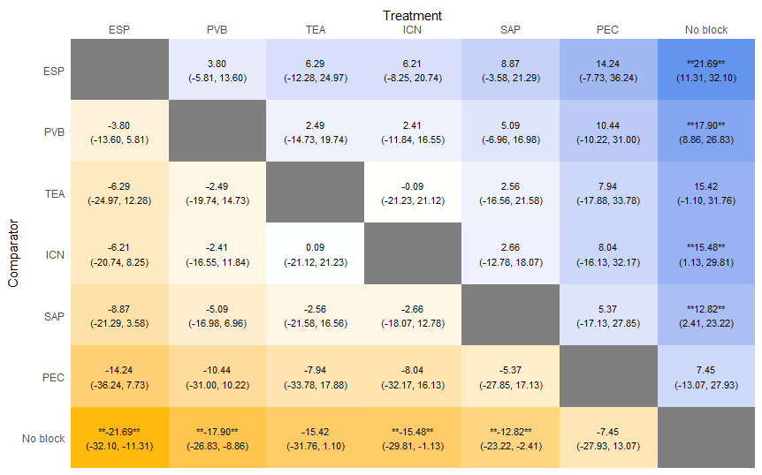

Forest plot
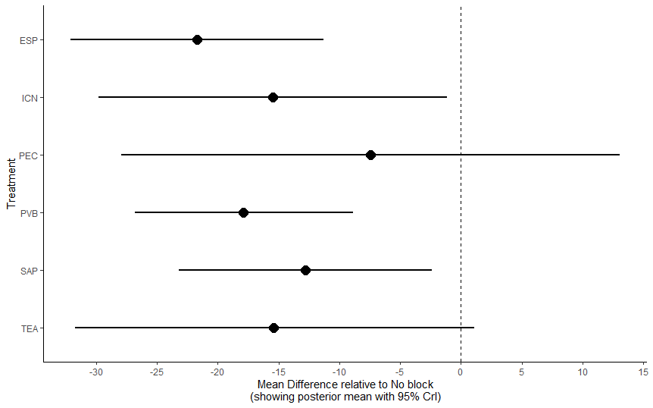
Leverage plot
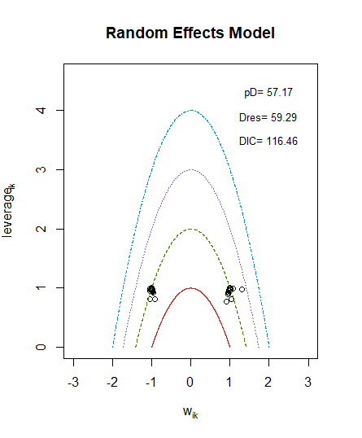
Consistency plot
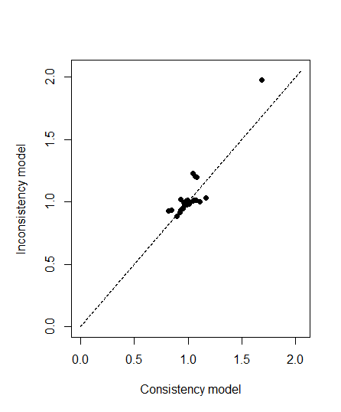

Sensitivity analysis excluding studies that used surgical site infiltration as control
Forest plot
‘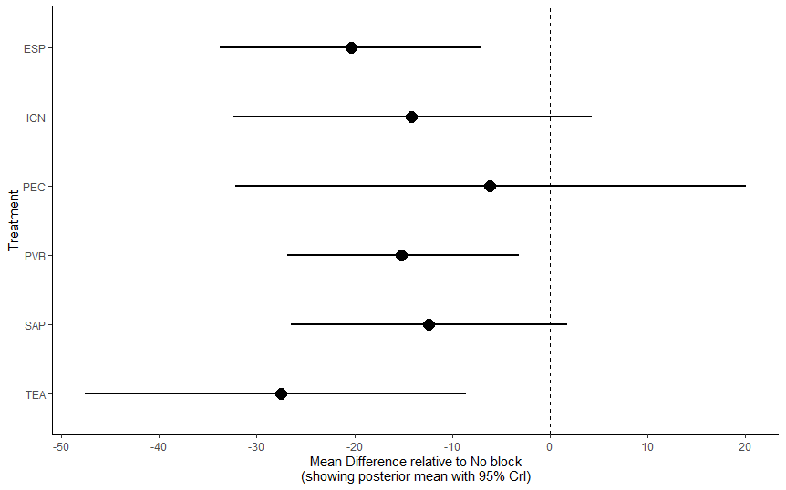

League table
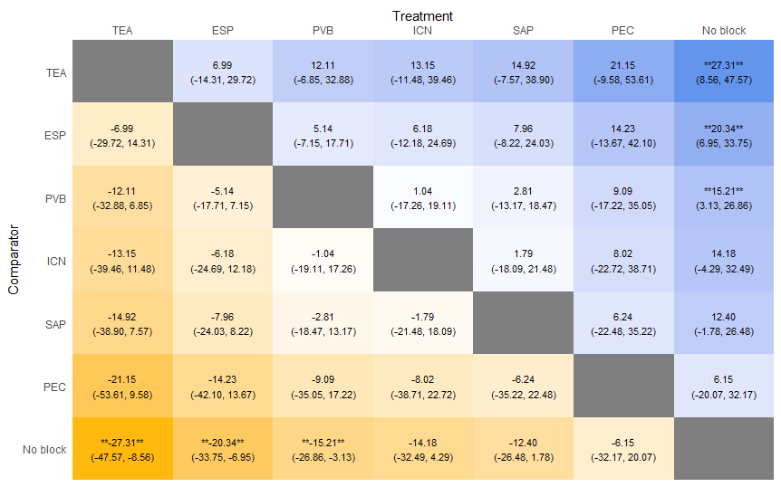

Leverage plot
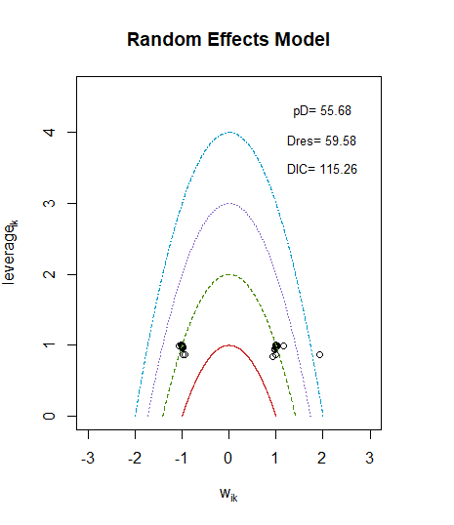

Sensitivity analysis excluding studies with high risk of bias
Forest plot
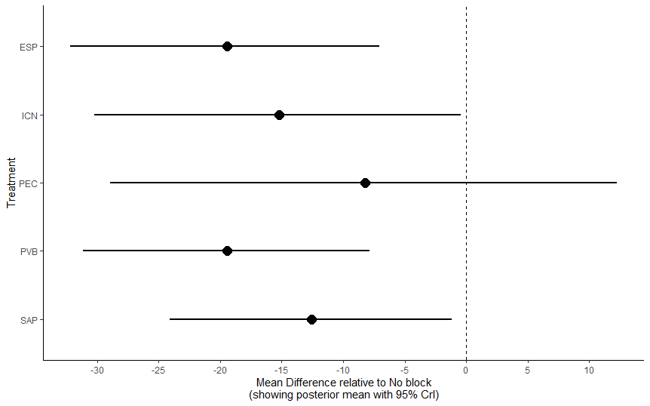
League table
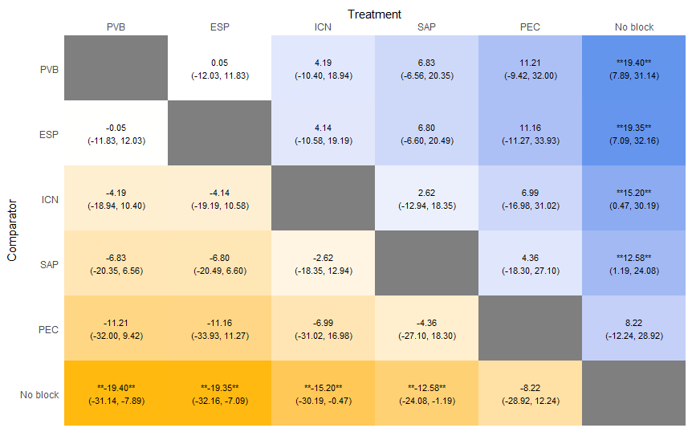
Leverage plot
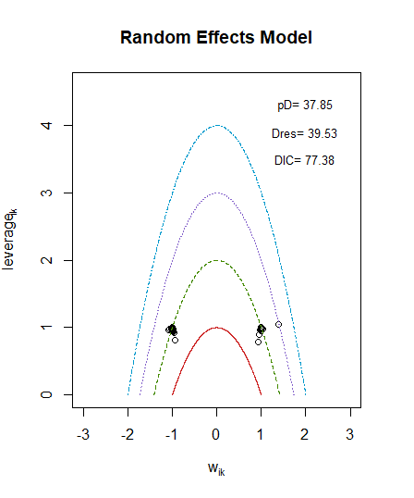

Sensitivity analysis excluding studies with inadequate patient blinding
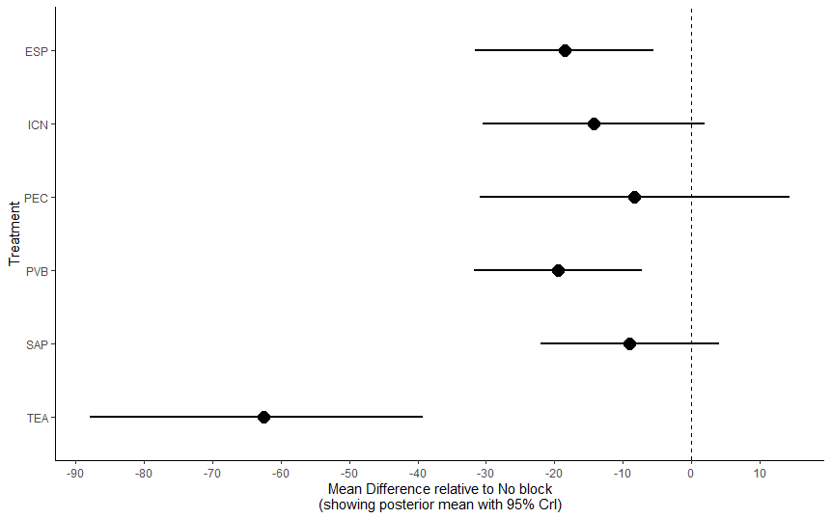
League table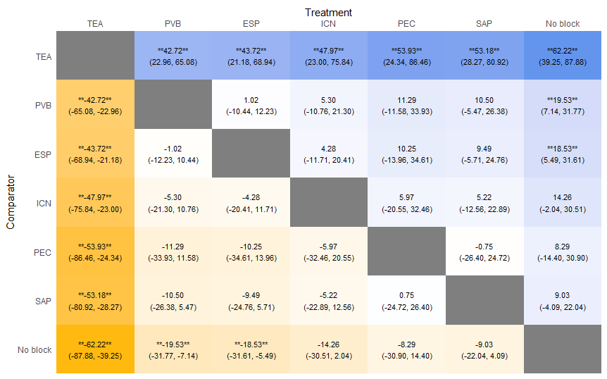

Leverage plot
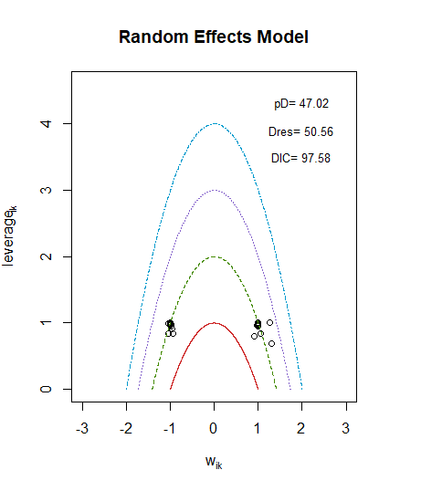

Subgroup analysis of studies with vs without chest tube
No tube
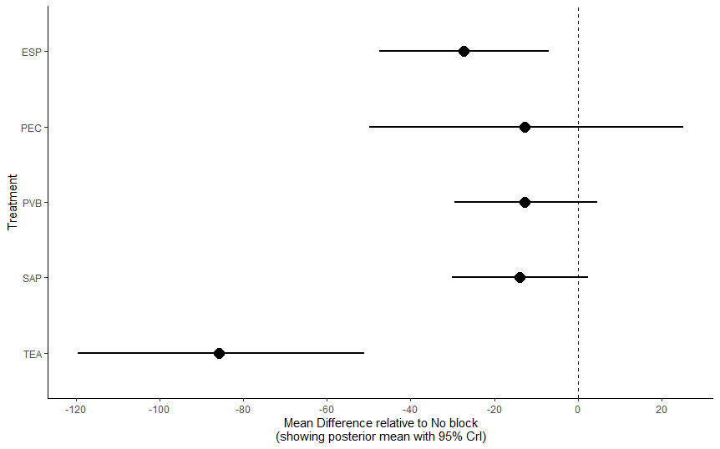

With chest tube
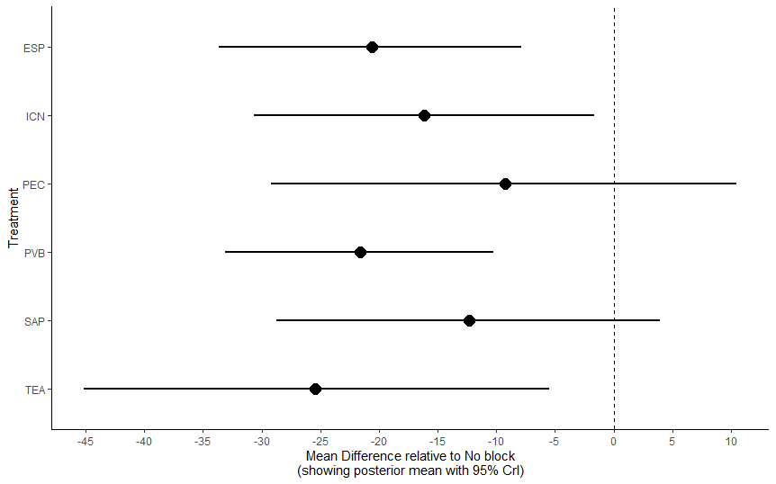

24-hour static pain score AUC

Network diagram for 24-hour pain score AUC comparisons
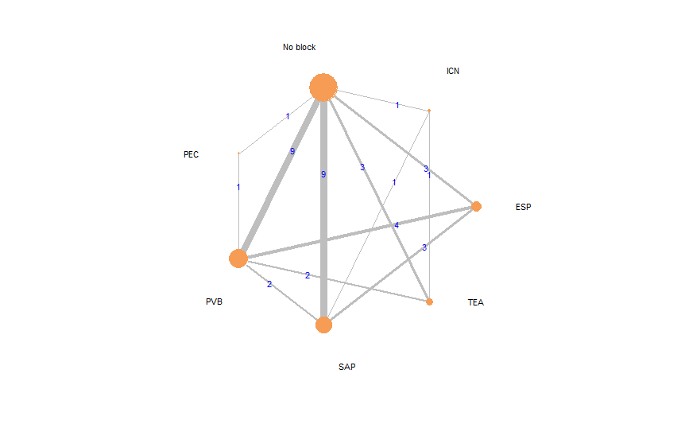

Rankogram for 24-hour pain score comparisons between the pain interventions
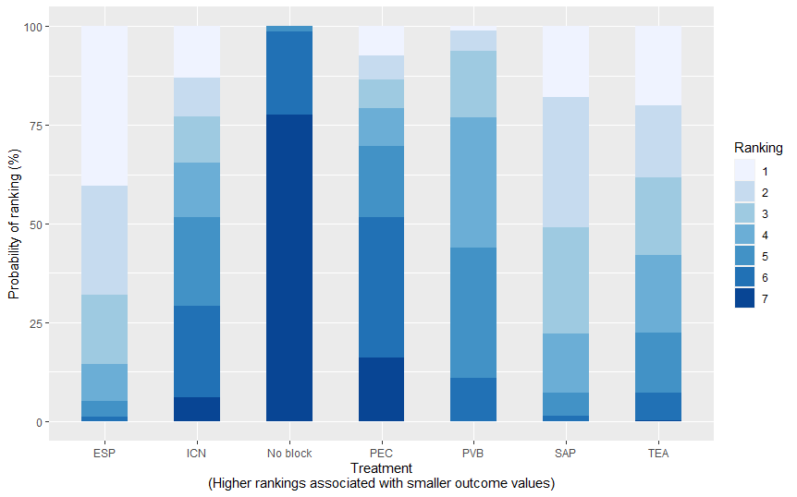

SUCRA graph for 24-hour pain score comparisons between the pain interventions
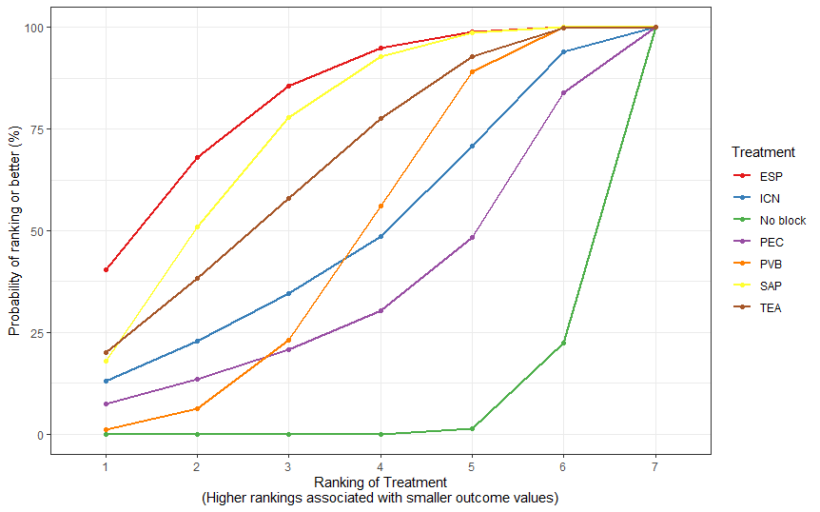

Funnel plot for 24-hour pain score comparisons
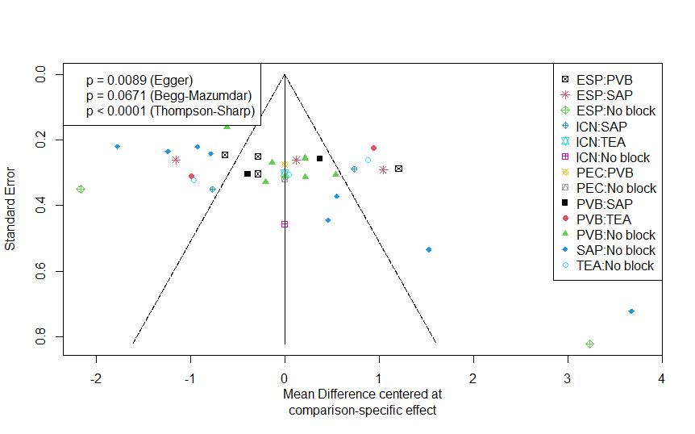

Leverage plot for 24-hour pain score comparisons
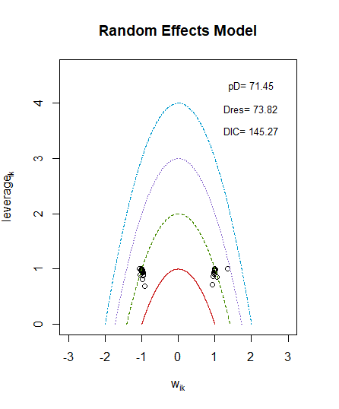

Consistency plot for 24-hour pain score comparisons
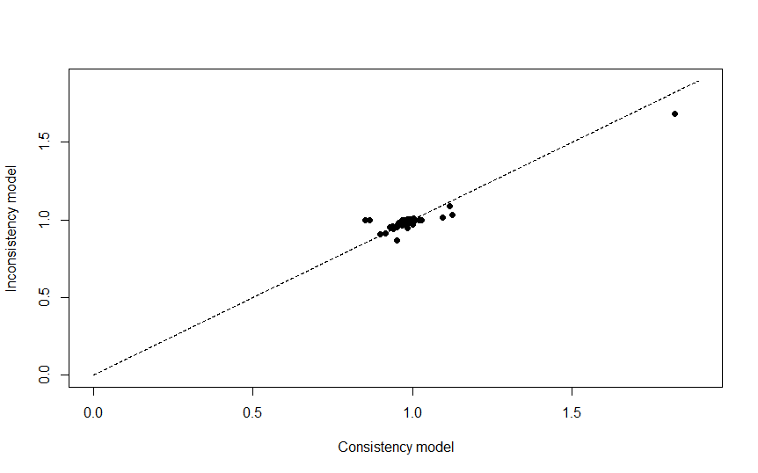

Sensitivity analysis excluding studies that used surgical site infiltration as control
League table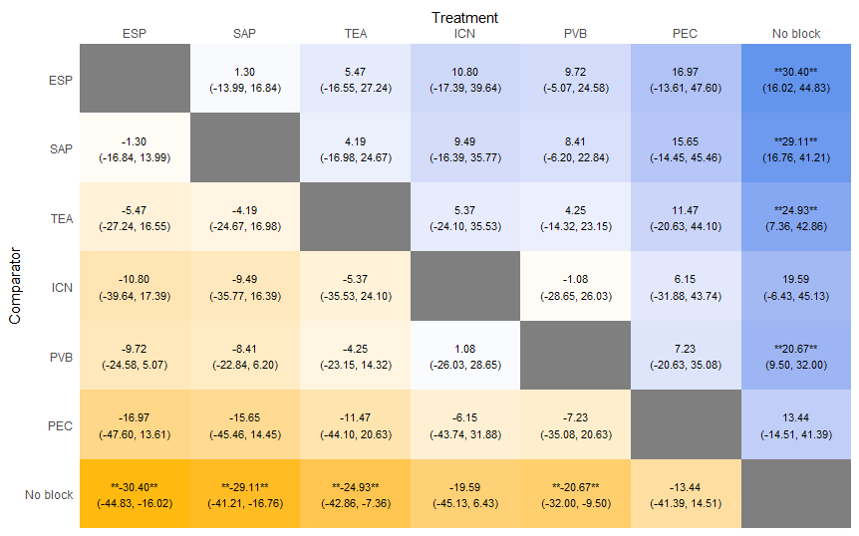

Forest plot
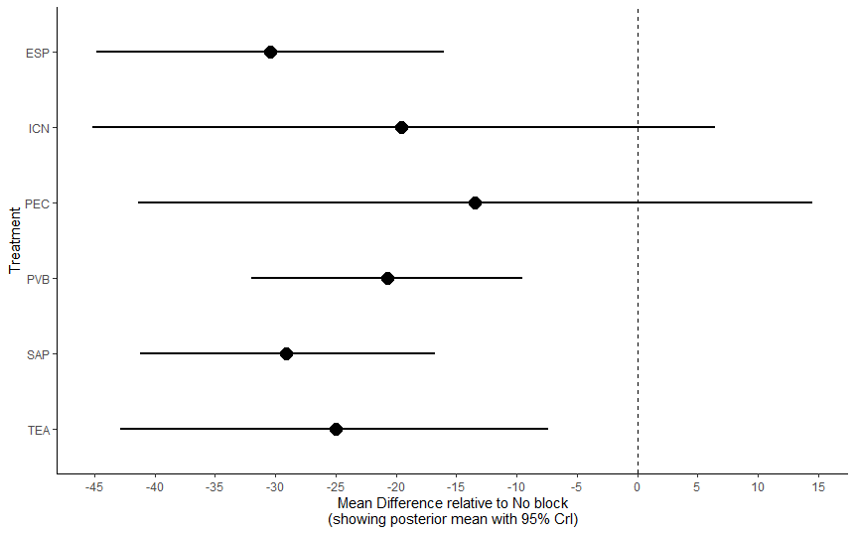

Leverage plot
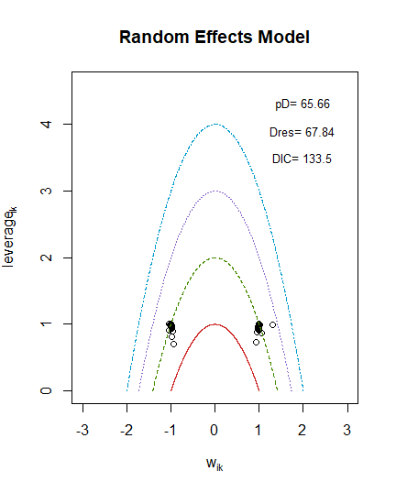

Sensitivity analysis excluding studies with inadequate patient blinding
League table
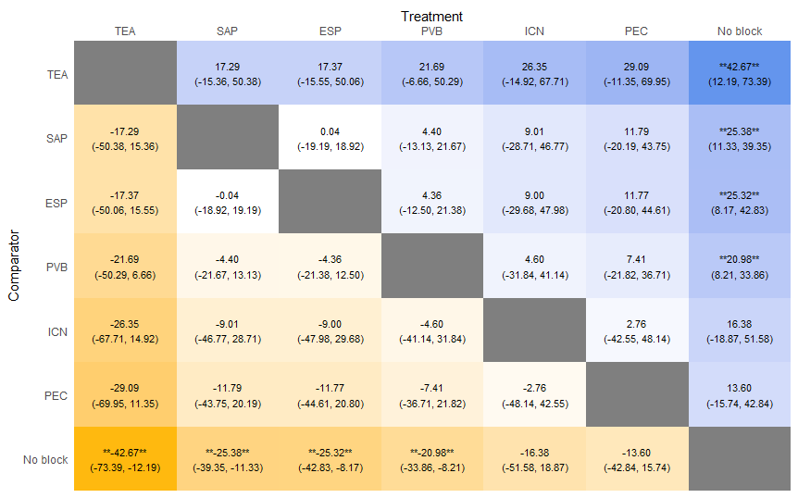
Forest plot
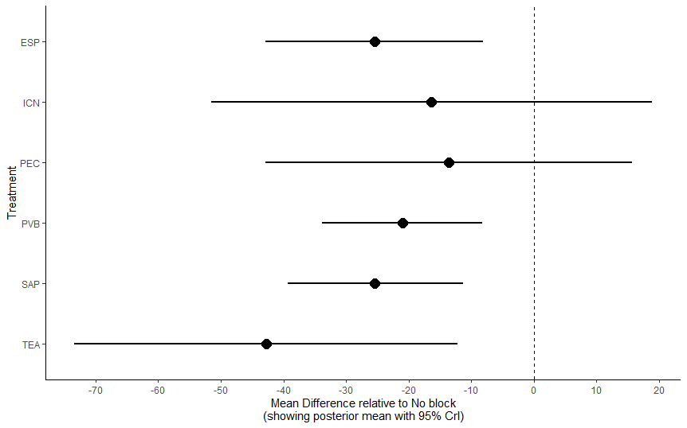
Leverage plot
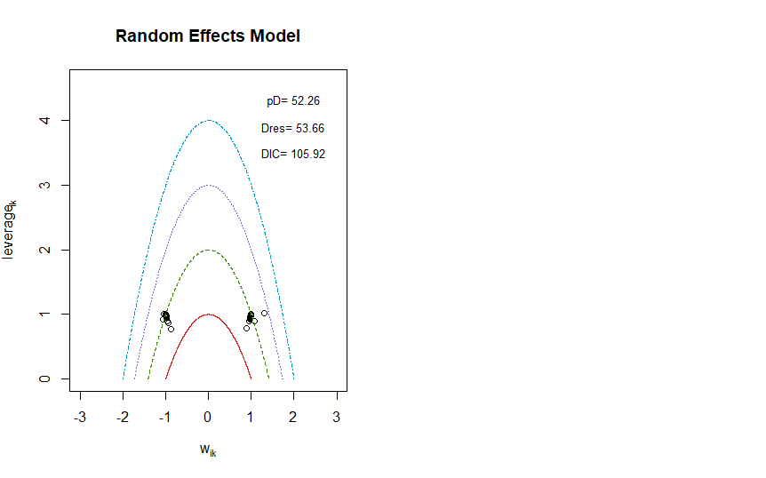

Sensitivity analysis excluding studies with high risk of bias
League table

Forest plot
Leverage plot

Subgroup analysis of studies with vs without chest tube
No tube
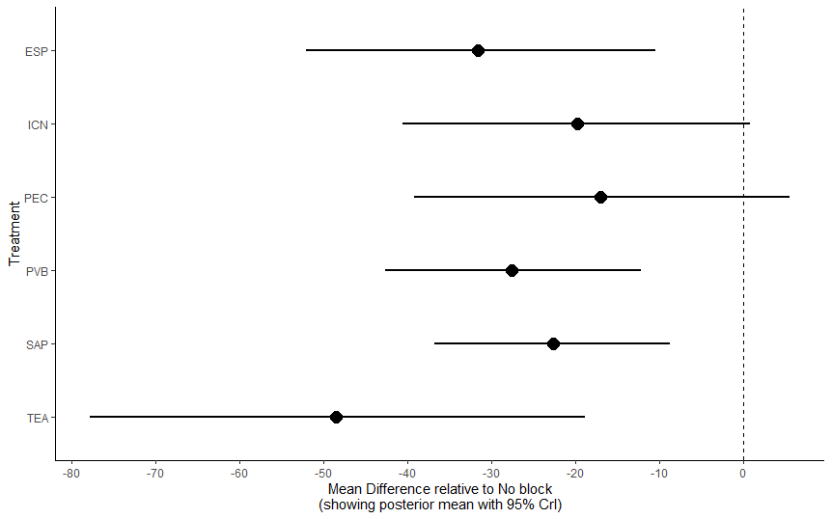
With chest tube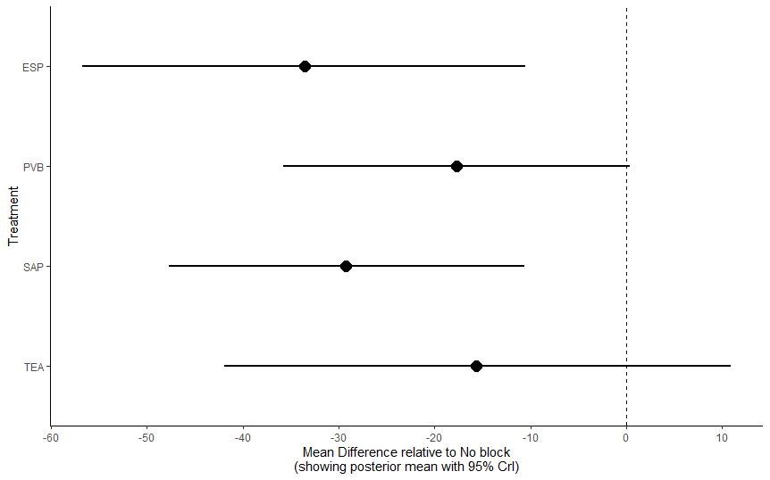

24-hour dynamic pain score AUC

Network diagram for 24-hour dynamic pain score AUC comparisons
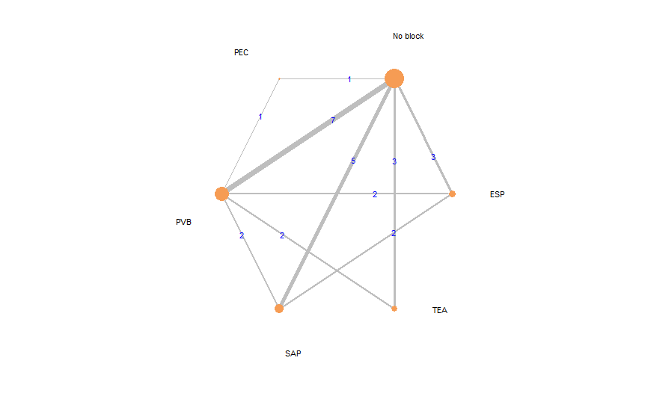

Forest plot for 24-hour dynamic pain score comparisons between the pain interventions
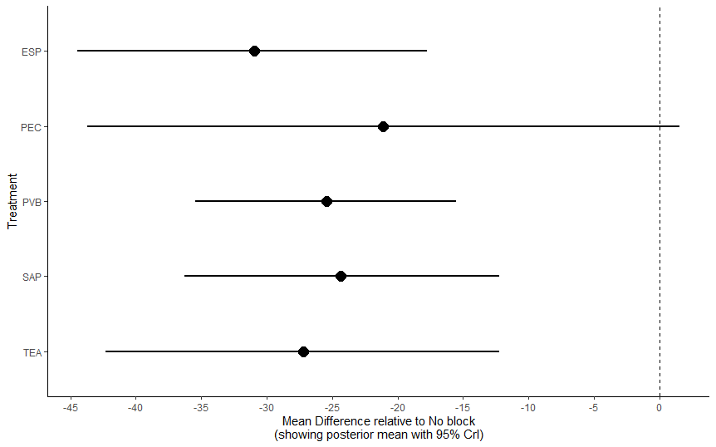

League table for 24-hour dynamic pain score comparisons between the pain interventions
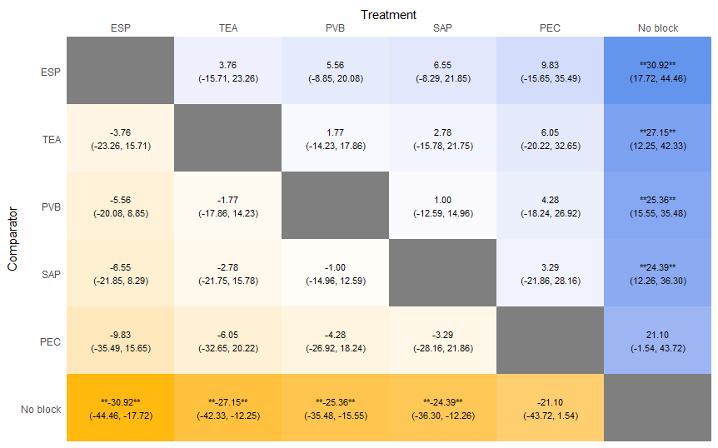

Rankogram for 24-hour dynamic pain score comparisons between the pain interventions
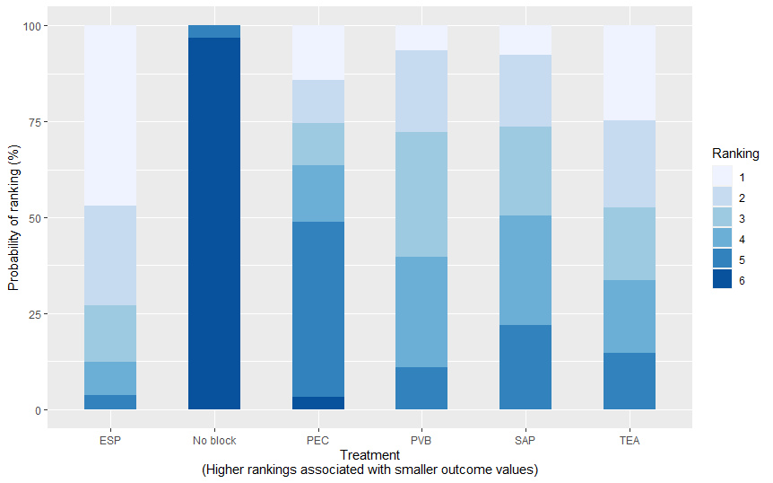

SUCRA graph for 24-hour dynamic pain score comparisons between the pain interventions
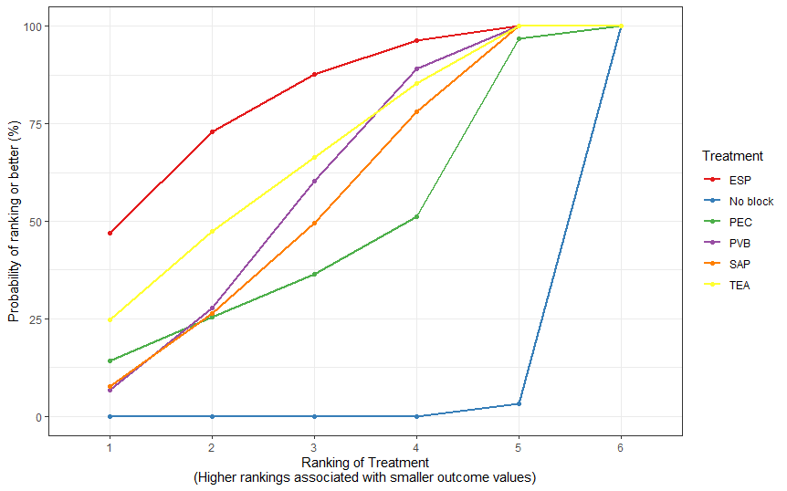

Funnel plot for 24-hour dynamic pain score comparisons
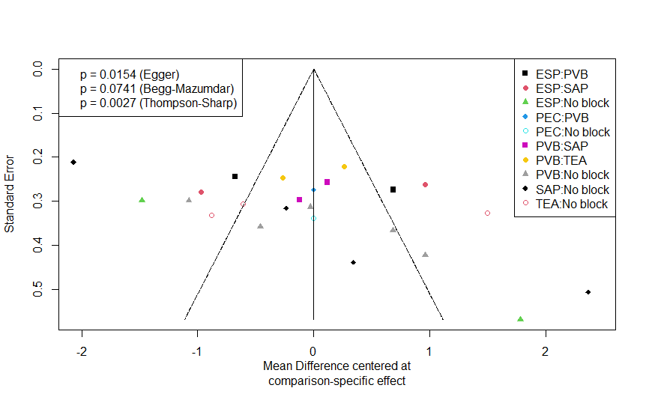

Leverage plot for 24-hour dynamic pain score comparisons
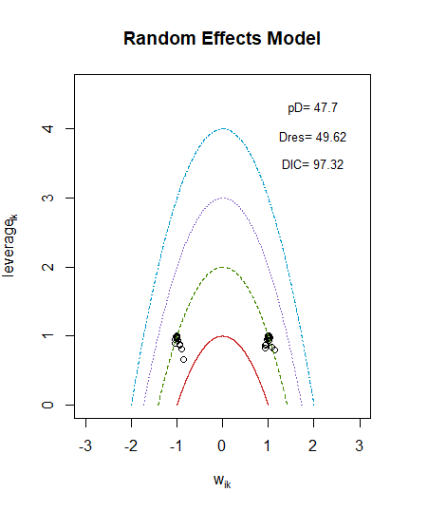

Consistency plot for 24-hour dynamic pain score comparisons
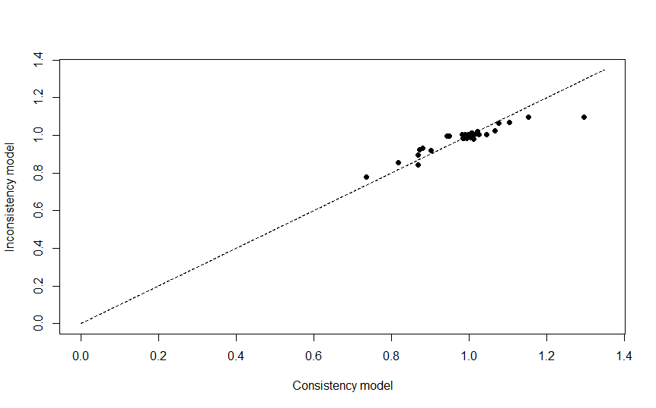

Postoperative nausea and vomiting (PONV) risk

Forest plot for PONV comparisons between the pain interventions

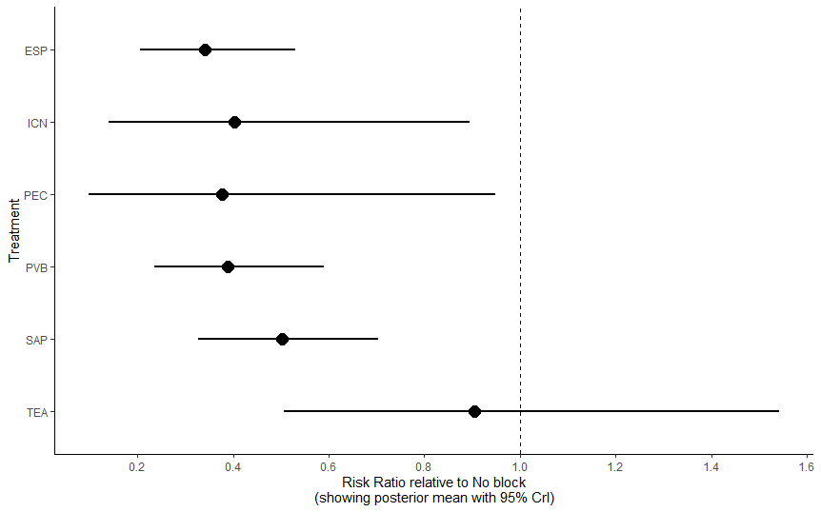

Network diagram for PONV comparisons
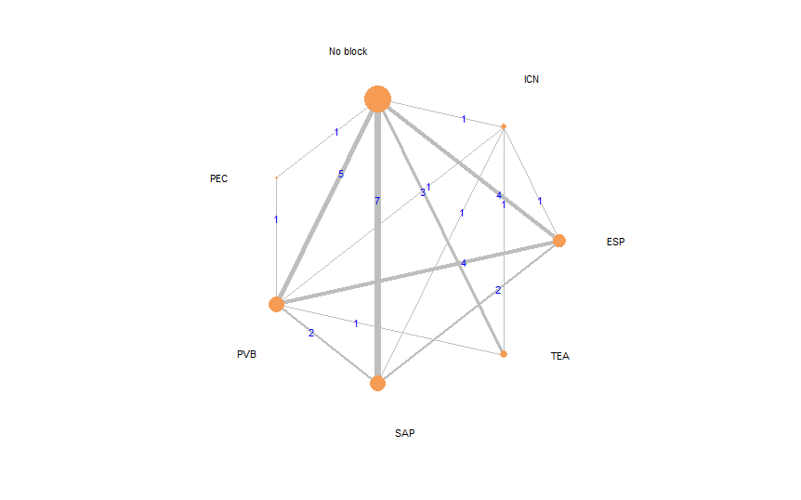
------

Rankogram for PONV comparisons between the pain interventions
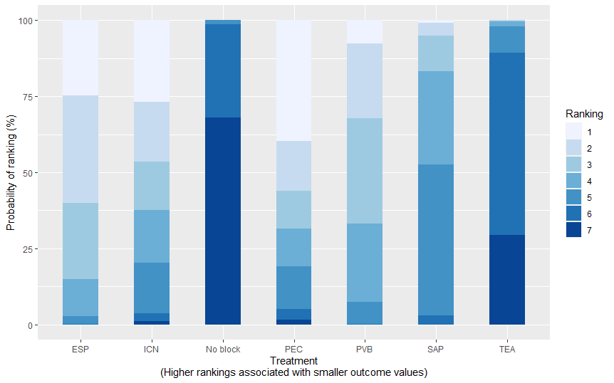

SUCRA graph for PONV comparisons between the pain interventions

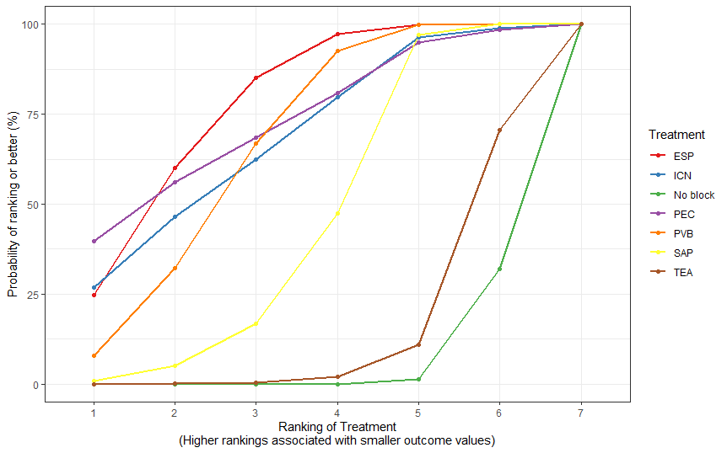

League table of PONV comparisons between the pain interventions
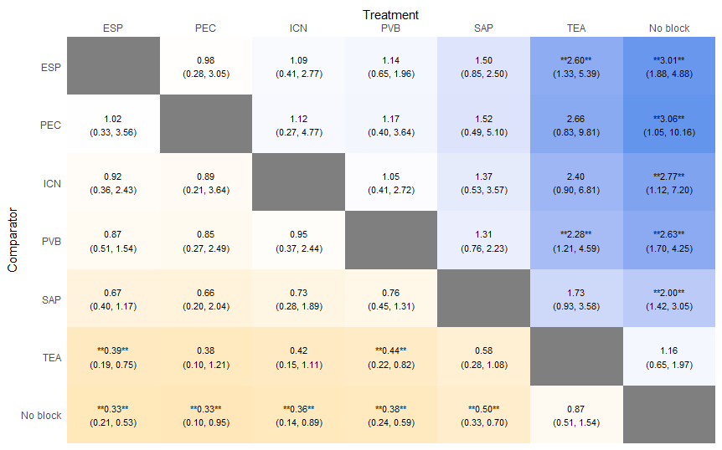

Consistency plot for PONV comparisons between the pain interventions
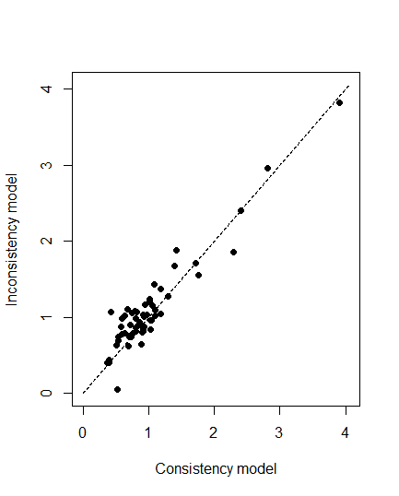

Leverage plot for PONV
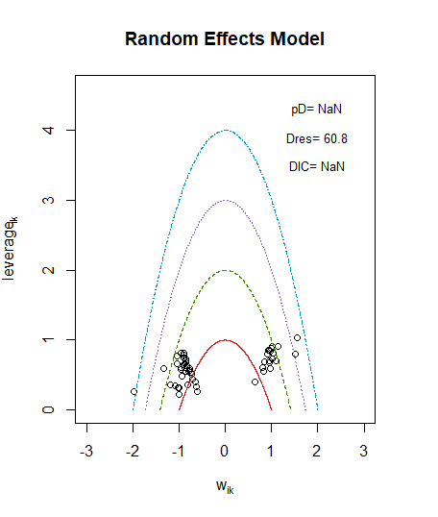
Funnel plot for PONV
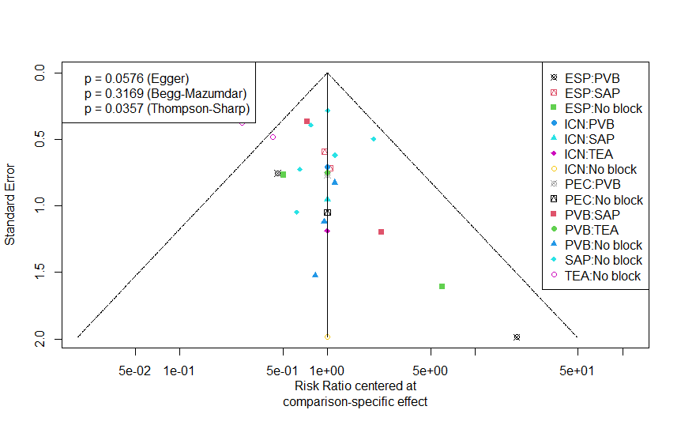

Length of stay

Network diagram for length of stay comparisons
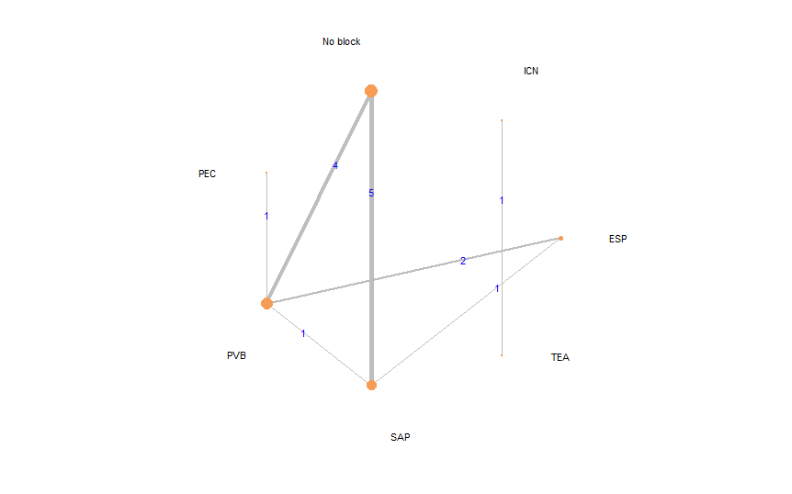

Forest plot for length of stay comparisons between the pain interventions
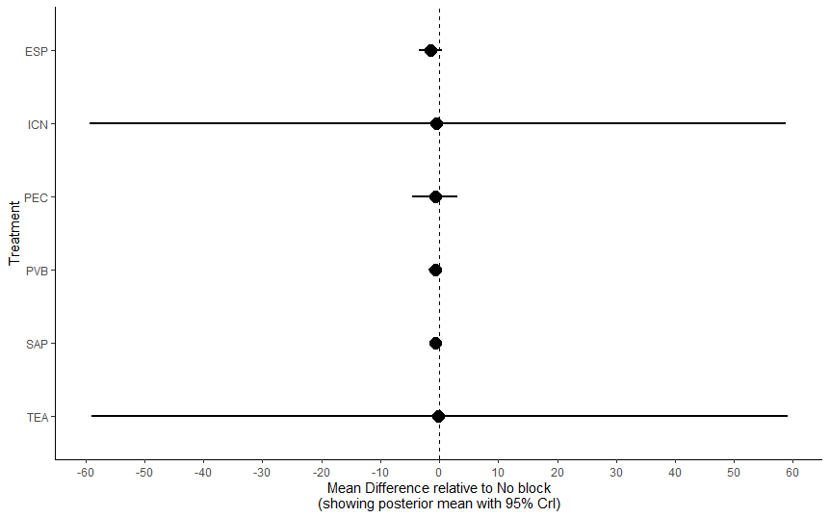

SUCRA graph for length of stay comparisons between the pain interventions
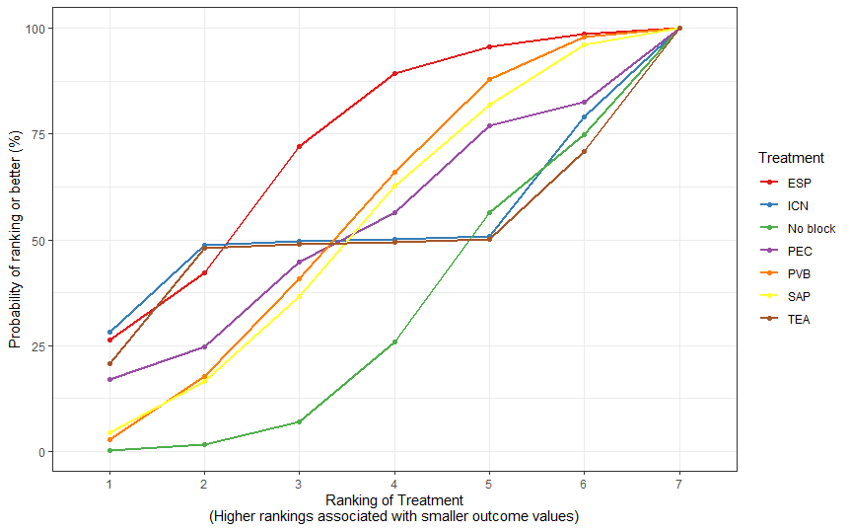

League table for length of stay comparisons between the pain interventions
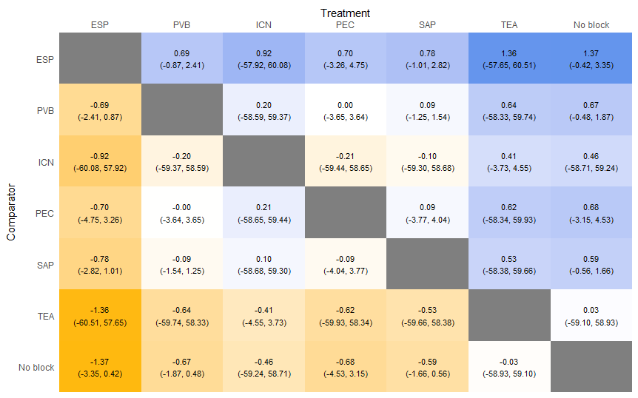

Table 2: GRADE summary of the secondary outcomes
Outcomes | Effects and confidence in the estimate of effects (network meta‐analysis)
Outcomes | ESP | TEA | SAP | PVB | ICN | PEC
24-hour dynamic pain score AUC
Total studies: 24; total participants: 1,455; number of treatments: 6 (5 block techniques, placebo)
Placebo | MD= 31,  95% CI= 12 to 44  Rank 1 of 5 interventions | MD= 27  95% CI= 12 to 42  Rank 2 of 5 interventions | MD= 24  95% CI= 12 to 36  Rank 4 of 5 interventions | MD= 25  95% CI= 16 to 42  Rank 3 of 5 interventions | No data available | MD= 21  95% CI= -1.5 to 43  Rank 5 of 5 interventions
Placebo | ⊕⊕⊖⊖ Low  Publication bias and heterogeneity | ⊕⊕⊖⊖ Low  Publication bias and heterogeneity | ⊕⊕⊖⊖ Low  Publication bias and heterogeneity | ⊕⊕⊖⊖ Low  Publication bias and heterogeneity |  | ⊕⊕⊖⊖ Low  Publication bias and heterogeneity
PONV
Total studies: 29; total participants: 1702; number of treatments: 7 (6 block techniques, placebo)
Placebo | RR 0.33  95% CI= 0.21 to 0.53  Rank 1 of 6 interventions | RR 1.16  95% CI= 0.65 to 1.97  Rank 6 of 6 interventions | RR= 0.5, 95% CI=0.33 to 0.7  Rank 5 of 6 interventions | RR= 0.38, 95% CI=0.24 to 0.59  Rank 4 of 6 interventions | RR= 0.36, 95% CI=0.14 to 0.89  Rank 3 of 6 interventions | RR= 0.33, 95% CI=0.1 to 0.95  Rank 2 of 6 interventions
Placebo | ⊕⊕⊖⊖ Low  Publication bias and heterogeneity | ⊕⊕⊖⊖ Low  Publication bias and heterogeneity | ⊕⊕⊖⊖ Low  Publication bias and heterogeneity | ⊕⊕⊖⊖ Low  Publication bias and heterogeneity | ⊕⊕⊖⊖ Low  Publication bias and heterogeneity | ⊕⊕⊖⊖ Low  Publication bias and heterogeneity
Length of stay
Total studies: 15; total participants: 1039; number of treatments: 7 (6 block techniques, placebo)
No significant difference seen between any arms
AUC: area under the curve, CI: confidence interval, ESP: Erector Spinae Plane (block), ICN: Intercostal nerve (block), MD: mean difference, PEC: Pectoralis (block), PVB: Paravertebral Block, RR: risk ratio, SAP: Serratus Anterior Plane (block), TEA: Thoracic Epidural analgesia,

