Supplementary Material

Appendix 1 – Brazilian Society Guideline for Glaucoma reference.
Ventura PV, Omi CA, Suzuki Jr ER, Tavares IM, Melo Jr LAS. 1.⁰ Consenso de Cirurgia de Glaucoma, first edition, Ipsis Gráfica e Editora, São Paulo, May 2017.

Unfortunately, the guideline has only a Portuguese version. Please see the complete pdf https://www.sbglaucoma.org.br/wp-content/uploads/2017/05/livreto.pdf

Appendix 2 – Figures 3-9.

Figure 3. Ahmed FP7 glaucoma drainage device (GDD).

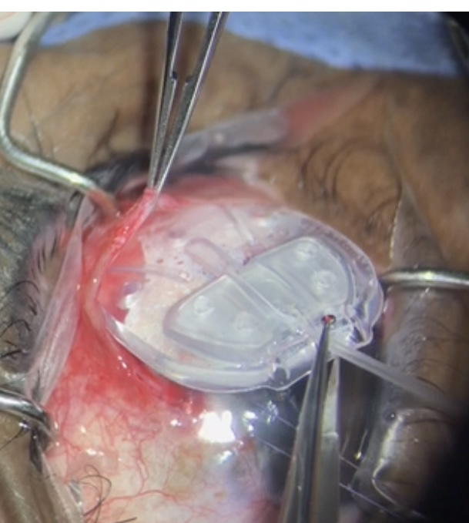

Figure 4. GDD sutured, and silicon tube inserted in the anterior chamber.
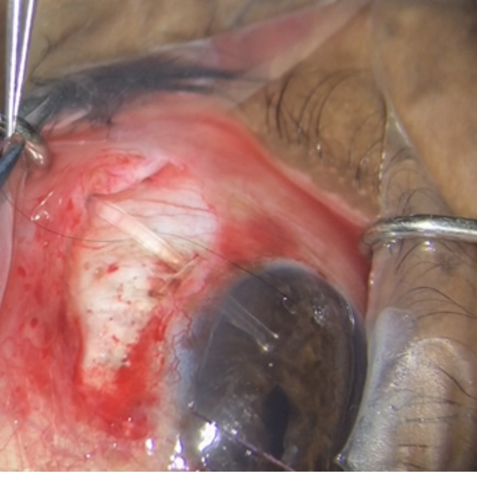

Figure 5. Scleral patch over the silicon tube.
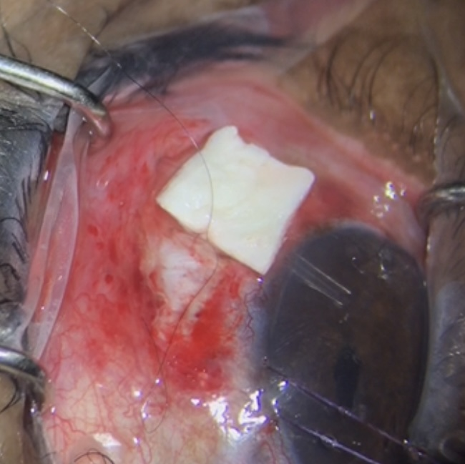

Figure 6. Ologen CM model 870051.
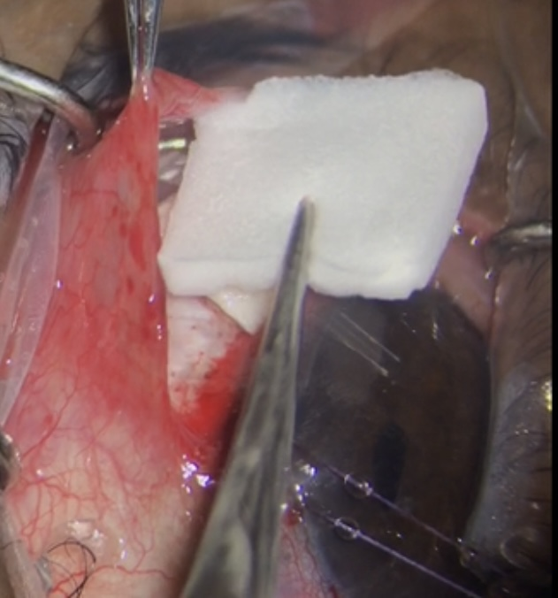

Figure 7. Ologen CM insertion above the GDD plate behind the valve.
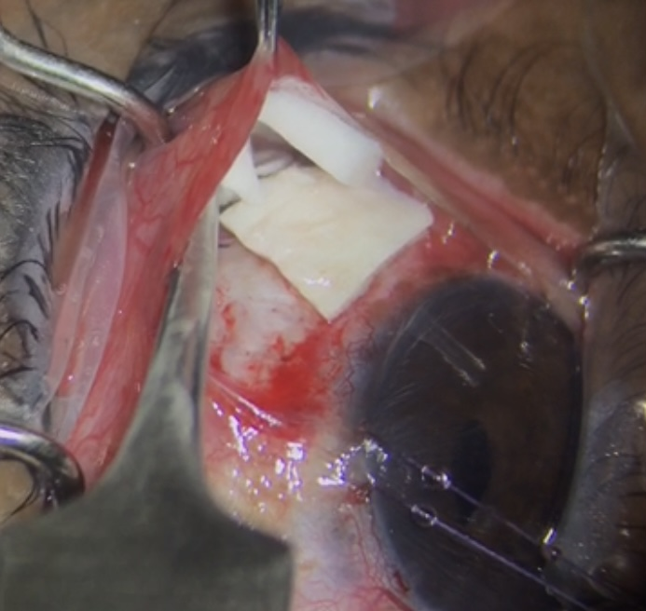

Figure 8. Ologen CM is already placed above the GDD plate.
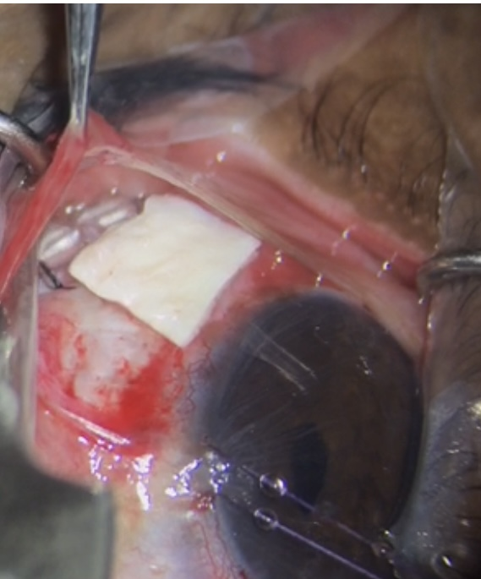

Figure 9. Closing sutures.
