Table S1 Protein-protein interaction analysis of the differentially expressed proteins.
Protein | Degree
C9 | 7
PON1 | 4
HPX | 4
CFHR1 | 2

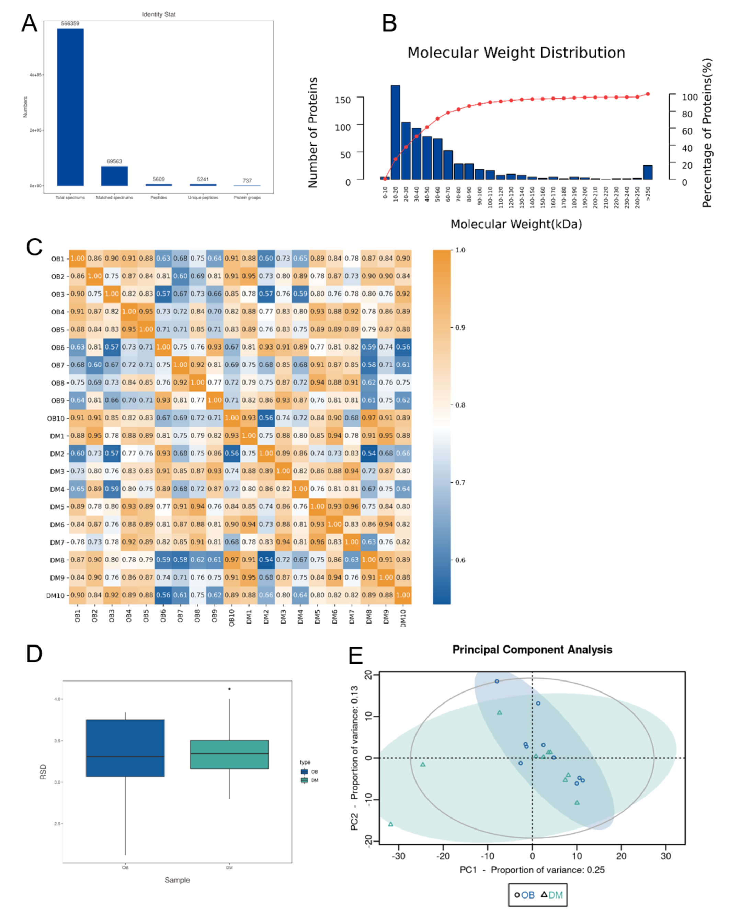
Figure S1 Quality control of the mass spectrometry data. A. The number of proteins/peptides identified by mass spectrometry. B. Molecular weight distribution. C. Heatmap of Pearson correlation coefficient. D. Relative standard deviation. E. Principal component analysis. OB, obese patients with type 2 diabetes; DM, non-obese patients with type 2 diabetes.

