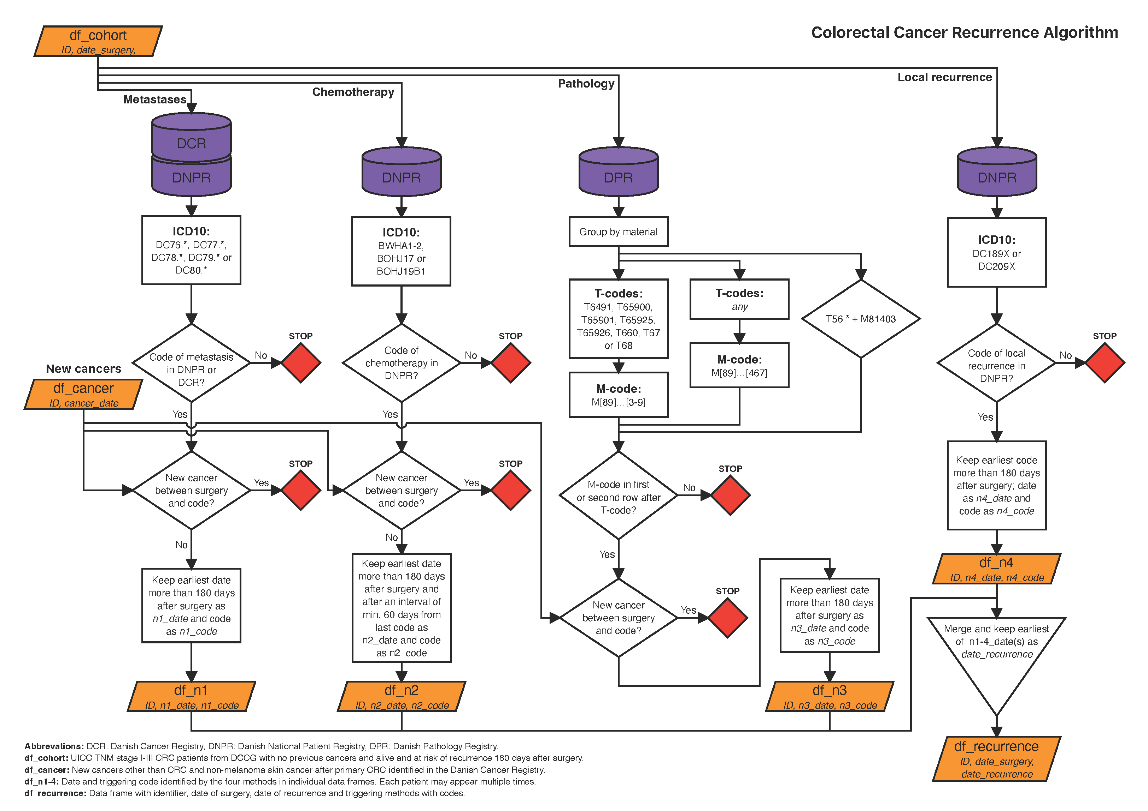
Figure S1: Flowchart of the colorectal cancer recurrence algorithm.

