Contents

Supplementary Table 1. ICD-10 codes utilized to identify people with foot-related diabetes complications and comorbid late-stage complications. Codes are classified into five diagnostic groups.

Supplementary Figure 1.a. Ten typical care pathways (pathways 1 to 5) presented to the expert panel.

Supplementary Figure 1.b. Ten typical care pathways (pathways 6 to 10) presented to the expert panel.

Supplementary Table 2. Distribution of the probabilities assessed by the expert panel in the second round by care pathway and by question.

Supplementary Table 3. Expert panel characteristics and expert panel’s assessments by round and by question.
Supplementary Table 4. Additional examinations needed according to the expert panel (only presented for the care pathways in the second round). The methods suggested by each expert are in a single row.

Supplementary Table 1. ICD-10 codes utilized to identify people with foot-related diabetes complications and comorbid late-stage complications. Codes are classified into five diagnostic groups.

Group | ICD-10 codes
Dermal | L97, L84, L85, L89, R02, S91.1, S91.2, S91.3, S91.7, L60.0
Infection | L03.0, L03.1, B35.1, B35.3, B07.9
Neuropathy | G63.2, G99.0
Orthopedic | M14.6, M86, M20.1, M20.2, M20.3, M20.4, M20.5, M20.6, M21.4, M21.5
Vascular | I79.2, I70.9
Comorbid late-stage complications
Coronary artery disease | I20, I21, I22, I23, I24, I25, R96, R98
Diabetic retinopathy | H34, H54, E103., E11.3, E12.3, E13.3, E14.3, H28.0, H36.0, H40.5, H42.0, H40.5, H42.0, H43.1, H45.0, CKC12, CKD05, CKD60, CKD65
Nephropathy | N18, Z49, Z94, N08.3
Neuropathy | E10.4, E11.4, E12.4, E13.4, E14.4, G57.1, G57.3, G57.5, G59.0, G63.2, G73.0, G99.0, I95.1, N48.4

Supplementary Figure 1.a. Ten typical care pathways (pathways 1 to 5) presented to the expert panel. 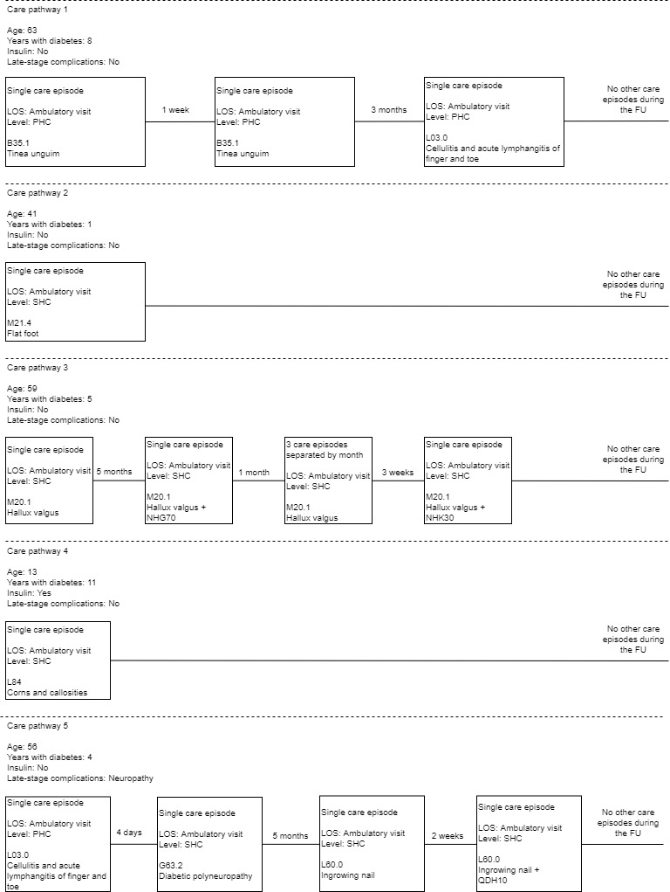

Supplementary Figure 1.b Ten typical care pathways (pathways 6 to 10) presented to the expert panel.
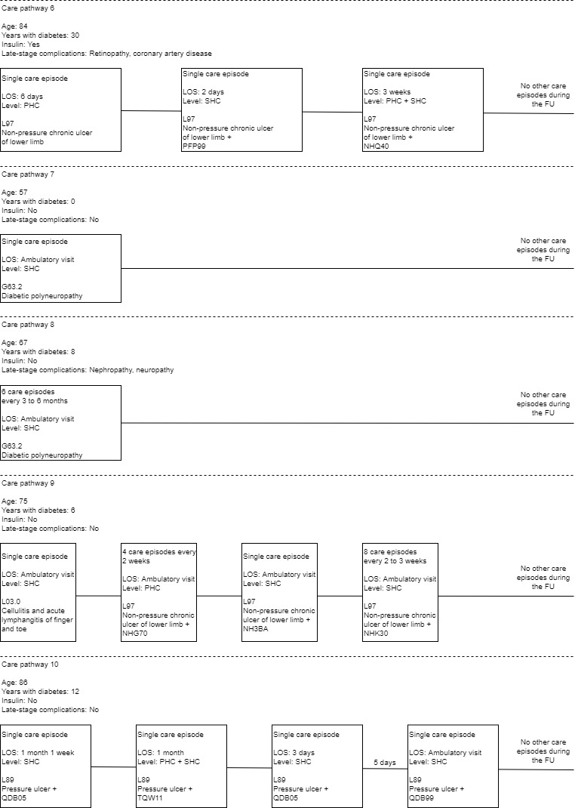

Legend for Supplementary Figure 1.a
Information provided includes patient characteristics, length of stay (LOS), level of care (PHC = primary health care, SHC = specialized health care) and ICD-10 code and procedure code. The time between care episodes is presented, where appropriate. Procedure codes: NHG70 = Arthroplasty of first tarsometatarsal joint, NHK30 = Osteotomy or rotation osteotomy of first metatarsal or tarsal bone, QDH10 = Transfer of toenail, microsurgical
Legend for Supplementary Figure 2.a
Information provided includes patient characteristics, length of stay (LOS), level of care (PHC = primary health care, SHC = specialized health care) and the care episode’s ICD-10 code and procedure code. The time between care episodes is presented, where appropriate. Procedure codes in the figure: PFP99 = Percutaneous plastic repair of artery of lower leg; NHQ40 = Amputation of toe; NHG70 = Arthroplasty of first tarsometatarsal joint; NH3BA = Extensive x-ray examination of foot and toe; NHK30 = Osteotomy or rotation osteotomy of first metatarsal or tarsal bone; QDB05 = Revision of wound of skin of lower limb; TQW11 = Vacuum treatment of wound; QDB99 = Other procedure for wound of skin of lower limb

Supplementary Table 2. Distribution of the probabilities assessed by the expert panel in the second round by care pathway and by question.
 | Care pathway
 | 4 | 6 | 7 | 8 | 9 | 10
Probability 1 (%)
Median; mean | 30; 40 | 60; 58 | 20; 18.5 | 35; 31 | 40; 39 | 60; 58.5
Quartiles | 21; 48 | 50; 80 | 0; 30 | 20; 40 | 20; 60 | 50; 80
Probability 2 (%)
Median; mean |  | 20; 22 |  |  |  | 35; 38
Quartiles |  | 20; 30 |  |  |  | 30; 50
Additional assessments, probability
Plain (x-ray) film | 10 | 11 | 0 | 11 | 22 | 33
Angiography (MRI) | 0 | 11 | 0 | 11 | 0 | 0
Electroneuromyography | 0 | 0 | 0 | 0 | 11 | 11

Supplementary Table 3. Expert panel characteristics and expert panel’s assessments by round and by question.
 | Round 1 | Round 2
Respondent, n  Physician  Podiatrist  Total | 4  5  9 | 6  5  11
Experience of IRT, n (multiple responses allowed)  Not used  Used  Familiar with studies  Has studied IRT | 3  2  4  - | 3  7  5  2
Pathway 1 (first diagnosis B351)  How probably the occurence could have been avoided?  range  median; mean  How important do you consider regular IRT?  median; mean | 0–50%  2.5; 8.8  1.5; 1.8 | not in the questionnaire
Pathway 2 (M214)  How probably the occurence could have been avoided?  range  median; mean  How important do you consider regular IRT?  median; mean | 0–75%  10; 18.6  2; 2.1 | not in the questionnaire
Pathway 3 (M201)  How probably the occurence could have been avoided?  range  median; mean  How important do you consider regular IRT?  median; mean | 0–40%  5; 7.9  1; 1.7 | not in the questionnaire
Pathway 4 (L84)  How probably the occurence could have been avoided?  range  median; mean  How important do you consider regular IRT?  median; mean  How often should IRT be performed? | 0–95%  30; 39.3  3; 3.3  - | 10–95%  30; 40  3; 3,1  1–10*per year
Pathway 5 (L030)  How probably the occurence could have been avoided?  range  median; mean  How important do you consider regular IRT?  median; mean  How probably the next occurences could have been avoided?  range  median; mean | 0–50%  20; 25  3; 2.7  0–75%  10; 24.2 | not in the questionnaire
Pathway 6 (L97)  How probably the occurence could have been avoided?  range  median; mean  How important do you consider regular IRT?  median; mean  How often should IRT be performed?  How probably the next occurences could have been avoided?  range  median; mean | 20–90%  60; 60  4; 3.4  -  0–20%  10; 10 | 20–90%  60; 58  3.5; 3.4  1–4*per year  0-50%  20; 22
Pathway 7 (G63.2, 1 visit)  How probably the occurence could have been avoided?  range  median; mean  How important do you consider regular IRT?  median; mean  How often should IRT be performed? | 0–100%  30; 42  3; 3.6  - | 0–40%  20; 18.5  3; 3  1–6*per year
Pathway 8 (G63.2, multiple visits)  How probably the occurence could have been avoided?  range  median; mean  How important do you consider regular IRT?  median; mean  How often should IRT be performed? | 10–80%  40; 44  4; 3.8  - | 10–50%  35; 31  3.4; 3.4  1–6*per year
Pathway 9 (L03.0)  How probably the occurence could have been avoided?  range  median; mean  How important do you consider regular IRT?  median; mean  How often should IRT be performed? | 10–80%  50; 48  2; 2.4  - | 10–80%  40; 39  3; 3.2  1–6*per year
Pathway 10 (L89)  How probably the occurence could have been avoided?  range  median; mean  How important do you consider regular IRT?  median; mean  How often should IRT be performed?  How probably the next occurences could have been avoided?  range  median; mean | 10–90%  80; 68  3; 3.2  -  0–90%  20; 30 | 10–90%  60; 58.5  3; 3.7  1-6*a year  10–70%  35; 38
Reliability (5 very reliable; 1 not at all reliable) | - | 3; 3
IRT = infrared thermography

Supplementary Table 4. Additional examinations needed according to the expert panel (only presented for the care pathways in the second round). The methods suggested by each expert are in a single row.
Care pathway | Other methods needed
4  Callus pathway | Clinical examination in primary health care  Clinical examination, examination of posture faults  Clinical examination of feet  Biomechanical examination  Assessment of podiatrist on fit of shoes  Native X-ray, foot status (tightness of calves, etc.)  Nothing
6  Amputation pathway | Clinical examination, ABI, Doppler  Circulation examination, pulse palpation, Doppler, measuring toe pressure, vascular surgical examination  Circulation status, foot status, native X-ray, adequate control of primary diseases  Toe pressure/ MRA/angiography
7  Short neuropathy pathway | Examination of biomechanics of lower extremities  Regular foot examinations e.g., microfilament  Laboratory tests, monofilament  Clinical examination
8  Long neuropathy pathway | X-ray of ankle and foot, clinical examination of feet  ENMG, quantitative sensory testing, symptom questionnaire on autonomic neuropathy  Basic examination of diabetic foot, e.g., sensory testing, microfilament testing  Laboratory tests, monofilament  Clinical examination, toe pressure
9  Nail pathway | X-ray of ankle and foot, clinical examination of feet  Regular screening and risk assessment  Clinical examination, pulse palpation, assessing fit of shoes, examination of posture faults, possible X-ray  Clinical examination, toe pressure, MRA/angiography, if needed
10  Ulcer pathway | X-ray of ankle and foot, clinical examination of feet  Nutritional status, adequate control of diabetes, hygiene  X-ray, examination of circulation: pulse palpation, toe pressure, assessment by vascular surgeon, if needed  Foot status, adequate control of diabetes, pulse status, native X-ray (loading)  Clinical examination, toe pressure, MRA/angiography, if needed
ABI = ankle-brachial index
MRA = magnetic resonance imaging
ENMG = electroneuromyography

