Table S1 Tumor response to the first cTACE among different pathological types according to mRESCIST in recurrence after surgical resection cohort.
Tumor response | MTM | Non-MTM | P | VETC | Non-VETC | P | CK19-positive | CK19-negative | P
CR+PR | 11 | 13 | 0.773 | 15 | 9 | 0.000* | 2 | 22 | 0.004*
SD+PD | 17 | 22 |  | 9 | 30 |  | 15 | 24
Total | 28 | 35 |  | 24 | 39 |  | 17 | 46

Table S2 Lipiodol deposition to the first cTACE among different pathological types according to mRESCIST in recurrence after surgical resection cohort.
Lipdiodol deposition | MTM | Non-MTM | P | VETC | Non-VETC | P | CK19-positive | CK19-negative | P
≥50% | 18 | 14 | 0.043* | 18 | 13 | 0.001* | 4 | 27 | 0.031*
<50% | 10 | 21 |  | 16 | 26 |  | 13 | 19
Total | 28 | 35 |  | 24 | 39 |  | 17 | 46

Table S3 Tumor response to the first cTACE among different pathological types according to mRESCIST in liver biopsy cohort.

Tumor response | MTM | Non-MTM | P | VETC | Non-VETC | P | CK19-positive | CK19-negative | P
CR+PR | 21 | 32 | 0.955 | 29 | 24 | 0.003* | 5 | 48 | 0.000*
SD+PD | 25 | 48 |  | 19 | 54 |  | 30 | 43
Total | 46 | 80 |  | 48 | 78 |  | 35 | 91

Table S4 Lipiodol deposition after the first cTACE among different pathological types according to mRESCIST in liver biopsy cohort.
Lipdiodol deposition | MTM | Non-MTM | P | VETC | Non-VETC | P | CK19-positive | CK19-negative | P
≥50% | 24 | 33 | 0.159 | 30 | 27 | 0.002* | 8 | 49 | 0.001*
<50% | 22 | 47 |  | 18 | 51 |  | 27 | 42
Total | 46 | 80 |  | 48 | 78 |  | 35 | 91

Table S5 Ki67, AFP and GPC3 expression in HCC tissues among different pathological types.
Variables | MTM  n=72 | Non-MTM  n=117 | P | VETC  n=76 | Non-VETC  n=113 | P | CK19-positive  N=52 | CK19-negative  n=137 | P
AFP-positive | 27 | 8 | 0.000* | 19 | 16 | 0.024* | 12 | 23 | 0.214
Ki67-positive | 36 | 54 | 0.537 | 35 | 55 | 0.476 | 22 | 68 | 0.231
GPC3-positive | 45 | 65 | 0.496 | 44 | 66 | 0.315 | 28 | 82 | 0.276

Table S6 Univariate and multivariate analyses of pathological types for ORR of the second cTACE treatment by Logistic Regression Analysis in the whole cohort.

Variable | Univariable OR[95% CI] | P | Multivariable OR[95% CI] | P
VETC | 3.86[1.49,10.04] | 0.006✳ | 3.31[1.24,8.83] | 0.017✳
MTM | 1.83[0.72,4.64] | 0.203 | 1.42[0.53,3.82] | 0.491
CK19-positive | 0.22[0.03,1.87] | 0.167 | 0.34[0.04,3.03] | 0.334

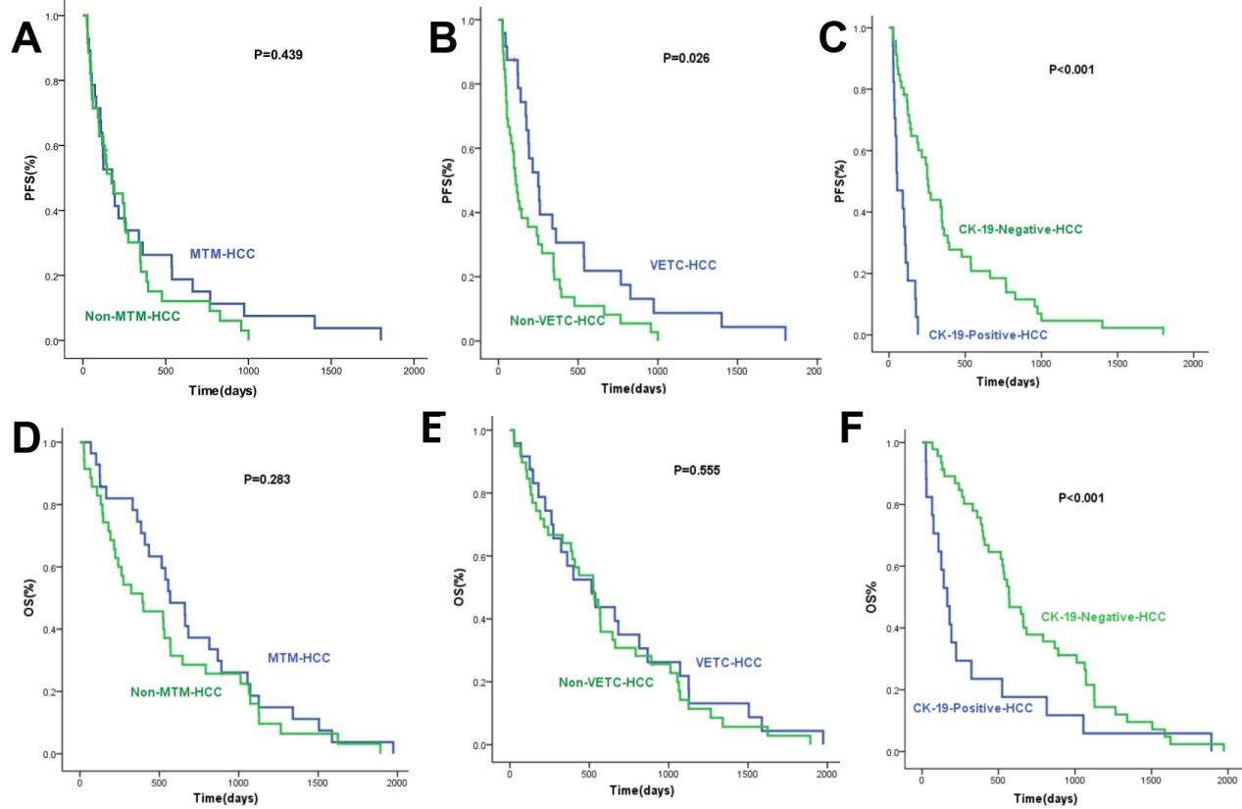
Figure S1 PFS and OS among different pathological types in recurrence after surgical resection cohort. A and B, cTACE therapy prolongs PFS of VETC-HCCs but not MTM-HCCs; C, CK-19-positive HCCs resist to cTACE therapy; D, E and F, OS of VETC and non-VETC, MTM and non-MTM HCCs were not significantly different, but CK-19-negative HCCs derive a significant survival benefit compared with CK-19-positive HCCs.

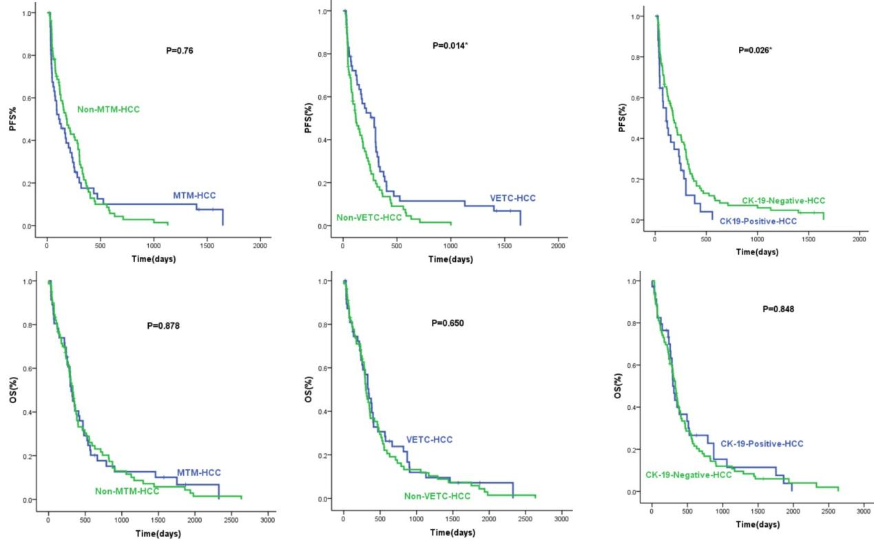
Figure S2 PFS and OS among different pathological types in liver needle biopsy cohort. A and B, cTACE therapy prolongs PFS of VETC but not MTM-HCCs; C, CK-19-positive HCCs resist to cTACE therapy; D, E and F, OS of VETC and non-VETC, MTM and non-MTM, CK-19-positive and CK-19-negative HCCs were not significantly different.

