Supplementary section

Supplementary Methods

PK and PK/PD Model Development for rVWF

Structural Models
One- and two-compartment disposition models with first-order elimination from the central compartment and a component describing endogenous VWF:RCo activity levels were evaluated for VWF:RCo PK. The one-compartment model parameters were clearance and central volume of distribution. For the two-compartment model, intercompartmental clearance and peripheral volume of distribution were added. Body weight was included as a structural covariate on clearance and volume parameters.
The structural model describing the VWF-FVIII relationship was based on the known mechanism of FVIII protection exerted by the VWF protein as well as on the hysteresis loops observed in the available PK/PD data (Supplementary Figure 2). This warranted the use of an indirect response model, which can capture the delayed FVIII response in relation to VWF activity (Supplementary Figure 1). Thus, the model takes into account FVIII levels at VWF:RCo activity of 0 IU/dL (FVIII₀), the zero-order production (k_{in}) and first-order removal (k_{out}) rate constants for FVIII, and the inhibitory effect of VWF:RCo on k_{out} described as
$$VWF effect=1-I_{max}∙\frac{VWF:RCo}{{IC}_{50}+VWF:RCo}$$
where I_{max} is the maximal inhibition of k_{out}, and IC₅₀ is the VWF:RCo activity level leading to a 50% reduction in k_{out}. Estimated system-specific parameters were FVIII₀ and k_{out}, while k_{in} was derived from the steady-state condition k_{in} = FVIII₀∙k_{out}. PK/PD model building was conditioned on the individual VWF:RCo parameters estimated in the PK step. For both models, samples below the LLOQ (lower limit of quantification) were retained in the analysis set and modeled using the likelihood-based M3 method.¹

Stochastic Model
First, IIV was included in an exponential manner as follows
$$P_{i}=TVP∙e^{η_{i}}$$
where TVP is the typical value of the parameter P in the population, P_{i} the i^{th} individual’s value of the parameter, e is exponent and η_{i} the random effect term accounting for IIV (η_{i}~N(0, ω²)), where ω is the standard deviation of interindividual variability. Second, because data from multiple dosing occasions were available, interoccasion variability (IOV) was also tested on the PK and PD parameters² as
$$P_{ik}=TVP∙e^{η_{i}+κ_{ik}}$$
where P_{ik} is the i^{th} individual’s value of the parameter at occasion k and κ_{ik} is the random effect term accounting for IOV (κ_{i}~N(0, ν²)). Finally, the residual unexplained variability was described by a combined additive and proportional error model.

Covariate Model Building
Following development of the base model including the structural and stochastic components, the covariate-parameter relationships in Supplementary Table 1 were evaluated using the stepwise covariate modeling (SCM) procedure.³ Significance levels of p<0.05 and p<0.01 were used for the forward inclusion and backward deletion of covariates in the SCM, respectively. Continuous covariate relationships were parametrized with power models as follows
$${ParCov}_{m}={\left(\frac{{Cov}_{i}}{{Cov}_{ref}}\right)}^{θ_{m}}$$
where Cov_{i} and Cov_{ref} are the individual and reference value of the covariate m, respectively (Cov_{ref} is normally set to the median covariate value in the analysis data set), and θ_{m} is the parameter quantifying the covariate effect.

Model-Building Approach and Software
Structural and stochastic models were initially evaluated to describe VWF:RCo and FVIII:C; this was followed by covariate model building and PK/PD simulations. The PK/PD model for FVIII:C was developed using a sequential approach (ie, conditioned on the individual PK parameters). The models were evaluated by inspecting graphical diagnostics, including goodness-of-fit plots, and changes in the objective function value.
Parameter estimation was performed using the first-order conditional estimation method with interaction (FOCEI) method in NONMEM. Uncertainty in parameter estimates was assessed by means of nonparametric bootstrap methods using 2000 samples resampled from the complete original data set. Covariate modeling and bootstrap were assisted by Perl-speaks-NONMEM (PsN) software.⁴

Supplementary Results

PK Model for rVWF
Graphical exploration of PK profiles indicated considerable differences in endogenous VWF between patients with VWD and severe hemophilia A. In the first step, the difference in the typical endogenous level between VWD and severe hemophilia A patients was added as a structural covariate in the model. In addition, the variability in the endogenous VWF was different between patient populations and this was also considered in the model. A significant number of VWD patients had endogenous VWF levels below LLOQ, and to stabilize the model, the typical endogenous level for this population was set to half the LLOQ (0.5 IU/dL). A sensitivity analysis where the typical endogenous level was fixed at other values did not suggest a significant impact of this parameter on the important PK parameters CL and V_{c}. In contrast to VWD type 3, non-type 3 VWD (types 1 and 2) is typically associated with endogenous levels above LLOQ. Therefore, in the second step, the difference in the typical endogenous level between VWD type 3 and non-type 3 was added as a structural covariate, where the typical endogenous level for VWD type 3 patients was kept to half the LLOQ (i.e. 0.5 IU/dL). Given that only ~9% (5/57) of patients with VWD type 3 had estimated endogenous levels above LLOQ, the variability in this group was set to 0, which is also supported by graphical extrapolation. The conclusion was that patients with severe hemophilia A had significantly higher endogenous VWF levels compared to patients with VWD but no other differences in PK parameters were identified between patient populations. This allowed patients with hemophilia A to be included in the PK Model for rVWF to increase sample size.

PK Model for pdVWF/FVIII
The pre-dose VWF:RCo was below the LLOQ in 18 patients and 1 IU/dL in two patients, and so fixing E_{VWF} to half the LLOQ at 0.5 IU/dL was considered appropriate for these data. Clearance (CL), intercompartmental clearance (Q), volume of distribution (V_{c}) and volume of distribution for the peripheral compartment (V_{p}) were allometrically scaled to body weight, with fixed allometric exponents, and parameterized as:
$${CL}_{i}= CL·{\left(\frac{{WT}_{i}}{75}\right)}^{0.75}·\exp^{(ηCL)}$$
$$Q_{i} =Q·{\left(\frac{{WT}_{i}}{75}\right)}^{0.75}$$

The covariate effects on V_{c} were expressed as below:
$${Vc}_{i} =Vc·{\left(\frac{{WT}_{i}}{75}\right)}^{1}·{\left(\frac{{Hematocrit}_{i}}{0.4}\right)}^{-0.334}·e^{(ηVC)}$$

$${Vp}_{i} =Vp·{\left(\frac{{WT}_{i}}{75}\right)}^{1}$$
where CL_{i}, Q_{i}, V_{ci} and V_{pi} are the individual estimates, and CL, Q, V_{c} and V_{p} are the typical estimates for CL, Q, V_{c} and V_{p}, respectively; WT_{i} is the individual body weight (WT) and 75 kg is the reference body weight; hematocrit_{i} the individual hematocrit and 0.4 L/L the reference hematocrit; and ηCL and ηVC the interindividual variability in CL and V_{c.}
Estimated exponents for CL and volume of distribution parameters were 0.54 and 0.33, respectively. This did not appear to be in line with previous experience⁵ and thus the fixed exponents were kept in the model. Interindividual variability terms were supported on CL and V_{c}. The residual unexplained variability for VWF:RCo was described by a combined proportional and additive error model.

PK/PD Model for pdVWF/FVIII
To account for the distribution of the pdFVIII dose, a volume of distribution of FVIII was introduced into the model, V FVIII. It was assumed that the elimination of pdFVIII was the same as for endogenous FVIII, and thus accounted for by k_{out} in the model. Indirect evidence supports the similarity of the elimination rates for pdFVIII and endogenous FVIII. First, the estimated k_{out} in the model (15.9 h⁻¹) corresponds to the FVIII elimination rate associated with zero VWF:RCo activity, but for VWF:RCo activities larger than zero, for example 50 IU/dL, the adjusted k_{out} for type 3 VWD would be 0.06 h⁻¹, which translates into a FVIII half-life of 11.5 h (95% CI: 10.1–13.3 h). This half-life is in the range of those observed for pdFVIII products.^{6,7} Moreover, it should be noted that the available data did not allow to separately estimate the elimination rates for pdFVIII and endogenous FVIII. Finally, model evaluation supported this assumption and has not revealed any sign of misspecification.
The system-specific parameters, baseline FVIII, k_{out} and the covariate effect of hematocrit on baseline FVIII can be expected to be similar across all VWD type 3 patients and independent of drug product. Fixing these estimates to those of the population PK/PD model for rVWF did not significantly impact the objective functional value or predictive performance of the model. The impact of hematocrit on the baseline FVIII was modeled using the equation:
$${Baseline {FVIII}_{i} =Baseline FVIII·{\left(\frac{{Hematocrit}_{i}}{0.39}\right)}^{ϴ-0.571}·exp }^{(η_{Baseline FVIII})}$$

where baseline FVIII_{i} is the individual baseline FVIII:C, hematocrit_{i} is the individual hematocrit at baseline and 0.39 is the reference hematocrit.

A second distribution compartment for FVIII was not supported.

Supplementary Table 1 Covariate-Parameter Relationships of Interest for the VWF:RCo and FVIII Models
Covariate | VWF:RCo PK Parameters | FVIII PK/PD Parameters
Age | CL, V_{c}, V_{p} | FVIII₀, IC₅₀
Body weight | CL, V_{c}, Q, V_{p} | FVIII₀, IC₅₀
Race | CL | ND
Sex | CL, V_{c}, V_{p} | FVIII₀, IC₅₀
Disease type | CL, V_{c}, V_{p} | FVIII₀, IC₅₀
Blood type | CL, V_{c}, V_{p} | FVIII₀, IC₅₀
rFVIII coadministration | CL, V_{c}, V_{p} | ND
Hematocrit | V_{c}, V_{p} | FVIII₀, IC₅₀
Abbreviations: CL, clearance; FVIII, factor VIII; FVIII₀, FVIII levels at VWF:RCo activity = 0 IU/dL; IC₅₀, activity level at half maximum inhibition; ND, not determined; PD, pharmacodynamic; PK pharmacokinetic; Q, intercompartmental clearance; rFVIII, recombinant FVIII; V_{c}, central volume of distribution; V_{p}, peripheral volume of distribution; VWF:RCo, von Willebrand factor:ristocetin cofactor.

Supplementary Table 2 Ethics committees for sites participating in studies
Study | Ethics committees
NCT00816660⁸ | Ethics Committee of the Medical, University of Vienna, Vienna, Austria  Landesamt für Gesundheit und Soziales Ethik Kommission des Landes Berlin, Berlin, Germany  North West Centre of Research Ethics Committees, Manchester, UK  Comitato Etico Dell’IRCCS Ospedale Maggiore Policlinico, Milan, Italy  Comitato Etico Indipendente Dell’Azienda Sanitaria, Naples, Italy  Comitato Etico per la Sperimentazione Clinica della Provincia di Vicenza, Venice, Italy  Comitato Etico per la Sperimentazione Clinica – Azienda Ospedaliero-Universitaria Careggi, Florence, Italy  Comitato Etico Istituto Giannina Gaslini, Genova, Italy  Comitato Etico per la Sperimentazione – Azienda Ospedaliera Di Padova, Padova, Italy  Comitato Etico Dell’Azienda Policlinico Umberto I di Roma, Rome, Italy  Children’s Hospital and Health Systems Human Research Review Board, Wauwatosa, WI, USA  St. Vincent Institutional Review Board, Indianapolis, IN, USA  Western Institutional Review Board (WIRB), Olympia, WA, USA  The University of Texas Health Science Center Houston / Office of Research Support Committees, Houston, TX, USA  Dana Farber Cancer Institute Office for Human Research Studies, Boston, MA, USA  Emory University Institutional Review Board, Atlanta, GA, USA  Rush University Medical Center / Research and Clinical Trials Administration Office, Chicago, IL, USA  University of Kentucky Office of Research Integrity IRB, IACUC, RDRC, Lexington, KY, USA  Capital Health Research Ethics Board, Halifax, Canada  Rochester General Health System Clinical Investigation Committee, Rochester, NY, USA  University of Louisville IRB / Human Subjects Protection Program, Louisville, KY, USA
NCT01410227⁹ | St. Vincent Hospital Institutional Review Board, Indianapolis, IN, USA  Children's Hospital of Wisconsin Institutional Review Board, Milwaukee, WI, USA  Western Institution Review Board, Olympia, WA, USA  University of Pennsylvania Office of Regulatory Affairs, Philadelphia, PA, USA  Rochester General Hospital Clinical Investigation Committee, Rochester, NY, USA  Newark Beth Israel Medical Center IRB, Newark, NJ, USA  UC Davis Medical Center, Sacramento, CA, USA  University of Illinois College of Medicine at Peoria Institutional Review Board, Peoria, IL, USA  University of North Carolina at Chapel Hill Biomedical Institutional Review Board, Chapel Hill, NC, USA  Michigan State University, Biomedical and Health Sciences Institutional Review Board, East Lansing, MI, USA  The Ethics Committee of the Institute of Haematology and Transfusion Medicine in Warsaw, Warsaw, Poland  Ethics Committee within Federal State-Funded Institution Federal Center of Heart, Blood, and Endocrinology n.a. V.A. Almazov under the Ministry of Healthcare of Russia, St. Petersburg, Russia  Ethics Committee within Regional Pediatric Clinical Hospital No.1, Ekaterinburg, Russia  Local Ethics Committee within Territorial State-Funded Healthcare Institution Territorial Clinical Hospital, Krasnoyarsk, Russia  Regionala etikprövningsnämnden i Lund, Lund, Sweden  Local Ethics Committee at Specialized Hospital for Active Treatment "Yoan Pavel", Sofia, Bulgaria  Cliniques Universitaires Saint-Luc - Comité d'Ethique, Brussels, Belgium  Commissie Medische Ethiek van de Universitaire Ziekenhuizen KULeuven, Leuven, Belgium  Erasmus MC METC, Rotterdam, Netherlands  Ethik-Kommission der Medizinischen Universität Wien und des Allgemeinen Krankenhauses der Stadt Wien, Wien, Austria  Landesamt für Gesundheit und Soziales Berlin, Berlin, Germany  Ethik-Kommission der Medizinischen Hochschule Hannover, Hannover, Germany  Ethik-Kommission der Landesärztekammer Rheinland-Pfalz, Mainz, Germany  NRES Committee London – Bloomsbury, Manchester, UK  Comitato Etico per la Sperimentazione Clinica della Provincia di Vicenza, Venice, Italy  Comitato di Etica della Fondazione Irccs Ca´ Granda Ospedale Maggiore Policlinico di Milano, Milan, Italy  Comitato Etico Azienda Policlinico Umberto I, Rome, Italy  Comitato Etico per la Sperimentazione Clinica dei Medicinali A.O.U. Careggi di Firenze, Florence, Italy  Ethics Committee for Multi-centre Trials, Sofia, Bulgaria  CEIC Hospital La Paz, Madrid, Spain  Regionala etikprövningsnämnden i Lund, Lund, Sweden  Ethikkommission der Ärztekammer Nordrhein, Düsseldorf, Germany  National Research Ethics Service, Manchester, UK  Comitato Etico per la Sperimentazione dell'Azienda Ospedaliera di Padova, Padova, Italy  Centro de Farmacovigilancia de Galicia, Galicia, Spain  Nagoya University Hospital Institutional Review Board Nagoya, Japan  Tokyo Medical University Hospital Institutional Review Board, Toyko, Japan  Ethics Committee, Jehangir Clinical Development Centre Pvt. Ltd, Pune, India  Sahyadri Hospitals Limited Ethics Committee, Pune, India  Institutional Review Board (Ethics Committee) Christian Medical College & Hospital, Vellore, India  Royal Perth Hospital Ethics Committee, Perth, Australia  Royal Adelaide Hospital Research Ethics Committee, Adelaide, Australia  Ogikubo Hospital Institutional Review Board, Tokyo, Japan
NCT02283268¹⁰ | Hollywood Private Hospital Research Ethics Committee, Nedlands, Australia  Royal Adelaide Hospital Research Ethics Committee, Adelaide, Australia  Royal Perth Hospital Human Research Ethics Committee, Perth, Australia  Ethikkommission der Medizinische Universität Wien, Vienna, Austria  Eticka komise FN Ostrava, Ostrava, Czech Republic  Landesaerztekammer Rheinland-Pfalz, Mainz, Germany  Comitato Etico di Area Vasta Centro, Florence, Italy  Comitato Etico Università Sapienza, Rome, Italy  Comitato Etico Milano Area B, Milan, Italy  Academisch Medisch Centrum, Amsterdam, The Netherlands  LEC at Territorial SBHI “Territorial Clinical Hospital”, Moscow, Russia  Ethics Committee of Regional State Budgetary Healthcare Institution “Regional Clinical Hospital”, Barbaul, Russia  LEC of “Kirov Scientific-Research Institute of Hematology and Blood Transfusion FMBA”, Kirov, Russia  Ethical Council at the MoH of Russian Federation, Moscow, Russia  CEIC Hospital Universitario y Politecnico La Fe, Valencia, Spain  Local EC:Comité AutonO’mico de E’tica de la Investigacion de Galicia, Santiago de Compostela a Coruna, Spain  Central EC:Instituto de Investigacion Sanitaria La Fe, Valencia, Spain  Tri-Service general Hospital Institutional Review Board National Defense Medical Center, Taipei, Taiwan  National Taiwan University Hospital Research Ethics Committee, Taipei, Taiwan  Taichung Veterans General Hospital Institutional Review Board, Taichung, Taiwan  Mersin University Clinical Research Ethics Committee, Mersin, Turkey  NRES Committee London – Hampstead, Manchester, UK  University of Miami Human Subjects Research Office, Miami, FL, USA  Medical College of Wisconsin/Froedtert Hospital Institutional Review Board, Milwaukee, WI, USA  Georgetown University Institutional Review Board, Washington, D.C, USA  University of Oklahoma Health Sciences Center Institutional Review Board Office of Administration, Oklahoma City, OK  Medical University of South Carolina Office of Research Integrity, Charleston, SC, USA  Dana Farber Cancer Institute IRB, Boston, MA, USA  Chesapeake Institutional Review Board, Columbia, MD, USA  Johns Hopkins Medicine Office of Human Subjects Research – Institutional Review Board, Baltimore, MD, USA  WIRB, Puyallup, WA, USA
EudraCT 2011-004314-42 | Biomedical Research Alliance of New York, Lake Success, NY, USA  The Ethics Committee of the Institute of Hematology and Transfusion Medicine, Warsaw, Poland  Western Institutional Review Board, Olympia, WA, USA  The Ethics Committee at Specialized Hospital for Active Treatment ‘Joan Pavel”, Sofia, Bulgaria

Figures
Supplementary Figure 1
Structure of the PK/PD model used to describe the relationship between VWF:RCo and FVIII activity following rVWF administration. The k_{in} and k_{out} represent the production and elimination rates of FVIII activity, respectively.
Abbreviations: CL, clearance; FVIII, factor VIII; FVIII:C, FVIII activity; k_{in}, zero-order production rate constant; k_{out}, first-order removal rate constant; PD, pharmacodynamic; PK, pharmacokinetic; Q, intercompartmental clearance; rVWF, recombinant von Willebrand factor; V_{c}, central volume of distribution; V_{p}, peripheral volume of distribution; VWF:RCo, von Willebrand factor:ristocetin cofactor.
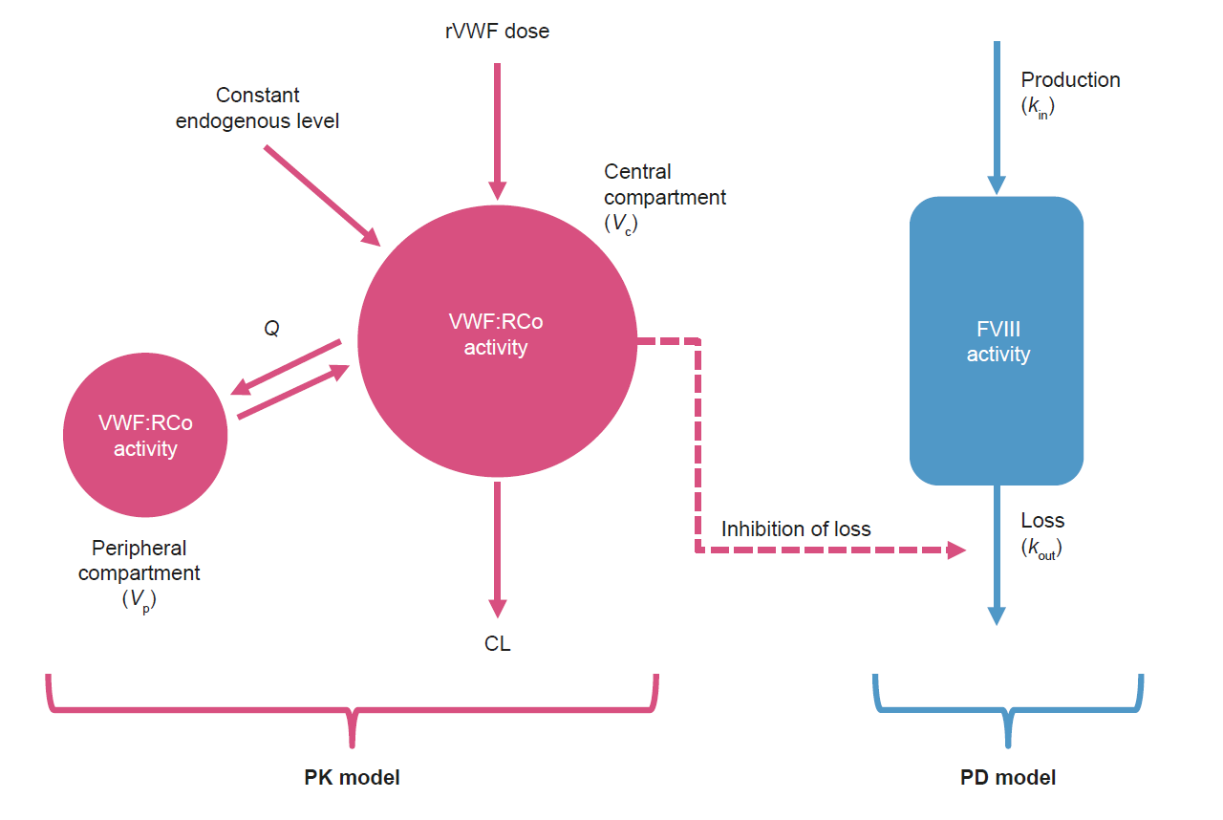

Supplementary Figure 2
VWF:RCo and FVIII:C data after single-dose administration of rVWF. (A) Observed VWF:RCo and FVIII:C data versus time, colored by VWD disease type. (B) Observed FVIII versus VWF:RCo activity for three representative individuals with each VWD type; the numbers in the labels represent the actual sampling time after rVWF dose. The observation at time = 0 is missing for type 1 VWD because no baseline FVIII measurements were included in the analysis for this population, owing to previous exposure to plasma-derived replacement therapy.
Abbreviations: CL, clearance; FVIII, factor VIII; FVIII:C, FVIII activity; rVWF, recombinant von Willebrand factor; VWD, von Willebrand disease; VWF:RCo, von Willebrand factor:ristocetin cofactor.
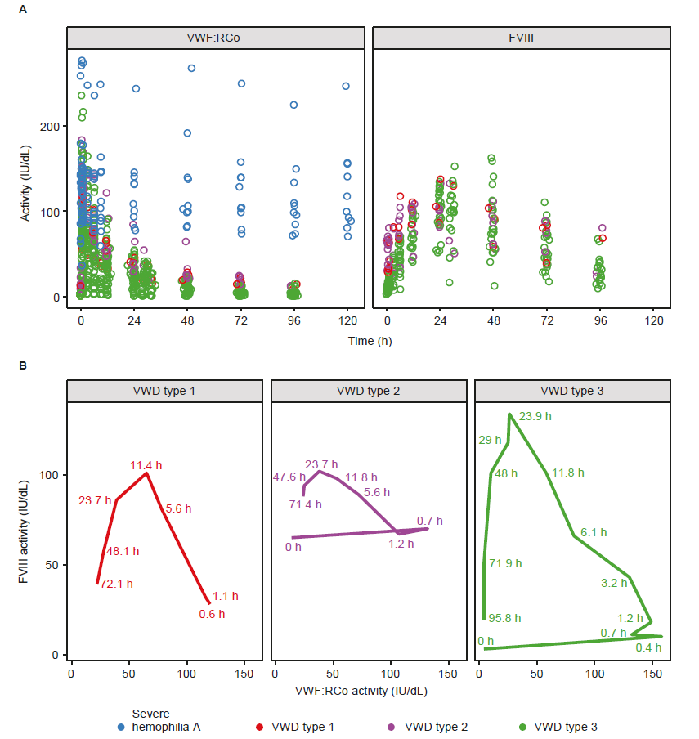

References
1. Ahn JE, Karlsson MO, Dunne A, Ludden TM. Likelihood based approaches to handling data below the quantification limit using NONMEM VI. J Pharmacokinet Pharmacodyn. 2008;35(4):401-421. doi:10.1007/s10928-008-9094-4
2. Karlsson MO, Sheiner LB. The importance of modeling interoccasion variability in population pharmacokinetic analyses. J Pharmacokinet Biopharm. 1993;21(6):735-750. doi:10.1007/BF01113502
3. Jonsson EN, Karlsson MO. Automated covariate model building within NONMEM. Pharm Res. 1998;15(9):1463-1468. doi:10.1023/a:1011970125687
4. Lindbom L, Pihlgren P, Jonsson EN. PsN-Toolkit—a collection of computer intensive statistical methods for non-linear mixed effect modeling using NONMEM. Comput Methods Programs Biomed. 2005;79(3):241-257. doi:10.1016/j.cmpb.2005.04.005
5. Holford NH. A size standard for pharmacokinetics. Clin Pharmacokinet. 1996;30(5):329-332. doi:10.2165/00003088-199630050-00001
6. Humate-P prescribing information. https://labeling.cslbehring.com/pi/us/humate-p/en/humate-p-prescribing-information.pdf Accessed 27 March 2023.
7. Wilate prescribing information. https://www.fda.gov/media/77812/download Accessed 27 March 2023.
8. Mannucci PM, Kempton C, Millar C, et al. Pharmacokinetics and safety of a novel recombinant human von Willebrand factor manufactured with a plasma-free method: a prospective clinical trial. Blood. 2013;122(5):648-657. doi:10.1182/blood-2013-01-479527
9. Gill JC, Castaman G, Windyga J, et al. Hemostatic efficacy, safety, and pharmacokinetics of a recombinant von Willebrand factor in severe von Willebrand disease. Blood. 2015;126(17):2038-2046. doi:10.1182/blood-2015-02-629873
10. Peyvandi F, Mamaev A, Wang JD, et al. Phase 3 study of recombinant von Willebrand factor in patients with severe von Willebrand disease who are undergoing elective surgery. J Thromb Haemost. 2019;17(1):52-62. doi:10.1111/jth.14313

