Solubilisation and Enhanced Oral Absorption of Curcumin Using a Natural Non-nutritive Sweetener Mogroside V

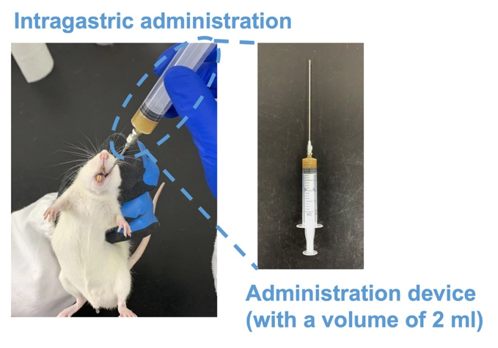
Supplementary Information (SI): The oral administration of curcumin to rats
Figure S1. The oral administration of curcumin to rats using an intragastric needle.

In the oral absorption experiments, the rat was orally administered with curcumin at a dose of 100 mg/kg. Fig. S1 showed the rat, weighing ~200 g, was given 2 mL CUR/Mog-V SDPs aqueous solution (10 mg/mL), by using an intragastric needle (No. 16) attached to a syringe.
Afterwards, the blood sample of 0.3 mL was collected immediately from the suborbital vein under ether anaesthesia and placed in heparinised 1.5 mL polythene tubes at 5-, 15-, 30-, 60-, 120- and 240-minutes post dosing.

